

The E-learner Support Project

Measuring the worth of e-learner support systems:

Developing a possible benchmarking method for evaluating effectiveness.

Jane Renwick & Stephen Owen

May 2005

ISBN Print version: 0-478-13309-X

ISBN Web version: 0-478-13310-3



The E-learner Support Project
Developing a possible benchmarking method for
evaluating the effectiveness of e-learner support systems.

This report was funded and supported by the New Zealand Ministry of Education through the Tertiary E-learning Research Fund, 2004. The views and opinions expressed in this document are the views of the authors only.

Acknowledgements

On behalf of the Aotearoa Tertiary Students Association (ATSA) and the researchers a special acknowledgment of thanks is extended to the Ministry of Education for their financial and administrative support of this project.
In addition, thanks are extended to the staff of the tertiary providers where the sample population of e-learners surveyed in this research had studied in 2004. Particular individuals were generous with the assistance they offered in their attempt to make contact with the e-learners and staff that were of interest to the researchers.

Also, a special mention of thanks is made to those research and tertiary professionals, independent to this project, who gave their advice and feedback at stages of the research. In particular, the assistance of the Association of Staff in Tertiary Education (ASTE), the wider group of professionals funded from the 2004 E-learning research and Dr Stephen Marshall (Victoria University) was greatly appreciated. In addition, thanks to Dr Joce Jesson (Auckland University) for her advice regarding the survey instrument.

Most importantly, we thank the e-learners who contributed data to this research project.

Table of contents

1 Acknowledgements 2
2 Executive summary 4
3 Introduction 6
3.1 Background: Framing the issues 6
3.2 The components of E-learner support. 9
4 Survey methodology 13
4.1 Summary 13
5 Findings 22
5.2 All importance-performance statements 27
6 Pre-enrolment advice 28
6.1 Importance – Performance analysis 28
6.2 Qualitative Analysis 31
6.3 Discussion 36
7 Orientation help 39
7.1 Importance – Performance analysis 39
7.2 Qualitative Analysis 43
7.3 Discussion 48
8 Social and personal support 51
8.1 Importance – Performance analysis 51
8.2 Qualitative Analysis 52
8.3 Discussion 58
9 Technical assistance 60
9.1 Importance – Performance analysis 60
9.2 Qualitative Analysis 63
9.3 Discussion 68
10 Conclusion & recommendations 72
10.1 Recommendations for providers 75
10.2 Policy considerations and recommendations 79
10.3 Apendices to this report are available as a supplemantary document. 80
10.4 SDR: Population, Sample and Respondents 81

Executive summary
The findings in this research (and those from overseas projects) indicate that student support services provide levels of assistance across a range of factors which contribute to the ability of e-learners to complete their study programme. Overall, the relative standard error of the quantitative findings in this report is 8.51% at a 95% confidence interval. The research confirms the factors identified in the ‘E-Learners Support Project’ are aspects of students support services which are likely to mitigate the attrition of e-learners from their study programme

Despite the fact that the population list used for this research was a year out of date at the time when the survey was undertaken, the methodology and research technique produced useful results. It is reasonable to assume that researchers could use a similar technique in the future to measure the worth of student support services, especially those provided to e-learners. It is also reasonable to assume that a similar survey to the ‘E learners Support Project’ would produce a significantly smaller standard error if it were implemented in a timely manner across common e-learning platforms to New Zealand tertiary students.

Currently, the New Zealand tertiary sector is implementing initiatives recommended in the Performance Review of the Performance Element to Tertiary Funding. As part of that review there is a proposal to undertake a survey of students’ tertiary experience. The findings of this report underline the importance of measuring the components of student support services and assessing their effectiveness. Furthermore, this research suggests that the introduction of a generic framework for a performance assessment would need to weight the responses from e-learners across components of student support services to take account of the greater reliance e-learners place on particular aspects of those services.

The findings from the research population indicate that overall the tertiary organisations are providing good student support services that approach the level of performance e-learners expect. They provide a useful bench mark that other providers could use to gauge their own performance across a range of factors which support the e-learner.

The research has highlighted areas where provision of services could be improved to meet the e-learners needs: a trial e-learning programme for potential students, easy navigation of web sites and learning platforms, improved access to generic information, for example, time management, provision of personalised communication with staff, social integration with their cohort and peers and help desk support that is readily understood. The recommendations in this report identify seven aspects of support services that providers with e-learners should measure and assess. Tertiary providers should now be encouraged to assess and monitor their performance as deliverers of those services.

Of particular interest to providers delivering these services will be the level of importance these e-learners place on the technical assistance they are given and the email communication they receive from staff. The research suggests providers are likely not to be reaching the performance level the e-learners declare optimum.

It appears from the findings that Technical Assistance is above all the most important aspect of support to e-learners. Currently tertiary providers are aware of the need to improve the delivery of this service by extending the hours that help is available.

The e-learners in this research are predominantly a female population with care giving responsibilities to a dependent person. They are clearly a population likely to do their e-learning activities outside the ‘normal’ operating hours of their provider. The recommendations of this report include a suggestion that a one place provision of technical assistance help desk support with extended operating hours is a feasible option for delivery of services to e-learners. The report suggests that the introduction of that service is advantageous as part of our national learning infrastructure.

Introduction

This report is an analysis of the perceived importance and effectiveness of various non-academic support services provided to on-line distance learners [e-learners] in New Zealand’s tertiary education sector. It is the final phase of the E-learner Support Project, one of five studies funded by the Ministry of Education’s 2004-2005 ‘E-learning Research Fund’.

Information collected during the earlier phases of of the E-learner Support Project provided the researchers with tools to develop the importance and effectiveness survey for e-learners. The literature review highlighted areas of international and national research where there was consistent agreement on a range of findings including the factors which provide positive learning experiences for e-learners. The review included an analysis of current e-learning policies and environments in the New Zealand context. This information provided a New Zealand framework and focus to the research.

One of the most consistent findings in the literature guided this research. The finding surrounds student support in ‘higher education’ and indicates a need for providers to build and maintain effective support services to meet the non-academic needs of learners. According to many professionals, e-learners require support across a range of social, personal and technical areas above and beyond their academic requirements. Several evaluation projects have indicated that when such needs are seen as important by students, and are or not met or under-met by providers, it is possible that students will fail to reach their full academic potential. As a consequence this event increases attrition [drop-out] rates or lessens grade/pass scores.

The overall objective of the project was to develop a set of indicators that education providers could use to evaluate the effectiveness of support services provided to e-learners.

Background: Framing the issues

The assumption underpinning this research is that a relevant set of effective student support services is one of the tools education providers can use to reduce attrition [drop-out] and enhance learner outcomes, as measured by improved pass rates.

Provision of student support is a condition of programme approval for all formal programmes of tertiary study. No formal investigation into the effectiveness of such support, as it relates to the specific circumstances and needs of e-learners, has been undertaken in New Zealand’s tertiary sector, although there is anecdotal evidence that the type and quality of support provided to e-learners may be less than optimally effective in preventing drop-out from study.

It is unproblematic to state that e-learners do not generally have access to the forms of support typically available to on-campus learners. The very nature of distance learning, involving separation of a learner from his/her provider’s physically located infrastructure, dictates that this must be the case.

Within traditional campus environments, learners have access to various technical, academic and social support structures as a matter of course. For example, Information Communication Technology (ICT) assistance in student computing suites is a basic-level service standard in the sector. Additionally, lecturers, tutors and support staff are generally approachable, either informally or via appointment systems. Career and course advisory assistance, and add-on or catch-up study programmes are prominently advertised, while counselling, child care, and other services are available at all public, and many of the larger private education providers. On-campus students access their learning and support needs within a social environment. These can be described as physically located systems of student support based within a coherent community of practice.

In contrast with this traditional model of tertiary education, most e-learners’ educational activities occur remotely, in workplaces or homes. Compared to what is available to on-campus students, the resources and social support networks available in such locations vary in quality and constancy. Even when such students attend block courses, their face-to-face interaction with provider staff, facilities and services is often transient.

Although there will always be instances when factors beyond the control of providers will result in learners discontinuing studies prematurely, past research has illustrated the centrality of effective learner support systems as a key factor in e-learner retention and successful completion.

This implies there is a causal relationship between educational success and the relevance and effectiveness of learner support systems. If this is the case, it follows that, in order to lessen attrition and improve learner outcomes, education providers need to implement student support systems that meet the needs of e-learners. These systems need to be evaluated against effective benchmarks on a regular evaluative cycle to ensure they are remaining relevant to the needs of students and effective in lowering attrition and improving educational outcomes.

Defining learner support
The E-learner Support Project’s description of learner support specifically excludes academic/pedagogic activities from its definition. The decision to exclude such support was based on pragmatic grounds. Firstly, there is a wide range of practices and benchmarks that education professionals use to assess the most effective approaches to academic success. The researchers felt that to include such activities would require consideration of pedagogic models [e.g. objectivism and constructivism] that would replicate past research and would add little to the central issue of supporting on-line students in their studies.

Secondly, running counter to the large body of literature that concerns the theory of education, there are very few publicly available reports that empirically investigate non-academic learner support issues in New Zealand. Although there is a considerable body of international evidence that investigates these aspects, from both traditional distance-based [e.g. ‘correspondence’-type provision] and more recently, from the perspective of on-line delivery, “there has been little analysis and research done into the needs and wants of [e-learning] students” in New Zealand’s tertiary education sector.

This decision to limit the study’s interest to non-pedagogic aspects was confirmed in the literature review. Somewhat surprisingly, and in contrast to the academic-theory debates, no fundamental disagreements were found between researchers about non-pedagogic learner support. Overseas research has generally found that effective support that addresses the personal and social needs of learners is a key factor in e-learner retention and successful completion [Ullyatt: 2003, Ludwig-Hardman & Dunlap: 2003, McCracken: 2004]. The evidence is also clear that in relation to marginalised learners, relevant and effective non-academic support services are the “key to their recruitment, retention and achievement, particularly for those non-traditional learners who may lack motivation or experience of learning” [Evans, 2000:19, see also, Brooks, 2001 and Murray, 2001].

For the above reasons, the definition of learner support used in this study is:
Those practices and services offered by education providers to e-learners that are not pedagogic practices in themselves but which meet the needs of learners in such a way that they have a positive influence on learning experiences and educational outcomes.

This definition was developed into a four-stage model of support. These are discussed in more detail below.

The components of E-learner support.

Following the literature review, and based on the primary goal of the project, to develop practical benchmarks that would aid evaluation of support services, the support systems of interest were located in four specific areas: [1] pre-enrolment advice, [2] orientation help, [3] social and personal support and [4] technical assistance. Although there are direct relationships between the four in operation [for example, during orientation help, social support and technical assistance is generally provided] these were defined as discrete ‘stand-alone’ activities to assist in developing the concepts into practical areas that could be evaluated via survey instruments. These four aspects, and the particular issues they pose for on-line distance education providers, are described more fully below.

Pre-enrolment advice
Pre-enrolment is the stage when an individual begins investigating her/his study options. Engagement with any particular provider may initially be tenuous. Various options can be considered during this stage, and accurate advice is needed. For example, information to inform final decisions about the most appropriate study method, be it on-line or distance or campus-based, may be required. Potential students can take e-learning courses for the wrong reasons and “lots of upfront information and advising” [Murray, 2001) will help lessen the possibility of early drop-out. Unlike on-campus enquirers, candidates for e-learning will often be distant from their providers. They may not be in a position to directly discuss their needs face-to-face with teaching or advisory staff. Central to the provision of pre-enrolment advice is the need to ensure enquirers make registration decisions based on an accurate matching of their “interests, aptitudes and motivation” [Simpson, 2002:35) with the most appropriate programme of study.

Orientation help
In New Zealand, ‘orientation’ is typically understood as describing the process of providing important information and offering structured activities to newly enrolled students before study-proper beginning. On-campus orientations generally occur in the first fortnight of each academic trimester.

The academic aim of all orientations is to ensure students have entry-level competencies for successful study. Orientation support needs to be more than a passive exchange of information. It should be consciously designed and provided with the aim of “enhancing learner success through appropriate induction and advice” (Blakely: 2003). The administrative aim of these activities is to introduce learners to their academic and social environment. Orientations also provide students with the opportunity to discover the range of non-academic services available. It is also the time when they should be advised about student advocacy and complaints procedures. During on-campus events, new learners also gain their first opportunities to interact socially and academically with fellow-students, academic and support staff.

The nature of distance learning, where students will never or rarely visit a ‘bricks and mortar’ facility, means that effective orientations must be delivered in a fundamentally different way if they are to achieve the goals of on-campus processes. E-learner orientations need to focus on preparing students to learn at a distance (Distance Learning Policy Laboratory, 2002).

Social and personal support
The social support needs of e-learners pose particular challenges for providers. The need for social interaction and institutional affiliation has long been a dominant theme in literature surrounding distance education. It is self-evident to state that "the on-line environment lacks the critical social dimension presumed by traditional classroom experiences." (Hamada & Scott, 2000). The reported high drop-out rates of students from e-learning study may be partly attributed to a “sense of isolation due to a lack of interaction” Coughlan & Ó Súilleabháin, 2003) that is immediate, visible and directly social in nature within an on-campus environment.

The positive relationship between “communication, participation and interaction” and academic achievement in web-based courses has been well documented” (McCracken, 2004) and communication channels that help learners affiliate with other students, tutors and the institution are seen as essential components of effective social support systems for on-line learners.

Without opportunities to “network and ‘connect’ with other students” (Carnwell, Moreland & Helm: 2001), distance based e-learners face the risk of isolation and drop-out. Barefoot’s (2003) USA study, for example, found that “failure to connect to the campus social systems” was a factor in early dropout of students. On traditional campuses, orientation to the range of rules, services and facilities may be initially frustrating for first time learners. Distance learners face the double jeopardy of needing to understand both a new ‘virtual’ environment and (often face) a lack of the immediate social support or assistance when things go wrong (Hook, 1999).

Technical assistance
The final category in the E-learner Support Project’s model of learner support encompasses the services and assistance required by e-learners to quickly and efficiently access and use the information and communication technologies (ICT) required for distance learning.

Technical support needs are more important for distance based e-learners than e-learners who study within a campus environment. Students studying exclusively at a distance do not have direct access to ICT assistance and support typically available to on-campus e-learners. Ongoing technical problems must eventually affect educational outcomes. Students who cannot communicate with their tutors and support personnel due to software and hardware problems will be unable to participate at an optimum level. There is wide consensus in the literature that provision of timely and effective technical support to distance based e-learners is a critical requirement for providers offering distance based e-learning. When such support is not available in a timely manner, some learners may discontinue study out of frustration, or discontinue further e-learning study to avoid similar problems in the future.

Testing the assessment model

To generate survey data that could be used to measure the importance and effectiveness of each type of support, the areas of Pre-enrolment, Orientation, Social and Personal Support and Technical assistance had to have a set of activities and factors itemized for respondents to rate under each of those headings. To assist the researchers in the development of factors to rate, three focus groups were organised with e-learning professionals. All focus group participants were presented with a general summary of the literature review’s findings, and background information on the projects goals and working definitions

The groups were asked to consider each area of focus and discuss what the salient features of those aspects were. The professional roles of focus group participants were various and this provided the researchers a scope of professional assessment on what factors the survey should itemize for assessment. Table 1 summarises the educational specialities of the focus group participants.

Table 1

Although there was some disagreement within the groups on aspects of detail within the learner support model, all three discussions identified generally common views on which aspects in the four support areas should be included for assessment. The researchers noted these aspects as most suitable for inclusion in the survey instruments.

Ensuring that the needs of Maori and Pacifica e-learners were being met in their tertiary environments was one of the issues discussed in two groups. The focus group of Maori and Pacifica participants emphasised the provider’s responsibility to ensure potential Maori and Pacifica e-learners had sufficient skills to participate effectively in an e-learning environment. That group also noted that tertiary providers’ had a responsibility according to the Tertiary Education Strategy (TES) to consult with their communities and if that included Maori and Pacifica then the provider must ensure they met that expectation to consult. In all instances these focus group members interfaced with tertiary providers who catered to the specific needs of their Maori and Pacifica populations.

Survey methodology

Summary
The methodology of the E-learner Support Project’s evolved to some degree during the research process as the researchers established what data they could access. Two main changes occurred to the intended data capture of the researchers. Firstly, it was not possible for the researchers to accurately identify the staff that supported the e-learners and therefore less staff than intended were contacted to participate in the survey which evaluated the same areas the e-learners did. It was not worthwhile processing the quantitative data captured from a survey of so few staff respondents.

The second change to the intended research process was the exclusion of the outcomes data analysis. The researchers had believed they could access some outcomes measurement for the population of interest, the sample population or the respondent population. However, the e-learners could not be identified within the outcomes data as the Single Data Return (SDR) is organised by programme level for example, Bachelor of Arts. Undergraduate e-learning occurs mainly at the course level.

The methodology was detailed and is outlined in the following summary. It is a summary of complex processes and culmination of two sets of survey data; e-learners and staff. To highlight but a few areas there are descriptions of how the instruments were constructed and the processes for selecting/contacting the simple random sample of students. The quantitative analysis section provides an overview of how the quantitative findings are interpreted. For readers of this report unfamiliar with Importance Performance indicators the reports quantitative section will be a useful reference to understand the I-P matrix and scores in the body of this report.

Testing the factors with e-learners.
Together with important factors identified in the initial literature review, the focus group findings were used to develop a set of variables that sat within each area of the study’s four-stage model of learner support. These were then tested with learners’ perceptions of their importance and relevance through telephone-based interviews with a small number [n=10] of on-line students. These participants were contacted via Student Job Search. No substantial changes in the variables were required following this data collection phase.

Questionnaire development

The data collected during focus group discussions identified factors of support that participants considered important to identify for an importance/performance assessment. In general, those factors that e-professionals identified tracked the general array of factors researchers elsewhere had established as appropriate factors for an e-learners support assessment.

These factors were developed as Likert-type statements in two survey-based questionnaires. The e-learners survey was adapted as a self-completion instrument for delivery online. The staff version was adapted for use as a telephone survey

The instruments were desk evaluated by independent researchers and then piloted with a small group of e-learners and e-learning staff. Some changes were made to the final instruments before they were delivered to the two sets of survey respondents.

The survey instruments were predominantly closed-response queries to a set of Likert-type statements from which respondents selected a rate that matched their perception and experience of learner support services. One set of statements required respondents’ to rate the relative importance of learner support services. There were four ranking scales, Very important, Moderately important, Slightly important and Not important. The other set of statements required respondents to rate the usefulness of support actually received. There were response options, Poor, Adequate, Good, Excellent and Did not receive.

The instruments also contained a series of open-ended questions. E-learner respondents were given the opportunity to make comments regarding the usefulness or otherwise of their experience. Staff were asked to comment on the usefulness or otherwise of their organisations activities. The decision to capture qualitative data was an important component of the survey. Potentially the questions could generate a depth of information that the ratings could not. Most importantly the qualitative findings were likely to help explain and contextualise the empirical findings. (See appendices for instruments)

Technique
The researchers decided to survey e-learners using an on-line web base instrument. Several factors contributed to the choice of this method including that the population were likely to be web orientated. Integral to the choice to web survey was the opportunity for the researchers to facilitate contact with a sample population via their email address. This factor was welcomed as e-mail addresses had the potential to be a stable means of contact with a population likely to present some residential mobility.

Desk evaluation and pilot surveys.
Prior to piloting the surveys with a small number of e-learners and staff, the questionnaires were desk evaluated by three external researchers. Their comments and suggestions were used to modify and improve the instruments’. No substantive amendments were required.

The questionnaire prepared for interviewing staff was piloted by four of the focus group participants. No recommendations for major amendments were suggested.
The questionnaire prepared for e-learners was piloted with the ten telephone interviewees found via Student Job Search who assessed the appropriateness of the survey statements at an earlier stage. Unfortunately, none of these participants self completed the survey as they had agreed to do during their telephone interview. The non-response factor of the self completion survey confirmed that non-response would pose obstacles in the data-collection stage. Clearly, it was appropriate to calculate that factor into the research considerations..

Population characteristics (see last page)

Sampling
Selecting a population
The researchers sought a means to access a population of e-learners for the purposes of surveying. The Single Data Return (SDR) provided a mechanism to access such a population and with the assistance of the Ministry of Education the researchers were able to establish a list of students to approach with a survey.

Ministry officials provided the ATSA researchers with a list of students recorded in the April 2004 SDR that meet the criteria of the population of interest. The population list provided individual identifiers (National Student Number) for each student and a range of variables that the researchers had used to filter the SDR. Demographic characteristics of interest were also included for example, the student’s gender.

The ‘E-learner Support Project’ SDR data requirements

In summary, the population list identified the group of full-time, undergraduate, distance, web based learners studying in New Zealand tertiary institutes as recorded in the Ministry of Education SDR April 2004.

The decision to identify that population of students was based on several assumptions. In particular, the researchers assumed that the population would have required a high level of support because they were remote learners with a maximum workload. These learners were thought to be well informed on what support was readily available to them and what support they considered important.

Facilitating contact with the sample.
Before sampling, and for surveying to occur, the researchers had to secure the co-operation of tertiary providers to assist with contacting students. (The process of contact required providers to trace students’ contact details by their National Student Number and forward, on behalf of the researchers, an invitation to participate in the survey).

The e-learner population was spread across four providers. Unfortunately, the researchers could not secure the assistance of one provider and had to remove that population of e-learners from the list of the national population. The remaining population were e-learners in a university environment.

Sampling
A simple random sample of 596 e-learners was selected from the list of approximately 1400 students. The size of the sample was designed to produce 5% standard error on the premise that the population was not a homogenous group, and 50% of the sample would respond to the survey. However, researchers did not anticipate in their calculations that 40% of the sample were probably unsuccessful e-learners that would not complete their course by the end of 2004 and were unlikely to respond to the survey. Post data collection the researchers concluded that the 1400 e-learners held more common characteristics than we had previously assessed and could therefore be assumed a homogenous population for the purposes of calculating standard error.

Privacy
The anonymity of the e-learning population was maintained throughout the survey process. Providers established contact with the students and the researchers were limited to identifying individual students by their national student number (NSN) only. At no time during the research process were researchers in a position to locate students and identify them by their names or addresses.

Assurances of e-learners anonymity were provided verbally and in writing to participating tertiary providers. E-learners were given the assurance of anonymity in the invitation to be a survey participant forwarded to their email address by their provider. Staff were told their responses were confidential and they or their provider would not be identified in the report.

Ethics
The researchers used the New Zealand Association of Social Researchers Code of Ethics as a guideline for the project. The research did not undergo a formal ethics approval. Throughout the project the researchers ensured the consultation process provided information for stakeholder to assess the propriety of the research. We were in close contact during the research process with a range of stakeholders. Information concerning the ‘E-Learners Support Project’ was made readily available to stakeholders and interested parties.

Quantitative analysis
The E-learner Support Project’s primary goal was to develop a set of indicators that providers could use to evaluate the effectiveness of the support systems provided to e-learners. This required an essentially analytic approach, with discrete [countable] information being the primary analytic data generated. As discussed above, this was collected with two types of Likert scales. These generated a binary set of related-data that could be manipulated through ‘importance-performance’ analysis. This was the primary quantitative method used to test the viability of the study’s approach.

Interpreting Importance-performance assessment
Importance-performance analysis [I-P analysis] was initially conceived by Martilla and James [1977] as an approach to measuring customer satisfaction by comparing service expectations [importance] with actual experiences [performance]. Either of these two variables, importance or performance, can provide useful stand-alone insights into improving quality but their real potential lies in the merging of the two concepts (Magel & Levenburg, 2005].

I-P analysis provides an inferential approach to assessing quality based on two variables. It has distinct advantages over other approaches to measuring satisfaction, not the least being its common-sense approach to analysis. Findings can be graphically displayed in a clear and unambiguous way [refer figure 1, over page]. This allows accurate identification of respondents’ beliefs about the relative importance of various factors, and their related judgments about how effectively the provider has performed in meeting their needs. Importance in this sense is a proxy for level of need, with performance being a measure for the usefulness or effectiveness of the service provided. The method provides a way to measure users’ beliefs about the relative value of a named service or thing [the importance measure] and their judgments on how useful the actual service/thing provided was to them [the performance measure]. Comparing these two parameters provides a measure of how effectively respondents’ needs have been met.

Two sorts of related data are generated by importance and performance measurements. One comprises the mean scores of all respondents’ importance and performance ratings. These scores are plotted graphically to generate a four-quadrant ‘I-P matrix’. This identifies aspects of services that require improvement, maintenance, or reduction according to the location of I-P scores on the grid.

The second set of data is obtained by calculating the difference between actual performance and judged importance of an aspect and generates a set of ‘performance gaps’. Any gap will be positive, negative or zero. A negative score indicates dissatisfaction with performance, while a positive value infers more than satisfactory service provision. When both importance and performance scores are the same, i.e., when the calculation ‘performance minus importance = 0.00’, the gap is zero; needs are being met.

The addition of a 45⁰ diagonal line in the I-P matrix graph used to display the mean importance-performance scores discussed above creates an “iso-priority line, where performance equals importance” [Magel & Levenburg, 2005]. The closer a gap score is to zero, the closer to this line is the related I-P score. A hypothetical example of such a matrix is illustrated in figure x, below. An explanation of its relevant features follows.

Figure 1: Hypothetical I-P matrix illustrating the four quadrants and the iso-priority line,
[Adapted from Martilla & James, 1977 and Magel & Levenburg, 2005]

The iso-priority line broadly describes areas of under- and over- performance. I-P scores located above this line [within the shaded area] provide indications that performance improvements are required to meet important needs. All I-P scores with negative gaps will be located in this region. The further such a score is from the line, the more it is judged usefulness is in deficit against it is assessed importance. Items with I-P scores below the line [positive gap] can be regarded as meeting and generally exceeding user’s needs.

Quadrant A: ‘Concentrate here’ [high importance/low performance] contains those aspects that respondents attached high importance to but assessed usefulness of actual support provided as low. This is the ‘high priority’ quadrant where additional resources are needed to meet learners’ important needs. Thus, service ‘1’ would require changes in provision or additional resources to move it into the desired quadrant, B.

Quadrant B: ‘Keep up the good work’ [high importance/high performance] locates aspects that are highly rated for importance by students who also judge the usefulness of the services provided to be very good or excellent. Provision of services ‘2’, ‘3,’ and ‘4’ would be regarded as real strengths. Any strategy would aim to maintain delivery at current levels. Item ‘4’, sits exactly on the iso-priority line – a location where there is an exact match between learners’ needs [as measured by importance] and their assessment of usefulness.

Quadrant C: ‘Possible overkill’ (low importance/high performance] includes elements that are of lesser importance but which students judge are being provided at a high level of usefulness. Depending on the actual location of a service within this quadrant, strategies could be directed at maintaining the status quo [as in the case of service ‘5’] or moving resources into improving quadrant A provision. This latter approach would typically be the case for service ‘6’.

Quadrant D: ‘Low priority’ [low importance/low performance] identifies aspects of support that students attach little importance to and which is provided in a less than satisfactory way. Given services such as ‘7’ are unimportant and are delivered poorly, the strategy would be to discontinue them and apply freed resources into improving quadrant A or maintaining quadrant B support services.

The underlying assumption of I-P analysis is that both the importance and performance scales measure equal increments. The equality of relationship between the two scales used in this study is illustrated below.

Table 4: Relationship between the importance and performance measures used in the E-learner Support Project’s survey instruments
Scale values |  | IMPORTANCE MEASURES | equates with | PERFORMANCE MEASURES
4 |  | Very important | = | Excellent
3 |  | Moderately important | = | Good
2 |  | Slightly important | = | Adequate
1 |  | Not important | = | Poor

Qualitative data analysis
While the majority of the data collected was used to generate the numerical relationships that underpin the importance – performance analysis, explanations of those findings required the collection of respondents’ narratives that could be used to contextualise the possible trends and relationships that I-P analysis uncovered. This qualitative information was collected by three open-ended questions at the end of each of the survey’s four sections. The first two of these invited respondents to identify any aspects of support [a] they found ‘particularly useful’ or [b] ‘could have been more helpful’. The final question in each section was designed to collect further comment on aspects of the enquiry the respondents wanted to contribute. This provided an opportunity to capture data the researchers might not have otherwise collected.

The qualitative data were initially content analysed with a standard ‘code-capture-count’ method before identified statements being placed in logical relationships with each other. Where possible, quotes that could be reliably identified as referring to the Likert-scaled statements were noted and later used in a summary assessment of the quantitative and qualitative findings. In particular, the summary analysis focused on linking information to the trends revealed by the I-P and gap scores.

Staff data
Originally, the E-learners research proposal outlined a methodological intention to compare the data from the E-learners to the data collected from the tertiary professionals that supported them. However, as the project progressed it became apparent that the researchers could not accurately identify the specific staff within the population of tertiary providers who supported the sample population. For example, it was not possible to identify either the individual courses the e-learners studied or the individuals who supported those populations of students

The diversity of staff identified as having a support role for the e-learners added additional complications to the researchers’ attempt to locate that support population. A range of support roles had been identified within the survey text following the findings of the focus group and interview data. Respondents during these phases had agreed that each of the roles were part of the staffing considerations for supporting e-learners. These roles included; student support services staff, library staff, technical assistants and tutor / teaching staff.

Eight staff, in various roles, was surveyed by telephone with a version of the e-learners survey that was adapted for the interview purpose. The researchers decided that there was insufficient quantitative data to present meaningful analysis of the importance/ performance ratings

Figure 2
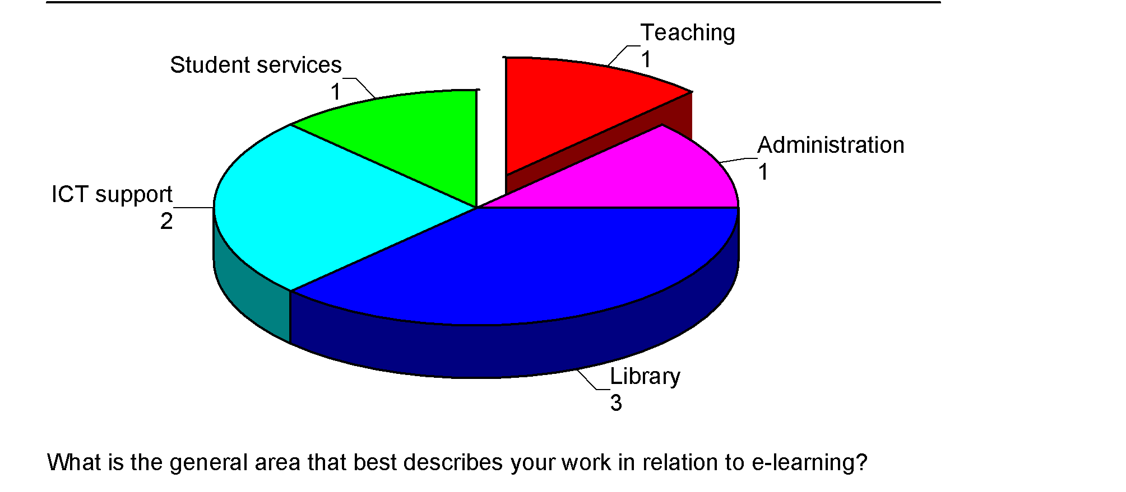

It became apparent during interviews with staff that their personnel role and position was directly related to how much information they could contribute or comment on. For example, some staff were unable to answer the usefulness ratings across the factors listed by Pre-enrolment, Orientation, Social and Personal Support and Technical Assistance. On the other hand, some staff for example, the administrative staff and librarians, had a good overview and appeared to be well informed of the support available to e-learners. In general, respondents rated aspects of their own area of employment as important and delivery of the support to e-learners as good if not excellent.

Findings

Following this summary on the four areas, limitations, response rate, non-response and the respondent characteristics, the remainder of this findings section is divided into three components. The three components are repeated at each area of the four areas of inquiry e.g. Pre-enrolment. Firstly, there is a summary of the e-learners quantitative data. Secondly there is a summary of the qualitative data, which is two-fold, data from e-learners then staff. The concluding summary is a discussion of the themes within the data and the salient features of interest to this project.

Limitations of the study
It was not possible for this research to randomly select a sample of e-learners from the 2004 national population of full-time, undergraduate, distance-based e-learners. Unfortunately, the decision of one provider not to participate in the research prevented the collection of data from a sample of e-learners who could have been statistically representative of the national population. Maori and Pacifica were highly represented in the population of interest at the tertiary provider who declined to participate. Consequently, the list that researchers had to draw a simple random sample from had a lower representation of Maori and Pacifica learners than the national population had.

Unfortunately, the overall response rate to the e-learners survey was low. Had it been higher there would have been the opportunity to present a meaningful in depth analysis of the statistical data. The researchers have discussed the high rate of non-response in some detail.

Based on these factors, the reports findings must be regarded as indicative only. It is not possible to draw definite conclusions about the population of e-learners based on this study. However, the findings in this report present a range of factors and issues which appear to be prima facie consistent.

Response rate
The total survey response rate of r= 126 only captured 21% of the total sample [n=595]. This was an effective non-response rate of 78.8%. Some surveys indicated the respondent had made very few if any valid responses.

Non contact and non response
At least 10% of the sample population (n=595) was not contacted as part of the surveying process. The invitation sent via providers to these e-learners was not received. Either the ISP address was invalid or the mailbox was full. It is not possible for the researchers to assess how different the response rate might have been had the survey been delivered via another approach for example, post. For the purposes of surveying this particular population, it seemed an appropriate and resourceful technique to use a web-based survey as the researchers could facilitate contact via email and participation via a hyper-link to the survey. However, there was some indication in the net collect data to suggest that the time it took to load sections of the instrument put respondents off continuing to answer the survey. For example, response rates dropped off correspondingly in sequence with the successive sections of the survey instrument. Despite ‘Technical Assistance’ being of predominant importance to respondents it incurred the lowest response rates overall. It was also the section placed at the end of the web based survey instrument.

Probably the most important characteristic to consider as part of the non-respondent population is that a portion will have been non-successful completers of their courses. The newly establish Performance Element to Tertiary Funding indicates that a 40% unsuccessful completion rate is an acceptable benchmark for tertiary organisations. It is highly unlikely that the unsuccessful sub population of e-learners in this research sample would have been motivated, incentive or not, to participate in this survey.

A final factor that might have influenced the response rate was the relative difficulty the researchers had in following up the sample population with reminders that they were requested to participate in the survey. Researchers were reliant on providers to distribute the communication to the sample population and it was not feasible to continually follow up the non-respondents. However, the researchers did attempt to facilitate the distribution of a letter to the sample population to explain the cut off date for responses had been extended. Few new participants joined the respondent population during the extension of time.

Confidence interval and relative standard error

Despite a low response rate to the survey the sample size was sufficient for the research to achieve an overall relative standard error of 8.5% at a 95% confidence interval.

Table 6
# Source: www.sch.abs.gov.au | # Population | # Confidence interval | # Confidence interval p+/- | # Relative standard error
SDR (filtered) | N=1364
SDR (filtered - X) | N=1324 | 95% | Upper=0.5834 Lower=0.4165 | 8.51%
Sample | n=595
Respondent | 126
*SDR 60%(filtered - X) | 794 | 95% |  | 8.21%
*40% non completing

If the population size is adjusted (N=794) to accommodate the estimated 40% of non-completing students believed not to be respondents to this survey the relative standard error improves slightly.

E-learners

Demographic characteristics
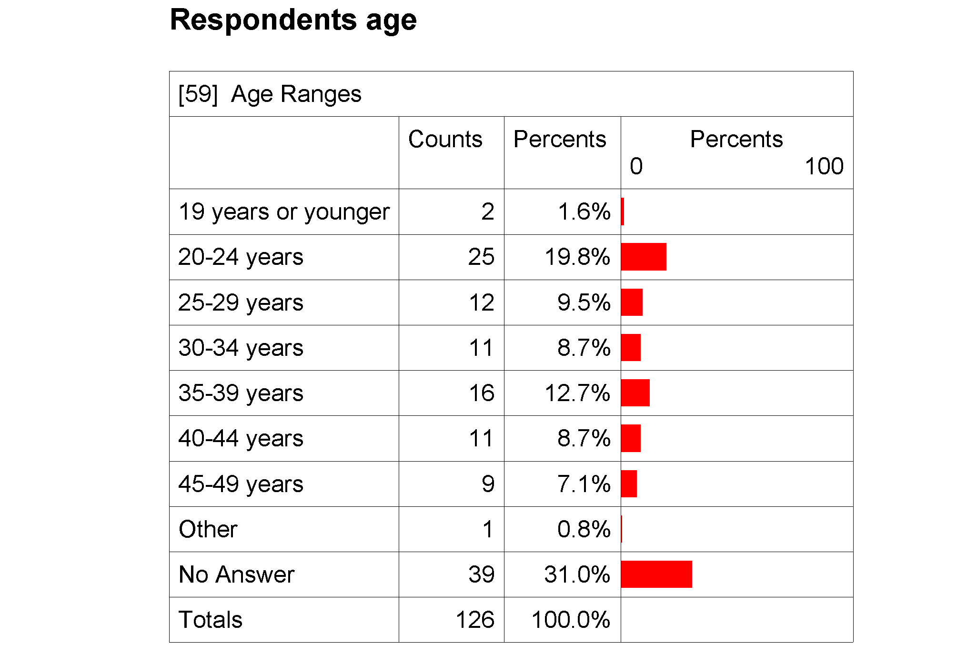

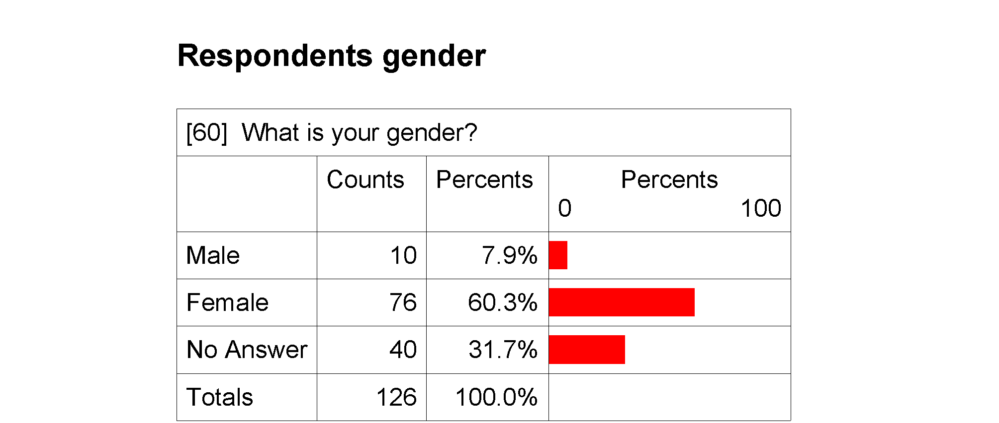

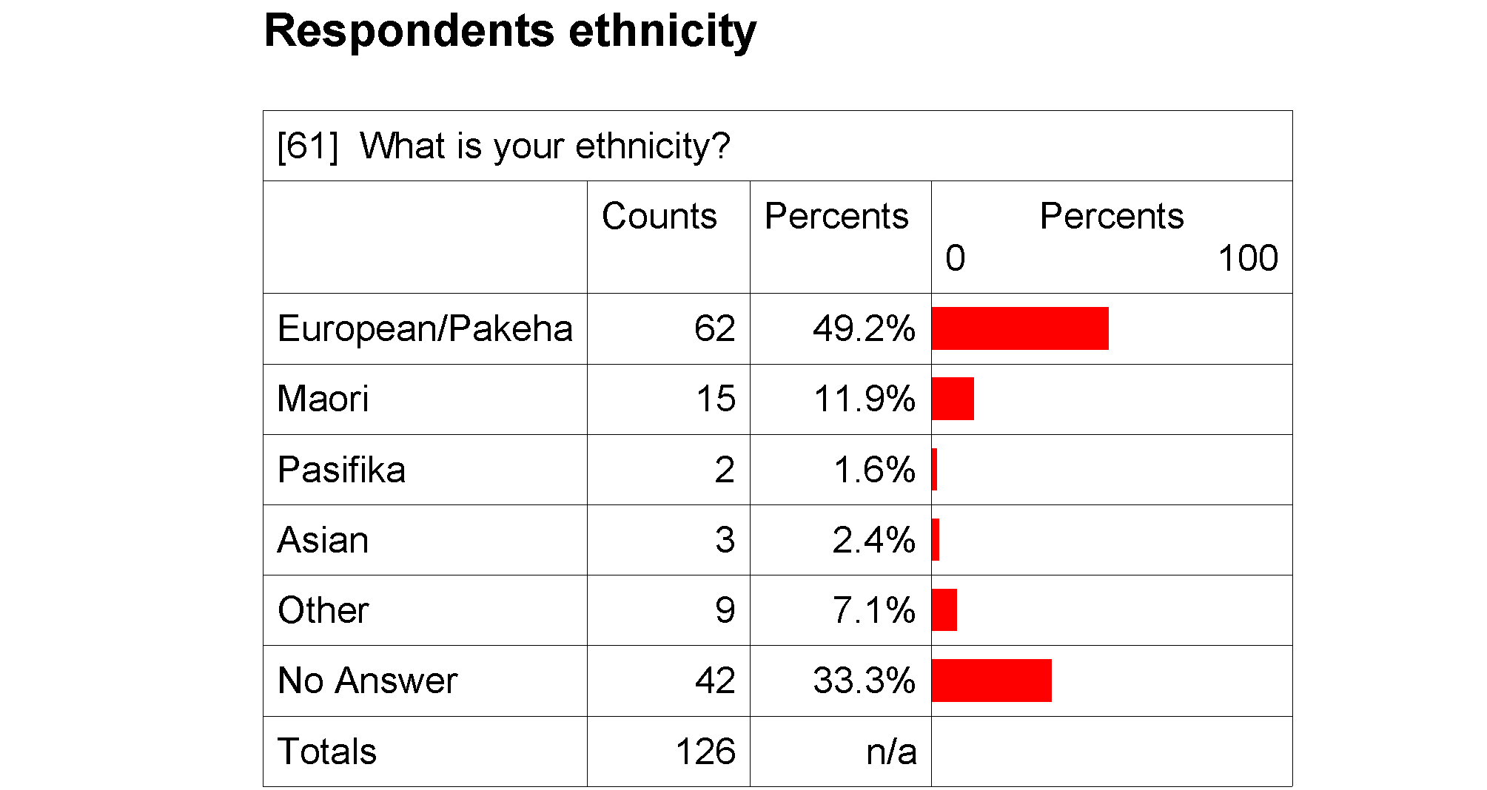

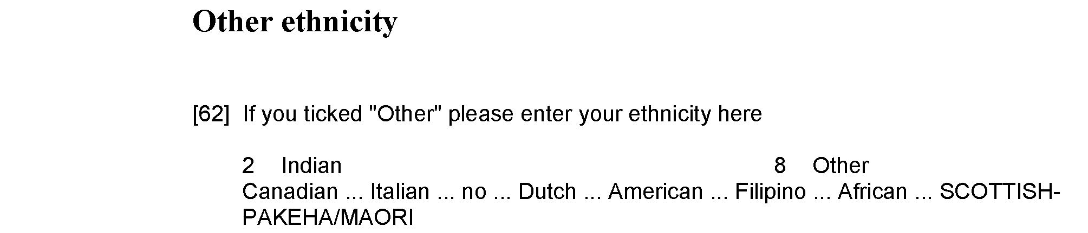

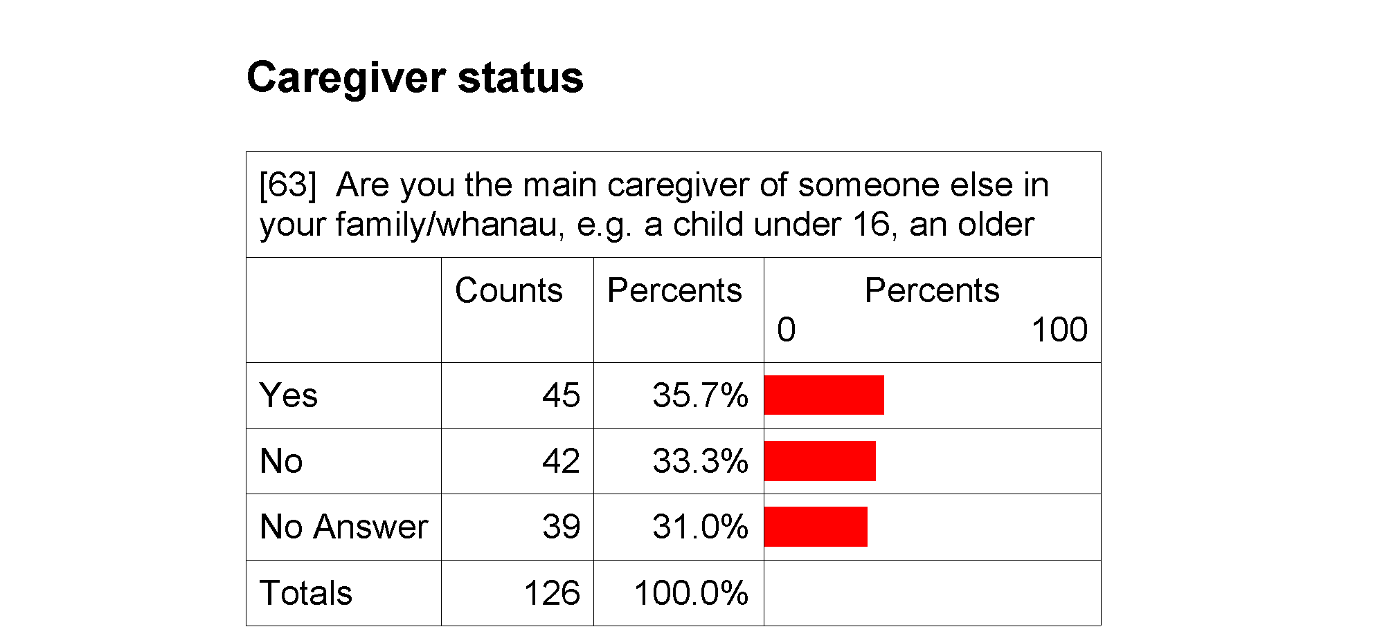

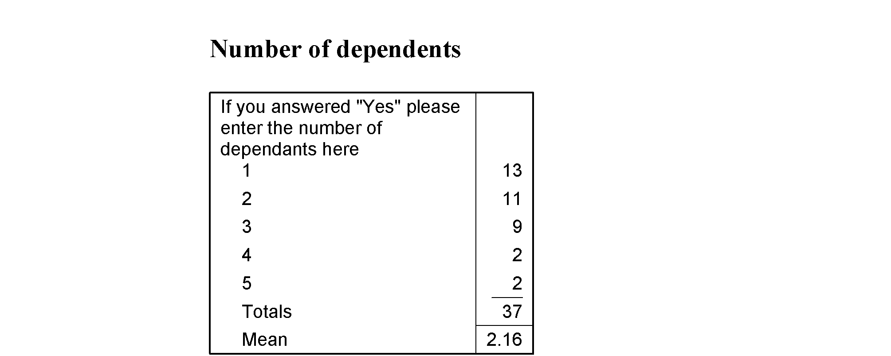

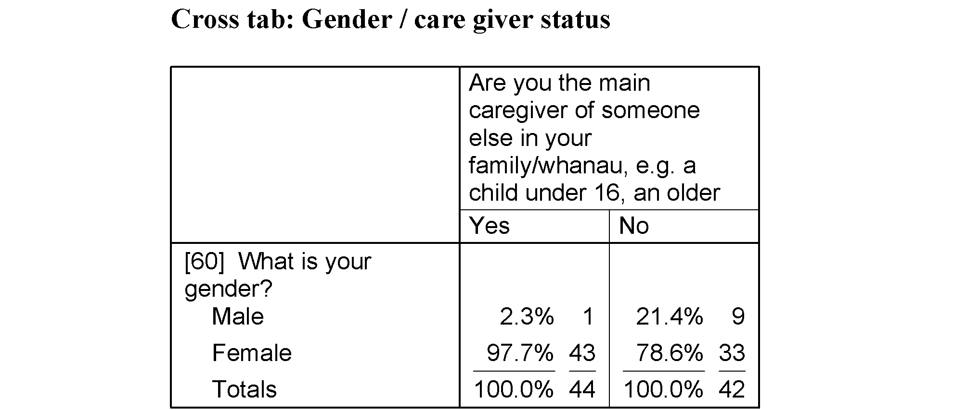

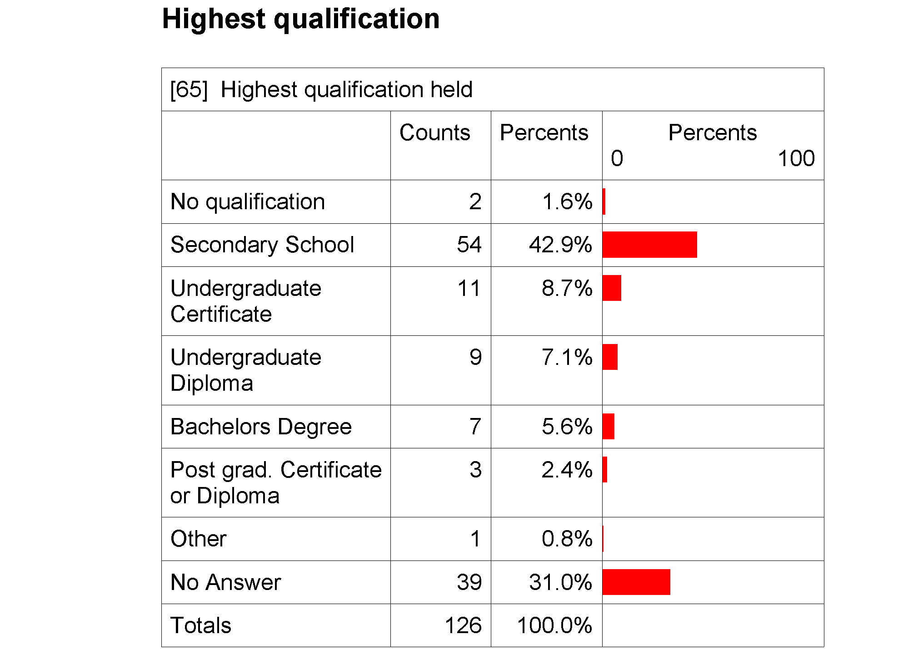

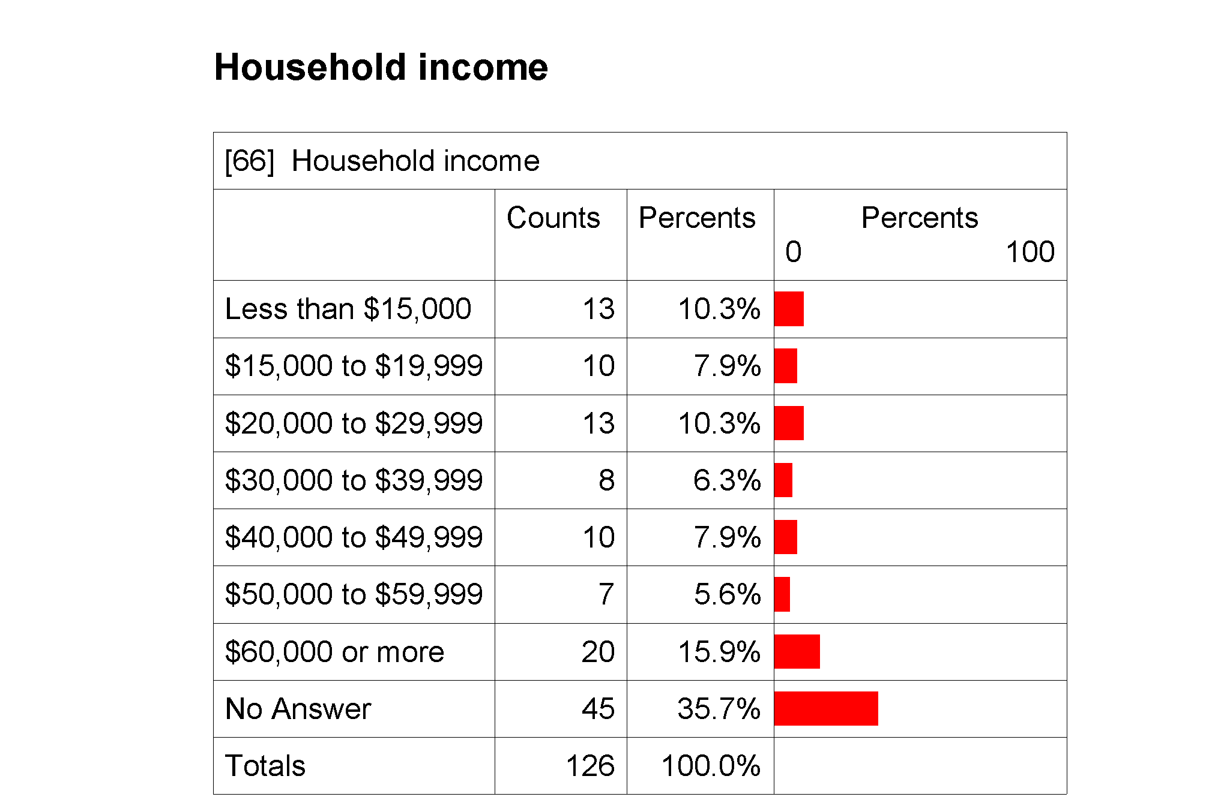

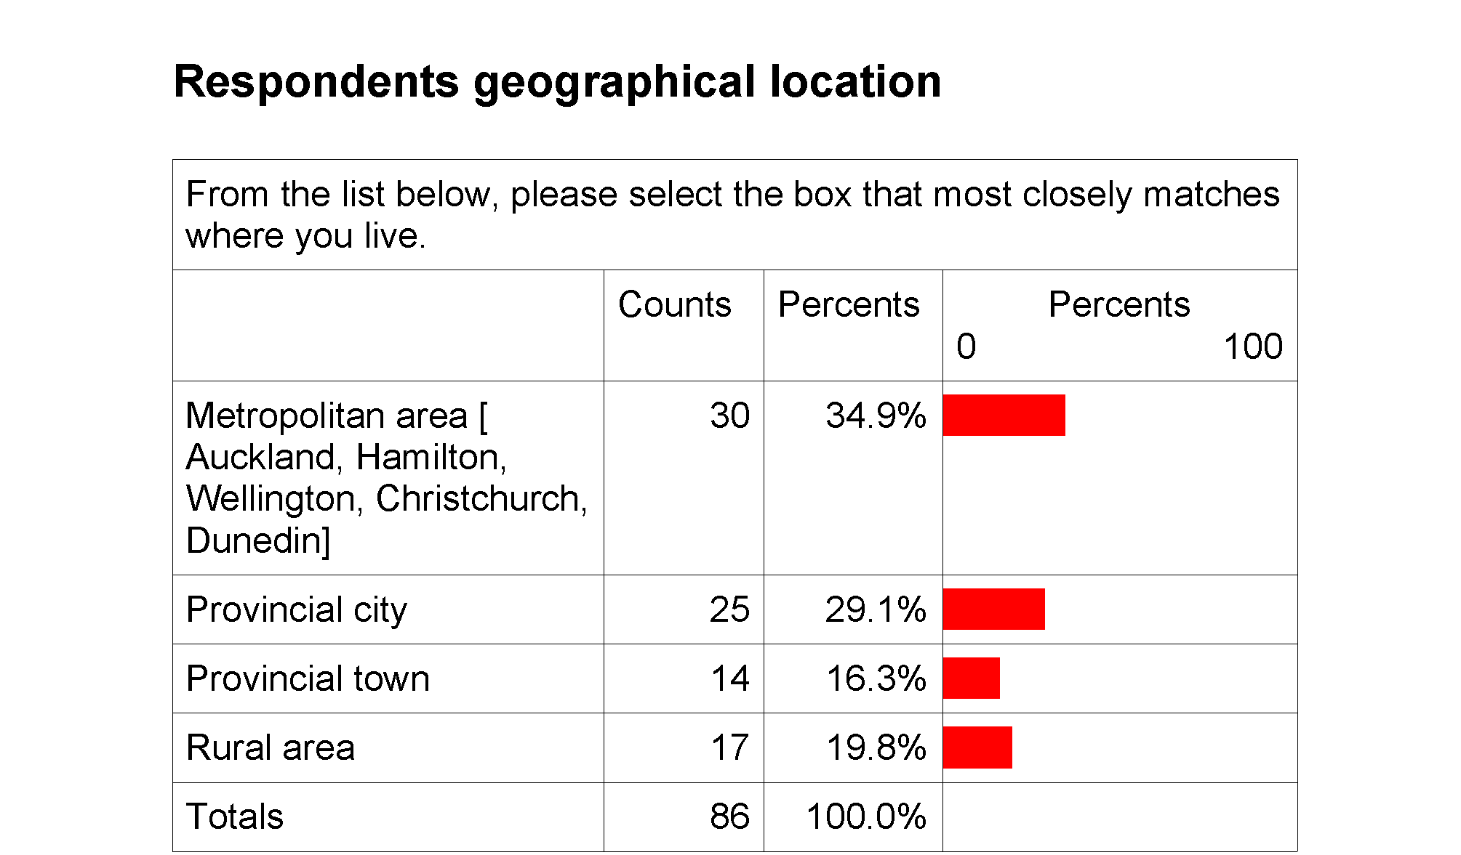

Respondents’ income
When the income categories are collapsed into smaller groupings 18.2% of respondents indicated they had a household income of less than $20,000 p.a.

A further 16.6% of respondents indicated that their household income was between $20, 000 and $40,000 p.a.

Nearly one third of respondents (29.4%) indicated that their household income was above $40,000 p.a.

Slightly more than one third of respondents (35.7%) did not answer the question.

An interesting trend emerges amongst the respondent population when caregiver status is cross tabulated by household income.
Table 7

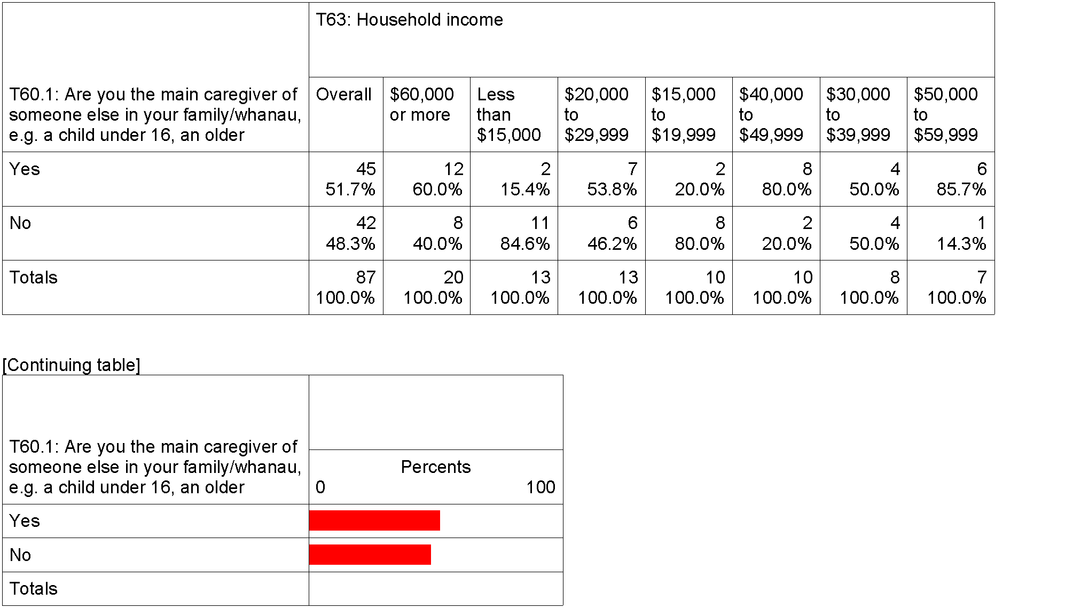

It appears that the respondent’s with a household income of $20,000 or less are the least likely to be responsible for the care of a dependent person. Respondents with a household income of $40,000 or more are more likely to be responsible for the care of a dependent person. So too are respondents with an income between $20, 000 and $30, 000. An equal distribution of care giver status and income bracket is recorded for respondents with a household income between $30,000 and $40,000.

Geographical location
Respondents indicated that at the time they answered the survey (April 2005) they lived in predominantly a metropolitan area or a provincial city. These respondents were defined as ‘distance learners’ in 2004. The data would suggest that whilst many of the respondents might have been geographically distanced from their provider in 2004 a significant portion were not geographically isolated from types of support that a tertiary e-learner might seek for example, libraries, peer discussion and computer service/supplies.

All importance-performance statements
The following table provides an overview of all the importance –performance scores across the four areas of the survey enquiries
Figure 3.

The matrix of all factors indicates that aspects of Pre—enrolment activities and Technical Assistance are of highest importance to the respondents. The matrix also indicates that the provision of these student support activities was approaching an optimum level. Overall, Orientation activities were not as important to the respondents and the spread of performance ratings indicate the activities were not gauged similarly. Two aspects of Social and Personal support are distinctive within the graph as areas where importance is high but usefulness was not as high. One aspect (Question 24) is at the top of the Technical Assistance cluster the other (Question 25) is plotted close to the adequate and highly important lines.

Pre-enrolment advice

Importance – Performance analysis
The following analysis provides a table of scores for each of the survey statements in the area of Pre-enrolment support and a plotted matrix of those scores. Salient features of those scores are highlighted and explained in more detail.

This component of the research investigation focused on data collected from eight Likert types statements regarding important factors of advice / assistance that the enquirers might have expected to encounter at the time of their Pre-enrolment phase. The mean importance and usefulness scores, together with the gap scores, for the areas of interest are detailed in table 8, with their locations on the I-P matrix shown in figure 4.

Table 8: Pre-enrolment advice. Mean importance and usefulness rankings and gap scores. |  | Figure 4: Pre-enrolment advice. I-P matrix, all aspects

Overall, the highest response rate across all the Likert type statements was the overall importance rating of Pre-enrolment advice (n=96). The aggregate indicates that Pre-enrolment advice was likely to be rated as important or very important by respondents. The mean over all rate (3.31) is the second highest of the four mean scores in the overall assessment category across the four components of the survey e.g. Social and Personal support etc.

Statement 1 in Figure 4 generated the highest importance / usefulness means overall the Pre-enrolment data. That indicated respondents had placed a high value on receiving a ‘Clear description of the qualification’ and a high value on the usefulness of the information they received. It was however one statement among several of the Likert statements that generated the higher scores in the GAP measurement for this area. That indicated there were a range of factors where the provision of Pre-enrolment support / advice had yet to match the respondent’s assessments of the importance of those features. The other three factors with a GAP score worth highlighting in this instance are two, seven and eight.

Nevertheless, the graphical display of the I-P mean scores [figure 4] locates most of those statements in quadrant B, ‘keep up the good work’. We can infer based on this I-P framework that, in general, that the education providers delivered useful and relevant pre-enrolment advice to these e-learners at their Pre-enrolment phase.

Statement 4, regarding assistance with skills, such as English language or maths generated a very low gap score of -0.04 which is very close to the iso-priority line in the I-P matrix, where usefulness matches importance

One area where service delivery was not matching the value the respondents placed on the support was the provision of trial on-line programmes to potential students (statement 8). The I-P score for this aspect is located in quadrant A, ‘concentrate here’. The respondents’ mean scores for the usefulness were the lowest score of all the Pre-enrolment statements. However, it also attracted the lowest importance mean of all statements for this area of inquiry.

A portion of respondents recorded their usefulness rating in the tick box labeled did not use or receive. This was true of the respondents that rated statement 7 and 8. , Non-users’ importance ratings for these two areas of support are illustrated in figure 5, below.

Importance assessments by respondents who did not use or receive Pre-enrolment help services.

Figure 5: Importance rankings of respondents who did not use/receive advice about study options or trial an on-line programmed before enrolling.

In both cases, majorities of importance ratings are located at the lower, less important end of the four-point importance scale. Just under two-thirds (60%) of non-users rated statement 7 as not or only slightly important. The relative lack of interest expressed by non-users in trialing an on-line programme at the pre-enrolment stage (statement 8) was even more pronounced. Close to three-quarters (71.7%) of the 53 non-users of a trial on-line programme attached low-priority to this type of support. Nearly one-half (45.3%) of the respondent group considered the opportunity to have a discussion with a tutor about study options as unimportant.

Caution is needed in interpreting these findings due to small number of survey responses and the evidence, which suggests respondents were ‘successful’ e-learners. It could be that students who do not complete their e-learning would have different beliefs about the relative importance of these aspects.

Qualitative Analysis

E-learners data

Were there any aspects of the Pre-enrolment Advice you received that were particularly useful to you?

For the purposes of this analysis the e-learners comments were grouped according to the predominant feature of that comment. The following table illustrates the predominant features which became the coding categories for the respondents’ answers. The number of times the similar responses were mentioned is included in the table.
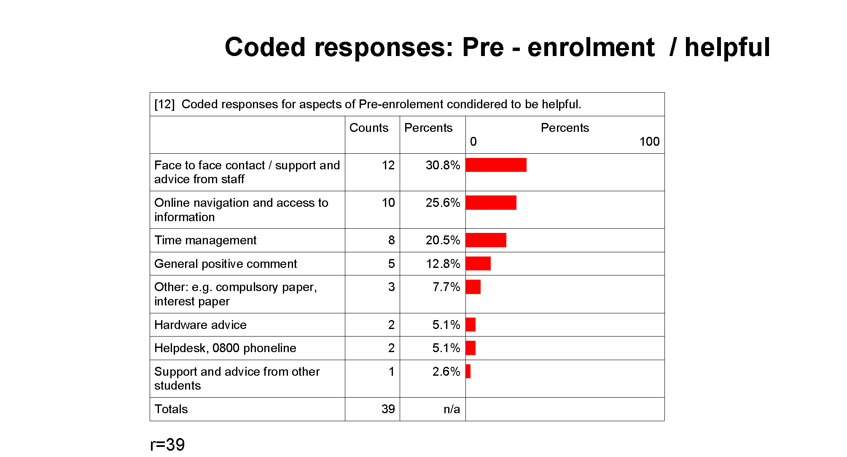

Clearly, the respondents valued the access they had to support and advice during Pre enrolment. Fourteen comments can be attributed to the useful aspects of personal assistance, for example, face to face contact / support and advice from staff and the helpdesk or 0800 services. The aspect of personal assistance appears to be particularly important as a confidence building exercise for these e-learners.

Explanation by the lecturer in a face to face manner of the style of learning and the aspects of the paper - this was especially important to me as the paper was not in a subject I had previously studied and I worried about perhaps being out of my league.

Because of distance an important aspect for me was rapport.....I felt comfortable talking to reception, the ease of access to the tutors, supervisors etc was reassuring

The 0800 (XXX) number is excellent - I discussed enrolment online with the XXX tutor and we discussed through WebCT and phone calls on what would be the best option for me.

Twenty responses included useful aspects of advice / information that could be described as generic. The generic information is suited to a broad population of e-learners for example, time management advice, hardware advice and instructions to assist with online navigation.

Many responses were expressions of how helpful access to generic information was. The respondents indicated the helpful information was presented by various modes of delivery including post. Overall the comments identified a range of generic information which did not require the support of specifically personal advice.

Times and Dates for assignments exams contact courses. Withdrawal dates admission dates, potential career or further study options.

Information on acquiring information such as the booklet ‘The Learning Game’ was very useful. Especially as an adult student where it had been along time since I had last studied.

The starting dates when I was expected to go online and start discussions. Also what they planned to cover in the course was great because that gave me a chance to look up some information prior to the course.

The responses included several affirmations that Time Management advice was a particularly useful aspect of the generic type Pre-enrolment information e-learners received.
Advice received on hours I needed to put into the study was very vital and a useful one.

Time management and keeping up with the study programme as part of learning online.

Yes. What was expected of you and how to go about dividing your time for study, extra curricular activities including family commitments so you don't fall behind etc.

Some responses described here as emphasising the helpfulness of generic advice / information at the Pre-enrolment phase featured the aspect of specifications for computer hardware and software.

The main requirement that was very important for me was the type of computer and programmes that were required as I was purchasing a computer especially to do my on-line learning

Needing to know what programmes I needed and where to get them was the most important advice for me that I did receive.

Several comments were an overall expression of Pre-enrolment as a positive experience. In addition, some responses offered comments that did not explicitly answer the question for example; one student indicated their status as an e-learner was part of their programme requirement.

Staff

Eight staff were interviewed and three made a comment when asked are there any aspects of the Pre-enrolment advice provided by your organisation that you think are particularly useful to enquirers.

Two staff contributed to the comment;
Particularly useful to enquirers is the opportunity to talk. We interview them so it changes the context. We establish a rapport with the student so they have a good understanding at the outset of what support / advice is available and what is expected of them as students. We offer advice but whether they take it on board or not is largely up to them. We do not test their skills, the course is for mature learners and we have an expectation that they already have a certain level of skill for example competency in English.

The other response was
The website contains information for future students. There is also a 0800 phone line.

For the purposes of this analysis the e-learners comments were grouped according to the predominant feature of that comment. The following table illustrates the predominant features which became the coding categories for the respondents’ answers. The number of time the responses were mentioned is included in the table.

E-learners data
Do you have any suggestions about Pre-enrolment Advice that could have been more useful to you?
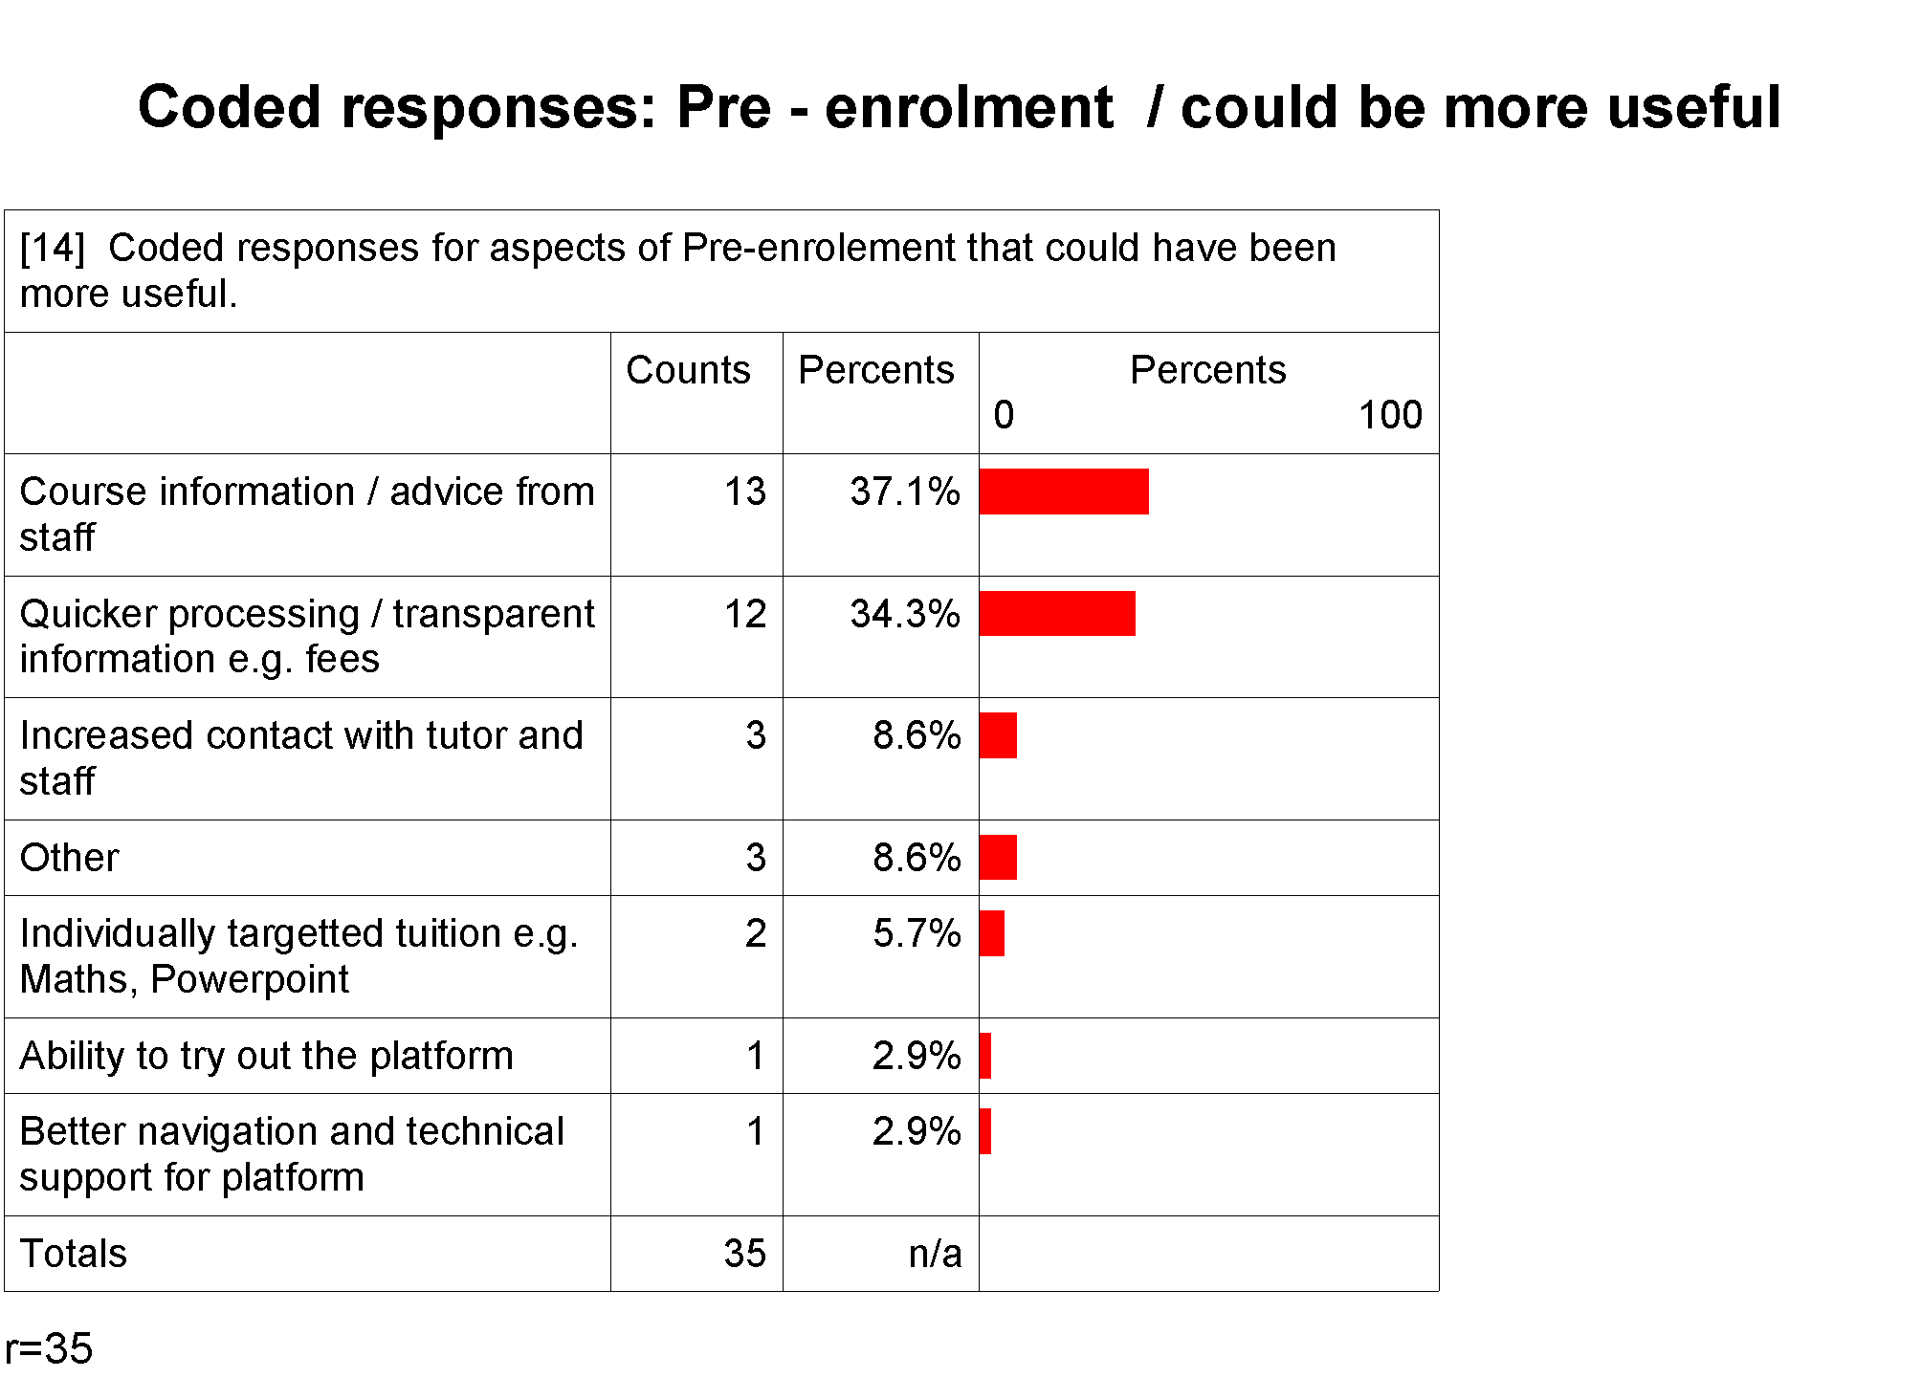

The majority of the e-learners comments were collapsed into two findings for this discussion of what could be more useful to the pre-enrolment experience. One finding is from those respondents whose comments suggest they would have appreciated individualised information. These respondents do not neatly fall into one response code they are spread overall across three response codes, increased contact, individual tuition and advice from staff. These respondents were looking for a personalised experience which might well have been a confidence building exercise.

The second finding is derived from responses where the e-learner was seeking advice/ information that could be considered generic and the learners might well have expected ready access to, for example, aspects of the study programme including course requirements. In addition, this discussion includes a large group of responses which addressed aspects of dissatisfaction with the internal operations of the tertiary provider, for example, the time to process an enrolment

Comments which indicated the respondents were seeking generic information and advice included;
I was never advised that I would get an 'E' instead of an 'incomplete' if I did not complete this course. I would not have taken this paper if I had known this, as I had a lot of other commitments at the time and was unsure about my ability to complete the paper.

More information about what to expect from lecturers in the online learning environment in terms of their frequency for entering and participating in the class forum.

It could be more up to date; some courses of study weren't shown but were offered.

Stress more to prospective students how imperative it is to manage time effectively and keep up to date with the work.

Perhaps a better overview which incorporates each element of on-line learning commitments; papers and potential of them, costs, computer requirements, time requirements and management needs, nature of learning (self driven) etc.

Some respondents suggested an opportunity to have contact with staff would have facilitated their access to generic information;
Have a person contact us to discuss requirements to graduate and exactly what the paper detail.

Ensure that students are accessing information and that they are tracked through some sort of system on line-email reminders and steps to follow on line.

A portion of the respondents indicated they were seeking personalised assistance for example a few suggested individual tuition would have been useful.
To brush up on my Maths. I have a real weakness in this area and I am currently feeling the pinch because of that. I suspect I will need extra tuition to get through.

Over a third of comments were collapsed into the group that expressed dissatisfaction with the internal procedures of their provider.
There were some complications with the on-line course which I was enrolled in last year which resulted in the course starting on a later date than the date specified. In future it would be good if the enrolment of students in on-line courses could be completed in time so that the course can start on the correct date.

I think that the administrators or people responsible for helping select your papers should explain what they think will happen the following year. For example, I had a couple of papers from my BA to my Bachelor of… which subsequently affecting the following year as I was down in EFTS and did not need to do papers that my peers were doing. So, the people who advise to your paper selection should have an understanding of what will happen should you select particular papers.

I needed to resign from my position within a school before the end of the preceding year and it was rather difficult to receive a clear cut answer as to whether I was accepted. Each letter stated I was accepted but each one also had a but so it was still not confirmed. It would have been helpful to know for sure a little earlier.

Would have been nice to be told a bit more about the cost involved and study time for each paper. Several things, that I found out later, were not made clear at enrolment. One involved money which didn't please me.

Staff responses
There were five comments to the question; Are there any aspects of the Pre-enrolment Advice provided by your organisation that you think could be more useful to enquirers.

Two of the staff suggested that students were seeking an on-line experience at the Pre-enrolment phase It would be good to offer the students an environment where they can experience the reality of e-learning. One of those staff did not consider it a feasible option. We cannot offer students access to a trial on-line programme at the pre-enrolment phase. We act on ongoing evaluations of our delivery to our students. We think we are proactive, we send out information at the time of acceptance to the course and we do provide assistance when requested to do so.

Three staff acknowledged a need for provision of pre-enrolment support; We could improve in some areas where we perform poorly for example, providing the opportunity for students to have face to face contact with staff. However, one of those respondents suggested that as much as the Pre-enrolment support was needed students did not recognise the importance of it until later.

Do you have any further comments you would like to make about Pre-enrolment Advice?

The most frequent further comment that respondents contributed was a positive expression of their pre-enrolment experience.
I think it is really hard for someone coming into an online degree programme to grasp the advice that is given, because one has no experience of this form of study or what it actually means. So the advice just 'goes over the top’. I do know that since I started my degree I have not been able to fault the support I have received from administrators, tutors and support staff e.g. Library.

A few e-learners carried through issues regarding aspects of their experience that could be improved upon, which they had expressed earlier in response to question 12 of the survey. The request for more information and quicker processing arose in their comments.
Stress more to prospective EDO students how imperative it is to manage time effectively and keep up to date with the work.

This year (2005) I have not received an enrolment booklet at all for the first time. Along with most other students in our Current Issues paper we had no idea what a 'contact' course meant and consequently spent the first 3 weeks online in this forum wondering where our tutor and lesson tasks were.

Some of the e-learners indicated they would have welcomed support and were not satisfied with their pre-enrolment (or other) experience.
I did not receive a lot of advice and found it hard to ask questions to head of dept as they did not have time.

Discussion

It has been noted in the quantitative analysis that one aspect in the provision of pre-enrolment support had a particularly favourable importance-performance score indicating the e-learners needs were well met. This aspect was the provision of support for skills such as English or Maths.

The data collected from some staff suggested that from the perspective of the provider it was reasonable to expect their students could demonstrate a competency level to cope with the course they were studying. However, staff agreed that this might not ordinarily be a formal type assessment. Earlier focus group participants had raised the issue of competency with e learning environments in relation to Maori and Pacifica populations of e-learners implying more should be done at the provider level to assess these students capacity to perform as e-learners.

In tertiary environments where an assessment of competency is either a requirement or presumed it might be unnecessary to assess/monitor or indeed provide support services for the skills the learners is expected to have for example, English competency. Staff data confirmed that their e-learners e-skills varied. However, they suggested all e-learners were likely to want course advice either in the form of a personalised approach or in the form of generic information. E-learners’ qualitative data suggested the respondents were seeking more useful information on the generic aspects of their course, for example, start dates. Some respondents suggested they wanted this advice delivered in a personalised approach, for example, through contact with a tutor.

It was noted by some staff that the provision of support at the pre-enrolment phase had to be balanced with what their organisations could reasonably expect from their students, which included a level of skills competency and readiness to learn. If indeed skills support is required by potential students at the Pre-enrolment phase it might well be more pronounced among individuals identified in a ‘special needs population’ of e-learners, for example, the students eligible for Special Supplementary Grants (SSG). These populations would also provide an opportunity for an importance / performance assessment of learner support systems which might be different to an assessment from other population groups.

Key themes: Pre-enrolment advice
Three key themes were evident in both the learners’ and staff professionals’ qualitative comments about pre-enrolment advice, as summarised in table 9, below.

Table 9: Key organising themes: Pre-enrolment advice

Course and study advice
Potential e-learners need accurate guidance about the structure and delivery of their intended programme of study. Academic skills needed for successful study are included in this area of pre-enrolment advice. Additionally, potential on-line students may appreciate finer details about the programme’s study agenda. This gives them an opportunity to ‘pre-read’ before formal study begins. This aspect of pre-enrolment advice also includes guidance in study approaches, such as time-management and essential skills advice.

Personalised guidance
Intending students value staff that provide relevant advice in a professional and empathic manner. Enquirers appreciate clear and concise guidance based on their personal needs. This is best done when there is rapport between the enquirer and advisor. Guidance based on individual needs can be delivered to a high level via telephone enquiry-desk or tutor discussion with individuals. When possible, face-to-face assistance is highly valued by individuals at the enquiry stage.

ICT advice
Potential on-line students value clear and concise information about the hardware and software they require for study. Although many may not need to trial an on-line programme at this early stage of interest, if such an option is provided, it needs to be relevant to the enquirer’s needs and level of computer ability.

input.doc

Importance – Performance analysis
The following analysis provides a table of scores for each of the survey statements in the area of Orientation help and a plotted matrix of those scores. Salient features of those scores are highlighted and explained in more detail.

Compared to the pre-enrolment component of learner support, a different pattern of responses occurred when the eight statements that looked at the various types of orientation help were analysed (figure 6, below). In contrast to the more spread-out array of pre-enrolment I-P scores, most of those related to orientation are more tightly contained within the moderately important / good performance region of quadrant B, ‘keep up the good work’.

Table 10: Orientation help. Mean importance and usefulness rankings and gap scores. |  | Figure 6: Orientation help. I-P matrix, all aspects

The overall importance score for the area of ‘Orientation help’ was rated the lowest (2.67) of the four areas in the survey. Few of the importance scores for the eight activities / services in the survey reached the level of moderately important although they came close. The two activities/services rated most important by respondents were ‘An introduction to the library and how to find books’ (3.00) and ‘Guidance about personal skills such as time management’ (3.03). The latter of these two activities/services also had the highest GAP score across all the Orientation activities and service. An introduction to the library and how to find books also had a higher GAP score than other statements.

Overall, more respondents answered this section of the survey than the following sections of Social and Personal Support and Technical Assistance.

The overall I-P score for orientation help sits very close to the optimum level, with a gap score of -0.01. The largest negative gap (-0.50) concerned statement 17, ‘guidance about personal skills such as time management’. Respondents gave this a mean importance score of 3.03, identifying it as ‘moderately important’, while the mean usefulness of such advice was assessed as 2.53, just within the ‘good’ performance region.

Two orientation activities had positive gap scores. ‘Assistance with setting up computer systems’ (gap=+0.27) and ‘advice about student support services’ (gap=+0.36) was ranked moderately important by respondents. The assessed usefulness of these services lies within the good performance range and under the iso-priority line. This indicates that, in general, respondents found the advice provided in these two areas more than sufficient for their needs. Although they are located in quadrant C, ‘possible overkill’, their location in that sector indicates that resources are being used effectively in the provision of such help.

The above I-P matrix excludes data from respondents who did not receive the particular help described in the survey statements. In this section, analysis of these data is limited to those aspects of orientation help that generated the largest negative gap scores, items 14, 17, 18 and 19. That group of respondents’ importance assessments of these items is discussed below.

Importance assessments by respondents who did not use or receive orientation help services.
A relatively large number of respondents to the survey’s orientation statements that generated the largest negative gap scores did not receive or use the named help. The importance scores of these individuals are illustrated in figure 7.

Figure 7: Importance rankings of respondents who did not use/receive various types of orientation help.

Two areas of orientation support, help directed at giving students guidance about personal skills, such as time-management and self discipline skills (statement 17), and advice about understanding personal learning styles (statement 18) were assessed by respondents who did not receive or use that support fairly evenly across the four importance options. The most frequently chosen importance ranking in both cases was ‘moderately’ important.

When ranking options are collapsed into two categories, ‘High’ (options: moderately and very important) and ‘Low’ (options: not and slightly important), the 20 respondents’ overall scores are evenly split (50% each) in the case of personal skills help (statement 17). The collapsed category scores for respondents’ ratings for learning style advice (statement 18) tend towards the high category. Just over half (55.5%) of the 27 respondents selected either the very or moderately important option.

With the two other orientation services with the largest gap scores, the assessment trend in the importance data that was excluded from the I-P calculations is consistently towards the high end of the importance scale. In the case of help directed at introducing students to library services (statement 14), nearly one-half (45.5%) of the 22 respondents who did not use or receive such help rated it as a very important aspect of support. When responses in this area are collapsed into high/low categories, nearly three-quarters (72.8%) selected one of the two higher importance options.

The second area where non-users’ importance scores were generally high was for statement 19. This area of inquiry referred to access to the learning platform before formal study beginning. Two thirds of the respondents identified as non-users/receivers of the access rated the importance of that factor during orientation as moderately or very important.

Qualitative Analysis

E-learners
Were there any aspects of the Orientation Help you received that was particularly useful to you?

Nearly one third of the respondents indicated that the opportunity to use the e-learning platform of their tertiary provider was the most helpful aspect of the Orientation experience.
Getting a chance to play around on the webCT before the serious work started gave me confidence that I knew how things worked

The encouragement to get online and in the e-environment so I could start familiarising myself with the virtual classroom. If I had of waited until studies began I would have been extremely frustrated!

With the exception of one or two responses the remaining comments suggested that the e-learners valued the range of support mechanisms they were offered. Support offered specifically to distance learners, for example, library resources were mentioned by several students.
Using the Distance Library and being able to access library catalogues via the internet. That was extremely useful.

Familiarising ourselves with resources within the university that we could access through distance learning (e.g. library being able to send resources out to us).

Support offered to specific population groups was also important to some individuals.
Library and student assistance - particularly the Maori services dept they were excellent.

The response time / advice and support of staff were identified as helpful at Orientation.
As an online student we are encouraged, no - exhorted, to keep tutors informed and ask for help when we need it and that would have to be the singular most important piece of advice given. Support people cannot read minds and so by keeping my tutors/support people informed of the various dramas, crisis and events happening in my life, and asking for help, I was given the support/encouragement/assistance that I needed. These people have seen all this and more, so are very experienced in how to manage/handle the various situations.

Also identified within the responses was the favourable mention of the support providers gave to the students’ cohort experience, for example on-line chat forums and opportunities to socialise face to face.
The opportunity just to get on line and communicate with the rest of the class thereby recognising that we had a wide range of experience. This helped build my confidence in participating online.

The opportunity to meet others & see the range of people we represented was really interesting & served to put personality behind the pictures & text in our discussion forum later on.

In contrast to the comments of helpful aspects were two criticisms from respondents who appeared to not value their Orientation experience. One of these comments suggested the student would have valued further attempts by the provider to contact the population of distance e-learners.
Orientation was not viable for me as I could not attend the orientation days due to travel, etc. I feel having orientation days/evenings for on-line study should be available in smaller towns, not just the larger cities as people such as myself have opted to study on line because of the distance factor, etc.

Staff

Three staff made suggestions to the question; is there any aspects of the Orientation advice provided by your organisation that you think are particularly useful to enquirers? One of those people described the full face to face immersion that their e-learners received at the Orientation phase.
Platform experience is important. We have them on campus for a week to guide, inform and show them what is required. We go a bit counter to the on-line literature. Some of the literature, especially out of the US, doesn’t consider face to face an important component of the support students require.

We give them a cohort experience by bringing them together face to face and this is important support.

Another staff indicated the provider carefully prepared resources to cover the needs of the non campus based e-learner.
The ICT services are targeted at on-line students, the service is not just repackaged campus material.

E-learners
Do you have any suggestions about Orientation Help that could have been more useful to you?
In general, the respondents emphasised their previous comment in their remarks to the question of what support would be more useful to them. Loosely grouped, the comments fell into two categories. A group of respondents requested an increase in the level of contact with staff and the student support services available to e-learners.
Much of the orientation was about the courses and what to expect with online learning but I think that perhaps an overview of what we could also access and join in with on-campus could be beneficial. For example, some lecturers were more than happy for us to come up to the university campus and attend one-off classes when we needed extra assistance with a particular topic.

I found with my online paper I did not do as well and I was confused for a long time about what to do. I needed to contact my lecturer or tutor

Another group of comments were requests from respondents for an increase in the level of support for e-learners to readily access information. Email was identified as an important pathway through which that information could be accessed. Comments also identified technical assistance and platform experience as areas where additional support and development were required for optimum performance from the providers during Orientation.
Having computers available so that programmes, emails, etc can be used with guidance on the proposed orientation evenings for people who need it. This will help familiarise the systems before study is started. Will also ensure all available help, etc can be found and utilised by all.

Emphasise to students that general discussion should be in the xxx part of each paper. The most frustrating part of the whole degree course was clicking on messages in lecturers, announcements, or class/group parts of the papers to see a casual message from one student to another that should have been in xxx. Frustrating and very time consuming.

Clearly some staff were competent e-support professionals and throughout the survey, including here, respondents identified individual people they considered exceptional.
Moodle, with (XXX) has been absolutely fantastic orientation wise. However my web-ct based paper has left much to be desired

One respondent requested further assistance for International students and two e-learners gave only praise for their Orientation experience.
Great system! Easy to understand and play around with.

Staff

There were four comments staff who contributed to the question, are there any aspects of the Orientation advice provided by your organisation do you think could be more useful to enquirers. One of the staff suggested an increase in the feedback students received could only assist the learner.
The key is to give early feedback to students regarding completed work. Response time is one factor but the feedback is most important.

Two staff suggested that students had limitations on the amount of information they could absorb at the Orientation phase and additional information would not be useful without initiative from the student.
It’s dependent of the students actually deciding to take up the opportunities they are given.

You can tell them more but they can only absorb so much.

E-learners
Do you have any further comments you would like to make about Orientation Help?

The majority of comments indicated an increase in the level of student support services could have improved the respondent’s satisfaction with their Orientation experience. In particular, the e-learners suggested that if information regarding support services had been readily available they would have found it useful.

Definitely, the information received in the post was fractured and somewhat bewildering. Resources for papers started being received before I knew what to expect and what to do about it all. One covering letter outlining the procedures of this would have helped pull it all together. This was only required in my first year when I had no idea what to expect.

Ensuring that all the preparation has been given and made to students to make sure studying formally online goes without any hiccups, in other words they know exactly what they are doing before hand (e.g. all inquires are answered fully)

More readily available information - what exactly is available, where, when etc

More information regarding the services of the Extramural Students' Association and the services
provided to distant learning students would be helpful.

Several students emphasised the importance of providers catering to the needs of particular populations within the e-learning cohort.

Scholarships and other financial aide available to Maori and Polynesian. Many people did not know where to start with this or who to see - therefore, they missed their chance to apply for grants. Perhaps in future, a Maori or Polynesian liaison person could visit online learners on-campus before the courses officially start and let them know what options are available to them including other support that they may not be aware of.

As a student with a degree in Maori Studies & being trained as a teacher to teach Maori, I found it
more than frustrating to be given no powhiri. It was a deeply important transition for me having
trained in another institution (Sth Island) as a newcomer to (XXX) campus. As I had traversed a
long distance to attend the orientation, I felt insignificant, unimportant and unrecognised. It
resulted in a rift for me with the design of the course.

International students need more help!

Other comments from the respondents suggested they were seeking an increase in contact with staff that could respond to and target their needs, either social or academic.

It would have been nice to receive any kind of help or advice.

Have online forums up and running prior to start dates so students can familiarise themselves with
things and each other. Provisions of maths assistance/advice etc in my case.

Nearly one fifth of respondents emphasised that their Orientation experience was positive.

Nothing, I thought everything worked great. I did start late and this did not hinder me in anyway.

No, it was well explained in terms of the importance.

Discussion

This discussion links the most salient features contained in respondents’ qualitative comments about orientation to the importance-performance findings discussed earlier. While there were no areas within orientation activities offered to e-learners that indicated provision of such services were seriously deficient (to the extent that their I-P scores would be located in quadrant A of the I-P matrix, refer figure 6), four areas did have negative gaps that indicated a generalised mismatch between respondents’ importance and performance rankings. These were collapsed into three thematic groups, labelled ‘personal skills development’, ‘information retrieval’ and ‘ICT competency’.

Their relationship to specific survey statements are detailed in table 11, below.

Table 11: Themes within aspects of orientation help with the largest negative gap scores
Theme |  | Survey statement |  | Mean importance | Mean performance | GAP
Personal
skills development

Personal  skills development |  | 17 | ‘Guidance about personal skills such as time management…’ | 3.03 | 2.53 | -0.50
Personal  skills development |  | 18 | ‘Advice about personal learning styles such as self-directed learning…’ | 2.83 | 2.56 | -0.27
Library skills
Library skills |  | 14 | ‘Introduction to the library and how to find/order book…’ | 3.00 | 2.70 | -0.30
ICT capability
ICT capability |  | 19 | ‘Opportunity to experiment with the learning platform…’ | 2.84 | 2.57 | -0.27

Although not-related to any specific survey statement, an additional theme, labelled ‘social integration’ ran through many of the respondents’ orientation remarks. With the addition of this theme four themes were identified as general areas of help seen as important to the survey respondents.

Figure 8: Key organising themes: Orientation help.

Personal skills development
The theme of ‘personal skills development’ in relation to general approaches to learning on-line was not mentioned as such by respondents. But, their remarks suggested that many of them were seeking to develop the skills they would need for e-learning at this early stage of their study programme.

According to the literature and this study the importance of students gaining general competencies in study behaviours are seen as important factors underlying success in on-line learning environments. In particular practitioners note that newly enrolled students often require guidance to ensure that they adopt an effective learning approach and study management techniques to be successful.

ICT competency
This theme was identified through the respondents’ assessments about the effectiveness of assistance which introduced them to their learning platform and related ICT systems. Competency gained in these areas during orientations is seen as important determinants in learners’ satisfaction with their on-line education experience. The literature review identified this as a key area of support that needed to be offered during orientations.

Platforms are the central ICT systems that link students with their education providers and fellow students. Newly enrolled students need to be given opportunities to gain platform competency as early as possible. To be successful learners students need to understand their learning platforms and the ICT systems that link them with their learning. This study found that respondents who received platform support found it very useful in their subsequent studies. Conversely, comments from those who received too generalised or poor platform training noted their dissatisfaction.

Several staff in this study agreed that Orientation is the most appropriate time for checking the student has the appropriate resources and skills to interface with the ICT systems. However, their overview of the environment suggested the fragmented areas of service delivery and resources hindered providers supporting the extent of all ICT components of e-learning. None the less the researchers suggested that there is the potential to develop a checklist template of the ICT components students will need to check to ensure they have communication compatibility between their software, hardware, Internet Service Provider and their tertiary learning platform. We suggest that Students would then have the tools to identify their ICT issues before it became a source of complaint during formal study.

Information retrieval
Learning about library services and the most effective search and retrieve methods are important skills needed by all students. Being based at a distance from their providers’ physical library resources poses particular challenges for e-learners. Respondents overall assessments of orientation to library services was generally positive, a finding confirmed by their qualitative comments.

Social integration
The theme of social integration was the final key theme to emerge for respondents’ qualitative remarks. Although there was no specific survey statement that tested for socialisation importance-performance relationships, this theme ran strongly throughout respondents’ orientation remarks. In particular, activities directed at providing e-learners with platform competencies provided opportunities for respondents to meet and interact with their cohort of students and staff. The positive effect of social integration can be also be discerned in respondents’ comments concerning the worth of face-to-face orientations.

Social and personal support

Importance – Performance analysis
The following analysis provides a table of scores for each of the survey statements in the area of Social and personal support and a plotted matrix of those scores. Salient features of those scores are highlighted and explained in more detail.

On average, the seven aspects of social and personal support assessed by e-learners were regarded as ‘moderately important’. The mean importance and usefulness scores, together with the gap scores, for the areas of interest are detailed in table 12, with their locations on the I-P matrix shown in figure 10.

Table 12: Social & personal support. Mean importance and usefulness rankings and gap scores. |  | Figure 10: Social & personal support. I-P matrix, all aspects

Statement 30 of Social and Personal Support was the activity across all areas of inquiry with the highest mean importance score (3.70). Statement 30 was also the factor with the second highest GAP score (-0.59) of all inquiries. The highest was statement 31 (-0.63). However, statement 31 was not rated as one of the more important factors and therefore the GAP score of statement 30 is probably the most significant issue. The GAP score indicates the respondents thought there was room for improvement in the response times to their email requests.

With the exception of statement 27, the practical guidance provided by staff where respondents’ generally rated usefulness in excess of their importance scores [gap=+0.26], all mean GAP scores were negative. This indicates that respondents’ needs for such support were being under-met. However, apart from the I-P score for the accessibility of non-teaching support staff [#25, gap=-0.47], which locates this aspect just within quadrant A, ‘concentrate here’, negative differences between mean usefulness and importance assessments were sufficiently small for the remaining support services to assessed as generally meeting learners’ needs.

The ‘Social and Personal support’ area of inquiry incurred the second lowest response rate, which is probably due to the placement at the rear end of the survey. As discussed elsewhere the respondents might have experienced survey fatigue or frustration with their ISP speed by the time they reached this area and consequently the response rate dropped off.

Qualitative Analysis

E-learners
Were there any aspects of the Social & Personal Support you received that was particularly useful to you?

Respondents to this question contributed mainly positive comments. Five comments were general praise of the social and personal support available to the student through their provider for example, one e-learner wrote When went looking and found it they were very helpful.

A large portion of the comments praised staff for being readily accessible by various means. Mention was made in eighteen comments of the timely response staff gave to the e-learners inquires. Staff also received favourable comments for the information they provided or solutions they gave to help solve student’s issues.
Response to requests for help was really fast. It was also good that you could choose to either ask in an online forum and possibly get questions others had answered as well, or use email to get personal responses

Our (XXX) course has a co-ordinator who in turn has an assistance that are non lecturing staff. Both these individuals were very helpful with any queries (queries). From how do I enrol to helping with accommodation, informing of second hand books on sale, suggestions and advice on papers, able to re organize you study load to a more suitable option, to general how are yous. Always available when ever you needed their assistance.

Our Administrator was fantastic. She responded to all queries and concerns promptly, was understanding and helpful (like a 'Camp Mother'), gave sound advice, steered us to the right person or acted as counsellor/mediator etc if necessary.

Some students indicated their tutors offered them a tremendous level of social and personal support which assisted them to the completion of their course.
Yes, I received personal support from (XXX) that helped me to complete my degree. I had an extremely upsetting event occur in my second year of study in the weeks that my exam started. The personal help I received supported me through that exam time. We also got to have dinner with my appraiser which was extremely uplifting.

When I stuffed up the online test (XXX) was so supportive and reassuring that it made the disaster less so. I was almost in tears - 10 minutes to go and I had just lost 40 minutes of writing. Fortunately I had notes to go by but what I wrote was rough. I was also given the option of completing another test but chose not to

Five respondents indicated the opportunity to have face to face contact was valued.
After the study was commenced we did have liaison people come to us periodically throughout the year (approx 3 times) and this was invaluable. Although I think prior to starting would have been good to meet these people and start a rapport with them sooner.

The support from liaison lecturers through regular visits was fantastic because it gave us the opportunity to voice concerns and has them addressed as appropriate, without the rather long wait period that it would normally take with only internet contact.

The lecturer was available to meet face-to-face if required, but otherwise all emailed queries were answered quickly and were useful.

A couple of e-learners in contrast to the positive responses contributed comments which questioned the availability of social and personal support.
No - didn’t receive much if any

I travelled a considerable distance to attend the on-campus requirements, although good socially, there was a lack of support beyond this.

One e-learner found no fault with the support available but indicated they did not need it.
I did not really have support; I gained feedback when I needed it. I established and sorted out problems for myself as that is my way. This does not reflect the course in anyway. There was always offers to our paper and links for help etc. I just never used them as I did not have to.

Staff
Five staff contributed comments to the question, are there any aspects of the Social and Personal Support advice provided by your organisation that you think are particularly useful to enquirers. One staff said there were good resources at their institution another said the use of a one stop support shop offered benefits to students.
One of the things we have done is to create a single reference point for support so we can successfully refer students on if we can't assist them with their support needs.

Another staff emphasised the importance of supporting the cohort of e-learners, I think they do try to build a strong cohort of students so they feel they belong as a group. Two staff implied that providing mechanisms for the e-learners to have individual contact as beneficial to their social and personal support needs.
The opportunity to access help and advice is precisely the support some students are seeking at this early stage.

E-learners
Do you have any suggestions about Social & Personal Support that could have been more useful to you?
The suggestions respondents gave for ways to make the Social and Personal support more useful in general fell into four groups. Firstly, seven e-learners wanted predominantly personalised and individual support.
A response that helped me out from the maths tutor would have been helpful for sure. Personal support prior to and during xxx would have made all the difference to my staying in study for the remainder of 2004 or not. Consequently through lack of personal and social support in this area I felt hugely let down and pulled out of studies because of this. I was suffering ill health during this time and received no support whatsoever from anyone from XXX whilst xxx came crashing down around my ears. I was bitterly disappointed and disillusioned with the whole set-up and almost gave up entirely were it not for the support of my husband who himself is very ill or social support as a cohort.

It would have been nice to be contacted by someone at XXX by email or telephone in Year 1 to check how things were going for me. The only contact I had was at my interview for a place on the course (i.e. prior to being accepted for the training), during my teaching experience placements, and in Year 3 at a casual meet-up when a visiting lecturer was in town doing placement assessments.

Another suggested a personal approach was worthwhile.
Maybe students would like a phone call? I don’t know. It’s really just a suggestion, not brought on by anything. I also understand this would be difficult, maybe students who are not being active in discussions, a phone call to see how they are?! Merely a suggestion, again, does not reflect the paper.

Secondly, five e-learners suggested they would have found it useful had they had a higher level of support for a cohort experience.
I did not experience much contact with class members and do prefer not to study on line because of this but I do to cut down on my travelling costs

We didn't set up a time for synchronised talk/ chat on class forum which could have been really useful....that was left up to us to organise, as a diverse group we didn't get it together.

The third grouping of respondent wanted more contact with or access to tutors and support staff.
A heightening concern throughout the course of study was a lack of support from online lecturers who appeared to give their first priority to on-campus students. In future, it would be nice to know that we could contact our lecturers with questions and concerns and have them responded to in the same timely fashion as on-campus students.

Most tutors were fantastic, responding to queries more promptly than I would expect if studying on campus. However, there was one who took weeks to even acknowledge a message, if at all, and was most unhelpful - equivalent to attending lectures with no lecturer.

The fourth group of responses were from four e-learners who wanted increased opportunities to receive generic type information such as time management and student support services.
Where I can get assistance from. Particularly for distance students

It would have been very helpful to receive a phone call about support with study and counsellor services

In addition, two students identified their need for specific support as a distance e-learner.
I would have loved to have some personal support. This type of studying was new to me and sometimes I felt like giving up because I felt alone.

Staff
There were four comments to the question are there any aspects of the Social and Personal advice provided by your organisation you think could be more useful to enquirers. Three staff indicated that the levels of support were variable across their organisations.
Overall we need to improve avenues of access for the student to pursue support. We need improvement in the response times and contact with students.

One comment suggested that while there were areas that could be improved situations were dependent on a range of issues.
Difficult - it is important that there is email support. Some people need high levels of social support. The level of provision for students to have chat room not directly related to their course work is variable. It depends on who the lecturer is. There is also an issue with privacy.

A comment by one staff indicated that the opportunity for e-learners to have face to face contact was important. Setting up times and opportunities for students to meet face to face. The provision of opportunities to have this contact was also considered important by one of the staff who suggested their organisations could be more consistent in the provision social and personal support; we contact students in various ways and we encourage them to visit us.

E-learners
Do you have any further comments you would like to make about Social & Personal Support?

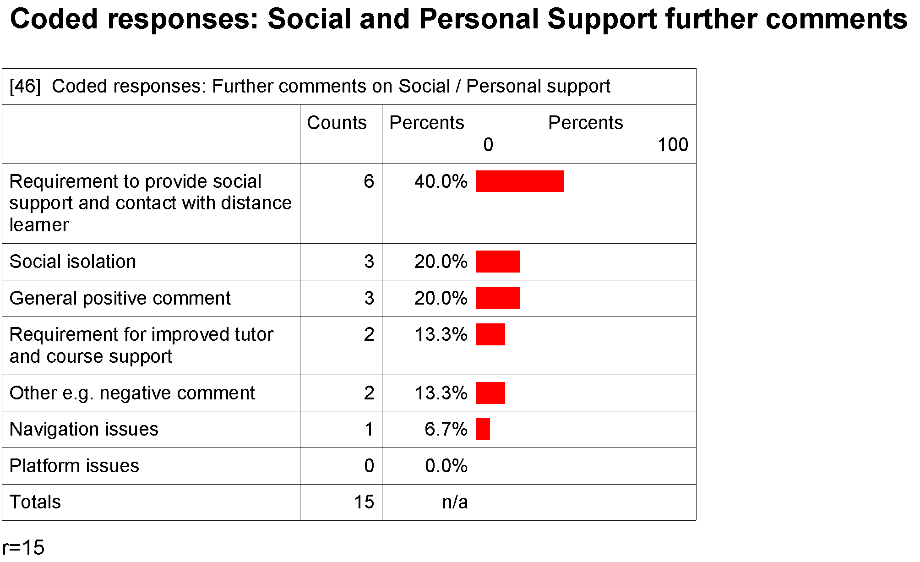

In response to this question most of the respondents highlighted support issues that affected them as distance e-learners. Several suggested it was a requirement of the provider to meet their needs and they had not been fully meet during the students study period.
Make the support personal - a personal phone call, email, or visit. Respond to cries for help of a social/personal nature (opposed to academic) quicker as they are often the "make or break" situations XXX students find themselves facing.

Yes. Remember we are people first and students second.

Furthermore, three e-learners mentioned aspects of social isolation as a factor in their student experience.
My situation was extreme isolation....as far south as I was, an outreach support person would have made a huge difference for me. It fell to my supervisor to be mentor, and social support, additional to the task of tutoring me, and I felt the weight of that role to be excessive professionally & personally. In one instance, I feel the poor outcome of the tutoring relationship I experienced with one of my tutors could have been alleviated by someone in that support role other than my other tutor

I felt isolated as there was little contact apart from the forum online discussions. Some of the tutors were better than others.

Three e-learners comments were in praise of the Social and Personal support they received.
I found the support offered by those running my course to be better than anything I had experienced before in my learning. I felt that I had the opportunity to ask questions which would be responded to in contrast to a lecture situation where there is a time limit and it is easy to decide that your question is not important enough to ask.

One additional comment was critical and one comment indicated that the student wanted more support for a cohort experience.
It would have been great to have some of my old group with me this year.

Staff
Five staff made further comments regarding the Social and Personal support offered to on-line students. One staff suggested the students were supported but did not always use the opportunities they were given; We try to be proactive regarding the support we offer to on-line students but most don't see the need to seek help until it’s crucial they find it.

Two staff agreed that levels of Social and Personal support were variable across their organisation, one suggested that the variation was to some extent resource dependent; There are variable factors in the support students are given, we are short of resources. Some departments are well funded some are not.

Social and personal support was an important area of provision according to two staff. One indicated that the support staff offered should facilitate personal and social contact with the on line learners; It's important that we solve the issue for our on-line students. People in an on-line situation like to establish contact with one person so they develop a relationship they are able to trust upon as supportive.

The other staff thought the facilitation of social and personal support was important for the cohort of on line learners; in on-line situations the options for students to meet up in cohort groups is hard but is make a difference to their experience. They need the opportunity to have this contact to make friends.

Discussion

Key themes: Social and personal support
Figure 10: Key organising themes: Social and personal support

Personalised staff guidance
Staff who display empathy and understanding play a key role in resolving what sometimes seem to be insurmountable problems from a student’s perspective. Often personal issues that ‘spill over’ into a learners’ study arena are perceived as unique to that person alone. Tutors are generally the first line of contact for problems specific to the learner and her/his academic endeavours. When confronted with social and personal issues that affect their study performance, learners require support and guidance delivered in a way that matches their real and perceived needs.

Cohort affiliation
Unlike on-campus students, e-learners have a greater need for structures that assist their affiliation into the academic community. Opportunities to discuss issues within a cohort group help create a sense of community. E-mail discussion groups and ‘chat-rooms’ aid in such socialisation. Synchronised chat and more formal real-time, on-line discussion forums play an important role in maintaining distance-based learner’s connection to their studies. The respondents who experienced cohort support emphasised the value of this social and personal support mechanism.

Support accessibility
Opportunities to have face-to-face visits from academic liaison staff correlates strongly with learners’ satisfaction with social and personal support services. The respondents also clearly value fast timely responses to their information request. The opportunity to have several communication pathways to access this support appears to provide the best opportunity for that communication to occur. In addition to face to face assistance respondents reported positive experiences of having their issues resolved through various interfaces include phone, email and opportunities for peer or cohort discussion forums.

Technical assistance

Importance – Performance analysis
The following analysis provides a table of scores for each of the survey statements in the area of Technical assistance and a plotted matrix of those scores. Salient features of those scores are highlighted and explained in more detail.

Table 13: Technical assistance. Mean importance and usefulness rankings and gap scores. |  | Figure 11: Technical assistance. I-P matrix, all aspects

On average, respondents regarded technical support overall, and the four particular areas assessed in this study, as very important aspects of support. The mean importance and usefulness scores, together with the gap scores, for the areas of interest are detailed in table 13, with their locations on the I-P matrix shown in figure 11.

Across the four support areas Technical Assistance scored the highest importance mean of the respondents overall (statement 41) assessment. Correspondingly this implies the respondents valued good services and activities that supported them. The respondents mean score for the overall usefulness of the Technical Assistance they received was also the highest over all the areas of inquiry. The favourable assessment of Technical Assistance is reflected on the matrix.

Technical Assistance was an area with a particularly poor response rate. The placement of the inquiry as the last section of the survey instrument might have contributed to a lower response rate that the other areas incurred.

The support activity the respondents regarded as most important across all factors was access to the learning platform to be available to them when they required (statement 39) Two others factors had close scores for second place of importance; access to easy to understand helpdesk support (statement 38) and the availability of continuous help desk assistance (statement 40).

As has been the case with the previous e-learner support systems discussed, respondents rated the usefulness of the technical assistance received at a lower level than their importance scores. All mean performance scores for such assistance were located in the range of ‘good’. In all cases, the negative gap relationship between usefulness and importance was sufficiently small for I-P scores to remain in the target quadrant, B, ‘keep up the good work’.

Respondents’ mean I-P scores for access to the learning platform (statement 39), together with the three statements which probed for assessments of help-desk support (statements 37, 38 and 40), generated noticeably larger negative gaps than were the case for the overall assessment of technical assistance.

Importance assessment - did not use or receive technical assistance.
The number of respondents who did not receive / use two types of technical assistance (contact information and access to the learning platform) was too few in number for analysis of their importance rankings. Two groups of non-use respondents were sufficiently large in number to warrant an analysis of their importance ratings. These concerned statements 38 (easy to understand help-desk advice) and 40 (availability of help-desk support). Findings are illustrated in figure 12, below.

Figure 12: Importance rankings of respondents who did not use/receive help-desk support

The above figures are based on data from a small percentage of respondents to each statement. Thus the portion of respondents in each ranking scale is an even smaller group of respondents. However, despite the small numbers, the figures do demonstrate that the respondents who did not use/receive easy to understand help-desk advice or availability of help-desk support placed different values on the importance of those aspects of support. More of the non users / receivers of availability of help-desk support rated the support as very important, and overall the spread was more polarized between the rankings than it was for the responding non users/ receivers of statement 38. For example, 65% of the respondents to statement 40 are located at either end of the ranking. Correspondingly, statement 38 has 46% of the population at either end of the ranking and only 13% thought that easy to understand help desk support was very important. More likely, they thought it slightly important.

Respondents were also asked to tick all the sources of technical help they had used during their 2004 e-learning programme. Respondents appear to have relied on their tertiary provider as one source of support but frequently they used other support mechanisms for example, friends or family.

Figure 13- Sources of technical help
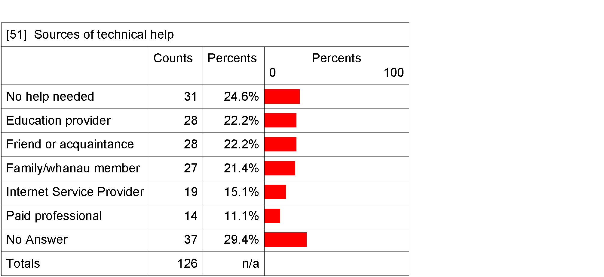

Qualitative Analysis

E-learners
Were there any aspects of the Technical Assistance you received that was particularly useful to you?

Overall, the most frequent comment from e-learners was that staff responded to their request for information in a timely manner.
Just that it is included in the Virtual classroom environment, easy to access, the replies are prompt, courteous and sometimes even humorous, could not be better.

Yes I could not access the webct to begin with. The technical assistance from the education provider was immediate.

More specifically nearly a quarter of the comments referred to the advice and skills of individuals.
It was good to be able to ask questions and to receive answers from other students or (XXX). Also rang 0800 (XXX) when I lost my pin, who them mailed it to me straight away.

(XXX) has always been extremely helpful to all students and very fast at responding effectively, without fail

Not applicable, our course administrator addressed most technical issues and that was brilliant.

Four comments suggested that the technical support was helpful because it was available and readily accessible.
When asked to complete a webpage assignment I would not have been able to without the constant support of WebCT technician (technician)

Technical support people were helpful in explaining the idiosyncrasies of our particular online platform

Two comments indicated the e-learners had accessed technical assistance via support mechanism amongst other student services. For example; International providers gives me tons of help.

Nearly one quarter of respondents to question 52 made comments that referred to useful mechanisms to support the technical assistance, on the other hand some respondents referred to the absence of support.
Usually when dealing with Technical issues, it is the tutor who makes the error, dating the information to become available in the wrong month etc and when that does happen, postings on the discussion boards (webCT) often makes the tutor aware of the problem for them to be able to fix it

Moodle instructions were sent in a hard-copy version. This made it easy to use (Please note that my ticks within the ranking are all regarding my online learning experience within Moodle. NOT Web CT).

In the first year there was a position on-line that we could visibly and easily refer to if we were having problems with download etc. This year I found I had immeasurable difficulties with one lecturer's lecture downloads and felt I had NO ONE to easily contact to help fix it. This was a major hurdle in studying for this paper. I nearly quit it.

I didn’t receive any assistance from the education provider

Staff
Four staff contributed comments to the question, are there any aspects of the ‘Technical Assistance’ provided by your organisation that you think are particularly useful to enquirers. All the comments suggested the provision of technical assistance was good. One staff indicated that the on-line students had good access to information prepared to assist them with the operations of the software they interfaced with. Our learning platform has an on-line tour and we have a CD ROM available to students.
However, the other three comments suggested it was the provision of library based support where on-line students received extensive assistance with technical issues.

I don't think that students know what a technical problem is and what an information problem is. We try to have a one stop shop here; we often diagnose what would be defined as ICT. It is a murky area for librarians. The ICT library and ICT technicians. One group is not a service culture.

The ratings I've given are from the perspective of the technical assistance we offer through the library. Mostly access to electronic resources is important and students are well provided for by the library.

E-learners
Do you have any suggestions about Technical Assistance that could have been more useful to you?

The most frequent request for Technical Assistance that could have been more helpful to the e-learner respondents was improved instructions and access to information.

Making sure that new changes being made before during and after the course was going to be accessible to all when needed, with full (understandable) instructions on how to use this new technology - a lot of us are older students who are not very savvy with computer use, to run a course with unknown technologies makes the learning experience very frustrating and stressful.

I have not received any help as to how to use Web-ct. Luckily I have knowledge from a previous paper

Four comments indicated that those e-learners would have appreciated an increased level of help desk support
People are online at different times during the day and into the night. If there were a technical issue that arose during the evening no one would be available to fix it. Perhaps a 24hr helpline (via the internet) may be a good idea.

Contact details for the technicians published on a webpage so that online students can contact them when required for help. It would be helpful to know which people to contact for particular issues and have their phone number as well as email address because many difficulties experienced by online students, relate to the internet. As far as I know, this contact list was not available to us so many students paid for other professionals to do the service they needed.

Another four comments suggested those e-learners wanted better communication and personal support to assist them with their technical issues.
Talk to us so we can understand you.

Some response from the lecturer would have been nice, so I could have found out HOW to fix my problem.

It took until Year 3 for it to be figured out why I couldn't access the WebCT chat rooms for my course. To do that, I had to visit a paid professional. I felt like I was frustrating the (XXX) technos and although they tried, what they were telling/asking me to do sounded like double-dutch to me. The terminology wasn't easy enough to follow so I sought help elsewhere.

Respondents’ other comments include praise of the learners experience of Technical Assistance on and off the campus.
No, everything was great. It was always there, but I did not really need it.

When needing technical assistance it was great that the university had computers to use so I could still complete assignment.

In addition, one comment indicated the e-learner pursued the opportunity to seek help elsewhere for their technical assistance.
Due to having a family member who is very sound in computer knowledge I went to them for assistance. If I did not have this kind of support I would appreciate knowing who was a reputable tech in the local area that understood the urgency of any required help.

Staff

There were three comments to the question are there any aspects of the Technical Assistance provided by your organisation you think could be more useful to enquirers. One staff emphasised the requirement to allocate adequate resources to provide the technical support; Students need to be assessed well, funded and provided with good access.

Another staff suggested that on-line students needed one point of access for the delivery of technical assistance; Students should not be sent to multiple places to seek the assistance they need it should be a one stop shop.

The other staff suggested there could be room for inclusion of more information for students to access; there’s always an opportunity to put help sheets on line- then it's a question of whether they would read it. We could provide more of this.

E-learners
Do you have any further comments you would like to make about Technical Assistance?

Overall, the majority of final comments emphasised the e-learners positive experience of the Technical Assistance they received, for example, Help line technicians were excellent.
Several respondents described the provision as good or better.

Four respondents praised the skill of an individual staff member for the Technical Assistance they provided.
I found the technical assistance was a crucial aspect to study on line. Study can be stressful enough and it was wonderful to have someone who would magically fix any difficulties. I was sad to hear that (XXX) position has been made obsolete. It was extremely important for online students.

Yes (XXX) was a great help in the first year. He was able to reply quickly to email and make the necessary changes ASAP.

A few students highlighted issues that had arisen and their subsequent need for better access to Technical Assistance.
Make sure the technos can speak in "normal" language as most people studying XXX are not computer-whizzes.

When posting group assignments on site to make sure the web CT site is compatible with all types of computer programmes.

Staff

Six staff made further comments regarding the support offered to e-learners. All agreed that the provision of Technical Assistance was important and required attention;

I think this is underrated by the university staff, they don't understand the extent to which students require support. The need for technical assistance needs to be picked up.

The library helpdesk is available seven days a week but the university help desk is less. I think we don't do it as a matter of course but we do do follow up. This is important because it gives the student and invitation to access more assistance.

However, one staff suggested students should take some responsibility for the level of technical assistance they needed.

Technical assistance is not the sole responsibility of the institution. To some extent the assistance given to students is dependent of the individual support person. I don't think a 24 hour helpdesk response is necessary but during working hours it is important to have the helpdesk support. I also think it is problematic providing technical assistance that meets student’s expectations because it depends on what the student expects to receive.

One staff acknowledged the need to increase the provision of assistance and discussed some of the issues their organisation was considering in relation to that

I think it would be nice to provide technical assistance for longer periods to the students. We have considered the need to provide good help desk staff. Currently we operate an 8.30 am - 5 pm service Monday to Friday. Outside of those hours we are not available. Lots of people study outside our hours of operation. We have discussed outside hours provision of help desk support. One option is to hook up with another university that provides this in another time zone.

One librarian described an innovative approach used to assist on-line students with their technical issues.
Different cultures-what is technically an information requirement and what is ICT. We try to have a computer with a dial up modem so we can diagnose faults from the ISP users view. It allows us to focus on the problem and we can pin point what is required. It's a matter of putting yourself in the learner’s shoes.

Discussion
All eight of the staff agreed that technical assistance was a very important aspect of their non-academic support systems. Their responses generally matched the e-learners positive remarks concerning the technical assistance they particularly valued.

Several of the staff raised the issue of providing technical assistance to e-learners beyond current periods of availability. They acknowledged that e-learners often did their course work outside normal operating hours and suggested the population could benefit from increased support hours. However, the extension of help-desk support was also considered by some staff in relation to other issues such as the availability of resources and the variation between the actual skills of the e-learners.

Key themes: technical assistance

This section links the most salient features contained in respondents’ qualitative comments about technical assistance to the importance-performance findings discussed earlier. These are also linked to remarks offered by the e-learning professional staff who were interviewed separately.

Respondents generally valued technical assistance very highly. As a group, they mean-rated all aspects as ‘very important’. The highest mean across the four areas of support was recorded for the overall importance assessment of Technical Assistance

Technical assistance is the only one of the four support systems investigated that did not have a spread of importance mean scores across a range of importance scales. Respondents’ assessments of the usefulness of the technical assistance they received also differ from responses in the other three areas. Taken in aggregate, respondents’ performance scores all tend towards the high side of ‘good’ performance, and do not have the spread across ranges seen in the other areas.

Table 14: Themes within aspects of technical assistance
Theme |  | Survey statement |  | Mean importance | Mean performance | GAP
Access & relevance

Access & relevance |  | 37 | ‘Contact information for technical assistance was easy to find’ | 3.45 | 2.92 | -0.53
Access & relevance |  | 38 | ‘Technical advice given by help-desk staff was easy to understand.’ | 3.58 | 3.12 | -0.46
ICT systems integrity
ICT systems integrity |  | 39 | ‘Access to the learning platform…was available whenever needed.’ | 3.64 | 3.19 | -0.45
ICT systems integrity |  | 40 | ‘Access to technical help-desk support was available whenever needed.’ | 3.57 | 3.16 | -0.41
Positive assessments concerning the importance of particular individuals, or the guiding and empathic approach taken by help-desk staff in resolving ICT problems, was a topic strongly evident in respondents’ qualitative remarks. This additional key theme has been labelled ‘Staff professionalism’.

Figure 14: Key themes: Technical assistance.

Access and relevance
The fundamental purpose of technical assistance is to help learners resolve ICT problems that prevent or limit them from studying on-line. To be effective, advice needs to delivered on-time, be issue-relevant and be comprehensible to the end-user. That person will often have a limited understanding of ICT systems and jargon.

A number of respondents were disappointed with the relevance of technical assistance they received. Respondents wanted technical assistance that was easy to access and which resulted in effective advice. Many in this group expressed dissatisfaction in overly technical advice some help-desk staff offered. Information that was not easy to comprehend was poor assistance from this group’s perspective.

Many distance-based e-learners do not study in the traditional hours of a ‘9-5’ working period. They are just as likely to require support at night as during the day. Week-ends are an important study period for many of them. Availability and ease of access to technical assistance ‘as and when needed’ are important indicators of on-line educational quality for this group.

Staff professionalism
Lifting the effectiveness of technical support services is dependent on people displaying staff professionalism. Respondents in this study singled out a number of personnel who can be described as ‘total e-learning professionals’. These are staff who had good competencies across a range of technical issues, and who displayed ‘can do’ attributes with ICT problem-solving on behalf of the e-learners’. Particular innovations were also deserving of the favourable comments attached to them. It appears that the individual behaviour and approach of personnel contributed a great deal to the student’s e-learning experience and is likely to have assisted in maintaining respondents’ commitment to their education.

This issue of adequate provision was highlighted by a staff member of the university with the largest population of e-learners connected to this project. Discussion included the lack of resources available to provide the extent of support students might require. For example, there was no provision to assist students with connection to their Internet Service Provider (ISP).

This particular university was considering increasing their provision of help desk assistance to better meet the needs of all students including e-learners. One proposal was to route the help desk operations to an off shore location during the hours help desk assistance was not available to their students.

One of the challenges for the future of New Zealand’s e-learning environments is to predict and provide for the changes in technology that will occur over time. Tertiary providers are looking for ways to accommodate those changes. Currently, it appears that many tertiary providers are taking advantage of open source software systems such as Moodle to use as platforms for e-learning operations.

ICT systems integrity
This organising theme has tracked through all aspects of learner support investigated in this study. This is to be expected, given that ICT systems are the main means of delivering on-line distance education services. Respondents saw ICT systems integrity as resting on effective support in two main areas; maintenance of learning platform access and availability of technical help as and when required. In instances where these aspects failed and the respondents expressed their disappointment it was easily understood how that experience impinged on their learning opportunities.

Systems integrity is not a stand-alone concept. The maintenance of operational effectiveness is dependent on the other two key areas discussed above; staff professionalism and access to relevant advice. However, in a certain sense, systems integrity is a more fundamental non-academic benchmark of e-learning quality than many other themes discussed in this report. If ICT systems remain stable, with no software or hardware conflicts interrupting access to learning platforms, on-line students in theory have virtual access to all the support mechanisms that the provider can offer the e-learners in particular.

Conclusion & recommendations

The findings identified in the analysis of the importance/performance survey of e-learners are specific to the respondent population. The response rate to the survey was lower than anticipated. Had it been better, there would have been the opportunity for detailed analysis of the data for example by cross tabulations of responses according to demographic characteristics within that population.

The empirical findings suggest that respondents are representative of the gender ratio in the national population. The e-learners in the population of interest are predominantly female. However, with the exclusion of one provider and their population of e-learners including a high representation of Maori and Pacifica, the sample population for this research could not achieve a representation of a national population across all the demographic characteristics of that population

It is highly likely that all the respondents to the student survey were ‘successful’ e-learners. It was not possible to access accurate outcome data to confirm that belief however; none of the completed surveys alluded to the fact that the respondent had not completed their course. Conversely, within the responses there were several comments that highlighted the obstacles individual e-learners had overcome, with or without support, to complete their study.

Predominantly, the findings of the survey research are based on a European /Päkehä female experience. Her (or his) response is based on the experience of a full-time, undergraduate, ‘distance learner’, enrolled at a university in a programme largely taught on-line in 2004. Typically, she is responsible for the care of one or more dependents. The recorded income of the household the she (or he) call their own in 2005 was most likely above $20,000 and probably, according to the data, closer to $40,000.

The combined survey data reveals the respondents experience overall is a positive one. Largely the support services they received, or staff provided, were useful and approached the level of importance respondents placed on receiving that support. It is reasonable to suggest that the positive findings for particular support services/activities might well extend to a wider population of ‘successful’ students that engaged in these e-learning environments. Overall, as suggested, we could infer that for successful students the e-learning arenas of these universities are mostly performing well.

Survey data for a series of factors is worth reiteration. The differing importance scores across areas and services/activities in this survey data suggest that an instrument designed for e-learners to assess the performance of their tertiary provider would require some consideration of weighting the different factors for the overall assessment. Evidently, some areas and factors were more important than others to the survey respondents.

Some features of this report have identified activities where the respondent’s needs were not being met at what they considered an optimum level. They are areas where providers might be encouraged to assess and monitor their provision. Probably, the underperforming areas would benefit from additional planning and resources. In general, the quantitative and qualitative data captured in both surveys support that assessment.

Of the four areas in the survey Pre-enrolment incurred the second highest overall mean and indicates that that phase of the tertiary experience was predominantly important to the respondents. More than half of the respondents did not have an opportunity to try out an on-line learning programme at this point although clearly it is a desirable aspect of an e-learning experience.

Elsewhere, it has been established that Pre-enrolment is an important phase for tertiary students in general and most particularly the e-learner. The phase permits the potential students to orientate themselves in preparation for an e-learning environment. In one sense, this survey might have presented an interpretation of Orientation as the actual event, which occurs just before commencement of a trimester. Outside the New Zealand experience, it would appear that the term orientation applies to the activity more so than the event. The lesser importance these respondents put on Orientation activities might be in part due to the respondents’ perception they were assessing what is known in the New Zealand context as the event of Orientation.

The area Technical Assistance generated the highest mean across all areas of the e-learners survey. It is not surprising that a mean response from a sample population of e-learners would generate that ranking. Clearly respondents valued stable ICT environments capable of facilitating access to information particularly information that could be defined as generic to the e-learners, for example, timetables.

Respondents also appreciated opportunities for personal communication including email and telephone. It appeared that the aspect of providing personal communication pathways did a great deal to assist students at the Pre-enrolment and Orientation phases and contributed to their overall level of confidence. Other researchers have concluded that the effectiveness of e-learning is in part dependent on the capacity of e-communication technologies and in part dependent on the provision for the e-learner to use other communication pathways to assist them, for example, telephone. We can conclude that e-learning environments need other communication pathways for the learner to experience optimum performance.

E-learners are disadvantaged to some extent over campus students because they have less opportunity to interface with their course and support staff by mechanisms such as face-to-face discussions. E-learners who are geographically distanced from their providers are further hampered. Respondents’ were from a mix of geographically defined areas and a significant portion was a city based sub population. These respondents will have had access to more resources than the others, for example, libraries. The distance based library services of tertiary providers were singled out for comment and we can conclude they were useful for all manner of respondents and in particular for non-city based ones.

Across all the areas that the respondents assessed, the vast majority of support activities/services were identified as performing well. Within each area and the corresponding list of activities/services, there were GAP scores, which also identified the support activities/services where the provider would need to improve their delivery to match the relative importance the respondents placed on receiving those activities/services.

The respondents’ quantitative data has highlighted that their provider’s performance regarding responses to student’s email are an issue worthy of consideration. Whilst this factor is located in this survey under Social and Personal support it could be located in other areas including those not assessed in this survey, for example, pedagogic practice. By definition, e-learners must be heavily reliant on email as a communication pathway to assist them with their study. It is fair to suggest that e-learners would be high users of that pathway and could expect timely and useful responses. It is also a communication pathway with a technical component and if the technology does not work for the e-learner, it can hinder their ability to study.

Elsewhere, the teaching staff of e-learners have confirmed there is a heavy demand on their time to communicate via email in a timely and appropriate way with individual students. It is clearly an area where service delivery and demand could be monitored. There are likely to be a range of issues specific to each provider that underlie performance issues of staff responses to students email. For example, staff workload might well be a factor for consideration. If the area of email communication were to be included in a generic performance assessment by learners of their tertiary provider’s performance, some consideration would be required on how to weight the survey instrument to take account of the greater importance the area is to e-learners.

The theme of social integration arose from this research as an important feature of the respondent’s e-learning experience. Respondents’ reported positive experiences of the facilitated opportunities staff provided for social communication amongst their cohort group including the opportunity for face-to-face interaction. Conversely, a few noted the absence of the experience. The instrument did not contain a statement regarding this form of social integration for respondents to rate in the area of Social and Personal support. The statements focused on the social and personal support activities between the e-learner and staff. Clearly, the student-to-student relationship is important. Responses from staff and e-learners indicated one particular tertiary provider had focused on creating a community of e-learning students. A body of the literature regarding e learning does not suggest social integration is a crucial component of the e-learners experience. However, another body of text does. This report would support the importance of social integration as one component of a complete e-learning experience, which could be given a performance assessment.

One of the fundamental concerns surrounding e-learner support is that the services are appropriate to their needs, which are different to campus students. It is fair to suggest that if service levels are not measured against the expressed requirements of learners, some areas may fail to meet the needs of particular student groups.

The e-learners data in this research is collected from ‘successful’ students. They appear to have progressed through to completion of their 2004 e-learning programme. Those that did not complete did not contribute to the importance performance rating. We do not have any assessment from that population. Surveying non-completing students is a difficult yet rewarding exercise. The researchers suggest a total assessment of performance would include a concentrated effort to collect responses from e-learners (or students in general) that do not progress within their tertiary environment including those that withdraw.

Most useful to the provider is the students’ knowledge of the performance of the learner support services and activities. If services/activities are indeed supporting students then the provider is more likely to see the retention, progression, and completion of the students through any tertiary environment including those designed for the e-learner.

Recommendations for providers

Communication with e-learners
This research has highlighted that e-learners seek personal communication with their course staff and place a high value on the responses they receive. Potential students are expecting to have access to staff to discuss their study programmes and prospective careers.

Providers should be fostering communication between the e-learner and the academic staff that support them. In this research respondents and staff identified particular success with aspects of personal communication between the e-learner and provider when a specific person was assigned that responsibility. Their role was to facilitate personal communication and assistance to the e-learner; they were the conduit between the learner and the provision of their education through an e-learning platform. It would appear from this research survey that where there was no designated person in those conduit roles e-learners relationships with staff were episodic. In an ideal situation e-learners would experience a connected relationship to their educators that was not merely a sequence of episodes. Most importantly to be adequately supported e-learners inquires need to be answered in a timely and appropriate way.

Maintaining contact with e-learners via the telephone and email are important ways of developing a rapport with e-learners and foster a connected relationship. If staff can meet face to face with the e-learner this is very helpful as part of the rapport building process. To foster supportive relationships with e-learners staff must have the time and inclination to do it. The provider must have sufficient technology and identify the pathways, for example email, by which they expect their staff to communication with their e-learners. The more pathways and expectations providers have of their staff to communicate the more likely it is that staff will receive and respond to their learners inquires.

Social integration
It is clear that e-learners appreciate support that enables them to feel socially integrated into their tertiary environment with their cohort. Providers should be fostering opportunities for e-learners to socially integrate with each other. There are opportunities to provide chat forums for e-learners on learning platforms and more use could be made of that mechanism for the purposes of socially integrating students. If e-learners have the opportunities for face to face encounters with their peers this will also provide successful socialisation experiences. E-learners could be encouraged to take these opportunities prior to the commencement of their studies. It will provide networks for the e-learners, and their peer encounters might well foster a foundation of support that the students would call upon at a later and more difficult stage of their learning programme.

On line orientation
E-learners are seeking the opportunity to experiment with the e-environment prior to proper enrolment and commencement of their course. Providers should be designing e-learning programmes which permit students to trial the environment and assess the suitability of the learning style. Two potential ways to do this are to give potential e-learners access to the learning platform in real time or distribute a programme which presents an example of course work done in the e-learning environment.

Navigation
Providers should be ensuring that students can use the learning platforms with the support of optimum navigation tools. An ideal way to assess the accessibility and usefulness of the navigation instructions is to test them with new e-learners. They are not familiar with the learning platform operations and will be a good judge of how easy it is to navigate through their e-learning environment.

Generic information
It is clear from this research that many respondents had difficulty accessing generic information relevant to their course or study programme. Providers should ensure that staff are correctly posting course information so it is readily accessible to the e-learners. Maintaining regular contact with the learners will present the necessary feedback if this is not occurring.

Providers should ensure that potential and enrolled students have ready access to tertiary related information specific to their provider, for example student liaison contacts or more generic information for example, student allowances. Easily navigated platforms and websites will encourage the distribution of correct and appropriate information.

There are three particular aspects of information that e-learners require at an early stage to prepare them with confidence for their study programme. Firstly, they require an orientation to the library services that are available to them and how they source documents. Secondly, the e-learner requires information on time management to assist them organise their work life balance as an on-line student. Thirdly, the e-learner wants a clear description of their qualification and potential career options.

Posting information to potential e-learners provides useful reference material to assist them with their inquiries, and all should receive such material. Potential e-learners should have a list of the software and hardware specifications that will be necessary to integrate them to the learning platform.

Technical Assistance
E-learners require technical assistance to support them interface with information and communication technology. Many e-learners are likely to have adopted the e-learning approach to their tertiary education out of convenience or necessity. A significant portion of this population was located outside of a metropolitan city and therefore was geographically distanced from their university. This research also indicates a significant portion of e-learners are likely to be responsible for the care of a dependent person. It follows that they will study outside of ‘normal’ operating hours of their provider. Providers must consider and assess their capacity to support e-learners with technical assistance outside of their ‘normal’ operating hours. It is desirable to offer technical assistance to e-learners when they need it.

It does not necessarily follow that a population of e-learners are technology savvy. Even if they are, there will be times when e-learners need technical assistance. Platforms must be stable and constantly accessible for the learner to be successful as an on-line student. Providers should monitor the performance of their platforms with the aim to deliver a constant and stable e-environment.

Several respondents found the technical assistance they were offered under-met their expectations. It is important that technical assistance be delivered in an idiom that e-learners can decipher. Help desk staff should be encouraged to deliver their services using approaches which maximise the understanding the e-learner can gain from their information. For example, common terms and language should be adopted above technical terms and jargon. Helpdesk staff should also have access to a dial up

Policy considerations and recommendations

The remainder of this conclusion moves from a focus on the survey research to focus on the policy environment of the New Zealand tertiary sector and aspects of that environment, which affect e-learners.

One of the challenges of e-learning is to foresee how the landscape will be in the future and how that landscape will affect the strategies and resources that are currently implemented. Practitioners and policy makers are focusing their attention on those considerations in their on-going strategic discussions.

It will be useful in any strategic discussion of e-learning in New Zealand to discuss what ways will best meet the on-going demands of tertiary institutions to support their e-learners with the technical assistance that allows the learner to interface effectively with their learning platforms. There is merit in discussing a centralised provision of help desk support to all students who use similar platforms across a variety of tertiary providers including universities, polytechnics, Wananga, Private Training Establishments (PTEs) and Industry Training Organisations (ITOs). Help desk support does lend itself easily to an anywhere, one point, service delivery and furthermore is not dependent on a specific location to be effective. Increasingly tertiary providers are turning to common open source software to integrate into their learning infrastructure. Tertiary providers are also discussing options for how to increase the technical assistance to support students at the interface level of that infrastructure. Discussions include increasing technical assistance through private contractors and off shore provision.

One very important advantage to centralising help desk support is the opportunity to provide increased hours of support and accumulate personnel with specialised and current competencies in e-learning technology. For smaller tertiary organisations or those with limited ability to acquire appropriate resources (for example, specialist help desk staff) the opportunity to source the support elsewhere might be a welcomed proposal. If the debate arises it will also be important to discuss whether that provision lends itself to private enterprise or should be a component of the public national learning infrastructure.

It was proposed during a 2004 review that the newly introduced Performance Element to Tertiary Funding, by which the performance of the tertiary sector will be monitored, will include a survey of students to assess their learning experience. We support this endeavour. Our findings include that a learner’s assessment of their experience is a good proxy for measuring the performance of tertiary providers. The current measurement of student retention, progression and completion is only one component of a performance measurement.

This project used an importance/performance matrix to measure e-learners assessment of their tertiary experience. We believe this method is a useful technique by which to measure performance. The method could be used as a suitable framework for a tertiary providers performance assessment completed by students. We would recommend that some of the findings from the responses to this research be considered in any discussion that occurs as a performance instrument is developed. In addition, we suggest that any instrument used to measure performance ought to include the opportunity to capture qualitative data and therefore provide some depth of information to include in the analysis of the quantitative findings and the final performance assessment.

It is worth noting that within particular e-learning platforms of tertiary providers there are mechanisms that could be adapted to collect data from students including e-learners. Some platforms for example, Moodle, have inbuilt surveys to assess the learners needs and the provider’s performance.

The mechanism to statistically track course level retention and completion of e-learners was sought for this project. The data is not available through the Ministry of Education SDR and it is held at the provider level. Had it been available the researcher s could have had a performance measurement to correlate with the importance/performance measurement of the e-learners experience. The outcomes data in the SDR is for programme level retention, progression and completion of students. It appears that the Ministry is increasingly receiving requests for data that can be analysed at the course level. We acknowledge that any attempt to capture course level data at a national level would correspondingly increase the resource allocation particularly of tertiary providers to produce course measurements. None the less some ability to compare performance measurement at the course level is desirable if performance across similar courses is to be monitored and understood. We suggest attempts should continue to accumulate outcomes data at a national level which facilitates analysis across similar academic courses, for example, those taught on-line.

Most importantly we end this project as advocates for the collection of data from students to assess the performance of their tertiary providers. It is important to get a national view of New Zealand students’ perceptions of their tertiary learning. It will be especially important that the newly proposed ‘National Centre for Tertiary Teaching Excellence’ has access to such data so that it can identify where teaching/learning excellence is located and where the shortcomings are.

Appendices to this report are available as a supplementary document.

SDR: Population, Sample and Respondents

See, for example: Brooks, Lori (2003). How the attitude of instructors, students, course administrators, and course designers affects the quality of an online learning environment. Online Journal of Distance Learning Administration, Vol. 7, No 4. Source: http://www.westga. edu/~distance/ojdla/winter64/brooks64.htm. Accessed: 21 February 2004; and Murray, Bridget (10 December 2001). What makes students stay? ELearn Magazine. Source: http://www. eleanmag.org /subpage/sub_page.cfm?article_pl=1301 &page_number_nb=1&title=FEATURE% 20STORY. Accessed: 15 February 2004.
New Zealand Government (2002). Highways and Pathways: Exploring New Zealand’s e-learning opportunities. The report of the e-learning advisory group. Wellington: New Zealand Government. p.6.
These are discussed more fully in the focus group report.
In particular, the researchers wish to thank Dr Joss Jesson (University of Auckland). She contributed to enhancing the instruments during her evaluation of the first draft.
By inference, the researchers could confirm that, as anticipated, non-response was an issue likely to arise in the final survey. The researchers continued to adapt their approaches to mitigate the non-responses issue. For example introducing an incentive for students to participate and modifying the length of the instrument.
The provider, which declined to participate, had a population of e-learners who were predominantly Maori. The population from which the researchers selected the sample from had fewer Maori than it would have done had it been included e-learners from all the providers.
Details of all the groups’ importance ratings by individual statements are in the appendices to this document, published as a separate report, available as a web document.
Owen & Renwick (2004:24), see also, Buchanan, 1999.
Owen & Renwick (2004:14).
Issues such as the speed of the respondents ISP service are likely to have contributed to a low response rate. It might have been slow enough that the respondents skipped this section because it took too long to load the page.
Benke, Meg (2003). Student satisfaction begins before class starts. Sloan C-View. http://www.aln.org/publications/view/v2n5/coverv2n5.htm:(3 August 2004). - Bruso, Jackie L. (2001). A comprehensive orientation to address diverse student needs. In Christine Dalziel & Michele Payne (Eds) Quality enhancing practices in distance education. Volume Two: Student Services. pp. 8-18. Instructional Telecommunications Council. www.itcnetwork.org. ( 15 September 2004). - Bozarth, Jane, Diane D. Chapman & Laura La Monica (2004).Preparing for Distance Learning: Designing An Online Student Orientation Course. Educational Technology & Society, 7 (1), 87-106: http://ifets.massey.ac.nz/periodical/7_1/index.html (15 September 2004).
Yoni, Ryan (2001). The provision of support services online. In Glen Farrell (Ed.) The changing faces of virtual education, pp. 71-94. The Commonwealth of Learning. Source; http://www.col.org/virtualed2pdfs/v2.chapter5.pdf. (15 February 2004).
Professionalism On-Line (Conference), Wellington, Association of Staff in Tertiary Education (2004)
Moodle has several inbuilt survey instruments that can be activated for collection of data from students by those with administrator’s access codes. However, it appears that the platforms programme code does not currently permit the survey respondent to remain anonymous.

