

The E-learner Support Project
Appendices to Report

Measuring the worth of e-learner support systems:
Developing a possible benchmarking method for evaluating effectiveness.

Jane Renwick & Stephen Owen
May 2005

ISBN Print version: 0-478-13309-X

ISBN Web version: 0-478-13310-3



Appendices

Appendix 1 Importance-Performance matrices- All survey statements page 3
Appendix 2 Participant information sheet and questionnaire page 37
Appendix 3 Letter to Providers page 53
Appendix 4 Bibliography page 55

3

Appendix 1: Importance-Performance matrices-All survey statements

Appendix 2: Participant information sheet and questionnaire
Invitation to participate in the E-learner Support Project
This letter has been sent by [TEI name] to a random sample of tertiary students who studied on-line [via the internet] in 2004. According to university records, you are one of those students.

From: The E-learner Support Project Researchers March 2005

Dear student;

How useful was the support you received during your on-line studies in 2004?

Please accept this message as an invitation to participate in the ‘E-learner Support Project’ survey and be in the draw to win computer equipment or overseas travel or $750 worth of petrol vouchers. Below is a brief summary of the project and the link to the survey. Prize details are at the bottom of the message.

- As part of the government’s Tertiary Education Strategy, the Ministry of Education administers the E-learning Research Fund.
- This supports research into the provision of on-line or electronically delivered education to tertiary students.
- In 2004, the E-learner Support Project from the Aotearoa Tertiary Students’ Association was one of four proposals awarded funding.
- The goal of the E-learner Support Project is to ask students about their experiences with the support they received during their on-line education and to develop a set of best-practice services that could help e-learners succeed in their studies.

This is an important project that will help improve educational outcomes for current and future students. Its success depends on the willingness of students who have studied on-line to complete an anonymous survey, provided on-line.

Your privacy is guaranteed
- Your name or any other information that could personally identify you will not be provided to the researchers or any other party.
- Participation in this survey is voluntary and anonymous.
- No information that could personally identify you is sought.
- The researchers abide by the Code of Ethics of the New Zealand Association of Social Researchers.

IMPORTANT!
- Because this is an anonymous survey, the researchers do not have access to your name or contact details.
- If you wish to enter the prize draw, you will need to enter your prize draw code which is: xxx
- The [TEI name] will contact you if your code is the winning number.
To participate and enter the prize draw, click on this link
http://203.96.212.200/netcollect/elearnerd/content/elearner_1.htm
to go to the on-line survey.
It should take about 20 minutes to complete. The last question asks for your prize draw code so keep it handy!
If you have any questions about this survey, please contact the researchers direct.
Jane Renwick E-mail: research@atsa.org.nz Stephen Owen E-mail: atsa@atsa.org.nz
PRIZE DRAW DETAILS
If you agree to participate in this survey, you are eligible to participate in the prize draw. To do this, you must enter your prize draw code detailed in this invitation. The winner number will be randomly selected from all eligible surveys.
If your prize draw code is selected, your education provider will contact you and ask you to choose your prize from the following list.
The winner can choose one of the following prizes. Only one prize can be selected and it cannot be exchanged for money.
1. ACER desk top computer 2. ACER notebook computer 3. ACER handheld PC with LCD screen 4. Petrol vouchers to the value of $750.00 5. Single return airfare from Akl/Wlg/Chc to Sydney with 3 nights accommodation [conditions apply]

E-learner Support Project

A survey of tertiary students who studied online in 2004

Thank you for opening the link to the E-learner Support Project on-line survey.
This page describes the general format of the survey and how to navigate through the sections. The survey should take about 20 minutes to complete.
If you wish to enter the prize draw, please make sure you have your prize draw code ready for entering at the end of the survey.

This survey seeks your views about the usefulness of the support you received during your on-line studies. It covers four areas.
1: Pre-enrolment Advice...........information you received before enrolling.
2: Orientation Help....................guidance offered to help you study online.
3: Social & Personal Support...non-teaching services used during study.
4: Technical Assistance...........help with computer & technical problems.
A fifth section seeks information about you and your studies. You will need to enter your prize draw code at the end of this.

All completed surveys received on or before 28 March will be entered into a draw to win one of the following:
Either an Acer desktop computer or an ACER notebook computer or an ACER handheld PC & LCD screen or
one return flight to Sydney plus 3 nights accommodation
or petrol vouchers to the value of $750.
[Conditions and details are in the 'Invitation to participate' email you received]

Filling out the survey
Once you have read through this page, click on the 'Start' button below.
Read each of the statements and then select your answer from the options listed in the columns.
You do this by clicking your computer mouse on the circle below the option that best matches your view.
Use your computer's TAB or arrow keys to move through the survey.
The last question asks for your prize draw code. This is in the 'Invitation to participate in the E-learner Support Project' e-mail advice you received from your provider. You must type in this number at the end of the survey if you wish to enter the prize draw.
Once you have completed the survey, select the 'Send Answers' button. This will send your answers to the data-base ready for analysis.
The researchers cannot identify you as an individual. Only your provider has that information and it will not be given to the researchers.

If you have questions about this study, please contact the researchers, Jane Renwick and Stephen Owen
Tel: 04 939 1417 E-mail: research@atsa.org.nz
Part One: Pre-enrolment Advice
This section seeks your views about the sorts of information you used before deciding to enrol for a course that was provided on-line.

How useful and important was the advice you received about learning on-line?
Please read each of the statements below and then select the circle that most closely matches how important that aspect was to you [the How important column] and then select the circle that most closely matches how useful any assistance received was to you [the How useful column].

 |  | HOW IMPORTANT  was this sort of advice to you? |  |  |  | HOW USEFUL  was the advice you received?
 |  | Not important | Slightly important | Moderately important | Very important | Poor | Adequate | Good | Excellent | I did not receive this advice
[1 | Clear description of the qualification, including its career or personal development potential.
[2 | Advice about study skills, such as self-directed learning & time management, needed to study on-line.
[3 | Information about cost of study, including tuition fees, books & other expenses.

cont. Part One: Pre-enrolment Advice
 |  | HOW IMPORTANT  was this sort of advice to you? |  |  |  | HOW USEFUL  was the advice you received?
 |  | Not important | Slightly important | Moderately important | Very important | Poor | Adequate | Good | Excellent | I did not receive this advice
4] | Advice about needed skills, such as English language or maths ability.
5] | Advice about the technical skills [computer, E-mail, etc.] needed to study on-line.
6] | Information about computer hardware & software requirements.
 |  | HOW IMPORTANT  was this sort of advice to you? |  |  |  | HOW USEFUL  was the advice you received?
 |  | Not important | Slightly important | Moderately important | Very important | Poor | Adequate | Good | Excellent | I did not receive this advice
7] | Opportunity to have a discussion [either face-to-face or by 'freephone'] with a tutor about study options.
[8] | Access to a trial on-line programme to test before enrolling.

cont. Part One: Pre-enrolment Advice
 |  | Overall importance of Pre-enrolment Advice to you. |  |  |  | Overall usefulness of Pre-enrolment Advice you received.
 |  | Not important | Slightly important | Moderately important | Very important | Poor | Adequate | Good | Excellent | I received no advice
9 | OVERALL, how important was Pre-enrolment Advice to you, and how useful was the advice you received?
[10] | Were there any aspects of the Pre-enrolment Advice you received that were particularly useful to you? [please type in the box below]
[11] | Do you have any suggestions about Pre-enrolment Advice that could have been more useful to you? [please type in the box below]
[12] | Do you have any further comments you would like to make about Pre-enrolment Advice? [please type in the box below]

Part Two: Orientation Help
This section looks at the sorts of help you received after enrolling but before [or very soon after] you began formal study.

How well did your provider introduce you to learning on-line?
Please read each of the statements below and then select the circle that most closely matches how important that aspect was to you [the How important column] and then select the circle that most closely matches how useful any help received was to you [the How useful column].

 |  | HOW IMPORTANT  was this sort of help to you? |  |  |  | HOW USEFUL  was the help you received?
 |  | Not important | Slightly important | Moderately important | Very important | Poor | Adequate | Good | Excellent | I did not receive this help
13 | Guidance in learning the ICT [Information & Communication Technologies] skills needed to study on-line.
14 | An introduction to the library and how to find/order books and other documents required to complete assignments.
15 | Assistance with setting up computer and E-mail systems required to study.

cont. Part Two: Orientation Help
 |  | HOW IMPORTANT  was this sort of help to you? |  |  |  | HOW USEFUL  was the help you received?
 |  | Not important | Slightly important | Moderately important | Very important | Poor | Adequate | Good | Excellent | I did not receive this help
16 | Help with any needed skills, such as English language or maths, required for study.
17 | Guidance about personal skills, such as time management & self-discipline, etc. needed for successful study.
18 | Advice about understanding personal learning styles and ways to study on-line.
 |  | HOW IMPORTANT  was this sort of help to you? |  |  |  | HOW USEFUL  was the help you received?
 |  | Not important | Slightly important | Moderately important | Very important | Poor | Adequate | Good | Excellent | I did not receive this help
19 | An opportunity, before formal study began, to experiment with the learning platform [WebCT, Blackboard, Moodle, etc.] that would be used.
20 | Advice about student support services, such as career guidance and counselling.
cont. Part Two: Orientation Help
 |  | Overall importance of Orientation Help to you. |  |  |  | Overall usefulness of Orientation Help you received.
 |  | Not important | Slightly important | Moderately important | Very important | Poor | Adequate | Good | Excellent | I received no help
[21 | OVERALL, how important was Orientation Help to you, and how useful was the help you received?
[22] | Were there any aspects of the Orientation Help you received that was particularly useful to you? [please type in the box below]
[23] | Do you have any suggestions about Orientation Help that could have been more useful to you? [please type in the box below]
[24] | Do you have any further comments you would like to make about Orientation Help? [please type in the box below]

Part Three: Social & Personal Support
This section seeks your views on how well any social or personal needs you had during study were met by your education provider.

How useful was the support offered by your provider?
Please read each of the statements below and then select the circle that most closely matches how important that aspect was to you [the How important column] and then select the circle that most closely matches how useful any assistance received was to you [the How useful column].
 |  | HOW IMPORTANT  was this sort of support to you? |  |  |  | HOW USEFUL  was the support you received?
 |  | Not important | Slightly important | Moderately important | Very important | Poor | Adequate | Good | Excellent |  | I did not receive this support
[25 | Non-teaching support staff [e.g., career advisors, counsellors, etc.] were readily accessible.
[26 | Student advocacy and complaints services were readily accessible.
[27 | Non-teaching support staff provided practical guidance and support.

cont. Part Three: Social & Personal Support
 |  | HOW IMPORTANT  was this sort of support to you? |  |  |  | HOW USEFUL  was the support you received?
 |  | Not important | Slightly important | Moderately important | Very important | Poor | Adequate | Good | Excellent | I did not receive this support
[28 | E-mail or 'chat room' facilities were available for discussions that were not directly related to course work.
[29 | There was an opportunity to have personal, face-to-face, discussions with tutors.
30 | E-mail requests for personal assistance or advice were responded to quickly.
 |  | HOW IMPORTANT  was this sort of support to you? |  |  |  | HOW USEFUL  was the support you received?
 |  | Not important | Slightly important | Moderately important | Very important | Poor | Adequate | Good | Excellent | I did not receive this support
31 | Before study began, someone from the provider made personal contact and offered advice or guidance about studying on-line.

cont. Part Three: Social & Personal Support
[32] | In thinking about your answer to Q.31, please select from the list on the right how personal contact was made | Method of contact [select as many as apply]
[32] |  | No contact made | E-mail | Telephone | Post | Fax | Personal visit
 |  | Overall importance of Social & Personal Support to you. |  |  |  | Overall usefulness of Social & Personal Support you received.
 |  | Not important | Slightly important | Moderately important | Very important | Poor | Adequate | Good | Excellent | I received no support
33 | OVERALL, how important was Social & Personal Support to you, and how useful was the support you received?
[34] | Were there any aspects of the Social & Personal Support you received that was particularly useful to you? [please type in the box below]
[35] | Do you have any suggestions about Social & Personal Support that could have been more useful to you? [please type in the box below]
[36] | Do you have any further comments you would like to make about Social & Personal Support? [please type in the box below]

Part Four: Technical Assistance
This section seeks your views on how effectively any technical [computer & communication] problems you had during study were resolved.

How useful was the computer & technical help you got from your provider?
Please read each of the statements below and then select the circle that most closely matches how important that aspect was to you [the How important column] and then select the circle that most closely matches how useful any assistance received was to you [the How useful column].
 |  | HOW IMPORTANT  was this aspect to you? |  |  |  | HOW USEFUL  was the assistance you received?
 |  | Not important | Slightly important | Moderately important | Very important | Poor | Adequate | Good | Excellent | I did not receive this assistance
[37] | Contact information for technical assistance was easy to find.
[38] | Technical advice given by help-desk staff was easy to understand.
 |  | HOW IMPORTANT  was this aspect to you? |  |  |  | HOW USEFUL  was the assistance you received?
 |  | Not important | Slightly important | Moderately important | Very important | Poor | Adequate | Good | Excellent | I did not receive this assistance
[39] | Access to the learning platform [e.g., Blackboard, WebCT, Moodle, etc.] used to deliver the course was available whenever needed.
[40] | Access to technical help-desk support was available whenever needed.
cont. Part Four: Technical Assistance
[41] | If you had computer or technical problems during your on-line study, who helped you fix them? [select as many as apply].
[41] | No help needed
[41] | Education provider
[41] | Family/whanau member
[41] | Friend or acquaintance
[41] | Internet Service Provider
[41] | Paid professional
 |  | Overall importance of Technical Assistance to you. |  |  |  | Overall usefulness of Technical Assistance you received.
 |  | Not important | Slightly important | Moderately important | Very important | Poor | Adequate | Good | Excellent | I received no assistance
42 | OVERALL, how important was Technical Assistance to you, and how useful was the assistance you received?
[43] | Were there any aspects of the Technical Assistance you received that was particularly useful to you? [please type in the box below]
[44] | Do you have any suggestions about Technical Assistance that could have been more useful to you? [please type in the box below]
[45] | Do you have any further comments you would like to make about Technical Assistance? [please type in the box below]
Part Five: Background Information
This final section seeks information about you and your studies.
[46] | What is your age?
[46] | 19 years or younger |  | 35-39 years
[46] | 20-24 years |  | 40-44 years
[46] | 25-29 years |  | 45-49 years
[46] | 30-34 years |  | 50 years or older
[47] | What is your gender?
[47] | Male |  | Female
 |  | European/Pakeha | Maori |  | Pasifika | Asian | Other
[48] | What is your ethnicity?
[49] | If you ticked "Other" please enter your ethnicity here
 |  |  |  |  |  |  | Yes | No
[50] | Are you the main caregiver of someone else in your family/whanau, e.g. a child under 16, an older person or someone with special needs?
[51] | If you answered "Yes" please enter the number of dependants here

[52] | Please select from the list below the highest qualification you held before enrolling for study in 2004.
[52] | No qualification | Bachelors Degree
[52] | Secondary School | Post grad. Certificate or Diploma
[52] | Undergraduate Certificate | Honours or Masters
[52] | Undergraduate Diploma | PhD

cont. Part Five: Background Information
[53] | What is your household's total annual income?  [Household only includes you and any of your family/whanau you live with]
[53] | Less than $15,000 |  |  | $40,000 to $49,999
[53] | $15,000 to $19,999 |  |  | $50,000 to $59,999
[53] | $20,000 to $29,999 |  |  | $60,000 or more
[53] | $30,000 to $39,999
[54] | From the list below, please select the box that most closely matches where you live.
[54] | Metropolitan area [ Auckland, Hamilton, Wellington, Christchurch, Dunedin]
[54] | Provincial city
[54] | Provincial town
[54] | Rural area
[55] |  | PRIZE DRAW CODE  Please enter in the box below your prize draw code that is printed in the e-mail you received from your education provider.  It is needed for your survey to be entered in the prize draw. If your survey wins the draw, your provider will contact you.
If you are the successful winner of the prize draw, please select the prize you want from the list below.
ACER Desktop computer |  |  | Travel to/from Sydney & 3 nights accommodation
ACER notebook computer |  |  | $750 Petrol vouchers
ACER handheld PC & LCD screen |  |  | I will decide later

That completes this survey! Thank you for your answers. Please select the Send Answers button to send this form to the research data-base.

Thank you for participating in the E-learner Support Project and good luck in the prize draw
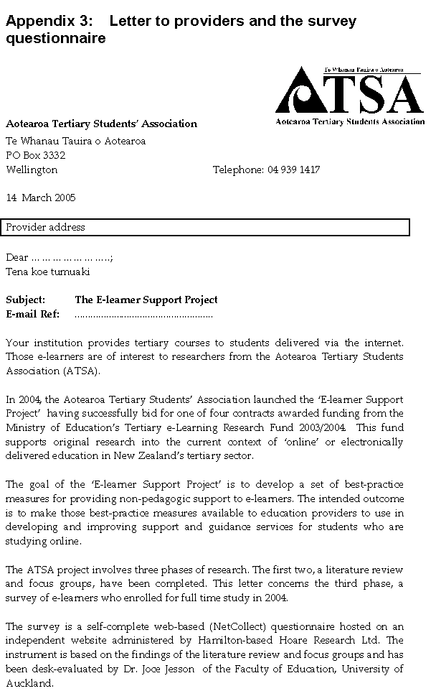
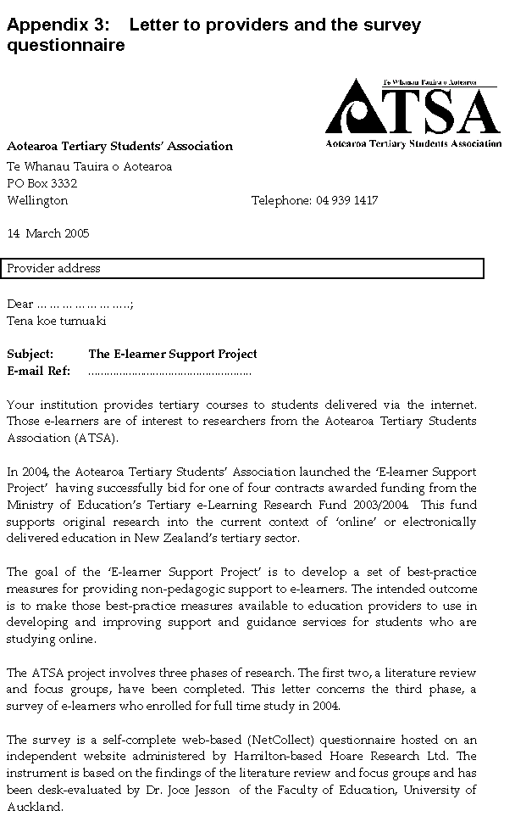
The research methodology ensures that the survey sample remains anonymous. At no time will the researchers have data that allows them to match individual students to the information they will provide in the web-based survey. These assurances of anonymity are included in the ‘invitation to participate’ e-mail letters (example copy attached), and are also summarised in the web-survey. The instrument can be viewed at: http://203.96.212.200/netcollect/elearnerd/content/elearner_1.htm

The survey sample has been randomly selected using National Student Number (NSN) identifiers contained in the April 2004 Single Data Return (SDR) provided to the researchers by the Ministry of Education. The ministry does not hold records of the contact details of students in the SDR. In total there are xxx students selected from [name of provider] in the sample.

Your institution has agreed to arrange delivery of e-mail invitations to the (XXX) University students in the sample. Because the research needs to match respondent data with the educational and demographic information contained in the SDR, each e-mail message is a personalised invitation that contains a unique ‘prize draw code’. This will ensure accurate matching of the survey and SDR data, but prevents a mass mail-out: each invitation needs to be e-mailed separately. Instructions to do this are contained in the enclosed CD-Rom. The disk also contains the individualised invitations, filed by NSN.

Should you require assurance of the authenticity and propriety of the survey proposed above, please contact the co-ordinator of the Tertiary e-Learning Research Fund, Dr Emma Madison (emma.madison@minedu.govt.nz; DDI: 04 463 8848). We hope that the support given to the project by Emma and her colleagues will provide further reason for you to extend co-operation and assistance to ATSA for the e-learner support survey.

More information about the ‘E-learner Support Project’ is readily available from the ATSA researchers, including the reports from phases one and two of the project. Please contact Jane Renwick or Stephen Owen if you require additional information.

We are very grateful for your willingness to assist us. Thank you.

Your sincerely
The E-learner Project Researchers
Jane Renwick research@atsa.org.nz
Stephen Owen atsa@atsa.org.nz

Attached: Example of ‘Invitation to participate’ e-mail message
Enclosed: CD Rom: ELP [provider name]. Survey instructions & sample.

Appendix 4: Bibliography

Barefoot, Betsy O. (2003). Higher Education’s Revolving Door: Confronting the Problem of Student Dropout in US Colleges and Universities. Paper presented at The Retention Symposium sponsored by ‘Open Learning’ and the Open University, UK. May 2003.

Benke, Meg (2003). Student satisfaction begins before class starts. Sloan C-View.
http://www.aln.org/publications/view/v2n5/coverv2n5.htm:(3 August 2004).

Bozarth, Jane, Diane D. Chapman & Laura La Monica (2004).Preparing for Distance Learning: Designing An Online Student Orientation Course. Educational Technology & Society, 7 (1), 87-106: http://ifets.(XXX).ac.nz/periodical/7_1/index.html (15 September 2004).

Brooks, Lori (2003). How the attitude of instructors, students, course administrators and course designers affects the quality of an online learning environment. Online Journal of Distance Learning Administration, Vol. 7, No 4.

Bruso, Jackie L. (2001). A comprehensive orientation to address diverse student needs. In Christine Dalziel & Michele Payne (Eds) Quality enhancing practices in distance education. Volume Two: Student Services. pp. 8-18. Instructional Telecommunications Council. www.itcnetwork.org. ( 15 September 2004).

Buchanan, Elizabeth A. (1999). Assessment measures pre-tests for successful distance teaching and learning? Online Journal of Distance Learning Administration, Vol. 2, No. 4.

Carnwell, Ros, Neil Moreland & Ruth Helm (2001). Co-opting learners. Addressing their learning support needs through a learning support needs questionnaire. Part two: a comparison of the learning support needs of campus and distance-based community nurse student. Research in Post-Compulsory Education, Vol. 6 No. 1, pp. 51-66.

Distance Learning Policy Laboratory (2002). Anytime, anyplace services for the 21st century student. Source:http://www.electroniccampus.org/policylab/Reports/Student%20services%20Final%20 31.02%20USE.pdf. Accessed: 15 April 2004

Hamada, Tomoko & Kathleen Scott (2000). Anthropology and international education via the internet: Collaborative Learning Model. The Journal of Electronic Publishing. Vol 6, No.1.

Hooke, Julie (1999). Distance education. The perils of the virtual student in hyperspace. The Journal of Electronic Publishing, Vol. 5, No.1.

Learning On-Line Conference: Association of Staff in Tertiary Education (2004), Wellington, New Zealand.

McCracken, Holly (2004). Extending virtual access. Promoting engagement and retention through integrated support systems. Online Journal of Distance Learning Administration, Vol.7, No.1

Magel, Simha R. & Levenburg, Nancy (2005). Using importance-performance analysis to evaluate e-business strategies among small businesses. Proceedings of the 38th Hawaii International Conference on System Sciences.

Martilla, john A & James, John C. (1977). Importance-performance analysis. Journal of Marketing, January 1977. pp. 77-79.

Ministry of Education (2004). Interim Tertiary e-Learning Framework. Wellington.

Ministry of Education (2004b). Introduction of a performance element to tertiary education funding. Report of the Technical Working Group. Wellington.

Murray, Bridget (10 December 2001). What makes students stay? eLearn Magazine. Source: http://www. eleanmag.org subpage/sub_page.cfm?article_pl=1301 &page_number_nb=1&title=FEATURE% 20STORY. (15 February 2004)

New Zealand Government (2002). Tertiary education Strategy, 2002-2007. Wellington.

New Zealand Government (2002). Highways and Pathways. Exploring New Zealand’s e-learning opportunities. The report of the e-learning advisory group. Wellington.

New Zealand government (2005). Statement of tertiary education priorities, 2006-2007. Wellington.

Yoni, Ryan (2001). The provision of support services online. In Glen Farrell (Ed.) The changing faces of virtual education, pp. 71-94. The Commonwealth of Learning. http://www.col.org/virtualed2pdfs/v2.chapter5.pdf. (15 February 2004).

Teaching Matters Forum (2005). Teaching for learning: proposals for a national centre for tertiary teaching excellence. Discussion document. Wellington.

