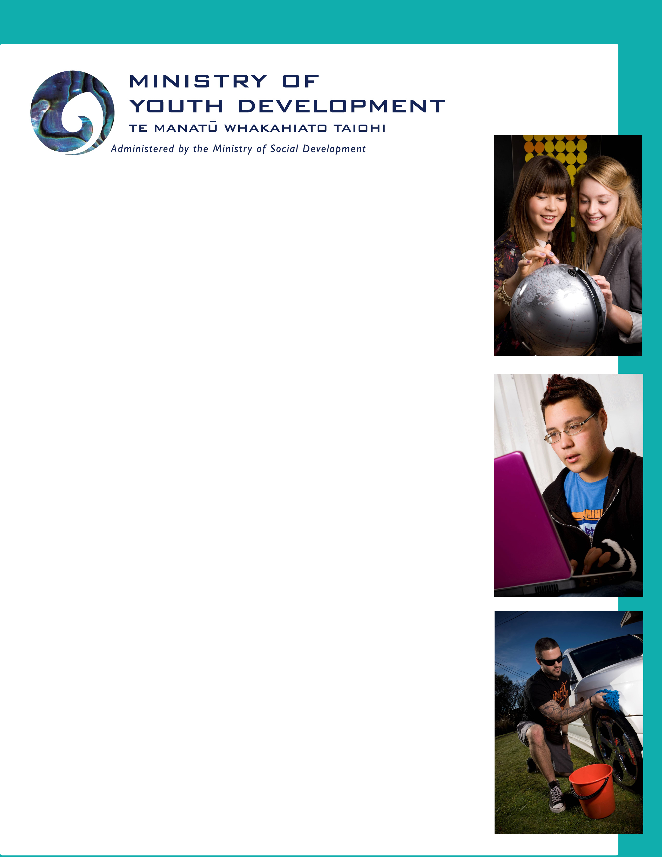

What’s important to Rangatahi Māori?

Results of a survey of Waikato Rangatahi Māori

by the Ministry of Youth Development for Te Puni Kokiri

September 2010

Executive Summary

Young people taking part in a Māori Youth Summit in Hamilton in September 2010 were invited to respond to a set of questions about what’s important for young Maori right now. This survey was part of a wider consultation that the Ministry of Youth Development is carrying out with young people across New Zealand to find out what is on young people’s minds, and what the big issues for young people are.
Six questions were asked:
- What is most important to you in your life right now?
- Is there anything that causes you to worry or be anxious?
- What do you think the big issue is for young people at present?
- If you were Prime Minister what would you do to make NZ a better place?
- If you had a chance to talk to someone who is a leader, who would it be?
- How important is it for you to know your whakapapa, tikanga and te reo?

Fifty one young people aged 15 -22 filled out the survey. There were more females than males in the group (30 females, 21 males).

For rangatahi Maori, the most important thing in their lives is “whanau”. Whanau is not only their strength and support, but also the main source of anxiety. A high proportion said they worry about the health and wellbeing of their families, especially when they are away from home.

“Alcohol” and “drugs” are seen as the big issue for young people at present. Females in this group also identified “low self esteem” and “lack of support” as a particular issue for young Maori.

If they were Prime Minister, this group of rangatahi Maori say they would focus on young people a lot more and give them more opportunities –“not limit them”. They would also do more to bring Maori perspectives to government and New Zealand in general, by having more Maori in Cabinet and making te reo Maori compulsory in schools.

The leader they would most like the chance to talk to is Barack Obama. But as many say that their mothers and fathers are the people they look up to most.

Findings from the Survey

Q1: What is the most important thing in your life right now?

Overwhelmingly, rangatahi Maori said that “whanau” was the most important thing in their lives. This finding corresponds with the responses from the general survey of young New Zealanders. Like their peers from the wider population, rangatahi Maori put family first, then their education, then friends.

 | Total | Male |  | Female
 |  | 12 -15 | 16 - 20 | 12 - 15 | 16 - 20
Whanau | 41 | 3 | 10 | 9 | 19
Education/passing exams | 21 | 2 | 4 | 5 | 10
Friends | 11 | 1 |  | 4 | 6
Sport | 8 | 1 | 2 | 3 | 2
Maoritanga/kapahaka; hapu/iwi | 5 |  | 3 | 1 | 1
Job | 4 |  | 2 |  | 2
Having fun | 2 |  | 1 |  | 1
Me /young people | 2 | 1 | 1
Partner | 1 |  | 1
Facebook | 1 |  |  |  | 1
Money | 1 |  |  |  | 1
My phone | 1 |  |  | 1

“Toku whanau!”

“Whanau – just ensuring that they are safe and happy”

“The most important thing in my life is my family – without them I would be nothing”

“Achieving my NCEA, being able to succeed”

“Getting that piece of paper saying that I have an education”

“Whanau, friends, my job”

“Family, friends, sport, education”

“My family and getting my qualifications for University next year”

“Family, and making something of myself”

“Having fun and learning”

“Friends, social life, family and Facebook”
Q 2: Can you think of anything that causes you to worry or be anxious?

“Whanau” is both the source of support and the cause of anxiety for rangatahi Maori. The young people in this survey expressed a range of concerns – from fear of losing touch with family who had moved overseas, to worrying about the health of elderly grandparents, to not being able to keep an eye on family once they left for university or a job. The fact that more females than males responded to this survey emphasised this concern: young women are more likely to feel anxious about family than young men. Young males are less likely to be worried about anything – a trend that is seen among the wider youth population.

 | Total | Male |  | Female
 |  | 12 -15 | 16 - 20 | 12 -15 | 16 - 20
Whanau | 17 | 1 | 2 | 3 | 11
Not getting it right; no support, not succeeding | 7 |  |  | 1 | 6
Education/exams | 4 | 1 | 1 | 2
Health | 4 | 1 | 3
Public speaking | 3 |  |  | 2 | 1
Loss of Te Reo Maori | 3 |  | 1 |  | 2
Money | 2 |  | 1 |  | 1
Stress/ too many things on | 2 |  |  |  | 2
When something happens | 2 | 1 | 1
Having a baby soon | 1 |  | 1
Transport | 1 |  |  |  | 1
Peer pressure | 1 |  |  |  | 1
New places, people | 1 |  | 1
Speed of change/ what lies ahead | 1 |  | 1
Can’t find phone or friends | 1 |  |  | 1
Heights | 1 | 1
Summit follow up | 1 |  | 1
Safety | 1 |  |  | 1
Next generation | 1 |  |  |  | 1
No/Can’t think of anything | 7 | 2 | 3 | 2

“The health of my grandparents”

“I’m always curious of my family’s safety when I’m not around them. When there’s storms or so I always worry and want to know if they’re alright”

“…..when my elders pass, that I haven’t learnt everything I know to keep my family how it is”

“Not staying in contact with whanau overseas”

“Having to do public speaking, shaming myself in front of people I don’t know”

“Not having enough encouragement and support to do anything”

“The development of society today. How change is occurring every second of your life . . . the expectation of what lies ahead”

“Too much responsibility at one time . . . training, school work, exams, peer pressure”

“That our language will maybe die out and be swept underneath the carpet”

Q 3: What do you think the big issue is for young people in New Zealand at present?

“Alcohol” and “drugs” are the big issues for young people according to rangatahi Maori. They agree with the wider youth population on this. For young Maori women however, there is another equally important issue: low self esteem and the lack of support and positive role models available to young Maori. This is an issue that hasn’t come up at this point among the wider youth population.

 | Total | Male |  | Female
 |  | 12-15 | 16- 20 | 12-15 | 16 - 20
Drugs | 16 | 2 | 9 | 2 | 3
Alcohol | 16 | 4 | 6 | 3 | 3
Lack of role models or support/ low self esteem | 7 |  | 1 | 2 | 4
Violence | 6 |  | 2 | 1 | 3
Gang affiliation | 6 |  | 3 |  | 3
Leaving kura without NCEA | 6 | 1 | 1 | 2 | 2
No motivation, | 6 |  |  | 1 | 5
Who you’re hanging out with | 3 |  | 1 | 1 | 1
Peer pressure | 3 | 1 |  |  | 2
Staying on the right track | 2 |  | 1 |  | 1
Deciding on goals in life | 1 |  | 1
Growing up | 1 | 1
Media influence | 1 |  |  |  | 1
Child abuse | 1 |  |  |  | 1
Smoking | 1 | 1
Pregnancy | 1 |  | 1
Graffiti | 1 |  |  | 1
Nothing to do | 1 |  |  |  | 1
Crime/stealing | 1 |  |  | 1
Being disconnected | 1 |  | 1
Return of Maori language and knowledge | 1 |  |  |  | 1

“Nga mahi tukino penei i te inu waipiro me te mahi tarukino”

“I feel that young people in New Zealand are not achieving NCEA levels 1 and 2 and are just leaving kura without it”

“Low self esteem - causes young people like us to do things we later regret”

“I think the biggest issue is our Maori rangatahi taking the easy way in life and not aiming for the top”

“For Maori, it’s the crowd you’re hanging with”

“Staying on the right track – drugs, education, sport, behaviour “

“Peer pressure . . wanting to be cool”

“Rangatahi not knowing what to do because they don’t have the right people to talk to them”

“Not having enough support to back them up when times get rough”

Q 4: If you were Prime Minister, what is the one thing you would do to make New Zealand a better place to live?

Rangatahi Maori would put a lot of focus on giving young people more opportunities, extending their horizons and providing more jobs and training. They would also do more to assure equality between Maori and non Maori – restoring Maori rights, and bringing a much stronger Maori perspective to Aotearoa through greater use of the Maori language.

They are concerned about improving people’s standard of living, with lower prices for food, warmer houses and lower taxes.

They would make Parliament a more co-operative place and would do what they could to change social attitudes and lessen racism.

Q 4: If you were Prime Minister, what is the one thing you would do to make New Zealand a better place to live?

 | Total | Male |  | Female
 |  | 12 -15 | 16 - 20 | 12 -15 | 16 - 20
Focus on rangatahi, more opportunities | 8 | 1 | 1 | 3 | 3
Bring a Maori perspective/ restore Maori rights/more Maori in Govt | 7 |  | 3 | 1 | 3
Lower GST/ taxes | 4 | 1 | 2 |  | 1
Help people have better standard of living | 4 | 1 | 2 |  | 1
More jobs, skills training | 4 | 1 | 2 |  | 1
Make Te Reo Maori compulsory | 3 |  |  |  | 3
Attend to Maori /Tainui issues | 3 |  | 1 |  | 2
Change social attitudes/racism | 2 | 1 |  |  | 1
Lower the price of food | 1 |  |  |  | 1
Ask Tamariki what would keep them out of trouble | 1 |  |  |  | 1
More youth centres | 1 |  |  |  | 1
Add extra subjects into curriculum: e.g.voting | 1 |  | 1
Get people reconnected | 1 |  | 1
Make Parliament more co-operative | 1 |  |  |  | 1
Work on preventing gangs | 1 |  | 1
Have fewer rules and regulations | 1 |  | 1
Raise driving age | 1 |  | 1
Protect our river from pollution | 1 |  |  | 1
More allowances for large families | 1 | 1
Safe warm houses for everyone | 1 |  |  | 1
Get involved and learn from other cultures | 1 |  |  |  | 1
Don’t know | 8 | 4 | 1 | 1 | 2

“Give young people more opportunities. Don’t limit them.”

“Bring Maori perspectives into the whole of Aotearoa’s economy; eg Maori place names compulsory and Maori compulsory in high schools”

“More youth centres, not only for troubled rangatahi but for all rangatahi, Pacific and Maori “

“Add extra subjects to the curriculum e.g. Voting. So that rangatahi are educated in it and will be able to vote”

“Have more jobs for rangatahi, no matter what ethnic group they’re from”

“Give Maori the opportunity that the Pakeha have, and what they deserve”

“Help other people and stop the racism”

“Provide everyone with the basic essentials”

“Working on our youth and making them happier. Giving them a more positive frame of mind”

“I guess just involving myself in more cultural events activities etc just so you can earn trust from other types of religions”

“I would make more equal rights between Maori and Pakeha as well as other ethnicities in our country”

Q 5: If you had a chance to talk to somebody who is a leader, who would it be?

Rangatahi chose leaders from home and abroad, from politics, sport and the media. However many also nominated their own parents or grandparents as leaders in their eyes.

Barack Obama (6)
Mum and/or Dad (6)
Tukuorangi Morgan (3)
Kingi Tuheitia (3)
Nanaia Mahuta (3)
Oprah Winfrey (2)
Nelson Mandela (2)
Nanna / Granddad (2)
Tariana Turia
Julian Wilcox
Pita Sharples
My uncle
Tiger Woods
Shelley Boyes
Mina Whare
Te Sir Robert Mahuta
Puea Herangi
John Key
Jarryd Hayne and NRL leaders
Tupac
Leon Wharekura
Malcolm X
Donnie Yen
Michael Jordan

Everyone is a leader – Don’t have to be famous
Someone Maori who’s successful and made it
Someone who leads with ferocity and knows where he’s from
A sportsperson
Our own rangatahi leaders
Someone in Tainui who has struggled to grasp Maori culture as I have
People from the Army or Navy
Someone from Maori Parliament

Q 6: How important is it for you to know your whakapapa, tikanga and te reo?

1 (Not important) | 2 | 3 | 4 | 5 (Very important)
 |  | 4 | 9 | 32

Appendix

In July/August 2010, MYD commissioned the research firm NRB to carry out a telephone survey of 1000 young New Zealanders aged 12 – 24. The survey aimed to find out what mattered to this cohort of young people – what was important to them personally, what they saw as the big issues for young people generally, and what they would do to make New Zealand a better place to live. A summary of the results is included below. MYD’s intention is to use this survey as the starting point for consultation with different groups of young people around the country. The findings from the survey will be shared with policy makers in central and local government.

What matters to young New Zealanders?

Findings from a survey of 1000 young people in July/August 2010

Question 1: What is most important to you in your life right now?
 | Total | 12-15 | 16-19 | 20-24
 | %* | % | % | %
My family | 45.3 | 53.3 | 42.4 | 40.4
My education | 42.2 | 42.0 | 53.1 | 32.8
My friends | 28.9 | 38.4 | 33.5 | 16.2
My job/work | 9.4 | 0.5 | 7.2 | 19.5
Sport | 8.7 | 17.4 | 7.3 | 1.9
Finding a job | 7.9 | 1.8 | 7.1 | 14.1
My social life | 4.6 | 3.8 | 6.4 | 3.8
Money | 4.3 | 0.6 | 4.0 | 8.1
My interests | 3.6 | 5.0 | 1.8 | 3.8
Being fit | 2.7 | 1.5 | 2.1 | 4.4

Question 2: What if anything causes you to worry or be anxious?

 | Total | 12-15 | 16-19 | 20-24
 | % | % | % | %
Passing exams | 18.2 | 20.9 | 25.0 | 9.8
Lack of money | 12.9 | 1.2 | 9.2 | 26.9
My family | 8.0 | 7.0 | 7.7 | 9.2
Personal issues | 7.0 | 6.6 | 7.3 | 7.1
Crime | 5.8 | 4.9 | 3.3 | 8.9
Getting a job | 5.5 | 1.1 | 5.7 | 9.5
Homework | 5.3 | 9.8 | 4.4 | 2.0
My friends | 3.9 | 3.3 | 6.0 | 2.6
My work | 3.6 | 0.0 | 2.4 | 8.0
The future | 3.2 | 1.9 | 4.8 | 3.0
Nothing | 22.0 | 32.4 | 19.1 | 14.9

Question 3: What do you think is the big issue for young people at present?

 | Total | 12-15 | 16-19 | 20-24
 | % | % | % | %
Teen drinking | 27.5 | 14.3 | 39.2 | 29.5
Drugs | 14.1 | 12.0 | 19.3 | 11.5
Unemployment | 13.6 | 2.0 | 10.0 | 27.4
Education | 10.7 | 12.7 | 12.2 | 7.6
Social life | 9.5 | 11.2 | 11.5 | 6.1
Peer pressure | 9.0 | 13.7 | 11.1 | 3.0
Girls/boys/dating | 6.4 | 10.7 | 4.6 | 4.0
Money | 6.4 | 0.9 | 1.8 | 15.4
Driving/speeding | 5.1 | 3.8 | 5.4 | 6.0
Sports | 4.9 | 10.4 | 2.1 | 2.3

Question 4: If you were Prime Minister, what is the one thing you would do to make living in NZ better than it is now?

 | Total | 12-15 | 16-19 | 20-24
 | % | % | % | %
Provide free education | 7.8 | 2.3 | 6.9 | 13.8
Create more jobs | 7.7 | 4.6 | 7.2 | 10.8
Address underage drinking | 7.3 | 7.6 | 8.4 | 6.0
Improve the education system | 7.0 | 8.6 | 6.5 | 5.8
Cut taxes | 6.8 | 5.5 | 6.3 | 8.4
Support low income families | 5.4 | 4.8 | 5.1 | 6.3
Address young people’s driving | 4.6 | 5.2 | 5.9 | 2.8
Increase wages | 4.4 | 1.7 | 5.2 | 6.1
Protect the environment | 4.3 | 6.7 | 5.4 | 1.2
Address crime | 4.2 | 5.5 | 4.8 | 2.4

