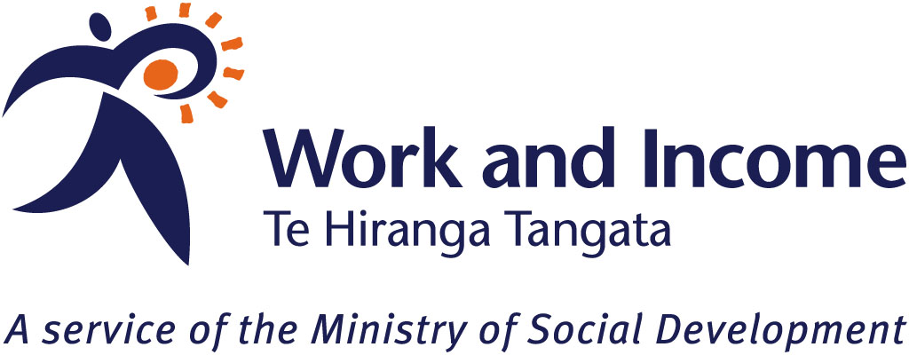

Auckland Youth and Employment
Introduction
Youth unemployment is a priority area for Government. In light of the growing concerns for young people’s wellbeing in this current economic climate, the Ministry of Youth Development and Work and Income conducted a project to explore young people’s perspectives on what they think young people need to ensure they are best placed to find employment. The final report provided young people’s views on the kinds of skills and support they need to find employment. This is a summary of what young people said.
Skills young people need to find employment
The types of skills young people think they need to find employment are closely linked to the difficulties they face when trying to find employment. The key skills young people view they need, and why, are:
- communication and listening skills – it was considered vital to be able to express oneself, in both written and oral contexts
- experience – this is often required when applying for a job, which was difficult for young people as, by virtue of their age, opportunities to gain experience were limited - “no experience to get a job to get experience”. It was suggested that in-programme job-training would help overcome this
- qualifications and training – participants acknowledged the importance of being able to show potential employers that they have the qualifications and the training “so that the employer doesn’t have to train you”
- the “right attitude” – participants expressed that having a positive attitude, working hard, being motivated and committed are needed to find a job and sustain it
- team work and leadership skills – working well with others, as well as knowing how to motivate and take charge were also key skills to have.
Other types of skills young people would also like to learn are a mix of both soft skills (such as, punctuality, managerial skills, and customer service skills) and trade skills (such as, how to use tools and machines, drive vehicles and forklifts, and computer skills).
Support young people need to find employment
The types of support young people view they need to find employment is also closely linked with the difficulties young people face, and range from personal support to government support.
This includes support from their family and friends, such as encouragement to help them build the confidence they need to pursue jobs and training opportunities.
They also felt a need for more government support in the areas of transport and the dissemination of information. In regards to the latter, participants expressed concern that while there were many existing services and support mechanisms for young people, the majority of young people are unaware of them. It was suggested that more visual and verbal marketing would be more effective than the flyers and brochures which hang around and go unread.

