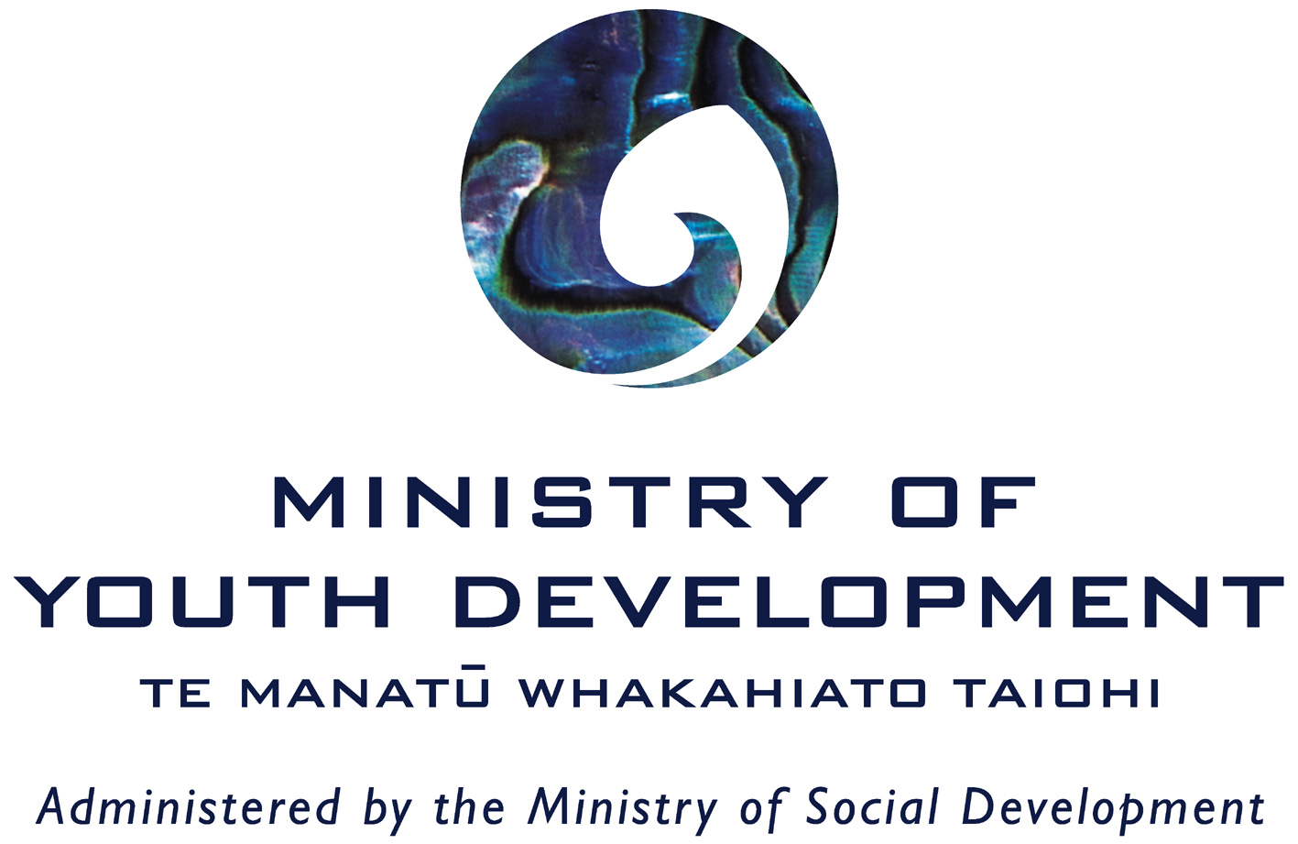

The Youth Participation Videos DVD profiles youth participation projects from around New Zealand that have been supported by the Ministry of Youth Development (MYD). This resource provides you with a summary of each project and the linkages to good youth participation practice, as outlined in the Ministry of Youth Development publication Keepin’ It Real. To download a copy of Keepin’ It Real go to our website – www.myd.govt.nz.

If you have any questions about the DVD or have any feedback, please call the Ministry of Youth Development on 0508 FOR MYD (0508 367 693) or email info@myd.govt.nz.

Franklin District Youth Advisory Board (8min 32sec)

The Franklin District Youth Advisory Board took a leadership role in redeveloping a former recycling station into a park for the whole community. Through a process of community consultation, including holding an open day on the site, a door to door survey of local residents and the production of a scale model for the proposed park, the Youth Advisory Board ensured that the community was engaged and had ownership over the redeveloped park.

As young people themselves, the Board members were able to ensure that the result was a park with amenities for all ages, including a flying fox, swing sets, a playground, barbeque areas, all with the underlying theme of sustainability.

At the beginning of the project, negative stereotypes of young people existed in the district. As a result of the work of the Youth Advisory Board and the redevelopment of Samual Miller Reserve, the public perception of young people has changed. The Youth Advisory Board members gained skills by undertaking community consultation, understanding Council processes, learning formal meeting procedures and how to develop a business model. These are transferable skills that the Youth Advisory Board members can apply to their future careers.

LINK Crew – Wellington (6min 5sec)

LINK from Wellington Boys’ and Girls’ Institute (BGI), are a group of young people who meet fortnightly to talk about what it is like to be young in Wellington and to come up with projects and initiatives that make life for young people in Wellington even better.

LINK provides young people with the opportunity to be better connected to their community and their peers. By undertaking the Wellington Youth Survey, the group gained an understanding of what young people want for their community. The survey was designed and developed by young people, and they carried out the interviews.

The survey showed that young people didn’t have a great understanding of the things out there in the community for them. Through funding from the MYD Youth Development Partnership Fund, the LINK group was able to develop the wellbo poster that was provided to schools and educational facilities giving Wellington young people one place where they can go for any issues that they might have. LINK is one way for young people to have a voice and for them to gain skills and training, while having their voice heard and contributing to their community.

E Oho Youth Development Programme – Rotorua (6min 10sec)

E Oho (the awakening) is a project aimed to stir the minds of young people towards effective citizenship in their neighbourhood. Through the support of the Rotorua District Council and the MYD Youth Development Partnership Fund, the E Oho project builds the skills of young people to take on leadership roles and understand the importance of partnership when making positive change in their community.

The E Oho approach is to work with a small group of young people from several neighbourhoods in the Rotorua district, building their skills in community development. This resulted in a wide range of projects being developed by young people. An example of this is the clean up of hazardous buildings in Fordlands which improved the aesthetic look of the community but more importantly, gave people a sense of ownership in resolving issues within their community. Through fostering close links with the Council, E Oho members developed valuable skills enabling them to effectively participate in community decision making.

The young people made a powerful submission to the Council highlighting their concerns about their communities. As a result, the Council allocated $600,000 to the development of local parks and reserves so they become a focus of positive youth activities in the community to increase community safety and youth engagement.

This was a great experience for young people to recognise that as active citizens in their neighbourhood, it is possible to directly impact on local decision making and make a difference in their local community.

Stratford District Youth Council (8min 45sec)

The Stratford District Youth Council comprise a wide range of young people who meet twice a month to talk and plan activities for the young people of Stratford.

The group plays an important role in communicating positive messages to the community about local young people. The group created the Area 201 Youth Centre by renting out one of the empty shops on the main street, and created a welcoming space for youth by opening in the mornings and providing breakfasts to young people.

The Youth Council has championed the Get on the Bus project that happens four times each year providing a safe and supervised opportunity for people to get out and experience things together. The Youth Council members report they have acquired a range of skills through their involvement in the Youth Council. This includes learning formal meeting procedures, consultation skills and project planning so they can make a difference in their local community.

Otara Youth Collective (8min 35sec)

The Otara community identified that there was no platform for young people to have a voice with local decisions often being made without input from young people. The Otara Youth Collective (OYC) was established to fill this need and comprises of 15 young people who come together to lift the image of young people in Otara.

The iChoose DVD project was developed to give young people the low down on what was available for young people in Otara. It is used by schools, libraries and other services to help young people in Otara understand what resources and supports are available to them. The iChoose DVD provides details of local youth friendly education, mental wellbeing, recreation and mentoring programmes and services.

Members are recruited at the annual Youth Week concert with existing members talking with the crowd to recruit potential members, and promoting the work of the OYC.

OYC members recommend that all communities look to engage young people in community decisions and report that their involvement in OYC has been life changing. Former OYC members have now moved onto jobs and are mentoring other young people to become actively engaged in the community.

Youth Participation linkages (p. 12 – 13 of Keepin It Real)

The Ministry of Youth Development’s Keepin It Real resource provides the full details on the steps you can take to prepare and plan for youth participation in your project. The table below highlights some examples from each of the DVD case studies. You can request a Keepin’ It Real workshop for your organisation by contacting the Ministry of Youth Development by email on info@myd.govt.nz or by calling toll-free on 0508 FOR MYD (0508 367 693).

Youth participation principle | Step 1:  Organisational Commitment | Step 2:  Create space for young people’s involvement | Step 3:  Create a youth friendly environment
Franklin District Youth Advisory | Franklin District Youth Advisory Board had good support from the Council with an allocated staff member to co-ordinate the project with adequate resources. They involved young people from the project planning stage through to letting them run consultations and writing media releases. | The Council created a space for young people's involvement by acknowledging young people’s values and the benefits of youth participation. | The Council invested a lot of time in developing the Youth Advisory Board and providing them with information and allowing them to be part of the decision making process. The Ministry of Youth Development worked alongside the Youth Advisory Board and provided them with youth participation training and support with presentations to Council. The young people have developed skills in project planning, report writing, media training, consultation, fundraising and other competencies through their involvement.
LINK Crew | LINK identified an opportunity to consult with young people in Wellington and with support and guidance from BGI staff who are well resourced and experienced youth participation practioners. | The group were provided with the opportunity to meet and work with other agencies enabling the survey to be distributed widely ensuring a diverse range of young people were able to participate in the process and planning. | The group have been involved from the start to the end of the survey project and been provided with further developmental opportunities in their communities. LINK continues to play a key role in BGI and young people are supported with ongoing training and development opportunities.
E Oho Youth Development Programme | The agencies working to support the E Oho project ensured a solid foundation for good youth participation by allocating adequate staff and funding resources to the project with funding support from the MYD Youth Development Partnership Fund. | The project provided young people with information and training to effectively establish priorities and accessible youth participation opportunities for them. | In acknowledging the skills of the young people and understanding their personal development needs, staff were able to fully prepare and develop young people towards being involved in influencing decision making processes.
Stratford District Youth Council | Through Council provision of a dedicated youth coordinator and an allocated budget, the Youth Council were able to identify and address the needs of local young people through a number of initiatives with the knowledge that the Council values and supports them. | The Youth Council recruit their members annually. Part of this process includes an induction day covering the expectations and benefits for members, as well as a behind the scenes view into Council business. | The group meet twice each month and meet with the Mayor and other councillors to update them on their initiatives and ongoing developments in the Stratford District.
Otara Youth Collective | Otara Youth Collective (OYC) had organisational commitment from Otara Health Inc, the Department of Internal Affairs and MYD who supported youth participation through resourcing and training. The young people were offered clear roles and were involved in the development of the group’s objectives. Supportive adults ensured participation opportunities were accessible through events and funding. | The recruitment process for OYC members ensures a diverse range of young people are invited to be part of the group. In order to develop the DVD project, OYC was provided with information around Otara's youth priorities by the Council. This information provided the OYC with an informed base from which to develop the project concept, with more in-depth and focussed consultation with the community. | The community boards and key community stakeholders can see the value of working with OYC and the benefits for the local community. This has resulted in OYC being actively sought out to provide youth advice and support on a range of youth-related community initiatives.

