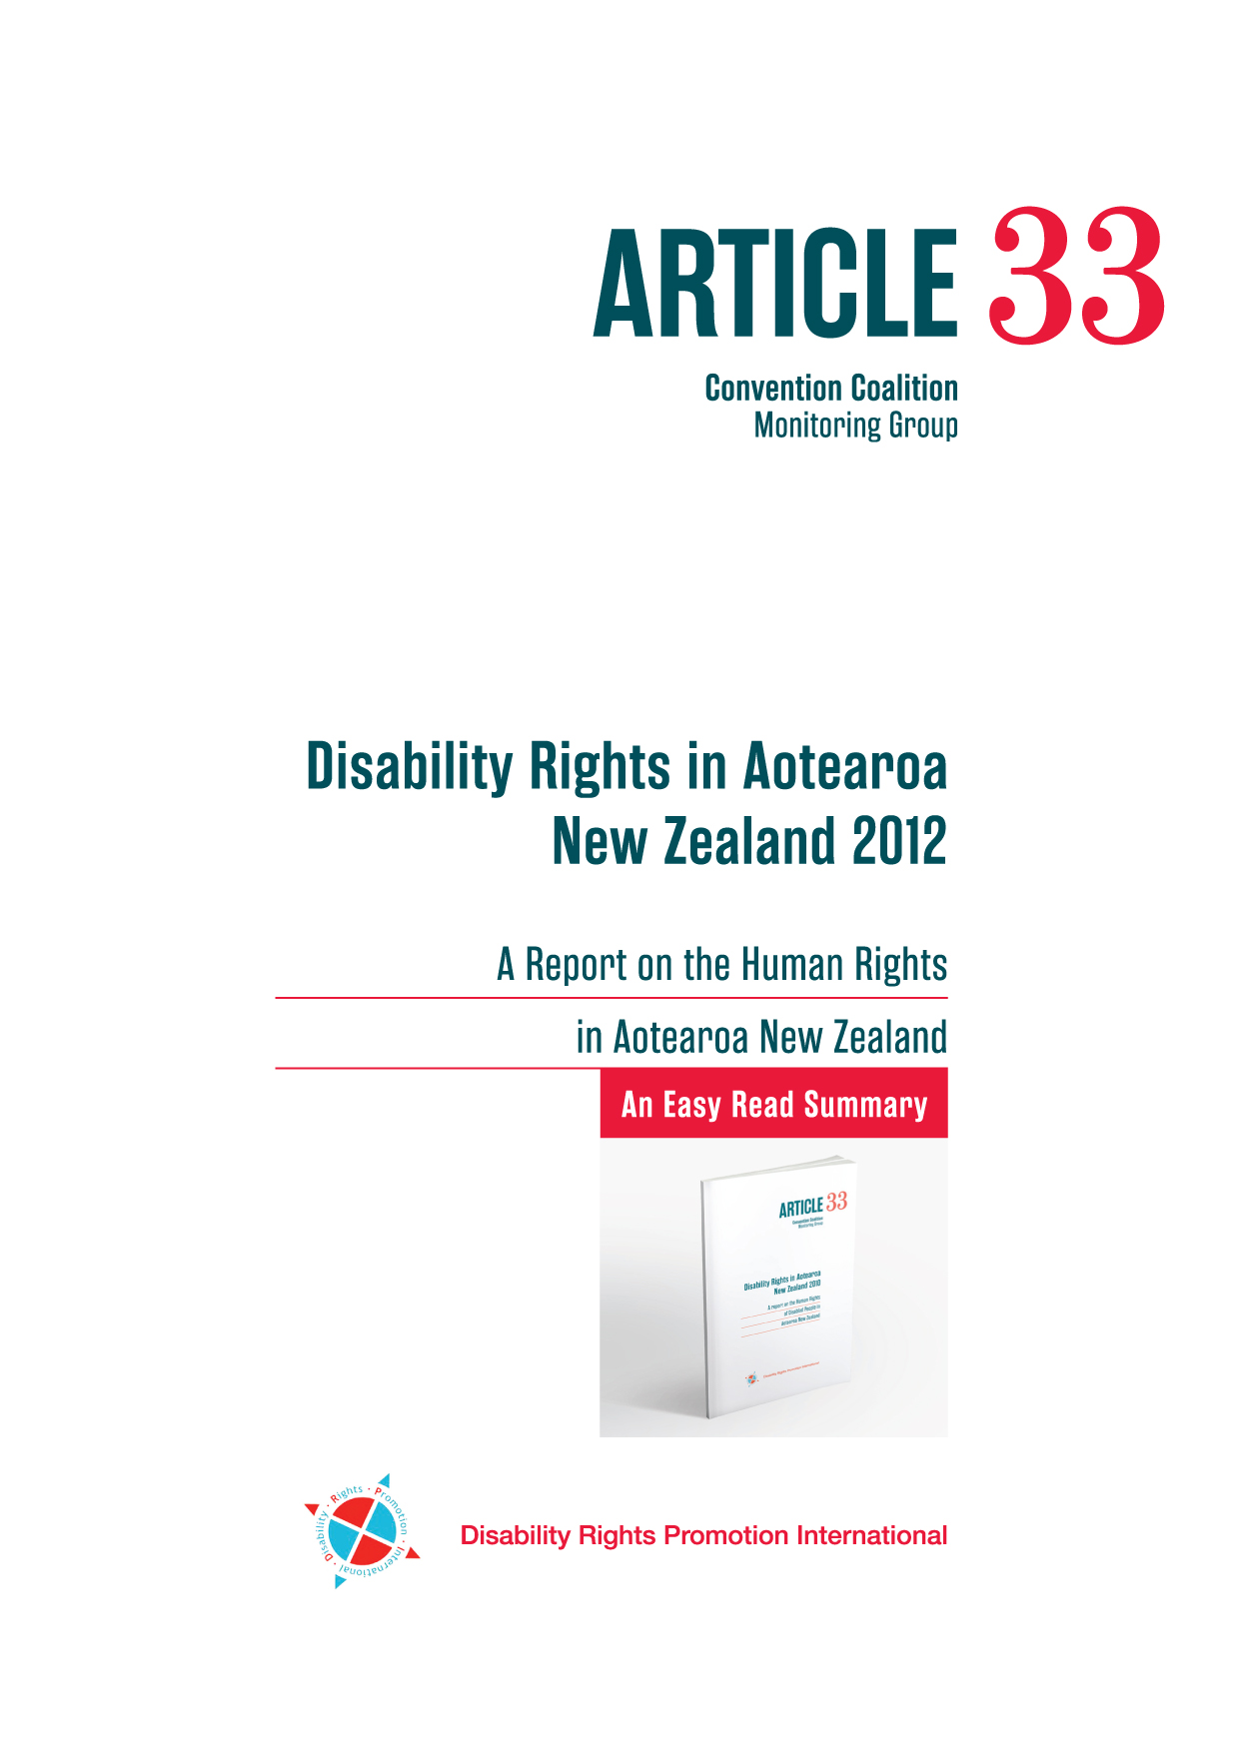
He mihi
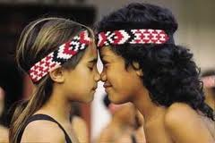

Karanga karanga karanga ra nau mai ki te ata hapara e kawea mai te rangi hou me maumahara tonu ki a raatou ma e moe nei i te moenga roa, moe mai moe mai moe mai ra.

Ka rere tonu ra nga kupu whakamihi ki teenaa ki teenaa ki teenaa o taatou ngaa ringa raupaa e tautoko kaha nei ki teenei kaupapa whakahirahira.

Ma te whakaaro ko te korero, ma te korero ko te waananga, ma te waanga ka tau mai te matauranga hei oranga ma tatou katoa.

Noo reira tena kautou tena kautou tena tatou katoa!

Do Disabled People Get Their Human Rights in New Zealand?
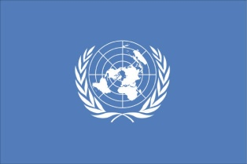
New Zealand has signed an international law called, The United Nations Conventions on the Rights of Persons with Disabilities.

Every four years New Zealand has to tell the United Nations if Disabled People in New Zealand get their Human Rights.

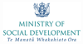
To help do this the Ministry of Social Development gave money to the UN Convention Coalition to do a project to find out if Disabled people get their Human Rights in New Zealand.


The UN Convention Coalition is made up of Disabled Peoples’ Organisations. The Coalition works together to make sure that Disabled people are fully included in society and valued equally.

The Disabled People’s Organisations are:
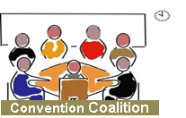
- Disabled Persons Assembly
- Blind Citizens New Zealand
- Balance New Zealand
- Deaf Aotearoa NZ
- DeafBlind (NZ) Incorporated
- Ngā Hau e Whā
- Ngāti Kāpo o Aotearoa Inc
- People First New Zealand Inc. Nga Tangata Tuatahi

Disability Rights in Aotearoa New Zealand 2012
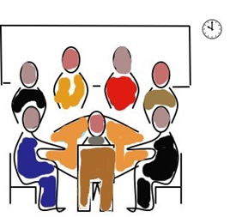
Convention Coalition
This report was made by the Convention Coalition to give advice and information about disability policy to the New Zealand Government.

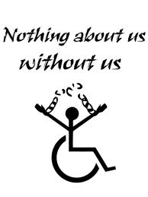
What is in this report will help the Government to work with Disabled people to develop policy that will make life better for Disabled people in New Zealand.
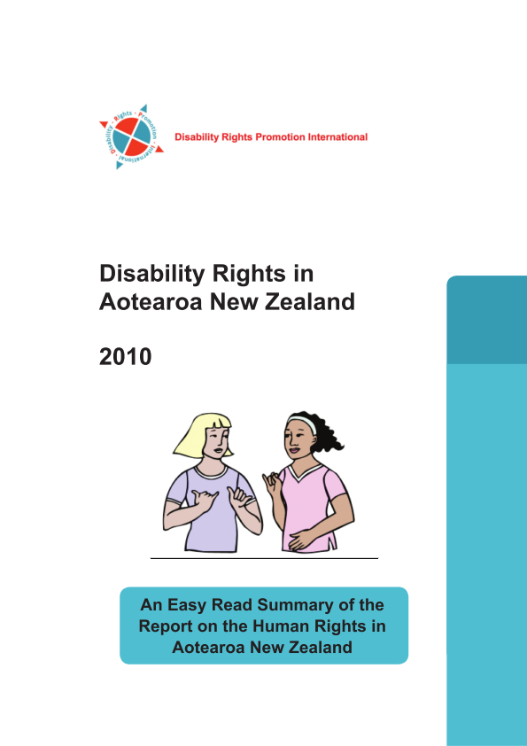
This report firstly talks about the last report the UN Convention Coalition did called Disability Rights in Aotearoa New Zealand 2010.

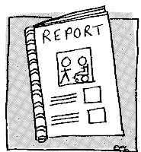
In this report Disabled people said they did not get their Human Rights in 6 main areas.

The 6 main areas that Disabled peope said they did not get their human rights are:

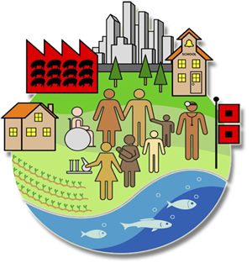
- Being included in the community.
- Getting good health services (doctors, dentists, hospitals).
- Finding a job.

- The way disability support services are run.

- Making complaints about employment and transport.
- People not understanding about Disabled people’s lives
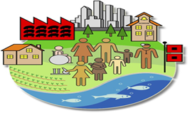
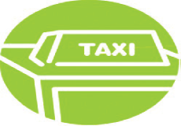
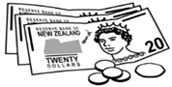
Disabled people said that the biggest issue was being included in the community. They said issues with transport, work, communication and support services made it harder to be included in the community.
Disability Rights in Aotearoa New Zealand 2012

In 2012 the UN Convention Coalition looked at the same 6 main areas and made a report.

The report says what the report writers found out when they looked at laws and how the laws are put into action.
The report also has
- what Disabled people said at meetings

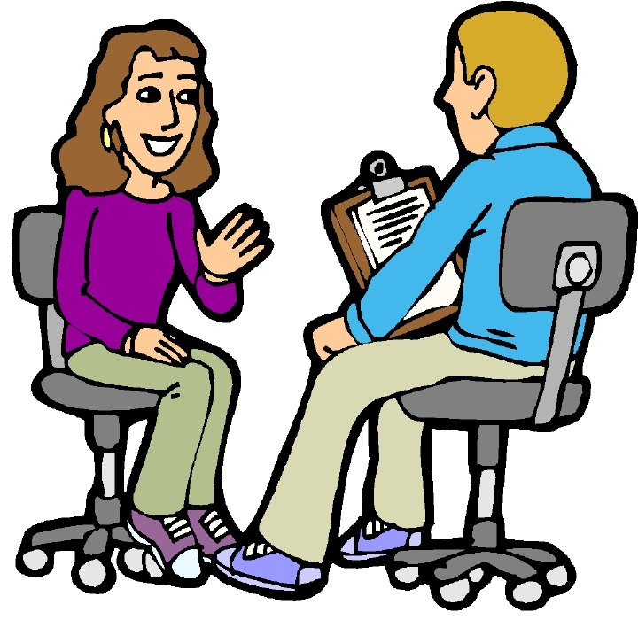
- what Disabled people and other people said in interviews

The main things in the report

Disabled people said that the biggest issue was being included in the community. Issues with transport, work, communication and support services made it harder to be included in the community.
Other things that were said are:
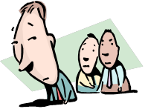
- being treated differently because you have a disability can make it harder to get what you want and need in a lot of ways
- not having a job is one of the things that makes it harder to be included in the community

- Not having a job can make it harder to get to health services

- not being able to get good health care can make it hard to speak up when things go wrong


When all of these things happen together they can make it hard for Disabled people to get what they want and need. It also makes it hard to be included in the community.

Other things that make it hard for Disabled people to be included in the community are:
:

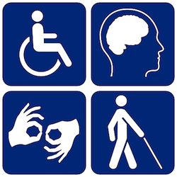
- the ways in which services are run

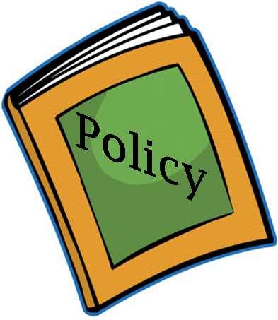
- laws and policies that do not include Disabled people

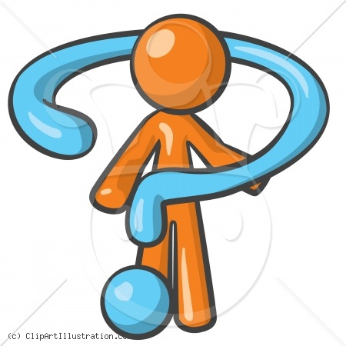
- bad communication, like having no Sign Language Interpreters or not having information in Easy Read or Braille.

- people making decisions for and about Disabled people without asking Disabled people what they want and need.
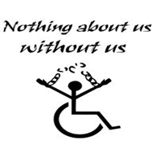

- people not understanding about Disabled peoples’ lives.

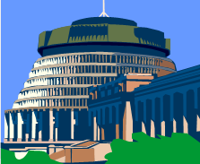
- Government departments having different plans when they should be working together to make life better for Disabled people.

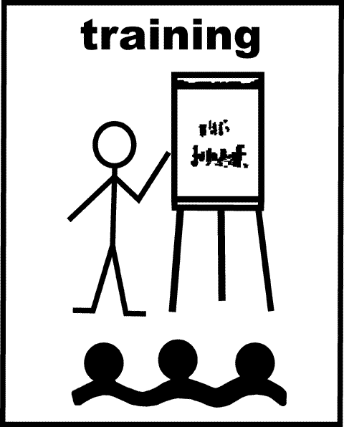
- Lots of people at the meetings said that staff should have good disability training. Training should be more than just disability awareness.

Disabled people said all of the Government needs to work with Disabled people through Disabled People’s Organisations (DPO’s).

Recommendations – the changes the
Convention Coalition wants made
:

The Convention Coalition wants changes made so that Disabled people get their Human Rights in New Zealand.

The government should work with Disabled Persons Organisations to:
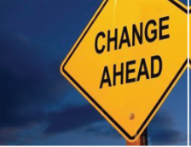
- make a plan to make sure that all the Rights in the United Nations Convention on the Rights of Persons with Disabilities (the Convention) happen in New Zealand

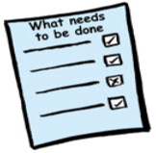
        - look at “reasonable accommodations” every four years, as well as looking at how the Convention is being used. “Reasonable accommodation” means changing things so that Disabled people are able to do the things what they want to
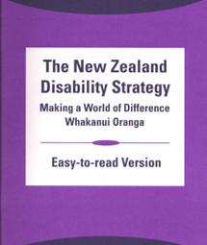
- make sure that the New Zealand Disability Strategy is up to date and works together with the Convention.

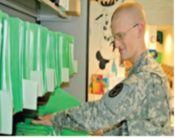
- get more information about the numbers of Disabled people and the things they do.

- sign up to the “Optional Protocol” of The Convention. This means that a person can complain to the United Nations if they do not get their rights.
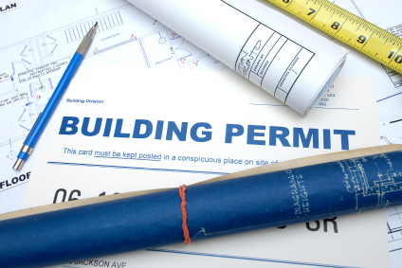
- make the Building Code better so that public buildings include things like hearing loops, visual alarms and ramps.

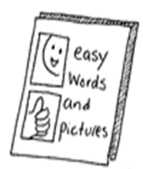
- make an easy system so that Disabled people can get the services they want and look after their own funding if they want to.

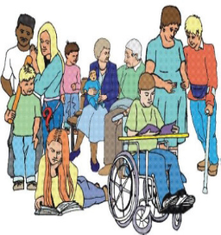
- make sure all disabled people are able to have their disability costs meet.


- look into having health information and labels for medications that are work for disabled people.

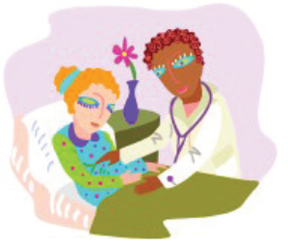
- look into workers who look after older people and Disabled people to make sure the trained workers get paid more than the workers who are not trained.

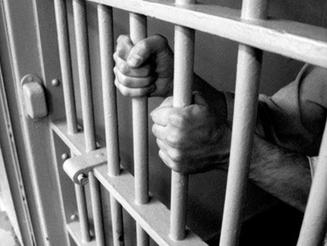
- stop putting people who have mental illness into prison like places.

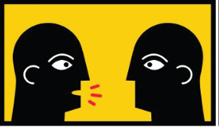
- say sorry to all Disabled people who lived in institutions for abuse or bad treatment that happened to them when they lived there.

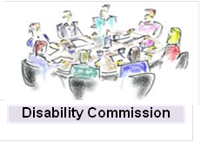
- set up a group to make sure that all the good ideas in the report : “To Have an Ordinary Life” and “Health Indicators for People with Intellectual Disabilities” happen.

- work with District Health Boards to make sure that Disabled people are treated well.

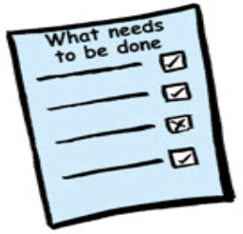
- make sure there is a plan to improve the health of people with learning disability. Have better training for all people working in health about disability,


- make sure all Disabled people and other people can get the medicine that they need.

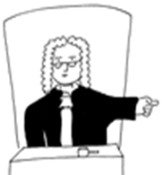
- look at all health and disability laws to make sure that they meet all human rights laws.


- make sure Disabled people getting divorce are able to keep the disability equipment they need which assists them to live.

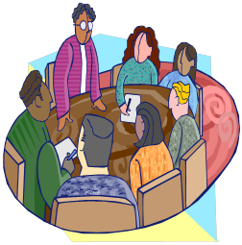
- make it easy for Disabled people to get all the services they need.

- look at all information and make sure that it works for all Disabled people.


- change the law so that the transport needs of Disabled people are part of all planning from the start.

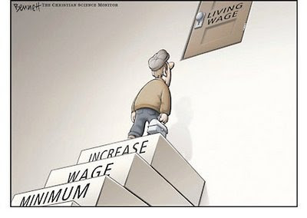
- take away the Minimum Wage Exemption Permit.

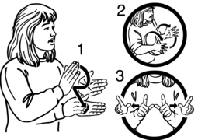
- make getting New Zealand Sign Language easier and make it work better for Deaf people.


- set up a Disability Commission and UN Convention to make sure all laws and policies are in line with the convention.

To get more copies of this report or the full version
People First New Zealand Inc – Nga Tangata Tuatahi
- 0800 20 60 70, 04 3813242

- Email: mail@peoplefirst.org.nz
- www.peoplefirst.org.nz

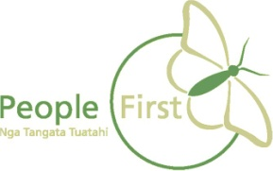

This information has been translated into Easy Read
by People First New Zealand Inc.


