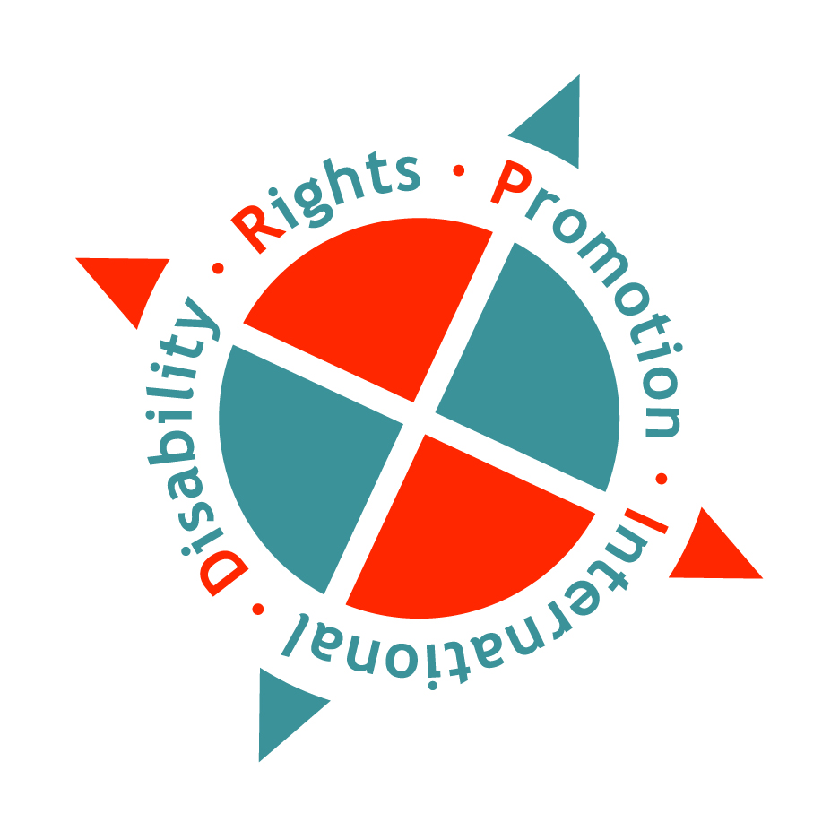

Disability Rights Promotion International

Disability Rights in
Aotearoa New Zealand

2010

An Easy Read summary of the Report
on the Human Rights in Aotearoa
New Zealand

Do Disabled People Get Their Human Rights in New Zealand?
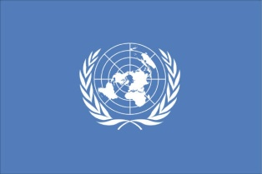
New Zealand has signed an international law called, The United Nations Conventions on the Rights of Persons with Disabilities.

Next year New Zealand has to tell the United Nations if Disabled People in New Zealand get their Human Rights.

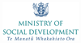
To help do this the Ministry of Social Development gave money to the Convention Coalition to do a project to find out if Disabled people get their Human Rights in New Zealand.
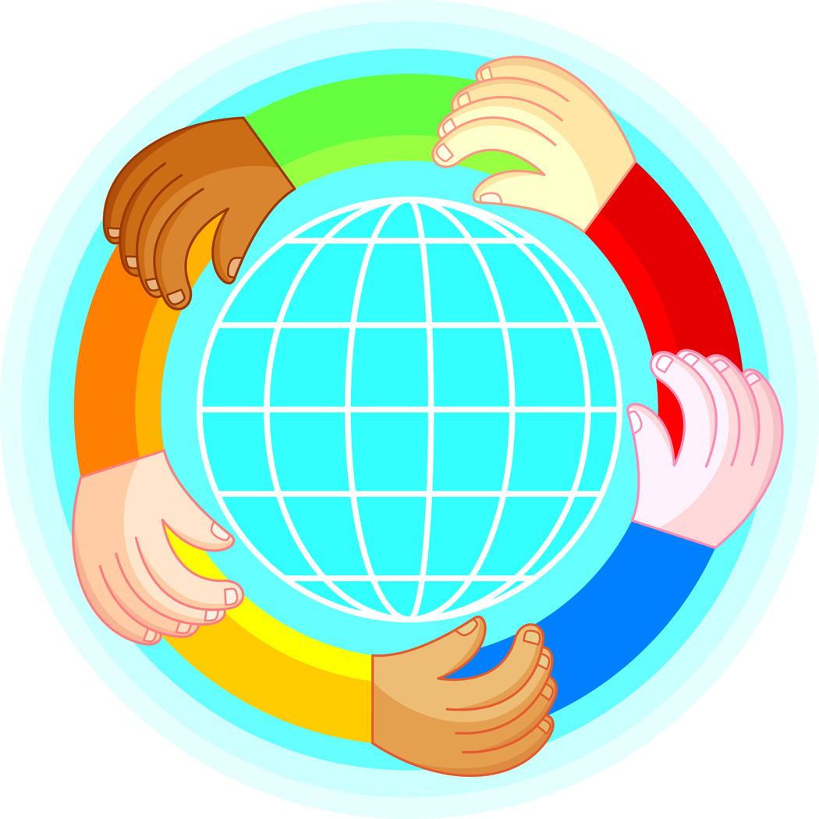
The Convention Coalition is made up of Disabled Peoples’ Organisations
The organisations are:
- Disabled Persons Assembly/ DPA
- Association of Blind Citizens
- Deaf Aotearoa
- Ngati Kapo
- Nga Hau E Wha
- People First New Zealand Inc. Nga Tangata Tuatahi
The project taught some Disabled people questions to ask other Disabled people to find out if they get their Human Rights
98 Disabled people were asked questions
40 were men and 58 were women
The Disabled people covered many different disabilities and many different cultures

The things the Disabled people said will be used to help:
- Disabled Peoples’ Organisations
- The government.
This report says:
- What Disabled people said
- What changes the Convention Coalition want.

Disabled people said they did not get their Human Rights in 6 main areas

The areas are:
- Being included in the community.
- Getting good health services (doctors, dentists, hospitals).
- Finding a job.
- The way disability support services are run.
- Making complaints about employment and transport.
- People not understanding about Disabled people’s lives

- Being included in the Community
This was the number one problem area that Disabled people talked about

- Getting out and about and being included in the community
Disabled people said to be included in communities you need:
- Accessible transport
- Friendships
- Social networks
- Being able to experience your culture.

A lot of Disabled people said that many non-disabled people:
- did not understand about Disabled people lives
- had bad attitudes towards Disabled people.
“I saw a guy when I was in the shop- I went down there. I knew him very well but he totally ignored me and he wouldn’t look at me. He saw me, he knew I was there but he wouldn’t acknowledge that I was there.”
- Moving around in the community
Disabled people said not having transport stops you having a social life.

Transport is:
- expensive
- not always available
and
- air travel can be very hard.

“I would say because I’m a wheelchair user, find access um, the biggest barrier, um into participating. That prevents me from participating fully, especially around travelling. If I need to go overseas airlines make it very difficult. Also my wheelchair gets damaged almost all the time travelling.”

Disabled people said It is hard to get meeting places and places to stay that work well.

“They don’t have a lot of wheelchair ramps; and if they do, they’re too small, the doors are too narrow.

- Communication and loneliness

Disabled people said that if it is hard to communicate it can get very lonely.

“My experience of being left out is very common as a deaf person, not just at school but pretty much everywhere. That’s the experience of being deaf, is not being able to participate as part of what’s going on around you.”

Disabled people also said that many non disabled people treat them differently.

“I used to get on the bus, and I would sit in the seat, and the bus might have been crowded, but no one sat next to me. Simply they would take one look and avoid sitting next to me. Which wasn’t so bad for me but I was always wondering why nobody was sitting next to me.”

- Getting good health services

This was the second biggest problem area that Disabled people talked about

It can be hard to find good carers.

“It’s hard too because the hourly rate for attendant carers is not very good and it is hard to attract decent and reliable attendant carers at the low rate.”

It is hard to get good health care.

“I’ve seen that happening to a lot of disabled. I’ve been like this for 36 years. I’ve been in Middlemore children’s spinal unit 6 years and I’ve seen a lot, a lot of human rights and deprivation and friends just die because there is no support.”

- Finding a job
It is known that Disabled people are good workers.

Many disabled people said:
- it is hard to find a job
- It is hard to get the right support for work.
Employers and co-workers do not understand about things that can help Disabled people in their work place or to do their job.

“There’s some people will look at me and think she looks fine- like there’s nothing (I won’t say the word)- nothing effing wrong with her- like why does she get the privilege of doing what she does- because some of the time I go in I do different duties. It might be just like paper work and things like that and you know- i suppose it might be looked upon as- she’s lucky, that’s all she’s doing but it’s not actually easy, it’s still physically demanding “you’re really lucky, or your- or those are good hours that you’ve got” sort of thing”.

- The running of disability support services
Disabled people said disability support systems must change to work better for Disabled people.

“Every time, or every year there’s a needs assessment and they’ll come and update the information and I- feels like I’m explaining the same information again and again and again.”

Disabled people said they often felt disability support services made decisions about them.

- Making complaints
All New Zealanders can take complaints to the Human Rights Commission. Sometimes Disabled people feel they cannot make complaints.

This happens in 3 areas:
- Work- this is because Disabled people are scared they might lose their job
- Transport - this is because Disabled people think nothing will change
- Support - This is because Disabled people are scared their support will be taken away
Also
Disabled people think many non-disabled people do not understand about the lives of Disabled people.

Disabled people think there should be a campaign like the “Like minds, like mine” TV campaign.

Recommendations – the changes the Convention Coalition wants made

The Convention Coalition wants changes made so that Disabled people do get their Human Rights in New Zealand.

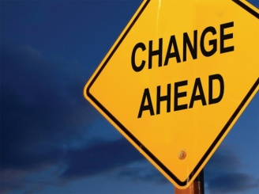
The changes the Convention Coalition wants are:

- That the government and Disabled Peoples’ Organisations work together to run a Disability awareness campaign to:

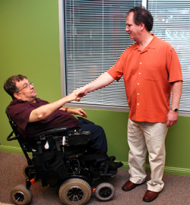
- teach people about including Disabled people
- teach people to treat Disabled people better
- give people more understanding about the what is hard for Disabled people and how to change things to make it easier for Disabled people.

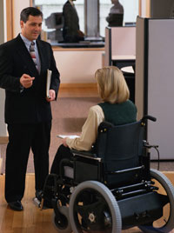
- That the New Zealand Government works with Disabled Peoples’ Organisations to find more out about the things that stop Disabled people doing the same things as non disabled New Zealanders.

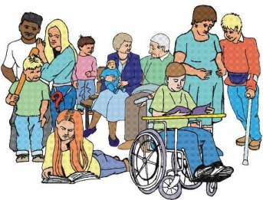
- That government departments and ministries have ways to see if Disabled people are getting their Human Rights.
And that the Disabled People Organisations and Disabled people are part of finding out if Disabled people are getting their Human Rights.

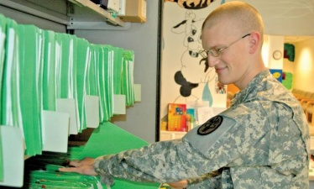
- That all people in New Zealand know about things that will help (accommodations) Disabled people and put them in place.

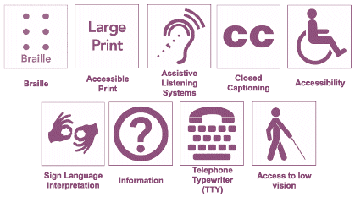
- That a symbol is made up and used to show which buildings, areas and things have been made or changed so that it is easy for Disabled people to use them.

To get a copy of the Easyread version of the United Nations Convention called the, International agreement on the rights of disabled people you can phone People First NZ Inc. on 0800 20 60 70

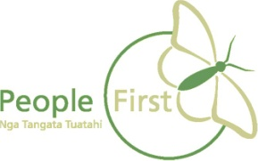

This information has been translated into Easyread by People First New Zealand Inc.

