

The Auckland study
An assessment of the tertiary
education needs of school leavers
in the Auckland region

Table of contents

Executive summary 4
Introduction 6
Purpose
Approach
Context
Overview 9
Population growth
Diversity
Youth
Migration
Tertiary education access 15
Barriers to tertiary education access
Secondary school achievement
Secondary to tertiary progression
Tertiary participation
Availability
Conclusion 32
Appendix A: Tertiary education profile by TA 35
Appendix B: Data information 41
Bibliography 44

Executive Summary
The Auckland region will continue to lead the population and economic growth across New Zealand. To ensure Auckland is able to reach the growth projected, the tertiary education system has a crucial role in providing for a skilled and productive workforce that meets the demands of its stakeholders. The role of the Tertiary Education Commission (TEC) is to invest in a responsive and collaborative tertiary education system that provides equitable access to the region’s growing and diverse population.
The review of existing research highlights the challenge of achieving equitable tertiary education access in Auckland, based on the socio-economic mix of the region’s growing population. In the next 25 years, Auckland will face population growth that is faster than the rest of New Zealand, as well as a younger, more ethnically diverse population profile, that will place stronger tertiary education demands on the region’s TEOs.
The objective of this study on Auckland is to inform future investment in tertiary education and training across the region by identifying the tertiary education needs and how they can be best addressed by the TEC. Due to the concentration and projected growth of youth for Auckland, the study is focused on the tertiary investment needs of youth across Auckland.
The study found there is presently under-investment across the Auckland region as well as limited tertiary education access in the most disadvantaged areas. With a third of the nation’s youth concentrated in the Auckland region, there is a noticeable gap between available tertiary provision and those wishing to access such provision. While the Auckland region attracted a quarter of the nation’s tertiary education investment for 2008, this is considerably lower than the potential learner demand across the region. With the youth population in Auckland projected to reach 39% by 2031, there is an explicit need for tertiary education to serve and connect the youth to the knowledge economy and society.
Findings from the study showed the tertiary education needs are consistent with the following themes:
- targeted vocational and foundation level training opportunities to assist and encourage those with no formal qualifications to re-engage with the tertiary system, especially in areas of Manukau City and Papakura District
- collaborative contribution between local providers in the region to form a cohesive and pathway focused programme of delivery
- stakeholder focused approach to identifying and addressing the needs of the communities, learners, industry and stakeholders to ensure the programme delivered are of relevance and applicability to the users of the system through processes such as regional facilitation
- facilitate the access, engagement, success of all students in the tertiary environment especially those from socially deprived backgrounds and those most disengaged with tertiary education
The focus of this analysis is to provide an access perspective to the investment needs across the Auckland region. In order to effectively plan delivery that will meet the needs of the tertiary education stakeholders, engagement must occur at the institutional and community level to allow for greater connectedness and relevance. As such, it is considered the responsibility of the tertiary education organisations (TEOs) to engage, identify, and deliver to the needs of their stakeholders.

Introduction
Purpose
The purpose of this study is to identify the tertiary education access needs of Auckland’s diverse and growing population. The findings of this study will form an information base to inform the future TEC investment into tertiary education across the Auckland region.
The study is based on a comprehensive literature review of existing research on Auckland. The review found several drivers common to the tertiary education needs identified in the literature. These were:
- population growth
- equitable tertiary education access and success for all learners
- industry growth and development
- clear and informative pathways through the tertiary system
Whilst all the factors that were identified are important to tertiary education across the region, the focus of this studyon tertiary education access is significant in enhancing opportunities for tertiary education success and for achieving the Government’s goals stipulated in the Tertiary Education Strategy 2010-2015 (MOE, 2009).
A common concern across the stakeholder groups is the equity in tertiary education access, with the most affected and under-represented groups being Māori and Pacific Peoples and youth. Inequalities in tertiary education are, to a great extent, dictated by inequities in preceding levels of education (OECD, 2008; Le & Miller, 2005). However, equitable access to tertiary provision is more important in ensuring those most disadvantaged can have opportunities to access and succeed in the tertiary environment. While there are defined groups targeted for equitable access, the present analysis examines the extent to which access inequity is experienced across the population.
In the following sections, this paper will examine the access needs across the Auckland region to inform the appropriate tertiary education investment needed to ensure and equitable access for students across the region.
This paper does not attempt to examine or identify the needs of industry. It is considered the responsibility of the TEOs to ensure stakeholder relevant delivery that is aligned to Government priorities. Through processes such as regional facilitation, TEOs can engage and align their delivery to the needs of the communities and stakeholders they serve.

Approach
To examine tertiary education access, analysis must focus on those most susceptible to participation barriers as they are also more likely to be negatively impacted by inequitable access. For this reason, the present analysis is focused on Auckland’s secondary school students. While secondary school students may move out of their school region for tertiary study, equitable opportunities should be provided to allow students to access relevant local provision when they decide to participate in the tertiary education system.
Student location is an indicative measure as students may change their residential or enrolment location during their studies or study at multiple providers in a given period. The present analysis defines secondary school student location as secondary school location reported by the Ministry of Education (MOE) school roll register, and tertiary student location as the Single Data Return (SDR) enrolment event location reported by the TEO.
Due to the timing of the report and the analysis, this study uses the funding and tertiary participation data from the 2008 academic year.
Context
This study was conducted prior to the formation of the Auckland super city. As such, the analysis and findings presented in this study are based on the seven territorial local authorities that formed the Auckland region. The Auckland region is defined by the boundaries of the Auckland Regional Council and encompasses seven territorial local authorities (TLAs). Four are cities - North Shore, Auckland, Waitakere and Manukau. The remaining three are districts - Papakura, and the predominantly rural districts of Rodney and Franklin (Figure 1).
The Auckland region is very large and complex, in terms of its demography, economy, and the mix of tertiary education provided. The seven territorial authorities within the region are themselves very diverse in size and population characteristics. Most are large enough to support analysis at a relatively low level, providing an opportunity to gain an understanding of variability within a region, as well as across New Zealand.

Figure 1: Map of New Zealand showing the TLAs of the Auckland region
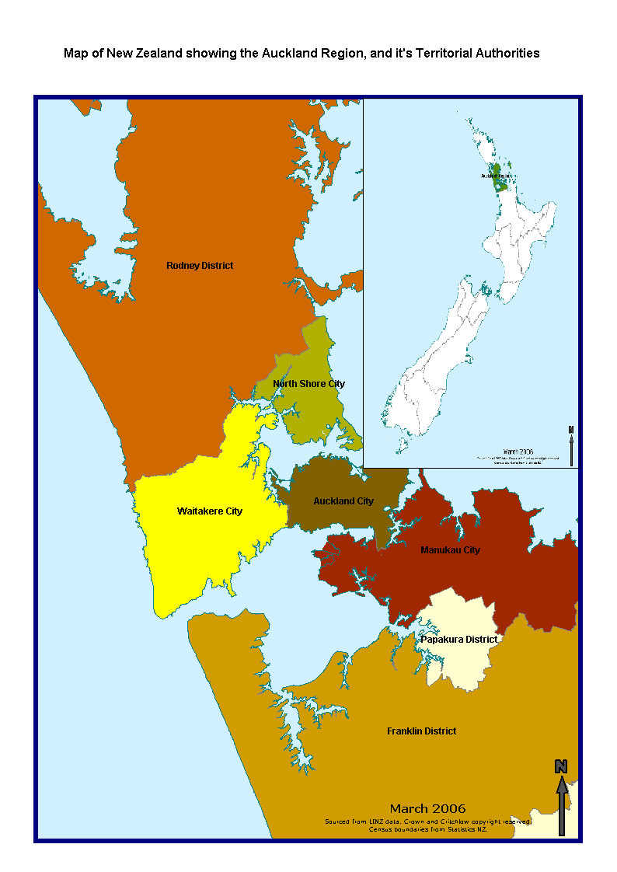
Map sourced from New Zealand Transports Agency

Overview
In 2006, the Organisation for Economic Co-operation and Development (OECD) published a report that identified several common factors underlying the success of internationally competitive metro-regions. These were: innovation, skilled human capital, connectedness, economic diversity and transport infrastructure (OECD, 2006). The OECD report noted that whilst Auckland exhibits the pace and concentration of growth characteristic to internationally competitive metro-regions, it demonstrated a mixed performance against the key dimensions. Recent OECD analysis has shown that in the area of skilled human capital Auckland’s share of the working age population with a tertiary education qualification is particularly poor. This trend is reflective of Auckland’s labour productivity, which measures below the OECD average (output per worker) across comparator cities.
With Auckland projected to grow at a faster pace than the rest of New Zealand and accounting for almost 40% of the nation’s population by 2031, the need for a skilled and qualified workforce will becomes more central to enable both the success of Auckland and New Zealand as a whole. To ensure this success, there is a need for a responsive tertiary education system to provide for a skilled and qualified workforce that meets the demands of its stakeholders.
Priorities stipulated in the Tertiary Education Strategy 2010-2015 (MOE, 2009) are focused on the successful transitions from school to tertiary and the achievement of Māori and Pasifika students. As such, equitable and sufficient tertiary education access has greater poignancy for the region’s youthful and growing population.
Access to tertiary education enables tertiary education success and should be an opportunity provided to all New Zealanders. While the choice to participate in tertiary education is upon the individual learner, the role of the government is to ensure there are sufficient available resources for the population to access relevant and quality education.
Equitable tertiary education access is defined as the opportunity for access as well as the facilitation of entry and the encouragement of sustained enrolment by all learners in appropriate education programmes. Thus access includes features of openness, supportiveness, and relevance of delivery to a heterogeneous population (OCED, 2006).
Like many other countries, New Zealand has an equity policy to enable greater access for those most disadvantaged in the tertiary education system. Evidence shows that students of Māori and Pacific ethnicity and students with disabilities experience clear disadvantages within tertiary education (TEC, 2009). The purpose of equity funding is to provide additional support for Tertiary Education Institutions (TEIs) to improve participation, retention, completion, and progression for the targeted groups.
Ensuring equal opportunities to access tertiary education is a specific challenge to Auckland due to the unique mix and concentrated growth of the region’s population. Youth populations concentrated across low decile communities are of specific concern as they are more likely to be negatively impacted by insufficient access to tertiary provision across the region.

Population growth
Auckland houses over a third of New Zealand’s population. Over the next 20 years, the significance of the region’s population will be defined by not only the concentration and pace of the growth but also how it will grow over the period.
Several studies have examined the projected growth of Auckland’s population (e.g., Committee for Auckland, 2008, CityScope Consultants, 2009). Whilst there is variance in the projected outcomes, recent analysis suggests the projected growth of Auckland is likely to reach the medium and high scenarios projected by Statistics New Zealand (SNZ) and such outcomes will need to be considered in relation to tertiary education provision to ensure Auckland is planned to address the growth ahead (CityScope Consultants, 2009).
SNZ projections proposed a high variant scenario whereby Auckland’s population could grow by 57% from 2006 to 2031, compared to 30% nationally (SNZ, 2009). If this scenario prevails, Auckland will account for 40% of the country’s population in 21 years time (Figure 2).
Figure 2: Population of Auckland region with 2011 to 2031 population projections
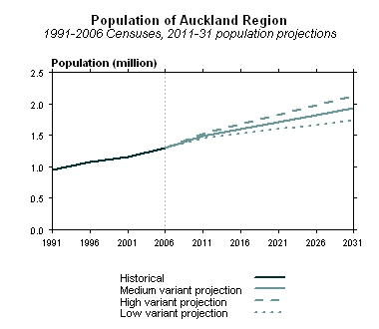
Historical
Medium variant projection
High variant projection
Low variant projection
Data sourced from Statistics New Zealand

Studies indicate Auckland’s rate of growth will impact significantly on the region’s workforce (Committee for Auckland, 2008). The pace of growth combined with the ageing workforce means there will be an increased dependency as well as longer periods of workforce participation. Whilst this trend is predicted to be an issue faced by all regions in New Zealand, the greater density and rate of population growth in Auckland will concentrate the issue for the region. This shift in demography demands greater input and responsiveness from the tertiary education system to provide the relevant education and training to enable and maintain a skilled and productive workforce.

Diversity
Auckland is more ethnically diverse than any other region in New Zealand. In 2006, 67% of New Zealand’s Pacific Peoples lived in Auckland, together with 66% of the nation’s people of Asian ethnicity. However, Auckland has proportionally fewer people identifying as Māori than the rest of New Zealand.
The magnitude of Auckland’s diversity is reflected in the distinct geographic spread by ethnicity with what appears to be geographic preferences by ethnicity. At the time of the 2006 census, people living in Manukau City were mainly of Pacific and Asian ethnicity, Auckland City had the highest proportion of Asian peoples, while in the Papakura District over 25% of the population identified with the Māori ethnic group, compared with 15% for New Zealand as a whole.
Population projections indicate that the ethnic diversity both in number and range will continue to increase. Diversification will be apparent across all territorial authorities. Population growth across Auckland will be driven disproportionately by minority ethnic groups, especially Asian and Pacific Peoples. This will result from future migration gains and the younger age structure of the present resident populations. Consequently, this will increase Auckland’s already distinctive ethnic, cultural, socio-economic, and geographic diversity.

Youth
Overall, Auckland’s population has and will continue to have a younger age profile than New Zealand (Figure 3). Analysis of the age structure across the region shows significant variations between the territorial authorities and population groups.

Figure 3: Population projections for Auckland and New Zealand - 2006 to 2031
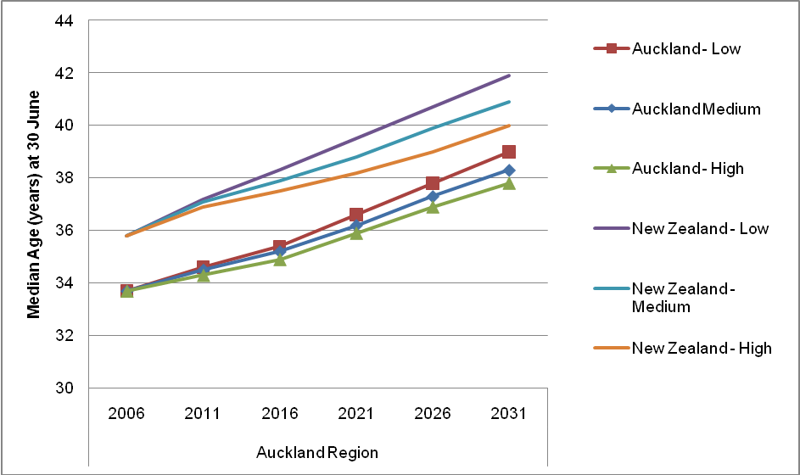
Data sourced from Statistics New Zealand

The ethnicity of youth (defined as 15-24 year olds) is more diverse than the total population of the region. Both Pacific and Māori populations have a younger age structure and larger proportions of youth. Projected growth by ethnicity suggests that the relative younger age structure of population groups of Pacific and Māori ethnicities will contribute to more rapid growth in areas where they are most concentrated. On the other hand, the European majority will dominate the older age groups above all the ethnicity groups.
At present, over a third of all young people (younger than 15 years) in New Zealand live in the Auckland region and this is projected to increase to 39% by 2031. Projections show the youth population in Auckland will grow at an annual rate ranging from 3% to 5% while New Zealand as a whole will increase by 1% to 2%. All of Auckland’s territorial authorities will grow at a faster pace than projected nationally, with Manukau city (13%) and Auckland city (10%) accounting for larger concentrations of youth than any other territorial authority in New Zealand by 2031.
The younger age structure of the populations within Auckland and Manukau City has particular implications for population growth, and consequently for tertiary education provision and labour force participation. Younger populations have higher birth rates, thereby further increasing the number requiring access to tertiary education.

Migration
Even though the Auckland region has a net outflow of people moving to the rest of New Zealand, there are a relatively high volume of people from other parts of New Zealand moving in to the region. Historically, net internal migration in the Auckland region has gradually been declining, except for a brief period between 1991 and 1996 (Figure 4).
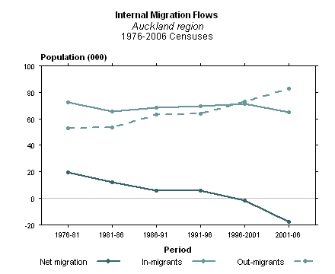
Figure 4: Internal migration flow for the Auckland region 1976 to 2006

Data sourced from Statistics New Zealand
Across the student population, tertiary students are highly mobile with a large proportion leaving their schooling region for tertiary education elsewhere in New Zealand. All of the main centres across New Zealand attract a significant flow of students from other regions (Figure 5). With some areas showing a net-inflow effect due to the disciplinary focus of the tertiary education offered in that location (e.g., Otago University is the only provider that offers dentistry programmes nationally). Additionally, the variety and volume of the available provision could also be attracting students to other regional centres (e.g., Auckland and Canterbury offers a larger variety of tertiary education programmes and providers than other national centres).
In 2009, the appeal of the Auckland region attracted a larger volume of within and out of region school students than other national centres. Auckland’s evident pull for tertiary students from the whole of New Zealand has significant implications on the overall capacity of the region and how available provision are used to meet local tertiary education needs.

Figure 5: Tertiary student mobility, 2009
Notes:
- Data sourced from Ministry of Education
- Out of region includes overseas students
- Students accounted are intramural enrolments across all funds

Tertiary education access
Barriers to tertiary education access
Equitable access to tertiary education is a challenge for many countries and a considerable amount of research has examined the barriers to access and those most likely to be affected in the tertiary education system (Birrell, Calderon, Dobson, & Smith, 2000). International research shows whilst demographic characteristics (such as ethnicity, age, gender) are commonly used to identify groups most disadvantaged, the underlying factor impacting on access is socio-economic status (OECD, 2008).
Populations with low socio-economic status often have the lowest levels of participation in post-school education and the effects of this have a dominant impact over other personal characteristics (such as gender, ethnicity, English as a second language, and secondary school type (private or publicly funded schools) to influence the individual’s access and participation in tertiary education (Calderon, Dobson, & Smith, 2000; James, 2002; OECD, 2008; Le & Miller, 2005). The impact of socio-economic background extends beyond the financial constraints as secondary school students from low socio-economic backgrounds also appear to lack the confidence and aspiration for tertiary education (Mallory & McKavanagh, 1999).
The recent Social report from the Ministry of Social Development showed the Auckland region has the most crowded households, below the national adult population educational attainment, and proportionally more low decile schools than other New Zealand regions (MSD, 2009). Socio-economic indicators across the region show there to be significant variability between the territorial authorities and population groups.
For the youth population, a commonly used indicator of socio-economic status is school decile. School decile presents the extent to which the school draws its students from low socio-economic communities. Decile one schools are the 10% of schools nationally with the highest proportion of students from low socio-economic communities, and decile 10 schools are the 10% of schools that have students from the highest socio-economic communities nationally.
In 2008, the Auckland region accounted for 40% of New Zealand’s school students from low socio-economic communities (decile 1 to 3 schools). Across the region, both Auckland City and Manukau City had the largest volume of New Zealand’s school students from low socio-economic communities. School student distribution within each territorial authority showed Manukau City, Papakura District, Waitakere City had the largest proportion of school students from decile 1-3 schools (Table 1).
Table 1: Low decile school and school students by TLA, 2008
 | Decile 1-3 schools relative to the region | Decile 1-3 school students within each TLA | Decile 1-3 school students relative to NZ
 | Proportions (%)
Auckland City | 29% | 19% | 8%
Franklin District | 1% | 7% | 0%
Manukau City | 47% | 58% | 24%
North Shore City | 1% | 1% | 0%
Papakura District | 6% | 40% | 2%
Rodney District | 1% | 1% | 0%
Waitakere City | 14% | 26% | 5%
Auckland Region | - | - | 40%
Data sourced from the Ministry of Education
Across the ethnicities, students of Pacific Peoples ethnicity appear to dominate across the low decile schools (Figure 6). European students were proportioned more across the medium to higher decile schools, while students of Māori and Asian ethnicities were more evenly spread across the school deciles.

Figure 6: Auckland region school students by ethnicity and school decile, 2008
Notes:
- Data sourced from Ministry of Education
- Ethnicity reported as prioritised ethnicity
- Other ethnicity category includes all category includes all other reported ethnicities and those that are unknown

Across Auckland, the socio-economic makeup appears clustered across geographic areas and population groups. The following sections attempts to identify the extent and depth of the socio-economic impact on tertiary access and participation.

Secondary school achievement
Overall, Auckland region school students perform above the national average. However, significant variation within the region and across particular population groups highlights the challenge for the tertiary education sector to respond to the educational gaps and needs of Auckland’s population.
In 2008, school achievement across the region follows the socio-economic distribution of local communities. Across the territorial authorities, areas with large proportions of school leavers achieving less than NCEA level 3 or higher were largely in the low decile communities such as Manukau City, Auckland City, Papakura District and Waitakere City (Figure 7).

Figure 7: Highest level of school attainment by school leavers in the Auckland region 2008
Data sourced from Ministry of Education

Population comparisons across TLAs are most pronounced when ethnicity is included; particularly across the lower levels of secondary school achievement (Figure 8). In 2008, 70% of the Māori school students left school with NCEA level 1 in the Auckland region compared with 88% for Europeans. This trend for Māori is particularly evident in Papakura and Rodney with attainment of NCEA level 1 as low as 60% and 62% respectively. On the other hand, Asian students perform particularly well in this respect with 92% leaving school with NCEA level 1 or over. High concentrations of Asian school students mask lower achievement by other ethnic groups in particular for Auckland City and Manukau city.

Figure 8: School leavers with NCEA level 1 or above by ethnicity and TLA, 2008
Notes:
- Data sourced from Ministry of Education
- Student numbers of less than five are not included
- MELAA stands for Middle Eastern/Latin American/African

School leavers are a key driver for tertiary education demand. School achievements of school leavers have a direct influence on the type and level of tertiary education they will need from the education system. Across the Auckland region the volume of school leavers with a university entrance qualification is higher than all other New Zealand regions. However, the significant proportion of school leavers with no university entrance and little formal attainment suggest alternative pathways will be required to engage those groups into tertiary study.

Secondary to tertiary progression
Direct and indirect progression from secondary school into tertiary education has a significant impact on likely success in the tertiary environment. Students that progress from secondary school directly into tertiary have higher completion rates, lower attrition and more likely to go onto higher levels of education than other cohorts (Ussher, 2008). On the other hand, indirect progression appears to suggest a process of self-selection whereby those more likely to be academically motivated come back to the education system after taking time off to cement their pathway and motivation for tertiary education. A recent study from MOE noted this effect for university students where those that took a year off achieved higher grades than those that went onto bachelor level study immediately after secondary school (Engler, 2010).
Figure 9: Auckland student progression from school to tertiary 2006 to 2008
Data sourced from Ministry of Education

Over the years, Auckland has followed the national trend of increased direct progression by school leavers into tertiary education (Figure 9). Across the Auckland region, almost half (41%) of the school leavers 24 years or younger directly progressed onto tertiary education, 11% took one year or more off before going onto tertiary studies, and 21% have not yet engaged with the tertiary education system (Figure 10).
Figure10: Secondary to tertiary progression across the Auckland region
Notes:
- Data sourced from Ministry of Education
- Analysis is based on all tertiary enrolments prior or in 2008 by students who have left an Auckland region school anytime in the past ten years

While taking gap year(s) after secondary school may provide an individual some time to consider what and how they want to progress towards tertiary education, the choice to take time off may also be driven by socio-economic factors. Noticeably across Auckland, school leavers that took gap year(s) and those not yet in tertiary study are mostly concentrated in the lower decile communities (Auckland City 34%, Manukau City 23% and Waitakere City 12%). Within these communities, a larger proportion of low decile school students are taking gap years and not engaging in tertiary study post-secondary school (Figure 11).
Figure 11: School leavers that have either indirectly or not yet progressed into tertiary study
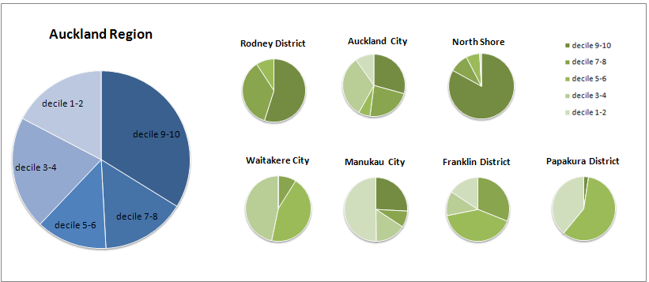
Notes:
- Data sourced from Ministry of Education
- Analysis is based on all tertiary enrolments prior or in 2008 by students who have left an Auckland region school anytime in the past ten years

Tertiary participation
Students from low socio-economic communities were more likely to access the locally available tertiary education than their counterparts (Figure 12). While transport provides students with the opportunity to access available provision elsewhere to their residential area, socio-economic factors impinge on the students’ ability to travel. Although this may not be the case for all students, it highlights the importance of accessible provision for those in low socio-economic communities to enable equitable opportunities for tertiary education access. TEOs have a role in ensuring “stakeholder relevant” provision, and part of that relevance is entailed in prioritising and addressing the needs of their local community, and most especially their learners.

Figure 12: Tertiary student mobility by school decile, 2009
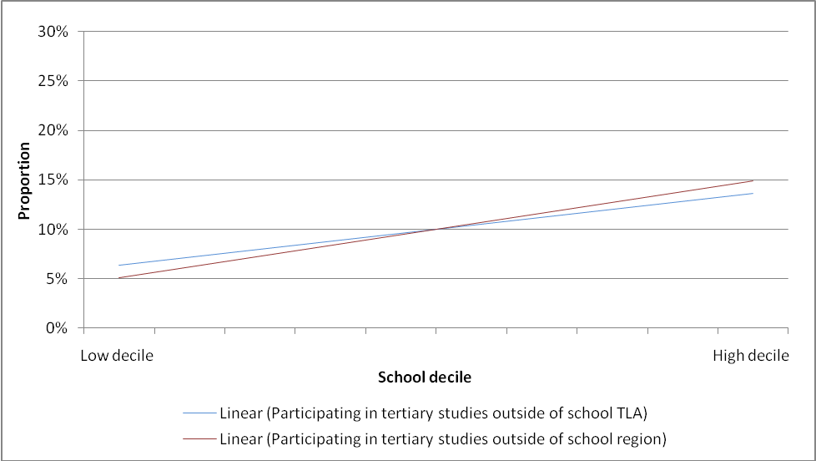
Notes:
- Data sourced from Ministry of Education
- Analysis is based on all tertiary enrolments in 2009

The socio-economic status of secondary school students appears to have a significant effect on tertiary education participation (Figure 13). Within the region, a smaller proportion of students from low socio-economic communities participated in tertiary education post-secondary school and this proportion increased as the socio-economic status of the students increased. Additionally, the difference between participation and no participation appears most marked for students from low socio-economic backgrounds. While school achievement has a direct impact on tertiary participation, the socio-economic impact on the individual’s tertiary education choices are important to the understanding of not only how and what tertiary participation looks like but what progression and success looks like once they get there.

Figure 13: School leaver progression in the Auckland region, 2006-2008
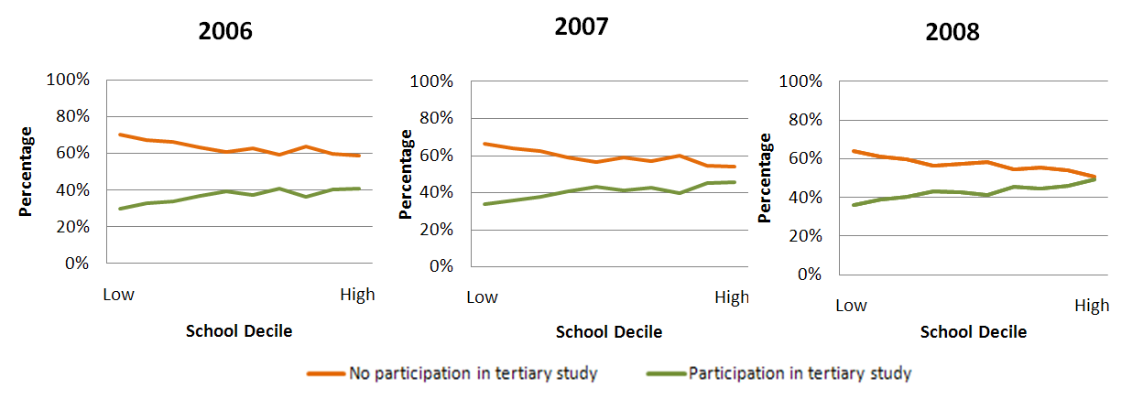
Data sourced from Ministry of Education
The post-school outcome of Auckland school leavers appear to differ across socio-economic groups. Across the school deciles, a larger proportion of high decile school leavers were engaged in provider-based tertiary study than, while a larger proportion of low decile school levers were studying through industry training and school-based vocational education programmes (Figure 14).
Figure 14: Post-school outcome by socio-economic background, 2008
Notes:
- Data sourced from Ministry of Education
- Analysis is based on all tertiary enrolments in 2008 by students who attended school in the Auckland region

The socio-economic impact on the type of tertiary study chosen is reflected in the distribution of enrolments across qualification level. The majority of students from low socio-economic backgrounds were engaged in levels 1 to 3 qualifications (76%), while students from higher socio-economic backgrounds were mainly studying qualifications at levels 4 and above (73%)(Figure 15).

Figure 15: Level of study by Auckland students by socio-economic background, 2008
Notes:
- Data sourced from Ministry of Education
- Analysis is based on all tertiary enrolments in 2008 by students who attended school in the Auckland region.

Across the ethnicities, the socio-economic effect on tertiary participation was evident across all groups other than European (Figure 16). Findings showed for most school leavers, regardless of ethnic group, those from high decile schools were more likely to progress onto tertiary education than their lower decile counterparts. For European students the impact of socio-economic status appear inversed with less proportions engaging in tertiary study when they are from higher socio-economic backgrounds.
One explanation for the varying effect of socio-economic status across ethnicities could be the representativeness of school decile for socio-economic status of all students at the school. School decile ratings are only indicative of the socio-economic status of students within their catchment; the approach with which it is calculated is more generalised and will be biased towards the socio-economic status of concentrated communities within the catchment area. Furthermore, the geographic spread and clusters of specific ethnic groups may be contributing to the pattern of participation across the socio-economic groups. Another explanation could be the prioritised ethnicity categories whereby if a student identifies with more than one ethnic category their ethnicity will be categorise allocated to a single ethnic group using the priority order across the ethnic groups. At the highest level the ordering is: NZ Māori, Pacific Island, Asian, Other and European.

Figure 16: Progression to tertiary study post-secondary school by ethnicity
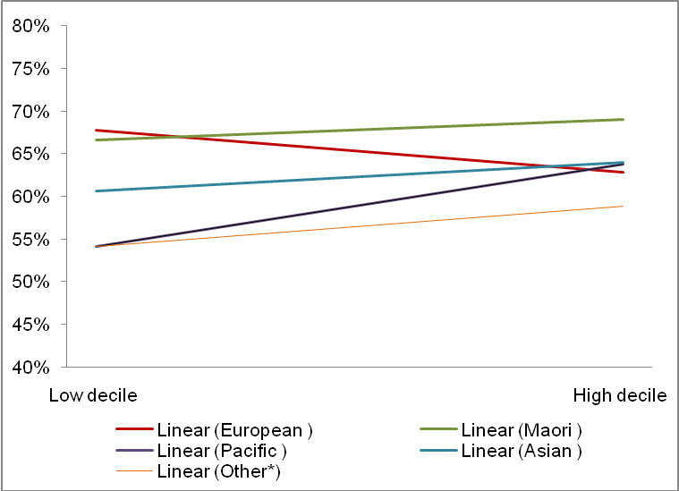
Notes:
- Data sourced from Ministry of Education
- Ethnicity reported as prioritised ethnicity
- Other ethnicity category includes all category includes all other reported ethnicities and those that are unknown
- Analysis is based on all tertiary enrolments prior or in 2008 by students who have left an Auckland region school anytime in the past ten years

Availability
There is growing empirical support for the importance of physical tertiary education presence on the educational aspirations of the community (DEEWR, 2009). Actual availability to relevant tertiary education is critical in addressing the needs of the local community and the region as a whole.
At present, the Auckland region is served by five universities, seven Institutes of Technology and Polytechnics (ITPs), two Wananga, and 91 Private Training Establishments (PTEs), some of which are multilevel institutions although most offer only a few programmes in niche areas. Industry Training Organisations (ITOs) are also active in the region, with 30,416 trainees engaged in industry training in 2008.
In total, the region had 141 tertiary education campuses that provided onsite tertiary education delivery (Figure 17). In 2008, Auckland’s provision was accessed by over 193,456 students which attracted over $650 million dollars of government funding. This equated to approximately a quarter of total funding given to the sector in 2008.
In comparison to total participation in New Zealand, Auckland has a slightly higher population base participation rate (14%) than the rest of New Zealand (12%) with the Auckland region accounting for 27% of the total tertiary enrolments in 2008.
Figure17: TEOs in the Auckland region, 2008
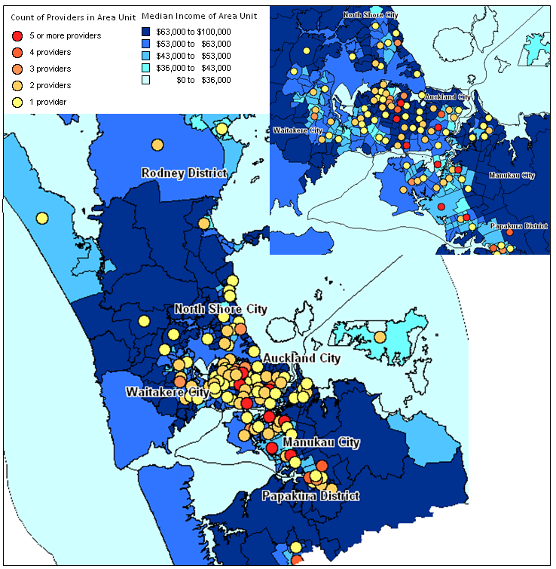
Data sourced from Tertiary Education Commission and Statistics New Zealand
In 2008, the largest proportion of TEOs was located within Auckland City. While there was provision elsewhere, the range and type of provision available is limited for the territorial authorities of Franklin, Papakura, Rodney and Waitakere. Participation rates across the local authorities are reflective of the geographic location of education delivery, with the majority participating in Auckland City (72%), 12% in Manukau City, and minute proportions in all other areas (Table 2).

Table 2: Participation in tertiary education for Auckland region, 2008
 | Enrolled students | Participation rate | TEOs
Rodney District | 2,369 (1%) | 3% | 5 (4%)
North Shore City | 13,137 (7%) | 7% | 5 (4%)
Waitakere City | 5,314 (3%) | 3% | 6 (4%)
Auckland City | 138,611 (72%) | 39% | 105 (74%)
Manukau City | 33,884 (18%) | 13% | 15 (11%)
Papakura District | 1,798 (1%) | 5% | 3 (2%)
Franklin District | 1,380 (1%) | 3% | 2 (1%)
Auckland Region | 193,456 (100%) | 14% | 141
New Zealand | - | 12% | -
These figures are indicatives only and were extracted TEC datasets (SDR, BASIL and ILU)
While the population base participation rate has limited applicability as it does not account for student mobility, it does provide a sense of scale to the enrolments relative to the population across the region. The sub-regional participation rates reinforce the impact of geographic location of the tertiary campus on local participation. Areas that have limited local access to TEO campus sites have proportionally less participation by the local population aged 15 years and older. The low levels of participation may also be contributed by the significant proportions of low socio-economic students in these areas.
Across the region, Auckland City accounted for the largest volume of students enrolled in tertiary education in 2008 which produced the largest population-based participation rate. Whilst Auckland City had a large proportion of school students from low socio-economic communities, the relatively positive picture of participation may be the result of Auckland city attracting a large number of out of region students as there are greater access opportunities due to the range and number of TEOs as well as more available transport options (Figure 18).

Figure18: Progression of Auckland school leavers
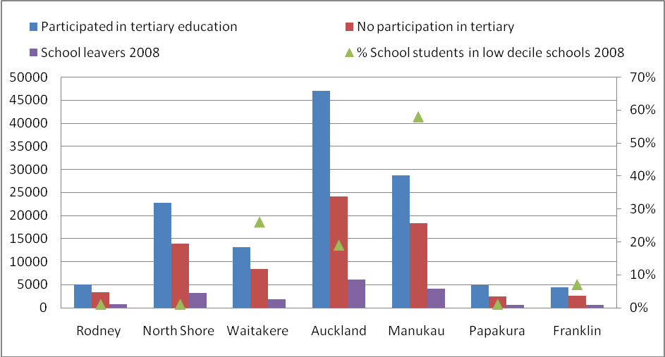
Notes:
- Data sourced from Ministry of Education.
- Analysis is based on all tertiary enrolments prior or in 2008 by students who have left an Auckland region school anytime in the past ten years.
Of those students not engaged in tertiary study across the Auckland region, 57% were aged between 15 to 19 years and 39% have no formal qualification achievement. Ethnic breakdown of these school leavers show 35% are of European ethnicity, 23% were Asian, 21% Pacific, and 13% of Māori ethnicity.
The necessity for travel is often raised as an issue for residents outside of Auckland City for reasons of accessing study, whether topic or provider, not locally available. Evidence shows the geographic location of tertiary provision is a key determinant in the travel needs for those wishing to participate in tertiary education (Usher, 2006). Areas that are more isolated from tertiary provision will present greater barriers to access as there is a greater need for travel. The requirement to travel is particularly significant for those students resident to the Rodney and Franklin Districts as both areas are served by one polytechnic campus and a small number of PTEs and neither of these areas have a tertiary facility at the university level.
While there are opportunities for students to engage in learning outside of TEO campus locations through blended or distance education, the access to this form of learning is dependent on the availability of effective telecommunications connections to the learner. The availability of telecommunication connections across the region further reinforces the distribution of socio-economic backgrounds as the lowest reported access were given by households in Papakura District (60%) and Manukau City (59%) (MSD, 2009).
There is growing evidence to confirm the positive impact of the physical presence of TEOs educational aspirations of the community (Edwards & Marks, 2008; James, 2000; Marks, Fleming, Long, & McMillan, 2000; Stevenson, Evans, Maclachlan, Karmel, & Blakers, 2001; James, Baldwin, Hepworth, McInnis, & Stephanou, 1999). Tertiary education organisations do this most obviously through the direct provision of courses and programmes of study. The indirect impact of tertiary education presence on local educational aspirations includes the more subtle influence they have on the career and life plans of students and their families. The most important factors influencing the low participation rates of low socio-economic students are community and family attitudes towards the relevance and advantages of tertiary education. The effect of tertiary education presence extends to school students where they have a significant effect on the general level of aspirations of students to pursue higher education. The greater the physical distance students are away from a tertiary education provider the less likely they are to have opportunities to engage with the idea of participating in tertiary education.
The impact of the institutional presence is supported by the participation trends across the Auckland region. The sub-regional participation rates are associated with the accessible tertiary campus within the territorial authority. The impact of limited access is most prevalent in areas with large proportions of low decile school students across the cities of Manukau, Waitakere and Papakura. While accessible provision is provided elsewhere, the relatively less mobile and less engaged school leavers highlight the compounded effect of limited physical availability and inequitable access on student aspirations and confidence to participate in tertiary education.

Conclusion
Tertiary education success encapsulates all successful achievements of value ascertained through tertiary education by the individual, society and government. While the path may differ across student groups, the common purpose of achieving tertiary education success is to gain meaningful and quality education that is able to facilitate the student’s successful integration and engagement with society.
Equitable access to available and relevant provision provides an opportunity for individuals to participate, engage, and succeed in the tertiary environment. The government has a core responsibility in ensuring that the tertiary education system allows for equitable access and there is a focus on benefiting the individual learner as well as the system contribution to the knowledge economy.
Tertiary participation is dependent on the choice of the individual, and central to this choice is the accessibility, availability, proximity, and type (i.e., qualifications taught, flexible modes of learning or distance education) of tertiary education present in their community or immediate environment.
Across Auckland, the significant socio-economic deprivation noted within the most youthful and diverse population places specific demands on the tertiary education system. Inline with previous research, there was an evident socio-economic impact on student participation across the Auckland region. The impact of socio-economic factors constrains student choice and this is where equitable access has a vital role in balancing the social inequities and allowing for individuals to make the choice to engage and participate. At present, access to available provision across Auckland is limited in the most deprived areas. Although all territorial authorities are served by at least one tertiary campus, access is limited by both in physical proximity and distance learning options for the most youthful and most socio-economically deprived communities, notably Manukau City, Waitakere City and Papakura District and most significantly across school students of Pacific and Māori ethnicities.
At present, the disproportional tertiary funding allocated across the Auckland region relative to New Zealand suggests there to be limited resources to meet the region’s population demands. With the region home to the largest proportion of school leavers from the most socially deprived backgrounds the compounded effects of limited access and socio-inequities appear to be playing a more significant role in impeding tertiary education participation across the region. As such there is a need for targeted investment to reflect demand and greater collaborative mechanisms to enable all learners to have opportunities to access and succeed in the tertiary environment.
This study on the tertiary education needs of school leavers suggests for:
- targeted vocational and foundation level training opportunities to assist and encourage those with no formal qualifications to re-engage with the tertiary system, especially in areas of Waitakere City, Manukau City and Papakura District
- collaborative contribution between local providers in the region to form a cohesive and pathway focused programme of delivery that encourages and engages local students
- stakeholder focused approach to identifying and addressing the needs of the communities, learners, industry and other stakeholders to ensure the programme delivered are of relevance and applicability to the users of the system
- facilitate the access, engagement, success of all students in the tertiary environment especially those from socially deprived backgrounds and those most disengaged with tertiary education
In order to enable the tertiary system to effectively address the needs of Auckland’s stakeholders the investment approach must be focused on the unique population demands of each territorial authority. Detailed profiles for the investment needs for each territorial authority are provided below:
Auckland City
- Greater collaborative mechanisms between schools and TEOs to enable more effective transitions and pathways into the tertiary system
- More targeted provision to engage students at the younger age groups with no university entrance and low formal achievement to participate and progress in the tertiary system
- Focused support and delivery to assist students from low socio-economic backgrounds to participate at the tertiary level
Manukau City
- Greater collaborative mechanisms between schools and TEOs to enable more effective transitions and pathways into the tertiary system
- Greater tertiary education presence and targeted provision at lower level foundation qualifications and vocational training to encourage students with no formal qualifications and more socio-economically deprived backgrounds to participate and progress in the tertiary system.
- With the large proportion of low socio-economic communities concentrated in the Manukau City, there may be a need for more focused delivery and support for school students from low socio-economic backgrounds to have the opportunity to engage in tertiary study
Franklin District
- More collaborative mechanisms may prove beneficial to encourage fluid transitions into the tertiary system especially for those.
- There may be a need for more targeted provision at lower level qualifications and vocational training to encourage students with no formal qualifications and younger age groups to engage at the tertiary level.

North Shore City
- More collaborative mechanisms to encourage fluid transitions into the tertiary system especially for those not engaged in tertiary study having achieved NCEA qualifications prior to leaving secondary school.
- With the significant proportions achieving NCEA level 1 and higher and not in tertiary study, there is a need for targeted delivery to engage local school leavers into the tertiary system.
Waitakere City
- More collaborative mechanisms between schools and tertiary education providers to enable more effective transitions into tertiary study.
- The large proportions not engaged require targeted provision at foundation and lower level qualifications to encourage participation at either provider based or vocational training (e.g., ITP delivery or on-job training opportunities).
Papakura District
- Collaborative strategies between secondary and tertiary may prove beneficial for school students in lower decile schools to progress and transition more effectively into tertiary study.
- Presence of more provision (e.g., lower level vocational education) in this area may be required to improve access for those students from lower socio-economic backgrounds to have equitable tertiary participation opportunities.
Rodney District
- The large proportions of 15 to 19 year olds not engaged in tertiary study argues for greater collaborative strategies between secondary and tertiary to enable more effective transitions and pathways into tertiary education.
- The significant proportion of school leavers with no formal qualifications suggests for more provision at lower level education to facilitate entry level participation.
This study is only focused on the access needs of the Auckland school leavers. This only provides one perspective of the demand on tertiary education across the Auckland region. To effectively address the educational needs of the region, it is the responsibility of the TEOs to effectively engage and apply their delivery to meet the needs of their key stakeholders, and this includes the equity needs of the learners served in their community. The role of the TEOs is to align delivery to the priorities of government while ensuring relevant provision to the communities and industry they serve. As such, engagement must occur at the institutional and community level to allow for greater connectedness and relevance.

Appendix A: Tertiary education profile by Territorial Authority in the Auckland region
Provision profile (current) | Student profile | Investment profile recommendations
Auckland City
- Auckland City has a variety of TEOs (105 TEOs) providing tertiary qualifications across all qualification levels.  - The population based participation rate is the highest across the region at 39% for 2008.  - The Auckland City accounted for 72% of all tertiary enrolments across the region in 2008. | - Accounts for 35% of total school leavers across the region in 2008 (n=6091), approximately 19% of those are from low socio-economic backgrounds.  - Significant amount of secondary school achievement with 90% of school leavers in 2008 achieving NCEA level 1 or higher.  - Over half of the school leavers not engaged in tertiary study are in the 15 to 19 age group (54%).  - Students not engaged in tertiary study were mainly of European (29%), Pacific (27%) and Asian (26%) ethnicities.  - A third of those not engaged in tertiary study have no formal qualifications (33%).  - There may be socio-economic barriers to access for a considerable volume of school leavers not in tertiary study as 46% of those not engaged in tertiary study were from low socio-economic backgrounds (decile 1-3 schools). | - More collaborative mechanisms between schools and tertiary education providers to enable more effective transitions and pathways into tertiary education.  - More targeted provision at lower level foundation qualifications to encourage students at the younger age groups to participate and progress in the tertiary system.  - Focused support (i.e., financial) may be required for assisting those from disadvantaged backgrounds to participate at the tertiary level.
Manukau City
- Manukau City is served by a wide range of TEOs (15) across the University, ITP, PTE, and Wananga sectors with provision available across all qualification levels.  - In 2008, students enrolled in Manukau City accounted for 18% of total enrolments across the region and the population base participation rate is 13%. | - Manukau City accounted for 24% of total school leavers across the region in 2008 (n=4207), over half of these students were from low socio-economic backgrounds (58%).  - Over half of school leavers not engaged in tertiary study are in the 15 to 19 age group (58%).  - Students not engaged in tertiary study were mainly of Pacific (34%), Asian (21%), and European (21%) ethnicities.  - Almost half of the school leavers not in tertiary study have no formal qualifications (46%).  - With 63% of those not engaged in tertiary study were from low socio-economic backgrounds (decile 1-3 schools), there appears to be some access barriers for those from low socio-economic communities to access available tertiary education. | - More targeted provision at lower level foundation qualifications and vocational training to encourage students with no formal qualifications and more disadvantaged backgrounds to participate and progress in the tertiary system.  - With the large proportion of low socio-economic communities concentrated in the Manukau City, there may be a need for more focused assistance (e.g., financial) for school students from low socio-economic backgrounds to have the opportunity to engage in tertiary study.
Franklin District
- Franklin District is served by two PTEs and the provision available is in levels 1-3 certificates.  - In 2008, 1% of students studying in the Auckland region were in the Franklin District.  - Due to the smaller population base in the district the enrolments for 2008 gave a 3% population base participation rate. | - Franklin District accounted for 4% of total school leavers across the region in 2008 (n=648), with a small proportion of these students coming from low socio-economic communities (7%).  - Over half of the school leavers aged 15 to 19 years is not engaged in tertiary study (61%).  - Students not engaged in tertiary study were mainly of European (54%), Māori (22%) and Pacific (14%) ethnicities.  - Almost half of those not engaged in tertiary study have no formal secondary school achievements (43%).  - Due to the higher socio-economic status of the Franklin District population, the spread of students not engaged in tertiary study are skewed towards students from higher socio-economic backgrounds (70% from decile 6-7 schools). As such, there does not appear to be a significant impact of socio-economic factors on tertiary education participation in the Franklin District. | - More collaborative mechanisms may prove beneficial to encourage fluid transitions into the tertiary system especially for those.  - There may be a need for more targeted provision at lower level qualifications and vocational training to encourage students with no formal qualifications and younger age groups to engage at the tertiary level.
North Shore City
- North Shore City is served by a range of TEOs (5) with provision covering the University, PTE, Wananga sectors.  - Qualifications available covered certificates through to post-graduate study options (levels 1-9).  - In 2008, 7% of students studying in the Auckland region were in North Shore City and the population base participation rate is 7%. | - North Shore City accounted for 19% of total school leavers across the region in 2008 (n=3275), with a small proportion of these students coming from low socio-economic communities (1%).  - Over half of those not engaged in tertiary study in are in the 15 to 19 age group (58%).  - The majority of the students not engaged in tertiary study were of European (49%) and Asian (32%) ethnicities.  - A large proportion of those not engaged in tertiary study have formal secondary school qualifications NCEA level 1 or higher (71%).  - With almost all of those not engaged in tertiary study from higher socio-economic communities (82% from decile 9-10 schools), there appears to be little socio-economic barriers impeding on the participation of these groups. | - There may be a need for more collaborative mechanisms to encourage fluid transitions into the tertiary system especially for those not engaged in tertiary study having achieved NCEA qualifications prior to leaving secondary school.
Waitakere City
- Waitakere City is served by five PTEs and one university in 2008.  - The provision available ranged from certificates to post-graduate study (levels 1-9).  - In 2008, 3% of students studying in the Auckland region were enrolled in Waitakere City.  - Due to the smaller population base in the district the enrolments for 2008 gave a 3% population base participation rate. | - Waitakere City accounted for 11% of total school leavers across the region in 2008 (n=1906), with 26% of these students coming from low socio-economic communities.  - Over half of those not engaged in tertiary study in are in the 15 to 19 age group (55%).  - The majority of the students not engaged in tertiary study were of European (36%), and Pacific (22%) ethnicities.  - Almost half of those not in tertiary studies have no formal qualifications (44%).  - The socio-economic impact is less noticeable as the proportions of students not engaged in tertiary study are spread quite evenly across the varying socio-economic levels (67% from decile 3-4 schools, 26% from decile 6-8 schools). | - More collaborative mechanisms between schools and tertiary education providers to enable more effective transitions into tertiary study.  - The large proportions not engaged at the younger age range and lack of formal achievements may require targeted provision at foundation and lower level qualifications to encourage participation at either provider based or vocational training (e.g., ITP delivery or on-job training opportunities).
Papakura District
- Papakura District is served by a three PTEs in 2008 with provision ranging at levels 1-7 certificates and diplomas.  - In 2008, 1% of students studying in the Auckland region were in the Papakura District.  - Due to the smaller population base in the district the enrolments for 2008 gave a 5% population base participation rate. | - Papakura District accounted for 3% of total school leavers across the region in 2008 (n=610), with a small proportion of these students coming from low socio-economic communities (1%).  - Over half of those not engaged in tertiary study in are in the 15 to 19 age group (58%).  - The majority of the students not engaged in tertiary study were of European (46%), Māori (26%) and Asian (17%) ethnicities.  - Half of those not in tertiary studies have no formal qualifications (49%).  - The socio-economic impact to tertiary education access and participation may be an explicit issue for those not engaging in tertiary study as 41% are from low socio-economic communities (decile 1-2 schools). | - Collaborative strategies between secondary and tertiary may prove beneficial for school students in lower decile schools to progress and transition more effectively into tertiary study.  - Presence of more provision (e.g., lower level vocational education) in this area may be required to improve access for those students from lower socio-economic backgrounds to have equitable tertiary participation opportunities.
Rodney District
- Rodney District is served by five PTEs in 2008 with provision ranging at levels 1-7 certificates and diplomas.  - In 2008, 1% of students studying in the Auckland region were in the Rodney District and relative to those 15 years and older in the population the participation rate is 3%. | - Rodney District accounted for 4% of total school leavers across the region in 2008 (n=784), with a very small proportion of these students coming from low socio-economic communities (1%).  - Over two thirds of those not engaged in tertiary study in are in the 15 to 19 age group (65%).  - The majority of the students not engaged in tertiary study were of European (63%), and Māori (14%) and Asian (13%) ethnicities.  - Almost half of those not in tertiary studies have no formal qualification achievements (46%).  - The socio-economic impact is less noticeable as the proportions of students not engaged in tertiary study are spread quite evenly across the varying socio-economic levels. | - The large proportions of 15 to 19 year olds not engaged in tertiary study argues for greater collaborative strategies between secondary and tertiary to enable more effective transitions and pathways into tertiary education.  - The significant proportion of school leavers with no formal qualifications suggests for more provision at lower level education to facilitate entry level participation.

Appendix B: Data Information
The main data sources used in the Auckland study are datasets from the Tertiary Education Commission (TEC), Ministry of Education (MOE), New Zealand Qualifications Authority (NZQA) and Statistics New Zealand (SNZ). Brief overviews of the main sources used are provided below.

Tertiary participation data (TEC)
TEC databases have been developed for the purposes of administering specific funds rather than for gaining an understanding of the network of tertiary education provision. Tertiary education participation and completion information are collected through three datasets relevant to the three main funds allocated by the Tertiary Education Commission:
- Single Data Return (SDR) - used for administration of the Student Achievement Component (SAC) funding;
- Industry Liaison Unit database (ILU) - used for Industry Training and Modern Apprenticeships data; and
- BASIL – collects information on Gateway, Skill enhancement, Training Opportunities and Youth Training.
Location information are based on all TEOs that have received TEC funding over the 2008 academic year and have a campus location in the Auckland region. All campus location information is submitted by the TEO and is extracted from the TEC database.

Census of Population and Dwellings 2001 and 2006 (SNZ)
The census is an official count of the number of people and dwellings in New Zealand. It is held every five years and counts everyone who was in New Zealand on census night, providing a ‘snapshot’ of the population at that point in time. The 2006 Census of Population and Dwellings was conducted by SNZ on Tuesday 7 March 2006.
The census collects a wide range of information on the demographic and labour force characteristics of individuals, their income, occupation, industry and educational attainment. It also collects information on the dwelling, household and family. As a census, results are not subject to sampling error, as are sample surveys. They are, however, subject to potential non-sampling error (which can result from the complexity of the survey process, inconsistencies in procedures, poor questionnaire design, respondent misinterpretation, processing errors and data adjustments, and even user misunderstanding. Most census questions have some percentage of non-response. Even though it comes from an official and well established census collection, the data must still be interpreted with care and with a full understanding of the survey methodology and subsequent treatment of the data.
Full documentation of the census methodology, questionnaires, variables, standards and classifications are available from the SNZ website. A wide range of 2006 Census data and more detailed earlier census data is also available from SNZ website.
Most of the data presented in this report was from data specifically requested from SNZ.

Population projections (SNZ)
SNZ calculates and publishes population projections on a national and sub-national basis. Population projections are estimates of the total size or composition of the population at a future date, and are based on certain assumptions about future fertility, mortality and migration. They take into account short-term and long-term historical trends, government policy, information provided by local planners, and other relevant information which may affect population change in each area.
Projections are produced at the sub-national level for the total resident population, Māori ethnicity, Pacific ethnicity, Asian ethnicity and European ethnicity, families and households. Projections of the total population are produced for regional council areas, territorial authority areas, and main urban areas and zones. Projections of families and households are produced for regions and territorial authority areas. Ethnic population projections are produced for most regions and some territorial authority areas depending on the size of the respective ethnic base population. Ad hoc population projections are available at area unit ('suburb') level for the total population.
The latest published projections are based on the estimated resident population at 30 June 2006 and are available for five year intervals (2011, 2016, 2021 and 2026). For each area, three alternative projection series (designated low, medium and high) were produced by SNZ, incorporating different fertility, mortality and migration assumptions (reflecting each area's unique socio-demographic characteristics).
For those areas where projections are available, projected changes in ethnic population size and structure should be interpreted with caution. It is also important to note that these ethnic populations are not mutually exclusive because people can and do identify with more than one ethnicity. People who identify with more than one ethnicity are included in each ethnic population. Further details on population projections can be found on the SNZ website.
School roll data (MOE)
Information on secondary school students were retrieved from the school roll datasets from MOE. MOE collects data annually from schools in two main returns, the March School Roll Return and the July School Roll Return.
The March School Roll Return is a compulsory annual return that collects information from all schools and provides information on the number of schools, school roll, number of foreign fee-paying students and number of students involved in Māori Medium Education. The March roll return primarily collects information on full-time equivalent students (FTEs) including regular and foreign fee-paying students and those in alternative education. The March return is mainly used for schools’ resourcing purposes. School leaver data is based on information from the March School Roll Returns.
The July School Roll Return collects information on student counts by gender, age, ethnic group, year level, student type, part/full-time, school roll, predicted roll, Māori language participation, secondary subjects, and prior early childhood education participation. The July School Roll Return is used for trend analysis as it contains more detailed information on students than the March return discussed above.

Secondary to tertiary transitions dataset (NZQA and TEC)
The secondary to tertiary transitions dataset is an amalgamation of the NZQA school achievement data and TEC tertiary study data. This dataset gives a pathways view of the students’ educational pathway from secondary school onwards.
This dataset excludes those students who left school without having gained any credits on the National Qualifications Framework. All tertiary information is based on tertiary enrolments in formal provider-based study, industry training and targeted training programmes. Data excludes those Private Training Establishments which neither received tuition subsidies nor were approved for student loans or allowances.
Tertiary education progression post-secondary school was examined for direct and indirect progression and all students over the age of 15 years in 2008 were included in the analysis.

Bibliography
Birrell, B., Calderon, A., Dobson, I. R., & Smith, T. F. (2000). Equity in Access to Higher Education. People and Place, 8 (1), 50-61.
CityScope Consultants. (2009). Auckland's population. Auckland: Royal Commission.
Committee for Auckland. (2008). Growing Auckland Growing New Zealand. Auckland: Committee for Auckland.
Department of Education, Employment and Workplace Relations (2009). Review of regional loading – issues for regional provision, Canberra: Department of Education, Employment and Workforce Relations.
Edwards, D. & Marks, G., (2008), ‘Preliminary Report on University Participation,
Access and Entry in Victoria’, Appendix 4 in Victorian Government Submission to
Review of Australian Higher Education. Victoria: Government of Victoria.
Engler, R. (2010). Academic performance of first-year bachelors students at university, Wellington: Ministry of Education.
James, R. (2002). Socio-economic Background and Higher Education Participation: An analysis of school students' aspirations and expectations. Canberra: Commonwealth of Australia.
James, R. (2000), TAFE, University or work? The early preferences and choices of
students in Years 10, 11 and 12. Adelaide: National Centre for Vocational Education Research.
James, R., Wyn, J., Baldwin, G., Hepworth, G., McInnis, C. & Stephanou, A. (1999). ural and Isolated School Students and their Higher Education Choices. Canberra: Departments of Education, Science and Training.
Le, A. T., & Miller, P. W. (2005). Participation in higher education: Equity and Access. The Economic Record, 81 (253), 152-165.
Mallory, O., & McKavanagh, M. (1999). CQ Connection: Breaking through the barriers to tertiary education. Retrieved August 31, 2009, from Australian Human Rights Commission
Marks, G., Fleming, N., Long, M. & McMillan, J. (2000). Patterns of participation in
year 12 and higher education in Australia: Trends and issues, LSAY Research Report, No. 17, Australian Council for Educational Research.
Ministry of Education. (2009). Tertiary Education Strategy. Wellington: Ministry of Education.
Ministry of Social Development. (2009). The Social Report. Wellington: Ministry of Social Development.

Organisation for Economic Co-operation and Development. (2006). OECD Territorial Reviews: Competitive Cities in the Global Economy. OECD.
Organisation for Economic Co-operation and Development. (2008). Tertiary Education for the Knowledge Society. OECD.
Statistics New Zealand. (2009). Mapping Trends in the Auckland Region. Retrieved November 10, 2009, from Statistics New Zealand
Stevenson, S., Evans, C., Maclachlan, M., Karmel, T. & Blakers, R. (2001). Access:
Effect of campus proximity and socioeconomic status on university participation rates
in regions, Occasional Paper Series 01/C. Canberra: Department of Education, Science and
Training.
Tertiary Education Commission. (2009). Equity Funding. Retrieved July 10, 2010, from Tertiary Education Commission: Tertiary Education Commission
Ussher, S. (2006). What makes a student travel for tertiary study? Wellington: Ministry of Education.
Ussher, S. (2008). Post-school choices: How well does academic achievement predict the tertiary education choices of school leavers? Wellington: Ministry of Education.

Published by the Tertiary Education Commission
January 2011

The figure is based on the high variant population projections from the Statistics New Zealand.
A review of existing literature was carried out by TEC in 2010.
Stakeholder groups are those that have an interest in the tertiary education investment across Auckland (i.e., students, industry, employers).
The map shows the old boundaries for the Auckland region prior to the formation of the Auckland Council. Auckland Council currently has 21 local boards and six areas as per the Auckland Council website.
The comparator cities are Brisbane, Melbourne, Adelaide, Seattle, Vancouver and Copenhagen.
The figure is based on the high variant population projections from the SNZ.
A heterogeneous population is all inclusive and not excluded based on personal and social circumstances, including factors such as socio-economic status, gender, ethnic origin, immigrant status, place of residence, age, or disability.
The information is based the high variant population projection scenario from SNZ as at 24th February 2010.
The present analysis is focused on the demographic characteristics inherent in the learner’s environment. It is important to note that factors relevant to the greater school environment such as peer-effect and school ethos may well contribute to the overall learning environment and outcome of the individual.
It is important to note that cultural attitude and economic conditions are two primary factors that account for the extreme variation in crowding levels between ethnic groups.
School decile is determined against five socio-economic indicators for households relevant to where the students live. These were: household income, occupation, household crowding, educational qualifications and income support.
MOE ethnicity data is based on prioritised ethnicity categories. Each respondent is able to list all applicable ethnic groups. The respondent is then allocated to a single ethnic group using the priority recording system. The priority order of ethnic groups at level one is: NZ Maori, Pacific Island, Asian, Other and European. This measure of ethnicity means that each respondent appears only once in the data and the groups will sum to give the total population.
These figures were extracted from the available TEC datasets and are indicatives only. All available provision includes all TEOs that received TEC funding in the 2008 academic year and student numbers are based on location information supplied by the TEOs.
These figures relate to TEO identified provision and may be over-represented in some areas due to TEO reporting.
These figures are indicatives only and were extracted from the SDR, BASIL and ILU.
Detailed description of provision by TLA can be found in the Appendix.
Detailed description of provision by TLA can be found in the Appendix.

