Household incomes in New Zealand:
Trends in indicators of inequality and hardship
1982 to 2014

Prepared by Bryan Perry

Ministry of Social Development
Wellington

August 2015

ISBN 978-0-478-32381-8 Print

ISBN 978-0-478-32382-5 Online

Changes since last report

- The 2015 report updates the previous one with findings based on the 2013-14 Household Economic Survey (referred to as the 2014 HES).

- Tables and charts from 2007 to 2013 have also been revised following improvements to the data provided by Statistics New Zealand (mainly through imputation of information for missing data). The changes to the resulting figures are very minor.

- The international comparisons are updated with the latest available data from the OECD, the EU and the Top Incomes database (usually 2011 or 2012).

- There is an Annex to Section H which brings together in one place the main findings about child poverty and material hardship (from both the Incomes and NIMs reports)

- The material hardship section (Section L) has been removed, updated and put into the companion report using non-income measures (the NIMs report).

- The reports give greater prominence to the income-wealth-consumption-material-wellbeing conceptual framework that sits behind the more detailed analysis and which gives coherence to the report’s many strands.

Next report

- The next report is scheduled for mid 2016 based on the 2015 HES. (The timing is dependent on the availability of the HES data.)

Availability on MSD website

- This report and previous ones are available on the MSD website:
www.msd.govt.nz/about-msd-and-our-work/publications-resources/monitoring/index.html

Updates since publication on 13 August 2015

4 Sep 2015:
- Table H.2: added the missing 2014 figures and revised the 2007 to 2010 figures in line with the rest of the report
- Table I.1: entered missing information in the OECD row
- Appendix 7: added the missing 2014 figures to Table 7.1
- Appendix 11: entered the revised figures for 2009 to 2012, and updated to 2014, in line with the other tables in the body of report.

Acknowledgements

I thank all those who provided comments on earlier drafts, especially Caroline Brooking from Statistics New Zealand whose detailed reviewing has been invaluable, and colleagues within the Ministry of Social Development whose advice, questions and smoothing out of rough patches have added considerably to the report’s robustness, readability and relevance. My thanks too to Nadra Zarifeh whose expert knowledge of the HES datasets and SAS coding have been crucial in the production of this report and previous ones. Responsibility for all the analysis and interpretation in the report (including any errors or omissions) remains mine alone.
Contents

About this report ........................................................................................................................ 1

Section A Introduction ……………………………………………………………………………… 3

Section B Household incomes in 2013-14 ……………………………………………………… 25

Section C Trends in key labour market, demographic and social assistance variables ……… 45

Section D Household incomes and income inequality, 1982 to 2014 ………………………… 57

Section E Low incomes, poverty and material hardship: conceptual and measurement issues 77

Section F Headline trends in income poverty, 1982 to 2014 …………………………………… 93

Section G Trends for the whole population, 1982 to 2014, by various individual and
household characteristics …………………………………………………………....... 109

Section H Trends for dependent children, 1982 to 2014, by various individual and
household characteristics ……………………………………………………………… 119
Annex: Summary of findings for children from both the Incomes Report and
the NIMs Report ……………………………………………………………….. 130

Section I Income trends for older New Zealanders …………………………………………….. 137

Section J International comparisons for income poverty and inequality ……………………… 147

Section K Income mobility and poverty persistence …………………………………………… 167

Section L Wealth, with international comparisons ……………………………………………… 181

References ………………………………………………………………………………….. 183

Appendices …………………………………………………………………………………… 189

Appendix 1 Key specifications for the incomes analysis in this report
Appendix 2 Choice of income sharing unit (ISU)
Appendix 3 Equivalence scales: sensitivity of results to choice of scale
Appendix 4 Analysis unit: sensitivity of results to choice of household or individual for calculating medians and reporting poverty rates and inequality
Appendix 5 Incomes before and after deducting housing costs (BHC and AHC)
Appendix 6 Rationale for setting the low-income thresholds or poverty lines
Appendix 7 Indices used to adjust for inflation
Appendix 8 The bottom income decile: income often not a reliable indicator of material wellbeing
Appendix 9 Decile and quintile means and shares (BHC), 1982 to 2014
Appendix 10 Supplementary poverty tables
Appendix 11 Supplementary tables for detailed breakdown for children by household type and so on (Table H.4), using 50% and 60% of median AHC moving line thresholds
Abbreviations

AHC After (deducting) housing costs
AS Accommodation Supplement
BDL Benefit Datum Line
BHC Before (deducting) housing costs
CV Constant value (referring to low-income thresholds or ‘poverty lines’ kept constant in real terms) = ‘fixed lines’
DPB Domestic Purposes Benefit
EFU Economic family unit
EU European Union
Eurostat The Statistical Office of the EU
FT Full-time (30 hours or more per week)
GFC Global Financial Crisis
HES Household Economic Survey
HLFS Household Labour Force Survey
HH Household
HNZC Housing New Zealand Corporation
IB Invalid’s Benefit
MEDC More economically advanced country
NAOTWE Net average ordinary time weekly earnings
NMI Non-monetary indicator
NZPMP New Zealand Poverty Measurement Project
NZS New Zealand Superannuation
OECD Organisation for Economic Co-operation and Development
PMP Poverty Measurement Project
PT Part-time (less than 30 hours per week)
REL Relative-to-contemporary-median (referring to low-income thresholds or ‘poverty lines’ that are calculated as a proportion of the median for the survey year in question) = ‘moving lines’
SB Sickness Benefit
SoFIE Survey of Family, Income and Employment
SP Sole parent
2P Two parent
Taxmod The NZ Treasury’s tax-benefit microsimulation model (up to HES 2004)
Taxwell The NZ Treasury’s tax-benefit microsimulation model (starting with HES 2007)
TPG Total poverty gap
UB Unemployment Benefit
UNICEF United Nations Children's Fund (formerly, the United Nations International Children's Emergency Fund)
WFF Working for Families
WL Workless (adult or HH)

- ‘Dependent children’ are all those under 18 yrs, except for those 16 and 17 year olds who are in receipt of a benefit in their own right or who are employed for 30 hrs or more a week.
- When ‘child’ is used without qualification, it means ‘dependent child’.
- A household ‘with children’ always means a household with at least one dependent child – the household may or may not have adult children or other adults who are not the parents or caregivers.

About this report

This report provides information on the material wellbeing of New Zealanders as indicated by their household incomes from all sources over the period 1982 to 2014. It updates the last report published in 2014 which covered 1982 to 2013.

The income measure used is household after-tax cash income for the twelve months prior to interview, adjusted for household size and composition. This is referred to as equivalised disposable household income and is taken as an indicator of a household’s access to economic resources and of its (potential) living standards.

The major focus of the report is on trends in income-based indicators of inequality and hardship. These trends are set in the context of a description of the changing overall income distribution in the period. Extensive international comparisons are provided.

The report is about more than just the numbers. It also provides commentary, contextual information and technical notes to assist the reader with a better understanding of the indicators and the trend figures they produce.

All results are estimates, based in the main on data from Statistics New Zealand’s Household Economic Survey (HES) which is a sample survey of around 2800 to 3600 private households. The latest income information is from the 2013-2014 HES which had an achieved sample of 3400 private households. The interviews for the survey are conducted face to face and for the 2014 HES were carried out from July 2013 to June 2014. The income questions ask about incomes for the twelve months prior to the interview.

The report is published as part of the Ministry of Social Development’s work on monitoring social and economic wellbeing. It is designed as a consolidated and accessible resource for use by a wide range of individuals and groups (policy advisors, researchers, students, academics, community groups, commentators and citizens more generally), to inform policy development and public debate around poverty alleviation and redistribution policies.

This is the ninth issue in the series of Income Reports which will be updated in similar format as new HES datasets become available. The next update with new findings is expected in mid 2016 based on the data from the 2015 HES.

The scope of the report is relatively narrow. Its focus is on the material wellbeing of New Zealanders as indicated by the equivalised disposable income of their households. Although it has a short section on the extent of re-distribution of households’ market income through taxation and government spending, it does not seek to give an account of how household income comes together from individual market incomes, social assistance paid to benefit units, and New Zealand Superannuation paid to older New Zealanders. Nor does the report seek to give a comprehensive explanation of the reported trends by drawing on the usual mix of labour market, demographic and macro-economic and geo-political factors, and on changes in tax and social assistance policy settings. Some limited context is given to point to macro-level changes that impact on household income, but the report is essentially descriptive.

There are several Appendices which provide more detail on some of the concepts, definitions and assumptions used in the report, and how these impact on the reported levels and trends in inequality and poverty.

There is also a companion report that uses non-incomes measures (NIMs) to measure and track material wellbeing.

A Key Findings document that covers both the Incomes and the NIMs reports is available on MSD’s website, along with another which gives some Guidelines on using and interpreting the findings in the reports.

Summary inequality figures are available from page 71 and from page 158 (international comparisons), and trends in low incomes / income poverty for the whole population and dependent children can be found from page 95 on. There is an Annex to Section H (starting on p130) that brings all the child poverty and hardship material together in one place.

* * * * * * * * * * * * * * *

Copies of the report are available on the Ministry of Social Development’s website at:
www.msd.govt.nz

Feedback on the report is welcomed, especially any suggestions for possible additional information or for the clarification or better presentation of what is already included.

For feedback and enquiries, contact Bryan Perry at: bryan.perry001@msd.govt.nz

Section A

Introduction

This Introduction outlines the core concepts and assumptions used in the report. More detail is provided on selected issues in the Appendices and in other Sections as indicated.

Following the definitions below of the income measures used in the report, the Introduction is divided into two parts:

- The first outlines and discusses the over-arching income-wealth-material-wellbeing framework used in this report and in the companion report using non-incomes measures (NIMs).

- The second sets out the key assumptions and approaches used in the income data analysis that forms the basis of the report. More detailed discussion of the income poverty measures is in Sections E.

The income measures used in this report

Gross and disposable household incomes

Gross household income is the total of all income before tax for the previous 12 months from all sources for all household members aged 15 years or over. Gross household income is calculated directly from the income information given by respondents in the survey.

Disposable household income is the total of all after-tax income for all household members. To calculate disposable income Statistics New Zealand uses the Treasury’s tax-benefit microsimulation model (Taxwell) to estimate tax liabilities for individuals and benefit units. The resulting personal disposable incomes are summed to give disposable household income. Disposable household income is sometimes referred to as net income or after-tax cash income.

Equivalised disposable household income

The primary income measure used in the report is disposable household income for the twelve months prior to interview, adjusted for household size and composition. This is referred to as equivalised disposable household income and is the international standard income measure for reports of this type. The rationale for adjusting for household size and composition and the difference that different equivalence scales make to findings are discussed below, after the next section.

In line with international practice, income from capital (eg interest and dividends) is included, but capital gains themselves are not. A capital gain or loss for a household is treated as a change in net worth or wealth, except where the proposed “capital gain” is in fact income as defined by tax law.
Income, wealth (net worth), consumption and material wellbeing

This report is about household incomes, their trends and levels over time, and how dispersed they are (levels of income inequality). While this information is of value in itself, one of the motivations for reporting on household income is to discover what it tells us about the material wellbeing of households – changes over time, and the relative positioning of different groups within the population.

In line with common practice among all OECD and EU nations, the report takes household income as an indicator or proxy measure of material wellbeing. Given the importance of income and cash in our sort of economy and society, the range of financial levers available to a government for influencing the distribution of income, and the ready availability of good income data from surveys and administrative records, there is a sound rationale for reports such as this.

Income however is not the only economic resource available to a household to generate its consumption possibilities. A household’s wealth (or lack of it) is another crucial factor. A household’s wealth is its total financial and non-financial assets less liabilities – this is sometimes called net worth. Income and net worth together largely determine the economic resources available to households to support their consumption of goods and services and therefore their material standard of living.

The diagram below (Figure A.1) shows the relationship between income, wealth and material wellbeing in a simple stylised form. It also indicates that “other factors” that vary from one household to the next can also impact on material wellbeing. These are especially relevant for low-income / low-wealth households, and can make the difference between “just getting by” and not being able to meet basic needs.

Figure A.1
The income-wealth-consumption-material wellbeing framework used in the report

Household income
Basic needs / essentials

Resources available for consumption
Discretionary spend / desirable non-essentials

Wealth

Material wellbeing or living standards
Other factors
eg assistance from outside the household (family, community, state), high or unexpected health or debt servicing costs, lifestyle choices, ability to access available resources

Income can be used for the current consumption of goods and services, or saved to increase wealth for later consumption. Some lower-income households have relatively high wealth levels and can support consumption levels well above those with similar incomes but lower net worth.

Households with resources that are not adequate for supporting consumption that meets basic needs (those experiencing poverty or hardship) are of special public policy interest. Low-income households with low net worth levels are especially vulnerable to the negative impacts of unexpected expenses or even small drops in income. Some are unable to purchase the essentials in the first place.
One of the clear implications of this framework for the central theme of this report (the material wellbeing of New Zealanders as indicated by their household incomes) is that:
- either, income and wealth (net worth) need to be considered together to produce a proper ranking of households from high to low material wellbeing when basing the ranking on economic resources
- or, material wellbeing needs to be measured more directly using non-income measures.

The rest of this part of Section A looks in more detail at these two implications.

The distributions of household income and wealth, separately and together

Income levels and wealth accumulation vary over the life-cycle. Wealth tends to grow steadily through to near “retirement” age, especially through retirement savings, home ownership and mortgage repayment, then is used to varying degrees in “retirement”. Household incomes tend to rise much more rapidly and earlier than wealth, then fall away as paid employment reduces or ceases. Figure A.2 below shows the average trend for Australia.

Figure A.2
Gross weekly household income and wealth by age of reference person, Australia, 2011-12
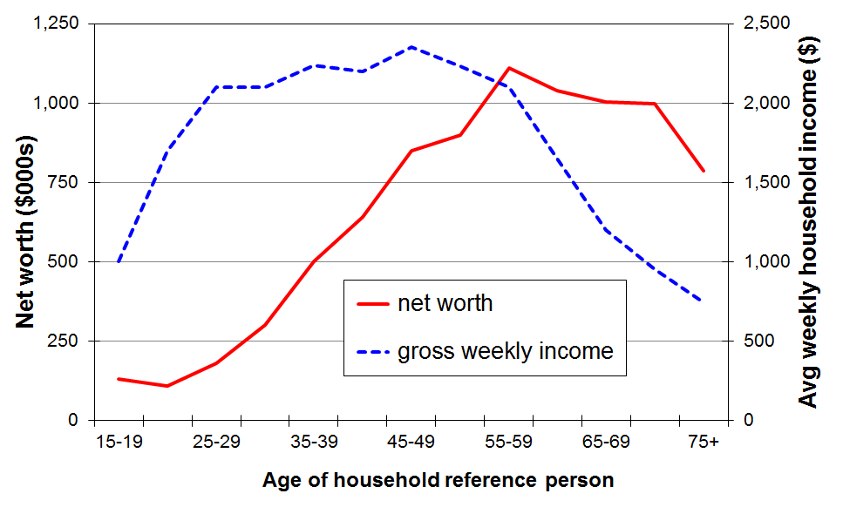
Source: Survey of Income and Housing (ABS), reported in ABS (2013b)

The life-cycle trends shown in Figure A.2 are averages. There are many whose life follows other trajectories that are not so tidy. For example, some accumulate very little wealth and become particularly vulnerable later in their life if their household income drops because of a relationship break-up, illness or redundancy.

Table A.1 shows that wealth is distributed more unequally than income. The figures are similar for both Australia and New Zealand. This is a well-established finding that applies to all OECD and EU countries and to many others.

For both Australia and New Zealand the Gini for wealth is roughly double the income Gini. The ratio of top quintile share to bottom quintile share (S5:S1) is 5 for income for both Australia and New Zealand, whereas the same share ratio for wealth is “off the scale” – around 70 for Australia.

Table A.1
Shares of income and wealth by respective quintiles (%)
 |  | Q1 (low) | Q2 | Q3 | Q4 | Q5 (high) | Share ratio, S5:S1
Household income | Australia | 8 | 13 | 17 | 23 | 40 | 5
Household income | NZ | 8 | 13 | 17 | 23 | 40 | 5
Household wealth | Australia | 1 | 5 | 12 | 21 | 61 | very large ~ 70
Household wealth | NZ | 0 | 5 | 12 | 24 | 59 | very large
Sources: Australia: ABS (2013), Tables 6 and 7, using SIH data.
New Zealand: for income, MSD analysis of HES data; for wealth, unpublished NZ Treasury analysis of SoFIE data (2003-04)

The separate distributions of income and wealth are of interest in themselves, but for the purposes of this report it is the joint distribution of household income and household wealth that matters, especially to better distinguish between households of higher and lower material wellbeing.

Table A.2 shows the joint distribution of income and wealth by reporting the share of total wealth held by households in the five income quintiles. For both Australia and New Zealand the wealth share ratio S5:S1 for income quintiles is much lower (3) than the raw wealth share ratio (70+) and is in fact lower than the income share ratio (5).

Table A.2
Shares of wealth by household income quintiles (%)
HH income quintile ➔ | Q1 (low) | Q2 | Q3 | Q4 | Q5 (high) | Wealth share ratio, S5:S1
Australia | 12 | 15 | 17 | 20 | 36 | 3
New Zealand | 12 | 15 | 14 | 19 | 39 | 3
Sources: Australia: ABS (2013), Tables 6 and 7, using SIH data (2011-12).
New Zealand: unpublished NZ Treasury analysis of SoFIE data (2003-04).

The joint distribution of wealth and income as shown in Table A.2 is a more comprehensive indicator of the distribution of household economic resources than either income or wealth on their own. The difference between the raw wealth distribution and the joint income-wealth distribution reflects in part the fact that people accumulate wealth over the course of their lives. Many older people have relatively high wealth (often in the form of a mortgage-free home in the main) but low income. Many younger households have lower wealth but higher incomes than many older people. Some of all ages have low incomes and low wealth levels.

Using the joint income-wealth distribution for better distinguishing between households with lower and higher material well-being (living standards)

Given the persuasive logic and potential public policy value of using income and wealth information to better identify the most disadvantaged households, why is it that this approach is not used as standard practice? There are two main challenges:
- first, for many countries, there are data limitations in that most regular income surveys do not also have wealth information
- second, it is not clear how best to combine the income and wealth information into one number for each household to allow household rankings to be made.

On the data front, there are signs that better survey data is coming available. The Australian efforts in this regard are well-advanced. In the 2014-15 HES, Statistics New Zealand is collecting income, wealth and more direct material wellbeing information in the one survey and plans to do so at regular intervals. This is a welcome advance that will allow a more comprehensive understanding of the links between income, wealth and material wellbeing.
However, even where good income and wealth data are available, there is no agreed way of combining the two to rank individual households on a single scale from high to low material wellbeing. This remains a significant challenge.

Even if income and wealth information cannot (yet) be combined at a household level to rank households by their economic resources, the information can be clumped at, say, a quintile level on the two dimensions in a simple cross-tabulation that enables the range of joint income and wealth scenarios to be better understood, and for the most vulnerable low-income-low-wealth groups to be identified.

Table A.3 illustrates this based on Australian data for 2009-10. It shows that around one third (35%) of those in the lowest income quintile are also in the lowest wealth quintile, while around a quarter (26%) have wealth in the top two wealth quintiles. Clearly the material wellbeing and actual day-to-day living standards of the latter group will be higher than for those with both low income and low wealth.

Table A.3
The distribution of wealth across household income quintiles, Australia (2009-10)
(%) |  | Household income quintiles
(%) |  | Q1 | Q2 | Q3 | Q4 | Q5
Household wealth quintiles | Q1 | 35 | 25 | 16 | 11 | 5
Household wealth quintiles | Q2 | 17 | 21 | 21 | 22 | 17
Household wealth quintiles | Q3 | 21 | 21 | 23 | 19 | 13
Household wealth quintiles | Q4 | 15 | 19 | 24 | 25 | 20
Household wealth quintiles | Q5 | 11 | 14 | 16 | 23 | 44
 | ALL | 100 | 100 | 100 | 100 | 100
Source: Table 8.3 in OECD (2013), from Australia’s Survey of Income and Housing

It is tempting to use a tidy-looking table like Table A.3 to reach conclusions about what proportions of low-income households (say, Q1) have low living standards and what proportion do not. To get to that next step requires further information about the actual wealth levels in the bottom two to three wealth quintiles. If these quintiles all have very low wealth, and Table A.1 indicates that they do, then the vulnerable low-income group expands from 35% to 74%. As is the case for low-income thresholds themselves, judgement calls have to be made about what wealth levels are sufficient to consider low-income households to no longer be vulnerable or “resource-poor”. In addition, the composition of the household wealth is relevant too, with some types being more liquid and accessible than others.

The 2014-15 HES will allow us to also identify the proportion in each cell in a table like Table A.3 who are also in material hardship (using the non-income measures in the HES). This will give a more comprehensive and robust picture of where the vulnerable groups are in the income-wealth grid.

Using non-income measures to measure material wellbeing

Non-income measures (NIMs) are now widely used in EU and in many OECD nations to more directly measure the material wellbeing of households, especially at the low living standards or “hardship” end of the spectrum. NIMs are sometimes called non-monetary indicators.

Using this approach, the impacts on material wellbeing of different levels of income and wealth and of the differing experiences of the “other factors” noted in Figure A.1 are all captured in the different scores reported using indices based on NIMs.

In addition to monitoring material wellbeing using household incomes, MSD also monitors material wellbeing and hardship through the use of non-income measures (NIMs) based around the basics people have and do not have, and the freedoms or restrictions they have in purchasing desirable non-essentials. Further detail is available in the companion NIMs report and in other publications available on MSD’s website.

The HES has collected information on NIMs since HES 2007.

Summing up: the use of household income as an indicator of material wellbeing

In the context of the framework indicated in Figure A.1, household income is taken to be either an imperfect but readily available and very important indicator of the “consumption possibilities” for a household, or as an indicator that allows comparisons of the potential living standards of households, all else assumed equal.

While the incomes approach has recognised limitations, there are several other factors to consider too when assessing its value for monitoring material wellbeing and hardship:
- Income and cash-in-the-hand are very important in our sort of economy and society. This is especially so for households that have low incomes, very tight budgets and very limited or negative net worth. Monitoring trends in low household incomes is very important for understanding how the more vulnerable groups are faring.
- Governments have a wide range of financial levers available to them for influencing the distribution of income. Although governments can also redirect resources to provide subsidies and services that reduce pressures on household budgets or more directly improve material wellbeing, the income levers use a much greater proportion of government expenditure than the subsidies or services (excluding public health and education).
- The ready availability of regular and good quality income data from surveys and administrative records.
- Using household income after deducting housing costs improves the congruence between the report’s findings on the income relativities between population groups and the relativities found using more direct non-income measures.

Protocols and technical information for the incomes analysis

This second part of the Introduction covers the following. See Sections E for detailed discussion of the income poverty measures used in the report.

- equivalisation: comparing incomes across different household and family types
- the income sharing unit and the unit of analysis for the presentation of results
- the bottom income decile: income not a reliable indicator of economic wellbeing
- housing costs
- data source: the Household Economic Survey (HES)
- convention for naming HES years and the HES years used in the report
- treatment of negative incomes
- adjusting for inflation
- ethnicity
- household and family types
- reliability of results
- summary of key measures used for reporting on income inequality and poverty.

Equivalisation: comparing incomes across different household and family types

Equivalisation reflects the two common sense notions that:
- a larger household needs more income than a smaller household for the two households to have similar standards of living (all else being equal), and
- there are economies of scale as household size increases.

Most sets of equivalence ratios also assume that children cost less than adults.

Equivalising is a means of standardising household incomes in terms of household size and composition so that the relative material wellbeing of households of different sizes and compositions can be more sensibly compared. The adjustment also makes comparisons over time more realistic because it takes into account the changes over time in the composition and average size of households.

While considerable research has been undertaken to try to estimate appropriate values for equivalence scales, no universally accepted ‘correct’ set of equivalence ratios has emerged, even when household size and composition are the only factors being considered.

The primary equivalence scale used in the analysis in this paper, the 1988 Revised Jensen Scale, is a scale that (by design) sits in the middle of the range of scales in the literature of that time. It is very close to what has come to be known as ‘the modified OECD scale’ which is now used by Eurostat, Australia, the United Kingdom and others. Different equivalence scales are used for the international comparison sections, in line with the conventions of the sources. Further discussion of the effect of the choice of equivalence scale is provided in Appendix 3.

This report uses the single person household as the reference household – ie a single person unit has an equivalence scale value of 1.0. A household of a couple and no children (2,0) is rated at 1.54, meaning that such a household is considered to have 1.54 equivalent adults. A two adult, two child household is rated as 2.17. This means that this household type (2,2) is rated as having 2.17 equivalent adults: it requires 2.17 times the income of a single person household to have the same purchasing power or to achieve a comparable material wellbeing, all else being equal.

Other commonly used reference households are the couple, the couple with one child and the couple with two children. The choice of reference household affects the numerical value of equivalised income but makes no difference to any of the distributional, inequality and hardship analysis that follows.

Table A.4 provides a look-up chart to convert equivalised dollars (dollars per equivalent adult) to ordinary dollars and vice versa for selected households.

The first row of figures identifies the family or household type: (1,2) is a one adult, two child household, and so on. The second row gives the values of the equivalence ratios used. The body of the table indicates, for example, that a (2,2) household needs around $28,000 to have the same purchasing power as a (1,1) household with an income of around $18,000. Each has an equivalised income of $13,000 (or, to put it another way, each household has an income of $13,000 per equivalent adult).

Table A.4
Conversion of equivalised dollars to ordinary dollars for households with low-to-middle unequivalised incomes
Equiv income | Income for families and households of various types  in ‘ordinary dollars’
 | (1,0) | (1,1) | (1,2) | (1,3) | (2,0) | (2,1) | (2,2) | (2,3) | (2,4) | (3,0)
 | 1.00 | 1.40 | 1.75 | 2.06 | 1.54 | 1.86 | 2.17 | 2.43 | 2.69 | 1.98
$10,000 | 10,000 | 14,000 | 17,500 | 20,600 | 15,400 | 18,600 | 21,700 | 24,300 | 26,900 | 19,800
$11,000 | 11,000 | 15,400 | 19,300 | 22,700 | 16,900 | 20,500 | 23,900 | 26,730 | 29,600 | 21,800
$12,000 | 12,000 | 16,900 | 21,000 | 24,700 | 18,500 | 22,300 | 26,000 | 29,160 | 32,300 | 23,800
$13,000 | 13,000 | 18,300 | 22,800 | 26,800 | 20,000 | 24,200 | 28,100 | 31,600 | 35,000 | 25,800
$14,000 | 14,000 | 19,700 | 24,500 | 28,800 | 21,600 | 26,000 | 30,400 | 34,000 | 37,700 | 27,700
$15,000 | 15,000 | 21,100 | 26,300 | 30,900 | 23,100 | 27,900 | 32,600 | 36,500 | 40,400 | 29,700
$20,000 | 20,000 | 28,100 | 35,000 | 41,200 | 30,800 | 37,200 | 43,400 | 48,600 | 53,800 | 39,600
$25,000 | 25,000 | 35,100 | 43,800 | 51,500 | 38,500 | 46,500 | 54,000 | 60,800 | 67,100 | 49,400
$30,000 | 30,000 | 42,100 | 52,400 | 61,600 | 46,100 | 55,900 | 64,800 | 72,900 | 80,600 | 59,300
$35,000 | 35,000 | 49,200 | 61,200 | 71,800 | 53,800 | 65,200 | 75,600 | 85,100 | 94,000 | 69,200
$40,000 | 40,000 | 56,200 | 69,900 | 82,100 | 61,500 | 103,700 | 74,600 | 86,400 | 97,200 | 79,000
$45,000 | 45,000 | 63,200 | 78,600 | 92,400 | 69,200 | 83,900 | 97,100 | 109,400 | 120,800 | 88,900
$50,000 | 50,000 | 70,236 | 87,367 | 102,641 | 76,844 | 93,200 | 107,900 | 121,500 | 134,300 | 98,800

This table uses the 1988 Revised Jensen equivalence scale, as does the rest of the report, except where it is stated otherwise.

A (2,3) household is one comprising 2 adults and 3 children (aged under 18 years), and so on.

Income sharing unit and the unit of analysis for the presentation of results

The household is used as the income sharing unit (or unit of income aggregation). All individuals in the household are assumed to benefit reasonably equally from the combined income of the household and to share a similar standard of living. Clearly this is not always the case but it is “defensible as [an approximation] to a very complicated reality of intra- and inter-household patterns of sharing” (Bradbury, 2003:25).

The use of the household as the income sharing unit is in line with international standard practice.

The unit of analysis for reporting purposes is the individual. The household’s equivalised disposable income is attributed to each household member as an indicator of the individual’s (potential) living standards and is used for ranking purposes.

For subgroup analysis individuals are grouped by their own characteristics (eg age), or by the characteristics of their household or family type (eg two-parent, ‘workless’, and so on). In all cases the individual is ranked or classified according to the income of their household as this gives the best income-based indication of their economic wellbeing, in line with the central purpose of this report.

A key subgroup in this report is dependent children. Dependent children are all those under 18 years, except for those 16 and 17 year olds who are in receipt of a benefit in their own right or who are employed for 30 hours or more a week.

For international comparisons using OECD data, children are taken as all those under 18 years. The use of ‘0 to17 years’ rather than ‘dependent children’ makes virtually no difference to the reported results.

The economic family unit (EFU)

An alternative income sharing unit that has sometimes been used is the benefit eligibility unit, often referred to in New Zealand as the economic family unit or EFU. The EFU approach allows for only three ways to group individuals when it comes to income sharing: couple only, two parent with dependent children, and sole parent with dependent children. All other individuals are treated as if they are ‘on their own’ even when they share (to varying degrees) in the general resources of a larger household. The Ministry of Social Development used the EFU approach in incomes analysis from 2002 to 2006 but reverted to the household approach in 2007 as fewer anomalies are created by this approach. It also brought New Zealand back into line with international practice.

Rules for determining household membership

A household for the HES relates to a ‘private household’ which is defined as:

either a single individual living in a dwelling who makes his or her own housekeeping arrangements

or a group of people living in or sharing a dwelling for four or more days a week, who participate in some measure at least in consumption of food purchased for joint use by members (or who, if not dependent upon a household member, contribute some portion of income towards the provision of essentials of living for the household as a whole).

The following are included in the household for survey purposes:

any person who, because of the nature of his or her occupation cannot spend as many as four nights a week in the household but who makes a financial contribution to the running of the household and is not currently a member of another New Zealand resident private household in a permanent dwelling

any person at boarding school or other non-private institution who usually spends holidays or other continuous periods at home, and whose living costs are subsidised by at least 50 percent by the household

any child whose custody is shared between two households but who spends more than half their time in the sampled household – where custody or care is shared equally between two households, the child should be included in the sampled household only if they are there the night the household questionnaire is completed.

The bottom income decile: income not a reliable indicator of material wellbeing

While household income is far from perfect as a measure of material wellbeing it is generally a useful enough indicator. There are however some households for whom it would clearly be very misleading to take their incomes as even a rough and ready indicator of their material living standards. This assessment is based on comparisons with income information from other surveys and known benefit levels, and from HES expenditure information: some households have implausibly low incomes, well below the minimum social support levels; some have reported expenditures well above their reported incomes.

Some of these households will be declaring income from self-employment which can legitimately be much lower than reported expenditure – the declared income may even be negative. Others will have accurately reported their incomes but will have had access to loans, gifts or ‘savings’ in one form or other which have been used for purchasing goods and services. Others will have intentionally or unintentionally under-reported their incomes.

Households with implausibly low incomes per se are of course found only in the bottom decile (bottom 10% of the income distribution). The reported incomes of many at the bottom are less than the incomes provided by government cash benefits or New Zealand Superannuation. This points to mis-reporting or data entry errors.

Those reporting expenditure much higher than reported income are found in most parts of the income distribution but the bulk of them are found in the bottom decile. For example, of all those in households reporting expenditure which is more than three times their income, around 70% to 80% are in the bottom income decile in any survey year.

This noise in the lower end of the income distribution has only a limited impact on most of the indicators used in this report. For example, it does not impact greatly on the medians as the bulk of households in question would remain below the median even if their expenditures were taken as better estimates of their actual income than what was reported as such. Nor does it impact significantly on trends over time for either poverty or inequality indicators.

In general the impact is significant where the indicator is highly dependent on the incomes of those in the bottom decile or a little above it. This means, for example, that point-in-time poverty levels are noticeably affected when BHC poverty lines are set at levels lower than the 50% of median line (eg 40% of median), or below 40% for the AHC approach. In addition, the level and trend of the P10 (10th percentile) line and measures of poverty depth (see Section E) are also significantly affected.

As appropriate, the report makes comment on the likely impact of the noise at the bottom end of the income distribution in the text associated with affected indicators. Appendices 8 and 9 provide a fuller discussion of the issue.

The companion NIMs report also discusses the issue in Section F.

Housing costs

The report provides information based on household income both before deducting housing costs (BHC) and after deducting housing costs (AHC).

Housing costs include all mortgage outgoings (principal and interest) together with rent and rates for all household members. Repairs and maintenance and dwelling insurance are not included. Any housing-related cash assistance from the state (eg Accommodation Supplement) is included in household income. These housing costs make up on average around 45% of the budget for working-age low-income working-age households (bottom three income deciles, unequivalised income). For many, of course, it is 50% or more.

For reporting on overall trends in household income and on income inequality, there is value in seeing the similarities and differences between the two measures (BHC and AHC) and in understanding the differing stories they tell. For reporting on trends in income poverty over time and for comparing hardship across subgroups of the population, the report recommends the use of AHC measures, although both BHC and AHC are reported.

The use of BHC measures is generally taken as the self-evident starting point. They are important for assessing the adequacy of market and social assistance incomes for delivering a minimum acceptable standard of living. Their use also ensures that the material wellbeing of those on low incomes who choose to live where accommodation is less expensive (eg some rural areas) or who live in ‘cheap’ substandard accommodation is not left overstated (relatively) as the use of an AHC approach on its own can do.

The rationale for the report’s position that AHC analysis should also be reported, and that the AHC approach is preferable for subgroup comparisons in New Zealand is that:
- First, variations in housing costs do not necessarily correspond to similar variations in housing quality. This is most significant when comparing the material wellbeing of age groups. Many older individuals are in households that have good accommodation and relatively low housing costs (eg those living in mortgage-free homes). Many in an earlier part of the life cycle have a similar standard of accommodation but relatively high accommodation costs. Ideally, the value of imputed rent for homeowners would be added to income to even up the comparisons (ie the BHC approach has limitations in this regard), but the practical difficulties are considerable. As an approximation for the purposes of comparing material wellbeing, the AHC approach deducts housing costs from after-tax cash income for all households.
- Once a household is committed to a particular residence, outgoings on housing costs cannot easily be adjusted or put off in “tight times” as they can for other expenses like entertainment and recreation, and even to some degree for basics like food and clothing. When the primary focus is on trends in income poverty and hardship, it is important to understand trends in “residual income”, taking housing costs as a given fixed cost in effect. Housing costs represent a very significant proportion of the total spending for many low-income households.
- Third, a unique characteristic of the New Zealand BHC income distribution is the large ‘pensioner spike’ at around the value of New Zealand Superannuation. In recent years, the spike has been located close to a 50% of median poverty line (BHC). In the late 1990s it was around a 60% of median poverty line. The presence of the spike can lead to large variations in reported poverty rates for the 65+ group over time, leaving the misleading impression that there are significant changes in material wellbeing occurring for this group. In addition, the same issue can lead to similarly misleading comparisons with the relative wellbeing of other age groups. An AHC approach largely avoids these issues and is more suitable as the primary measure (for New Zealand at least). See also Section I.

Imputed rent

For households with similar income and similar other characteristics, the consumption possibilities are much greater for households with low housing costs than for those with high housing costs. As discussed above, standard income measures of material wellbeing do not capture this difference: households with the same BHC income are ranked in the same place despite housing cost differences.

The use of “imputed rent” is an important way of dealing with this in a formal way. Imputed rent for home-owners is the difference between the estimated market rent of the dwelling and the usual costs a landlord would incur such as mortgage interest, rates, insurance and minor repairs. For renters whose rent is subsidised, imputed rent is the difference between market rent and actual rent paid.

The inclusion of imputed rent in household income is something to be aspired to. It provides a more realistic and meaningful comparison of the material wellbeing of households of different tenure type. Several OECD and EU countries are developing methodologies to enable this advance to be applied and used, but there is no standard approach agreed to as yet. The imputation is a quite data intensive exercise. (See Figari and Paulus (2013) and Maestri (2012) for reports on empirical efforts to impute rents and to observe the changed ranking of households that follows.)

In the meantime, this report uses the AHC approach outlined above to take some account of the implications of different tenure arrangements for comparing the material wellbeing of households.

Further discussion on the relative merits of the BHC and AHC approaches is in Appendix 5.

Main data source: the Household Economic Survey (HES)

The report draws on data from Statistics New Zealand’s Household Economic Survey (HES). The HES was an annual survey from 1982 to 1998, using March years, then three-yearly from 1998 to 2007, using June years from 2001 on. The 2007-2008 survey was the first of the new HES (Income) Surveys which makes income, housing cost and living standard indicator data available in each of the two years between the full HES surveys. The HES (Income) collects the same information on these domains as the full HES does. The full HES (including full expenditure information) is still on a three-yearly cycle. The 2012-2013 HES is the latest full HES.

A sample of approximately 3000 private households is achieved each survey (see Table A.5 below for details). Interviews are conducted face to face. For the full HES, contact with each participating household extends for a period of just over two weeks. During that time, each household member aged 15 years or over keeps an expenditure diary for 14 consecutive days, recalls major purchases made in the previous 12 months, and provides income and employment data. The income information is also for the 12 months prior to interview.

The target population for the HES is New Zealand resident private households living in permanent dwellings. This means, for example, that those in institutions and those in non-permanent dwellings are not included.

Table A.5
Achieved sample sizes and response rates for recent HES (for data held by MSD)
HES year | Achieved sample size | Response rate
2000-01 | 2808 | 73%
2003-04 | 2854 | 73%
2006-07 | 2550 | 62%
2007-08 | 3295 | 77%
2008-09 | 3210 | 74%
2009-10 | 3126 | 69%
2010-11 | 3536 | 81%
2011-12 | 3565 | 83%
2012-13 | 3003 | 67%
2013-14 | 3400 | 81%
Note: The response rate for 2009-10 and later is the post-imputation response rate. For other years it is the pre-imputation response rate. See the text below.

Imputation was introduced into HES for the 2009-10 survey. Imputation is a data set enhancing process that replaces missing values with actual values from similar respondents. At that time, imputation was also applied to the data for the 2006-07, 2007-08 and 2008-09 surveys, and Statistics New Zealand has updated its Hot Off the Press tables and Table Builder information accordingly.

The 2015 Incomes Report has revised all the relevant tables and charts from HES 2006-07 using the data sets with imputation. The revisions are all relatively minor, and there is no change to trends or relativities or Key Findings.

The report also uses some net worth and income mobility information from Statistics New Zealand’s longitudinal Survey of Families, Income and Employment (SoFIE).

Population weighting

The preparation of the HES weights provided by Statistics New Zealand to enable population estimates to be produced from the HES sample follow a two stage process:
- the sample design weight (the inverse of the selection probability) is calculated for each private household, along with an adjustment for non-response
- the weight of each household is adjusted using integrated weighting, calibrating to independent benchmarks of the number of people by age, sex, ethnicity and region and the number of households by household size (from estimates based on the 2006 Census for the 2013-14 HES).

The HES weights do not calibrate to the number of people receiving income-tested benefits or New Zealand Superannuation payments. The HES underestimates these numbers by around a third in each survey.

The Treasury has also developed a set of weights for use with its HES-based tax-benefit microsimulation model, Taxwell. The Taxwell weights include the number of beneficiaries as one of the key benchmarks, in accordance with Treasury’s primary use for the HES in the Taxwell model. Treasury’s Taxwell weights therefore provide a better estimate, for example, of the number of children in beneficiary families, although to achieve this there has been a trade-off with achieving other benchmarks. This report almost always uses Statistics New Zealand’s HES weights. Where the Taxwell weights are used, this is made clear in the text.

Convention for labelling HES years

The report adopts a common short-hand convention for describing HES years. For example, “the 2007 HES” is short for “the 2006-07 HES”. The 2007 survey is for the year ending 30 June 2007 with its midpoint in December 2006. For the 1998 HES and earlier ones the survey period was for March years. The 1998 HES therefore has a midpoint of September 1997. There is therefore a good case to be made for the 2006-07 HES being labelled the “2006 HES”. While logic and clarity support this, it would unfortunately fly in the face of common custom and possibly lead to confusion. This report has therefore (reluctantly) followed the custom to date.

In its international league tables and other publications the OECD uses the “2006-07” = 2006 approach. As the OECD’s reports are now much more easily accessible, better promoted and more widely read, there is a better case now for adopting that pattern. It is likely to change for next year’s report.

The income values, inequality figures, poverty rates, and so on for specified HES years are best interpreted as being for the calendar year in which the survey started unless noted otherwise. Particular care is required in establishing which survey year will pick up the implications of policy changes or of significant labour market or GDP changes, or of other major events, when some or all of these changes occur during a survey year.

HES years used in the report

The tables and graphs report for each second HES year from 1982 to 1998 and every three years to 2007, then each survey for 2009 to 2014. Key changes in the income distribution occurred in the years from 1988 and again from 1994. The loss of information that arises from using every second year only does not impact on the overall trends reported as these key years are included in the reporting.

The points on the graphs are all joined by straight or smoothed lines. This is done for presentational purposes only to give the general trends, and should not be taken to mean that the data points in the intervening years would all lie on the interpolated lines.

Special note on the data for the 2008 HES (Income)

The income poverty and inequality figures for 2008 published in the 2009 report are not included in subsequent reports as a significant issue was discovered with the calculated disposable income variable in the Taxwell data in Statistics New Zealand’s 2007-08 HES dataset. Initial investigations suggested that the issue arose from the modeled Accommodation Supplement amounts used in calculating the household income variable. This led to household disposable incomes for the 2007-08 year being understated for many low-income households. The poverty and inequality figures reported in the 2009 report were therefore inflated for the 2008 year.

The issue is now resolved and we expect to be able to report on 2008 findings in the 2016 report.

Treatment of negative incomes

In each HES survey there are a few records showing negative incomes. For this report these negative incomes are re-assigned a value of zero before analysis is undertaken. This is done to reasonably approximate the treatment of negatives asked for by the OECD in the data sent to them by statistical agencies such as Statistics New Zealand and it therefore assists with international comparisons. This treatment of negatives has no effect on medians, no impact on reported trends over time for the approaches used in this report, nor on poverty rates at any point in time, nor on the composition of the poor. It has a very small impact on means and income shares for quintiles.

Adjusting for inflation

Household incomes and low-income thresholds are adjusted for inflation at various places in the report. Household incomes are converted to 2013 dollars for reporting on income trends in real terms. For the reporting on trends in income poverty based on an “anchored” or “fixed line” approach, thresholds are based on proportions of the 2007 median and are held constant in real terms over other years.

The adjustments for inflation are carried out using CPI full-year averages for a March year up to and including the 1998 survey and a June year from 2001. For BHC incomes Statistics New Zealand’s CPIQ.SE9A series is used, with the annual figure being the average of the four quarters for the period. AHC incomes and thresholds from 1989 to 2013 are adjusted using the index from the “All Groups less Housing” series (CPIQ.SE9NS1010) for the survey’s midpoint quarter. For 1982 to 1988 the AHC adjustments are based on the author’s extrapolation of the series. The reported trends in AHC incomes and the size of low-income populations are not greatly sensitive to different assumptions within a plausible range for the index in the estimated years. See Appendix 7 for the indices used.

Ethnicity

Ethnicity of individuals aged 15 and over is as reported by the individual. Children under 15 are attributed with the ethnicity of the survey respondent in years to HES 2004. Starting with HES 2007, ethnicity for children is provided in the survey data, with the information coming from either the children themselves or from their parents. No analysis is carried out based on household or family ethnicity as ethnicity is a characteristic of individuals.

If a respondent reports more than one ethnicity, the ethnicity attributed is determined according to a prioritised classification of Māori, Pacific Island, Other and then European/Pākehā. Using a “total counts ethnicity” approach makes no noticeable difference to the findings in this report. The table below illustrates this using the 50% AHC moving line measure for the whole population. Moving to the total ethnicity convention is on the agenda for a future issue of the Incomes Report.

rate (%) | Prioritised | Total
European/Pakeha | 10 | 11
Maori | 21 | 21
Pacific | 20 | 22
Other | 23 | 22
ALL | 14 | 15

Only limited analysis by ethnicity is reported because of the relatively small sample sizes for Maori, Pacific and Other (especially for Pacific). See the discussion below under “Reliability of results”.
Household and family types

The report uses the following household types for subgroup analysis.

Household type | Definition
One person HH, 65+ | one person aged 65+
Couple HH, 65+ | at least one partner is 65+
One person HH, under 65 | one person aged under 65
Couple HH, under 65 | both partners are under 65
SP with children | SP with children, at least one of whom is dependent
2P with children | 2P with children, at least one of whom is dependent
Other family HHs with children | Family HHs (other than SP or 2P HHs) where there is at least one dependent child
Other family HHs, adults only | Family HHs (other than couples) where there are no dependent children
Non-family HHs | Unrelated individuals

For family types, the report uses the ‘economic family unit’ (EFU). There are four types of EFU:
- couple only
- two parent with dependent children
- sole parent with dependent children
- everyone else (ie unattached individuals who are not dependent children).

In each case the EFU may be living in their own separate household or with others in a wider household.

Note that the household is always used as the income sharing unit. Individuals are attributed with their household’s equivalised income, then assigned to a particular household or family type, carrying their household’s equivalised income with them as an indicator of their material wellbeing.

Reliability of results

As the figures in this report are estimates taken from a sample survey, they are subject to variation as a result of both sampling error and bias due to non-sampling error, especially non-response.

In addition, there are assumptions made in the use of equivalised income as an indicator of (potential) living standards and in constructing the measures of inequality and hardship.

All these factors raise the question of the reliability of the results.

Sampling error

Sampling error is about the variability that occurs by chance because a sample rather than an entire population is surveyed. For example, the relative sampling error for average household income is typically around 4% at the 95% confidence level. This means that there is a 95 percent chance that the true value lies within 4% of the survey mean.

The sampling error is larger the greater is the degree of disaggregation at which results are presented. Special care is therefore needed when interpreting results applying to smaller subgroups. Care is also needed when comparing estimates from one survey to the next as both estimates are subject to sampling error.

Three examples are discussed below to illustrate the issues.

People living in sole parent households are a relatively small subgroup, making up only 8% of the population. In Table B.7 the distribution of the population across household income quintiles is reported by various household types. Only 5% of those in sole parent households are found in the top income quintile. On the other hand, a high proportion have incomes in the lower end of the income distribution. When reading Table B.7 for the distribution of those in this household type across the quintiles, it is reasonable to conclude that “around four in five are found in the bottom two quintiles”, and “there are very few in the top quintile”, but to claim that “15,600 (5% of 312,000) are in the top quintile” would be spurious precision.

Another example is reporting on poverty trends by ethnicity. The example uses changes from HES 2004 to 2007. The Pacific, Maori and Other groups made up 6%, 15%, and 13% respectively of the population in 2007, using the HES weights. Between the 2004 HES and the 2007 HES, the estimated poverty rates using the AHC 60% fixed line measure fell dramatically for those classified as Pacific (29% to 12%), while for Maori there was very little change (22% to 24%). The large change for Pacific is inconsistent with independent information for the period from the Income Supplement (IS) of the Household Labour Force Survey (HLFS) which has a larger sample than the HES. It would be misleading to report on the basis of these two HES surveys that “poverty has reduced significantly for Pacific people” – or, if it went to, say, 25% in HES 2008 that “Pacific poverty rose sharply from 2007 to 2008”.

For those classified as Other for ethnicity the estimated poverty rate fell from 38% (2004) to 21% (2007). Again, this is inconsistent with HLFS-IS information for the period. In this case, the size of the subgroup is itself probably not the only issue. The volatility for those classified as of Other ethnicity is likely to be driven to a large degree by the considerable heterogeneity in this group, and its changing composition over recent years. This heterogeneity adds another source of potential sampling error when using smaller subgroups. It applies much more to a subgroup like those classified as of Other ethnicity than to a similar sized group such as sole parent households discussed above which is more homogeneous in relation to household incomes and factors which impact on these. Those in one person 65+ households are a smaller still subgroup (4%), but are even more homogeneous (eg they are all in the same household type, in the same age group, and are mainly European/Pakeha).

For these reasons, poverty trends by ethnicity are not reported. Instead, trends in median household incomes are provided, and the distribution across quintiles is given to provide an indication of the relative spread of incomes. The median incomes are still subject to sampling error but as they use information from the whole sample rather than just from those at the low end, the trends are more reliable. For poverty levels the report uses the average of the latest three surveys to give a reasonably robust estimate of relativities of one group compared with the others.

The third example is from the reporting on trends in income inequality using the Gini coefficient. From 2008-09 to 2009-10 there was a sizeable decrease in the Gini, and from 2009-10 to 2010-11, an even larger increase. Both these changes are statistically significant. However, the more modest net change from 2008-09 to 2010-11 is not statistically significant. This example illustrates why this report cautions against reading too much too soon into year on year changes, and generally encourages the taking of a longer run perspective on trends.

Non-response

The reliability of the results is also affected by any bias due to differential non-response from households chosen for interview. To go some way to correct for this, when weights are being assigned to households to produce population estimates, those households that are under-represented in the sample are given larger weights to compensate. The weights are chosen so that grossed-up population estimates accord with key control variables such as the age, gender and household type distributions from the latest census or census-based projections.

There is, however, no guarantee that such weighting procedures will deliver accurate population estimates for all variables of interest. One area where this is an issue affecting reliability of results using the HES is in the estimates of the number of beneficiaries. The HES typically underestimates beneficiary numbers by around one-third. The total value of the Accommodation Supplement (AS) reported in the HES is around 40% to 50% of that recorded in the Ministry of Social Development’s administrative data. This may not necessarily mean that half the AS income is missed, as some of the “missing” amount is likely to be counted in the reported benefit income which is in aggregate usually higher than administrative records report.

The report uses Treasury ‘s modelled values of benefit income, modelled WFF tax credits and modelled AS, so the actual reported values do not come into the analysis in the report.

Income as an indicator of material wellbeing

There is a general question as to how well income performs as an indicator of access to resources or as a proxy for living standards, but the most pressing issue, as noted above, is that there are particular problems in the bottom decile where the incomes of many households cannot be taken even as a rough and ready indication of resources. Where the noise in the bottom decile significantly impacts on reported results, the associated text notes and describes the impact. This issue is further discussed in Appendices 8 and 9.

Avoiding unwarranted impressions of precision

The use of too many significant figures or decimal places in reporting results can imply a spurious precision that is inconsistent with the considerations noted above. This applies particularly to poverty rates, and especially for figures relating to subgroups of the whole population. Poverty rates and poverty structure are therefore generally reported to the nearest whole number rather than to one decimal place as is common elsewhere.

Longer-term trends over several surveys and significant differences between subgroups within a year can be counted as providing robust and reliable information. Smaller changes between surveys and small differences between subgroups in the one survey year should not be used to support definitive conclusions about change or differences.

Beneficiary incomes in the 2013-14 data: implications for reporting

The incomes of some beneficiary families are implausibly low in the 2013-14 data. The issue arose in association with the change in core benefit categories and names in July 2013. It appears that some respondents did not tick the boxes for both the old and new categories when they actually received both over the survey period, thus leading to an under-estimate of their time on benefit. For the HES-Taxwell data beneficiary income is modelled based on benefit type, time on benefit, and other survey information. As the time on benefit for some is under-estimated, their income is also under-estimated. No separate annual income estimate is asked for in the survey. Statistics New Zealand has developed an adjustment to account for the under-estimate issue where they can, but there remain some implausibly low incomes for some beneficiary families and individuals. The number of beneficiaries in the sample is not impacted by this income issue: in 2013-14 they are as expected.

The bulk of families and individuals in receipt of a core benefit have incomes in the bottom two BHC income deciles, mainly the bottom decile. The 2013-14 data shows a higher proportion of all beneficiaries have incomes in the bottom decile compared with previous years (63% rather than typically around 50%), and slightly lower proportions in the second and third deciles. This is likely to have a small downward impact on the dollar value of the bottom decile boundary (P10), but no noticeable impact on the decile 2 boundary (P20) as around 80% of beneficiaries have incomes below P20.

The income data issue has no impact on the bulk of the figures in this report. For example:
- None of the findings using non-incomes measures are affected.
- Median household income is not affected as beneficiaries have incomes at the lower end of the income distribution, well below the median.
- Figure A.3 shows the Gini inequality figures for the population as a whole and for the whole population with beneficiaries removed. The rise through to 2013-14 is driven in the main by the rises in incomes for the top three deciles and around the median, while the lower two deciles remained much the same in real terms.

Figure A.3
Income inequality trends for the whole population and for the non-beneficiary population
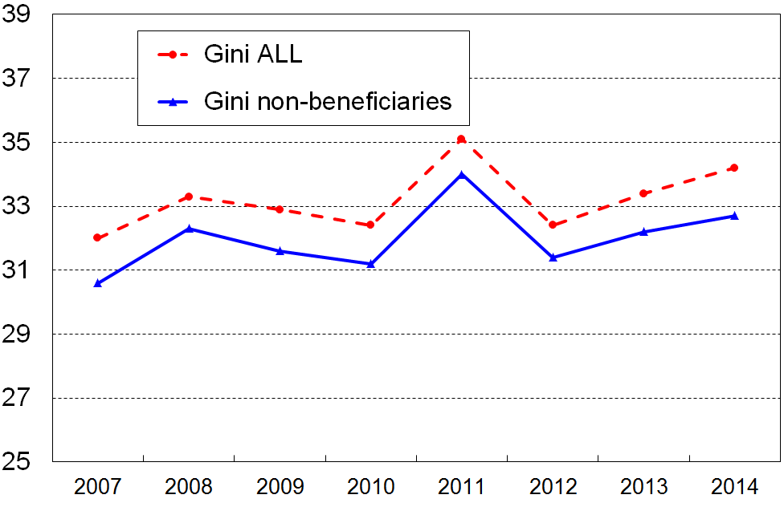

There is an impact on the bottom decile mean and bottom decile share of total income, but the Incomes Report advises against using these figures anyway (see Appendices 8 and 9), so there are no practical implications there.

As a precaution, there are five figures that this year’s report is not reporting given the known data issue. The table below lists these and the rationale for their omission, and comments on the decision.

Measure not reported | Rationale for omission | Comment
90:10 household income inequality measure | The P10 dollar figure (top of decile one) is likely to be a little lower than it ought to be, thus slightly inflating the 90:10 ratio. | The report already cautions on the volatility of the 90:10 ratio.  The real dollar value of P90 rose 6% through to 2013-14 so this, not the small P10 drop, would have dominated the 90:10 change if it had been used .
P10 dollar value of upper boundary of decile 1 | The P10 dollar figure (top of decile one) is likely to be a little lower than it ought to be. | The reported change from HES 2013 to 2014 is close to zero, as it was from HES 2012 to 2013. It is likely that the correct reported change from HES 2013 to 2014 would be slightly positive.
50% of median BHC income poverty measure | Most sole parents on the DPB or JS or SPS who are in private rentals and who have no other income have total incomes just a little below or a little above 50% of the median. It is possible that with other income their total income could be more than 50% of the median. Because of the proximity of these incomes to the 50% line, the 50% of median figures are not reported this year. | Other JS recipients have incomes well below the 50% line.  The median increased 5% in real terms to 2013-14 and this increase accounts for the bulk of the increase in the numbers under a 50% line.  The decision to not report on the 50% of median figure is therefore a conservative one.  The 60% of median figures are reported as the impact on them is likely to be small as few beneficiaries have incomes in that area.
40% of median AHC income poverty measure | There are some beneficiaries in private rental accommodation with incomes near the 40% AHC line. Figures using the 40% AHC line are therefore not reported. | Most beneficiary families have AHC incomes below the 40% of median line (AHC). The figures using the 50% and 60% fully relative AHC measures and the AHC 60% anchored lines are not likely to be greatly affected. These and the corresponding anchored line measure are the main measures used in the detailed analysis in the report.
Main source of income for those with low BHC incomes (benefit or paid work?) | The report does not report on this proportion using a BHC 50% threshold, for the reasons noted above. | Source of income figures are reported for households with low AHC incomes, using the AHC 60% of median anchored line as the threshold. This is safe as almost all beneficiaries have AHC incomes that put them well below this line even when there are no questions about the income data  The analysis can still be done using non-income measures.  The main message about the proportion of “working poor” is not affected.

Summary of key measures used for reporting on income inequality and poverty

The table below gives a high-level outline of the measures used in the report for the inequality and poverty analysis. Issues around each decision point are discussed in the main sections that follow and in the Appendices.

Decision point | Option used in this report
income sharing unit | household (HH)
income concept | equivalised disposable HH income (ie after-tax cash income, adjusted for HH size and composition)  - before deducting housing costs (BHC)  - after deducting housing costs (AHC)
equivalence scale | revised Jensen 1988 (except for Section J, the international section, in which the ‘square root’ scale is used for OECD comparisons, and the ‘modified OECD scale’ for EU comparisons
inequality measures | percentile ratios (90/10 and 80/20)  decile and quintile share ratios  Gini coefficient
types of low-income thresholds or ‘poverty lines’ | ‘moving line’ thresholds – set relative to the median for the survey year (REL)  ‘fixed line’ thresholds – anchored in a base year (2007) and kept at a constant value in real terms (CV)
setting of low-income thresholds or ‘poverty lines’ | REL thresholds set at 50% and 60% of the median HH income (BHC)  CV thresholds set at 50% and 60% of the 2007 median HH income (BHC), and adjusted forward and back by the CPI  AHC thresholds are set at 25% less than the corresponding BHC threshold, as an allowance for average housing costs
primary measure for income poverty trends | AHC ‘fixed line’ (60%) – the rationale for this is noted earlier in this Section and is further discussed in Section E.

Section B
Household incomes in 2013-14

This section provides general information on the distribution of household income using the 2013-14 HES (2014 HES). The following are reported:
- means and medians for gross, disposable and equivalised disposable income
- medians for different household types
- graphs of the income distribution for the whole population
- a table to assist households to identify where they fall in the distribution
- distribution of individuals across household income quintiles by various household and individual characteristics
- income shares for income deciles
- the extent of re-distribution of market income through taxes and cash benefits.

Means and medians

Table B.1 reports median and mean household incomes for the 2014 HES using gross, disposable (after-tax), and equivalised disposable concepts, and the changes in real terms from the 2009 to 2011 HES and from the 2011 to 2014 HES. Longer term trends are reported in Section D.

In the 2014 HES, median annual household income after taking account of all income tax paid and transfers received (eg welfare benefits, NZS, WFF tax credits) was $70,900. Mean or average household income was higher at $84,200.

Table B.1
Gross, disposable and equivalised disposable household incomes:
annual medians and means (HES 2014), with changes from recent years
 | Median |  |  | Mean
 | 2013-14 HES | Real changes |  | 2013-14 HES | Real changes
 | 2013-14 HES | 2008-09 to 2010-11 | 2010-11 to 2013-14 | 2013-14 HES | 2008-09 to 2010-11 | 2010-11 to 2013-14
Gross | $84,700 | -3.8% | +7.6% | $103,000 | -2.0% | 5.1%
Disposable (BHC) | $70,900 | -1.7% | +8.4% | $84,200 | +1.0% | 6.2%
Disposable (AHC) | $55,900 | -1.3% | +11.1% | $68,900 | +0.8% | +7.8%
Equiv disposable (BHC) | $35,700 | -2.9% | +8.9% | $43,200 | +0.7% | +7.0%
Equiv disposable (AHC) | $27,800 | -3.1% | +6.9% | $35,400 | +0.5% | +9.1%
Note: The equivalised income rows in the table (the bottom two) use the one person household as the reference. The unit is ‘dollars per equivalent adult’.

The impact on household incomes of the global financial crisis and economic slowdown began to be seen in the 2009-10 HES. Using the 2008-09 HES as the reference year the “2008-09 to 2010-11” columns show the cumulative impact over two surveys.

The gross median income fell by some 4% and disposable (after tax) household income by 2% in real terms. The smaller after-tax decline reflects the higher average income tax rate for higher income households. The household disposable income distribution is less spread than the gross income distribution and the changes from year to year are therefore smaller in percentage terms.

Changes in the mean are a little different than changes in the median as they are strongly influenced by what happens to higher incomes whereas changes in the median are influenced by what happens to incomes in the middle parts of the distribution.

The “2010-11 to 2013-14” columns show evidence of household incomes recovering: an 8% real increase for median gross household income and for median household income after tax and after adjusting household size and composition (equivalised disposable household income).

Medians are calculated by assigning individuals the income of their household, ranking the individuals and finding the middle one. This person-weighted approach is different from the household-weighted approach which simply ranks households by their income and finds the middle household. The person-weighted approach is the international standard for the sort of analysis carried out for this report. See Appendix 4 for further information.

Mean incomes are higher than median incomes because of the skew of the income distribution towards the lower end. The relatively few households with incomes at the very upper ranges of the income distribution have a disproportionately large upward impact on the mean compared with their impact on the median, and therefore pull the mean up above the median. The varying number of very high income households in different years can also lead to the mean being less stable than the median.

Medians for households of different types

The overall median BHC household disposable income in the 2014 HES was $70,900 (ordinary dollars). In equivalised terms this is 35,700 dollars per equivalent adult.

Different household types have different median incomes, some above and some below the overall median. For example, the median household income for households comprising a couple plus one dependent child was $81,400 in ordinary dollars and $40,800 when the ranking is done by equivalised household incomes (ie 40,800 dollars per equivalent adult).

Table B.2 shows the median disposable incomes (BHC) of different household types using incomes before equivalising (centre column) and after equivalising the household incomes (right hand column).

Table B.3 shows the same information for AHC incomes.

Tables B.2 and B.3 show that the median equivalised household incomes for older one-person and couple households, sole-parent households and larger two-parent households are all below the overall median. This means that these households are all more concentrated in the lower half of the equivalised income distribution.

On the other hand, “working age” couple-only households, two parent with one dependent child households and family households with no dependent children have equivalised medians above the overall median and are therefore more concentrated in the upper half of the equivalised income distribution.

The relatively large increases in median incomes for “working age” couple-only households, older family households with no dependent children and for smaller two parent family households flowed through to drive the 6% rise in the median from HES 2012-13 to 2013-14 (in nominal terms), as these households are relatively dense around the median and above.

Table B.2
Median disposable income (BHC) for different household types (HES 2014)
in ordinary and equivalised dollars
HH type | Median disposable income for the HH type  (ordinary $) | Median disposable income for the HH type  ($ per equivalent adult)
One person, 65+ | 20,300 | 20,300
Couple, 65+ | 50,000 | 32,500
One person, under 65 | 34,000 | 34,000
Couple, under 65 | 82,200 | 53,400
SP, 1 child | 36,000 | 21,300
SP, 2 children | 32,900 | 18,800
SP, 3 or more children | 37,500 | 17,700
2P, 1 child | 81,400 | 40,800
2P, 2 children | 74,900 | 35,000
2P, 3 or more children | 74,500 | 27,500
Other family HHs with children | 92,200 | 34,000
Family HHs, all < 65 – no children | 96,000 | 47,700
Family HHs, at least one 65+ – no children | 74,100 | 37,500
Whole population | 70,900 | 35,700

Table B.3
Median disposable income (AHC) for different household types (HES 2014)
in ordinary and equivalised dollars
HH type | Median disposable income for the HH type  (ordinary $) | Median disposable income for the HH type  ($ per equivalent adult)
One person, 65+ | 18,000 | 18,000
Couple, 65+ | 45,000 | 29,300
One person, under 65 | 23,600 | 23,600
Couple, under 65 | 66,500 | 43,200
SP, 1 child | 22,700 | 14,900
SP, 2 children | 23,400 | 11,700
SP, 3 or more children | 22,300 | 10,400
2P, 1 child | 64,700 | 32,300
2P, 2 children | 56,500 | 25,100
2P, 3 or more children | 57,500 | 21,800
Other family HHs with children | 72,100 | 26,700
Family HHs, all < 65 – no children | 76,700 | 37,800
Family HHs, at least one 65+ – no children | 65,500 | 33,100
Whole population | 55,900 | 27,800

Note: See the box on the next page for further information about the relationship between the two columns of figures in these tables.

Reconciling Table A.4 with Tables B.2 and B.3
This report uses the one person household as the reference for the equivalising process. The unit is dollars per equivalent adult. To convert ordinary disposable income to equivalised incomes for a particular household type, the ordinary incomes need to be divided by the appropriate equivalence ratio listed in Table A.1 in the Introduction. For example for a (2,1) household, divide by 1.86. This means that a (2,1) household with a disposable income of $65,500 has an equivalised disposable income of $35,200 (ie 35,200 dollars per equivalent adult). (65,500 / 1.86 = 35,200)

This relatively simple conversion can be applied to any individual household. It cannot however be generally applied to medians of the population as a whole or of any subgroup of the population. There are three reasons for this:
- For the population as a whole, the concept of equivalence ratio is meaningless as individuals come from a range of different household types, and different equivalence ratios apply to each of these.
- For some subgroups (eg “other family households with children”), no equivalence ratio is defined as there are unknown numbers of children and adults in each household in this group.
- For any subgroup of households which have children, children of different ages are assigned a slightly different equivalence ratio when using the 1988 Revised Jensen scale. This means that the ranking of individuals using equivalised incomes can end up slightly different than the ranking of individuals using ordinary household incomes for the same household type (eg couple plus one dependent child). This leads to the equivalised median being not quite the same as the “ordinary” income divided by the appropriate equivalence ratio. Note that for couple households without children, the simple conversion does work. See Tables B.2 and B.3.

Income distribution for the whole population, HES 2013

Figures B.1 and B.2 (next page) show the general shape of the income distribution for the whole population, with the 65+ age-group distinguished from the rest.

The graphs also show two of the main low-income thresholds (“poverty lines”) that are used later in the report: 50% and 60% of the (current survey) median for BHC incomes, and these less 25% for AHC incomes.

Apart from the skew to the left with a long right-hand tail of higher household incomes, the distinctive feature of the BHC distribution is the ‘pensioner spike’ just above the 50% threshold, and the strong bunching of those aged 65+ in households with incomes in the 50% to 70% of median range. The pensioner spike arises because:
- New Zealand has a universal pension for those aged 65 and over that is neither income nor asset tested (New Zealand Superannuation (NZS))
- there is no mandatory second tier employment-related component
- in 2013, 50% of those aged 65+ report household incomes of less than $100pw (per capita) from sources other than NZS
- the value of NZS was around 51-54% of the BHC median from 2010 to 2014 and between 51% and 67% from 1988 to 2008.

This strong bunching of incomes for older New Zealanders in the 50% to 70% of median range has implications for the reporting of poverty rates for this group. When using thresholds set as a proportion of the current median, a small shift in the median from one year to the next can lead to a very large change in reported income poverty for the 65+ even though there has been little or no change in their income or living standards. Similarly, using a 50% of median income threshold gives a very different picture than when a 60% threshold is used.

For the AHC distribution, there is still a reasonably strong bunching of incomes between the median and the 60% threshold used with AHC incomes, but the pensioner ‘spike’ is broadened out and in the main lies above the 50% and 60% thresholds. This happens because of the high proportion of older New Zealanders with mortgage-free homes and very low housing costs. Small shifts in the median or the threshold do not therefore have the same disproportionate and misleading effects on (trends in) poverty rates as they do when using BHC incomes. In addition, differing housing costs among some lower-income 65+ households spread their AHC incomes over a wider range than their BHC incomes. These two factors combined form part of the rationale for this report’s position that using AHC incomes is more useful for monitoring poverty trends for older New Zealanders and for making comparisons with the rest of the population. This is discussed further in Section E, Section I and in Appendix 5.

Figure B.1
BHC household income distribution for all individuals: HES 2013
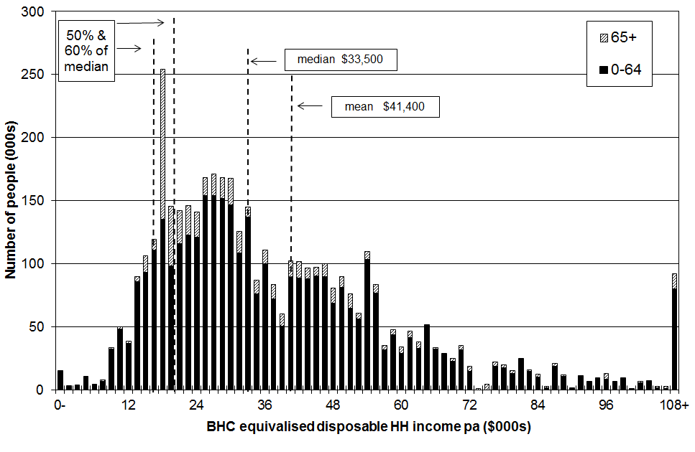

Figure B.2
AHC household income distribution for all individuals: HES 2013
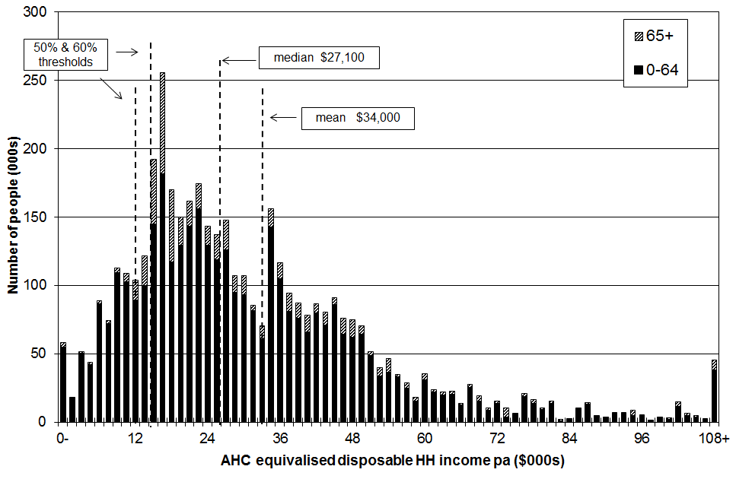

Notes: 1 For both graphs, individuals are grouped by their household incomes in multiples of $1500 pa ($30 pw). This is a rough and ready way of showing the shape of the income distribution and the number of people in different income bands.
2 Figure B.1 draws attention to the pensioner spike in the BHC distribution. In 2013 the pensioner spike was just above the 50% of median line.
3 The AHC low-income thresholds (‘poverty lines’) are set at the 50% and 60% BHC thresholds, less 25% to allow for housing costs. See Appendix 6.

Income distribution for sole parent and two parent families, HES 2013

Figure B.3 shows the distribution of family incomes for sole parent and two parent families. In 2013, around 90% of sole-parent families had incomes below the median household income for all households, with or without children. For two-parent families the proportion was 50%. This is similar to previous years.

The relatively low incomes of sole parent families reflects in the main two factors: (a) there is only one potential earner in a sole parent family, and (b) the relatively low full-time employment rate for sole parents (around 35% in 2013). In 2013, 76% of sole mothers and 54% of sole fathers were receiving a main benefit. 18% of these sole parents had declared earnings in June 2015. Sole parent beneficiary families are clustered in the lower part of the income distribution.

Figure B.3
Distribution of sole parent and two parent family income, HES 2013
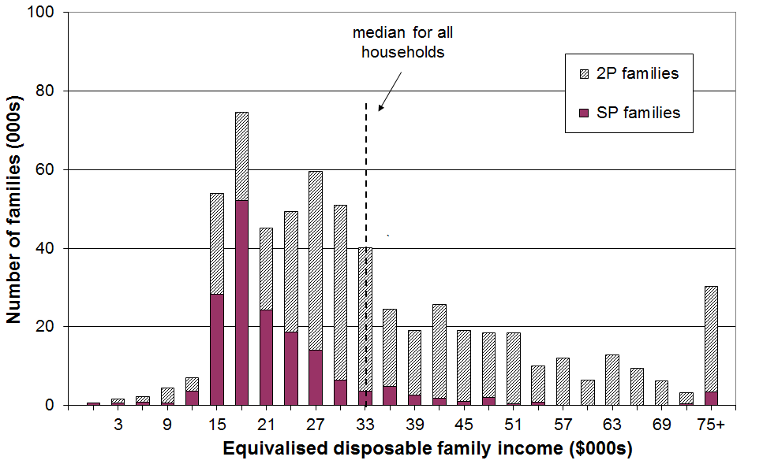

Notes: 1 Individuals are grouped by their family incomes in multiples of $3000 pa ($60 pw).
2 ‘Family’ here means ‘Economic Family Unit’.
3 Treasury’s Taxwell weights are used as they give a better population estimate of the number of beneficiary families.

It is clear from Figure B.3 that whatever standard income poverty measure is used, the proportion of those in sole parent families with incomes below the selected threshold (ie the income poverty rate for sole parent families) will be high in itself, and also higher than for those in two parent families.

Where does your household fit?

Many people do not have a realistic idea as to where they (and their household) fit in the income distribution. Tables B.4A and B.4B give the annual (unequivalised) disposable income levels (BHC) of different household types in each (equivalised) income decile. From these tables, most people will be able to locate where they and their households fit on the income distribution.

To use these tables, select the column heading that best describes your household or family situation. Go down the column until you find your household’s disposable income range (ie annual after-tax income, including all social assistance from the state). The row gives the equivalised income decile for your household income. For example, a household comprising a sole parent with two children with a disposable income of $48,000 pa is in decile 4.

Table B.4A

Where does your household fit in the overall household income distribution (BHC)?
HES 2013
Equivalised income decile | Ordinary dollars (ie not equivalised)
Equivalised income decile | One person,  no children  (reference HH) | Sole parent, one child | Sole parent, two children | Sole parent, three children | Sole parent, four children
Bottom decile | < $17,400 | < $24,400 | < $30,500 | < $35,900 | < $40,600
Decile 2 | 17,400 - 20,900 | 24,400 - 29,300 | 30,500 - 36,600 | 35,900 - 43,100 | 40,600 - 48,700
Decile 3 | 20,900 - 25,500 | 29,300 - 35,700 | 36,600 - 44,600 | 43,100 - 52,500 | 48,700 - 59,400
Decile 4 | 25,500 - 29,400 | 35,700 - 41,200 | 44,600 - 51,500 | 52,500 - 60,600 | 59,400 - 68,600
Decile 5 | 29,400 - 33,500 | 41,200 - 46,900 | 51,500 - 58,600 | 60,600 - 69,000 | 68,600 - 78,000
Decile 6 | 33,500 - 40,800 | 46,900 - 57,100 | 58,600 - 71,400 | 69,000 - 84,100 | 78,000 - 95,100
Decile 7 | 40,800 - 47,700 | 57,100 - 66,700 | 71,400 - 83,400 | 84,100 - 98,200 | 95,100 – 111,100
Decile 8 | 47,700 - 54,900 | 66,700 - 76,900 | 83,400 - 96,100 | 98,200 - 113,100 | 111,100 - 127,900
Decile 9 | 54,900 - 70,100 | 76,900- 98,100 | 96,100 - 122,600 | 113,100 - 144,300 | 127,900 – 163,300
Top decile | > $70,100 | > $98,100 | > $122,600 | > $144,300 | > $163,300

Note: use disposable household income when using this table – that is, household income from all sources after paying personal income tax and after receiving all tax credits (from Working for Families) and other state transfers (eg NZS, AS, main benefits)
Table B.4B

Where does your household fit in the overall household income distribution (BHC)?
HES 2013
Equivalised income decile | Ordinary dollars (ie not equivalised)
Equivalised income decile | Couple or 2 adults sharing | Couple,  one child | Couple,  two children | Couple,  three children | Couple, four children | Three adults, one child
Bottom decile | < $26,800 | < $32,400 | < $37,800 | <$ 42,300 | < $46,900 | < $39,400
Decile 2 | 26,800 - 32,200 | 32,400 - 38,900 | 37,800 - 45,400 | 42,300 - 50,800 | 46,900 - 56,200 | 39,400 - 47,300
Decile 3 | 32,200 - 39,200 | 38,900 - 47,400 | 45,400 - 55,300 | 50,800 - 61,900 | 56,200 - 68,600 | 47,300 - 57,600
Decile 4 | 39,200 - 45,300 | 47,400 - 54,700 | 55,300 - 63,900 | 61,900 - 71,500 | 68,600 - 79,200 | 57,600 - 66,500
Decile 5 | 45,300 - 51,600 | 54,700 - 62,300 | 63,900 - 72,700 | 71,500 - 81,400 | 79,200 - 90,100 | 66,500 - 75,700
Decile 6 | 51,600 - 62,900 | 62,300 - 75,900 | 72,700 - 88,600 | 81,400 - 99,200 | 90,100 - 109,800 | 75,700 - 92,200
Decile 7 | 62,900 - 73,400 | 75,900 - 88,700 | 88,600 - 103,400 | 99,200 - 115,800 | 109,800 - 128,200 | 92,200 - 107,700
Decile 8 | 73,400 - 84,600 | 88,700 - 102,100 | 103,400 - 119,100 | 115,800 - 133,400 | 128,200 - 147,700 | 107,700 - 124,100
Decile 9 | 84,600 - 107,900 | 102,100 - 130,300 | 119,100 - 152,100 | 133,400 - 170,300 | 147,700 - 188,500 | 124,100 - 158,400
Top decile | > $107,900 | > $130,300 | > $152,100 | > $170,300 | > $188,500 | > $158,400

Note: use disposable household income when using this table – that is, household income from all sources after paying personal income tax and after receiving all tax credits (from Working for Families) and other state transfers (eg NZS, AS, main benefits)

Distribution of individuals across income quintiles by various household and individual characteristics

When the population is ranked on their household incomes and divided into five equal groups, each group is called a quintile. A quintile contains 20% of the population.

Table B.5 shows the position of groups of individuals in the household income distribution (BHC) according to various household and individual characteristics. The proportions sum to 100% across the quintiles.

The numbers in each quintile can be obtained by using the information in the right-hand column which gives the number of individuals in the various subgroups. For example, in the lowest quintile (Q1), there are around 175,000 individuals in sole parent households where there are dependent children (56% of 312,000), and 210,000 in two parent households with dependent children (13% of 1,625,000).

Table B.6 shows the composition of each income quintile (BHC) according to various household and individual characteristics. The proportions sum to 100% down the columns for each set of characteristics.

Tables B.7 and B.8 repeat the analysis for AHC incomes.

Caution

When using the figures for smaller sub-groups, the proportions in each quintile should be taken as indicative rather than precise.

For example, in Table B.8 those living in one person 65+ households are reported as making up only 4% of the population. When reading Table B.7 for the distribution of those in this household type across the quintiles, it is reasonable to conclude that “around two thirds are found in the bottom two quintiles”, but to claim that 19,600 (12% of 163,000) are in the top quintile is spurious precision.

Another example is the distribution across the quintiles by ethnicity. With the Pacific group making up only 7% of the population, the same sort of caution applies as for the one person 65+ households noted above. The ‘Other’ group is larger (12%) but is very diverse, so results for each quintile can be volatile from year to year. An example of what it is reasonable to conclude from the analysis in the tables which follow is that household incomes for those of Maori and Pacific ethnicity are similarly distributed across the quintiles (50% to 60% are in the lower two quintiles), and are each quite differently distributed than are household incomes for European/Pakeha (for whom around one third are in the lower two quintiles).

See further comments in Section A under “Reliability of results”.

Table B.5
Distribution of individuals across income quintiles (BHC)
by various household and individual characteristics (%)
(sum to 100% across rows)
HES 2013 | Equivalised disposable household income |  |  |  |  | All individuals (000s)
HES 2013 | Q1 | Q2 | Q3 | Q4 | Q5 | All individuals (000s)
Age
0-17 | 23 | 26 | 23 | 16 | 12 | 1074
18-24 | 18 | 21 | 22 | 22 | 17 | 437
25-44 | 16 | 19 | 20 | 23 | 23 | 1158
45-64 | 15 | 15 | 18 | 24 | 28 | 1112
65+ | 34 | 20 | 16 | 15 | 15 | 586
All | 20 | 20 | 20 | 20 | 20 | 4368
Household type
One person 65+ | 48 | 22 | 13 | 8 | 9 | 163
Couple 65+ | 29 | 21 | 16 | 16 | 19 | 375
One person under 65 | 25 | 11 | 22 | 25 | 17 | 198
Couple under 65 | 12 | 9 | 12 | 26 | 41 | 533
SP with dependent children | 56 | 25 | 11 | 4 | 4 | 312
2P with dependent children | 13 | 26 | 26 | 18 | 17 | 1625
Other family HHs with dependent children | 20 | 24 | 18 | 30 | 7 | 309
Family HHs with no dependent children | 23 | 11 | 21 | 23 | 26 | 580
Non-family HHs | 16 | 18 | 19 | 24 | 28 | 272
All | 20 | 20 | 20 | 20 | 20 | 4338
Ethnicity
European/Pākehā | 16 | 17 | 19 | 22 | 25 | 2885
NZ Māori | 27 | 26 | 19 | 19 | 9 | 651
Pacific | 35 | 30 | 25 | 6 | 5 | 289
Other | 23 | 22 | 22 | 19 | 14 | 543
All | 20 | 20 | 20 | 20 | 20 | 4368
Main source of income (under 65s)
Market | 10 | 21 | 23 | 23 | 24 | 3353
Government transfer | 79 | 16 | 5 | 0 | 0 | 429
All | 18 | 20 | 21 | 21 | 21 | 3782
Tenure (under 65s)
Owned with mortgage | 8 | 16 | 22 | 27 | 26 | 1606
Owned without mortgage | 16 | 16 | 18 | 20 | 31 | 677
Rented - private | 25 | 26 | 22 | 15 | 12 | 1219
Rented - HNZC and local authority | 53 | 26 | 14 | 5 | 2 | 231
Children by household type
Children in SP HHs | 59 | 24 | 9 | 3 | 4 | 180
Children in 2P HHs | 13 | 27 | 28 | 16 | 16 | 746
Children in other family HHs | 22 | 23 | 21 | 28 | 6 | 117
Children in non-family households | * | * | * | * | * | 21
All children | 23 | 26 | 23 | 16 | 12 | 1064

Notes:
1 See note on page 67 for the need for caution in interpreting results for smaller sub-groups.
2 The sample numbers for children in non-family households are too small to give reliable estimates of their distribution across the quintiles.

Interpreting Tables B.5 and B.6: an example
Consider the 0-17 year old group (children).
- Table B.5 (distribution of each group across the quintiles) shows that 49% children are in households in the bottom two income quintiles.
- Table B.6 (composition of each quintile) shows that children make up 28% of all people in households with incomes in the bottom quintile.

Table B.6
Composition of income quintiles (BHC)
by various household and individual characteristics (%)
(sum to 100% down columns)
HES 2013 | Equivalised disposable household income |  |  |  |  | Overall composition
HES 2013 | Q1 | Q2 | Q3 | Q4 | Q5 | Overall composition
Age
0-17 | 28 | 32 | 29 | 19 | 15 | 25
18-24 | 9 | 11 | 11 | 11 | 8 | 10
25-44 | 21 | 25 | 26 | 30 | 30 | 27
45-64 | 19 | 19 | 23 | 30 | 36 | 25
65+ | 23 | 13 | 11 | 10 | 10 | 13
All | 100 | 100 | 100 | 100 | 100 | 100
Household type
One person 65+ | 9 | 4 | 2 | 2 | 2 | 4
Couple 65+ | 12 | 9 | 7 | 7 | 8 | 9
One person under 65 | 6 | 2 | 5 | 6 | 4 | 5
Couple under 65 | 7 | 6 | 8 | 16 | 25 | 12
SP with dependent children | 20 | 9 | 4 | 1 | 2 | 7
2P with dependent children | 24 | 49 | 49 | 34 | 31 | 37
Other family HHs with dependent children | 7 | 9 | 7 | 11 | 3 | 7
Family HHs with no dependent children | 11 | 7 | 14 | 17 | 18 | 13
Non-family HHs | 4 | 6 | 6 | 7 | 9 | 6
All | 100 | 100 | 100 | 100 | 100 | 100
Ethnicity
European/Pākehā | 54 | 57 | 64 | 72 | 83 | 66
NZ Māori | 20 | 20 | 14 | 14 | 7 | 15
Pacific | 12 | 10 | 8 | 2 | 2 | 7
Other | 14 | 14 | 4 | 13 | 9 | 12
All | 100 | 100 | 100 | 100 | 100 | 100
Main source of income (under 65s)
Market | 50 | 91 | 97 | 100 | 100 | 89
Government transfer | 50 | 9 | 3 | 0 | 0 | 11
All | 100 | 100 | 100 | 100 | 100 | 100
Tenure (under 65s)
Owned with mortgage | 19 | 35 | 45 | 56 | 54 | 43
Owned without mortgage | 16 | 14 | 16 | 18 | 27 | 18
Rented - private | 46 | 41 | 34 | 24 | 18 | 32
Rented - HNZC and local authority | 18 | 8 | 4 | 2 | 1 | 6
Children by household type
Children in SP HHs | 45 | 16 | 6 | 4 | 6 | 17
Children in 2P HHs | 41 | 73 | 82 | 74 | 89 | 70
Children in other family HHs | 11 | 10 | 10 | 20 | 5 | 11
Children in non-family HHs | 3 | 2 | 2 | 2 | 2 | 2
All children | 100 | 100 | 100 | 100 | 100 | 100

Notes:
1 See note on page 67 for the need for caution in interpreting results for smaller sub-groups.

Interpreting Tables B.5 and B.6: an example
Consider the 0-17 year old group (children).
- Table B.5 (distribution of children across the quintiles) shows that 49% of this group are in households in the bottom two income quintiles.
- Table B.6 (composition of each quintile) shows that children make up 28% of all people in households with incomes in the bottom quintile.
Table B.7
Distribution of individuals across income quintiles (AHC)
by various household and individual characteristics (%)
(sum to 100% across rows)
HES 2013 | Equivalised disposable household income |  |  |  |  | All individuals (000s)
HES 2013 | Q1 | Q2 | Q3 | Q4 | Q5 | All individuals (000s)
Age
0-17 | 27 | 23 | 23 | 16 | 11 | 1074
18-24 | 20 | 23 | 21 | 22 | 15 | 437
25-44 | 21 | 17 | 20 | 22 | 20 | 1158
45-64 | 16 | 12 | 19 | 22 | 31 | 1112
65+ | 16 | 12 | 19 | 22 | 31 | 586
All | 20 | 20 | 20 | 20 | 20 | 4368
Household type
One person 65+ | 20 | 47 | 12 | 9 | 12 | 163
Couple 65+ | 10 | 31 | 19 | 18 | 23 | 375
One person under 65 | 35 | 8 | 22 | 22 | 14 | 198
Couple under 65 | 14 | 6 | 14 | 25 | 42 | 533
SP with dependent children | 63 | 20 | 11 | 2 | 5 | 312
2P with dependent children | 17 | 23 | 25 | 19 | 15 | 1625
Other family HHs with dependent children | 21 | 24 | 19 | 31 | 5 | 309
Family HHs with no dependent children | 16 | 12 | 18 | 22 | 32 | 580
Non-family HHs | 10 | 20 | 22 | 27 | 21 | 272
All | 20 | 20 | 20 | 20 | 20 | 4338
Ethnicity
European/Pākehā | 15 | 18 | 19 | 23 | 25 | 2885
NZ Māori | 30 | 24 | 19 | 18 | 10 | 651
Pacific | 29 | 33 | 29 | 5 | 4 | 289
Other | 32 | 18 | 21 | 15 | 14 | 543
All | 20 | 20 | 20 | 20 | 20 | 4368
Main source of income (under 65s)
Market | 13 | 18 | 23 | 23 | 23 | 3353
Government transfer | 82 | 14 | 4 | 0 | 0 | 429
All | 21 | 17 | 21 | 21 | 21 | 3782
Tenure (under 65s)
Owned with mortgage | 12 | 16 | 22 | 26 | 24 | 1606
Owned without mortgage | 11 | 9 | 20 | 22 | 38 | 677
Rented - private | 35 | 22 | 20 | 15 | 9 | 1219
Rented - HNZC and local authority | 40 | 32 | 18 | 8 | 2 | 231
Children by household type
Children in SP HHs | 67 | 17 | 10 | 2 | 4 | 180
Children in 2P HHs | 18 | 24 | 26 | 18 | 14 | 746
Children in other family HHs | 24 | 22 | 23 | 27 | 4 | 117
Children in non-family households | * | * | * | * | * | 21
All children | 27 | 23 | 23 | 16 | 11 | 1064

Notes:
1 See note on page 67 for the need for caution in interpreting results for smaller sub-groups.
2 The sample numbers for children in non-family households are too small to give reliable estimates of their distribution across the quintiles.
Interpreting Tables B.7 and B.8: an example
Consider the 0-17 year old group (children).
- Table B.7 (distribution of children across the quintiles) shows that 50% of this group are in households in the bottom two income quintiles.
- Table B.8 (composition of each quintile) shows that children make up 33% of all people in households with incomes in the bottom quintile.
Table B.8
Composition of income quintiles (AHC)
by various household and individual characteristics (%)
(sum to 100% down columns)
HES 2013 | Equivalised disposable household income |  |  |  |  | Overall composition
HES 2013 | Q1 | Q2 | Q3 | Q4 | Q5 | Overall composition
Age
0-17 | 33 | 28 | 28 | 20 | 14 | 25
18-24 | 10 | 11 | 10 | 11 | 8 | 10
25-44 | 28 | 22 | 26 | 30 | 26 | 27
45-64 | 20 | 16 | 24 | 28 | 39 | 25
65+ | 9 | 23 | 11 | 11 | 13 | 13
All | 100 | 100 | 100 | 100 | 100 | 100
Household type
One person 65+ | 4 | 9 | 2 | 2 | 2 | 4
Couple 65+ | 4 | 13 | 8 | 8 | 10 | 9
One person under 65 | 8 | 2 | 5 | 5 | 3 | 5
Couple under 65 | 9 | 4 | 8 | 15 | 25 | 12
SP with dependent children | 22 | 7 | 4 | 1 | 2 | 7
2P with dependent children | 32 | 43 | 47 | 36 | 28 | 37
Family HHs with dependent children | 7 | 9 | 7 | 11 | 2 | 7
Other family HHs with no dependent children | 11 | 8 | 12 | 15 | 21 | 13
Non-family HHs | 3 | 6 | 7 | 8 | 7 | 6
All | 100 | 100 | 100 | 100 | 100 | 100
Ethnicity
European/Pākehā | 49 | 60 | 64 | 76 | 82 | 66
NZ Māori | 22 | 18 | 14 | 13 | 7 | 15
Pacific | 10 | 11 | 10 | 2 | 1 | 7
Other | 20 | 11 | 13 | 10 | 9 | 12
All | 100 | 100 | 100 | 100 | 100 | 100
Main source of income (under 65s)
Market | 56 | 92 | 98 | 100 | 100 | 89
Government transfer | 44 | 8 | 2 | 0 | 0 | 11
All | 100 | 100 | 100 | 100 | 100 | 100
Tenure (under 65s)
Owned with mortgage | 25 | 39 | 45 | 54 | 50 | 43
Owned without mortgage | 10 | 9 | 17 | 19 | 34 | 18
Rented - private | 53 | 40 | 31 | 23 | 14 | 32
Rented - HNZC and local authority | 12 | 11 | 6 | 2 | 1 | 6
Children by household type
Children in SP HHs | 43 | 13 | 7 | 2 | 7 | 17
Children in 2P HHs | 47 | 73 | 80 | 78 | 88 | 70
Children in other family HHs | 10 | 11 | 11 | 18 | 4 | 11
Children in non-family HHs | 1 | 3 | 2 | 3 | 1 | 2
All children | 100 | 100 | 100 | 100 | 100 | 100

Notes:
1 See note on page 67 for the need for caution in interpreting results for smaller sub-groups.

Interpreting Tables B.7 and B.8: an example
Consider the 0-17 year old group (children).
- Table B.7 (distribution of children across the quintiles) shows that 50% of this group are in households in the bottom two income quintiles.
- Table B.8 (composition of each quintile) shows that children make up 33% of all people in households with incomes in the bottom quintile.

Income shares across the distribution

Figures B.1 and B.2 above show that income is not distributed evenly across the population even after taxes and transfers have been taken into account. Figure B.4 presents the same information in a different way by showing the share of the total income that is received by the different income deciles (BHC). Because the income concept is equivalised household disposable income, the information in the graph needs to be interpreted as comparisons of the consumption capabilities for those in the various deciles, having adjusted for household size and composition.

Figure B.4
Shares of total income by deciles: HES 2013
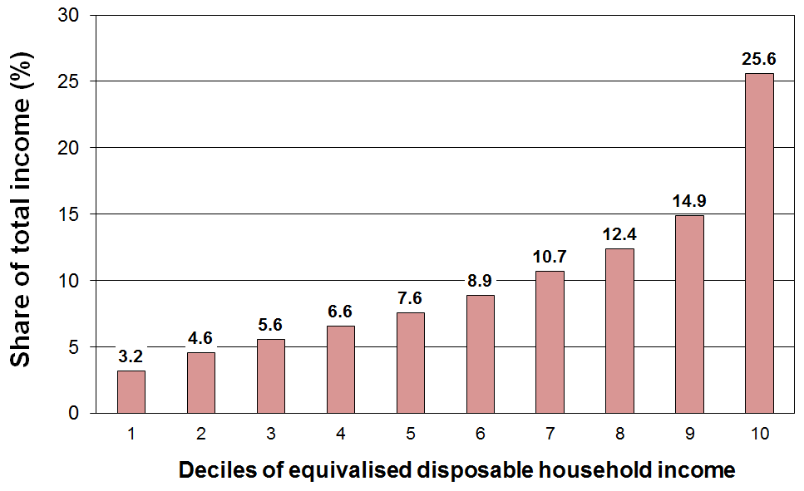

The top 10% receive just over a quarter and the top 30% receive just over a half of the total population (equivalised) income. This is much the same as in recent years. The average figures from HES 2007 to HES 2012 are 25% and 53% respectively.

Table B.9 shows that the distribution of household income in New Zealand is broadly similar to that in the UK, Australia and Canada, but more dispersed than for Finland and Norway.

Table B.9
Shares of total income by quintiles of equivalised disposable household income (%):
international comparisons for c 2012
 | Q1 (low) | Q2 | Q3 | Q4 | Q5 (high)
Norway | 10 | 16 | 19 | 23 | 33
Finland | 10 | 14 | 18 | 23 | 36
Sweden | 9 | 15 | 19 | 23 | 34
France | 9 | 13 | 17 | 22 | 40
New Zealand | 8 | 13 | 17 | 23 | 40
UK | 8 | 13 | 17 | 22 | 41
Australia | 8 | 13 | 17 | 23 | 40
Canada | 7 | 12 | 17 | 24 | 40
Italy | 7 | 13 | 18 | 23 | 39
Spain | 6 | 12 | 17 | 24 | 41
Greece | 6 | 12 | 18 | 24 | 40

Sources: Australia (Table 1 in ABS (2013) for 2012; Canada (Table 202-0606 in Statistics Canada (2011) for 2009; European countries (Eurostat statistical database for Population and Social Conditions for 2012).

The redistribution of income: market income, government cash benefits, income tax, consumption tax and publicly provided services

The income that households receive from wages and salaries, from investments and from people running their own businesses (market income) is redistributed through government intervention via taxation and social expenditure. This reduces the income inequality that would otherwise exist. This section provides an indication of the extent of the redistribution and the impact on inequality.

The extent of the redistribution of income

In interpreting the findings in this section it is important to note that market income is not the counterfactual or “natural state” that would exist if there was no government intervention. The existence of taxes, government expenditure and the apparatus of the welfare state influences citizens’ behaviour in relation to labour market participation, living arrangements, and so on. The analysis can be taken as an indication of the extent of redistribution given that we live in a redistributive welfare state.
Figure B.5
Cash transfers and income tax paid: HES 2013
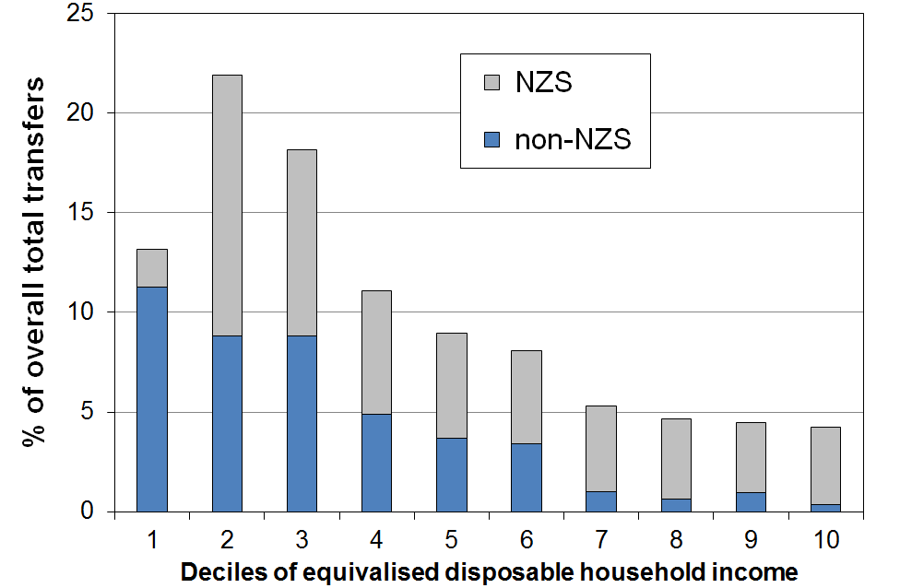
“Government transfers” include working-age welfare benefits, New Zealand Superannuation (NZS), the Accommodation Supplement, Working for Families tax credits, special needs grants, and so on. Figure B.5 (upper) shows the distribution of these transfers across household income deciles, with NZS separated out.

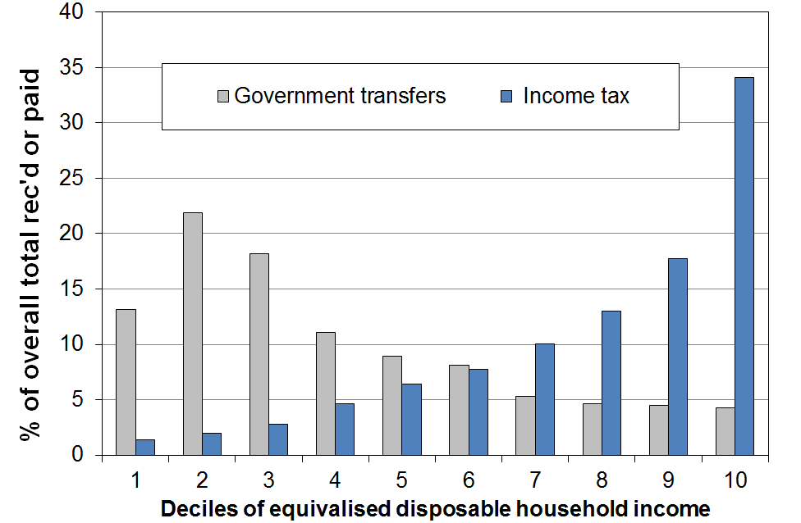
A useful way of looking at the extent of redistribution is to look at the difference between income taxes paid and transfers received for households in different income deciles (see Figure B.5 (lower). For many households, the amount they receive in transfers is greater than what they pay in income tax. They have a negative net tax liability.

One group with negative net tax liability is low- to middle-income households with dependent children. For example, single-earner families with two children can earn up to around $60,000 pa before they pay any net tax. Around half of all households with children receive more in welfare benefits and tax credits than they pay in income tax. The vast majority of older New Zealanders (aged 65+) live in households where there is a negative income tax liability – the income tax they pay is less than the value of New Zealand Superannuation (NZS) they receive. “Working-age” working households without dependent children have a positive income tax liability whatever their income.

Figure B.6
Income tax less govt cash transfers: HES 2013
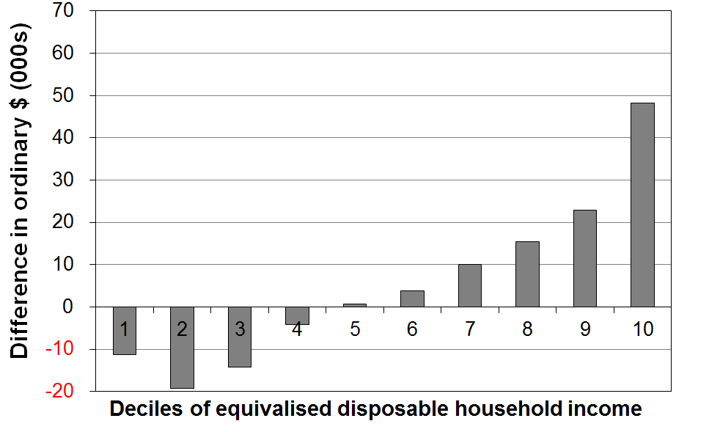
When all households are counted (working age with children, working age without children, and 65+ households), and looking at households grouped in deciles rather than looking at individual households, the total income tax paid by each of the bottom five deciles is less than the total transfers received (tax credits, welfare benefits, NZS and so on). See Figure B.6. It is only for each of the top five deciles that total income tax paid is greater than transfers received.

The inequality-reducing impact of taxes and transfers

Figure B.7 and Table B.10 show the inequality-reducing impact of taxes and transfers by comparing the Gini scores for household market income and household disposable income – that is for household incomes before and after taxes and transfers.

Figure B.7
Gini scores (x100) for market and disposable household income, 1986 to 2013 (18-64 yrs)
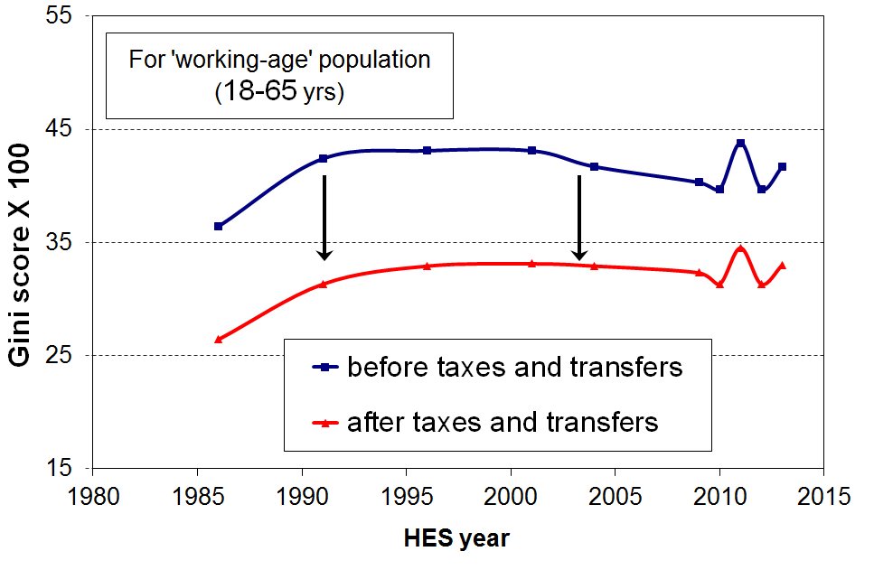

Table B.10
Gini scores (x100) for market and disposable household income, 1986 to 2013 (18-65 yrs)
HES year | Before taxes and transfers (market income) | After taxes and transfers (disposable income) | Reduction (%)
1986 | 36.4 | 26.4 | 27
1991 | 42.4 | 31.3 | 26
1996 | 43.1 | 32.9 | 24
2001 | 43.1 | 33.1 | 23
2004 | 41.7 | 32.9 | 21
2009 | 40.3 | 32.3 | 20
2010 | 39.7 | 31.3 | 21
2011 | 43.8 | 34.5 | 21
2012 | 39.7 | 31.3 | 21
2013 | 41.7 | 33.0 | 21

For working-age New Zealanders (aged 18 to 65 years), the reduction in the household market income Gini was 21% from 2004 to 2013. This reduction is similar to Australia and Canada (~23%), less than the UK (~27%), and much lower than many European countries such as Sweden, Norway, France and Austria (33-36% reductions). The median OECD reduction is 28% (c 2010 and 2011).

When the full population is used, New Zealand’s reduction in inequality is 28% compared with the OECD median of 35%.

“Final” household income

Figure B.5 tells only a part of the government transfer story. A more comprehensive analysis needs to include tax paid through GST especially as lower-income households generally apply all or almost all their income to expenditure on GST-able goods and services, whereas higher-income households apply a lesser proportion of their income to GST-able expenditure, with a portion going to savings and interest payments which do not attract GST. GST is therefore generally a higher proportion of the income of lower-income households than for higher-income households.

Households also receive government-funded health and education services which means that they do not have to pay for them directly from their own income. These services can be seen as a form of income or in-kind government benefit to be counted along with any cash benefits received.

In this broader framework the concept of “final” household income is sometimes used as a means of taking into account cash and in-kind income from the market and the government and consumption taxes as well as income taxes. Crawford and Johnston (2004) have shown that, using a final household income approach, there is further redistribution from more well-off households to less well-off households because households in the higher income deciles pay more consumption tax and also receive less in the way of in-kind benefits from education and health spending combined. They conclude that “final incomes are more equally distributed than disposable incomes” (p29).
Figure B.8
Redistribution of market income: HES 1998
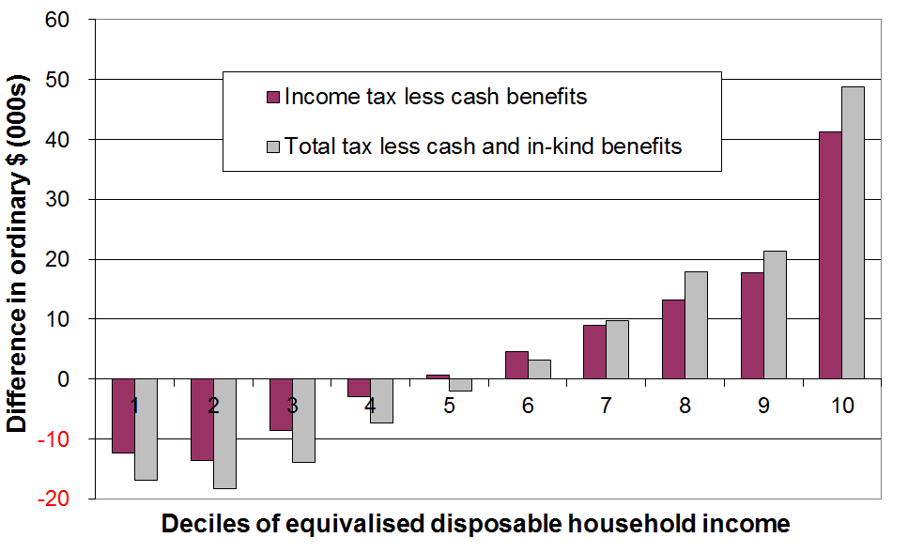
This finding is illustrated in Figure B.7 which compares the redistribution using both the narrower and broader frameworks for 1998.

The large additional transfer to low- to middle-income households through the Working for Families package in 2005 to 2007 and the tax switch changes in October 2010 are not captured in their analysis. The Treasury have since updated the analysis to 2010 (Aziz and colleagues, 2012), and that analysis confirms the earlier findings on inequality, among other things. This is consistent with other similar research from other OECD countries.
Source: Crawford and Johnston (2004)

An example is a 2008 OECD study on the equality-enhancing impact of taxes and cash transfers and of government services. The study found that:
- public expenditure on the provision of social services (mainly health and education) significantly reduces inequality within countries and reduces the range of inequality otherwise found across countries
- the size of the reduction in inequality from government in-kind services is on average less than that achieved by income taxes and transfers, but is still significant – it is around a quarter when using the inter-quintile share and a half when using the Gini coefficient
- the inequality-reducing impact of the countries’ tax and transfer systems is more variable across countries than the impact of public services
- the ranking of countries on inequality does not change very much when moving from a household disposable income measure to the broader measure that includes public services (correlation ~ 0.95).
Section C

Trends in key labour market, demographic, housing costs and social assistance variables

This report is essentially descriptive. It does not attempt, for example, to give a detailed explanation of changes in the income distribution by drawing on what we know about the impacts of key labour market, demographic, macro-economic and geo-political factors and of tax and social assistance policy settings.

This section however goes a little beyond description by providing information on trends in some key variables which clearly impact on the income distribution. These trends provide the basis for a high-level account of changes in the middle and at the lower end of the distribution in line with the main themes and focus of this paper.

At a high level, the trend in real GDP per capita sets the context, although the relationship of the GDP trend to that of disposable household income is not simple or direct. There are many mediating and modifying factors that impact on how the cake is divided up across households, independent of the size of the cake itself.

From a distributional perspective a rough rule of thumb is that median household incomes for the population as a whole generally follow the trend for incomes of two-parent-with-dependent-children households. This group made up around half of those in both the second and middle quintiles from the mid 1990s to 2013 and an even greater proportion during the 1980s. In other words, this group dominates the income distribution from P20 to P60, and changes for this group impact quite significantly on overall household income trends. The median income of this household type is very close to the overall median income in the 1982-2014 period (see Figure D.9 in the next section).

The two factors that impact the most on the incomes of two-parent-with-dependent-children households are average wage rates and the total hours worked by the two parents. The total number of hours worked is in turn related to the overall employment rate and to social norms, in relation to labour force participation for mothers and fathers of dependent children. This section therefore reports on the employment rate (by sex), net average ordinary time weekly earnings (NAOTWE), and the hours worked in two-parent-with-children-households. The trend in median household income is strongly influenced by trends in these factors.

The lower part of the income distribution includes those from households whose main income is from paid employment (“the working poor”) and those from households whose main income is from income-tested benefits or New Zealand Superannuation (NZS). Trends in the numbers below typical low-income thresholds (ie trends in income poverty rates) are therefore strongly influenced by three sets of factors: (a) average wage levels and employment rates; (b) (trends in) the levels of social assistance; and (c) trends in the numbers in receipt of social assistance. Social assistance is taken here to refer to the main income-tested benefits for those under 65, together with the Family Tax Credit (FTC) (formerly Family Support (FS)) and In-Work Tax Credit where there are dependent children, and NZS for those aged 65+.

This section therefore also reports on trends in the total number receiving a main benefit, the real value of the main benefits plus FTC/FS where relevant, and the unemployment rate.

This report promotes the value of using household incomes after deducting housing costs (AHC) as the preferred approach for comparing the material wellbeing of different subgroups of the population. This section therefore also reports on trends in gross expenditure on accommodation as proportion of household income.

Trends in GDP, employment, unemployment and weekly earnings

Figure C.1 shows the pattern of the business cycle from 1982 to 2014 in terms of annual GDP growth and the HLFS unemployment rate. The 2014 HES interviews were carried out from July 2013 to June 2014. The incomes reported by households in the survey are for the twelve months prior to the interview. Those interviewed in July 2013 would therefore be reporting on incomes in the period from August 2012 to July 2013, and so on. The household incomes data in the 2014 HES, as in the previous two surveys, could be expected to reflect the impact of the ongoing recovery after the economic slowdown associated with the GFC and the Christchurch earthquakes and other factors.

Figure C.1
Real GDP annual changes and unemployment rates, 1990 to 2014
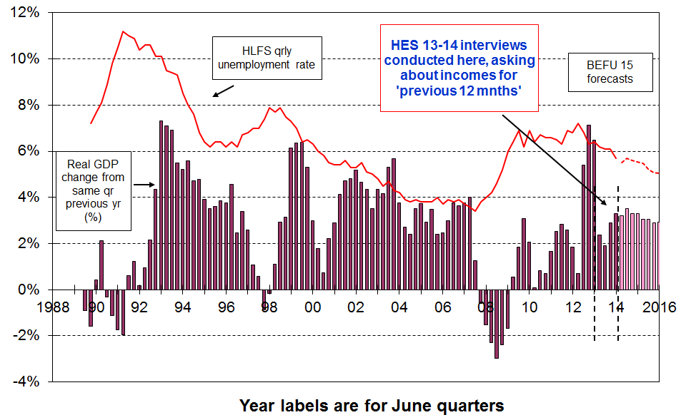

Figure C.2
Employment rate (15-64yrs), 1987 to 2015
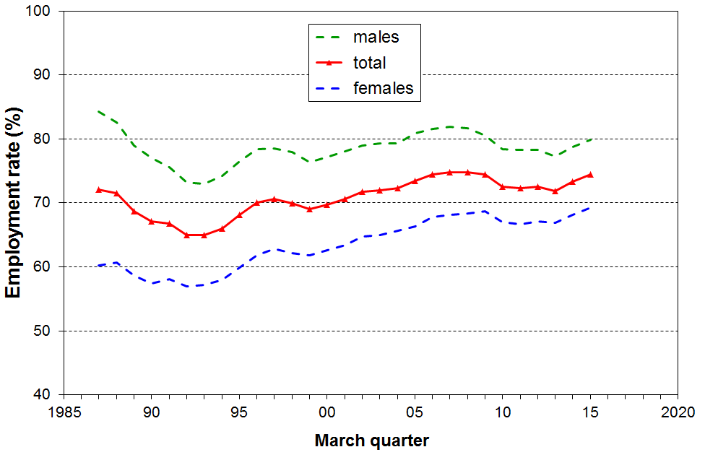

The improving employment rates in 2014 are consistent with the general rise in household incomes in the 2013-14 HES (see Table B.1 and Section D). The further increase through to March 2015 points to a further general rise in household incomes in the 2014-15 HES, all else equal.
Figure C.3 shows the trend in after-tax wages in real terms – they grew 33% in real terms from 1994 to 2014. Gross (before tax) wages grew by 24% in the period. In contrast median household incomes grew 53% in real terms.

Figure C.3
Net average ordinary time weekly earnings ($ Dec 2014)
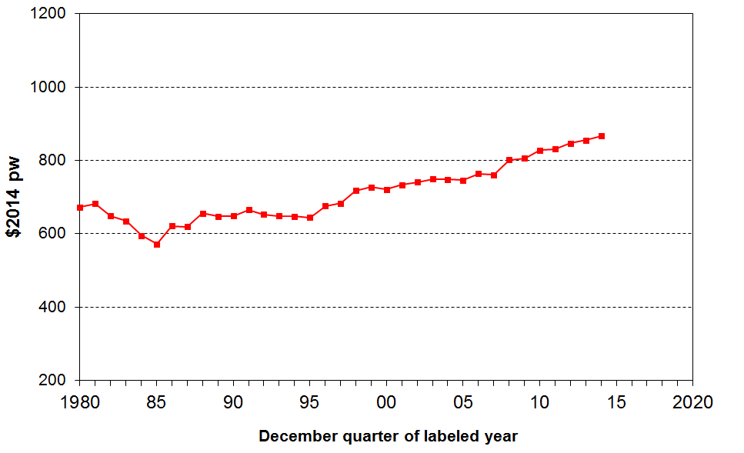

Incomes around the median: the longer-term trend

Figure C.2 shows the trend in the proportion of the population aged 15-64 who are in paid employment for at least one hour per week (the “employment rate”). After falling to a low in 1992 the employment rate rose through to 1996, faltered for two years then rose each year through to 2007, with a slower growth rate from 2004 to 2007. Overall employment rates fell from 2007 to 2010, returning to 2002 levels, and remained flat for three years to 2013. The female employment rate was considerably higher in 2014 (69%) compared with the mid 1980s (60%) whereas male employment in 2014 (80%) was below what it was in the mid 1980s (84%). Both male and female rates have increased in the last three years to give an overall rate of 75% in March 2015, back to pre-recession high of 75% in 2008.

Figure C.4 shows the increased work intensity in two-parent-plus-dependent-children households, since the mid 1990s. The two-earner proportion in recent years (68%) is around the OECD average (65%) for the 21 countries for whom comparable data is available.

Figure C.4
Proportion of two parent HHs by hours of paid employment (where at least one is FT)
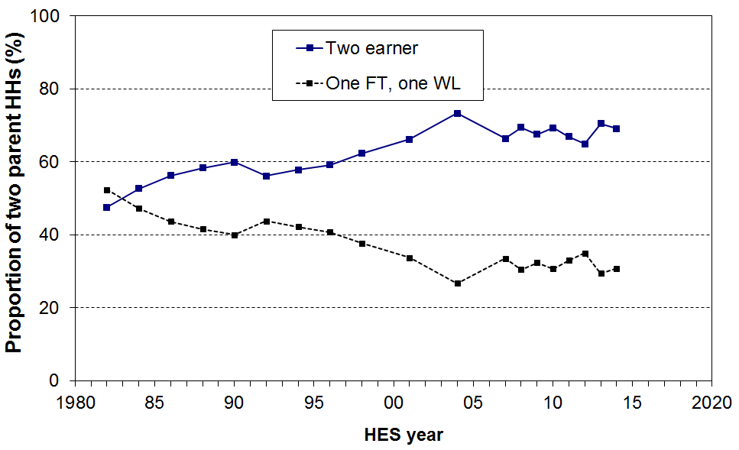
These factors together with the rising average wage point to median household incomes falling away in the early 1990s as employment declined, and rising from the mid 1990s through to 2004, with reasonably strong growth from 2001 to 2004 when all three factors lined up together to drive up income of two parent with dependent children households. From 2004 to 2007, the median incomes of two-parent households could be expected not to change as greatly as their employment hours remained steady overall (Figure C.4), and the WFF package had only an negligible impact on the median.

The rise in the median over the last three surveys (from HES 2010-11 to HES 2013-14) is consistent with the rising real average wage, rising employment rates and relatively steady average employment hours for two parent families whose incomes influence the median more than others.

See Figures D.1 and D.9 in the next section for the trends in median household incomes.

Incomes at the lower end of the income distribution

Incomes at the lower end of the distribution are significantly affected by trends in the levels of social assistance delivered through income-tested benefits and child-related support, and trends in the numbers for whom social assistance income is their primary source of income.

Figure C.5 shows the rise in the total number of EFUs (benefit units) receiving a main benefit through to 1994, the further rise through to 1999, the steady decline to June 2008, the rise through to June 2010 reflecting the recession and the global financial crisis, and the subsequent fall to just under 300,000 in March 2015. Numbers in receipt of the unemployment benefit follow a trend that is a rough mirror image of the employment rate (Figure C.2).

Figure C.5
Number of families / benefit units in receipt of income-tested benefits (all ages), 1986 to 2015:
(30 June figures to 2012, 31 March for 2013 to 2015)

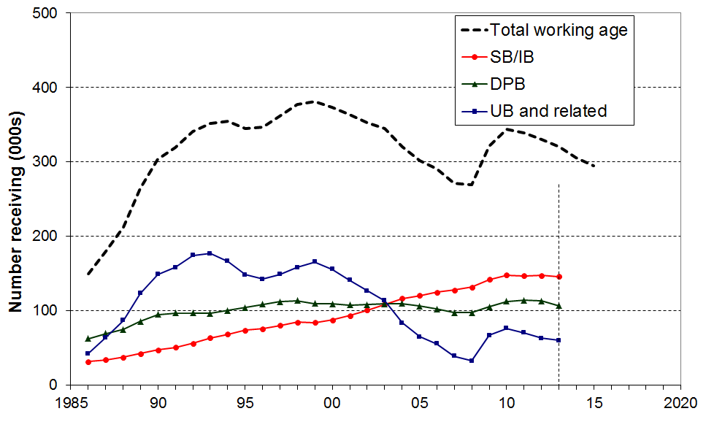
Note: The changes to benefit categories and names in 2013 means that the time series for the specific benefit types in the chart above cannot be continued – a new series will be developed for future reports. See http://www.msd.govt.nz/about-msd-and-our-work/publications-resources/statistics/benefit/index.html#Datatables6 for detailed information on benefit numbers.

Figure C.5 above is based on the number of EFUs receiving an income-tested benefit.

Table C.1 (next page) shows both the number of EFUs and the total number of individuals in beneficiary families (EFUs) and the number of individuals receiving NZS.

Figure C.6
Number of families / benefit units in receipt of working-age income-tested benefits and number of individuals receiving NZ Superannuation or Veterans’ Pension, and total number of individuals receiving either a benefit or NZS/VP:
(30 June figures to 2012, 31 March for 2013 to 2015)
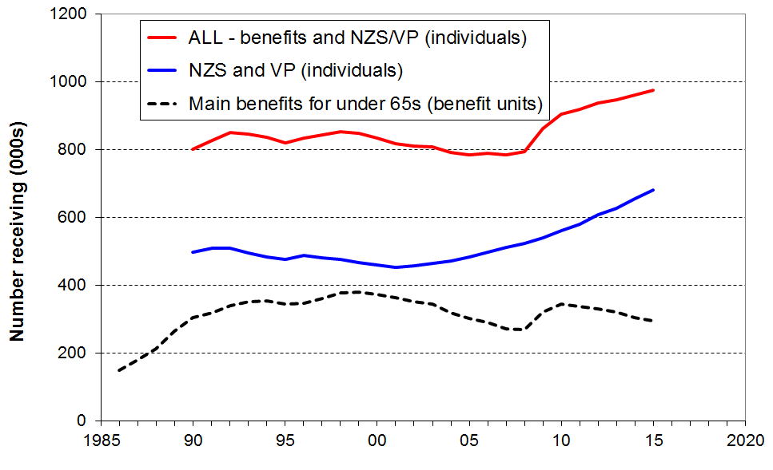

Table C.1
Individuals in EFUs in receipt of an income-tested benefit or NZS (30 Jun to 2012, 31 Mar thereafter)
 | Total working age EFUs in receipt of an income-tested benefit (000s) | All people (adults and children) where prime recipient of an income-tested benefit is under 65  (000s) | Children (<18) dependent on a recipient of an income-tested benefit (all ages), (000s) | NZS/VP recipients  (000s) | Proportion of children (<18) dependent on a recipient of an income-tested benefit  (%) | Proportion of all people under 65 in an EFU in receipt of an income-tested benefit  (%) | Proportion of whole popln in an EFU in receipt of an income-tested benefit or NZS/VP  (%)
1998 | 368 | 701 | 281 | 477 | 30 | 21 | 31
1999 | 372 | 701 | 277 | 468 | 28 | 21 | 30
2000 | 364 | 684 | 271 | 461 | 27 | 20 | 30
2001 | 354 | 662 | 263 | 454 | 26 | 19 | 29
2002 | 343 | 638 | 256 | 458 | 25 | 18 | 28
2003 | 334 | 622 | 253 | 467 | 24 | 18 | 27
2004 | 309 | 584 | 245 | 473 | 24 | 16 | 26
2005 | 290 | 548 | 233 | 484 | 22 | 15 | 25
2006 | 280 | 523 | 221 | 498 | 21 | 14 | 24
2007 | 261 | 485 | 205 | 513 | 19 | 13 | 24
2008 | 258 | 482 | 200 | 525 | 19 | 13 | 24
2009 | 310 | 554 | 221 | 542 | 21 | 15 | 25
2010 | 333 | 591 | 233 | 561 | 22 | 16 | 26
2011 | 328 | 591 | 232 | 581 | 22 | 15 | 27
2012 | 320 | 575 | 227 | 608 | 22 | 15 | 27
2013  (31 Mar) | 310 | 552 | 217 | 628 | 20 | 14 | 26
2014 (31 Mar) | 295 | 518 | 200 | 655 | 19 | 13 | 26
2015 (31 Mar) | 284 | 493 | 187 | 681 | 17 | 13 | 26

Sources: Columns 1-4, MSD Statistical Reports and Information Analysis Platform
Columns 5-7 use population estimates from Statistics New Zealand for the denominator

Figure C.7 shows the trend in real terms of average earnings and of income-tested benefits for the period. The earnings measure is net average ordinary time weekly earnings (NAOTWE) and the income-tested benefit measure is the value of the main benefit plus the Family Tax Credit (or Family Support prior to 2007) for which the respective families are eligible in relation to the dependent children in their care. None of the scenario lines include the Accommodation Supplement or the subsidy received by those on income-related rents vis-à-vis market rents.

Figure C.7
Income-tested benefits (plus FTC) and average earnings in real terms for selected HH types
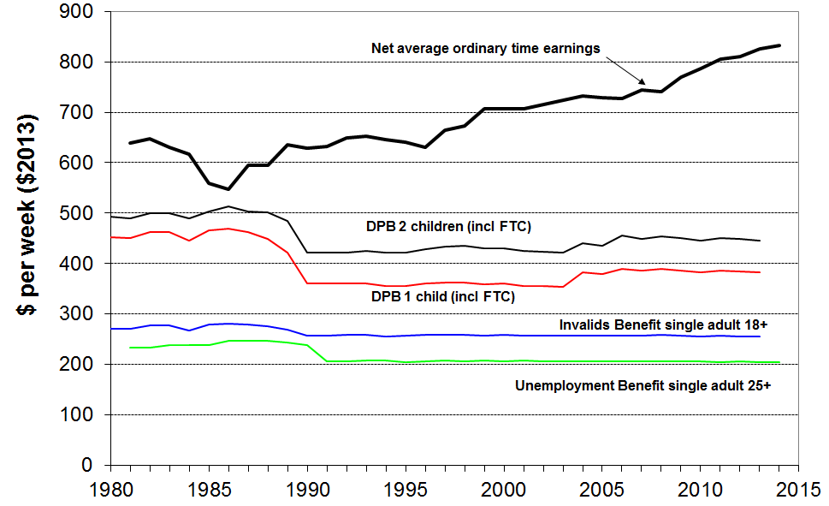

Figures C.8A, C.8B and C.8C expand the comparisons above by including NZS and median disposable household income. They show the different trajectories for the different income measures by using an index set to 100 in 1983, 1994 and 2007 respectively. These three starting points are for before the 1991 benefit cuts, after the benefit cuts and when the economy was growing and benefit numbers had fallen considerably, and after the introduction of the Working for Families package. The three different starting points are shown as for this sort of analysis a different picture can emerge depending on the starting point used.

Figure C.8A
Relativities between main benefit levels, NZS, average wage and median household income,
1983 = 100

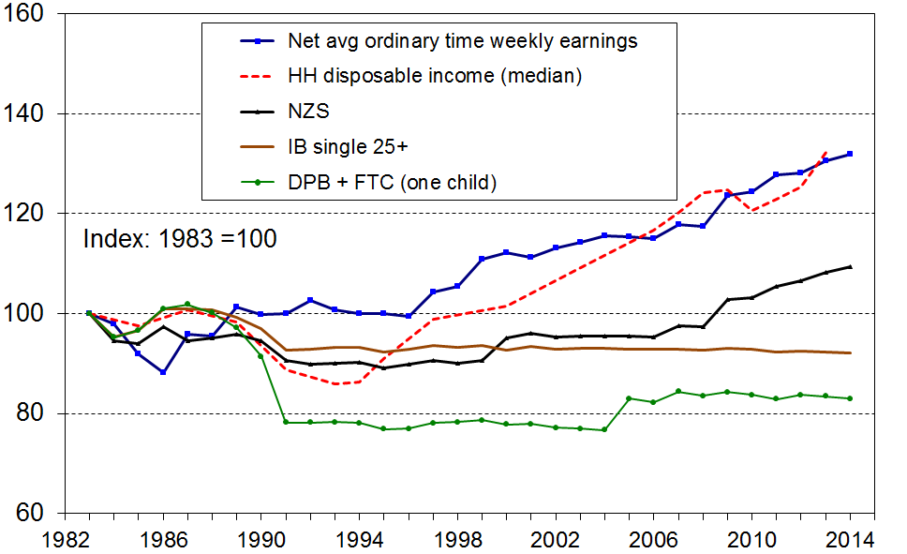

Figure C.8B
Relativities between main benefit levels, NZS, average wage and median household income,
1994 = 100
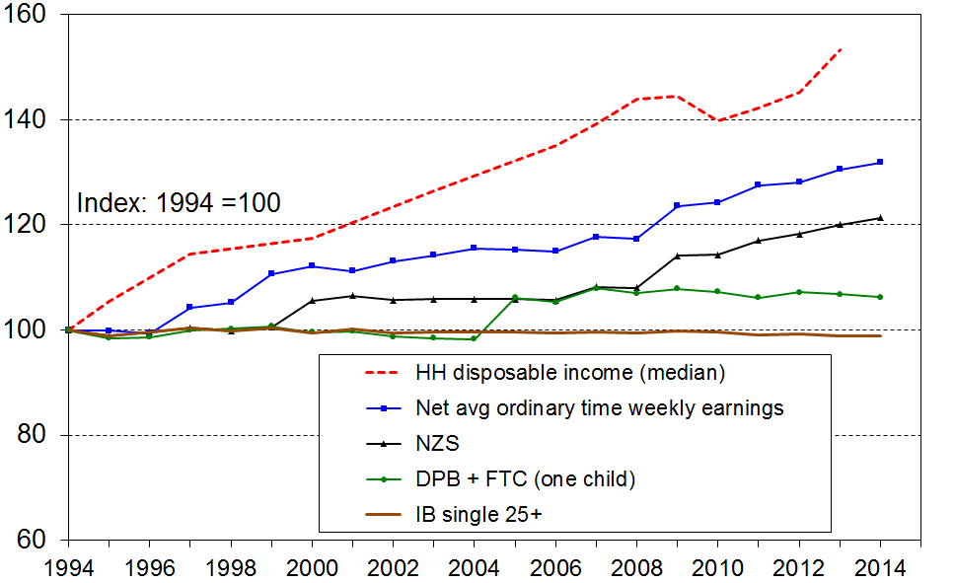

Figure C.8C
Relativities between main benefit levels, NZS, average wage and median household income,
2007 = 100
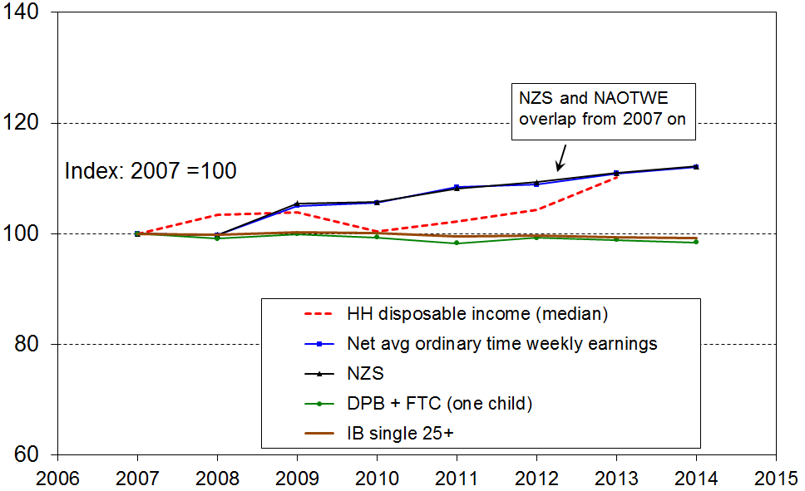
Note: the vertical scale for Fig C.8C is a little different from the one used for both 8A and 8B.

Table C.2
Relativities between main benefit levels, NZS, average wage and median household income:
summary table
% change from base year
(CPI adjusted – ie ‘real’ changes)
 | 1983 to 2014 | 1994 to 2014 | 2007 to 2014
Median household income (see note below) | +25 | +45 | +5
Net average ordinary time earnings | +32 | +32 | +12
NZS | +9 | +21 | +12
DPB plus family assistance (one child) | -17 | +6 | -2
Invalids Benefit – single aged 25+ | -8 | -1 | -1
Note: The change in median household income is to calendar 2012 only (HES 2013). Assuming modest household income growth from 2012 to 2014, a further 3 to 4 percentage points needs to be added to the changes for household income noted in the table for more realistic comparisons.

Housing costs

High housing costs relative to income are often associated with financial stress for low- to middle-income households. Low-income households especially can be left with insufficient income to meet other basic needs such as food, clothing, transport, medical care and education for household members.

The figures and trends in the summaries that follow are national average figures. There are regional differences that a relatively small sample survey like the HES cannot pick up (see, for example, pp73ff in Johnson (2015) for regional differences). Preliminary work has shown that an “Auckland and the rest” analysis is probably feasible, and we will seek to have this new analysis for the next report in 2016.

Figure C.9 and Table C.3 show the trends by income quintiles for households with high “outgoing-to-income ratios” (OTIs), using 30% as the benchmark for high OTIs.

Figure C.9
Proportion of households with housing cost OTIs greater than 30%, by BHC income quintile
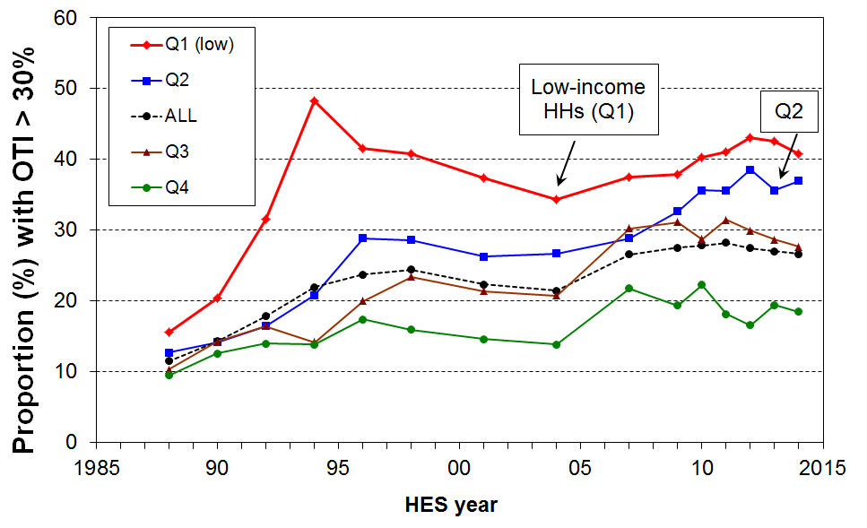

Table C.3
Proportion of households with housing cost OTIs greater than 30%, by income quintile
HES year | Q1 | Q2 | Q3 | Q4 | Q5 | ALL
1988 | 16 | 13 | 10 | 9 | 9 | 11
1990 | 20 | 14 | 14 | 13 | 10 | 14
1992 | 32 | 16 | 16 | 14 | 11 | 18
1994 | 48 | 21 | 14 | 14 | 13 | 22
1996 | 42 | 29 | 20 | 17 | 11 | 24
1998 | 41 | 29 | 23 | 16 | 13 | 24
2001 | 37 | 26 | 21 | 15 | 12 | 22
2004 | 34 | 27 | 21 | 14 | 12 | 21
2007 | 38 | 29 | 30 | 22 | 14 | 27
2009 | 38 | 33 | 31 | 19 | 17 | 28
2010 | 40 | 36 | 29 | 22 | 12 | 28
2011 | 41 | 36 | 31 | 18 | 15 | 28
2012 | 43 | 39 | 30 | 17 | 9 | 27
2013 | 43 | 36 | 29 | 19 | 9 | 27
2014 | 41 | 37 | 28 | 18 | 10 | 27

In 2014, just over one in four households (27%) had high housing OTIs (>30%), compared with one in five in the early 1990s, and one in ten in the late 1980s. These are national average figures, and there are variations regionally.

For the bottom quintile, the proportion with high OTIs steadily reduced from 48% in 1994 to 34% in 2004, as unemployment fell, employment and income rose, and income-related rental policies were introduced in 2000 for those in HNZC houses. It then rose to 41-43% for 2011-2014.

For households in the second quintile there was a strong rise from the 1980s through to the mid 1990s, followed by a relatively flat trend to 2004. From 2004 to 2012 there was a strong rise from 27% to 39%. The rate was much the same in HES 2014 at 37%.

The rise for the third quintile from 21% in 2004 to 31% in 2011 is also noteworthy, but unlike the trend for households in the second quintile the rise seems to have stopped, and there is preliminary evidence of some easing for this group.

OTIs greater than 40%

From 2007 to 2014, around 15% of households had an OTI greater than 40% - up from 5% in the late 1980s (see Figure C.10).

For those in Q1 (lower quintile), the proportion with these higher OTIs peaked in the late 1990s at 34%, declined to 25% in 2004, then rose again to be back at the 1994 rate in 2013 (34%). It is not clear if the HES 2014 figure (29%) is a statistical blip or a genuine fall. The proportion in the second quintile rose from 15% in 2001 to just over 20% in 2011 to 2014.

Figure C.10
Proportion of households with housing cost OTIs greater than 40%
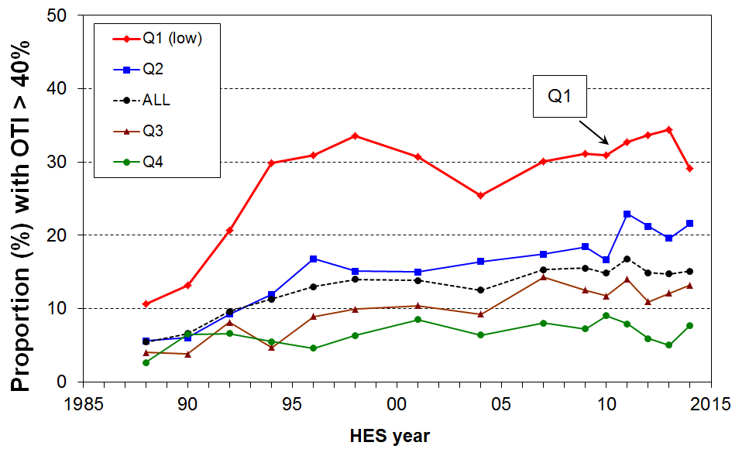

OTIs greater than 50%

In HES 2013, just over one in four Q1 households reported spending more than half their income on accommodation (Figure C.11). This has risen from a steady one in five from 2004 to 2009 and was higher than any time since the time series begins in 1988. Whether the lower number in HES 2014 is a genuine fall or merely a statistical blip is unclear. A further survey or two will clarify this.

Figure C.11
Proportion of Q1 households with housing cost OTIs greater than 30%, 40% and 50%
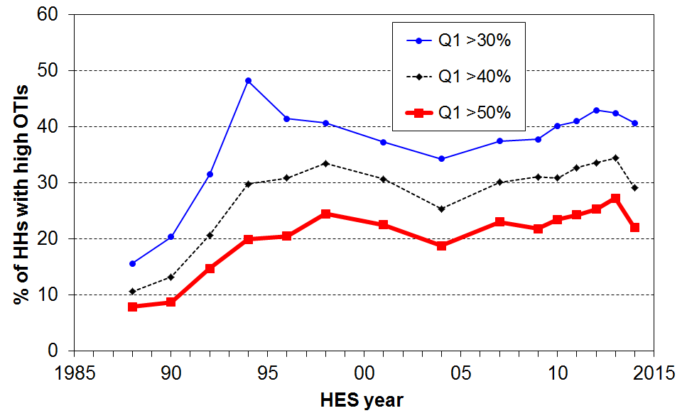

OTI trends by household type

Table C.4 provides a breakdown by household type. The analysis uses the “30-40 rule” that is common in Australia and elsewhere – that is, it looks at the those in the lower two quintiles (40%) who have OTIs greater than 30%.

Sole parent households have the highest housing stress on this measure. As most sole parent households are at the lower end of the income distribution it makes little difference as to whether all sole parent households are considered (rate is 63%) or just those in the lower two quintiles (rate is 68%). Taking the lower two quintiles only does however have an impact on the relativities between household types. For example, using the 30-40 rule, all working-age households except for sole parent households have much higher reported housing stress.

Around one third of sole parent families live in larger households with other adults. The sole parent household figures In Table C.4 do not therefore fully represent the situation for all sole parent families, a good portion of whom are captured in the “Other family households with some dependent children” row.

Table C.4
Proportion (%) of households in lower two income quintiles and in all quintiles with housing cost OTIs greater than 30%, by household type, average for HES 2012 to HES 2014
Household type | Q1 & Q2 | ALL
Single 65+ | 15 | 13
Couple only maxage 65+ | 12 | 9
Single <65 | 58 | 44
Couple only maxage<65 | 53 | 21
SP household with some dependent children | 68 | 63
2P household with some dependent children | 45 | 30
Other family households with some dependent children | 41 | 28
Family households with no dependent children maxage <65 | 46 | 21
Non-family households | 56 | 32
ALL households | 39 | 27

OTI trends using the individual rather than the benefit unit or household as the unit of analysis

Figures C.9 to C.11 above use the household as the analysis unit. For some purposes, such as examining the different levels of housing stress by age, analysis needs to be done using individuals rather than households. Table C.5 provides a breakdown by age group. The proportions with high OTIs in 2014 are on average much higher than in the late 1980s for all age groups (doubling or even tripling for some), although still remaining relatively low on average for older New Zealanders.

Table C.5
Proportion of individuals in households with housing cost OTIs greater than 30%, by age group
 | 0-17 | 18-24 | 25-44 | 45-64 | 65+ | ALL
1988 | 12 | 12 | 15 | 5 | 3 | 11
1990 | 16 | 16 | 18 | 7 | 2 | 14
1992 | 22 | 21 | 24 | 8 | 3 | 18
1994 | 27 | 22 | 28 | 10 | 5 | 22
1996 | 32 | 24 | 28 | 14 | 6 | 24
1998 | 33 | 26 | 31 | 14 | 7 | 26
2001 | 32 | 29 | 28 | 16 | 7 | 25
2004 | 26 | 28 | 25 | 15 | 6 | 22
2007 | 32 | 33 | 33 | 20 | 9 | 27
2009 | 39 | 26 | 35 | 22 | 8 | 29
2010 | 35 | 31 | 34 | 22 | 10 | 28
2011 | 33 | 35 | 34 | 23 | 8 | 28
2012 | 37 | 32 | 35 | 20 | 10 | 28
2013 | 34 | 28 | 35 | 20 | 9 | 27
2014 | 34 | 35 | 32 | 21 | 11 | 27

Trends using households and individuals compared

Long-run trends are very similar whichever unit of analysis is used (compare, for example, the “ALL” columns in Tables C.3 and C.4). There can however be some divergence from survey to survey especially for sub-groups, mainly because the bottom quintile (20%) of households has only around 17% of the total population in it, reflecting in particular the high proportion of small households in decile 2 (the top half of the bottom quintile). As a consequence of this difference, the second quintile of households does not perfectly coincide with the second quintile of individuals.

Figure C.12 compares the trends for second quintile individuals and second quintile households and shows that despite the wobbles and divergences that are evident at times from survey to survey, the trends are the same.

Figure C.12
Proportion of Q2 individuals and households with housing cost OTIs greater than 30% and 40%
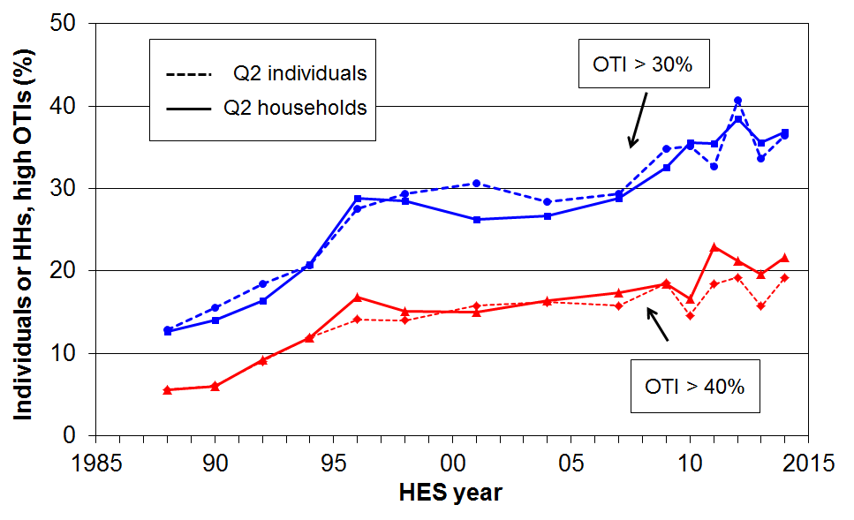

OTIs for those receiving the Accommodation Supplement – information from administrative data

Table C.6 focuses on those households receiving accommodation support through the AS (Accommodation Supplement). It shows the proportions of these AS households that have high OTIs – those that are spending more than 30%, 40% and even 50% of their income on accommodation.
- in 2013, almost all renters (94%) receiving the AS spent more than 30% of their income on housing costs, three in four spent more than 40% and one in two (48%) spent more than 50%
- an increasing proportion of AS recipients are receiving the maximum payment (33% in 2007 and 50% in 2013).

Table C.6
Housing stress for AS recipients using three OTI thresholds (30%, 40% and 50%), 2013
Group | This group as a proportion of all who receive AS | housing costs as a proportion of income
Group | This group as a proportion of all who receive AS | >30% | >40% | >50%
All | 100 | 92 | 67 | 40
Renters | 66 | 94 | 75 | 48
Single adult | 52 | 93 | 71 | 45
2 parent with dependent children | 9 | 89 | 52 | 23
One parent with one child | 17 | 92 | 69 | 42
One parent with 2+ children | 15 | 89 | 64 | 32
NZS/VP | 10 | 83 | 49 | 23

Section D

Household incomes and income inequality,

1982 to 2014

This section reports on:
- changes in equivalised household incomes for the whole population
- changes for different parts of the distribution
- changes in medians for different household types
- the changing shape of the household income distribution
- trends in inequality using income shares, percentile ratios and the Gini coefficient.

Income changes in real terms, 1982 to 2014

Whole population, overall trends

Figure D.1 shows the trends in real equivalised household disposable income (BHC and AHC) from 1982 to 2014.

After 15 years of steady growth in median household income (3% pa in real terms from HES 1994 to HES 2009), the impact of the economic downturn on household incomes showed in the HES 2010 and 2011 figures in which both the BHC and AHC medians declined or were flat year on year. The 2012 HES picked up the beginning of the recovery with both the BHC and AHC medians rising each year through to 2014 HES (8% and 7% rises respectively, in the three years).

Prior to 1994, the BHC median fell 15% in the six years from 1988. It took until 2001 to restore it to its 1988 level.

The general trend for AHC medians is similar to that for BHC medians, although the AHC median fell from 90% of the BHC median in 1982, to 86% in 1988, and 80% in 1998. Since 2007 the relativity has been steady at 78-79%. This reflects how accommodation costs have risen as a proportion of household income for low- to middle-income households since the 1980s.

Figure D.1
Real equivalised household disposable incomes, 1982 to 2014 (2014 dollars)
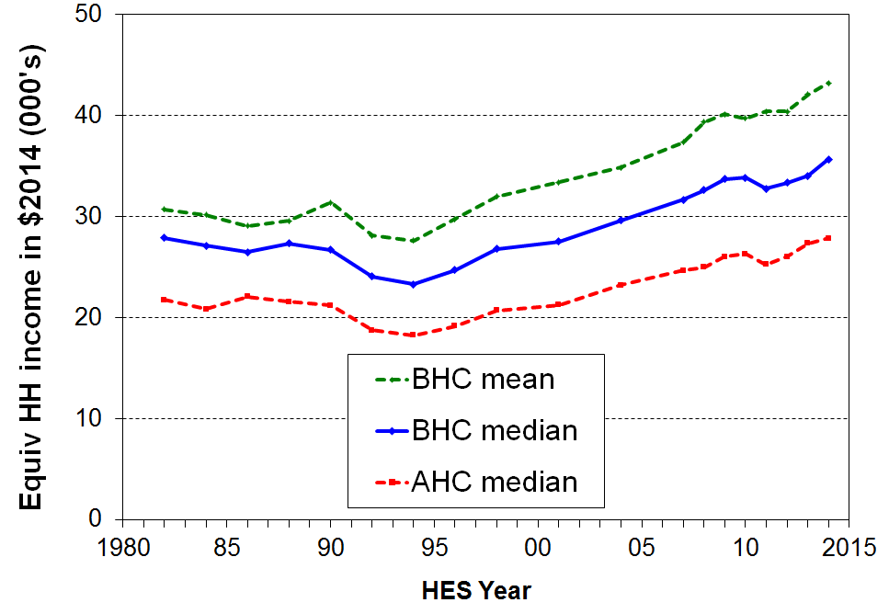

Table D.1
Real equivalised household disposable incomes, 1982 to 2014 (2014 dollars)
 | 1982 | 1986 | 1990 | 1994 | 1998 | 2001 | 2004 | 2007 | 2009 | 2010 | 2011 | 2012 | 2013 | 2014
BHC mean | 30,700 | 29,100 | 31,400 | 27,600 | 32,000 | 33,400 | 34,800 | 37,400 | 40,100 | 39,700 | 40,400 | 40,400 | 42,100 | 43,200
BHC median | 27,900 | 26,500 | 26,700 | 23,300 | 26,800 | 27,500 | 29,600 | 31,600 | 33,700 | 33,800 | 32,700 | 33,300 | 34,000 | 35,700
AHC median | 21,700 | 22,000 | 21,200 | 18,200 | 20,700 | 21,300 | 23,200 | 24,600 | 26,000 | 26,300 | 25,200 | 26,000 | 27,400 | 27,800

The mean and median generally move in the same direction. The most notable exception is for the period 1988 to 1990 during which the mean rose but the median fell. In this period, average incomes for households in the top quintile of the income distribution rose in real terms but those in the other four quintiles fell (cf Figure D.5). This lowered the median but raised the mean as the impact of the rises of those with higher incomes was the dominant effect.

Differing trends for different parts of the distribution (BHC)

Trends in the overall median or mean household income provide useful high-level summaries, but they tell only a part of the story as different parts of the income distribution (can) show quite different relative movements over time.

One way to show these differing changes is to divide the population into ten equal groups (deciles) and show the trends in real incomes for the median, mean or top of each decile. This part of the analysis uses the latter as it fits well with the use of percentile ratios for summarising trends in inequality, which is done later in this section. Changes for incomes at P95 (the median of the top decile) are also included. Decile means are reported in Appendix 9.

Recent changes (2007 HES to 2014 HES)

Figure D.2 shows the changes for the decile boundaries from HES 2007 to HES 2014, broken down into two two-year and one three-year comparisons. The top graph shows the 3-4% pa growth across all deciles prior to the GFC. The impact of the GFC is clearly evident in the HES 2009 to 2011 graph, with net declines for deciles 1-6 and small gains for the higher income deciles (7-10). The lower graph shows the impact of the recovery on household incomes across the distribution.

Figure D.2
Real equivalised household incomes (BHC): changes for top of deciles, HES 2007 to HES 2014
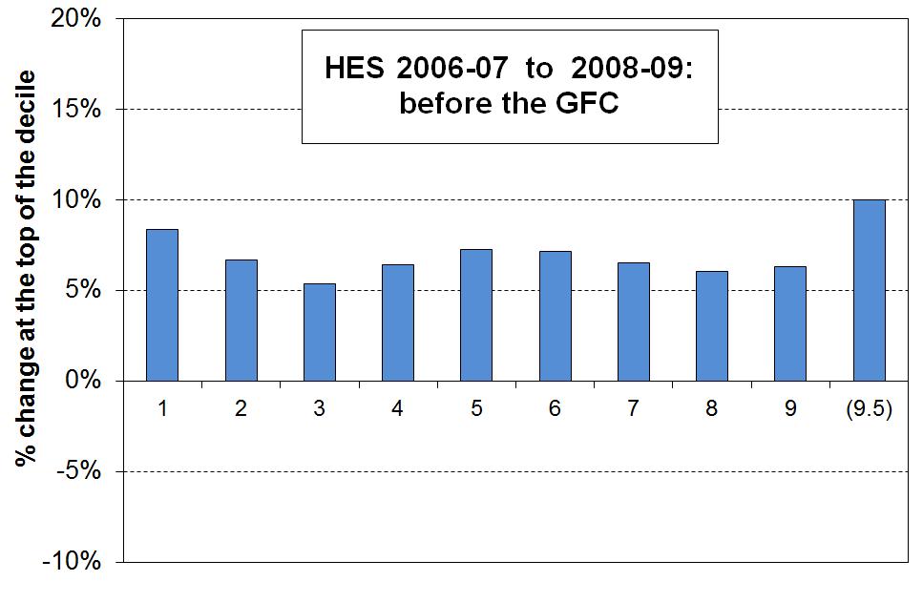

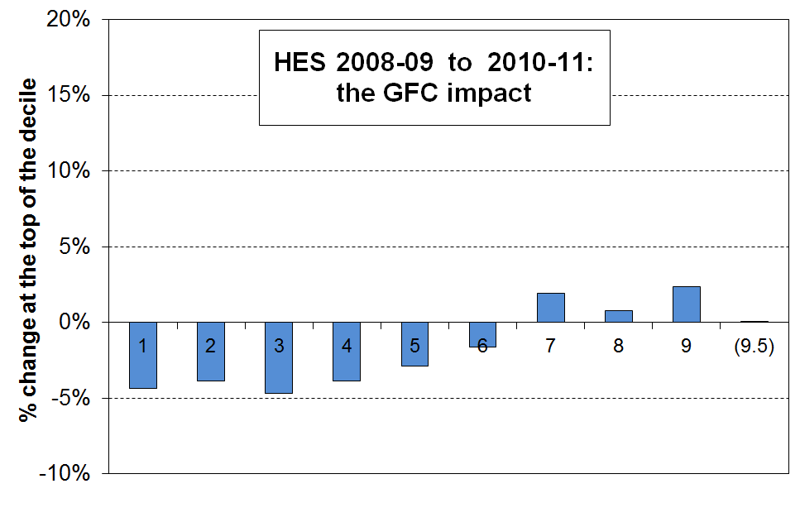

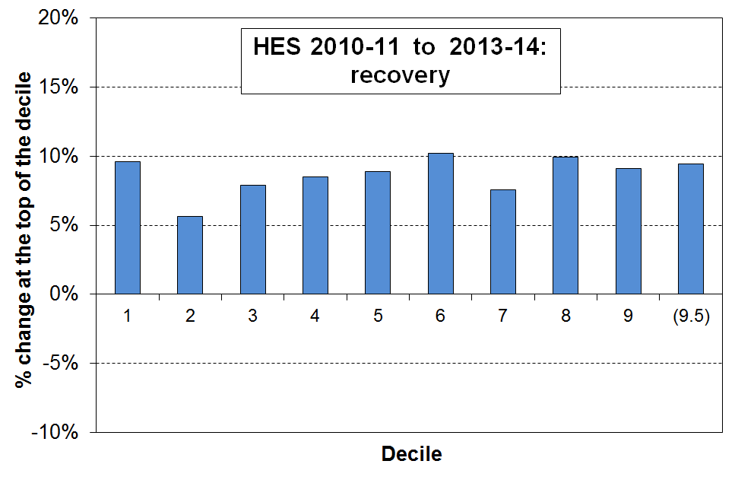
The Working for Families impact (2004 HES to 2007 HES)

The changes from 2004 to 2007 reflected the major part of the impact of the Working for Families package (Figure D.3). The transfer of an extra approximately $1.6b pa to low- to middle-income households with children made a tangible difference to the income distribution. The general pattern up to 2004 had been for the income of higher-income households to rise more quickly than those of lower- to middle-income households. The 2004 to 2007 period was the only one in the 25 years to 2007 in which the incomes of low- to middle-income households grew more quickly than those of households above the median.

Figure D.3
Real equivalised household incomes (BHC): changes for top of deciles, 2004 to 2007
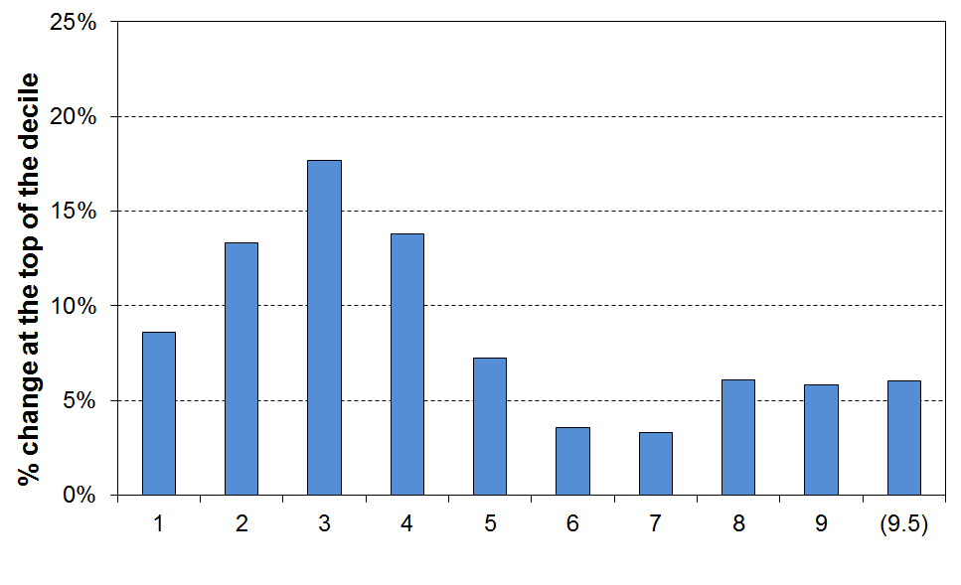

Longer term trends

Figure D.4 shows the differing changes for different parts of the income distribution (top of deciles 1 to 9, plus P95) from 1988 to 2004. The period is divided at 1994 when incomes were at their lowest in real terms.

The graphs show the very large falls in real household income from 1988 to 1994 for all but the very highest income group, followed from 1994 to 2004 by steady and fairly even income growth across the bulk of the income distribution, although the growth for lower income households (bottom 20 to 30%) was not as strong as for the rest.

Figure D.4
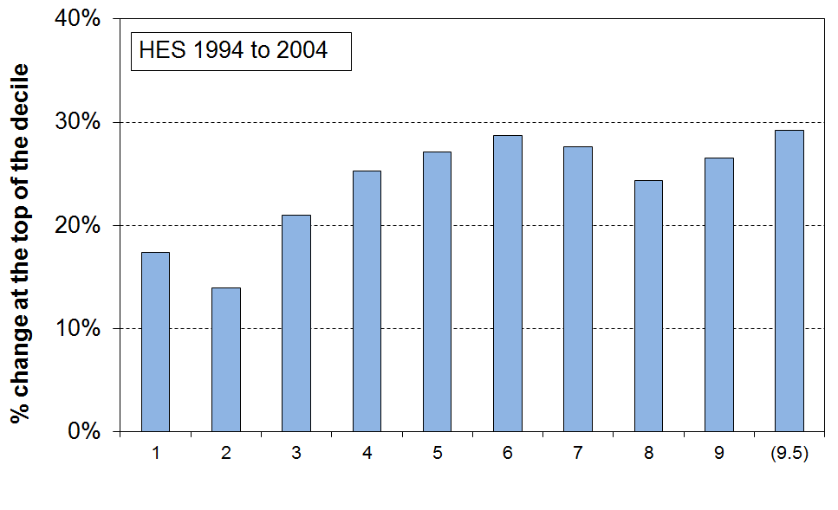
Real equivalised household incomes (BHC): changes for top of deciles, 1988-94, and 1994-04

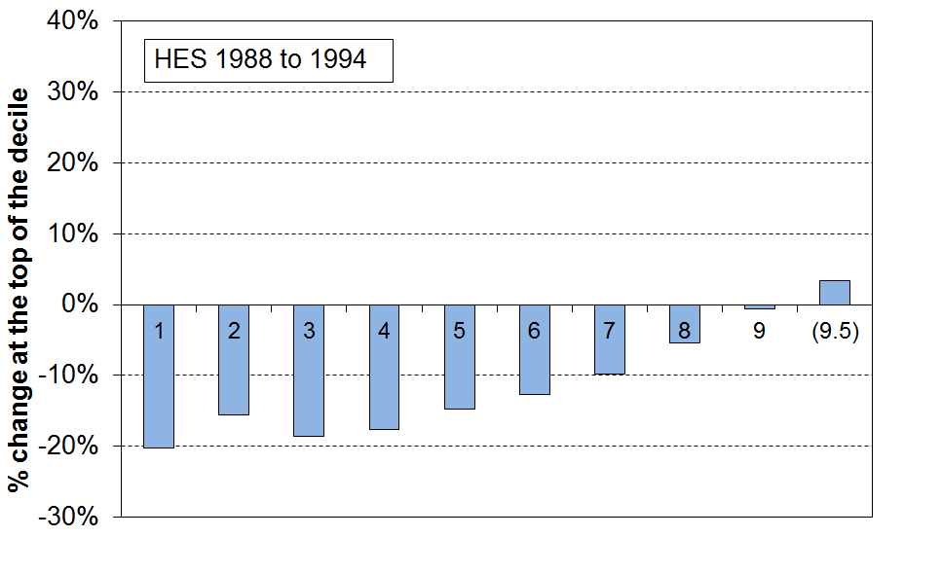
The net effect of the changes from 1988 to 2004 is captured in Figure D.5 which shows the large net increase in inequality that took place in that period. Most of the increase occurred from the late 1980s to the mid 1990s.

Figure D.5
Real equivalised household incomes (BHC): changes for top of deciles,1988 to 2004
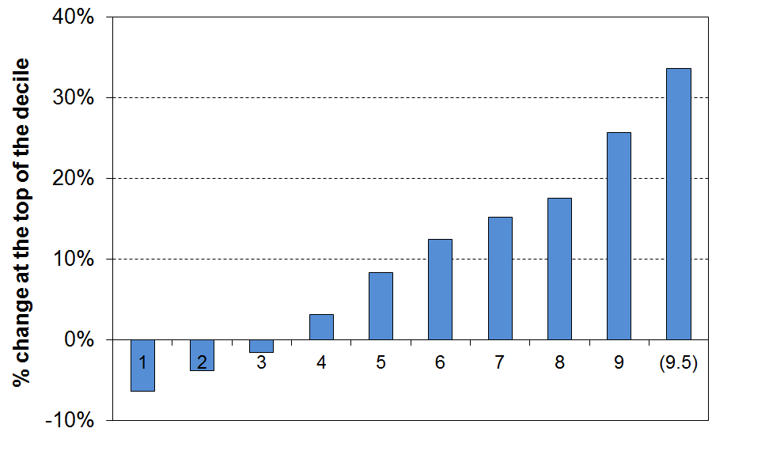

Figure D.6 shows the net changes for the full period from HES 1982 to 2014. All income groups gained in real terms, with the highest income group gaining much more than the rest, and the lowest income group gaining the least. The different growth rates show that income inequality is higher in HES 2014 than in 1982 (though most of the change occurred from the late 1980s to the mid 1990s).

Figure D.6
Real equivalised household incomes (BHC): changes for top of deciles,1982 to 2014
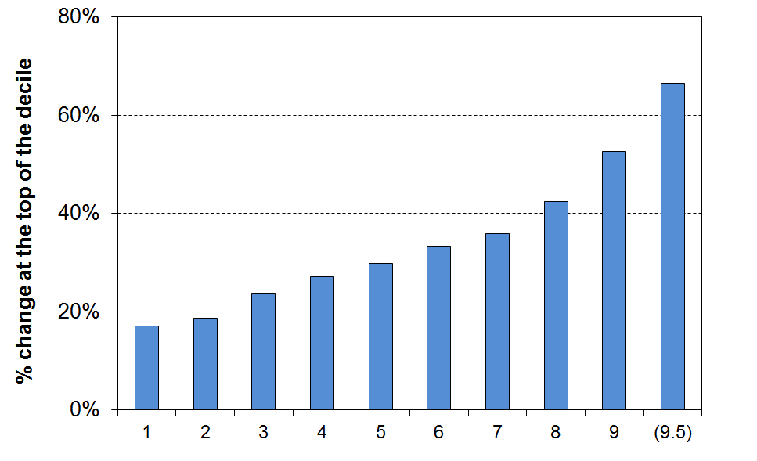

Static and dynamic analysis
In interpreting the time series analysis that is based on the HES data (as above), it is important to understand that the HES provides repeat cross-sectional data with different people interviewed each survey. The HES does not follow the same individuals across time. Some individuals do stay in roughly the same income band for many years, some move up and some move down. The degree of income mobility in New Zealand is discussed in Section K using longitudinal data from Statistics New Zealand’s Survey of Family, Income and Employment (SoFIE).

Figure D.7 and Table D.2 show the above analysis in a different way. The greater dispersion of household incomes in HES 2014 compared with the 1980s is clear. For the period as a whole, incomes for households in the top quintile increased proportionately and in absolute terms much more than did the incomes of households in the lower-income deciles.

Figure D.7
Real equivalised household incomes (BHC): decile boundaries, 1982 to 2014
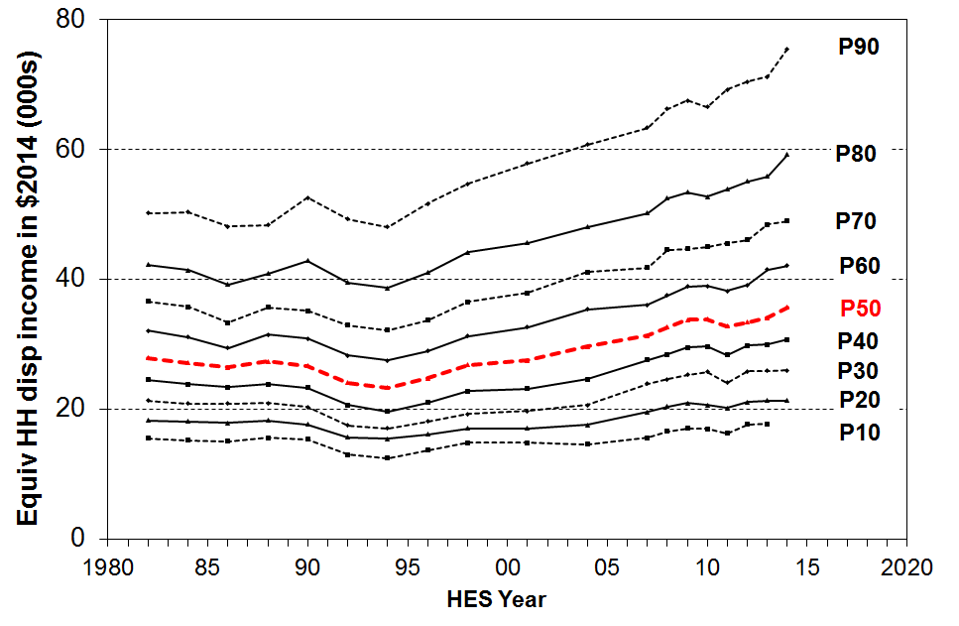

Table D.2
Real equivalised household incomes (BHC): decile boundaries (2014 dollars)
 | 1982 | 1986 | 1990 | 1994 | 1998 | 2001 | 2004 | 2007 | 2009 | 2010 | 2011 | 2012 | 2013 | 2014
P90 | 50,200 | 48,000 | 52,500 | 48,000 | 54,700 | 57,800 | 60,700 | 63,300 | 67,500 | 66,500 | 69,100 | 70,400 | 71,200 | 75,400
P80 | 42,200 | 39,200 | 42,800 | 38,600 | 44,100 | 45,500 | 48,000 | 50,200 | 53,400 | 52,700 | 53,800 | 55,100 | 55,800 | 59,100
P70 | 36,600 | 33,200 | 35,100 | 32,100 | 36,500 | 37,800 | 41,000 | 41,700 | 44,600 | 45,000 | 45,500 | 46,000 | 48,400 | 48,900
P60 | 32,000 | 29,400 | 30,800 | 27,400 | 31,200 | 32,600 | 35,300 | 36,000 | 38,800 | 38,900 | 38,200 | 39,000 | 41,500 | 42,100
P50 | 27,900 | 26,400 | 26,700 | 23,300 | 26,800 | 27,500 | 29,600 | 31,300 | 33,700 | 33,800 | 32,700 | 33,300 | 34,000 | 35,700
P40 | 24,500 | 23,300 | 23,200 | 19,600 | 22,800 | 23,100 | 24,600 | 27,500 | 29,400 | 29,600 | 28,300 | 29,800 | 29,900 | 30,700
P30 | 21,300 | 20,800 | 20,300 | 17,000 | 19,200 | 19,600 | 20,600 | 23,900 | 25,200 | 25,700 | 24,000 | 25,700 | 25,900 | 26,000
P20 | 18,200 | 17,800 | 17,600 | 15,400 | 17,000 | 17,000 | 17,500 | 19,500 | 20,900 | 20,600 | 20,100 | 21,100 | 21,200 | 21,300
P10 | 15,400 | 15,000 | 15,300 | 12,400 | 14,800 | 14,800 | 14,500 | 15,600 | 17,000 | 16,900 | 16,200 | 17,600 | 17,700 | -

Table D.3 translates the income information in Table D.2 into index form using various base years. The numbers in the body of the table indicate the percentage gains or losses over a given period (119 means a 19% rise; 84 means a 16% fall, and so on).

A disadvantage of using upper decile boundaries is that the top of decile 10 (P100) is very volatile and it is not sensible to report that trend. In line with the graphs above, Table D.3 incorporates information on changes for P95 to give some indication of trends for the top decile, while avoiding the misleading picture that reporting on P100 would give. The inequality part of Section J gives information on trends for very high incomes based on tax records.

Table D.3
Changes in real equivalised household incomes (BHC) relative to selected base years:
index = 100 in base year
HES period | base HES year | P10 | P20 | P30 | P40 | P50 | P60 | P70 | P80 | P90 | P95
1982-2014: overall
1982 - 2014 | 1982 | 115 | 117 | 122 | 125 | 128 | 131 | 134 | 140 | 150 | 164
Relative to low point in 1994
1988 - 1994 | 1988 | 80 | 84 | 81 | 82 | 85 | 87 | 90 | 95 | 99 | 103
1994 - 2014 | 1994 | 144 | 138 | 152 | 156 | 153 | 153 | 152 | 153 | 157 | 164
Relative to 2001, the year the median returned to what it had been in the late 1980s
1988 - 2001 | 1988 | 95 | 93 | 94 | 97 | 101 | 104 | 106 | 111 | 120 | 124
2001 - 2014 | 2001 | 120 | 125 | 132 | 133 | 130 | 129 | 129 | 130 | 130 | 137
The Working for Families impact (as seen in the greater gains for low to middle income HHs)
2004 - 2007 | 2004 | 107 | 112 | 116 | 112 | 106 | 102 | 102 | 104 | 104 | 104
After the WFF implementation through to impact of the GFC on incomes and to the recovery from HES 2011 to HES 2014
2007 - 2009 | 2007 | 108 | 107 | 105 | 106 | 107 | 107 | 107 | 106 | 106 | 110
2009 - 2011 | 2009 | 95 | 96 | 95 | 96 | 97 | 98 | 102 | 101 | 102 | 100
2011 - 2014 | 2011 | 108 | 105 | 108 | 106 | 104 | 109 | 107 | 104 | 103 | 100
2009 - 2014 | 2009 | 105 | 102 | 103 | 104 | 106 | 108 | 110 | 111 | 112 | 109
Notes 1 P10 = top of decile 1, and so on.
2 Recall that HES 2004 is really HES 2003-04, and that the incomes reported are on average from ~ calendar 2003, and so on.

New Zealand’s post-GFC gains compared with other OECD countries

New Zealand’s post-GFC gains are better overall than for many OECD countries. For example, median incomes for both the UK and Ireland fell through the GFC and have been flat since. Italy, Spain, France and Germany were flat through the GFC and have remained so since. The US median has been flat for the last 5 years. New Zealand’s post-GFC gain of 9% at the median is more like that of the top performers such as Belgium, Norway and Sweden (10%), though they did not have the fall in median during the GFC that New Zealand did (-3%).
Differing trends for different parts of the distribution (AHC)

Figure D.8 and Table D.4 show the trends in real incomes (AHC) for the top of each decile. From HES 2009 to 2011, the impact of the economic downturn, global financial crisis and rise in rents is clear in the fall in AHC incomes across the income range. The decline for the median was 3% in real terms. There were more substantial falls (-5%) for the P30 and P40 regions, that is, for households below the median but above the usual poverty lines. The impact of the recovery is evident in the rises across all income deciles from HES 2011 to 2014, though the P10 figure has in 2014 only just returned to what it was prior to the GFC.

From a longer-term perspective, in HES 2014 household incomes at the top of the bottom decile were lower in real terms than they were in the 1980s. This is the only decile for which this is the case. The net % gains relative to that benchmark for the next two deciles (deciles 2 and 3) were much lower than for middle to higher income gains. The AHC income distribution was more dispersed in 2014 than in the 1980s.

Figure D.8
Real equivalised household incomes (AHC): decile boundaries, 1982 to 2014 (2014 dollars)
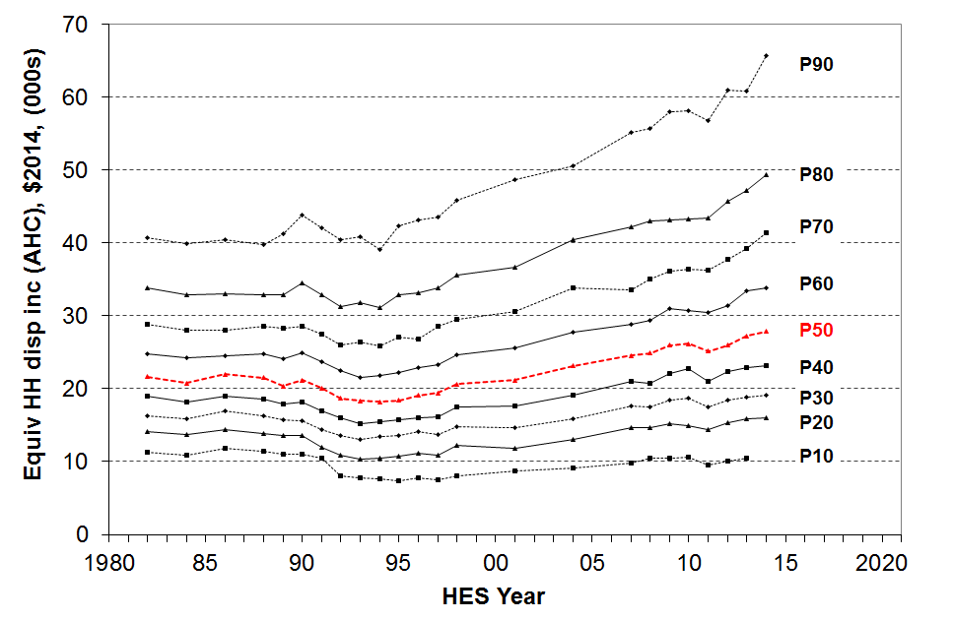

Table D.4
Real equivalised household incomes (AHC): decile boundaries (2014 dollars)
 | 1982 | 1986 | 1990 | 1994 | 1998 | 2001 | 2004 | 2007 | 2009 | 2010 | 2011 | 2012 | 2013 | 2014
P90 | 40,700 | 40,500 | 43,800 | 39,100 | 45,800 | 48,600 | 50,500 | 55,200 | 58,000 | 58,200 | 56,800 | 60,900 | 60,800 | 65,800
P80 | 33,900 | 33,100 | 34,500 | 31,100 | 35,600 | 36,700 | 40,500 | 42,200 | 43,200 | 43,300 | 43,400 | 45,700 | 47,300 | 49,400
P70 | 28,800 | 28,100 | 28,500 | 25,900 | 29,500 | 30,600 | 33,800 | 33,500 | 36,200 | 36,400 | 36,200 | 37,800 | 39,300 | 41,400
P60 | 24,800 | 24,600 | 24,900 | 21,900 | 24,600 | 25,600 | 27,700 | 28,900 | 31,000 | 30,700 | 30,400 | 31,400 | 33,400 | 33,800
P50 | 21,700 | 22,000 | 21,100 | 18,200 | 20,600 | 21,200 | 23,100 | 24,600 | 25,900 | 26,200 | 25,100 | 26,000 | 27,300 | 27,800
P40 | 18,900 | 19,000 | 18,200 | 15,400 | 17,500 | 17,600 | 19,100 | 21,000 | 22,100 | 22,700 | 21,000 | 22,300 | 22,900 | 23,100
P30 | 16,200 | 17,000 | 15,600 | 13,400 | 14,800 | 14,600 | 15,900 | 17,700 | 18,400 | 18,800 | 17,500 | 18,500 | 18,800 | 19,000
P20 | 14,100 | 14,400 | 13,600 | 10,400 | 12,200 | 11,800 | 13,000 | 14,700 | 15,200 | 14,900 | 14,400 | 15,400 | 15,900 | 16,000
P10 | 11,200 | 11,800 | 11,000 | 7,600 | 8,000 | 8,700 | 9,100 | 9,800 | 10,400 | 10,600 | 9,500 | 10,100 | 10,400 | -

Trends in the median for different household types

Figure D.9 shows the trends in real equivalised household disposable income (BHC) from HES 1982 to 2014 for selected household types.

Working-age couple only and two parent households show solid recovery after the downturn.

The median income trend for sole parent households is flat over recent years and is much lower than for other household types. This low level of the sole parent median reflects both the more limited employment hours available to the household compared with others with more than one adult, and the lower earning potential on average of the sole parent adult (lower educational attainment on average than other working age adults in other multi-adult households). Around one third of sole parent families live in larger households with other adults. The sole parent household figures In Figure D.9 do not therefore fully represent the situation for all sole parent families.

Trends for those in single and couple 65+ households are omitted from Figure D.9 to avoid clutter, but are shown in Table D.5 (next page):
- For those in one-person 65+ households, median incomes ($2014) remained relatively steady at around $16,500 to $17,500 pa from 1982 to 1998, with a small rise to $18,800 by 2007, and then to $21,000 on average for HES 2013 and 2014. Part of that rise reflects the personal income tax changes in October 2008, April 2009 and October 2010 which have an impact on NZS via the net wage benchmark.
- Median incomes of those in 65+ couple households remained reasonably steady from 1992 to 2001 at around $19,500 pa. From 2004 to 2010, median incomes for these households grew 37% in real terms to $27,800 pa. This rise reflects the increase from 65% to 66% of the average wage for the floor for the married couple rate for NZS (starting in 2006), the increased employment income for some 65+ couples, and the personal income tax changes in October 2008 and April 2009. In HES 2011 and 2012) their median income was around $26,000 but in 2013 and 2014 it had risen to $30,600 and $32,500 respectively. $32,500 (equivalised) is $50,000 pa in unequivalised terms (ie “ordinary dollars”).
- See Section I for more information on the incomes of older New Zealanders.

Figure D.9
Median equivalised household incomes (BHC) for selected household types, 1982 to 2014 ($2014)
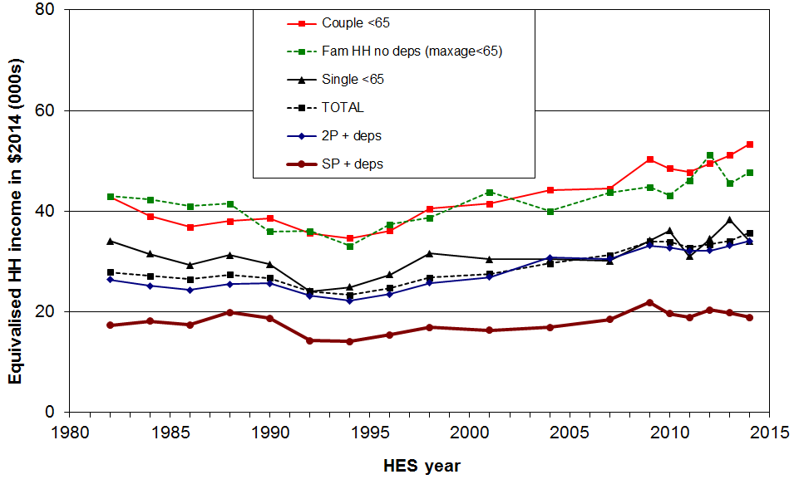
Note: The median incomes in Figure D.9 are equivalised household incomes. Table B.2 gives median household incomes in ordinary (unequivalised) dollars.

Table D.5
Median equivalised household incomes (BHC) for selected household types, 1982 to 2013 ($2013)
 | 1982 | 1986 | 1990 | 1994 | 1998 | 2001 | 2004 | 2007 | 2009 | 2010 | 2011 | 2012 | 2013
Single < 65 | 33,500 | 28,800 | 29,000 | 24,500 | 31,100 | 30,000 | 30,000 | 29,600 | 33,600 | 35,600 | 30,500 | 33,900 | 37,700
Couple < 65 | 42,200 | 36,200 | 38,000 | 34,100 | 39,900 | 40,900 | 43,500 | 43,800 | 49,500 | 47,700 | 47,000 | 48,700 | 50,300
Other multi-adult fam HH <65, no dep ch | 42,300 | 40,400 | 35,400 | 32,500 | 38,000 | 43,100 | 39,400 | 43,000 | 44,100 | 42,400 | 45,400 | 50,400 | 44,800
Two parent | 25,900 | 23,900 | 25,300 | 21,800 | 25,300 | 26,500 | 30,300 | 30,100 | 32,600 | 32,200 | 31,600 | 31,400 | 32,600
Sole parent | 17,000 | 17,100 | 18,400 | 13,900 | 16,600 | 16,000 | 16,600 | 18,100 | 21,500 | 19,300 | 18,500 | 20,000 | 19,500
Couple 65+ | 20,400 | 20,300 | 21,000 | 18,800 | 19,100 | 19,100 | 20,000 | 22,300 | 27,000 | 27,400 | 26,100 | 25,100 | 30,200
Single 65+ | 17,100 | 16,300 | 15,700 | 16,000 | 17,300 | 17,900 | 17,900 | 18,400 | 20,100 | 20,300 | 19,600 | 21,500 | 21,200
ALL | 27,400 | 26,000 | 26,300 | 23,000 | 26,400 | 27,100 | 29,100 | 30,800 | 33,500 | 33,300 | 32,200 | 32,800 | 33,500

Trends in the median by ethnicity

Ethnicity of individuals aged 15 and over is as reported by the individual, and children under 15 are attributed with the ethnicity of the survey respondent. If a respondent reports more than one ethnicity, the ethnicity attributed is determined according to a hierarchical classification of Māori, Pacific Island, Other and then European/Pākehā. The household’s equivalised disposable income is attributed to the individual for ranking purposes, just as it is for analysis by age.

Figure D.10 and Table D.6 show the trends in real equivalised household disposable income (BHC) from the 1988 HES to 2014 by ethnicity.

The overall impact of the GFC, the economic downturn and recovery is still emerging for the Maori and Pacific ethnic groups. The medians for these two groups have been relatively flat since the crisis, with some evidence of a decline for Pacifika. At this stage it looks as if the impact of the downturn is proving to be longer-lasting for Maori and Pacifika compared with Eurpean/Pakeha and those of “Other” ethnicity.

From a longer-term perspective, all groups showed a strong rise from the low point in the mid 1990s through to 2010. In real terms, overall median household income rose 47% from 1994 to 2010: for Maori, the rise was even stronger at 68%, and for Pacific, 77%. These findings for longer- term trends are robust, even though some year on year changes may be less certain. For 2004 to 2010, the respective growth figures were 21%, 31% and 14%.

Figure D.10
Real equivalised median household incomes (BHC) by ethnicity, 1988 to 2014 ($2014)
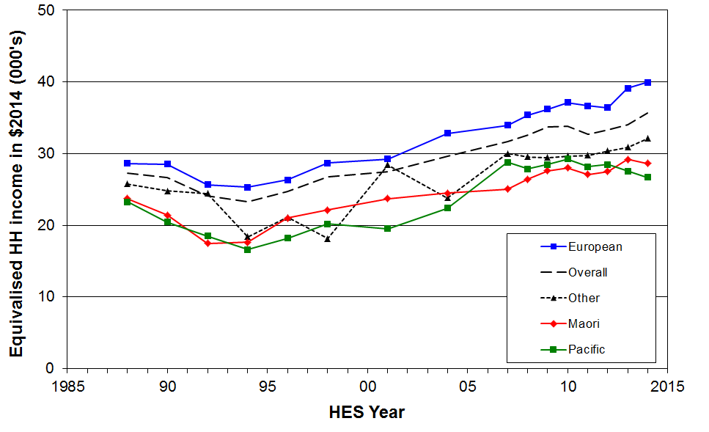

Table D.6
Real equivalised median household income (BHC) by ethnicity, 1988 to 2013 ($2013)
 | 1988 | 1990 | 1992 | 1994 | 1996 | 1998 | 2001 | 2004 | 2007 | 2009 | 2010 | 2011 | 2012 | 2013
Euro/Pakeha | 28,200 | 28,100 | 25,300 | 24,900 | 25,900 | 28,200 | 28,800 | 32,300 | 33,200 | 36,600 | 36,600 | 36,000 | 35,900 | 38,500
NZ Māori | 23,400 | 21,100 | 17,200 | 17,400 | 20,700 | 21,800 | 23,400 | 24,100 | 23,600 | 27,100 | 28,100 | 25,200 | 28,900 | 28,500
Pacific | 22,900 | 20,100 | 18,200 | 16,400 | 17,900 | 19,900 | 19,200 | 22,100 | 25,800 | 29,100 | 28,000 | 27,400 | 28,800 | 25,700
Other | 25,400 | 24,400 | 24,100 | 18,100 | 20,800 | 17,800 | 28,100 | 23,500 | 29,500 | 29,300 | 29,100 | 29,500 | 30,300 | 30,500
ALL | 26,900 | 26,300 | 23,700 | 22,900 | 24,300 | 26,400 | 27,100 | 29,200 | 30,800 | 33,500 | 33,300 | 32,200 | 32,800 | 33,500

The incomes reported in Te Ao Marama

Statistics New Zealand recently published Te Ao Marama, a small collection of statistics relating to Maori. It reports that median income from all sources declined for Maori from 2008 to 2011, whereas median income for the whole population remained reasonably steady in the same period.

Te Ao Marama reports the incomes of individuals not of households. This is why the Te Ao Marama trends are different from those reported in this Incomes Report (which uses household incomes).

The update in 2014 showed that in 2013 incomes are still lower than those in 2008, though they have risen since 2011.

Inequality

There are many types of inequality that are relevant to public policy

Income inequality is about how dispersed incomes are, what the size of the gap is between those on ‘higher’ and those on ‘lower’ incomes. There are however many types of inequality other than income inequality that are of relevance to public policy formulation and debate, and it is useful to be clear about which sort of inequality is being discussed at any time.

Some of the main inequalities often discussed are:
  - market income inequality for individuals:
      - wage differentials across all wage earners
      - focusing on total market income for the very top 1% or so, compared with the rest
  - inequality of disposable household income (income from all sources after taxes and transfers):
      - across all households
      - focusing on the very high income households, compared with the rest
  - inequality of wealth (total assets less liabilities).
  - inequality of community resources and amenities available to local residents
  - inequality of educational outcomes
  - inequality of health outcomes
  - inequality of socio-economic status (combining education, occupation and income)
  - inequality of opportunity.

The major focus of the Incomes Report is on inequality of household disposable income and the shares of total market income received by top income earners, together with some reference to wealth distribution and wealth inequality.

It is important to maintain a clear distinction between wage inequality, household income inequality and wealth inequality. They are quite different concepts, each with their own particular characteristics.

Inequality and (income) poverty are sometimes used as if they are interchangeable ideas. They are different concepts and while there are some links between them, they need to be kept distinct as far as possible.

Inequality is essentially about the gap between the better off and those not so well off (on whatever measure) – it is about having “less than” or “more than”. (Income) poverty is about household resources being too low to meet basic needs – it is about “not having enough” when assessed against a benchmark of “minimum acceptable standards”.

A major difference between income inequality and income poverty is that a certain degree of inequality is considered by almost everyone to be inevitable and acceptable, and even desirable. There is no similar widely held view about unacceptably low incomes and material deprivation. Income poverty and material deprivation are by definition unacceptable states of affairs. There can be and is legitimate debate over the meaning of poverty and hardship in more economically developed countries. In building measures, there is debate as to where to set the low-income and deprivation thresholds, and over the relative merits of different approaches to the income concept used (eg BHC or AHC). There are however very few who advocate for “acceptable levels” of income poverty or hardship. On the other hand, when it comes to income (or wealth) inequality a part of the debate is about what is an acceptable or at a least tolerable level of income (or wealth) inequality. Unlike any debate around income poverty or hardship, there are very few calls for the elimination of income or wealth inequality.

There is no evidence of any statistical link between the income share received by the top 1% and income poverty rates.

There is no link between trends in income poverty using a fixed line approach and standard inequality measures.

The strongest conceptual and statistical link between income poverty and income inequality is between the P50:P20 or P50:P10 percentile ratio inequality measures and standard fully relative income poverty measures in which the threshold is set at a selected proportion of the current median (eg 50% or 60%). All these, both the percentile ratios referred to and the poverty measures, are about inequality in the lower half of the household income distribution and are therefore highly correlated, as expected.

On the other hand, there is only a modest correlation between inequality as measured by the Gini and income poverty measured using the fully relative approach. The relationship is stronger when using percentile ratios as the inequality measure. The lack of very strong correlation arises because standard income inequality measures do not focus just on the lower half of the distribution but on both higher and lower incomes (percentile ratios and share ratios) or on all incomes (eg the Gini).

Maintaining as clear as possible a distinction between poverty and hardship on the one hand and income inequality on the other means that:
- as a society, and as groups within it, we cannot easily avoid having to make the judgement call about minimum acceptable standards, even if we use two or three of differing severity
- we are better placed to seek to understand the relationship (if any) between the two, rather than blurring them into the Same Thing.

Income inequality: summary indicators

Income inequality is about how dispersed the income distribution is.

Figures D.2 to D.8(above) give a visual impression of how the income distribution became more dispersed from 1982 to 2014, with most of that increased dispersion occurring from the late 1980s to the mid 1990s.

There are several ways that are used to summarise the amount of income dispersion or inequality in a single statistic. No one statistic has emerged as the generally accepted way, mainly because each one captures a different aspect of the way the dispersion of incomes changes over time. It is now common to report on more than one indicator and to compare the trends produced by each.

This section uses three types of inequality measure:
- percentile ratios
- quintile and decile share ratios
- the Gini coefficient.

The international section (Section J) also reports on the share of taxable income received by high and very high income individuals based on tax records.

Percentile ratios

When individuals are ranked on the equivalised income of their respective households and divided into 100 equal-sized groups, each group is called a percentile. If the ranking starts with the lowest income then the income at the top of the 10th percentile is denoted P10, the median or top of the 50th percentile is P50 and so on. Ratios of values at the top of selected percentiles, such as P80/P20, are often called percentile ratios. Percentile ratios summarise the relative distance between two points in the income distribution.

The report uses four percentile ratios to provide a succinct picture of trends in income inequality.
- The P90/P10 ratio provides a good indication of the full spread of the distribution, going as far as possible to the extremes without running the risk of being overly influenced by unrepresentative very high incomes or by the difficulties with bottom decile incomes.
- The P80/P20 ratio gives a better indication of the size of the range within which the majority of the population fall and has less volatility than the P90/P10 ratio.
- The P80/P50 and the P20/P50 ratios give an indication of how higher and lower incomes compare with the midpoint.

For the P90/P10, P80/P20 and P80/P50 indicators, the higher the ratio the greater is the level of inequality. For the P20/P50 indicator, the higher the ratio the lower is the level of inequality in this part of the distribution.

Figure D.11 shows the trends for the P80/P20 ratio. Incomes after adjusting for housing costs (AHC) are more dispersed than BHC incomes.

The most rapid rises in inequality occurred from around 1988 to 1994. There was a further net rise for BHC incomes in the decade from 1994 to 2004 but the rate of increase was slower. From 2004 to 2010, the P80/P20 ratio fell, indicating decreasing inequality on this measure in the period, mainly as a result of the Working for Families package (2004 to 2007) and improving employment prior to the GFC.

The impact on incomes of the GFC and the associated downturn and recovery has led to some volatility in the index between the 2010 and 2014 HES. It will take another survey or two before the post-crisis inequality level becomes clear. There is however no evidence of any sustained longer-term rise in inequality on this measure. Current rates are similar to what they were in the mid 2000s.

The 90:10 ratio (BHC) was much the same post-GFC in HES 2012 and HES 2013 (4.02) as it was pre-GFC in HES 2008 and HES 2009 (4.0). In contrast the 90:10 AHC ratio was higher in 2012 and 2013 (5.9) than in pre-GFC times when it was around 5.5.

Figure D.11
Income inequality in New Zealand: the P80/P20 ratio, 1982 to 2014, total population
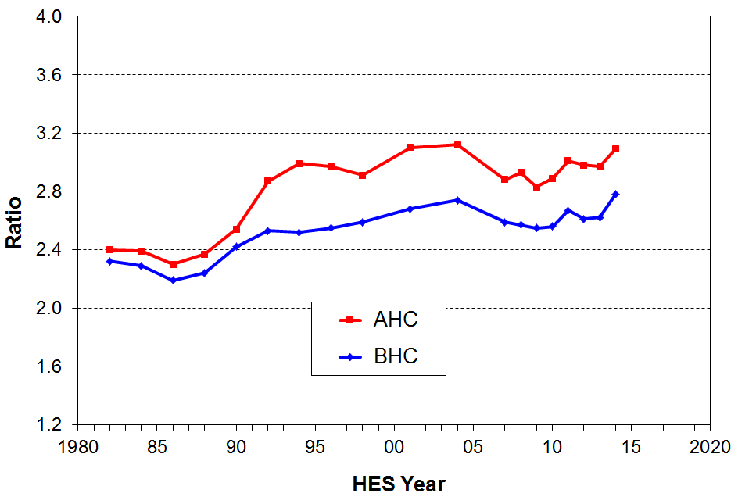

Tables D.7 and D.8 summarise the trends in all four percentile ratios from 1982 to 2014.

Table D.7A
BHC income inequality in New Zealand: percentile ratios, 1982 to 2014, total population
 | 1982 | 1986 | 1990 | 1994 | 1998 | 2001 | 2004 | 2007 | 2008 | 2009 | 2010 | 2011 | 2012 | 2013 | 2014
P90/P10 | 3.25 | 3.20 | 3.43 | 3.87 | 3.68 | 3.91 | 4.17 | 4.13 | 4.01 | 3.98 | 3.93 | 4.26 | 4.01 | 4.02 | -
P80/P20 | 2.32 | 2.19 | 2.42 | 2.52 | 2.59 | 2.68 | 2.74 | 2.59 | 2.57 | 2.55 | 2.56 | 2.67 | 2.61 | 2.62 | 2.78
P80/P50 | 1.51 | 1.48 | 1.60 | 1.66 | 1.65 | 1.66 | 1.62 | 1.61 | 1.61 | 1.58 | 1.56 | 1.64 | 1.65 | 1.64 | 1.66
P20/P50 | 0.65 | 0.68 | 0.66 | 0.66 | 0.64 | 0.62 | 0.59 | 0.62 | 0.62 | 0.63 | 0.61 | 0.62 | 0.63 | 0.63 | 0.60

Table D.7B
AHC income inequality in New Zealand: percentile ratios, 1982 to 2014, total population
 | 1982 | 1986 | 1990 | 1994 | 1998 | 2001 | 2004 | 2007 | 2008 | 2009 | 2010 | 2011 | 2012 | 2013 | 2014
P90/P10 | 3.63 | 3.46 | 3.98 | 5.16 | 5.74 | 5.57 | 5.57 | 5.64 | 5.33 | 5.54 | 5.52 | 5.96 | 6.03 | 5.84 | -
P80/P20 | 2.40 | 2.30 | 2.54 | 2.99 | 2.91 | 3.10 | 3.12 | 2.88 | 2.93 | 2.83 | 2.89 | 3.01 | 2.98 | 2.97 | 3.09
P80/P50 | 1.57 | 1.51 | 1.63 | 1.71 | 1.73 | 1.73 | 1.75 | 1.72 | 1.73 | 1.67 | 1.65 | 1.73 | 1.76 | 1.73 | 1.77
P20/P50 | 0.65 | 0.65 | 0.64 | 0.57 | 0.59 | 0.56 | 0.56 | 0.60 | 0.59 | 0.59 | 0.57 | 0.58 | 0.59 | 0.58 | 0.57

Table D.8
BHC income inequality in New Zealand: percentile ratios, 1982 to 2014,
individuals in households with children
 | 1982 | 1986 | 1990 | 1994 | 1998 | 2001 | 2004 | 2007 | 2008 | 2009 | 2010 | 2011 | 2012 | 2013 | 2014
P90/P10 | 3.25 | 2.70 | 3.11 | 3.44 | 3.19 | 3.49 | 3.81 | 3.49 | 3.52 | 3.31 | 3.58 | 3.62 | 3.55 | 3.67 | -
P80/P20 | 2.07 | 1.92 | 2.11 | 2.41 | 2.19 | 2.40 | 2.49 | 2.06 | 2.26 | 2.13 | 2.24 | 2.38 | 2.20 | 2.34 | 2.42
P80/P50 | 1.42 | 1.37 | 1.51 | 1.61 | 1.46 | 1.57 | 1.62 | 1.45 | 1.53 | 1.46 | 1.50 | 1.56 | 1.53 | 1.58 | 1.59
P20/P50 | 0.68 | 0.71 | 0.71 | 0.67 | 0.67 | 0.65 | 0.65 | 0.70 | 0.68 | 0.68 | 0.67 | 0.65 | 0.69 | 0.68 | 0.66
P50/P10 | 1.80 | 1.67 | 1.65 | 1.77 | 1.79 | 1.83 | 1.88 | 1.87 | 1.91 | 1.79 | 1.86 | 1.91 | 1.85 | 1.87 | 1.86

Note for Tables D.7 and D.8:

The “modified OECD scale” (1.0, 0.5, 0.3) is used for Table D.8 to enable better comparisons with EU analysis.

The 90:10 and 50:10 ratios are not reported for HES 2013-14 because of concerns about the reliability of the income data at the very low end of the distribution – see Section A for more on this.

Quintile and decile share ratios

The percentile ratios give an indication of how far apart are two points on the income distribution.

The income share ratios compare the shares of total household income received by higher and lower groupings. They are becoming more common: the top to bottom quintile share ratio is used by the EU as one of their top tier formal inequality measures, and the OECD regularly reports on the top to bottom decile share ratio.

There are two measurement challenges for this inequality measure. First, top income households are generally under-represented in sample surveys. This means that measured upper income shares understate the true shares at the top. Similarly, low income shares understate the shares actually received as there are always households with implausibly low reported incomes in the bottom decile (see Appendix 8 and 9 for more on this issue). The percentile ratio approach does not have these issues.

Figure D.12 shows the top to bottom quintile share ratios for the last three decades, 1982 to 2014. Over recent years the 20% of households with higher incomes have on average received around 5.5 times the income of the 20% with lowest incomes. The spike in HES 2011 and the large rise from HES 2013 to HES 2014 are part of the volatility after the GFC and is similarly reflected in the Gini (two pages over). Whether the 2014 figure is another spike or blip or a new higher level cannot be determined until the information from another survey or two is in.

Table D.9 shows the trends in three income share ratios from 1982 to 2014, including the Palma ratio. Further detail on the Palma ratio is provided below.

Figure D.12
BHC income inequality in New Zealand: quintile share ratio for Q5 to Q1, 1982 to 2014
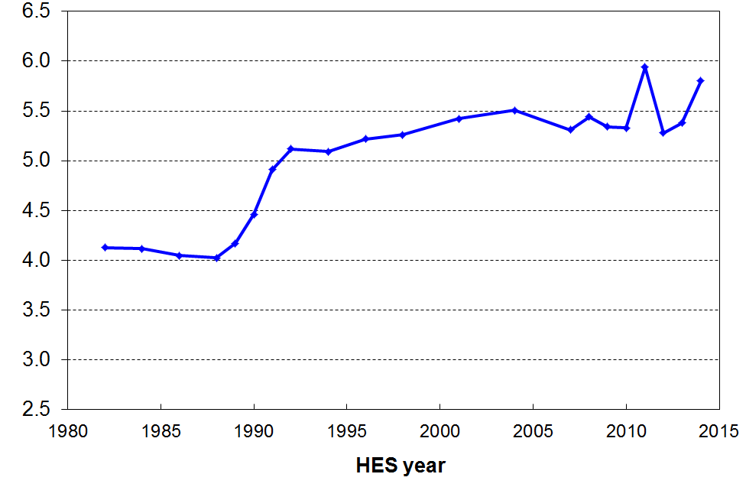

Table D.9
BHC income inequality in New Zealand: decile and quintile shares, 1982 to 2014, total population
 | 1982 | 1986 | 1990 | 1994 | 1998 | 2001 | 2004 | 2007 | 2009 | 2010 | 2011 | 2012 | 2013 | 2014
Q5/Q1 | 4.13 | 4.04 | 4.46 | 5.09 | 5.26 | 5.42 | 5.51 | 5.31 | 5.34 | 5.33 | 5.94 | 5.28 | 5.38 | 5.80
D10/D1 | 6.15 | 6.06 | 6.35 | 8.03 | 8.66 | 8.32 | 9.15 | 8.10 | 8.53 | 8.62 | 9.75 | 8.23 | 8.29 | 9.59
D10/D1-4 (Palma) | 0.91 | 0.91 | 1.10 | 1.21 | 1.31 | 1.34 | 1.31 | 1.20 | 1.28 | 1.25 | 1.44 | 1.23 | 1.30 | 1.36
Note: this analysis uses the square root equivalence scale as used by the OECD to ensure harmony with the figures used in the international comparisons in Section J.

The Palma: the ratio of the top decile share to the share for the lower four decile shares

The Palma measure or ratio is a relatively new addition to the suite of inequality measures used for international comparisons. It is named after Chilean economist Gabriel Palma whose 2011 paper brought the measure and its rationale to light. The OECD now reports the Palma in its Income Distribution database.

At one level, the Palma is just another share ratio in the wider family of share ratios. It has several features however that make it worth a second look:
- Palma found that among middle income and richer countries those in deciles 5-9 receive around 50% of the total income share, and that this share size seems reasonably stable over time as well as over countries. These are the middle to upper-middle income households between the “rich” and the “poor”. Figure D.13 shows the share for New Zealand has been fairly stable at around 55% from 1990 to 2014.
- He also found that the remaining 50% or so (45% for New Zealand) of total income was split between the top 10% and bottom 40% in quite different ways across the countries he looked at. This inspired the first part of the title for his 2011 paper - “Homogeneous middles and heterogeneous tails".
- He found that the correlation between the Palma and the Gini is close to perfect across the 150 countries in the World Bank dataset he used.
- Given that the Palma is much easier to explain than the Gini, and that it ranks countries in the same order, then he and others are proposing that it might be a useful alternative to the Gini for international comparisons. For example, what does it mean in practice to say that one country has a Gini of 42 and another 31? On the other hand, a Palma of 2.1 compared with a Palma of 1.7 has specific and easily grasped meaning in terms of the ratio of higher incomes to lower incomes, with the ”middle” remaining constant. The jury is still out on whether it can / ought to / will replace the Gini, but it certainly has the communication edge over the Gini.
- In the international section (Section J), New Zealand is ranked relative to other OECD countries on the Palma ratio.

Figure D.13
Proportion of total income received by deciles 4 to 9, 1982 to 2014

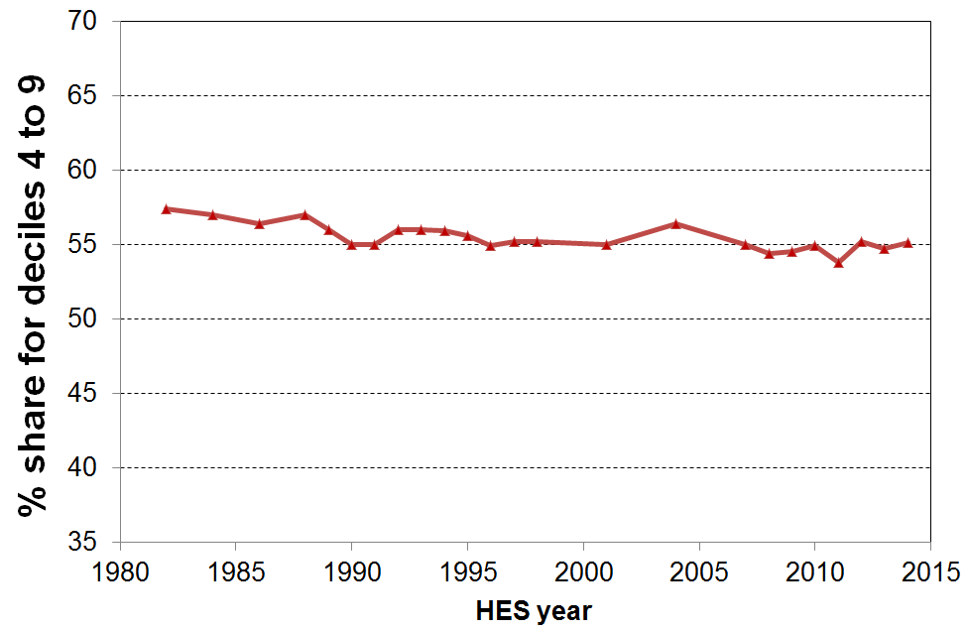

Gini coefficient

In contrast to the percentile ratios and the share ratios the Gini coefficient takes the incomes of all individuals into account. It gives a summary of the income differences between each person in the population and every other person in the population. A difference of, say, $1000 between two high-income people contributes as much to the index as a difference of $1000 between two low-income people. This in itself reflects an implicit value judgement – for example, there is a case that can be made that the difference at the lower end is of “greater significance” than the same difference nearer the high end. The Atkinson Index is one that makes the impact of these types of assumptions visible, but is beyond the scope of this report, in part because there is no easily available international time series data using the measure.

When comparing changes in income distributions over time, it is important to note that the Gini coefficient is more sensitive to changes in the more dense low-to-middle parts of the distribution than it is to changes more towards the ends of the distribution. The Gini scores (x100) range from 0 to 100 with scores closer to 100 indicating higher inequality and those nearer zero indicating lower inequality (ie greater equality).

The first main feature of Figure D.14 is the steep rise in the Gini coefficient from the late 1980s to the early 1990s. This is a similar trend to that shown by the P80/P20 ratio (Figure D.11) and the Q5/Q1 share ratio (Figure D.12).

The second main feature is the relative flatness of the Gini trend line from the mid to late 1990s through to 2014. The Gini declined a little from 2001 to 2007, reflecting improving employment, reducing unemployment and the impact of the WFF package which boosted incomes for low- to middle-income households with children. Year-on-year income inequality figures have been volatile recently with the GFC shock impacting on investment returns, employment and wages over the five years from 2008-09. There is no conclusive evidence yet of any sustained rise or fall in income inequality using the Gini measure since the mid 1990s. The trend-line is almost flat. However, if the next survey shows a Gini figure similar to or higher than the HES 2014 figure, then that will give reasonable evidence of higher income inequality compared with the level a decade before. On the other hand, if it falls to the trend line or below, the current assessment will stand.

Figure D.14
Inequality in New Zealand: the Gini coefficient
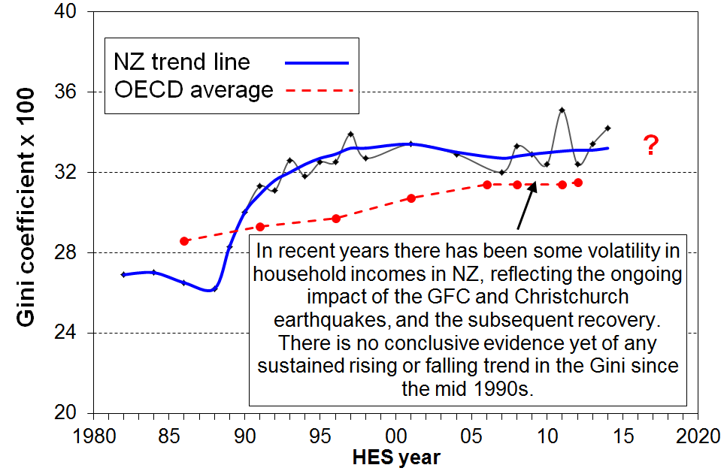

Table D.10 shows that inequality is greater for AHC incomes than for BHC, as is the case when using percentile ratios and share ratios. This reflects the fact that housing costs generally make up a greater proportion of household income for lower-income households than for higher-income households, thus increasing the spread of AHC incomes.

The BHC row uses the “square root” equivalence scale as is standard in OECD publications. The trends are the same whether the Jensen or the square root scale are used (See Appendix 3).

Table D.10
Income inequality in New Zealand: the Gini coefficient (x100)
 | 1984 | 1988 | 1990 | 1992 | 1994 | 1996 | 1998 | 2001 | 2004 | 2007 | 2009 | 2010 | 2011 | 2012 | 2013 | 2014
BHC (OECD) | 27.0 | 26.2 | 30.0 | 31.1 | 31.8 | 32.5 | 32.7 | 33.4 | 32.9 | 32.0 | 32.9 | 32.4 | 35.1 | 32.4 | 33.4 | 34.2
AHC | 28.5 | 28.5 | 32.1 | 34.9 | 35.6 | 37.2 | 37.5 | 38.1 | 37.0 | 36.2 | 37.6 | 37.1 | 40.3 | 37.7 | 38.3 | 39.2

For information on longer-run inequality, especially when looking only at very high incomes, see Section J.

Box 1
How the income inequality picture changes depending on the income concept used

The level of inequality or dispersion in the distribution of incomes depends on which income concept is used.

This report uses equivalised disposable household income as the income concept for all its income distribution, inequality and poverty analysis. This is the total after-tax income of all individuals in the household, together with Working for Families Tax Credits and other non-taxable income such as the Accommodation Supplement (AS) and so on, adjusted for household size and composition. This is standard international practice for reports of this type, where the focus is on household income as an indicator of the material wellbeing of household members relative to others from other households.

The graph below shows the different levels of inequality that different income concepts produce, using the 80:20 percentile ratio as the measure.

Inequality is lower when the focus moves from individuals to households (HHs). The 80:20 ratio falls from 5.8 for individual taxable income to 3.6 for HH gross taxable income. HH gross taxable income excludes all non-taxable components such as WFF tax credits, AS, and so on. When these are included, inequality drops further (HH gross). Taking personal income tax deductions into account further reduces the 80:20 ratio, as does the adjustment for household size and composition. The 80:20 ratio is more than halved in going from individual taxable income to equivalised disposable HH income. The latter is the best of these income concepts to use when using income to assess the material wellbeing of the population, and of subgroups within it.

80:20 percentile ratio for different income concepts, 2012-13
(HLFS for individuals, HES for households)
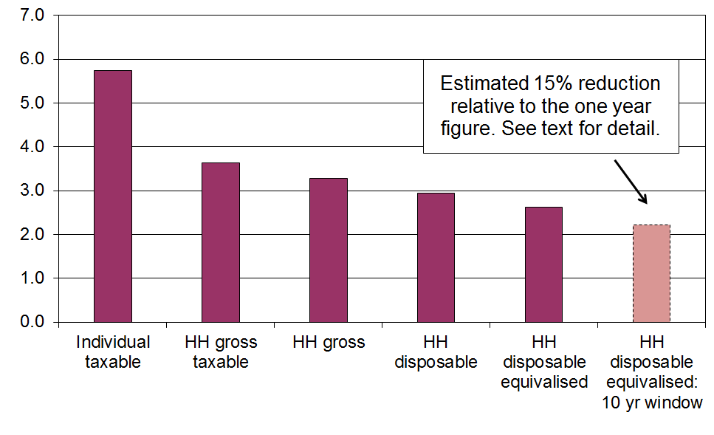

When the same group of individuals is followed over time (longitudinal data), and the income concept is the average household disposable income of the individual over, say, ten years rather than one, then measured inequality falls even further as a result of income mobility. For Australia the fall was around 15% for both the 90:10 ratio and the Gini from 2001 to 2010 and for the UK it was around 15% for the Gini for five year periods starting at various years in the 1990s. The right-hand bar above assumes a 15% reduction for illustrative purposes. See Section K for more on this.

Section E

Low incomes, poverty and material hardship: conceptualisation and measurement issues

For the analysis of trends in income poverty, this report uses low-income thresholds set at 50% and 60% of median household income, adjusted for household size and composition.

Individuals and groups below such lines can be described in a bland analytical way as “low-income populations”, but it is now very common practice in New Zealand and internationally for the 50% and 60% thresholds, and others in that general part of the distribution, to be referred to as “poverty lines” and those below them as “poor” or “in poverty” or “at risk of poverty”.

The growing acceptability of “poverty” language in more official contexts in the more economically developed countries (MEDCs) is reflected in recent OECD and UNICEF publications of international comparisons of poverty rates, and in decisions by the European Union (EU) to regularly publish income-based poverty indicators as part of a wider social reporting by Eurostat.

The positions taken by governments of OECD countries have been mixed with respect to a poverty discourse and whether or not to adopt any official measure or measures of poverty. In the United States, the War on Poverty announced in 1964 and the associated establishment of an official poverty line shortly thereafter have done much to ensure that poverty language has been and still is an accepted part of economic and social policy discourse in the United States. By contrast, in the United Kingdom, a Conservative government in the 1980s and the first half of the 1990s did not approve of poverty language and did not adopt an official measure. “Margaret Thatcher, supported by Helmut Kohl in Germany, … successfully banished the word “poverty” from the political lexicon for a generation. Tony Blair rehabilitated its use in a keynote speech in 1999 [where he] committed the government to eradicating child poverty [within a generation]” (Tomlinson and Walker, 2009:8). The UK now has official measures of child poverty, enshrined in the Child Poverty Act 2010 and supported by the Cameron-Clegg coalition government, albeit the chances of achieving the targets now seem remote. Ireland adopted official poverty measures and a National Anti-Poverty Strategy in 1997. Canada has an elaborate low income measurement regime using low income cut-offs (LICOs), low income measures (LIMs) and a Market Basket Measure (MBM), but Statistics Canada has consistently noted that these are not poverty lines. Neither Australia nor New Zealand have official poverty measures.

As recently as 1996, the government of the time in New Zealand was openly disapproving of any poverty discourse. However, in 2002, in the context of the Agenda for Children, the Labour-led government made a commitment to eliminate child poverty, and in the Speech from the Throne in November 2005, the Governor-General described the Working for Families package as “the biggest offensive on child poverty New Zealand has seen for decades”. In its response to the Children’s Commissioner’s Expert Advisory Group’s 2012 Report on Solutions to Child Poverty, the current National-led government declined to take up the recommendations for a suite of official measures and a set of official targets for reducing child poverty. On the other hand, the government response used “poverty” language throughout its report, setting out its general approach to addressing child poverty. The current National-led government, like the previous Labour-led government, espouses the principle that paid work is the best way to reduce child poverty.

Researchers, advocacy groups and others in all the MEDCs have used poverty language and a range of poverty measures for a long time. The growing acceptance of the discourse by governments and their agencies can be seen as helpful to the extent that it represents official recognition that some citizens are experiencing unacceptable material hardship. It can serve to remind us all that behind the statistics are real people who are to varying degrees experiencing the stressful and demoralising exclusion from ordinary life that financial strictures and material hardship bring.

It is however very easy for such language to be used in a way that ignores the fact that the conceptualisation and measurement are contested. For example it used to be said that “one in three children in New Zealand are below the poverty line”. This claim is really short-hand for “using an income measure after housing costs have been deducted, around one in three children are below a threshold set at 60% of the median”. If another measure were used, the summary sound bite would be different. For example, on the most common measure used by the OECD, using income without deducting housing costs and a lower threshold of 50% of the median, around one in seven children were “below the line” at that time, less than half the one in three rate that was commonly referred to. These observations underline the importance of always being clear as to what measure is being used when reporting poverty rates.

All income poverty measures, even official ones, are constructs requiring judgement calls. These calls have to be made on a range of matters which can at first sight appear to be just technical decisions but which in fact reflect or imply underlying assumptions. There is no clear delineation between the poor and the non-poor that science can identify independent of judgment. This is not to say that any measure will do nor that all measures are equally suspect – some are clearly more defensible and reasonable than others. What is crucial in discussing poverty rates and trends is to identify what measure is being used, and to be aware of the different rationales for and pictures presented by the different measures. One of the goals of this report is to encourage and contribute to that sort of discussion and awareness in measuring, monitoring and better understanding “poverty and hardship” in New Zealand.

This section and the ones that follow:
- Outline key issues involved in conceptualising and measuring poverty using household incomes.
- Report on trends in proportions of people below various low-income thresholds, by:
- age group
- ethnicity (to a limited extent)
- highest household educational qualification
- household and family type
- labour market status
- tenure.
- Summarise findings on income mobility and poverty persistence from recent research using longitudinal income data from the Survey of Families, Income and Employment.
- Report international comparisons of income poverty.
- Provide an integrated account of the findings on child poverty and hardship using both household incomes and non-income measures.

What is meant by “poverty” in the more economically developed countries?

Despite the current wide use of poverty language in MEDCs, there is considerable disagreement and at times confusion about what “poverty” actual means or could mean for citizens in the richer nations. The lack of consensus and clarity is to a large degree driven by two fundamental aspects of “poverty”. In the first place, whatever else poverty is understood to be it is in its essence an unacceptable state-of-affairs. Properly understood, “use of the term “poverty” carries with it an implication and moral imperative that something should be done about it” (Piachaud, 1987:161). This makes it very different from other related issues such as inequality which is not in itself considered unacceptable, although there is legitimate debate about what an acceptable level of inequality might be, whatever the measure used.
Disagreements over the definition of poverty run deep and are closely associated with disagreements over both the causes of and solutions to it. In practice all these issues of definition, measurement, cause and solution are bound up together, and an understanding of poverty requires an appreciation of the interrelationships between them all.
Alcock (1993:57)

The second main reason for the lack of consensus and clarity is that there is a prima facie incongruity about using the same word (or concept) to describe both the circumstances of the less-well-off in richer nations, as seriously debilitating and demeaning as these circumstances may be, and also the life-and-death struggles of many in “third world” countries or the deprivations experienced by our forebears in past centuries.

The relative-absolute distinction

A common approach to address this latter point is to make a distinction between absolute and relative poverty.

Absolute poverty is generally based on the notion of subsistence, the minimum needed to sustain life. For example, the UN’s World Summit on Social Development in 1995 in Copenhagen defined absolute poverty as “a condition characterised by severe deprivation of basic human needs, including food, safe drinking water, sanitation facilities, health, shelter, education and information. It depends not only on income but also on access to social services”. Advocates of an “absolute” definition have often claimed a degree of objectivity about the resulting definition, with the focus being on attempts to clearly define subsistence and minimal needs.

A relative approach on the other hand requires many a judgement call. Relative poverty is about the standard of living (actual or potential) of those identified as poor compared with that of those declared to be non-poor. It is about a state of relative disadvantage that is deemed to not meet minimum acceptable community standards. It is now sometimes asserted that in MEDCs there is little or no absolute poverty but that there are varying degrees of relative poverty depending on the stringency or generosity of the threshold used.

While the relative-absolute distinction seems at first sight to be a useful starting point for discussion, it is not only not a clear-cut distinction, it is also an over-simplification that can mislead.

First, the absolute notion turns out to have unavoidable relative aspects, or at least aspects that require a judgement call. For example, there can be legitimate debate as to what the subsistence notion actually covers. Is it just mere physical survival, or do the basics of life include access to basic education and information as in the UN definition above? Even a basic notion such as adequate shelter has to be understood relative to local climate and social convention. Adequate nutrition for adults varies depending on the energy requirements of their daily work, and even in “third world” countries, minimum standards have changed over time.

Furthermore, the absolute concept is also used to describe MEDC income poverty lines held fixed in real terms (starting in a reference or anchor year). This dilutes and muddies the concept. The UK’s annual Households Below Average Income series uses “absolute” in this way. The US poverty line is another, even though the value of the poverty line in the reference year (1965) was derived in a different way than the UK’s absolute line now anchored in 2010-11.

None of this means that the relative approach is therefore correct or even “better”. It too has its challenges. For example, if the real dollar value of the poverty line increases as a society becomes more affluent, and if “today’s comforts and conveniences are yesterday’s luxuries and tomorrow’s necessities” (Fuchs, 1967), then it is difficult to distinguish between the “poor” and those who are just less well-off in an unequal social order. In other words, relative poverty becomes hard to distinguish from inequality.

Adding to the challenges of making sense of and using the relative-absolute distinction is the fact that the notion of “relative” itself has several dimensions. The inherent comparisons required in a relative approach can be about relativities over time (minimum standards change) or relativities between countries (different countries have different minimum standards). As noted above, even an assessment of basic notions such as what adequate nutrition or adequate shelter mean cannot be separated from their social, historical and cultural contexts.

These and other critiques of the relative perspective and the undisputed relative aspects of so-called absolute approaches have led some to conclude that there is no coherent basis for making any sensible claims about poverty in MEDCs, as it is all allegedly just about judgements and assumptions and constructed social needs. Assuming that poverty is about a person or household having inadequate resources to meet their basic human needs, many would argue that nothing definitive can be said about poverty in MEDCs as “the quest for universal and objective needs is [considered to be] a search for a will-o’-the-wisp” (Doyal and Gough, 1991: 21). Thus, some conclude that poverty in MEDCs should simply be seen as a form of inequality.

The relative-absolute synthesis

There is however a way forward. Over the last twenty or thirty years there has been a growing acceptance among many that the way in which the relative-absolute distinction has traditionally been constructed and spoken about is itself a large part of the problem. Rather than seeing them as competing theories, it is proposed that there are grounds for re-stating the relationship between the absolute and relative aspects of poverty. In so doing, it becomes possible to integrate in the one framework the notion of poverty in both MEDCs and “third world” and “developing” countries.

The new synthesis was given impetus through the very public debate in the mid 1980s between Townsend (an advocate of the relative perspective) and Sen (there is an “irreducible absolutist core in the idea of poverty” (Sen, 1983: 159)). Progress continued through Doyal and Gough’s work on a theory of human need (Doyal and Gough, 1991), and by further publications from both Townsend and Sen (separately) that articulated an integrated perspective. Townsend, for example expressed support for the definitions adopted by the 1995 UN World Summit on Social Development in Copenhagen which reflect the integrated approach (see Gordon and Townsend (eds) (2000: 17f)). Rather than outlining the synthesis here, it is incorporated into the following section (especially in a) to f)) which lays out the approach taken in this report.

Poverty and hardship in MEDCs: the approach taken in this report

Building off this new synthesis, this report uses the following framework to underpin its rationale, analysis and findings. It is laid out in a structured way to facilitate discussion and debate about each step of the argument.
- The over-arching concept is that poverty is about resources being inadequate to meet basic human needs. This is a very standard concept.
- Humans are social as well as physical beings and the basic human needs that the resources must meet must reflect both aspects.
- There is a set of basic human needs that are reasonably universal (the absolutist core). See the box below for a list of basic material needs for New Zealand citizens in 2014.
- The way these needs are met varies over time and between countries and cultures (one aspect of relativity).
- To meet these basic needs to minimum acceptable standards in MEDCs often requires many times more dollars per week than for households in “third world” countries. This is because of the different way in which MEDCs are structured in terms of food supply, property rights, transport, labour market, the legal requirements that govern minimum standards for housing, and more generally a mixed economy for the provision of goods and services and different social norms and expectations for citizen participation, and so on. Households, and especially households with children, cannot simply opt out of the structures and expectations of their MEDC society and “go bush” or “live off the land”. The basics set out in c) above, and the societal expectations and human need for some participation above mere physical survival, all place unavoidable minimum demands on the family budget.
- Poverty and hardship in MEDCs are real issues in relation to basic human needs not being met. They are about relative disadvantage within a given society, but there is an “absolutist core” (Sen) of needs that must be met. This is what makes poverty about more than just inequality. Poverty is about “not enough”, not just about “less than”.
- Household income is an important resource for meeting needs in the mixed economy of an MEDC, albeit there are other resources available to or required by households to meet basic needs (for example – household appliances and furnuiture, financial assets, government services).
- There is value in looking at poverty from both an adequacy of resources perspective as well as more directly in terms of the degree to which basic needs are being met in practice. The use of non-income measures of material deprivation is an essential part of a comprehensive monitoring of poverty and hardship.
- There is room for debate about where to “draw the line” for any measure of poverty or material hardship, but in practice there is a reasonably narrow range for credible and defensible thresholds. Drawing on the views of ordinary citizens (for example, through focus groups and surveys) as well as those of experts greatly assists with the setting and legitimisation of poverty thresholds and of lists of items of things that everyone should have and no one should have to go without.
- Poverty and hardship exist on a continuum from less to more severe.
- Assumptions and judgement calls must be clearly declared and sensitivity testing reported to show what difference, if any, the different assumptions make.
- The overall poverty and hardship narrative is not one-dimensional: the story that integrates the trends for several measures needs to be clearly told in a coherent way.

List of basic material needs for New Zealand citizens in 2014
- clean drinking water
- sanitation and waste disposal
- adequate food / nutrition
- hot running water
- suitable clothes and shoes
- adequate housing – shelter / warmth
- dental and medical care as required
- mains electricity or equivalent
- household durable goods:
  - food storage and cooking, sleeping, cleaning and maintenance, having people around, ……
- transport (for employment, supplies, ‘helping’, children …., leisure)
- ICT including a computer in the household and broadband internet access
- social engagement that involves financial cost
- financial resources to cope with unexpected essential expenses

See Doyal and Gough (1991), chapter 10, for a list of needs that goes wider than the material needs listed here.

Poverty – narrow or wide?

Poverty and hardship are multi-dimensional. Different contexts and different purposes require a focus on one or other dimension or indeed on multiple disadvantage across several dimensions. When talking about “poverty” it is important to be clear about which dimension is being discussed, or if the wider notion of multiple disadvantage is in scope that that too is made clear.

Poverty is primarily used to refer to the status of those in households that have income below a given low-income threshold, however determined. This is a narrow but legitimate perspective.

At other times “poverty” is used to describe those whose actual living conditions are very restricted and below minimum acceptable levels. This is a slightly wider perspective as these outcomes are determined by more than just income alone. The report uses “material hardship” or “deprivation” for this aspect.

“Poverty” is also used almost as a catch-all term to refer to any serious disadvantage or cluster of disadvantages experienced by households or geographical areas (for example, low education, poor quality housing and local amenities, poor health, high unemployment).

It is important to be clear just which of these concepts is being used in any given context. This report is about the first notion mainly with a little on the second.

Poverty experienced

The understanding of poverty and the associated measurement approach used in this report is narrowly focused. It is about “unacceptable financial or material hardship” and the insights about this that can be gleaned from a large-scale national survey.

This is a legitimate focus, but in pursuing it it is important to be aware that there is much more to “poverty” than what can be measured (albeit imperfectly) through analysis of data from income or deprivation surveys. These can tell us about the material core (“unacceptable material hardship”), but a different type of research is needed to give insight into how this unacceptable hardship is experienced and understood.

What is at issue here is the non-material as well as the material manifestations of poverty. Poverty has to be understood not just as a disadvantaged and insecure economic condition but also as a shameful and corrosive social relation … [The non-material aspects include] … lack of voice; disrespect, humiliation and assault on dignity and self-esteem; shame and stigma; powerlessness; denial of rights and diminished citizenship … They stem from people in poverty’s everyday interactions with the wider society and from the way they are talked about and treated by politicians, officials, the media and other influential bodies. Lister (2004:7)

What people on low incomes report is a situation of great complexity in which the pressures they face are cumulative. Basics become luxuries that have to be prioritised and saved for. Solutions to one problem create problems of their own, as when saving on heating exacerbates illness and borrowing from the rent money generates arrears and threats of eviction. Poverty feels like entrapment when options are always lacking, the future is looming and unpredictable, and guilt seems ever present, arising from an inability to meet one’s children’s needs, one’s own expectations and society’s demands. Tomlinson and Walker (2009:16)

Some common misunderstandings

There are some common misunderstandings about poverty and its measurement, especially income poverty. These derive in part from misunderstandings about the relative-absolute distinction discussed above and set aside as being more of a hindrance than a help to poverty discourse. The misunderstandings are briefly described below then discussed in the context of framework outlined above and of some empirical findings.

“Income poverty is essentially about inequality”
  - This view derives from the old relative-absolute distinction rather than the synthesis described above. It misses the point about an absolute core of human need that must be met from resources. This latter means that poverty is essentially about “not enough” rather than “less than”.

“Because (income) poverty is relative, no country can ever eliminate poverty”
  - The assertion is based on the view that there will always be a group of households with incomes or living standards that are low relative to those in the middle. By definition, therefore, “the poor will always be with us”.
  - It misses the point that the incomes of the poor can be raised without raising the level of the median. This is what happened when the WFF package was rolled out from 2004 to 2007. The shape of the income distribution at the lower end is not fixed in stone – it can be changed.
  - It is true that measured income poverty is not ever likely to reach zero, but this is because (among other things) there are always households that have very low incomes from time to time even if on average over several years their incomes are above the average poverty line, not because the notion of relative income poverty makes it a necessary conclusion.

“Relative income poverty is an invalid and unhelpful measure – for example, if every household’s income doubled then the same number are in poverty as before even though everyone is much better off”
  - Assuming this hypothetical scenario could be carried out, then the day after the income rise everyone would have plenty.
  - But the reality is that for wages and salaries and transfers to increase by this amount and stay that way then presumably firms would have to put up the price of their goods and services to be able to pay these new high wages and salaries.
  - This would be highly inflationary and when a new equilibrium was reached citizens at the bottom of the distribution would once again be finding it difficult to make ends meet as prices would have gone through the roof.

In this report poverty is understood as exclusion from the minimum acceptable way of life in one’s own society because of inadequate resources.

While there is an explicit relative element in the definition, and while judgment calls are needed to establish what “minimum acceptable” means, the minimum acceptable way of life relates to an “absolute core” of things that everyone should have and no one should have to go without, as noted in the box on page 81.

The definition includes both resources and outcome elements – this double perspective is reflected in the use of both income measures and non-income measures in the report (though the focus of the report is on incomes).
Constructing measures of income poverty

Reported levels of income poverty and the direction of trends over time depend not only on changes in the economic circumstances of families and households but also on the specific measure used to produce the poverty numbers.

Key decisions in constructing a measure

The general approach to using household incomes to give headcount measures of poverty and hardship is well-established. Each household member is assigned the equivalised disposable income of their household as an indicator of their (potential) living standards and individuals in the population are ranked accordingly. One or more poverty thresholds are decided on, the numbers below these cut-offs are counted and the numbers or proportions ‘in poverty’ are reported.

Within this general approach there are however a range of decisions on key issues that can make a significant difference to what is reported for levels or trends in poverty numbers, and in the composition of the group identified as poor. Different measures reflect the different decisions at key points on such matters as:
- whether to use incomes before or after deducting housing costs (BHC or AHC)
- which equivalence scale to use, reflecting different judgments about factors such as the strength of the economies of scale as household size increases, and the relative weight to be given to children compared with adults
- where to draw thresholds (poverty lines) that are consistent with a minimum acceptable standard of living, all else equal
- how to update the thresholds from one survey to the next.

Different decisions on the first three matters generally lead to different poverty levels being reported at a given time and some difference in the reported composition of those identified as poor. However the general trends over time tend to be not greatly affected by the choices made for these three factors. This paper reports sensitivity analysis for the different choices made on these issues.

One factor that does have a significant effect on reported trends in income poverty (and the level at a given time) is the decision about how to adjust the low-income threshold(s) over time. There are two common ways in which this adjustment is made and they differ in how they assess whether an improvement has occurred in a household’s income circumstances:
- one approach considers that a low-income household has improved its situation when its income rises in real terms, irrespective of what is happening to the incomes of other households - the ‘fixed line’, ‘anchored’, or ‘constant-value (CV)’ approach;
- the other uses the median household as the reference and an improvement is considered to have occurred when a poor household moves closer to the median – the ‘moving line’ or ‘relative (REL)’ approach.

These two approaches are discussed below.

Using fixed line and moving line thresholds to adjust thresholds over time

The constant-value (CV), ‘fixed line’ or ‘anchored’ approach to adjusting thresholds over time maintains the real value of a chosen poverty line by adjusting it each year with the CPI. On this approach a household’s situation is considered to have improved if its income rises in real terms, irrespective of whether its rising income makes it any closer or further away from the middle or average household.

The relative-to-contemporary-median (REL) or ‘moving line’ approach sets the poverty line as a proportion of the median income from each survey so that the threshold changes in lockstep with the incomes of those in the middle of the income distribution. On this approach the situation of a low-income household is considered to have improved if its income gets closer to that of the median household, irrespective of whether it is better or worse off in real terms.

Both approaches reflect the ‘relative disadvantage’ concept of poverty and hardship. The REL approach is self-evidently a relative approach. The CV approach has to be benchmarked against community standards in some way to start with, then after some years of being kept at the same level in real terms it has to be re-based – again relative to some estimate of community standards.

Both approaches are used in income poverty analysis in OECD-type nations. They each have a valid story to tell about the situation of people in lower-income households.

In the short to medium term, the fixed line (CV) measure can be seen as the more fundamental measure in the sense that it reveals whether the incomes of low-income households are rising or falling in real terms. Whatever is happening to the incomes of the ‘non-poor’, if more and more people end up falling below a CV threshold, as happened in New Zealand from the late 1980s through to the mid 1990s, then in the population at large there is likely to be wide concern about increasing poverty.

In times of good economic growth with rising real wages, rising employment and declining unemployment, poverty rates measured on a CV approach can generally be expected to decline, as they have in New Zealand since the mid 1990s. There is however a limit to how low even CV rates can fall when there is a large beneficiary population on incomes that do not (often) rise in real terms.

The REL or moving line approach can produce counter-intuitive results over time. For example, in times of good economic growth with rising real wages, rising employment and reducing unemployment, median income (and therefore the poverty lines which are simply a proportion of the median) can rise more quickly than the incomes in the lower parts of the income distribution. In these circumstances a REL measure would report increasing poverty even if those in low-income households were experiencing real income growth.

This counter-intuitive result was observed in Ireland in the 1990s: the poor became ‘richer’ in real terms, but because the income growth of the middle income households was even greater, poverty rates grew considerably as measured using a REL threshold. This also happened for New Zealand from 1998 to 2004, albeit on a more modest scale.

The reverse is also possible. It was observed in the Czech Republic, Hungary and Poland in the early 1990s when each of these nations experienced large falls in national income. Real incomes fell, but poverty was reported as declining as measured by a REL approach as a result of the falling median and therefore the lowering poverty thresholds. In New Zealand, real incomes for many fell in the period from 1988 to 1994. Using a threshold held fixed in real terms, the CV approach clearly showed the worsening situation for many of the poor. Using a REL approach, poverty rates stayed reasonably constant in the period as both household incomes and the thresholds set as a proportion of the median were falling. (See Section F.) See also the case study for Ireland on p9 of the Overview and Summary.

This report provides trend information using both the CV and REL approaches, but considers the CV approach as the more fundamental measure for the purposes of tracking material wellbeing using household incomes in the short to medium term.

Two questions are sometimes raised in relation to updating thresholds over time.
- As median household incomes rise (or fall) in real terms, CV or fixed thresholds fall (rise) as a proportion of the contemporary median. How often should the reference year be re-set so that the value of the CV thresholds do not move too far from the implied reference level relative to the population as a whole?
- In times of economic growth, can poverty rates ever fall when measured using a moving line approach?

These are discussed below.

The reference year for measures using a fixed line approach

As median household incomes rise (or fall) in real terms over time, the fixed (CV) poverty lines can become unrealistically low (or high) relative to the contemporary median. The question arises as to how often to re-set the CV poverty lines. The decision on this depends to a large degree on the rate of change in median incomes: higher rates of change mean that the re-setting needs to occur sooner so that the thresholds do not move too far from (or get too close to) average incomes.

Until the 2010 report, the Household Incomes series (and its pre-cursors) used 1998 as the base or reference year for setting CV thresholds, adjusting back and forward using the CPI. Because of the way median incomes fell then rose from 1982 to 2008, 1998 CV measures were convenient and appropriate to use for the period.Table E.1 and Figure E.1 show that the CV threshold set at 60% of the 1998 median stayed within a band of 50% to 70% of the BHC median for 1982 to 2008, and within five to six percentage points of 60% for the bulk of the period.

Table E.1
CV threshold set at 60% of the 1998 median
expressed as a proportion of the contemporary median (BHC), 1982 to 2012
1982 | 1984 | 1986 | 1988 | 1990 | 1992 | 1994 | 1996 | 1998 | 2001 | 2004 | 2007 | 2008 | 2009 | 2010 | 2011 | 2012 | 2013 | 2014
58% | 59% | 61% | 59% | 60% | 67% | 69% | 65% | 60% | 58% | 54% | 51% | 49% | 48% | 48% | 49% | 48% | 47% | 45%

Figure E.1
CV threshold set at 60% of the 1998 median
expressed as a proportion of the contemporary median (BHC), 1982 to 2014
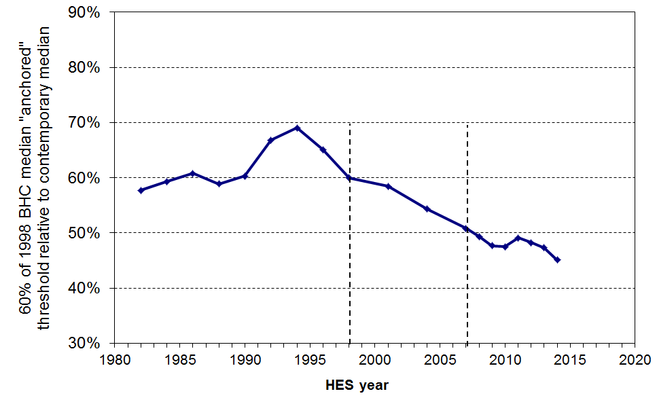

The 2011 report shifted the reference year for ‘fixed line’ poverty measures from 1998 to 2007. Moving the reference year only to 2004 ran the risk of requiring another move of reference year in a relatively few years. The decision to go to 2007 was made with a view to not having to change it again for some time.

Figure E.2 shows the impact of the choice of reference year on where the CV threshold sits relative to the contemporary median. The continued use of a 1998 CV threshold would have lacked credibility, with its value dipping below 50% of the contemporary median in HES 2008 and 2009 and highly likely to reduce even further in the near future. Moving only to 2004 seemed to be likely to require a another change in perhaps 2011 or 2012, so the reference year was moved to 2007. As it turned out, the GFC intervened and slowed the fall relative to the median, but this trend is now evident again.

Figure E.2
CV threshold set at 60% of the 1998, 2004 and 2007 medians
expressed as a proportion of the contemporary median (BHC), 1982 to 2009

Figure E.3 shows what a re-basing to 2004 and 2007 does for the AHC 60% CV poverty trend. In effect it simply shifts the trend line up over the whole period.

Figure E.3
Changing the base year from 1998 to 2004 or 2007 for CV poverty lines:
an illustration using AHC incomes, 60% CV threshold, whole population

Reporting on poverty figures back to 1982 using 2007 as the reference year tells us what proportion were ‘poor’ back then relative to a standard set in 2007. While this is an interesting exercise, it has no real value for giving a fair and useful picture of the extent of hardship ‘back then’ relative to the standards prevailing at the time or near to it. In this 2014 report, 2007 CV figures are therefore rarely given for the years before 2007 – only 1998 CV figures are usually given for these earlier years. 1998 CV figures are given in the main income poverty tables for 2007 to 2013 to provide overlap comparison for a few years. The report at present does not use the 1998 CV series for years after the 2013 HES. The discontinuity in the CV series adds a complexity to ‘telling the story’, but it also has the value of making explicit just what the CV (fixed line) approach is about: it emphasises that it too is really a relative measure – a relative measure held fixed for the short to medium term.

Can poverty rates ever fall using a REL or moving threshold approach?

It has often been pointed out that measuring poverty using a REL or moving threshold approach makes it very difficult for poverty rates to decline during periods of sustained economic growth. During such periods, median household incomes are likely to rise, and unless incomes in the bottom decile or two show an equal or greater rise, then poverty rates using a REL approach will be reported as increasing because the poverty line (set as a proportion of the median) will rise more quickly than the incomes of these low-income households.

This means that to achieve a reduction in poverty using a REL approach there has to be a rate of increase in incomes for low-income households that exceeds the rate of increase at the median. In other words, to achieve REL poverty reduction requires a changing of the shape of the lower end of the income distribution such that it gets moved to the right, closer to the median.

The Working for Families (WFF) package, progressively introduced from 2004 to 2007, put an additional $1.6b per annum mainly into low- to middle-income families once fully implemented. Although a little of the new money went to families at or above the median, the bulk went to families below the median and especially to those well below it. The shape of the bottom end of the income distribution was changed by the WFF package, and child poverty rates were reduced from 2004 to 2007 as a result, even on moving line measures.

Reporting levels and trends for older New Zealanders (aged 65+)

Section A drew attention to the pensioner spike as a distinctive feature of New Zealand’s BHC income distribution. The spike is a direct consequence of (a) New Zealand having a universal New Zealand Superannuation (NZS) that is neither income nor asset tested, and (b) there being a good proportion of superannuitants with little other income over and above NZS.

The spike has implications for reporting on income poverty both for the 65+ and more generally. In the period from 1982 to 2004 the value of NZS moved within a range of 56% to 67% of the median household income (BHC). This means that on a BHC basis income poverty rates for the 65+ in the period are reported as near to zero using a 50% threshold. Using a 60% threshold they fell from 25% in 1988 to close to zero in the mid 1990s when the median fell in real terms and NZS was above the 60% threshold, and in 2010 were at 36% as the median had risen in real terms and the NZS value was well below the 60% threshold. These features (low for 50% then high, and very volatile for 60%) mean that a BHC approach for reporting trends in poverty rates for the 65+ is not useful. This is further discussed in Section I.

In 2009, the value of NZS relative to the median had fallen to 48%, so on a 50% of median measure, BHC poverty rates for older New Zealanders are reported as fairly rapidly rising from very low in 2001 to 22% in 2009. This leaves the misleading impression that the living standards of a sizeable group of older New Zealanders took a sudden turn for the worse over the few years up to 2009.

The AHC distribution still has some strong bunching but the pensioner spike is not as sharp. Furthermore, what remains of the spike is well above the 50% of median threshold for AHC incomes, and is mainly above the 60% of median threshold. Small shifts in the median or the threshold do not therefore have the same disproportionate and misleading effects on (trends in) poverty rates for the 65+ as they do when using BHC incomes.

This report therefore uses the AHC approach as the primary one for reporting on poverty rates for the 65+ and therefore for all subgroups so that the comparisons are on the same metric (see Appendix 5 for more detail on this decision, or the Introduction for a summary of the key points).

The low-income thresholds or poverty lines used in this report

Tables E.2 and E.3 below give the value of the report’s low-income thresholds (‘poverty lines’) in ordinary 2014 dollars pw for different household types. The values in 2015 dollars will be much the same as inflation has been low.

This report uses low-income thresholds for BHC incomes set at 50% and 60% of the median equivalised household income (BHC), using both ‘moving’ and ‘fixed’ thresholds (REL and CV (constant value)).

AHC thresholds are calculated by deducting 25% from the corresponding BHC threshold as an allowance for housing costs. Each household’s AHC income is then assessed against the chosen threshold. There is a short discussion of the 25% allowance for housing costs below the tables. The rationale for the choice of thresholds (BHC and AHC) is discussed more fully in Appendix 6.

Table E.2
50% and 60% low-income thresholds or ‘poverty lines’ for various household types (BHC)
(2014 dollars, per week)
 |  | REL (‘moving’) |  | CV (‘anchored’ /‘fixed’)
Household type | Equiv ratio | 50% of 2014 median | 60% of 2014 median | 60% of 2007 median in $2014
One-person HH | 1.00 | 345 | 410 | 365
SP, 1 child | 1.40 | 480 | 575 | 510
SP, 2 children | 1.75 | 600 | 720 | 640
SP, 3 children | 2.06 | 705 | 850 | 750
Couple only | 1.54 | 530 | 635 | 560
2P, 1 child | 1.86 | 640 | 765 | 680
2P, 2 children | 2.17 | 745 | 895 | 790
2P, 3 children | 2.43 | 835 | 1000 | 890
2P, 4 children | 2.69 | 620 | 1110 | 980
3 adults | 1.98 | 680 | 815 | 720

Table E.3
50% and 60% low-income thresholds or ‘poverty lines’ for various household types (AHC)
(2014 dollars, per week)
 |  | REL (‘moving’) |  | CV (‘anchored’ /‘fixed’)
Household type | Equiv ratio | 50% of 2014 median | 60% of 2014 median | 60% of 2007 median in $2014
One-person HH | 1.00 | 260 | 310 | 270
SP, 1 child | 1.40 | 360 | 430 | 380
SP, 2 children | 1.75 | 450 | 540 | 480
SP, 3 children | 2.06 | 530 | 635 | 560
Couple only | 1.54 | 400 | 475 | 420
2P, 1 child | 1.86 | 480 | 575 | 510
2P, 2 children | 2.17 | 560 | 670 | 590
2P, 3 children | 2.43 | 625 | 750 | 670
2P, 4 children | 2.69 | 690 | 830 | 740
3 adults | 1.98 | 510 | 610 | 540

Note: AHC thresholds are calculated by deducting 25% from the corresponding BHC threshold as an allowance for housing costs. Each household’s AHC income is then assessed against the chosen threshold. See the discussion above.

The 25% allowance for housing costs

The AHC median has been 18-20% lower than the BHC median for the last 20 years or so. This means that middle-income households spend on average 18-20% of their income on housing costs (rent, rates and mortgages). This is clearly a much lower proportion than for lower-income households. For those in HNZC houses (‘state houses’), their rent is set at 25% of their income. We also know that for those renting in the private sector and receiving the AS, almost all pay more than 30% of their income (which includes AS) to rent, and just under half pay more than 50%.

If the AHC thresholds (‘poverty lines’) were simply set at 50% or 60% of the AHC median, this would in effect be allowing only 18-20% of income for housing costs for low-income households. This is unrealistically low compared with what is actually spent. This report sets the AHC thresholds at the BHC thresholds less 25% as an allowance for housing costs. There is a case that something more like a third (30-33%) would be a more realistic allowance. This issue and the general rationale for the choice of thresholds (BHC and AHC) are discussed in Appendix 6.

Poverty depth and persistence

Reporting on trends in headcount poverty rates provides valuable information for assessing our progress as a nation and for informing policy development and debate. However, such information tells only a part of the incomes story. Two other insights are needed to round out the picture: trends in the depth of poverty and in the persistence of poverty for individuals over time.

Understanding poverty depth is about knowing what is happening to the incomes of those identified as poor from survey to survey. Are the poor today in the main sitting just below, say, a 50% threshold, or are they on average much poorer than their counterparts in earlier surveys, generally having incomes below, say, a 40% threshold? There are issues around the quality of the data among households with very low incomes, and these present challenges to providing robust information on poverty depth. Subject to these limitations, measures of poverty depth are discussed and trends reported at the end of the next section (Section F).

Secondly, while surveys like the HES are very valuable they give only repeated snapshot information of a different sample of households each survey. They cannot tell us, for example, how many of the poor in one survey are still among those counted as poor in the next. A more comprehensive picture needs information from surveys which follow the same people over many years and thus enable information on the persistence of poverty and income mobility to be reported. Statistics New Zealand’s longitudinal Survey of Families, Income and Employment (SoFIE) began data collection in 2002-2003 and analysis of the first seven waves is now available. A summary of this, with international comparisons is reported in Section K.

Interpreting and reporting differences and trends in the poverty figures which follow

Four sorts of analyses and comparisons are provided regarding headline trends in Section F and in the more detailed breakdowns in later sections:
- proportions and numbers of people ‘in poverty’ at a point in time
- changes from one survey to the next
- longer-term trends
- relativities between subgroups and composition of those identified as ‘poor’.

The findings and summaries for proportions ‘in poverty’ depend crucially on the threshold and measure used. Where point-in-time poverty rates are being reported, it is strongly recommended that those using the figures from this report also explicitly state what measure is being used (always).

Nothing should be read into small changes from one survey to the next, as sampling and non-sampling errors mean that such differences are unlikely to have any significance (see the Introduction, Section A).

In contrast, analysis of longer-term trends and relativities between subgroups generally produce robust and uncluttered summary findings. Although there is sometimes a difference in trend depending on the particular measure used, these differences are relatively easy to explain from first principles based on the different conceptualisations for the different measures.

More elaborated version of the stylised diagram in Figure A.1

The diagram below shows at a high level the different factors that can impact on living standards. Figure A.1 is the simplified version of this. The level and quality of financial and physical assets, assistance from support networks and government services, and special demands on the household budget can all have significant positive or negative effects on living standards, over and above the effect of current income. As these factors fall differently across different households, households with the same or similar equivalised incomes can have different living standards. For these reasons, current household income, even when adjusted for household size and composition, can only be a rough indicator of actual household living standards.

Same current income – different living standards (material wellbeing)
+
Current HH income
(last 12 months)
- adjusted for HH size and composition
Budgeting knowledge, skills and commitment, and ability to access available resources

Govt services and subsidies

+
+

+
Living standards
(material wellbeing)
Income, gifts, etc received in earlier years

Financial
and
physical
assets

–
Contributions to assets and current budget not picked up by ‘income’
eg - HH production
- help from outside the HH
Special demands on the budget (especially for those with low current incomes and limited financial assets)
eg - health/disability costs
- high accommodation costs
- high debt servicing
- unexpected bills
±
+
Differences in prices for different geographical areas

Another way of looking at the relationship between household income and living standards is to understand equivalised disposable income to be an indicator that allows comparisons of the potential living standards of different households – that is, comparison of the relative levels of consumption of goods and services that individuals could attain given the disposable income of the household in which they live, all else being equal. This recognises that equivalisation takes (reasonable) account of two major differences between households (size and composition), but not of other special demands on the budget, differences in wealth and assistance from outside the household, and so on. All else is in fact not equal.

Whether understood as a rough but readily available proxy for actual household living standards or as a measure of potential living standards (all else being equal), equivalised household disposable income is an important measure to understand and report on. For modern governments, direct income support is one of the most straightforward policy levers available for poverty alleviation. Changes over time in the overall distribution of household income and in the relative position of subgroups can give insight into changes in the social and economic fabric of the country and inform policy evaluation and development. Income information is regularly collected, easily manipulable and relatively easy to understand.

Section F

Headline trends in income poverty, 1982 - 2014

This section reports on the trends in headcount poverty rates – the numbers and proportions of individuals who are in households with incomes below selected thresholds (“poverty lines”).

Information on poverty trends is presented for both the whole population and for dependent children.

A full range of poverty measures is used, as shown in the table below.

Table F.1
Poverty measures reported on in Section F
BHC |  |  |  | AHC
REL  (‘moving line’) |  | CV-98 (to 2007)  CV-07 (from 2007)  (“anchored line”) |  | REL  (‘moving line’) |  | CV-98 (from 1982)  CV-07 (from 2007)  (“anchored line”)
50 | 60 | 50 | 60 | 50 | 60 | 50 | 60
✓ | ✓ | - | ✓ | ✓ | ✓ | - | ✓
Note: ‘CV-98’ indicates that 1998 is the reference year used. ‘CV-07’ uses 2007.

For a fixed or anchored line measure the poverty threshold is set in a reference year (eg at 60% of the median in 1998), then held at constant value (CV) in real terms for other years using the CPI. If the incomes of low- and middle-income households rise in real terms over time, the fixed line poverty threshold eventually becomes too low relative to median income to be useful, and a new reference year has to be chosen. For 1982 to 2007, 1998 was used as the reference year. 2007 is the reference year for 2007 and later years. In this section, poverty figures for 2001 to 2014 are given using both reference years to provide a good overlap for comparison. See Section E for more detail on this.

The thresholds used for the AHC measures are based on the corresponding BHC measure with 25% deducted to allow for housing costs. For example, what is referred to as “the 60% AHC threshold” is equal to the 60% BHC threshold less 25%. This threshold value is applied to the AHC household income distribution and those in households with AHC incomes below the line are counted up. The rationale for this approach is provided in Appendix 6.

While each of the six measures used in this section has an important story to tell, this report recommends the AHC “fixed line” (CV) measure as the primary indicator for monitoring short to medium-term trends. In the longer run the story told by the “moving line” measures needs to be taken into account too. For example, if poverty rates on fixed line measures are falling while rates using a moving line measure are rising then that indicates rising inequality among low- to middle-income households, despite incomes improving in real terms for low-income households. This raises social cohesion and equity issues. No one measure is adequate on its own in the medium to longer term.

The report also recommends the use of an AHC measure for comparing the material wellbeing of various subgroups, as it gives a much more meaningful comparison between groups with very different housing costs (for example, people aged 65+ compared with households with children). A full account of the rationale for this is provided in Section E and Appendix 5.

Section F also reports on poverty depth, using two indicators:
- the ratio of the number below a 50% of median line to the number below a 60% line
- median poverty gap ratios (= median poverty depth).
Impact of changing incomes and housing costs on the different poverty measures

Table F.2 indicates how changes in poverty rates reflect the net impact of changes in:
- BHC incomes at the median
- BHC incomes for low-income households
- housing costs for low-income households.

For example, the top row in Table F.2 indicates that when the median rises, then both BHC and AHC “moving line” poverty rates will rise, provided everything else remains the same. A rising median has no impact on poverty rates measured using a ‘fixed line’ approach.

Table F.2
Impact of selected factors on different poverty measures, 2001 to 2012
when these increase …. | …. the impact on the measured poverty rate is …
 | BHC |  | AHC
 | anchored line (CV2007) | moving line (REL) | anchored line (CV2007) | moving line (REL)
BHC median / incomes around the median ↑ | no impact | ↑ | no impact | ↑
BHC incomes in the bottom quintile (20%) ↑ | ➲ | ➲ | ➲ | ➲
Housing costs (for low-income HHs) ↑ | no impact | no impact | ↑ | ↑

The moving line and the anchored line approaches reflect two quite different notions of poverty

The moving and anchored line approaches to updating the poverty line are both relative approaches – they have that in common. The difference between them is the choice of reference point that each uses to establish the standard against which incomes are assessed.
- The moving line approach sets a poverty line relative to the median, relative to the income of the middle household in the income distribution. This income changes from survey to survey – the poverty line “moves”.
- The anchored or fixed line approach sets the poverty line relative to a fixed standard, set in the reference year relative to the median that year or to some other community standard. The poverty line is then held at that level in real terms – it is an “anchored” or “fixed” line, and its value is not influenced by the changing median in other years.

Each approach has its strengths and limitations, as discussed in Section E. This report takes the fixed line approach as the primary one for monitoring short to medium term trends, simply on the grounds that, at the very least, New Zealanders would want to know whether the incomes of low-income households are rising or falling in real terms, whatever is happening to the incomes of the “non-poor”. The BHC moving line approach did not and could not pick up the rising hardship of the early to mid 1990s. The fixed line measures could and did.

“There are no poor children, just poor families”

Later in this section, the headline trends for child poverty are reported using a range of measures.

It is sometimes said that the idea of “child poverty” doesn’t make sense as it’s really about families with financial and material resources that are not adequate for meeting the basic needs of the family (ie it’s not poor children, it’s poor families).

In this report, when it is said that “the child poverty rate on a given measure is 18%”, this is a short-hand for “18% of children live in families whose total income is below the threshold used in the given measure”. It is too cumbersome to repeat this each time, so the shorthand version is used: “the child poverty rate is 18%”.

Headline trends for whole population

- For the BHC and AHC fixed line measures, population poverty rates were steady through to 2014.

- On the moving line approach there was a reported rise to 2014, reflecting the sharp rise in the median.

Before Housing Costs (BHC)

- The overall trends from 1982 to 2014 in Figure F.1 clearly show the value and need to monitor poverty rates using both fixed line and moving line approaches. This is well illustrated by looking at two periods: the first half of the 1990s, and from 1994 to 2004.

- The first half of the 1990s:
- in this period there was a very large increase in the number of people in low-income households and a fall in median household incomes
- on a moving line measure, the combined effect of these two changes meant that (relative) poverty rates remained fairly steady and provide no evidence of the growing extent of hardship among low-income households
- on the other hand the fixed line measure gives a very clear indication that there were growing numbers of households with very low incomes.

- From 1994 to 2004:
- there was a continuing decline in the poverty rate on the fixed line measure, but the moving line (relative) poverty rate steadily rose to a peak of 21% in 2004
- the fall in the anchored line poverty rate reflects the falling unemployment, rising employment, rising real wages and increase in the number of two earner families with children
- the rising moving line poverty rate reflects the fact that median income rose more quickly in real terms than the incomes of low-income households – the gap between middle-income and low-income households increased from 1994 to 2004.

- From 2004 to 2007, the upward trend of the moving line poverty rates reversed for the 60% measure and halted for the 50% measure (the WFF impact). The anchored line poverty rate continued to fall.

- For 2007 to 2009, BHC income poverty rates reduced on the fixed line measures, but remained much the same on moving line measures. This means that:
- real BHC incomes rose for some low-income households, leading to fewer in poverty on the fixed line measure, and
- this rise was about the same as the rise in the BHC median leading to no change in poverty rates on the moving line measure.

- Comparisons of moving and fixed line trends over a longer time-scale (1982 to 2007):
- the 60% fixed line CV-98 poverty rate in 2007 (11%) was a little below what it was in the 1980s (12 to 14%)
- the large decline in 60% fixed line poverty rates from 1994 (26%) to 2007 (11%) reflects the significant rise of incomes in real terms for low-income households (see Tables D.2 and D.3)
- in contrast, moving line poverty rates were still higher in 2007 than in the 1980s and the 1990s (even after WFF), reflecting the net widening of the gap between middle-income and low-income households that occurred between 1994 and 2007.

After Housing Costs (AHC)

- Using the AHC anchored line measure (60% of median, reference year = 2007), the poverty rate for the population as a whole rose to 19% in HES 2011 following the GFC and economic downturn, then fell a little to 17% in 2014.
- Anchored line AHC (CV-98) poverty rates were higher in 2007 than in the 1980s, even though BHC incomes were higher in real terms for low-income households. The reason for this is that housing costs made up a much greater proportion of household income for low-income households in 2007 than in 1982. This increase more than cancelled out the gains in BHC incomes for low-income HHs, leaving anchored line poverty rates higher in 2007 than in 1982.
- Using the AHC moving line measure (60%),the population poverty rate rose a little following the GFC impact, falling back to pre-GFC levels (18%) in 2013. The two percentage point rise to 20% in 2014 reflects the rise in the median, not changing incomes at the low end. Rates in 2013 and 2014 were roughly double what they were in the 1980s.

Proportion of all individuals below selected thresholds (BHC)

Figure F.1
Proportion of whole population below selected thresholds (BHC):
fixed line (CV) and moving line (REL) approaches compared
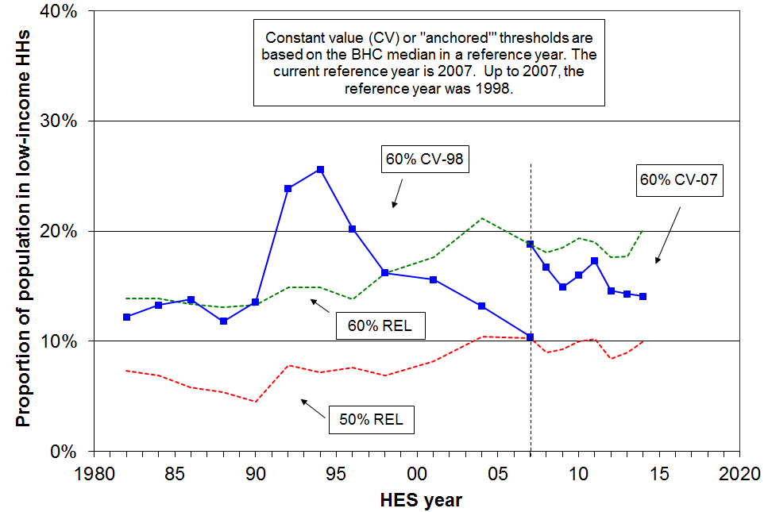

Table F.3
Percentage of whole population below selected thresholds (BHC)
Threshold type | ➔ Constant value |  | Relative to contemporary median |  | Population (million)
HES year | 60% 1998 median | 60% 2007 median | 50% contemp median | 60% contemp median | Population (million)
1982 | 12 | - | 7 | 14 | 3.03
1984 | 13 | - | 7 | 14 | 3.06
1986 | 14 | - | 6 | 13 | 3.07
1988 | 12 | - | 5 | 13 | 3.11
1990 | 14 | - | 5 | 13 | 3.15
1992 | 24 | - | 8 | 15 | 3.23
1994 | 26 | - | 7 | 15 | 3.32
1996 | 20 | - | 8 | 14 | 3.43
1998 | 16 | - | 7 | 16 | 3.54
2001 | 16 | 27 | 8 | 18 | 3.80
2004 | 13 | 25 | 10 | 21 | 3.96
2007 | 11 | 19 | 10 | 19 | 4.13
2009 | 7 | 15 | 9 | 19 | 4.21
2010 | 9 | 16 | 10 | 19 | 4.26
2011 | 10 | 17 | 10 | 19 | 4.31
2012 | 7 | 15 | 8 | 18 | 4.34
2013 | 8 | 14 | 9 | 18 | 4.37
2014 | 8 | 14 | 10 | 20 | 4.42

Note: In real terms, the BHC median in 1998 was close to what it was in 1982. There was therefore a good case for using 1998 as the reference year for producing ‘fixed line’ poverty rates back to 1982, as well as for the more usual application moving forwards from 1998. By 2007 the median was 16% up on 1998 and by 2009, 26%. This large change led to the reference year being changed to 2007. As the poverty figures in Table F.3 show, the value of the CV-98 threshold had in 2009 dropped below 50% of the contemporary median (~48%), and has remained around or below this level since then. The intention had been to draw a line on 1998 series shortly after 2009, but the GFC came upon us and this temporarily halted the upward trend in the median. The CV98 figures will continue to be reported for some years.

Proportion of all individuals below selected thresholds (AHC)

Figure F.2
Proportion of whole population below selected thresholds (AHC):
fixed line (CV) and moving line (REL) approaches compared

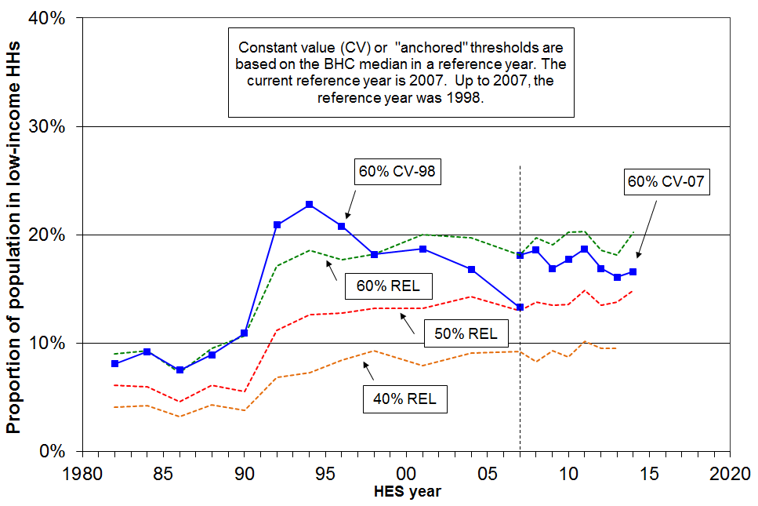

Table F.4
Percentage of whole population below selected thresholds (AHC)
Threshold type | ➔ Constant value |  | Relative to contemporary median |  |  | Population (million)
HES year | 60% 1998 median | 60% 2007 median | 40% contemp median | 50% contemp median | 60% contemp median | Population (million)
1982 | 8 | - | 4 | 6 | 9 | 3.03
1984 | 9 | - | 4 | 6 | 9 | 3.06
1986 | 8 | - | 3 | 5 | 7 | 3.07
1988 | 9 | - | 4 | 6 | 10 | 3.11
1990 | 11 | - | 4 | 6 | 11 | 3.15
1992 | 21 | - | 7 | 11 | 17 | 3.23
1994 | 23 | - | 7 | 13 | 19 | 3.32
1996 | 21 | - | 8 | 13 | 18 | 3.43
1998 | 18 | - | 9 | 13 | 18 | 3.54
2001 | 19 | 25 | 8 | 13 | 20 | 3.80
2004 | 17 | 22 | 9 | 14 | 20 | 3.96
2007 | 13 | 18 | 9 | 13 | 18 | 4.13
2009 | 12 | 17 | 9 | 14 | 19 | 4.21
2010 | 12 | 18 | 9 | 14 | 20 | 4.26
2011 | 14 | 19 | 10 | 15 | 20 | 4.31
2012 | 13 | 17 | 10 | 14 | 19 | 4.34
2013 | 12 | 16 | 10 | 14 | 18 | 4.37
2014 | 13 | 17 | - | 15 | 20 | 4.42

Note: AHC thresholds are calculated by deducting 25% from the corresponding BHC threshold as an allowance for housing costs. Each household’s AHC income is then assessed against the chosen threshold.

See the note under Table F.3 for information on the choice of reference year (1998 or 2007) for the CV figures.

Headline trends for children

Before Housing Costs (BHC)

- On both the 60% fixed line measure (using 2007 as the reference year), and on the 50% and 60% moving line measures, child poverty rates rose from HES 2009 to HES 2010 and HES 2011, reflecting the impact of the GFC on household incomes. In HES 2013, these rates are back to close to their pre-GFC rates.
- On a longer timescale for the moving line measure:
- The rise in moving line child poverty rates from 1990 to 1992 was driven by two factors: the rise in unemployment, and the 1991 benefit rate cuts which decreased real incomes for beneficiaries by a greater amount than the median fell in the period.
- From 1992 to 1998 the 60% of median moving line poverty rate for children fell as unemployment rates fell and incomes for those around the poverty line rose more quickly than the median in the period.
- From 1998 the median continued to grow in real terms, but the incomes of many low-income households with children remained fairly static through to 2004. This meant that the moving line child poverty rate rose to 2004, indicating that low-income households with children were on average further from the median in 2004 than in 1998.
- From 2004 to 2007, this trend was reversed, with rates falling from 26% to 20% (60% threshold), reflecting the impact of the WFF package which transferred considerable financial support to households with children on low to middle incomes. As almost all the extra WFF money went to households below the median, the median itself was largely unaffected.
- the 60% and 50% of median BHC moving line child poverty rates in HES 2013 were around the same as what they were in the 1980s (20%, and 11% respectively).
- On the fixed line measure, poverty rates decline when fewer households have incomes below a threshold held fixed in real terms, irrespective of what is happening elsewhere in the distribution.
- Using the 60% BHC fixed line threshold (1998 reference year), this is what happened from the mid 1990s to 1998 as a result of improving economic conditions, improving employment rates and reducing unemployment.
- From 1998 to 2004 child poverty rates using the 60% threshold remained reasonably steady at 19-22%.
- From 2004 to 2007, the poverty rate fell strongly from 19% to 13% - the WFF impact.

After Housing Costs (AHC)

- On the AHC fixed line measure, the child poverty rate fell significantly from 1994 to 2007 (35% to 16%, using 1998 as the reference year). In HES 2014, child poverty rates on this measure are much the same as in HES 2007 (17% using 1998 as the reference year and 23% with 2007 as the reference year). In between, it rose 2 to 3 percentage points in 2010 and 2011 after the GFC impact.
- On the AHC 60% of median moving line measure, the child poverty rate rose by 3 percentage points (25% to 28%) from HES 2009 to HES 2010 following the GFC impact, but in HES 2013 had returned to close to the pre-GFC rate (24%). This is lower than in the 1990s (28-30%), but double what it was in the 1980s (~12%). In 2014, the moving line rate rose because of the rise in the median.
- The trend for the AHC 40% of median moving line measure has been fairly steady since the benefit cuts in 1991 (11-13%).
Housing costs and the longer-run trends in child poverty (1982 to 2007, 2007 to 2014)

- The BHC 60% fixed line child poverty rate (1998 reference year) was lower in 2007 than what it was in the 1980s, and the BHC moving line rates were around the same in 2007 as in the 1980s. The AHC long-run trends are quite different: the fixed line poverty rate in 2007 (1998 reference year) was just a little above what it was in the 1980s, and the moving line rate in 2007 was much higher than in the 1980s.
- A key factor in explaining the longer-term differences between AHC and BHC rates is that housing costs in 2007 on average made up a higher proportion of household expenditure for low-income households than they did in the 1980s. For example, in 1988 17% of those in the bottom quintile lived in households that spent more than 30% of their income on housing. In 2007 there were 39%, after peaking at 52% in 1994.
- The longer-run AHC findings on child poverty reflect the fact that AHC incomes in 2007 for low-income households were around the same as they were in the early 1980s in real terms (so the fixed line child poverty rates are around the same in 2007 as in the 1980s), but that relative to the median, the incomes of lower-income households with children had fallen away (leading to higher moving line poverty rates).
- Both the income-related rental policies introduced in 2000 for those in HNZC houses and changes to the Accommodation Supplement (AS) settings in the mid 2000s helped to reduce net housing expenditure for some low-income households compared to what it would have been. This support contributed to the reductions in child poverty as measured on an AHC approach from 2001 to 2007.
- The policy settings for the AS have remained unchanged since 2005.

How many poor children are there in New Zealand?
(ie How many children live in households with incomes below selected thresholds?)

Table F.5
Numbers of poor children in New Zealand
(ie the number of children in households with incomes below the selected thresholds)
 | BHC |  | AHC
 | BHC ‘moving line’ |  | AHC ‘moving line’ |  |  | AHC ‘anchored line (2007)’
HES year | 50% | 60% | 40% | 50% | 60% | 60% (07 ref)
2001 | 120,000 | 250,000 | 115,000 | 215,000 | 310,000 | 380,000
2004 | 150,000 | 265,000 | 115,000 | 200,000 | 285,000 | 320,000
2007 | 135,000 | 210,000 | 115,000 | 175,000 | 240,000 | 240,000
2009 | 125,000 | 230,000 | 140,000 | 210,000 | 280,000 | 255,000
2010 | 150,000 | 250,000 | 120,000 | 210,000 | 315,000 | 275,000
2011 | 145,000 | 235,000 | 130,000 | 210,000 | 290,000 | 270,000
2012 | 130,000 | 225,000 | 135,000 | 215,000 | 285,000 | 255,000
2013 | 120,000 | 215,000 | 135,000 | 205,000 | 260,000 | 235,000
2014 | 150,000 | 250,000 | - | 220,000 | 305,000 | 245,000

- Using non-income measures of hardship, and an internationally comparable hardship threshold, around 200,000 children (18%) were below the threshold in 2008.

- There are clearly degrees of severity of poverty and material hardship. For example, children in households with incomes below a 50% AHC moving line measure will on average experience greater material disadvantage than those just below the 60% threshold. Some in households with incomes above the 60% AHC line will experience hardship because of high debt servicing or health costs, or long-run low income. See Appendix 6 and Section E for further discussion on the setting of the low-income thresholds (“poverty lines”).
Proportion of dependent children below selected thresholds (BHC)

Figure F.3
Proportion of children below selected thresholds (BHC):
fixed line (CV) and moving line (REL) approaches compared
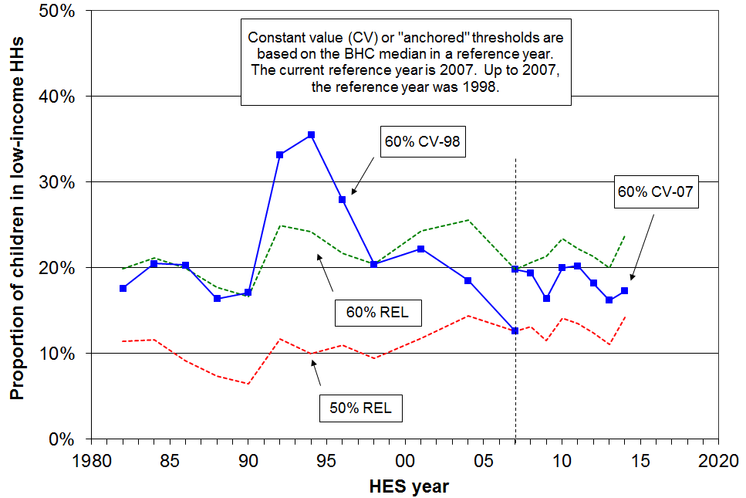

Table F.6
Percentage of children below selected thresholds (BHC)
Threshold type | ➔ Constant value |  | Relative to contemporary median |  | Total children (thousands)
HES year | 60% 1998 median | 60% 2007 median | 50% contemp median | 60% contemp median | Total children (thousands)
1982 | 18 | - | 11 | 20 | 940
1984 | 21 | - | 12 | 21 | 925
1986 | 20 | - | 9 | 20 | 895
1988 | 16 | - | 7 | 18 | 885
1990 | 17 | - | 7 | 17 | 875
1992 | 33 | - | 12 | 25 | 875
1994 | 36 | - | 10 | 24 | 910
1996 | 28 | - | 11 | 22 | 940
1998 | 20 | - | 9 | 20 | 950
2001 | 22 | 35 | 12 | 24 | 1020
2004 | 19 | 30 | 14 | 26 | 1040
2007 | 13 | 20 | 13 | 20 | 1065
2009 | 9 | 16 | 12 | 21 | 1070
2010 | 12 | 20 | 14 | 23 | 1065
2011 | 13 | 20 | 13 | 22 | 1067
2012 | 11 | 18 | 12 | 21 | 1047
2013 | 10 | 16 | 11 | 20 | 1064
2014 | 10 | 17 | 14 | 24 | 1058

Note: In real terms, the BHC median in 1998 was close to what it was in 1982. There was therefore a good case for using 1998 as the reference year for producing ‘fixed line’ poverty rates back to 1982, as well as for the more usual application moving forwards from 1998. By 2007 the median was 16% up on 1998 and by 2009, 26%. This large change led to the reference year being changed to 2007. As the poverty figures in Table F.6 show, the value of the CV-98 threshold had in 2009 dropped below 50% of the contemporary median (~48%), and has remained around or below this level since then. The intention had been to draw a line on 1998 series shortly after 2009, but the GFC came upon us and this temporarily halted the upward trend in the median. The CV98 figures will continue to be reported for some years.

Proportion of dependent children below selected thresholds (AHC)

Figure F.4
Proportion of children below selected thresholds (AHC):
fixed line (CV) and moving line (REL) approaches compared

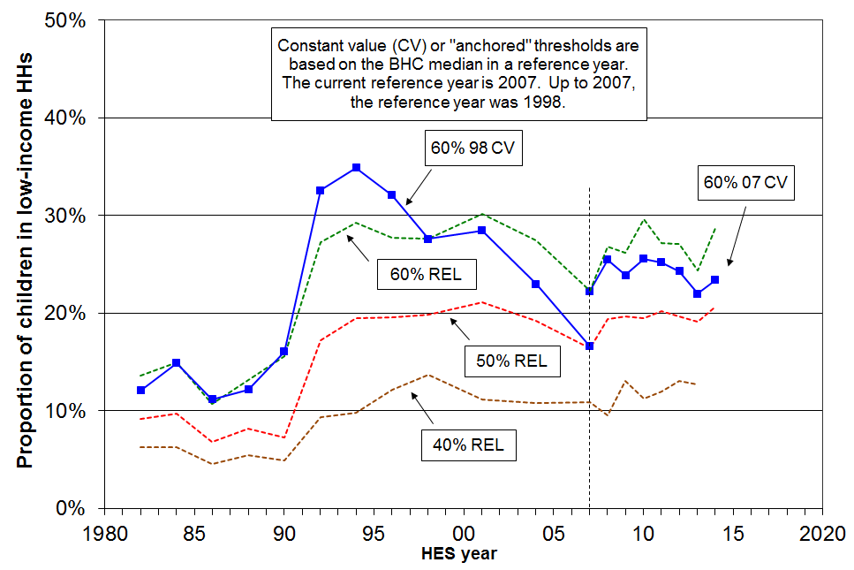

Table F.7
Percentage of children below selected thresholds (AHC)
Threshold type | ➔ Constant value |  | Relative to contemporary median |  |  | Total children (thousands)
HES year | 60% 1998 median | 60% 2007 median | 40% contemp median | 50% contemp median | 60% contemp median | Total children (thousands)
1982 | 12 | - | 6 | 9 | 14 | 940
1984 | 15 | - | 6 | 10 | 15 | 925
1986 | 11 | - | 5 | 7 | 11 | 895
1988 | 12 | - | 5 | 8 | 13 | 885
1990 | 16 | - | 5 | 7 | 16 | 875
1992 | 33 | - | 9 | 17 | 27 | 875
1994 | 35 | - | 10 | 20 | 29 | 910
1996 | 32 | - | 12 | 20 | 28 | 940
1998 | 28 | - | 14 | 20 | 28 | 950
2001 | 29 | 37 | 11 | 21 | 30 | 1020
2004 | 23 | 31 | 11 | 19 | 28 | 1040
2007 | 17 | 22 | 11 | 16 | 22 | 1065
2009 | 18 | 24 | 13 | 20 | 26 | 1070
2010 | 17 | 26 | 11 | 20 | 30 | 1065
2011 | 20 | 25 | 12 | 20 | 27 | 1067
2012 | 19 | 24 | 13 | 20 | 27 | 1047
2013 | 16 | 22 | 13 | 19 | 24 | 1064
2014 | 17 | 23 | - | 21 | 29 | 1058

Note: AHC thresholds are calculated by deducting 25% from the corresponding BHC threshold as an allowance for housing costs. Each household’s AHC income is then assessed against the chosen threshold.

See the note under Table F.6 for information on the choice of reference year (1998 or 2007) for the CV figures.

Sensitivity of levels and trends to choice of poverty line

Figures F.5 and F.6 show how the choice of threshold impacts on reported poverty rates for a given measure at a point in time and for trends over time. Figure F.5 uses BHC incomes with thresholds set relative to the contemporary median (the REL or moving line approach). Figure F.6 uses AHC incomes with thresholds held constant in real terms (the CV or “anchored line” approach).

The broad trends over time are largely unaffected by the choice of threshold within the usual range, especially in the AHC anchored line case.

The main exception to this generalisation is that for the period from the 2004 HES to the 2007 HES the reversal of the upward trend in ‘low-income rates’ in Figure F.5 (BHC REL) is strong for thresholds set at 60% to 90% of the median, but for lower thresholds (50% and 55%) the trend lines just flatten. This difference reflects the WFF gains in income for lower income households in work or for those moving from benefit to work, compared with those whose main source of income was from a working age benefit or New Zealand Superannuation. For these latter households, many of whom had incomes below a 55% threshold in that period, there were no gains relative to the median from the 2004 HES to the 2007 HES.

The other point of interest is the stark way in which Figure F.6 shows the impact on household incomes of the global financial crisis and associated downturn and recovery. It shows that from HES 2009 to HES 2011 (approximately calendar 2008 to 2010) the low-income rates all rose then fell from HES 2011 to 2013. The impact is detectable in the BHC REL chart (Figure F.5) but is not as stark as the REL low income rates are affected by the movement of the median as well as the changes in the incomes of low-income households.

Figure F.5
Proportion below a range of ‘moving line’ thresholds (BHC, REL)

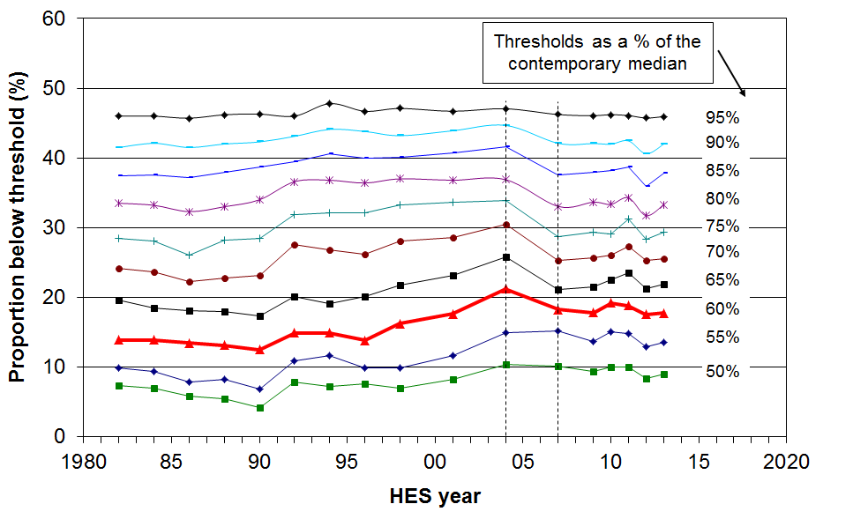

Figure F.6
Proportions below a range of ‘anchored’ thresholds (AHC, CV1998)

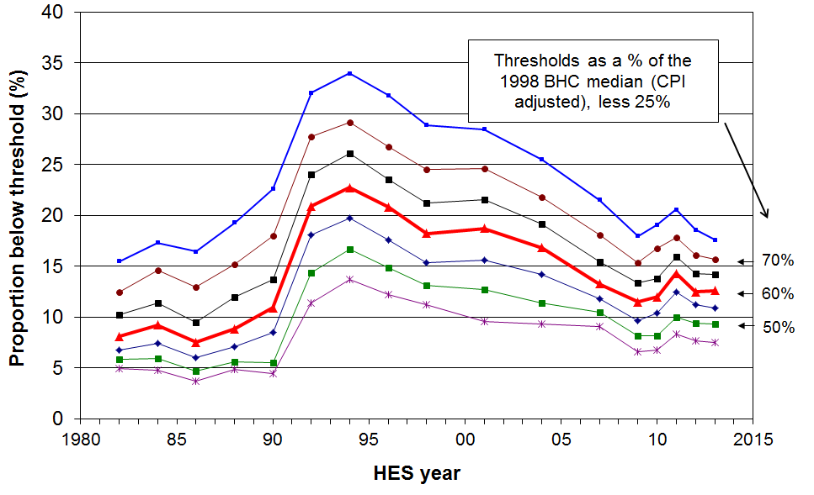

Depth of poverty

Trends in head-count poverty rates tell only a part of the story. It is important also to have an understanding of what is happening to the incomes of those identified as poor, that is, what is happening to trends in the depth of poverty.

This report uses two indicators of poverty depth:

- The ratio of the number below the 50% line to those below the 60% line. The higher this ratio, the greater is the depth of poverty.

- Median poverty gap ratios. These compare the gap between the poverty threshold and the median income of those below the threshold with the threshold itself.

There are issues around the quality of the data among households with very low incomes, and these present challenges to providing robust information on poverty depth. See Appendix 8 for a discussion on the effect of noise in the bottom income decile on measures of poverty depth, and the noise-reducing adjustments to the dataset adopted for the estimates in this section.

This section is not yet updated beyond the 2007 HES and also retains 1998 as the reference year.

Poverty depth: the ratio of 50% poverty rates to 60% poverty rates

Comparing the numbers below a 50% of median threshold with those below a 60% threshold gives an indication of the ‘depth’ of poverty. The higher the ratio, the greater the depth.

Figure F.7 shows that during the 1980s the 60% CV (fixed line) BHC poverty rate for those aged under 65 was relatively steady at around 12%. Poverty depth, however, declined, as measured by the 50% to 60% ratio. In contrast, in the 1998-2004 period, poverty depth as measured by this ratio increased while the poverty rate again remained relatively steady at 15%, pointing to increasing poverty depth. From 2004 to 2007, the ratio was steady and the 60% rate declined, indicating no change in poverty depth.

Figure F.7
Ratio of 50% poverty rate to 60% poverty rate using 1998 CV thresholds (BHC),
population under 65 years

Figure F.8 shows a similar combination of trends for children, except that both the poverty rates and poverty depth (on this measure) are higher for children than for the population as a whole.

Figure F.8
Ratio of 50% poverty rate to 60% poverty rate using 1998 CV thresholds (BHC),
dependent children
Poverty depth: mean and median poverty gap ratios

The median poverty gap ratio compares the gap between the poverty threshold and the median income of those below the threshold with the threshold itself.

The mean poverty gap ratio compares the gap between the poverty threshold and the mean income of those below the threshold with the threshold itself. It is much more affected by the incomes of households with very low incomes than is the median.

Figure F.9 shows that:
- median gap ratios are smaller than mean gap ratios, reflecting the higher concentration of households with incomes nearer the poverty lines compared with the concentration further down
- up to 2004, the estimates of poverty gap ratios are not greatly dependent on whether a REL (‘moving line’) or CV (‘fixed line’) approach is used
- apart from the blip in 1990, the mean gap ratio remained reasonably steady from 1982 to 2004, but has clearly risen from 2004 to 2007 on the REL (moving line) measure

Figure F.9
Mean and median poverty gap ratios

Section G

Trends for the whole population, 1982 to 2014,

by various individual and household characteristics

This section:
- compares trends in poverty rates for subgroups within the population
- reports on the changing composition of those identified as poor on the chosen measures.

The individual and household characteristics used for subgroup analyses are:
- age of the individual
- sex of the individual
- ethnicity of the individual (no trends)
- tenure
- household type
- number of children in the household
- main source of income for households under 65.

For subgroup comparisons, the report recommends the use of AHC measures (see Appendix 5). Table G.1 notes the AHC measures used in this section.

Table G.1
Poverty measures reported on in Section G for subgroups of the whole population
BHC |  |  |  | AHC
REL  (‘moving line’) |  | CV-98 (to 2007)  CV-07 (from 2007)  (‘anchored line’) |  | REL  (‘moving line’) |  | CV-98 (to 2007)  CV-07 (from 2007)  (‘anchored line’)
50 | 60 | 50 | 60 | 50 | 60 | 50 | 60
- | - | - | - | ✓ | ✓ | - | ✓
Note: ‘CV-98’ indicates that 1998 is the reference year used. ‘CV-07’ uses 2007.

Individuals in low-income households by age

- Setting aside the 18-24 year old group, Figure G.1 and Table G.2 show that there has been a hardship gradient across the age groups since the early 1990s, with older New Zealanders having lower income poverty rates than children, and other ages falling in between.
- The position of those aged 18-24 years deteriorated relative to other groups from the 1980s to 2004, but there is some evidence of recovery from 2004 to 2010, although in 2011 and 2012 the rate was back up to close to what it was in 2007.

Figure G.1
Proportion of all individuals in low-income households by age, 60% CV threshold (AHC)

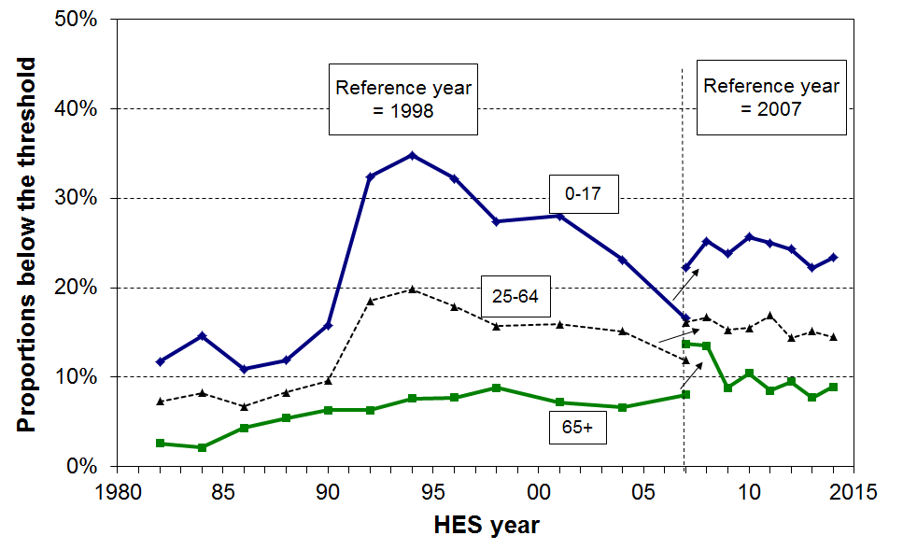

Table G.2
Proportion of all individuals in low-income households by age, 60% CV threshold (AHC)
 | Reference year = 1998 |  |  |  |  |  |  |  | Reference year = 2007
 | 1982 | 1986 | 1990 | 1994 | 1998 | 2001 | 2004 | 2007 | 2007 | 2009 | 2010 | 2011 | 2012 | 2013 | 2014
0-17 | 12 | 11 | 16 | 35 | 27 | 28 | 23 | 17 | 22 | 24 | 26 | 25 | 24 | 22 | 23
18-24 | 6 | 5 | 8 | 20 | 16 | 21 | 21 | 18 | 23 | 17 | 16 | 25 | 22 | 17 | 22
25-44 | 9 | 8 | 12 | 23 | 18 | 18 | 17 | 12 | 17 | 16 | 17 | 18 | 17 | 17 | 15
45-64 | 4 | 5 | 6 | 15 | 12 | 14 | 13 | 12 | 16 | 14 | 14 | 16 | 12 | 13 | 14
65+ | 3 | 4 | 6 | 8 | 9 | 7 | 7 | 8 | 14 | 9 | 10 | 9 | 10 | 8 | 9
TOTAL | 8 | 8 | 11 | 23 | 18 | 19 | 17 | 13 | 18 | 17 | 18 | 19 | 17 | 16 | 17

Figure G.3 shows trends in poverty rates by age group using the 60% of median moving line measure (AHC). The hardship gradient is evident here too, with older New Zealanders having lower income poverty rates than younger New Zealanders. However, from 1992 to 2009 the age group poverty trends are quite different using the moving line measure compared with the trends using the fixed line measure (Figure G.1). This reflects the two different notions of poverty that underlie the measures. For example:
- Child poverty on this moving line measure remained steadily high (~28%) from 1994 to 2004, with no fall despite the rising employment, falling unemployment and rising real incomes for many low-income households. The trend reflects the poverty concept for the moving line measure: it is based on distance from the median, rather than distance from a fixed standard held constant in real terms, and the median rose in real terms in the period.
- The only significant fall in child poverty on the moving line measure after 1994 was from 2004 to 2007, reflecting the impact of the WFF package in lifting the incomes of many low- to middle-income families without it having any great impact on the median itself.
- For older New Zealanders, the rise from 1992 to 2009 reflects the fact that the value of the NZS fell in this period relative to the median, even though in real terms the value of the NZS remained steady. From 2009 to 2012, the real value of NZS rose (driven in the main by income tax changes), while the median was relatively unchanged.

Figure G.3
Proportion of all individuals in low-income households by age, 60% REL threshold (AHC)

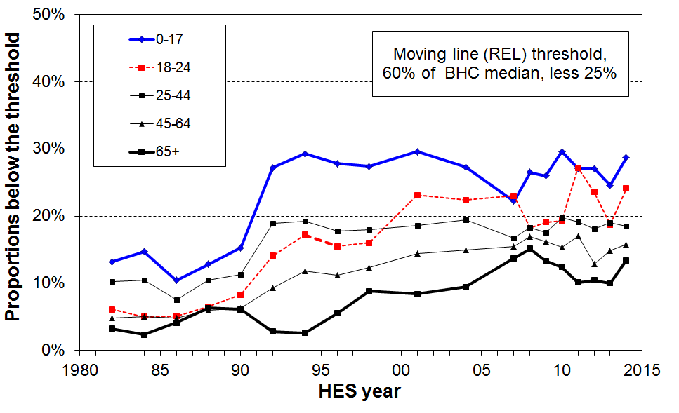

Table G.3
Proportion of all individuals in low-income households by age
A. AHC (REL threshold, 60% of BHC median, less 25%)
 | 1982 | 1984 | 1986 | 1988 | 1990 | 1992 | 1994 | 1996 | 1998 | 2001 | 2004 | 2007 | 2009 | 2010 | 2011 | 2012 | 2013 | 2014
0-17 | 13 | 15 | 10 | 13 | 15 | 27 | 29 | 28 | 27 | 30 | 27 | 22 | 26 | 30 | 27 | 27 | 25 | 29
18-24 | 6 | 5 | 5 | 7 | 8 | 14 | 17 | 16 | 16 | 23 | 22 | 23 | 19 | 19 | 27 | 24 | 19 | 24
25-44 | 10 | 10 | 8 | 10 | 11 | 19 | 19 | 18 | 18 | 19 | 19 | 17 | 18 | 20 | 19 | 18 | 19 | 19
45-64 | 5 | 5 | 5 | 6 | 6 | 9 | 12 | 11 | 12 | 14 | 15 | 15 | 16 | 15 | 17 | 13 | 15 | 16
65+ | 3 | 2 | 4 | 6 | 6 | 3 | 3 | 6 | 9 | 8 | 9 | 14 | 13 | 12 | 10 | 10 | 10 | 13
TOTAL | 9 | 9 | 7 | 10 | 11 | 17 | 19 | 18 | 18 | 20 | 20 | 18 | 19 | 20 | 20 | 19 | 18 | 20

B. AHC (REL threshold, 50% of BHC median, less 25%)
 | 1982 | 1984 | 1986 | 1988 | 1990 | 1992 | 1994 | 1996 | 1998 | 2001 | 2004 | 2007 | 2009 | 2010 | 2011 | 2012 | 2013 | 2014
0-17 | 9 | 9 | 7 | 8 | 7 | 17 | 20 | 20 | 20 | 21 | 19 | 16 | 19 | 20 | 20 | 20 | 19 | 21
18-24 | 5 | 3 | 2 | 5 | 5 | 10 | 13 | 11 | 12 | 15 | 18 | 18 | 14 | 14 | 22 | 17 | 15 | 21
25-44 | 7 | 7 | 6 | 7 | 7 | 13 | 13 | 13 | 13 | 13 | 15 | 12 | 13 | 13 | 14 | 14 | 15 | 14
45-64 | 3 | 4 | 3 | 5 | 3 | 6 | 8 | 9 | 10 | 9 | 11 | 12 | 11 | 12 | 13 | 9 | 12 | 13
65+ | 1 | 1 | 2 | 2 | 2 | 1 | 1 | 3 | 4 | 3 | 5 | 7 | 6 | 6 | 5 | 6 | 4 | 7
TOTAL | 6 | 6 | 5 | 6 | 6 | 11 | 13 | 13 | 13 | 13 | 14 | 13 | 13 | 14 | 15 | 14 | 14 | 15
Individuals in low-income households by sex

- Table G.4 shows that from 1988 to 2014 on the 60% of median AHC fixed line measure, females were slightly more likely than males to be below the threshold.
- Table G.5 gives the numbers in each group for HES 2013 and HES 2014

Table G.4
Proportion of individuals aged 15+ in low-income households by sex,
AHC income, 60% of median (CV threshold)
 | Reference year = 1998 |  |  |  |  |  |  |  |  | Reference year = 2007
 | 1988 | 1990 | 1992 | 1994 | 1996 | 1998 | 2001 | 2004 | 2007 | 2007 | 2009 | 2010 | 2011 | 2012 | 2013 | 2014
Female | 8 | 9 | 18 | 20 | 18 | 16 | 17 | 15 | 13 | 18 | 14 | 16 | 17 | 15 | 15 | 16
Male | 7 | 8 | 16 | 17 | 15 | 13 | 14 | 15 | 11 | 16 | 13 | 13 | 14 | 14 | 13 | 15
TOTAL (15+) | 8 | 9 | 17 | 18 | 17 | 15 | 16 | 15 | 12 | 17 | 14 | 15 | 16 | 15 | 14 | 14

Table G.5
Numbers of individuals aged 15+ in low-income households by sex, HES 2012 and HES 2013
AHC income, 60% of median (CV threshold)
 | HES 2014 |  | HES 2013
 | Total | “Poor” | Total | “Poor”
Female | 1.81m | 280,000 | 1.78m | 270,000
Male | 1.72m | 240,000 | 1.69m | 220,000
TOTAL (15+) | 3.53m | 520,000 | 3.48m | 490,000

Individuals in low-income households by ethnicity (whole population)

As noted in the Introduction, only limited analysis by ethnicity is reported because of the relatively small sample sizes for Maori, Pacific and Other ethnic groups (especially Pacific). The analysis in this section combines the data from two surveys (HES 2013 and 2014) to give an indication of the differences in low-income rates by ethnicity.

Poverty rates for those in the Maori and Pacific ethnic groups are consistently higher than for those in the European/Pakeha ethnic group (roughly double), whatever measure is used.

For example, on average over the two surveys HES 2013 and 2014, using the AHC 60% anchored line measure, 12% of European/Pakeha, 26% of Maori, 25% Pacific and 26% “Other” were in households with incomes below this line.

The above use ethnicity defined on a prioritisation approach (see Introduction). Using a “total count” approach makes little difference for this purpose: the corresponding figures are 13%, 26%, 26% and 25%.

Composition of the poor by ethnicity

It is important to distinguish between the proportion of a group who are counted as poor, and the proportion of the poor who are from a particular group, that is, between rates and composition.

Using the same approach as for the rates above, just under half (47%) of those identified as poor are in the European/Pakeha group, 33% in the Maori and Pacific groups, and 20% in the Other group.

Using a more stringent poverty line (50% of median), the composition proportions are 47%, 33% and 21% respectively. There is no evidence here of greater depth of poverty for any one group.

Individuals in low-income households by highest household educational qualification

There is a well-established positive link between adult educational qualifications and employment opportunities and wages received.

Table G.6 shows the fairly steep gradient for poverty rates for individuals from households of lower and higher educational qualifications.

A higher educational qualification does not of itself guarantee an adequate income however, as the 10% poverty rate for university graduates indicates.

One third of those in the low-income group have post-school non-degree qualifications, even though the low-income rate for this group is much lower than that for the group with no formal qualifications, now a relatively small group.

Table G.6A
Poverty rates and poverty composition by highest household educational qualification:
averages over HES 2012 to 2014, using the AHC 60% of median threshold measure, anchored in 2007
individuals under 65
 | Poverty rate (%) | Poverty composition (%) | 0-64 population composition (%) | Risk ratio
No formal qualification | 47 | 16 | 7 | 2.4
School qualification only | 28 | 33 | 23 | 1.4
Post-school non-degree | 19 | 33 | 35 | 0.9
Degree or post-graduate | 10 | 18 | 35 | 0.5

Table G.6B
Poverty rates and poverty composition by highest household educational qualification:
averages over HES 2012 to 2014, using the AHC 60% of median threshold measure, anchored in 2007
those aged 0-17 yrs
 | Poverty rate (%) | Poverty composition (%) | 0-17 population composition (%) | Risk ratio
No formal qualification | 58 | 14 | 6 | 2.5
School qualification only | 33 | 34 | 24 | 1.4
Post-school non-degree | 22 | 34 | 36 | 0.9
Degree or post-graduate | 12 | 18 | 34 | 0.5

Individuals in low-income households by tenure

- There is a clear hardship gradient across different tenures for those aged under 65 (Table G.7A): low poverty rates for those in mortgage-free homes and a little higher for those who still have a mortgage, and relatively high rates for those in rental properties, especially in HNZC tenancies.
- For those aged 65+, the hardship gradient is also clear (Table G.7B). The figures underline the value of having a mortgage-free home in “retirement” years. This is not a surprising finding given the use of an AHC measure.
- Around half (49%) of all those aged under 65 who are in poverty live in private rental accommodation. The figure rises to two in three (65%) when HNZC and private rentals are counted together.

Table G.7A
Proportion (%) of individuals aged under 65 in low-income households by tenure,
AHC CV threshold (60% of 1998 or 2007 BHC median, less 25%)
 | Reference year = 1998 |  |  |  |  |  |  | Reference year = 2007
 | 1992 | 1994 | 1996 | 1998 | 2001 | 2004 | 2007 | 2007 | 2009 | 2010 | 2011 | 2012 | 2013 | 2014
Owned or FT without mortgage | 10 | 8 | 9 | 7 | 10 | 9 | 6 | 12 | 9 | 7 | 10 | 4 | 8 | 9
Owned or FT with mortgage | 22 | 23 | 20 | 15 | 17 | 12 | 9 | 14 | 13 | 12 | 11 | 12 | 10 | 11
Rented - private | 33 | 41 | 36 | 35 | 33 | 30 | 23 | 29 | 29 | 28 | 32 | 28 | 30 | 27
Rented – HNZC or local authority | 55 | 64 | 59 | 53 | 37 | 41 | 29 | 37 | 39 | 38 | 50 | 50 | 33 | 49
TOTAL (under 65) | 23 | 25 | 22 | 19 | 20 | 18 | 14 | 19 | 19 | 18 | 20 | 17 | 17 | 18
Notes: 1 ‘Owned or FT without mortgage’ means that the dwelling is owned by the householders or a Family Trust, and the householders make no mortgage payments.

Table G.7B
Proportion (%) of individuals aged 65+ in low-income households by tenure,
AHC CV threshold (60% of 1998 or 2007 BHC median, less 25%)
 | 1992 | 1994 | 1996 | 1998 | 2001 | 2004 | 2007 | 2007 | 2009 | 2010 | 2011 | 2012 | 2013 | 2014
Owned or FT without mortgage | 1 | 1 | 1 | 2 | 2 | 2 | 4 | 7 | 3 | 3 | 2 | 1 | 1 | 2
Owned or FT with mortgage | 6 | 16 | 15 | 32 | 31 | 11 | 10 | 16 | 20 | 15 | 17 | 16 | 16 | 12
Rented | 36 | 53 | 64 | 53 | 30 | 37 | 23 | 44 | 47 | 51 | 41 | 51 | 39 | 43
TOTAL (65+) | 6 | 8 | 8 | 9 | 7 | 7 | 8 | 14 | 9 | 10 | 9 | 10 | 8 | 9
Notes: 1 ‘Owned or FT without mortgage’ means that the dwelling is owned by the householders or a Family Trust, and the householders make no mortgage payments.
2 For the 65+ ‘owned or FT with mortgage’, the sample numbers are small – the general conclusion that the poverty rate for mortgage payers is significantly higher than for those who own without a mortgage is robust, but the sample numbers do not support precise figures.
3 For the 65+, all renters are grouped together as the sample numbers are too small to split private and HNZC renters.

Individuals in low-income households by household type

Key findings

Using AHC incomes:

- Sole-parent households with dependent children have the highest income poverty rates of all household types (Table G.8), 56- 60% in the last three surveys.

- Around one in three sole-parent families (EFUs) live in wider households with others. Table G.6 shows the lower poverty rates for these embedded sole-parent EFUs (20% on average over HES 2011 to HES 2013) compared with those who live in sole-parent households on their own (67% in the same period).

- Two-parent households with dependent children have much lower poverty rates than sole-parent households, but there are more poor individuals from this household type than from sole-parent households (Table G.9).

- Table G.9 and Figure G.4 show that while those in households with dependent children continue to make up the bulk of those classified as poor, working-age adults in households without dependent children now make up a larger proportion of the poor than in earlier years (30% on average in 2010 to 2013, compared with 19% in the mid 1990s and 15% in the mid 1980s). This rise is driven not only by the increasing share of households without dependent children but also by the generally higher recent poverty rates compared with 1984 for working-age households with no dependent children.

- Working-age adults in single-person households have the second highest poverty rate of all household types, after sole-parent households. From the 1980s to 2007, poverty rates for this group trebled (10% to 30% on the 1998 AHC anchored line measure). For 2011 to 2014 the rate for the older group (45 to 64 years) averaged 32%, compared with 14% for the population overall, and 54% for sole parents using the same AHC fixed line 1998 reference year measure. There is little difference in the poverty rates for younger (18 to 44 years) and older (45 to 64 years) one-person households, 30% and 32% respectively.

- Overall poverty rates for those aged 65+ have been considerably lower than those for the rest of the population over the full period from 1982 to 2014 (Table G.2 above). However, those older New Zealanders living on their own have generally had a much higher proportion below the threshold than have those in couple households (eg 13% compared with 7% for the last three surveys, on average).

Table G.8
Individuals in low-income households by household and family type
60% AHC CV
Proportions below the threshold
 | Reference year = 1998 |  |  |  |  |  |  |  |  |  |  | Reference year = 2007
 | 84 | 86 | 88 | 90 | 92 | 94 | 96 | 98 | 01 | 04 | 07 | 07 | 09 | 10 | 11 | 12 | 13 | 14
In all households
Single 65+ | 3 | 9 | 12 | 13 | 10 | 13 | 11 | 14 | 9 | 14 | 12 | 23 | 16 | 23 | 14 | 13 | 12 | 14
Couple 65+ | 1 | 2 | 2 | 3 | 4 | 5 | 6 | 5 | 8 | 3 | 6 | 10 | 5 | 5 | 7 | 9 | 7 | 6
Single under 65 | 10 | 10 | 12 | 15 | 30 | 30 | 29 | 22 | 28 | 27 | 30 | 36 | 30 | 30 | 37 | 28 | 30 | 35
Couple under 65 | 5 | 4 | 6 | 7 | 11 | 12 | 11 | 10 | 9 | 12 | 11 | 14 | 10 | 9 | 16 | 10 | 12 | 9
Sole parent with children | 27 | 22 | 15 | 25 | 69 | 72 | 74 | 62 | 70 | 55 | 47 | 57 | 52 | 61 | 61 | 60 | 56 | 59
Two parent with children | 12 | 9 | 12 | 12 | 25 | 26 | 21 | 19 | 19 | 16 | 9 | 14 | 16 | 16 | 15 | 15 | 14 | 14
Other family HHs with children | 10 | 7 | 3 | 12 | 14 | 16 | 21 | 16 | 13 | 16 | 18 | 20 | 15 | 21 | 15 | 16 | 14 | 15
Other family HHs, adults only <65 | 2 | 2 | 2 | 4 | 5 | 6 | 5 | 6 | 6 | 12 | 6 | 12 | 11 | 12 | 11 | 9 | 11 | 10
Non-family HHs | 3 | 2 | 7 | 4 | 14 | 22 | 15 | 20 | 24 | 24 | 15 | 18 | 13 | 11 | 18 | 18 | 8 | 19
Total population | 9 | 8 | 9 | 11 | 21 | 23 | 21 | 18 | 19 | 17 | 13 | 18 | 17 | 18 | 19 | 17 | 16 | 17
In households with dependent children
Total | 13 | 10 | 11 | 14 | 29 | 31 | 29 | 24 | 25 | 20 | 15 | 20 | 20 | 23 | 22 | 21 | 20 | 21
- with 1 child | 7 | 7 | 8 | 8 | 26 | 25 | 25 | 19 | 18 | 16 | 17 | 19 | 17 | 20 | 23 | 18 | 21 | 21
- with 2 children | 12 | 9 | 9 | 13 | 25 | 28 | 29 | 27 | 26 | 16 | 11 | 17 | 19 | 20 | 17 | 19 | 18 | 16
- with 3 or more children | 17 | 13 | 15 | 21 | 36 | 39 | 32 | 27 | 30 | 28 | 19 | 26 | 28 | 29 | 29 | 28 | 22 | 26
In families (EFUs) with dependent children
SP families overall | - | - | 13 | 22 | 57 | 62 | 63 | 52 | 61 | 42 | 40 | 48 | 45 | 54 | 53 | 51 | 50 | 54
- living on their own | - | - | 17 | 29 | 79 | 76 | 77 | 68 | 76 | 56 | 49 | 59 | 57 | 67 | 71 | 67 | 65 | 65
- within wider HHs | - | - | 4 | 9 | 18 | 24 | 31 | 22 | 23 | 20 | 25 | 32 | 21 | 29 | 24 | 22 | 18 | 31
2P families | - | - | 11 | 13 | 24 | 26 | 22 | 19 | 19 | 16 | 9 | 14 | 16 | 16 | 14 | 15 | 14 | 14
Under 65, by main source of household income in the 12 months prior to interview
Market | 7 | 6 | 7 | 9 | 12 | 14 | 14 | 12 | 13 | 12 | 8 | 11 | 11 | 10 | 11 | 11 | 10 | 11
Income-tested benefit | 33 | 28 | 26 | 24 | 64 | 66 | 65 | 61 | 62 | 56 | 54 | 76 | 71 | 78 | 77 | 76 | 73 | -
All in households under 65 | 10 | 8 | 9 | 12 | 23 | 25 | 23 | 19 | 20 | 18 | 14 | 19 | 16 | 18 | 19 | 17 | 17 | 18
Under 65, by work status of adults in household at time of interview
Self-employed | - | - | - | - | - | - | - | - | - | - |  | 10 | 12 | 18 | 19 | 16 | 12 | 14
One or more FT | - | - | - | - | - | - | - | - | - | - |  | 10 | 10 | 8 | 9 | 8 | 9 | 8
None FT | - | - | - | - | - | - | - | - | - | - |  | 62 | 58 | 57 | 66 | 64 | 59 | -
Workless | - | - | - | - | - | - | - | - | - | - |  | 68 | 62 | 63 | 68 | 69 | 64 | -

Notes: 1 ‘01’ means the 2000-01 HES year, and so on.
2 Around one in three sole-parent families (EFUs) live in wider households with others. Note that individuals in the EFU analysis in Table G.8 retain the equivalised income of their household of origin for this analysis on the grounds that those in the wider households share to a reasonable degree in the benefits of the wider households and the economies of scale.
3 The HH type “SP with children” can include non-dependent children and other adults. On the other hand a family that is “SP on own” has only the one adult plus dependent child(ren).
4 See Appendix 11 (Table 11.3) for this table repeated for the 50% AHC CV threshold (ref year = 2007).

Table G.9
Individuals in low-income households by household type
60% AHC CV
Composition of those below the threshold, by household type
(add down columns for 100%)
 | Reference year = 1998 |  |  |  |  |  |  |  |  |  | Reference year = 2007
 | 86 | 88 | 90 | 92 | 94 | 96 | 98 | 01 | 04 | 07 | 07 | 09 | 10 | 11 | 12 | 13 | 14 | Popln in ‘14’
By household type
Single 65+ | 4 | 5 | 5 | 2 | 2 | 2 | 3 | 2 | 3 | 3 | 5 | 4 | 5 | 3 | 3 | 3 | 3 | 4
Couple 65+ | 2 | 1 | 1 | 1 | 1 | 2 | 2 | 3 | 1 | 3 | 4 | 2 | 2 | 3 | 4 | 4 | 3 | 9
Single under 65 | 5 | 6 | 6 | 6 | 6 | 6 | 5 | 7 | 8 | 11 | 9 | 8 | 8 | 9 | 8 | 8 | 10 | 5
Couple under 65 | 7 | 9 | 7 | 6 | 7 | 7 | 8 | 6 | 9 | 10 | 10 | 7 | 6 | 11 | 8 | 9 | 7 | 12
Sole-parent with children | 14 | 11 | 16 | 24 | 22 | 28 | 25 | 26 | 19 | 25 | 21 | 25 | 24 | 26 | 25 | 25 | 24 | 7
Two-parent with children | 56 | 60 | 51 | 48 | 50 | 43 | 41 | 41 | 35 | 26 | 29 | 33 | 34 | 30 | 32 | 33 | 32 | 37
Other fam HHs with ch | 9 | 3 | 7 | 6 | 5 | 7 | 8 | 6 | 10 | 11 | 10 | 8 | 9 | 6 | 8 | 6 | 6 | 7
Other fam HHs, adults only | <1 | 2 | 4 | 3 | 3 | 2 | 4 | 3 | 9 | 5 | 8 | 8 | 8 | 6 | 5 | 9 | 6 | 13
Non-family HHs | 2 | 5 | 3 | 3 | 4 | 3 | 5 | 6 | 5 | 6 | 6 | 5 | 4 | 6 | 7 | 3 | 9 | 7
Under 65, by main source of household income in the 12 months prior to interview
Market <65 | - | - | - | - | - | - | - | - | - | - | 53 | 57 | 48 | 46 | 53 | 53 | - | 89
Govt < 65 | - | - | - | - | - | - | - | - | - | - | 47 | 43 | 52 | 54 | 47 | 47 | - | 11
Under 65, by work status of adults in household at time of interview
Self-employed | - | - | - | - | - | - | - | - | - | - | 5 | 8 | 10 | 9 | 7 | 7 | 8 | 9
One or more FT | - | - | - | - | - | - | - | - | - | - | 39 | 38 | 31 | 31 | 35 | 40 | 34 | 74
None FT | - | - | - | - | - | - | - | - | - | - | 51 | 51 | 57 | 58 | 56 | 52 | - | 15
- PT only | - | - | - | - | - | - | - | - | - | - | 12 | 11 | 12 | 12 | 12 | 10 | - | 4
- Workless | - | - | - | - | - | - | - | - | - | - | 39 | 40 | 44 | 46 | 44 | 42 | - | 11
Total population | 100 | 100 | 100 | 100 | 100 | 100 | 100 | 100 | 100 | 100 | 100 | 100 | 100 | 100 | 100 | 100 |  | 100

To properly interpret the trends in composition of the poor by household type (as in Table G.8 above), both the trend in poverty rates and the changes over time of the composition of the population as a whole need to be known. One way of integrating and summarising these two trends is to use the ‘poverty risk ratio’ (PRR). The PRR for a given sub-group is the ratio of the poverty rate of that sub-group to that of the population as a whole. This gives an indication of the over- or under-representation of the subgroup at the lower end of the income distribution. A PRR greater than one indicates over-representation.

Figure G.4 shows the trends in the PRR for selected years from 1984 to 2012 for different household types. One person 65+ households have consistently had a higher PRR than couple 65+ households. The PRR rose from 1984 to 2012 for sole-parent households and fell for two-parent households. Perhaps the most significant change is the much higher PRR for one person working-age households in 2012 (1.8) compared with a quarter century earlier in 1984 (1.2).

Figure G.4
Poverty risk ratio by household type, AHC CV 60% threshold, selected years
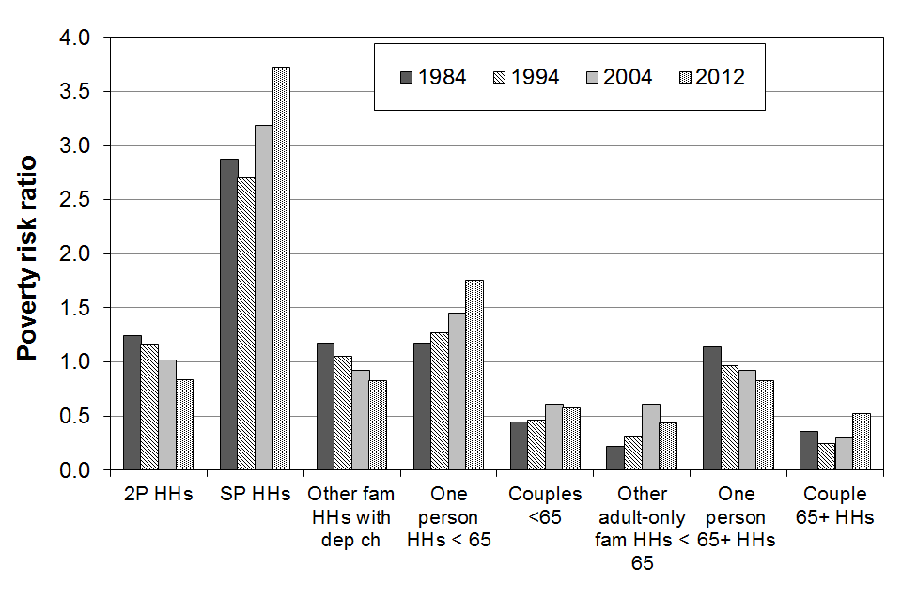
Section H

Trends for dependent children, 1982 to 2014,

by various individual and household characteristics

This section:
- compares trends in poverty rates for subgroups of dependent children
- reports on the changing composition of those children identified as poor.

The individual and household characteristics used for subgroup analyses are:
- age of the children
- ethnicity of children (no time series)
- highest household educational qualification
- tenure
- household type
- family type
- hours of work of adults in households where there are dependent children.

AHC measures are used in this section (Table H.1).The rationale for this approach when comparing subgroups is outlined in Appendix 5. The anchored threshold approach is mainly used. Further tables based on the fully relative approach are in Appendix 11.

Table H.1
Poverty measures reported on in Section H for subgroups of dependent children
BHC |  |  |  | AHC
REL  (‘moving line’) |  | CV-98 (to 2007)  CV-07 (from 2007)  (‘anchored line’) |  | REL  (‘moving line’) |  | CV-98 (to 2007)  CV-07 (from 2007)  (‘anchored line’)
50 | 60 | 50 | 60 | 50 | 60 | 50 | 60
- | - | - | - | ✓ | ✓ | - | ✓

Children in workless and working households

Policy development and public debate around improving the wellbeing of children often involve discussion about the links between child poverty rates and the labour market involvement of their parents. A special subsection at the end of this section therefore brings together in one place a range of information on the numbers of children in workless and working households, their respective poverty rates, and the composition of children identified as poor vis-à-vis the work status of adults in their households.

Poverty rates for children and the composition of poor children

It is important to distinguish between the proportion of a group who are counted as poor, and the proportion of the poor who are from a particular group, that is, between rates and composition.

In Table H.8 (later in this Section) rate and composition statistics are summarised for children by household type, family type, number of children in the household, ethnicity, highest household educational qualification, tenure and main source of income for the household (benefit or market).

Children in low-income households by age

- Figure H.1 shows that from 1982 to 2013, poverty rates for younger children (0 to 11 years) were consistently higher than the rates for older children (12 to 17 years). See ‘caution’ under the tables for the 2013-14 figures.
- Table H.2 breaks the younger group into two groups (0-6 yrs and 7-11 yrs). In most years there is little difference in poverty rates for these two younger subgroups on any of the three measures.

Figure H.1
Proportion of children in low-income households by age, 60% CV threshold (AHC)

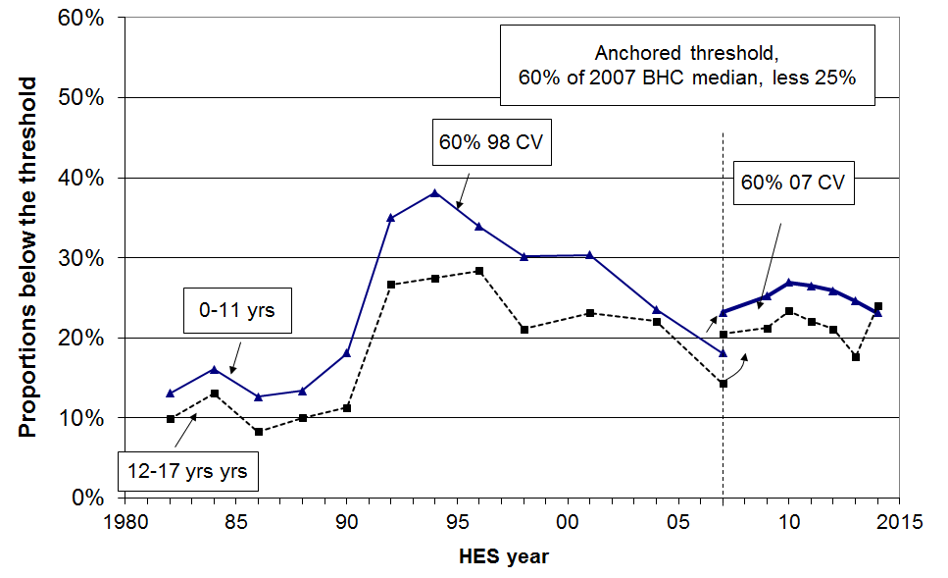

Table H.2
A. Proportion of children in low-income households by age, 60% CV threshold (AHC)
 | Reference year = 1998 |  |  |  |  |  |  |  |  |  |  | Reference year = 2007
 | 1984 | 1986 | 1988 | 1990 | 1992 | 1994 | 1996 | 1998 | 2001 | 2004 | 2007 | 2007 | 2009 | 2010 | 2011 | 2012 | 2013 | 2014
0-6 | 15 | 13 | 14 | 18 | 36 | 39 | 34 | 31 | 31 | 23 | 20 | 24 | 24 | 26 | 26 | 26 | 25 | 23
7-11 | 17 | 12 | 13 | 19 | 33 | 38 | 33 | 29 | 29 | 25 | 16 | 22 | 26 | 28 | 27 | 26 | 24 | 23
12-17 | 13 | 8 | 10 | 11 | 27 | 28 | 28 | 21 | 23 | 22 | 14 | 20 | 21 | 23 | 22 | 21 | 18 | 24
0-17 | 15 | 11 | 12 | 16 | 32 | 35 | 32 | 27 | 28 | 23 | 16 | 22 | 24 | 26 | 25 | 24 | 22 | 23

B. Proportion of children in low-income households by age, 60% REL threshold (AHC)
 | 1982 | 1984 | 1986 | 1988 | 1990 | 1992 | 1994 | 1996 | 1998 | 2001 | 2004 | 2007 | 2009 | 2010 | 2011 | 2012 | 2013 | 2014
0-6 | 15 | 16 | 12 | 15 | 17 | 30 | 32 | 30 | 31 | 33 | 26 | 24 | 27 | 31 | 28 | 28 | 27 | 30
7-11 | 15 | 17 | 12 | 14 | 18 | 28 | 32 | 28 | 29 | 32 | 30 | 22 | 28 | 32 | 30 | 30 | 27 | 28
12-17 | 10 | 12 | 8 | 10 | 11 | 23 | 23 | 25 | 21 | 24 | 26 | 21 | 24 | 27 | 24 | 24 | 20 | 28
0-17 | 14 | 15 | 11 | 13 | 16 | 27 | 29 | 28 | 28 | 30 | 28 | 22 | 26 | 30 | 27 | 27 | 24 | 29

C. Proportion of children in low-income households by age, 50% REL threshold (AHC)
 | 1982 | 1984 | 1986 | 1988 | 1990 | 1992 | 1994 | 1996 | 1998 | 2001 | 2004 | 2007 | 2009 | 2010 | 2011 | 2012 | 2013 | 2014
0-6 | 10 | 10 | 7 | 9 | 8 | 19 | 22 | 22 | 21 | 24 | 19 | 19 | 20 | 20 | 22 | 22 | 22 | 22
7-11 | 10 | 10 | 7 | 8 | 8 | 18 | 21 | 19 | 21 | 21 | 21 | 16 | 23 | 21 | 22 | 21 | 21 | 20
12-17 | 7 | 9 | 6 | 7 | 5 | 15 | 16 | 17 | 16 | 17 | 19 | 15 | 17 | 19 | 17 | 16 | 14 | 20
0-17 | 9 | 10 | 7 | 8 | 7 | 17 | 20 | 20 | 20 | 21 | 19 | 16 | 20 | 20 | 20 | 20 | 19 | 21

Caution: the large increase in rates for older children (12-17yrs) from 2012-13 to 2013-14 should not be taken as a new or definitive finding – another year of survey data is needed to properly assess whether the change is ‘real’ or just a statistical blip.

Children in low-income households by ethnicity

As noted in the Introduction, only limited analysis by ethnicity is reported because of the relatively small sample sizes for Maori, Pacific and Other ethnic groups (especially Pacific). The sample sizes are even smaller when looking only at children. The analysis in this section combines the data from the last three surveys (HES 2012, 2013 and 2014) to give an indication of the differences in low-income rates for children by ethnicity. The figures are very close to those from last time, the average of HES 2011 to HES 2013.

The poverty rates for children in the Maori and Pacific ethnic groups are consistently higher than for those in the European/Pakeha ethnic group, whatever measure is used. For example, on average over 2012 to 2014, using the AHC 60% anchored line measure, around 16% of European/Pakeha children lived in poor households, 33% of Maori children, and 28% of Pacific children (approximately double the rate for European/Pakeha children).

The higher poverty rate for Maori children reflects the relatively high proportion of Maori children living in sole-parent beneficiary families and households (around 46% of all main benefit recipients are Maori).

On average from 2012 to 2014, just under half (46%) of poor children were Maori or Pacific using this measure. Overall, ~32% of children are Maori or Pacific.

Children in low-income households by highest household educational qualification

There is a well-established positive link between parental educational qualifications and a wide range of outcomes for their children. The positive impact is understood to occur through several pathways in addition to genetic endowment. Higher education means: higher family incomes on average, and this improves the chances of higher investment in the children in relation to the things that money can buy; higher chance of more constructive parenting style and a wider range of vocabulary and so on; lower chance of on-going stress in the family from financial pressures. None of these linkages are deterministic, but they do apply “on average”.

Table H.3 shows the steep gradient for poverty rates for children from families with different educational qualifications, supporting aspects of the pathways perspective described above.

Table H.3
Poverty rates and poverty composition by highest household educational qualification:
averages over HES 2012 to 2014, using the AHC 60% of median threshold measure, anchored in 2007
those aged 0-17 yrs
 | Poverty rate (%) | Poverty composition (%) | 0-17 population composition (%) | Risk ratio
No formal qualification | 58 | 14 | 6 | 2.5
School qualification only | 33 | 34 | 24 | 1.4
Post-school non-degree | 22 | 34 | 36 | 0.9
Degree or post-graduate | 12 | 18 | 34 | 0.5

Children in low-income households by tenure

Using the AHC 60% fixed line measure, the child poverty rates show a clear gradient across different tenure types. For 2010 to 2012:
- the rates were 54% in HNZC homes, 38% in private rental, 13% in privately owned homes with a mortgage and 2-6% where there is no mortgage
- 53% of poor children lived with their families in private rental accommodation, and another 19% in HNZC homes.

In the early to mid 1990s, the majority of children identified as poor (50 to 55%) came from households that owned their own home. The difference today is in part a reflection of the fact that in the early to mid 1990s 72% of children lived in households that owned the home, whereas in 2010 to 2012 this proportion had fallen to 57%.

Children in low-income households by household type, family type and work status of adults in the household

Using AHC incomes (Table H.4):

- Children living in sole-parent (SP) households experience significantly higher poverty rates than those in two-parent (2P) households and other family households (62%, 15% and 18% respectively in 2013 and 2014 on average).

- Around one in three SP families (EFUs) live in households with other adults. Children living in these SP EFUs have lower poverty rates than those in SP EFUs living on their own because of the wider household financial resources available to them, both directly and indirectly.

- Although poverty rates for children in SP families are much higher than for children in 2P families, around half of poor children come from 2P families and half from SP families.

- Children in households with three or more children generally have poverty rates considerably higher than those with only one or two children (30% and 20% respectively on average from 2007 to 2014. In 2014, children in these larger households made up just under half of all poor children (45%).

- In 2001 and 2004, around one in two poor children came from households where at least one adult was in full-time paid employment or was self-employed. On average from 2009 to 2013 this proportion had dropped to around two in five (41% in 2013).

- From 1992 to 2004, children in workless households generally had poverty rates around four times higher than for those in households where at least one adult was in full-time work. From 2007 to 2013, the difference was even greater – around six to seven times higher for children in workless households. This to a large degree reflects the greater WFF assistance for working families than for beneficiary families.

- The fall in child poverty rates from 2004 to 2007 for children in one-FT-one-workless 2P households was very large (28% to 9%), reflecting the WFF impact, especially through the In-work Tax Credit.

Table H.4
Children in low-income households by household and family type:
60% AHC CV
A. Proportions of children below the threshold, by household and family type
 | Reference year = 1998 |  |  |  |  |  |  |  |  |  |  |  |  |  |  |  |  |  |  |  |  |  |  |  |  |  |  |  |  |  |  |  |  | Reference year = 2007
 | 84 |  |  | 86 |  |  | 88 |  |  | 90 |  |  | 92 |  |  | 94 |  | 96 |  |  | 98 |  | 01 |  |  | 04 |  |  |  |  | 07 |  |  | 07 |  | 09 |  |  | 10 |  |  | 11 |  |  | 12 |  |  |  | 13 |  |  | 14
By household type
Children in SP HHs | 31 |  |  | 24 |  |  | 17 |  |  | 28 |  |  | 74 |  |  | 76 |  | 77 |  |  | 65 |  | 74 |  |  | 56 |  |  |  |  | 49 |  |  | 59 |  | 56 |  |  | 63 |  |  | 66 |  |  | 64 |  |  |  | 61 |  |  | 63
Children in 2P HHs | 13 |  |  | 10 |  |  | 13 |  |  | 14 |  |  | 27 |  |  | 29 |  | 23 |  |  | 20 |  | 21 |  |  | 17 |  |  |  |  | 9 |  |  | 15 |  | 17 |  |  | 18 |  |  | 16 |  |  | 16 |  |  |  | 14 |  |  | 15
Children in other fam HHs | 14 |  |  | 9 |  |  | 4 |  |  | 15 |  |  | 15 |  |  | 17 |  | 23 |  |  | 21 |  | 16 |  |  | 20 |  |  |  |  | 18 |  |  | 23 |  | 15 |  |  | 23 |  |  | 16 |  |  | 18 |  |  |  | 19 |  |  | 18
By family type (n1)
Children in SP families | - |  |  | - |  |  | 14 |  |  | 24 |  |  | 60 |  |  | 65 |  | 65 |  |  | 55 |  | 64 |  |  | 44 |  |  |  |  | 42 |  |  | 49 |  | 47 |  |  | 55 |  |  | 56 |  |  | 53 |  |  |  | 52 |  |  | 56
- in SP families on own | - |  |  | - |  |  | 18 |  |  | 31 |  |  | 80 |  |  | 78 |  | 78 |  |  | 70 |  | 77 |  |  | 57 |  |  |  |  | 49 |  |  | 60 |  | 66 |  |  | 69 |  |  | 73 |  |  | 69 |  |  |  | 66 |  |  | 66
- within wider HHs | - |  |  | - |  |  | 4 |  |  | 7 |  |  | 20 |  |  | 26 |  | 32 |  |  | 23 |  | 25 |  |  | 21 |  |  |  |  | 25 |  |  | 34 |  | 20 |  |  | 29 |  |  | 25 |  |  | 24 |  |  |  | 18 |  |  | 34
Children in 2P families | - |  |  | - |  |  | 12 |  |  | 14 |  |  | 25 |  |  | 28 |  | 23 |  |  | 20 |  | 20 |  |  | 18 |  |  |  |  | 9 |  |  | 14 |  | 18 |  |  | 17 |  |  | 15 |  |  | 16 |  |  |  | 14 |  |  | 15
By # of children in HH
1 or 2 children | 11 |  |  | 9 |  |  | 10 |  |  | 12 |  |  | 29 |  |  | 30 |  | 31 |  |  | 27 |  | 26 |  |  | 18 |  |  |  |  | 14 |  |  | 19 |  | 20 |  |  | 22 |  |  | 21 |  |  | 21 |  |  |  | 22 |  |  | 21
3 or more children | 19 |  |  | 14 |  |  | 15 |  |  | 22 |  |  | 38 |  |  | 41 |  | 34 |  |  | 29 |  | 32 |  |  | 30 |  |  |  |  | 20 |  |  | 28 |  | 30 |  |  | 32 |  |  | 32 |  |  | 30 |  |  |  | 24 |  |  | 29
By main source of household income in the 12 months prior to interview
Market | - |  |  | - |  |  | - |  |  | - |  |  | - |  |  | - |  | - |  |  | - |  | - |  |  | - |  |  |  |  | - |  |  | 12 |  | 14 |  |  | 13 |  |  | 12 |  |  | 13 |  |  |  | 12 |  |  | 12
Income-tested benefit | - |  |  | - |  |  | - |  |  | - |  |  | - |  |  | - |  | - |  |  | - |  | - |  |  | - |  |  |  |  | - |  |  | 79 |  | 85 |  |  | 86 |  |  | 80 |  |  | 85 |  |  |  | 81 |  |  | -
By work status of adults at time of interview (all HHs with children)
- Self-employed |  | 11 |  |  | 8 |  |  | 16 |  |  | 8 |  |  | 17 |  |  | 21 |  | 20 |  |  | 12 |  | 21 |  |  |  | 21 |  |  |  | 6 |  | 10 |  |  | 17 |  |  | 21 |  |  | 20 |  |  | 20 |  |  |  | 13 |  | 16
- One or more FT |  | 12 |  |  | 10 |  |  | 10 |  |  | 14 |  |  | 17 |  |  | 20 |  | 19 |  |  | 17 |  | 17 |  |  |  | 14 |  |  |  | 8 |  | 11 |  |  | 12 |  |  | 12 |  |  | 10 |  |  | 10 |  |  |  | 11 |  | 11
- None FT |  | 34 |  |  | 23 |  |  | 18 |  |  | 26 |  |  | 73 |  |  | 75 |  | 74 |  |  | 66 |  | 72 |  |  |  | 58 |  |  |  | 49 |  | 65 |  |  | 66 |  |  | 64 |  |  | 70 |  |  | 72 |  |  |  | 66 |  | -
- Workless |  | 38 |  |  | 25 |  |  | 18 |  |  | 25 |  |  | 78 |  |  | 77 |  | 78 |  |  | 71 |  | 77 |  |  |  | 60 |  |  |  | 58 |  | 72 |  |  | 73 |  |  | 70 |  |  | 74 |  |  | 81 |  |  |  | 74 |  | -
By work status of adults at time of interview (two parent HHs)
- Both full-time |  |  | 11 |  |  | 11 |  |  | 9 |  |  | 7 |  |  | 12 |  | 10 | 18 |  | 8 |  |  |  |  | 6 |  | 7 |  |  | 3 |  |  |  | 6 | 8 |  |  |  | 6 |  |  |  | 9 |  |  |  | 7 |  |  |  | 2 |  | 2
- One FT, one PT |  |  | 9 |  |  | 8 |  |  | 7 |  |  | 7 |  |  | 10 |  | 11 | 11 |  | 9 |  |  |  |  | 19 |  | 8 |  |  | 6 |  |  |  | 10 | 6 |  |  |  | 14 |  |  |  | 5 |  |  |  | 8 |  |  |  | 8 |  | 12
- One FT, one workless |  |  | 15 |  |  | 9 |  |  | 16 |  |  | 23 |  |  | 27 |  | 32 | 23 |  | 28 |  |  |  |  | 24 |  | 28 |  |  | 9 |  |  |  | 11 | 20 |  |  |  | 18 |  |  |  | 12 |  |  |  | 13 |  |  |  | 22 |  | 17
All children, all HHs |  |  | 15 |  |  | 11 |  |  | 12 |  |  | 16 |  |  | 33 |  | 35 | 32 |  | 28 |  |  |  |  | 29 |  | 23 |  |  | 16 |  |  |  | 22 | 24 |  |  |  | 26 |  |  |  | 25 |  |  |  | 24 |  |  |  | 22 |  | 23

B. Composition of children below the threshold, by household and family type
 | 84 |  | 86 |  |  |  | 88 |  | 90 |  | 92 |  |  | 94 |  |  | 96 |  |  | 98 |  |  | 01 |  |  | 04 |  |  | 07 |  | 07 | 09 |  | 10 |  | 11 |  | 12 |  | 13 | 14
Children by household type
Children in SP HHs | 19 |  | 21 |  |  |  | 18 |  | 27 |  | 36 |  |  | 34 |  |  | 42 |  |  | 40 |  |  | 40 |  |  | 35 |  |  | 38 |  | 40 | 46 |  | 41 |  | 50 |  | 45 |  | 47 | 45
Children in 2P HHs | 71 |  | 68 |  |  |  | 79 |  | 65 |  | 59 |  |  | 61 |  |  | 50 |  |  | 51 |  |  | 53 |  |  | 52 |  |  | 48 |  | 46 | 46 |  | 49 |  | 42 |  | 45 |  | 45 | 47
Children in other fam HHs | 11 |  | 11 |  |  |  | 4 |  | 8 |  | 6 |  |  | 4 |  |  | 7 |  |  | 9 |  |  | 6 |  |  | 13 |  |  | 14 |  | 14 | 6 |  | 10 |  | 7 |  | 9 |  | 8 | 7
Children by family type (n1)
Children in SP families | - |  | - |  |  |  | 19 |  | 29 |  | 39 |  |  | 37 |  |  | 45 |  |  | 44 |  |  | 44 |  |  | 39 |  |  | 56 |  | 50 | 45 |  | 49 |  | 49 |  | 57 |  | 51 | 51
- in SP families on own | - |  | - |  |  |  | 18 |  | 26 |  | 34 |  |  | 33 |  |  | 39 |  |  | 38 |  |  | 40 |  |  | 33 |  |  | 44 |  | 36 | 38 |  | 42 |  | 40 |  | 48 |  | 45 | 42
- within wider HHs | - |  | - |  |  |  | 2 |  | 3 |  | 4 |  |  | 4 |  |  | 6 |  |  | 6 |  |  | 4 |  |  | 7 |  |  | 13 |  | 14 | 7 |  | 8 |  | 8 |  | 9 |  | 5 | 10
Children in 2P families | - |  | - |  |  |  | 81 |  | 71 |  | 61 |  |  | 64 |  |  | 55 |  |  | 56 |  |  | 56 |  |  | 60 |  |  | 44 |  | 50 | 55 |  | 51 |  | 51 |  | 43 |  | 49 | 49
By main source of household income in the 12 months prior to interview
Market | - |  |  | - |  | - |  |  | - |  |  | - |  |  | - |  |  | - |  |  | - |  |  | - |  |  | - |  |  | - | 47 | 50 |  | 41 |  | 37 |  | 45 |  | 47 | -
Income-tested benefit | - |  |  | - |  | - |  |  | - |  |  | - |  |  | - |  |  | - |  |  | - |  |  | - |  |  | - |  |  | - | 53 | 50 |  | 59 |  | 63 |  | 55 |  | 53 | -
By work status of adults (all HHs with children)
Self-employed | 10 | 9 |  |  | 14 |  |  | 4 |  | 4 |  |  | 5 |  |  | 6 |  |  | 5 |  |  | 8 |  |  | 7 |  |  | 4 |  |  | 5 |  | 9 |  | 9 |  | 9 |  | 7 | 6 | -
One or more FT | 56 | 62 |  |  | 61 |  |  | 57 |  | 34 |  |  | 36 |  |  | 39 |  |  | 40 |  |  | 42 |  |  | 45 |  |  | 32 |  |  | 33 |  | 33 |  | 29 |  | 25 |  | 28 | 35 | -
None FT | 34 | 29 |  |  | 26 |  |  | 38 |  | 62 |  |  | 59 |  |  | 56 |  |  | 55 |  |  | 50 |  |  | 49 |  |  | 65 |  |  | 62 |  | 58 |  | 62 |  | 65 |  | 64 | 60 | -
- PT only | 3 | 2 |  |  | 5 |  |  | 6 |  | 6 |  |  | 10 |  |  | 9 |  |  | 11 |  |  | 12 |  |  | 12 |  |  | 13 |  |  | 18 |  | 15 |  | 15 |  | 13 |  | 15 | 12 | -
- Workless | 31 | 27 |  |  | 21 |  |  | 32 |  | 56 |  |  | 49 |  |  | 47 |  |  | 44 |  |  | 38 |  |  | 37 |  |  | 52 |  |  | 45 |  | 43 |  | 47 |  | 52 |  | 49 | 48 | -
All children | 100 | 100 |  |  | 100 |  |  | 100 |  | 100 |  |  | 100 |  |  | 100 |  |  | 100 |  |  | 100 |  |  | 100 |  |  | 100 |  |  | 100 |  | 100 |  | 100 |  | 100 |  | 100 | 100 | 100
Notes: 1 Family here is ‘economic family unit’ (see Section A for definition), and see n2 under Table G.8.
“4 out of 10 poor children are from working families” – discussion of this stylised fact

There are three main ways that the HES data can be used to produce an estimate of the composition of poor children by the work status of the adults in their households – that is, of all the children identified as poor by a particular measure, what proportion are from working families? The three approaches (for working-age households) are:
- by source of household income in the 12 months prior to interview, with more than 50% of the household income coming from market income defining the household as a “working household” (higher thresholds can be used if desired)
- by excluding all households in which any adult in the household says that they received any main benefit at all in the last 12 months, with the rest being “working households”
- by including all households which at the time of interview declared self-employment or had at least one adult in full-time employment – this is a relatively high bar to achieve for a household to be considered to be a “working household”.

On average in HES 2012 and HES 2013, the source of income approach identified 45% of poor children as being from working families, the second approach 48%, and the third one 38%. If part-timers were included in the third approach its percentage comfortably goes beyond 38%.

One of the challenges for this analysis is that the standard Statistics New Zealand weights applied to the survey data underestimate the number of beneficiary children in the population by a considerable amount. This leads to an underestimate of the proportion of poor children who are in beneficiary families and an over-estimate of the proportion of poor children coming from working families.

There are two ways of obtaining alternative estimates. One is to use Treasury’s Taxwell weights which are designed to (among other things) give good population estimates of benefit numbers. The other is to take the beneficiary poverty rates (not greatly impacted by weighting) and apply them to beneficiary numbers drawn from administrative data. When these two approaches are used the proportion of children found to be in working households drops by about three to four percentage points.

Whether the estimate is 38% to 48% or more like 35% to 45% is not too important. The most important thing is that we know that a sizeable portion of poor kids come from working families.

The non-incomes approach produces even higher proportions. In 2012 to 2014, just over 50% of children in hardship were from families who had no adult on benefit at any time in the 12 months prior to interview.

The stylised fact that around 4 in 10 of poor children are from working families has strong evidence to support it.

Note that because of concerns over the income issue for some beneficiaries (see Section A), no HES 2014 figures are produced for estimates of the working poor / beneficiary poor proportions based on incomes.
Children in ‘workless’ and ‘working’ households

Policy development and public debate around improving the wellbeing of children often involve discussion about the links between child poverty rates and the labour market involvement of their parents. This subsection contributes to that discussion by reporting on:
- the number and proportion of children in workless and working households
- poverty rates for children, by the work status of the adults in their household
- the composition of poor children, by the work status of the adults in their household.

In a future issue, it is hoped to also have information from SoFIE about ‘churning’ in and out of work for low-income households.

Numbers and proportions of children in working and workless households

Table H.5 shows the trend in the proportion of children in ‘workless’ households and in beneficiary families over time.

The final row in the table (children in beneficiary families) is a “census” as at 30 June each year (31 March for 2012 and 2013), from MSD’s administrative data. This is robust data. In contrast, the first four rows are estimates only, based on the HES sample. We know that the estimates using Statistics New Zealand’s weights consistently under-estimate the number of beneficiaries compared with the administrative data. Generally, the estimates using the Treasury’s Taxwell weights are closer to the administrative data, but the sampling error from the HES can still lead to either or both weighting regimes under- or over-estimating the population numbers.

What can be said with certainty is that more than one in five and perhaps as many as one in four New Zealand children live in households where there is no adult in full-time employment. These rates and the rate for children in workless households are high by OECD and EU standards (see Section J).

Table H.5
Proportion of children in ‘workless’ households (% of all children)
HES year | 86 | 88 | 90 | 92 | 94 | 96 | 98 | 01 | 04 | 07 | 08 | 09 | 10 | 11 | 12 | 13 | 14
In workless HHs - SNZ wgts | 12 | 15 | 21 | 23 | 22 | 19 | 17 | 14 | 14 | 14 | 14 | 14 | 17 | 18 | 15 | 14 | 14
- TSY wgts | - | - | - | - | - | - | - | - | - | 17 | 16 | 17 | 20 | 20 | 18 | 16 | 15
In HHs with no FT worker - SNZ wgts | 15 | 18 | 24 | 28 | 27 | 24 | 23 | 19 | 19 | 22 | 20 | 21 | 25 | 24 | 22 | 20 | 20
- TSY wgts | - | - | - | - | - | - | - | - | - | 25 | 22 | 25 | 29 | 27 | 25 | 22 | 21
In beneficiary families | - | - | - | - | - | - | 30 | 26 | 24 | 19 | 19 | 21 | 22 | 22 | 20 | 19 | 17

Comparing employment rates for adults in sole-parent and two-parent families

Figure H.2 uses Census data to show the proportion of parents of dependent children who were employed (either FT or PT) in the three decades from 1976 to 2006, for both sole and partnered parents.

Table H.6 uses HLFS data to show the proportion of sole and partnered mothers employed, FT and PT, in 1999 and 2009. (Around five in six sole-parent families are headed by sole mothers.)

The key features of the graph and the table for the purposes of this report are:
- the steady rise in the proportion of partnered mothers in employment to around 70% (71% in the 2006 Census, 69% in the 2009 HLFS) – thus increasing the proportion of dual earner two parent families
- the steady rise in the proportion of sole mothers in employment to around 50% (52% in the 2006 Census, 50% in the 2009 HLFS)
- the steady rate of PT employment for both sole and partnered mothers from 1999 to 2009 (19% and 30% respectively)
- the corollary of this, that the increase in mothers’ employment has been driven by their increased FT employment since the late 1990s – in 2009, almost one in three sole mothers were employed FT, a 50% increase from 1999.

Figure H.2

Proportion (%) of parents of dependent children employed, 1976–2006
Source: Figure 3 in MSD (2010), (drawing on the Census of Population and Dwellings)

Table H.6
Proportion of sole and partnered mothers employed, FT and PT
 |  | 1999 | 2009
Employed FT (30+ hrs pw) | Sole mothers | 20 | 31
 | Partnered mothers | 34 | 38
Employed PT (<30hrs pw) | Sole mothers | 19 | 19
 | Partnered mothers | 30 | 30

Source: Derived from Table 3 in MSD (2010), (drawing on the HLFS)

Proportions of children in workless households, by family type

In 2009, 80% of children in workless households were from sole-parent families, 20% from two-parent families. The proportions were very similar in 2007 and 2008.

The proportions here are proportions of all children, including those where the work status of the adults is ‘self-employed’. Almost all the self-employed are in two-parent households. From HES 2009 there were 273,000 children in sole-parent families. Assuming around half are from workless families (see Table H.6 above, based on the HLFS), then around 80% of children in workless families are from sole-parent families (137,000 out of 171,000). This is close to the figure that can be derived directly from the HES.

In 2013, 76% of sole mothers and 54% of sole fathers were receiving a main benefit. 18% of these sole parents had declared earnings in June 2015. In 2013, 35% of sole parents were employed full-time. This is low on international standards. Sole parent beneficiary families are clustered in the lower part of the income distribution.

Increasing proportion of dual-earner two-parent households

Figure H.3 and the associated Table H.7A and H.7B show the trend to increasing work intensity among two-parent households with dependent children. The option of one partner in FT paid employment and one not in paid employment (‘workless’) was the dominant pattern in the early 1980s. In 2014, the most common arrangement was for both parents to be employed FT (42%).
- Around two of every three two-parent families were dual-earner families from 2007 to 2014, up from one in two in the early 1980s. The new pattern seems to have stabilised.
- The most common arrangement in HES 2014 was for both parents to be working full-time (42%), with another 27% with one full-time and the other part-time. In contrast, in 1982 the dominant pattern (52%) was one in full-time work and the other ‘workless’ (WL), with only 20% having both in full-time work.

Figure H.3
Increasing proportion of two-earner two-parent households (with dependent children)

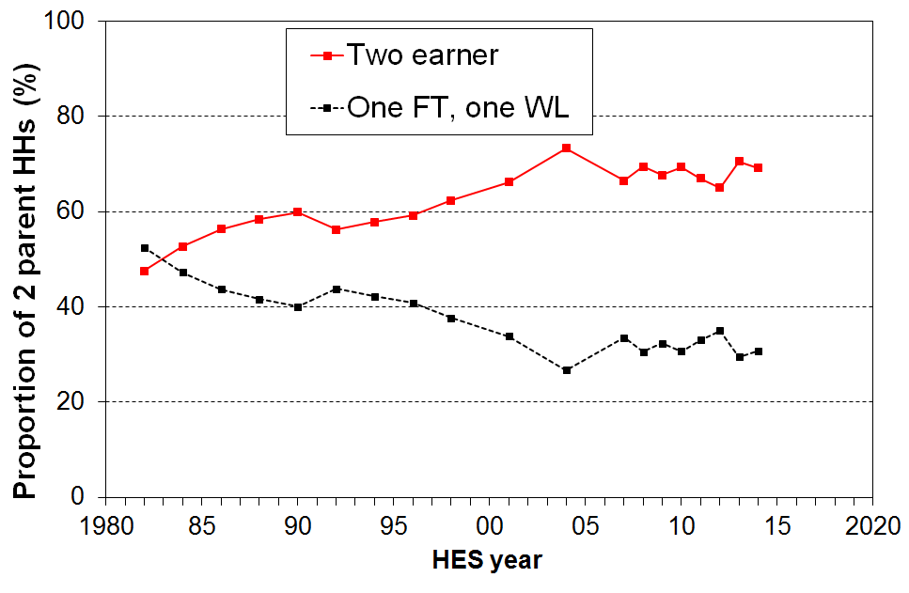

Table H.7A
Proportion of 2P HHs where there is at least one FT adult worker
 | 1982 | 1984 | 1986 | 1988 | 1990 | 1992 | 1994 | 1996 | 1998 | 2001 | 2004 | 2007 | 2009 | 2010 | 2011 | 2012 | 2013 | 2014
One FT, one WL | 52 | 47 | 44 | 42 | 40 | 44 | 42 | 41 | 38 | 34 | 27 | 34 | 32 | 31 | 33 | 35 | 30 | 31
One FT, one PT | 28 | 30 | 30 | 31 | 30 | 29 | 26 | 27 | 27 | 29 | 30 | 30 | 23 | 26 | 26 | 26 | 27 | 27
Both FT | 20 | 23 | 26 | 28 | 30 | 27 | 32 | 32 | 35 | 38 | 43 | 37 | 44 | 43 | 41 | 40 | 43 | 42

Table H.7B
Proportion of children in 2P HHs where there is at least one FT adult worker
 | 1982 | 1984 | 1986 | 1988 | 1990 | 1992 | 1994 | 1996 | 1998 | 2001 | 2004 | 2007 | 2009 | 2010 | 2011 | 2012 | 2013 | 2014
One FT, one WL | 54 | 47 | 46 | 43 | 42 | 46 | 46 | 42 | 41 | 36 | 30 | 36 | 36 | 34 | 36 | 39 | 32 | 36
One FT, one PT | 28 | 30 | 30 | 30 | 32 | 29 | 26 | 27 | 29 | 31 | 33 | 30 | 24 | 27 | 26 | 28 | 30 | 28
Both FT | 19 | 23 | 25 | 27 | 26 | 25 | 29 | 30 | 30 | 33 | 38 | 34 | 39 | 39 | 38 | 34 | 38 | 36

Poverty rates and composition for children in working and workless households

Three factors impact on child poverty rates and on the proportion of poor children who come from various subgroups (that is, on the composition of the poor):
- the economy and the labour market (impacting on employment and unemployment rates, wage rates and on benefit numbers (including numbers of sole-parent families))
- demographic shifts and changing cultural norms (eg the number of sole-parent families, whether sole-parent families live in households on their own or with other adults, the proportion of dual-earner two-parent households)
- policy changes (eg policy changes around benefit rates, income-related rents, the AS and WFF all had clear impacts on the child poverty rates for children from working and workless households, and on the relativities between the two groups).

The information in Figures H.4, H.5 and H.6 below illustrate these factors at work and support the following findings:
- child poverty rates in workless households are consistently several times higher than those for children in working households (three to four times higher in 1992 to 2004, six to seven times higher from 2007 to 2013 after WFF)
- child poverty rates in workless households were very high from 1992 to 2001 (after the benefit cuts), typically just under 80% using the AHC 60% fixed line measure (CV-98)
- the introduction of income-related rents contributed to the reduction in the child poverty rate from 2001 (78%) to 2004 (60%) for children in workless households
- the WFF package had little impact on the poverty rates for children in workless households
- for children in ‘working’ households (self-employed or at least one FT worker) the child poverty rate from 1992 to 2004 was reasonably steady at around 18-20%
- the WFF impact was significant for this group, with the rate in 2007 (11%) half what it was in 2004 (22%)
- nevertheless, on average from 2007 to 2013, around two in five (40%) poor children still came from working families – down from just over one in two (52%) in 2004 before WFF.

Figure H.4 shows the poverty rates for children in workless and working households. A working household is one where at least one adult is in FT employment, or where the main source of income for the previous 12 months is from self-employment (cf Table H.3 above).

Figure H.4
Poverty rates for children in ‘workless’ and ‘working’ households (AHC 60%, fixed line)
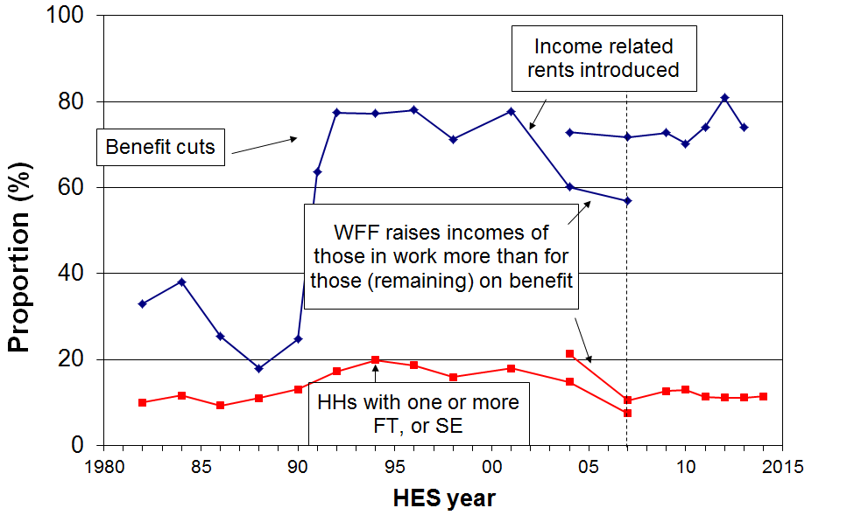
Note: The discontinuity at 2007 arises because of the change of reference year from 1998 to 2007. The 2004 to 2007 changes are shown using both reference years.
Figure H.5 shows the proportion of poor children who live in workless households. As there are fewer children in workless households than in working households the proportion of all poor children who come from workless households is much lower than their poverty rate in any given year. In addition, this proportion is also affected by policy changes and changes in the economy and labour market, as indicated in the text boxes in Figure H.5.

In 1992, after the benefit cuts in 1991 and with unemployment high, the proportion of poor children who came from workless households peaked at 56%. The improving labour market and growing economy then helped to reduce that proportion to 37% by 2004. The WFF package gave greater financial assistance to working families than to (those who remained as) beneficiary families. This was reflected in the decrease in child poverty rates for those in working families. The consequence was a rise to 52% in 2007 in the proportion of poor children who come from workless families. Using the updated reference year (2007), that proportion was 49% in 2013.

Figure H.5
Proportion of poor children who live in ‘workless’ households (AHC 60%, fixed line)
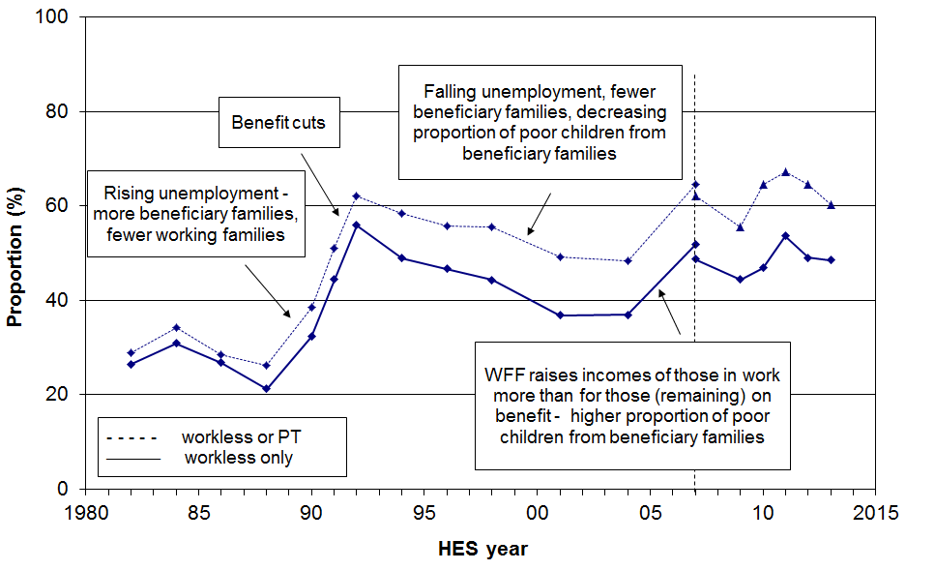

Figure H.6 looks at the composition of children identified as poor from the other perspective – what proportion of poor children come from working households? The trend is overall a mirror image of the one on Figure H.5. The secondary (broken) line omits self-employed households.

The WFF package reduced the proportion of poor children coming from working families from just over one in two (52%) in 2004 to around two in five (40%) on average from 2007 to 2012.

Figure H.6
Proportion of poor children who live in ‘working’ households (AHC 60%, fixed line)
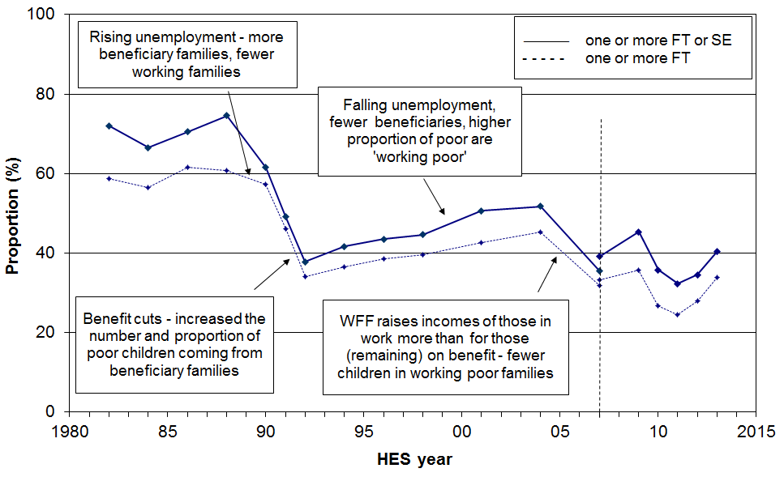

Annex to Section H

Summary of low income (poverty) and material hardship findings for children,
drawing on both the Incomes Report and the companion report using non-income measures (NIMs)

This Annex brings together in one place all the key material on child poverty and material hardship from the Incomes Report and the companion report using non-incomes measures (the NIMs Report).

Using and interpreting the figures in the reports

As well as providing the figures themselves, the reports provide guidelines for the use and interpretation of the reported figures. These are summarised and elaborated in the Guidelines document on the website. The main points are that:
- Poverty and hardship are multi-dimensional and levels and trends cannot be captured in a single measure: the reports use a multi-measure approach.
- Poverty and hardship exist on a spectrum from less to more severe. There is legitimate debate about where the ‘less severe’ level starts. The reports use a multi-level approach.
- For reporting trends, the reports use a hierarchical approach, taking the material hardship and anchored line income measures as primary in the short to medium term. The reports encourage users to look at movement over several years rather than making too much of year-on-year changes.
- Information on the composition of the poor and of those in hardship is an important aspect of monitoring child poverty and hardship.

The most challenging aspect is reporting on current levels of poverty and hardship as the resulting figures depend a great deal on the threshold used. The multi-level approach used in the reports helps to some degree on this, but a decision is still required on a plausible range of thresholds. The reports are clear on this range for material hardship measures, but do not have the same clarity for income measures. While for BHC measures there are international standards in common use, there is limited use of AHC measures and international standards are not as well developed.

There is an understandable desire to be able to say that “there are X thousand older New Zealanders in poverty”, and so on. To give some meaning to statements like that requires some reference point that the reader can readily understand. To have them widely accepted requires a standard or measure which is at least plausible, and hopefully even better than that.

In practice there are three main options available for defining usable reference points:
- comparisons with the population rate and rates for other age groups on the same measure (and the use of risk ratios)
- comparisons with historical trends on the same measure
- international comparisons giving relativities with other countries using the same measure.

There are two main ways of establishing a standard or standards:
- use international standard measures
- develop local standards which are constructed based on evidence and on argument with the assumptions and judgements declared for others to consider and critique:
  - the NIMs report constructs such a standard when it puts the case for the upper limit of its plausible range of thresholds for monitoring material hardship
  - for low incomes and income poverty (AHC), the same carefully argued case is not yet made in the reports – there is a place for the use of scenario budgets, for example, in assisting with this task, and further work on this is planned.

What the reports do not say

Before coming to a summary of what the reports say about the numbers, there are two matters which are sometimes directly and sometimes indirectly attributed to the reports or to MSD, when in fact the reports do not make the claims being asserted.

First, it is often said that “There are 270,000 (300,000) children in poverty in New Zealand”, or similar. This claim is often attributed implicitly or explicitly to the Incomes Report as if that is the report’s definitive view. That is not correct. While it is true that that is one figure given in the range of income poverty figures reported, the Incomes Report does not support such a bald definitive claim that is misleadingly matter-of-fact. Among other things, it breaches the reports’ multi-level approach to monitoring. If users wish to use that or other figures definitively, it needs to be made clear that that is the user’s call rather than it being (implicitly) attributed to MSD’s reports as if it is their definitive view. It is not.

Sometimes, users go even further and implicitly or explicitly attribute various child-specific lacks (eg raincoats, birthday parties, school trips) and household deprivations (eg lack of good heating and meals) to all those under a chosen income poverty line. The reports do not make that claim. In fact the evidence in the reports contradicts the claim: the NIMs report shows that most children in households with incomes under a 60% of median AHC line actually have all or almost all the listed items. Less than half of the children under AHC 60% and 50% low income lines are in families identified as in hardship, using the “standard” EU deprivation measure.

Readers are also referred to the myths and misunderstandings section on pp 82-83.

What the reports do say

The graphs and tables that follow give the key trends, composition and current levels information on child poverty and material hardship.

International comparisons

Type of measure | Threshold |  | NZ (%) | EU or OECD median (%) | Comment
Material hardship EU-13 | ‘standard’ | 0-17 | 18 | 16 | International comparisons using material hardship indices are more robust than income-based comparisons such as the BHC % of median measures noted below. They compare real-life circumstances of access to the basics using the same standard for each country
Material hardship EU-13 | ‘standard’ | Popln | 11 | 11
Material hardship EU-13 | ‘severe’ | 0-17 | 8 | 7
Material hardship EU-13 | ‘severe’ | Popln | 4 | 5
BHC income | 50% of median (OECD) | 0-17 | 13 | 11 | International comparisons using income measures compare how citizens are faring relative to national standards, not a common international standard as the hardship measures do. They are essentially about the different levels of inequality in the lower half of the income distributions – these are important statistics but they do not tell us how people are actually faring on the ground.
BHC income | 50% of median (OECD) | Popln | 10 | 10
BHC income | 60% of median (EU) | 0-17 | 20 | 20
BHC income | 60% of median (EU) | Popln | 18 | 17

UK comparisons for low AHC incomes
(avg of 2012-13 and 2013-14 survey years, except for the 40% rows which are for 2012-13)
Type of measure | Threshold |  | NZ | UK | Comment
AHC income | 40% of median | 0-17 | 13 | - | There are very few countries that publish AHC trends. The UK is one that does. The UK AHC figures for the 50% and 60% lines are very similar to those in New Zealand. As for New Zealand, there has not been much change in AHC relative rates in the last decade.
AHC income | 40% of median | Popln | 10 | -
AHC income | 50% of median | 0-17 | 20 | 18
AHC income | 50% of median | Popln | 14 | 14
AHC income | 60% of median | 0-17 | 27 | 27
AHC income | 60% of median | Popln | 19 | 21

Trends in AHC low income (poverty) rates, material hardship rates and rates for those in low income and experiencing material hardship

Figure F.4
Proportion of children below selected thresholds (AHC):
fixed line (CV) and moving line (REL) approaches compared
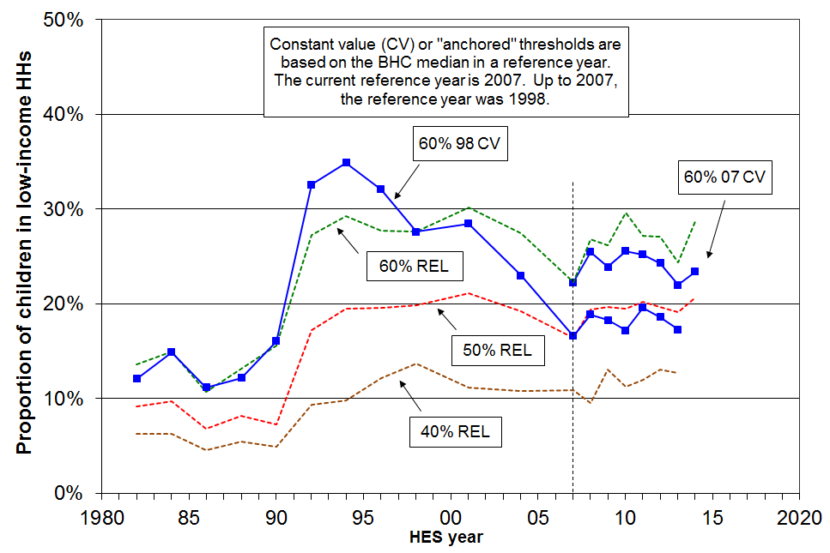

Figure G.3 (from companion NIMs report)
Material hardship trends for different thresholds (0-17yrs)
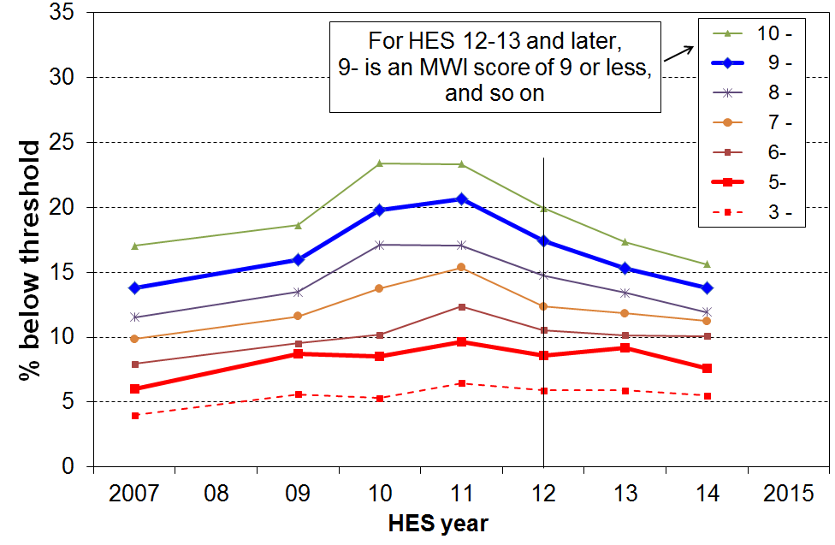

Figure G.6 (from companion NIMs report)
Trends in the proportion of those who are both income poor and materially deprived, 2007 to 2014
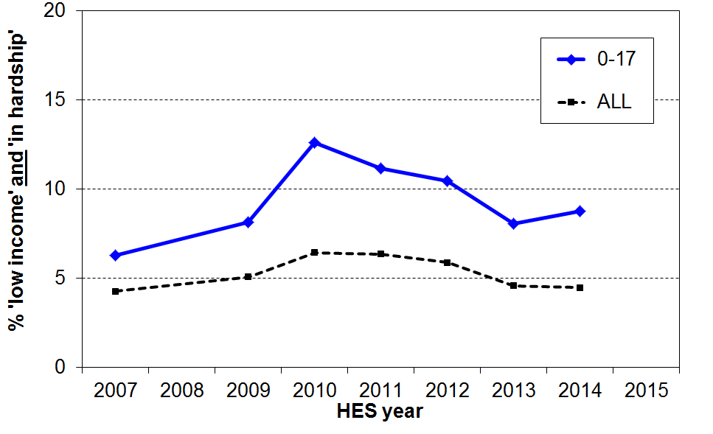

The tables below are from Section F in the Incomes Report and Section G in the Non-Incomes Report.

How many poor children are there in New Zealand?
(ie How many children live in households with incomes below selected thresholds?)

Table F.5
Numbers of poor children in New Zealand
(ie the number of children in households with incomes below the selected thresholds)
 | BHC |  | AHC
 | BHC ‘moving line’ |  | AHC ‘moving line’ |  |  | AHC ‘anchored line (2007)’
HES year | 50% | 60% | 40% | 50% | 60% | 60% (07 ref)
2001 | 120,000 | 250,000 | 115,000 | 215,000 | 310,000 | 380,000
2004 | 150,000 | 265,000 | 115,000 | 200,000 | 285,000 | 320,000
2007 | 135,000 | 210,000 | 115,000 | 175,000 | 240,000 | 240,000
2009 | 125,000 | 230,000 | 140,000 | 210,000 | 280,000 | 255,000
2010 | 150,000 | 250,000 | 120,000 | 210,000 | 315,000 | 275,000
2011 | 145,000 | 235,000 | 130,000 | 210,000 | 290,000 | 270,000
2012 | 130,000 | 225,000 | 135,000 | 215,000 | 285,000 | 255,000
2013 | 120,000 | 215,000 | 135,000 | 205,000 | 260,000 | 235,000
2014 | - | 250,000 | - | 220,000 | 305,000 | 245,000
* 40% of median AHC income poverty figures and 50% of median BHC figures are not reported for HES 2014 because of data issues for some beneficiary incomes – see main report.

AHC = after deducting housing costs
BHC = before deducting housing costs

‘anchored line’:
- this is the line set at a chosen level in a reference year (now 2007), and held fixed in real terms (CPI adjusted)
- the concept of ‘poverty’ here is – have the incomes of low-income households gone up or down in real terms compared with what they were previously?

‘moving line’:
- this is the fully relative line that moves when the median moves (eg if median rises, the poverty line rises and reported poverty rates increase even if low incomes stay the same)
- the concept of ‘poverty’ here is – have the incomes of low-income households moved closer or further away from the median?

How many children are there in households experiencing material hardship?
(ie How many children live in households with deprivation scores below selected thresholds?)

Material hardship rates (%) and numbers for children
HES year | EU ‘standard’ threshold |  | EU ‘severe’ threshold
 | rate (%) | numbers | rate (%) | numbers
2007 | 14 | 145,000 | 6 | 65,000
2009 | 16 | 170,000 | 9 | 95,000
2010 | 20 | 210,000 | 9 | 90,000
2011 | 21 | 220,000 | 10 | 105,000
2012 | 17 | 180,000 | 9 | 90,000
2013 | 15 | 165,000 | 9 | 100,000
2014 | 14 | 145,000 | 8 | 80,000

Children from income-poor households: composition by their ethnicity and by selected household characteristics

Table H.8 brings together in one place the poverty rate and composition information from earlier pages in Section H. The shaded column shows the proportion of poor children in the various sub-groups. Some sub-groups have high poverty rates but if there is a relatively small proportion of children in that sub-group overall, then the proportion of poor children coming from that sub-group is much lower than their poverty rate would suggest (and vice versa). For example:
- the poverty rate for children in sole-parent families living on their own is high at 69%, but only 45% of all poor children come from such families
- on the other hand, the poverty rate for children in two-parent families is much lower at 15%, yet 47% of poor children come from these families
- this difference arises from the fact that there are many more children in two-parent families than in sole-parent families living on their own (76% and 16% respectively).

Table H.8
Poverty rates and composition for children by their ethnicity and by characteristics of their households, based on the 60% of median CV (fixed line) AHC measure:
average over last three surveys, HES 2011 to HES 2013
Dependent children (0-17 yrs):  1,060,000 | Children in income-poor households |  | All children
Dependent children (0-17 yrs):  1,060,000 | What % of this category are poor? | What % of poor children are in this category? | What % of all children are in this category?
 | Poverty rate (%) | Composition of the poor (%) | Approximate composition for all children (%)
Household type
Sole parent HH | 64 | 47 | 18
Two parent HH | 15 | 44 | 69
Multi-adult family HH | 16 | 8 | 12
Family type
Sole parent families | 53 | 53 | 24
- in SP family on own | 69 | 45 | 16
- within a wider HH | 23 | 8 | 8
Two parent families | 15 | 47 | 76
# of children in the household
1 or 2 | 21 | 55 | 63
3+ | 29 | 45 | 37
Ethnicity
Maori | 34 | 34 | 24
Pacific | 34 | 13 | 10
Other | 27 | 14 | 12
Euro/Pakeha | 17 | 38 | 54
Highest household educational qualification
No formal qualification | 55 | 15 | 7
School qualification only | 35 | 38 | 25
Post-school non-degree | 21 | 33 | 38
Degree or post-graduate | 12 | 14 | 30
Main source of income for HH
Benefit | 75 | 63 | 22
Market | 12 | 37 | 78
Tenure
HNZC | 54 | 19 | 9
Private rental | 38 | 53 | 33
Own home | 12 | 28 | 59
Children overall | 23 | 100 | 100
Table D.9 (from companion NIMs report)
Hardship rates and composition for different family and personal characteristics,
by different levels of hardship (using DEP-17): children (0-17yrs)
LSS 2008 | Hardship rates |  |  |  |  | Composition
 | what % of this group of children are in hardship, using the different thresholds? |  |  |  |  | what % of all children in hardship (using a given threshold) are in this group / cell? |  |  |  |  | Over-all
 | 6+ | 7+ | 8+ | 9+ | 11+ | 6+ | 7+ | 8+ | 9+ | 11+
All children (0-17 yrs)
Hardship rates for children | 21 | 17 | 13 | 10 | 6 | - | - | - | - | -
Children as % of all people in hardship | - | - | - | - | - | 39 | 41 | 42 | 47 | 48 | 26
Family type
Sole parent | 46 | 40 | 32 | 27 | 16 | 48 | 53 | 58 | 65 | 70 | 25
Two parent | 17 | 12 | 8 | 5 | 2 | 52 | 47 | 42 | 35 | 30 | 75
Main income source for parent(s)
Benefit (no movement off or onto benefit) | 61 | 52 | 43 | 35 | 20 | 40 | 44 | 48 | 54 | 55 | 16
Some movement | 42 | 35 | 29 | 23 | 13 | 10 | 10 | 11 | 12 | 12 | 5
Paid work (no main benefit income) | 15 | 11 | 7 | 5 | 2 | 50 | 46 | 41 | 35 | 33 | 79
Number of children in household
1 | 22 | 17 | 13 | 9 | 4 | 22 | 21 | 21 | 21 | 16 | 23
2 | 20 | 15 | 12 | 8 | 4 | 34 | 34 | 32 | 32 | 31 | 40
3 | 25 | 20 | 16 | 11 | 7 | 23 | 24 | 25 | 24 | 28 | 22
4+ | 35 | 28 | 21 | 16 | 10 | 22 | 22 | 22 | 23 | 25 | 15
Ethnicity (total)
European | 18 | 14 | 10 | 8 | 3 | 42 | 41 | 37 | 35 | 33 | 59
Maori | 39 | 33 | 27 | 19 | 11 | 29 | 31 | 33 | 33 | 33 | 19
Pacific | 51 | 43 | 36 | 30 | 19 | 20 | 22 | 24 | 28 | 31 | 10
Other | 19 | 12 | 8 | 4 | 3 | 9 | 7 | 7 | 6 | 5 | 12
Tenure of the household
Owned, FT, or Other - with payments | 15 | 10 | 8 | 5 | 3 | 33 | 28 | 27 | 25 | 24 | 51
Owned, FT, or Other - no payments | 4 | 4 | 3 | 1 | 1 | 2 | 3 | 3 | 1 | 1 | 13
Private landlord | 36 | 29 | 23 | 17 | 8 | 42 | 45 | 46 | 47 | 39 | 28
Housing New Zealand | 70 | 61 | 46 | 36 | 26 | 22 | 25 | 24 | 26 | 37 | 8
FT = Family Trust

Section I
Income trends for older New Zealanders

This section:
- describes the distribution of incomes for older New Zealanders relative to the rest of the population, noting the ‘pensioner spike’ in the BHC income distribution
- notes the significant sensitivity of reported poverty rates to the choice of BHC poverty line for older New Zealanders (because of the ‘pensioner spike’), and outlines what can be done about this to ensure that trends in reported poverty rates more realistically reflect changes in the relative material wellbeing of older New Zealanders
- compares the value of NZS to average wages and median household incomes
- reports on trends in the relative contributions of state income support (government transfers), employment income, and other private income to the incomes of older New Zealanders.

The BHC incomes of older New Zealanders

Figure I.1 shows the distribution of equivalised household disposable income for individuals. Individuals are grouped by their household incomes in multiples of $1500 pa ($30 pw). The graph clearly shows the ‘pensioner spike’ at close to the 50% of median poverty line, and also the high proportion with incomes between 50% and 60% of the median.

The spike is a direct consequence of (a) New Zealand having a universal New Zealand Superannuation (NZS) that is neither income nor asset tested, and (b) there being a large proportion of older New Zealanders with very little other income over and above NZS.

Figure I.1
BHC household income distribution for older New Zealanders relative the rest of population,
HES 2013
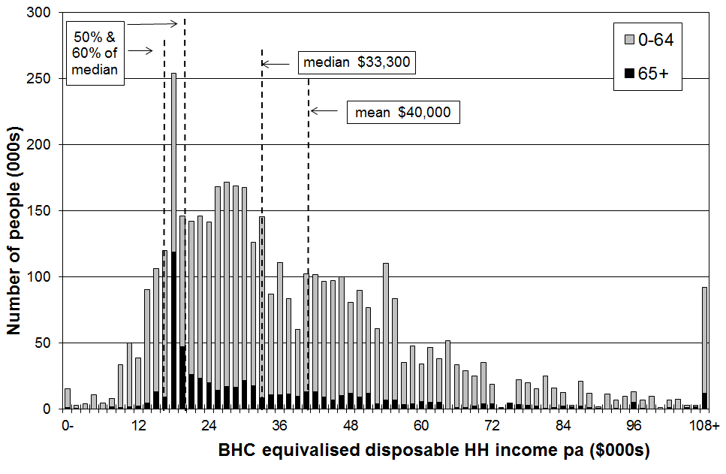
NZS relative to average earnings and median household income

For a very large proportion of older New Zealanders (aged 65+), NZS provides the bulk of their income. In assessing the relative material wellbeing of older New Zealanders it is therefore useful to know how NZS tracks:

in real terms

relative to average wages

relative to median household incomes.

In these comparisons, NZS is the equivalised NZS which puts couple and single living alone rates at the same equivalised dollar value. Average earnings are net average ordinary time weekly earnings (NAOTWE), and median incomes are median equivalised household disposable incomes. Average earnings are just one factor impacting on household incomes. Another major factor is the total number of hours of paid employment being worked by households. These hours have been increasing, so household incomes have risen more rapidly than average wages (since c1994). The October 2008 and 2010 tax cuts also increased net average wages and after-tax household incomes.

Figure I.2 shows that the value of NZS (and its predecessors) has remained reasonably steady in real terms from the mid 1980s through to 2014, whereas there have been considerable movements in average earnings and median household incomes in the period. The NZS nevertheless rose by 14% in real terms from 2007 to 2014, as a result of the rising NAOTWE.

Figure I.2
Trends in average earnings, median household incomes and NZS (in $2014)
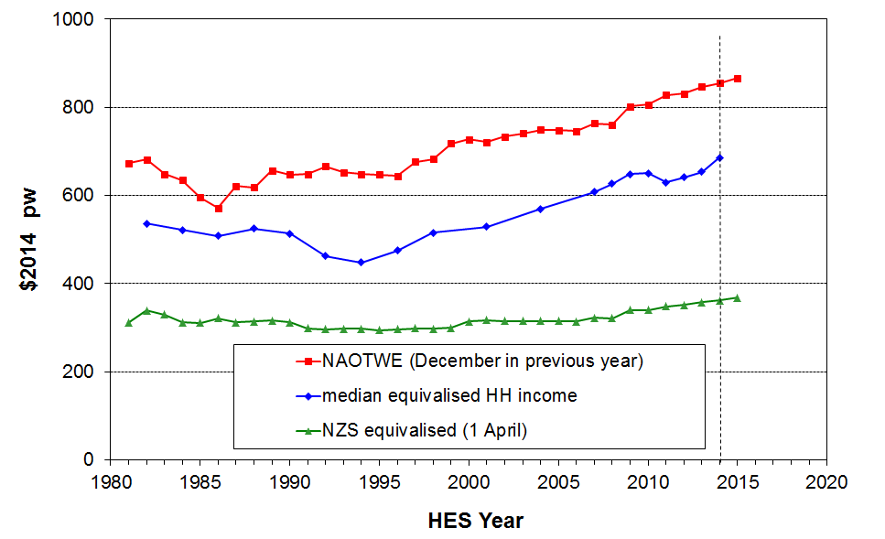
Figure I.3 reformats the information in Figure I.2 to show the trends in NZS relative to average earnings and median household income.

In 2014, the NZS married couple rate was close to the 66% floor relative to average earnings, as shown in the upper trend line in Figure I.3.

NZS has declined in value relative to median household incomes since the mid 1990s. This is because median household income has risen steadily in real terms, while the real value of NZS did not change greatly in real terms from the mid 1980s through to 2007. Table I.1 gives the figures behind the lower trend line in Figure I.3.

Figure I.3
NZS relative to average earnings and median household incomes

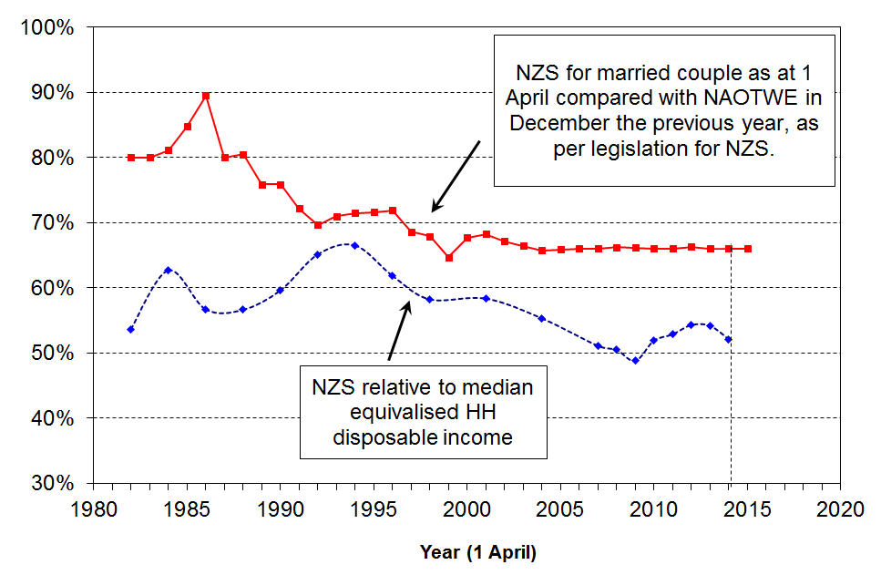

Table I.1
NZS relative to the median equivalised BHC household income median (%),
using both the 1988 Jensen equivalence scale (RJS) and the square root scale as used by the OECD
 | 84 | 86 | 88 | 90 | 92 | 94 | 96 | 98 | 01 | 04 | 07 | 08 | 09 | 10 | 11 | 12 | 13 | 14
RJS | 63 | 57 | 57 | 60 | 65 | 67 | 62 | 58 | 58 | 56 | 52 | 51 | 49 | 52 | 53 | 54 | 54 | 52
OECD |  |  | 56 | 60 | 65 | 66 | 62 | 59 | 57 | 55 | 50 | 50 | 49 | 51 | 52 | 53 | 54 | 52
Note: NZS is updated on 1 April each year, and sometimes on 1 October also if there have been tax changes. The HES interviews are carried out from 1 July to 30 June. For Figure I.3 and Table I.1, the NZS in year ‘n’ is compared with the HES median for year ‘n to n+1’. For example, the 1 April 2009 NZS is compared with the median for the 2009-10 HES. This is a reasonable approximation, but note that the actual NZS amount received over the 12 months prior to interview depends on the actual interview date for each household. The trend of NZS relative to the household median income in Figure I.3 and Table I.1 is robust for a ‘stylised fact’, but not for the precise micro detail for all older households.

Sensitivity of reported BHC poverty rates to the choice of poverty line

Table I.2 shows the proportion of older New Zealanders (65+) in households with incomes under two commonly used “poverty lines”. The top line uses the “square root” equivalence scale and a 50% of median threshold to ensure consistency with OECD publications. The second line also uses a 50% of median threshold but adjusts household incomes with the Revised Jensen scale as in the rest of the report.

Using the 50% of median measure (OECD), the poverty rate was close to zero for the whole period 1984 to 2001. This was because the value of NZS was (well) above 50% of the median. By 2009, with the value of NZS just below the 50% of median, the reported “poverty rate” had risen to 19%. From the 2009 HES to the 2010 HES, NZS rose more rapidly than the median which brought the reported poverty rate down to 13%. For 2010 to 2013 the rate was steady at around 10%, but rose again to 15% in 2014, as the rise in the median was greater than the rise in the NZS rate. (Using a 48% of median threshold, the 2014 rate is close to zero (2%).)

Using a 60% threshold the poverty rates fell from 25% in 1988 to close to zero in the mid 1990s when the median fell in real terms and NZS was above the 60% threshold. By 2004, the rising median had led to 37% of older New Zealanders being classed as ‘in poverty’ on this measure. This fell to 30% on average in 2012 and 2013, but rose again in 2014 to 37%.

Table I.2
Proportion of older New Zealanders (65+) in households with BHC incomes below low-income thresholds (‘poverty lines’), set at 50% and 60% of the median in the survey year (%)
 | 84 | 86 | 88 | 90 | 92 | 94 | 96 | 98 | 01 | 04 | 07 | 08 | 09 | 10 | 11 | 12 | 13 | 14
50% OECD equiv | 2 | 2 | 8 | 2 | 1 | 1 | 1 | 3 | 2 | 9 | 18 | 14 | 19 | 13 | 10 | 9 | 10 | 15
50% NZ equiv | 1 | 1 | 1 | 1 | 1 | 1 | 1 | 2 | 2 | 3 | 8 | 4 | 9 | 5 | 3 | 2 | 4 | 3
60% NZ equiv | 14 | 17 | 25 | 20 | 3 | 1 | 3 | 25 | 20 | 37 | 38 | 38 | 35 | 34 | 30 | 31 | 29 | 37

The large variations in reported poverty rates for the 65+ group (using BHC incomes) can leave the misleading impression that there are significant changes in material wellbeing occurring for this group, when in fact there is very little change occurring.

The pensioner spike in the income distribution noted in Figure I.1 and elsewhere has implications for reporting on income poverty for the 65+ and for comparisons of subgroups within the population as a whole. Figure I.4 illustrates the issue using HES 2012 data, showing the sudden rise in reported poverty rates for the 65+ just above 50% of the median which is the level of NZS for the survey period. Poverty rates for the 65+ are close to zero when a 50% threshold is used, but 31% using a 60% threshold (using the Revised Jensen equivalence scale). Other age groups have a much steadier increase in reported poverty rates as the threshold rises.

Figure I.4
Sensitivity of income poverty rates for the 65+ to the threshold used:
BHC incomes, 2012
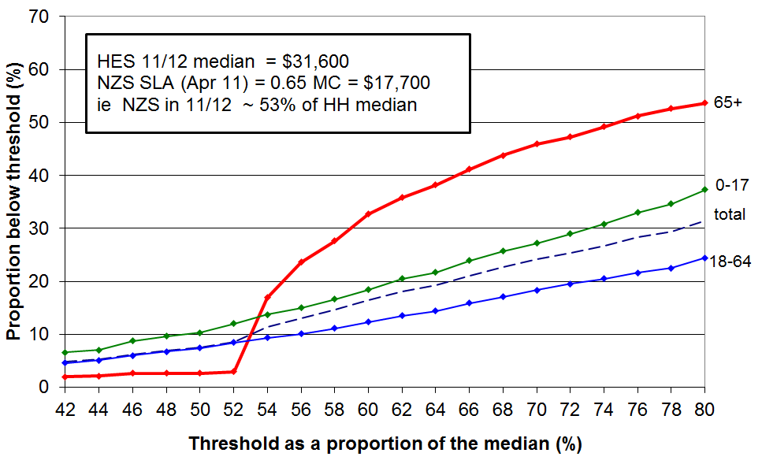
Using incomes after deducting housing costs (AHC incomes) to give more stable and reliable results

There are good grounds for using AHC incomes to compare subgroups, irrespective of the pensioner spike. These are discussed in Appendix 5 and in the Introduction. The pensioner spike for BHC incomes provides another rationale.

The AHC distribution still has some strong bunching but the pensioner spike is not as sharp. Furthermore, what remains of the spike is mainly above the 60% of median threshold for AHC incomes. Small shifts in the median or the threshold do not therefore have the same disproportionate and misleading effects on (trends in) poverty rates for the 65+ as they do when using BHC incomes. This is shown for 2012 in Figure I.5 below.

Figure I.5
Sensitivity of income poverty rates for the 65+ to the threshold used:
AHC incomes, 2012
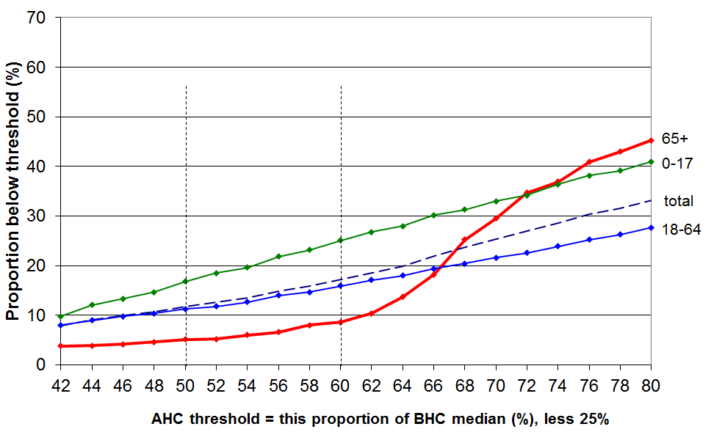

Table I.3 shows that the proportion of older New Zealanders below the 60% fixed line AHC threshold has remained consistently lower than the population as a whole and reasonably low in its own right from 1982 to 2014. Those living on their own generally have higher proportions below the threshold than do those in couple households, and since 2004 have had poverty rates similar to that of the population as a whole. There is very little difference in poverty rates for females and males.

Table I.3
Proportions of older New Zealanders (aged 65+) in low-income households, by HH type:
AHC CV 98 and 07 60% measure
 | reference year = 1998 |  |  |  |  |  |  |  |  |  |  |  | reference year = 2007
 | 82 | 84 | 86 | 88 | 90 | 92 | 94 | 96 | 98 | 01 | 04 | 07 | 07 | 09 | 10 | 11 | 12 | 13 | 14
All 65+ | 3 | 2 | 4 | 5 | 6 | 6 | 8 | 8 | 9 | 7 | 7 | 8 | 14 | 9 | 10 | 9 | 10 | 8 | 9
Single 65+ | 5 | 3 | 9 | 12 | 13 | 10 | 13 | 11 | 14 | 9 | 14 | 12 | 23 | 16 | 23 | 14 | 13 | 12 | 14
Couple 65+ | 1 | 1 | 2 | 2 | 3 | 4 | 5 | 6 | 5 | 8 | 3 | 6 | 10 | 5 | 5 | 7 | 9 | 7 | 6
Total popln | 8 | 9 | 8 | 9 | 11 | 21 | 23 | 21 | 18 | 19 | 17 | 13 | 18 | 17 | 18 | 19 | 17 | 16 | 17

See also Tables G.3 and G.6B for further information on income poverty trends for older new Zealanders using other AHC measures.

Sources of income for older New Zealanders

This section reports on the sources of income for older New Zealanders using a three-way division:

government transfers - New Zealand Superannuation (NZS), Veterans Pension (VP) and other state support such as the Disability Allowance (DA) and the Accommodation Supplement (AS)
- income from employment and self-employment
- other private income from private superannuation and other investments.

NZS and VP make up around 98% of government transfers for older New Zealanders (66+) as a group. Around 3-4% receive the AS, and 23% the DA (maximum of $57 pw in 2010).

For this subsection, older New Zealanders are taken to be those in the survey aged 66 and over. Those aged 65 are not considered as almost all of them will have received NZS for only a part of the 12 months prior to interview.

All the surveyed 66+ can be classed as belonging to one of two economic family unit (EFU) types: couple EFU with at least one partner aged 66 or more, or one person EFU with the person aged 66 or more. The analysis is at times kept separate for couple and one person EFUs as there are quite significant differences between the two groups regarding the amounts they receive from non-government sources.

In looking at the sources of income for older New Zealanders, the 66+ EFUs are ranked on their equivalised gross income and put into deciles for comparison. Note that these are not deciles based on a ranking of the whole population. Older New Zealanders are clustered in the lower four deciles of the population income distribution (40% were in the lower two deciles in 2012).

There are usually around 700 66+ EFUs in the sample. As the findings focus on stable patterns and clear trends rather than on smaller year on year changes, a sample of this size is adequate.

Summary of findings regarding the sources of income for older New Zealanders

- The great majority of older New Zealanders (aged 66+) are very dependent on NZS and other government transfers for their income
- 40% have virtually no other income source
- the next 20% have on average around 80% of their income from NZS and other government transfers
- this degree of dependence has not changed greatly in the last two decades
- those in couple EFUs tend to have higher per capita non-government income than do those in single person EFUs.
- Around one in three older New Zealanders receive more than half their income from sources other than NZS or VP
- for this group, the proportion of income from other sources has grown a little over recent years, mainly due to increasing non-government income for those in ‘younger’ couple EFUs (aged 66-75)

Table I.4 provides more detail to support and enlarge on these summary findings. The right hand column gives the links to the relevant tables and charts that follow – these support and illustrate the summary above and the findings reported in the table. Around 98% of all government transfers to older New Zealanders come from NZS/VP. For some in lower income deciles, the extra state assistance (eg DA and AS) is significant and is more than the 2% average.

Table I.4
Summary of key findings about sources of income for older New Zealanders
2012 HES | Changes from 1989 to 2012 | Ref
For the great majority, there is very high dependence on NZS … |  | Fig I.6
- NZS provided virtually all the income (98%) for the lower 40% (Q1 and Q2) | - there has been very little change in these proportions since 1989 | Fig I.7
- NZS provided 80% of income for the next 20% (the middle quintile) | - there has been a small but definite decline in this proportion since 2004, from 90% to 80% | Fig I.8
- for the next 20% (Q4), NZS provided half the income | - this is down a little from the 65% to 70% that prevailed from 1989 to 2001 | Fig I.6
the lower 60% reported less than $200 pw (per capita) from sources other than government transfers | - there has been little change since 1989 (in real terms) | Derived from Fig I.11 and I.7
the lower 40% reported less than $20 pw (per capita) from sources other than government transfers | - there has been little change since 1989 (in real terms) | Derived from Fig I.11 and I.7
… and single person EFUs are more dependent on NZS than are couple EFUs
- 60% of all the income for single person EFUs came from government transfers, 45% for couples | - the proportion of all incomes coming from government transfers has declined since 1989, but the proportion for singles is always higher than for couples (eg 70% and 60% respectively in 1998) | Fig I.9
- of the 25% of older NZers reporting more than $400 pw (per capita) non-govt income, 3 in 4 were from couple EFUs and 1 in 4 from single-person EFUs |  | Derived from Fig I.11
For a smaller group (around 30%), income from other sources is significant and for this group the % of total household income coming from these other sources is increasing
- other income made up more than half of total income for 30% of all older NZers (15% of singles and 35% of couples) | - the size of this group has almost doubled since 1998 | Fig I.9
for deciles 8 and 9 together, 38% of their income was from NZS | - this is down from 56% in 1998 and 55% in 1989 | Fig I.6
for ‘younger’ couples (aged 66-75) in deciles 5-6 of this group’s income distribution, 50% of their income came from non-government sources | - this is up from 20% in 1998 and earlier, and is driven by both increasing employment and private income for this group | Fig I.10
for those in the top decile (mainly couples) only 17% of their income was from NZS | - this is down from 29% in 1989 and 23% in 1998 | Fig I.6
Overall …
govt transfers made up around half the reported income (51%) for older NZers as a group, but as the above findings indicate, this aggregate figure masks large differences across the deciles and between single person and couple EFUs | - this (48%) is down from 67% in 1989 and 64% in 1998 | Fig I.6

Figure I.6
Proportion of gross income of older New Zealanders (66+)
coming from government transfers (almost entirely NZS and VP)
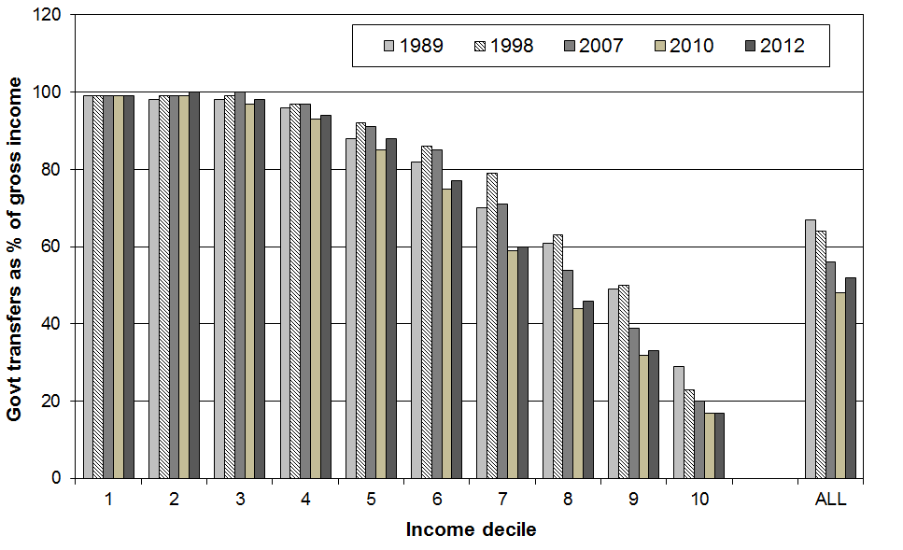

Figure I.7
Income sources for deciles 1-4, all 66+ EFUs
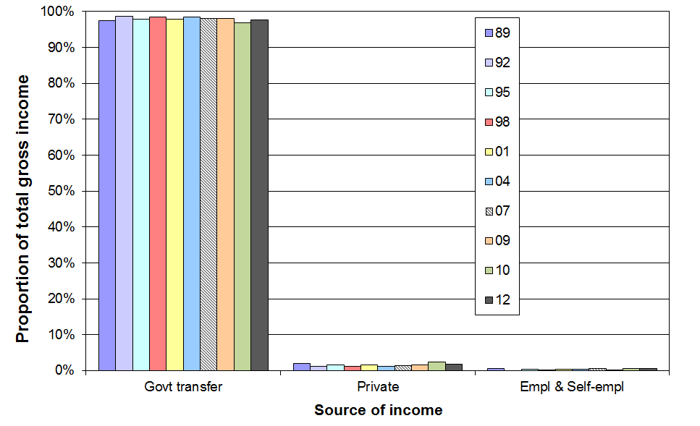

Figure I.8
Income sources for deciles 5-6, all 66+ EFUs
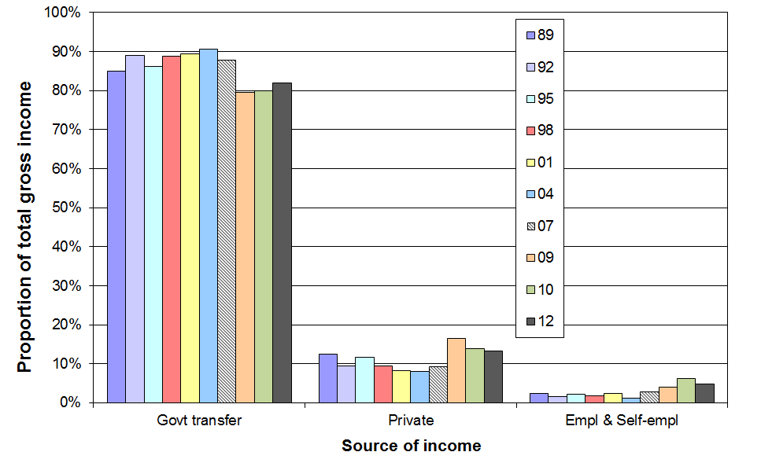
Figure I.9
Proportion of gross income coming from government transfers (almost entirely NZS and VP):
one person and couple EFUs compared, HES 2012
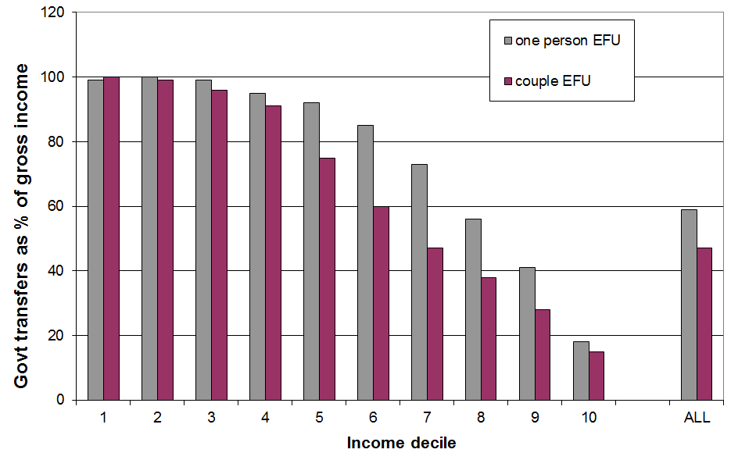

Figure I.10 shows that for a group of ‘younger’ couple EFUs (aged 66-75) there was a strong and sustained increase in income from non-government sources in the decade from 2001 to 2010. The proportion of their income which came from employment increased from 2009 to 2010, although the total dollar amount from employment remained much the same. The proportion and dollar amount coming from other private sources (investment returns) fell.

For these ‘younger’ couples in the middle quintile (deciles 5 and 6), there was a reduction in the proportion of their income coming from NZS (80% to 50% from 2001 to 2010), but for the lower two quintiles for this group dependence on NZS and other government transfers remains high (87%).

There have been no comparable changes for those in one-person EFUs.

Investment income fell a little more from 2010 to 2012 and income from employment remained the same in 2012 as in 2010.

Figure I.10
Changing proportions from three sources for couples (aged 66-75) in deciles 5-6 for couples
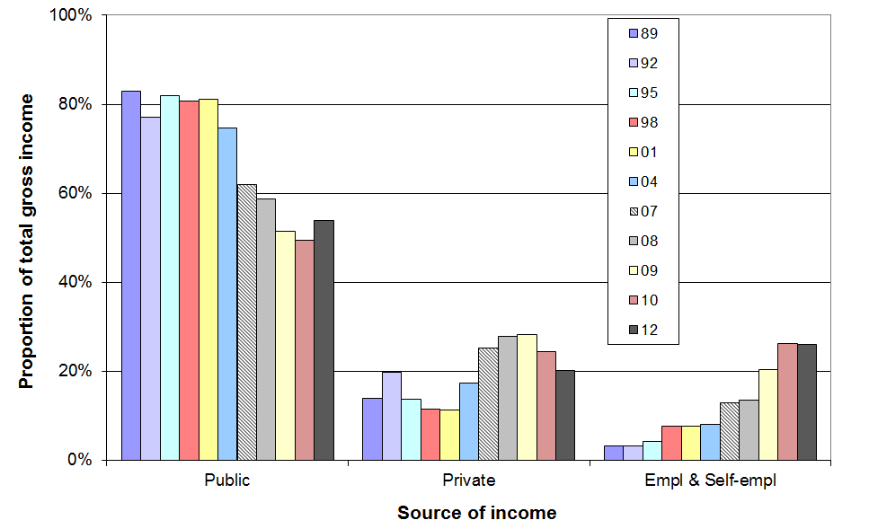

Table I.5 shows the amounts received by one person and couple EFUs (66+) from sources other than government transfers (ie from employment, self-employment, private superannuation and other investments). Each EFU type is ranked separately on their respective non-government incomes. Decile means and decile upper boundaries are given.

Table I.5
Amount received per week by 66+ EFUs from non-government sources by decile, HES 2012
(each EFU type is ranked separately on their respective non-government incomes)
 |  | 1 | 2 | 3 | 4 | 5 | 6 | 7 | 8 | 9 | 10 | TOT
one person EFUs | mean | 0 | 0 | 0 | 4 | 25 | 70 | 175 | 320 | 610 | 2000 | 325
one person EFUs | upper bndry | 0 | 0 | 0 | 10 | 40 | 115 | 255 | 420 | 770 | - | -
couple EFUs | mean | 0 | 0 | 15 | 65 | 190 | 380 | 650 | 955 | 1460 | 3150 | 695
couple EFUs | upper bndry | 0 | 0 | 30 | 100 | 250 | 530 | 765 | 1170 | 1910 | - | -

Note: When making estimates of the number or proportion of individuals (rather than EFUs) receiving less than or more than a given amount from non-government sources, note that there are around 50% more individuals in couple EFUs than in single EFUs (ie the relative weighting is around 3:2).

Figure I.11 plots the upper boundaries from Table I.5 for deciles 1-8 and interpolates to provide a simple means of estimating proportions of older New Zealanders with non-government incomes above or below selected amounts. For couple EFUs, the Table I.4 amounts are halved to convert them to per capita amounts. The top two deciles are omitted to enable a sensible vertical scale to be used.

Figure I.11
Income from non-government sources for one person and couple EFUs (66+):
weekly amounts per person, decile upper boundaries, deciles 1-8, HES 2012
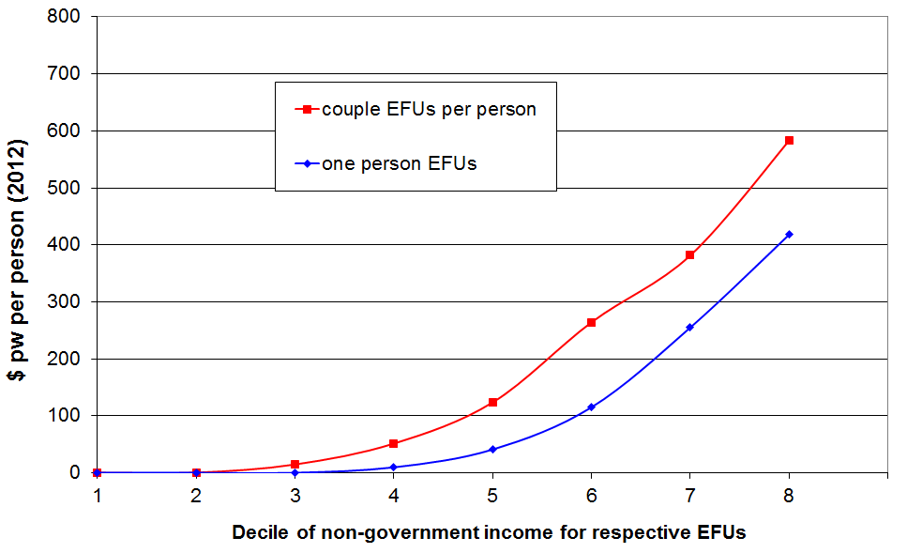

For example, for those in couple EFUs, 47% have less than $100 pw, and for one person EFUs, around 58% have less than $100 pw. There are around 50% more people in couple EFUs than in one person EFUs (3:2 ratio). The weighted average of 47% and 58% is 52%. So, in 2012, around half of older New Zealanders had income of less than $100 pw over and above government transfers, similar to 2010, but down from 56% in 2008 and 60% in 2007.

Section J

International comparisons

for income poverty, inequality and wealth

The information for the international comparisons of income poverty and inequality in this section comes from three sources.

The OECD income inequality and poverty comparisons using household incomes come from information sent to the OECD by national experts based on national survey data and using common assumptions and definitions. The OECD analysis for New Zealand mainly uses information supplied by Statistics New Zealand based on the 2012-13 HES, and some from earlier surveys. The latest comparisons across the OECD as a whole are available for most countries for calendar year 2012 (2012-13 surveys).

The most significant difference between the OECD assumptions and definitions and those used in the rest of this report for New Zealand BHC analysis is that the OECD work uses an equivalence scale that treats children as costing the same as adults (the “square root scale”). This difference generally has only a small to modest impact on the level of various indicators at a given time, and a quite limited impact on trend analysis over time. The use of different equivalence scales can produce different directions for changes from one survey to the next when the changes are small. Long-term trends are not affected.

The comparisons with the EU and other European countries draw mainly on survey-based information compiled by Eurostat for the EU and other European countries. The equivalence scale used in this source is almost identical to the Revised Jensen Scale used in this report for New Zealand analysis.

The information on very high incomes based on tax records rather than sample surveys comes from the World Top Incomes Database held by the Paris School of Economics.

The information for international comparisons of wealth inequality comes from the Luxembourg Wealth Study, the Credit Suisse Global Wealth Databook, and New Zealand Treasury analysis of the 2003-04 wave of the Statistics New Zealand’s Survey of Family Income and Employment (SoFIE) dataset.

International comparisons of income poverty

The OECD poverty indicator uses a moving line approach with a 50% of median BHC threshold. The EU poverty indicator uses a moving line 60% of median BHC threshold.

Comparing poverty rates across countries using the OECD or EU approaches is essentially a comparison of the proportion of people from households that have incomes more than a defined distance from middle incomes for each country. This is consistent with the relative disadvantage notion of poverty and can be useful when looking at trends and relativities within a country, subject to the limitations discussed in Section E. If understood properly, it can also be a useful way of comparing how dispersed or compressed the income distribution is below the median on a country by country basis.

A major difficulty arises, however, when international league tables of poverty rates are seen as ranking countries by their poverty rates understood in terms of the proportion of the population experiencing poor material living conditions assessed against some common international standard. This is still a relative perspective, but the reference is no longer the middle incomes of a particular country, but some notion of minimum acceptable living conditions that is the same for all the countries being compared.

For example, in 2012, using the 60% of median EU measure, the Czech Republic had a poverty rate (10%) that is lower than the rates for Denmark, Sweden and France (13-14%), yet the poverty lines in each of the latter three countries are all above the median household income level for the Czech Republic. What this means is that the Czech Republic has less inequality in the lower half of the income distribution than the others – a smaller proportion more than 40% below the Czech median than other countries. The figures are often mistakenly interpreted or even portrayed as if the league table ranking means that the Czech Republic is doing better than the others for less well-off citizens against some unstated international reference level.

The EU faces this challenge even more pointedly than the OECD – for income poverty measurement, is the reference society the EU or the individual member country? In contrast to the situation described above when the reference is the income levels in a single country, counting the whole EU as one notional country and taking a whole-of-EU median produces a poverty rate of 40% for the Czech Republic, 9% for France and Sweden, and 6% for Denmark (Nolan and Whelan, 2011: 61).

The issues are well illustrated in the two scatter-plots below. The charts draw on data from the OECD’s 2011 Society at a Glance publication. Figure J.1 shows that there is very little relationship between income poverty rates for OECD countries and the proportion who report in Gallup polls that they are finding it difficult or very difficult on their current income. On the other hand Figure J.2 shows that there is a reasonably strong relationship between median household incomes (made comparable through the use of USD Purchasing Power Parities) and the proportion reporting income difficulties.
Figure J.1
Very weak relationship between income poverty and reported income difficulties

Figure J.2
Strong negative relationship between median household incomes and reported income difficulties
Note: Two outliers (Hungary and Greece) have been removed. When they are included the R² value drops to 0.61 – still a reasonably strong relationship.
It appears as if respondents to the Gallup polls have in mind some notion of an internationally comparable minimum standard of living when they give their answers. In contrast, income poverty rates use the median income levels within countries as the benchmarks. The problem arises when people interpret the international income poverty league tables as if they were using a common cross-country standard and give an indication of ‘income difficulties’.

International comparisons using non-income measures

Partly in response to these concerns, the EU has developed and adopted a 9-item deprivation index based on non-income measures (NIMS) as one of its primary social inclusion indicators. The OECD is also taking steps to develop international comparisons of material hardship based on NIMs.

Although these too have their challenges and limitations, they have the potential to provide another useful perspective to set alongside the comparisons based on income.

MSD’s 2008 Living Standards Survey has items in it that allow comparisons of material deprivation with EU countries using NIMs. A summary of findings from this research is included in the 2015 companion report using NIMs.

Cautions when making comparisons between poverty figures across countries: summary

International league tables such as those produced by the OECD, Eurostat and UNICEF have a popular appeal, but need to be treated with considerable caution for several reasons:
- those identified as “poor” in two countries which have the same or similar reported income poverty rates may have quite different actual day-to-day living standards (as discussed above)
- poverty rates for countries can bunch together, and small differences in rates can mean very large differences in rankings – comparison with the median or average is therefore often more useful than the ranking itself for assessing or summarising relative performance
- some countries’ reported rates can change significantly from year to year on a moving line (REL) approach, thus making the choice of comparison years crucial when reporting rankings.

Population poverty using a 50% BHC threshold

- On the OECD 50% of median moving line (REL) measure, the average New Zealand rate through the mid 1990s (1994 to 1996) was 9%, which was at the OECD median.
- By the time of the 2013 HES (approximately calendar 2012) the rate was 10%. Table J.1 shows that this places New Zealand at the OECD median, similar to the UK (11%) and Canada (12%), lower than Australia (14%), and well below the United States (18%). Iceland, Denmark and the Czech Republic have the lowest proportion with incomes below the 50% line (5-6%).

Table J.1
Population poverty rates (%) in the OECD-34, c 2012:
50% of median threshold (BHC)
Israel | 18 | Austria | 10
Mexico | 19 | New Zealand | 10
Turkey | 18 | OECD median | 10
Chile | 18 | Switzerland | 9
United States | 18 | Sweden | 9
Japan | 16 | Slovenia | 9
Korea | 15 | Germany | 8
Greece | 15 | Ireland | 8
Australia | 14 | France | 8
Spain | 14 | Norway | 8
Italy | 13 | Netherlands | 8
Portugal | 13 | Slovak Republic | 8
Estonia | 12 | Luxembourg | 8
Canada | 12 | Finland | 7
United Kingdom | 11 | Iceland | 6
Poland | 10 | Denmark | 5
Belgium | 10 | Czech Republic | 5
Hungary | 10

Source: OECD Income Distribution Database, accessed on 20 July 2015 at www.oecd.org/social/income-distribution-database.htm

Population poverty using a 60% BHC threshold

- Table J.2 shows New Zealand’s relative position among selected European countries, Canada, the United States, Mexico and Australia using a 60% BHC threshold. The New Zealand figure (18%) is based on the 2013 HES (approximately calendar 2012), and the analysis uses the same equivalence scale as the Eurostat analysis. It is just slightly above the EU median.
- For comparison purposes the figures for Canada, the US, Mexico and Australia (from the OECD Income Distribution database) should be reduced by one or two percentage points as the equivalence scale used in the OECD analysis gives population poverty rates approximately that much higher than the one used in the Eurostat analysis.
- In 2004, the New Zealand rate was 21% and the EU median was 16%.

Table J.2
Population poverty rates (%) in selected European countries, Canada, the US, Mexico and Australia
c 2012:
60% of median threshold (BHC)
Mexico * | 28 | United Kingdom | 16
Turkey | 27 | Switzerland | 16
United States * | 25 | Germany | 16
Greece | 23 | Ireland | 15
Romania | 23 | Belgium | 15
Spain | 22 | Luxembourg | 15
Australia * | 21 | Hungary | 14
Canada * | 19 | France | 14
Lithuania | 19 | Austria | 14
Italy | 19 | Sweden | 14
Latvia | 19 | Slovenia | 14
Estonia | 18 | Finland | 13
Portugal | 18 | Denmark | 13
New Zealand | 18 | Slovakia | 13
Poland | 17 | Norway | 10
EU -27 | 17 | Netherlands | 10
EU-15 | 17 | Czech Republic | 10
 |  | Iceland | 8

Sources: Most of the data in the table is drawn directly from the Eurostat statistical database for ‘Living Conditions and Social Protection’, accessed on 22 May 2014. The rates for Canada, the US, Mexico and Australia are drawn from the OECD Income Distribution Database. The OECD uses a different equivalence scale than Eurostat, but the difference that makes for these poverty rates is small and is not enough to impact significantly on rankings (see text above).
Child poverty comparisons using a 50% BHC threshold

- On the OECD 50% of median moving line (REL) measure, the average New Zealand child poverty rate through the mid 1990s (1994 to 1996) was 13%, rising to 15% in 2004.
- By the time of the 2012 HES (approximately calendar 2011) the rate was 14%. Table J.3 shows that this placed New Zealand a little above the median for child poverty for the 34 OECD countries (11%), very close to Australia and Canada (13-14%).

Table J.3
Child poverty rates (%) in the OECD-34, c 2012:
50% of median threshold (BHC)
Turkey | 26 | OECD median | 11
Mexico | 26 | France | 11
Chile | 26 | Belgium | 11
Israel | 24 | Netherlands | 10
Spain | 21 | United Kingdom | 10
Greece | 21 | Austria | 10
United States | 20 | Ireland | 9
Italy | 18 | Korea | 9
Portugal | 18 | Slovenia | 9
Japan | 16 | Switzerland | 8
Slovak Republic | 15 | Czech Republic | 8
Canada | 14 | Sweden | 8
Australia | 13 | Iceland | 8
New Zealand | 13 | Germany | 7
Poland | 13 | Norway | 6
Luxembourg | 13 | Denmark | 3
Estonia | 12 | Finland | 3

Source: OECD Income Distribution Database, accessed on 20 July 2015 at www.oecd.org/social/income-distribution-database.htm

Child poverty comparisons using a 60% BHC threshold

- Table J.4 shows New Zealand’s relative position among selected European countries, Canada, the United States, Mexico and Australia using a 60% of median moving line measure (BHC). The New Zealand figure (20%) is based on the 2013 HES (approximately calendar 2012), and the analysis uses the same equivalence scale as the Eurostat analysis. It is at the EU median.
- For comparison purposes the figures for Canada, the US, Mexico and Australia (from the LIS database) should be reduced by one or two percentage points as the equivalence scale used in the LIS analysis gives population poverty rates approximately that much higher than the one used in the Eurostat analysis.
- New Zealand’s rate in the 2004 HES (calendar 2003) was 25%, above the EU 2004 average of 20%. By the time of the 2007 HES, the rate had dropped to 20%, at the EU average. This change reflects the impact of the Working for Families package in raising the incomes of many (working) families with children from the 50% to 60% of median income range to above the 60% of median threshold.

Table J.4
Child poverty rates (%) in selected European countries, Canada, the US, Mexico and Australia
c 2012:
60% of median threshold (BHC)
Turkey 2006 | 36 | New Zealand | 20
Mexico 2004 | 30 | France | 19
Spain | 30 | United Kingdom | 19
United States 2004 | 29 | Switzerland | 18
Greece | 27 | Austria | 18
Italy | 26 | Estonia | 17
Canada 2004 | 25 | Ireland | 17
Latvia | 24 | Belgium | 17
Luxembourg | 23 | Sweden | 15
Hungary | 23 | Germany | 15
Poland | 22 | Slovenia | 14
Portugal | 22 | Czech Republic | 14
Australia 2003 | 22 | Netherlands | 13
Slovak Republic | 22 | Finland | 11
Lithuania | 21 | Iceland | 10
EU-27 | 21 | Denmark | 10
EU-15 | 20 | Norway | 8

Sources: Most of the data in the table is drawn directly from the Eurostat statistical database for ‘Living Conditions and Social Protection’, accessed on 22 May 2014. The rates for Canada, the US, Mexico and Australia are drawn from the LIS Key Figures database at www.lisdatacenter.org accessed on 22 May 2014.

Children in workless households

There is more than one way in which the general concept of “children in workless households” is operationalised and reported by various national and international agencies.

The most straightforward way is to count the number of children in workless households and express this number as a proportion of all children (~16% in HES 2013). This report uses this approach.

A second way is to count up the number of households with children where there is no adult in work, and express this as a proportion of the number of all households with children. This “workless households with children” approach gives a very similar trend to that produced by this report’s “children in workless households” approach, albeit the actual proportions can sometimes be very slightly different than in the first approach.

Table J.5 compares New Zealand with EU countries on the proportion of children in workless households. In 2012, New Zealand was at the high end of the table with a rate of 15%, similar to Hungary, and a little below the United Kingdom (17%). The figure for New Zealand is calculated using the sample weights derived by the Treasury for use with the HES.

Table J.5
International comparisons of the proportion of children living in workless households (%):
EU and New Zealand figures are for 2012 (HES 2012-13)
Ireland | 20 | Estonia | 9
United Kingdom | 17 | Greece | 9
Hungary | 16 | Germany | 9
New Zealand | 16 | Poland | 9
Belgium | 13 | Italy | 8
Lithuania | 13 | Sweden | 8
Turkey | 12 | Portugal | 8
Spain | 12 | Denmark | 8
Latvia | 11 | Czech Republic | 7
EU-27 avg | 11 | Netherlands | 5
France | 10 | Austria | 5
Slovakia | 10 | Finland | 5
EU-27 median | 9 | Luxembourg | 5

Source: Eurostat data accessed on 21June 2014

Older New Zealanders

Extra care needed here
Using household income as an indicator of material wellbeing has some significant and well-known limitations, especially for international comparisons. The reader is referred to the opening pages of Section A and of this Section, the text below, and to Section I for detailed discussion and analysis of the limitations of BHC income-based poverty comparisons, and the potential that they have for leaving misleading impressions as to how countries and groups within them are faring relative to each other. These risks especially apply to comparisons for older people.

Using the 50% of median threshold (OECD measure), New Zealand had one of the higher poverty rates in the OECD in HES 2008-09 for those aged 66+ (19%).

In previous OECD league tables (for c2000 and 2004) New Zealand had the lowest poverty rate in the OECD for the 66+ group (~2%).

The sudden increase occurred because the value of New Zealand Superannuation (NZS) was above 50% of the median household income in earlier years (2001, 2004) but fell just below it during 2009. There are many older New Zealanders whose income is little more than NZS so there is a clumping of 65+ households at around the NZS level. In 2001, NZS had a value of just under 60% of the median. From 2001 to 2009 the median rose in real terms at a faster rate than the real rises in NZS. In 2009 the OECD poverty line (50% of the median) cut through the clump thus producing a large change in the reported poverty rate for older New Zealanders. There is more detail on all of this in Section I.

By the 2011 HES (approximately calendar 2010) the New Zealand rate had fallen to 11% and in the 2013 HES to 9%.

Table J.6
66+ poverty rates in the OECD (%) c 2011:
50% of median threshold (BHC)
Korea | 47 | New Zealand | 9
Mexico | 31 | Portugal | 8
Switzerland | 24 | Ireland | 8
Japan | 22 | Estonia | 7
Israel | 21 | Greece | 7
Chile | 21 | Canada | 7
United States | 19 | Spain | 7
Turkey | 18 | Denmark | 7
Slovenia | 15 | Australia | 6
Belgium | 11 | Slovakia | 6
Austria | 11 | France | 5
Italy | 11 | Hungary | 5
United Kingdom | 11 | Norway | 4
Finland | 10 | Luxembourg | 3
Poland | 10 | Iceland | 3
Sweden | 10 | Netherlands | 2
Germany | 9 | Czech Republic | 2
Source: OECD Income Distribution Database, accessed on 20 June 2014 at www.oecd.org/social/income-distribution-database.htm

This sudden rise and fall of the income poverty rate for older New Zealanders can easily leave the misleading impression that there has been a very large and sudden change for the worse in the actual living conditions of many older New Zealanders, followed by an equally sudden improvement. Neither conclusion is warranted. The rapid changes simply reflect the existence of the “pensioner spike” in the New Zealand income distribution.

In its 2007 country report for New Zealand, the OECD noted that New Zealand has “successfully erased poverty among the elderly”, basing its assessment on the information in the 2000 version of Table J.6. To be consistent, it would have had to report for 2009 something along the lines of “poverty among the elderly in New Zealand is very high compared with other OECD countries and is clearly a matter that the country needs to address.” If it had done so, it would have been consistent, but it would be misleading on both counts.

The opening pages of this section raised serious questions about the value and wisdom of international league tables which use income-based measures of poverty and which leave the reader with the impression that the rankings somehow reflect the degree of material hardship being experienced by different groups across the countries ranked in the table. The rapid and large changes for “poverty rates” for older New Zealanders as noted above provide another reason to treat such tables with great care, or even to not use them at all for international comparisons of “poverty”.

Table J.7 compares poverty rates for older people using a 60% threshold for selected European countries and New Zealand. Using this higher threshold, poverty figures are more stable from year to year as the threshold is above most clumps or pensioner spikes in the income distributions.
Table J.7
65+ poverty rates in selected European countries and New Zealand (%) c 2012:
60% of median threshold (BHC)
Australia 2010 | 52 | Germany | 15
Switzerland | 30 | Romania | 15
New Zealand | 29 | Spain | 15
United States 2010 | 22 | EU-27 and EU-15 | 14
Slovenia | 20 | Poland | 14
Lithuania | 19 | Denmark | 14
Belgium | 18 | Ireland | 11
Finland | 18 | Norway | 10
Sweden | 18 | France | 9
Greece | 17 | Slovakia | 8
Portugal | 17 | Czech Republic | 6
Estonia | 17 | Netherlands | 6
United Kingdom | 16 | Hungary | 6
Italy | 16 | Iceland | 4
Austria | 15

Sources: Most of the data in the table is drawn directly from the Eurostat statistical database for ‘Living Conditions and Social Protection’, accessed on 22 May 2014. The rates for the US and Australia are drawn from the OECD Income Distribution Database. The OECD uses a different equivalence scale than Eurostat, but the difference that makes for these poverty rates is small and is not enough to impact significantly on rankings.

When using household income as an indicator of relative material wellbeing, and especially for comparisons with other age-groups, this report takes the view that an AHC approach is more useful. The rationale for this position is set out and discussed in the Introduction (Section A), in Section I and in Appendix 5. Comparable AHC figures for the EU or OECD are not available.

None of this is meant to imply that the comparison of household incomes within a country is of little or no use. The point is about the limitations of using household incomes for international comparisons of poverty and material hardship among those in the richer nations (eg OECD or EU), especially when it comes to the relative position of older New Zealanders.

Using non-income measures for international comparisons of hardship for older people (65+)

The use of non-income measures (NIMs) provides a useful alternative way of assessing relative material wellbeing. The EU has developed and adopted an official measure of material hardship (deprivation) using NIMs. The 2008 New Zealand Living Standards Survey has the EU questions in it and this allows New Zealand to be located relative to European countries using the EU index. See the 2015 companion non-income measures (NIMs) report for more details on this.

Figure J.3 shows that older New Zealanders have a much lower deprivation rate (3%) than their counterparts in most European countries. As for the population as a whole there is a reasonably clear division between the ‘old’ EU countries and those more recently gaining membership.

Figure J.3
Deprivation rates (% with 3+ enforced lacks) using the 9 item EU index, those aged 65+
EU-25 - MT + NO + IS +NZ (EU 2007, NZ 2008)
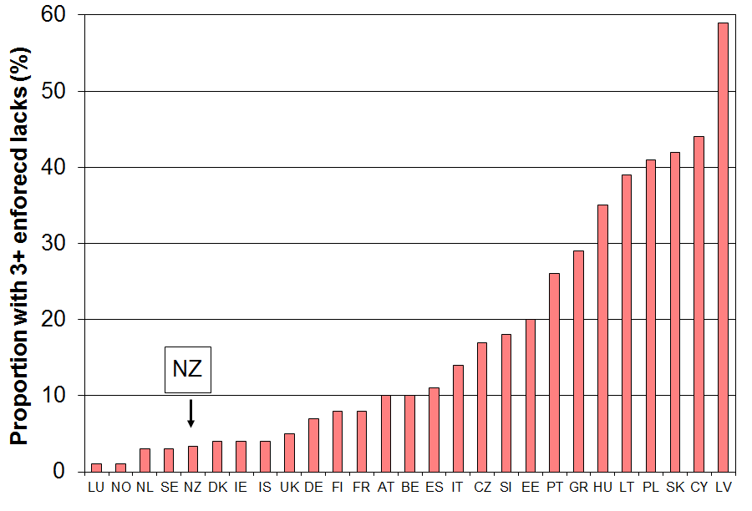

Table J.8
Deprivation rates (% with 3+ enforced lacks) using the 9 item index (EU-1), those aged 65+
EU-25 - MT + NO + IS +NZ (EU 2007, NZ 2008)
 |  | % with 3+ |  |  | % with 3+
Norway | NO | 1 | Spain | ES | 11
Netherlands | NL | 3 | Italy | IT | 14
Sweden | SE | 3 | Czech Republic | CZ | 17
New Zealand | NZ | 3 | Slovenia | SI | 18
Denmark | DK | 4 | Estonia | EE | 20
Ireland | IE | 4 | Portugal | PT | 26
Iceland | IS | 4 | Greece | GR | 29
United Kingdom | UK | 5 | Hungary | HU | 35
Germany | DE | 7 | Lithuania | LT | 39
Finland | FI | 8 | Poland | PL | 41
France | FR | 8 | Slovakia | SK | 42
Austria | AT | 10 | Cyprus | CY | 44
Belgium | BE | 10 | Latvia | LV | 59
Note: An improved 13-item index has been developed by the EU and is in process to becoming the new official measure. The hardship rate and ranking for older New Zealanders remains unchanged on this new index (see Perry 2014, forthcoming).
International comparisons of income inequality

The latest full set of information available from the OECD is for 2012 (our 2012-13 HES). International comparisons are given for the Gini coefficient, three share ratios for different decile groupings, and for the P90/P10 percentile ratio. The OECD sources do not have comparisons for the P80/P20 ratio.

In contrast to the share ratios and the percentile ratios the Gini coefficient takes the incomes of all individuals into account. It gives a summary of the income differences between each person in the population and every other person in the population. A difference of, say, $1000 between two high-income people contributes as much to the index as a difference of $1000 between two low-income people. The Gini scores (x100) range from 0 to 100 with scores closer to 100 indicating higher inequality and those nearer zero indicating lower inequality (ie greater equality).

Inequality comparisons using the Gini coefficient (c 2012)

Figure J.4 shows inequality rankings for 34 OECD countries for around 2012 using the Gini coefficient. There has been very little change since the last update for 2012. New Zealand’s score of 33.1 gave a 2012 ranking of 23rd out of 34. Rankings are not generally a useful way of comparing countries on league tables as there is often a clustering that can mean that a very minor difference in score can be the difference between a ranking of, say, 10th and 17th. Distance from the median and relativity to countries with whom comparisons are traditionally made are more useful approaches. On the latest OECD figures (c 2012), New Zealand’s Gini score of 33 was close to those of Australia and Italy (33), a little lower than the UK (35), and a little higher than Canada (32). The OECD-34 median was 31. Countries such as Denmark, Norway and Finland have lower than average inequality (Ginis of 25-26). The US score was 39.

Figure J.4
Income inequality across the OECD: Gini coefficients (x100) c 2012, whole population
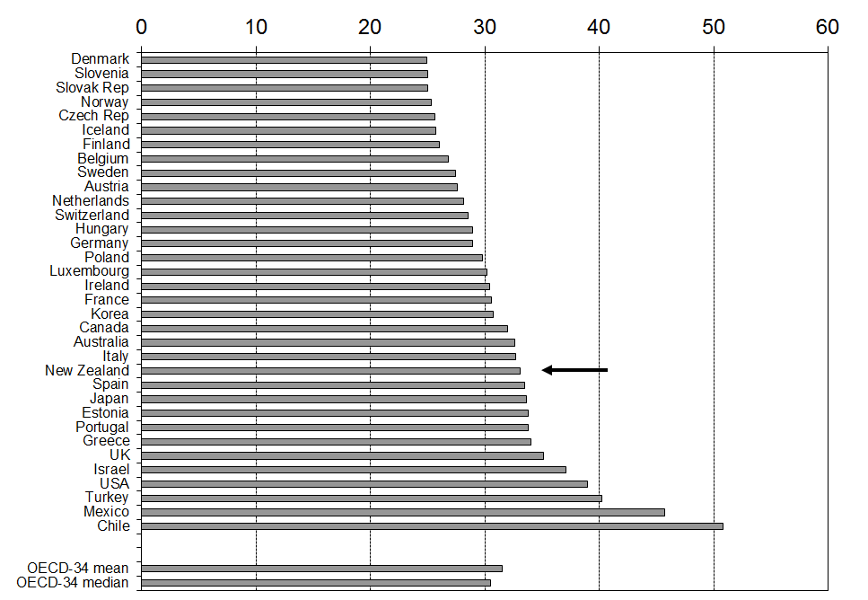
Source: OECD Income Distribution database, accessed on 24 July 2015.
Changing inequality in the OECD and New Zealand: 1982 to 2013

Figure J.5 shows the way inequality as measured by the Gini coefficient has changed in New Zealand over the last thirty years.

From the late 1980s to the mid 1990s income inequality in New Zealand increased significantly and rapidly, taking New Zealand from well under the OECD average to well above. From the mid 1990s to 2013 the trend-line for New Zealand was relatively flat while the OECD average has risen, thus bringing the two lines closer together.

In recent years income inequality figures have been volatile with the GFC shock impacting on investment returns, employment and wages over the five years from 2008-09. There is no conclusive evidence yet of any sustained rise or fall in income inequality using the Gini measure since the mid 1990s. The trend-line is almost flat. However, if the next survey shows a Gini figure similar to or higher than the HES 2014 figure, then that will give reasonable evidence of higher income inequality compared with the level a decade before. On the other hand, if it falls to the trend line or below, the current assessment will stand.

Figure J.5
Inequality in New Zealand and the OECD trend: the Gini coefficient
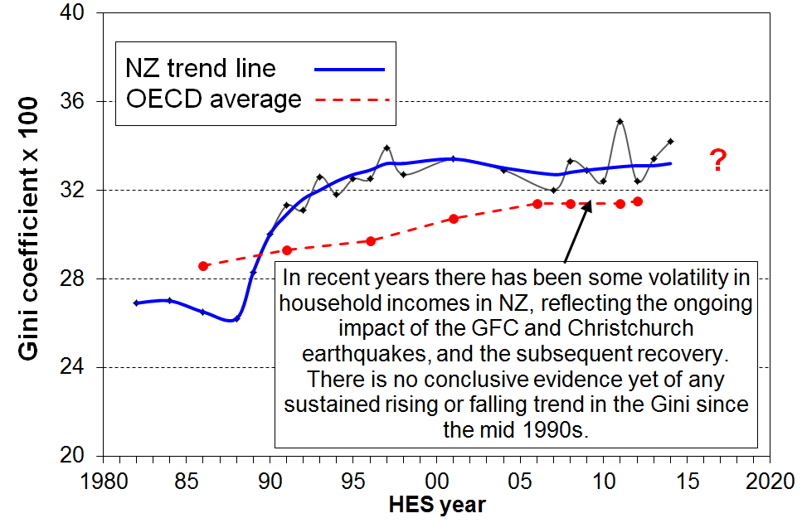

Inequality comparisons using three share ratios

Another approach used by the OECD is to compare the share of total income received by higher income households compared with the share received by lower income households. Three share ratio measures are reported here:
- the D10 to D1 ratio, comparing the top decile share with the bottom decile share
- the Q5 to Q1 ratio, comparing the top quintile share with the bottom quintile share
- the D10 to D1-4 ratio, comparing the top decile share with the share from the bottom four deciles (the Palma measure).

The Palma: the ratio of the top decile share to the share for the lower four decile shares

The Palma measure or ratio is a relatively new addition to the suite of inequality measures used for international comparisons. It is named after Chilean economist Gabriel Palma whose 2011 paper brought the measure and its rationale to light. The OECD now reports the Palma in its Income Distribution database.

At one level, the Palma is just another share ratio in the wider family of share ratios. It has several features however that make it worth a second look:
- Palma found that among middle income and richer countries those in deciles 5-9 receive around 50% of the total income share, and that this share size seems reasonably stable over time as well as over countries. These are the middle to upper-middle income households between the “rich” and the “poor”. Figure J.6 shows the share for New Zealand has been fairly stable at around 55% from 1990 to 2014.
- He also found that the remaining 50% or so (45% for New Zealand) of total income was split between the top 10% and bottom 40% in quite different ways across the countries he looked at. This inspired the first part of the title for his 2011 paper - “Homogeneous middles and heterogeneous tails".
- He found that the correlation between the Palma and the Gini is close to perfect across the 150 countries in the World Bank dataset he used.
- Given that the Palma is much easier to explain than the Gini, and that it ranks countries in the same order, then he and others are proposing that it might be a useful alternative to the Gini for international comparisons. For example, what does it mean in practice to say that one country has a Gini of 42 and another 31? On the other hand, a Palma of 2.1 compared with a Palma of 1.7 has specific and easily grasped meaning in terms of the ratio of higher incomes to lower incomes, with the ”middle” remaining constant. The jury is still out on whether it can / ought to / will replace the Gini, but it certainly has the communication edge over the Gini.

Figure J.6
Proportion of total income received by deciles 4 to 9, 1982 to 2014

Table J.9 reports the three share ratios (D10:D1, Q5:Q1, and the Palma) for around 2011 for the 34 OECD countries. New Zealand is at or just above the middle of the rankings on each of the three measures.

Table J.9
Income inequality using income share ratios, OECD, 2011
 | D10:D1 | Q5:Q1 | D1:D1-4 (Palma)
Denmark | 5.3 | 3.6 | 0.87
Slovenia | 5.3 | 3.6 | 0.81
Finland | 5.5 | 3.8 | 0.93
Czech Republic | 5.5 | 3.7 | 0.89
Iceland | 5.6 | 3.6 | 0.86
Belgium | 5.8 | 4.0 | 0.91
Slovak Republic | 5.8 | 3.9 | 0.89
Luxembourg | 5.9 | 4.0 | 0.97
Norway | 6.1 | 3.8 | 0.85
Sweden | 6.3 | 4.1 | 0.96
Netherlands | 6.6 | 4.1 | 0.99
Switzerland | 6.9 | 4.4 | 1.04
Germany | 6.9 | 4.4 | 1.07
Austria | 7.1 | 4.4 | 0.99
Hungary | 7.3 | 4.5 | 1.04
France | 7.4 | 4.7 | 1.18
Ireland | 7.7 | 4.7 | 1.10
Poland | 7.7 | 4.8 | 1.11
New Zealand | 8.2 | 5.2 | 1.22
Estonia | 9.1 | 5.4 | 1.20
Canada | 8.5 | 5.2 | 1.19
Australia | 8.5 | 5.4 | 1.23
United Kingdom | 9.6 | 5.6 | 1.40
Portugal | 9.9 | 5.8 | 1.36
Italy | 10.2 | 5.6 | 1.22
Korea | 10.2 | 5.7 | 1.13
Japan | 10.7 | 6.2 | 1.30
Israel | 12.5 | 7.4 | 1.55
Greece | 12.6 | 6.3 | 1.30
Spain | 13.8 | 6.7 | 1.34
Turkey | 15.2 | 8.4 | 1.99
United States | 16.5 | 8.2 | 1.74
Chile | 26.5 | 13.0 | 2.93
Mexico | 30.5 | 13.7 | 3.27
Source: OECD Income Distribution Database, accessed on 20 June 2014 at www.oecd.org/social/income-distribution-database.htm
Note: The 8.2 figure for New Zealand in the D10:D1 share ratio is slightly higher than the figure Statistics New Zealand produces and which the OECD therefore uses. We agree on the 2012 figure (HES 2013) of 8.3. MSD and Statistics New Zealand will continue to resolve the minor difference. It makes no difference to New Zealand’s ranking on the measure.

Long-run trends for (very) high incomes

While the bulk of the international comparisons of inequality trends and rankings use the incomes of all households (eg the Gini), or most households (the P90:P10), or at least those of the top and bottom 10% (S10:S1), recent public debate and protest has often been about the way in which those with very high incomes have been receiving a disproportionate share of the growth in overall income compared with the rest (hence the catch-cry of “we are the 99”). Those with very high incomes (for example, the top 1%) make up a small share of the population but their incomes make up a relatively large share of total income (and total income tax paid).

Until recently there was no reliable and internationally comparable data on very high incomes as sample surveys such as the HES do not have large enough samples to pick up enough such households to enable robust figures to be reported. Long-run time series on very high incomes based in the main on income tax data have recently become available on the World Top Incomes database, largely due to the work of Tony Atkinson (UK), Thomas Pikketty (France) and Emmanuel Saez (US). See for example, Atkinson and colleagues (2011) and Alverado and colleagues (2012).

Figure J.7 shows the share of total income received by those with the top 1% of income from the 1920s to around 2010 for the US, the UK, Canada, Australia and New Zealand.

For the US, the UK and Canada there is a clear U-shaped curve with the share of total income received by the top 1% rising fairly steeply for the US and the UK from the mid 1980s, more than doubling from 8% to 19% in 2011 for the US and from 6% to 15% for the UK (although the UK figure has declined to 13% in 2011). For New Zealand and Australia the proportion of total incomes received by the top 1% is less than for the US and the UK, but the rise from the mid 1980s to the mid 2000s is still steep. Ireland also has a U-shaped curve.

Not all OECD countries show the U-shaped curve. For example, France, the Netherlands, Germany and Japan show more of an L-shaped curve: they do not show the rapid rise from the mid-1980s that the English-speaking countries do, remaining steady in the 5-10% range (which is where New Zealand and Australia have ended up in 2010 to 2011).

Figure J.7
Very high income: share of income received by top 1%, 1920 to 2011

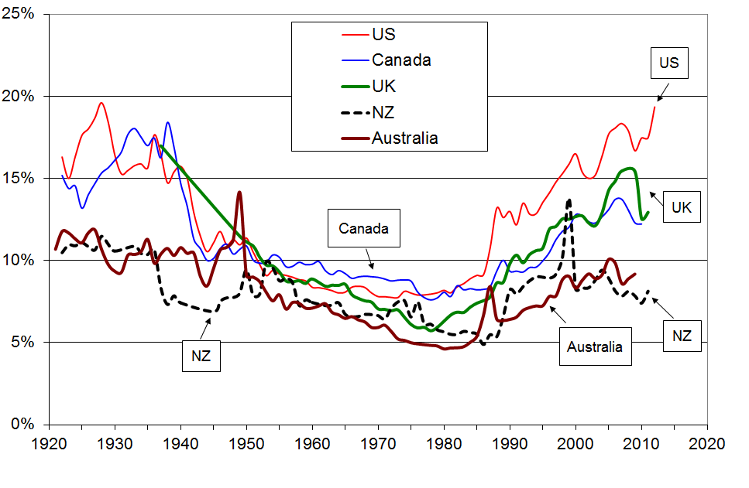

Source: World Top Incomes database accessed on 18 May 2014

The long-run perspective in Figure J.7 can tell more than one story. Taking the end of the “great compression” (1950 to 1980) as the starting point, the conclusion is that for the five English-speaking countries in the graph, inequality (understood as the share of income received by the top 1%) increased strongly to 2011. With the 1920s as the starting point, the “great compression” can be seen as the “aberration” and now the distribution has returned to where it was ninety years ago.

Figure J.8 shows selected OECD countries ranked by their top 1% income share. The top 1% in New Zealand received around 8% of all taxable income in 2010 and 2011 (before tax), more than in Denmark, Finland and Sweden (5 to 7%), similar to Norway, France and Australia, lower than Ireland (11%) and Canada (12%), and much lower than the UK (14%) and the US (17%).

For almost all OECD countries, the latest figures are all higher than in the 1980s (eg 10% for France, 40% for NZ and Japan, 60% for Ireland and Canada, 90% for the UK and Australia, and 120% higher for the US).

Figure J.8
Share of gross income received by top 1% (2011 & 2012, or latest available)
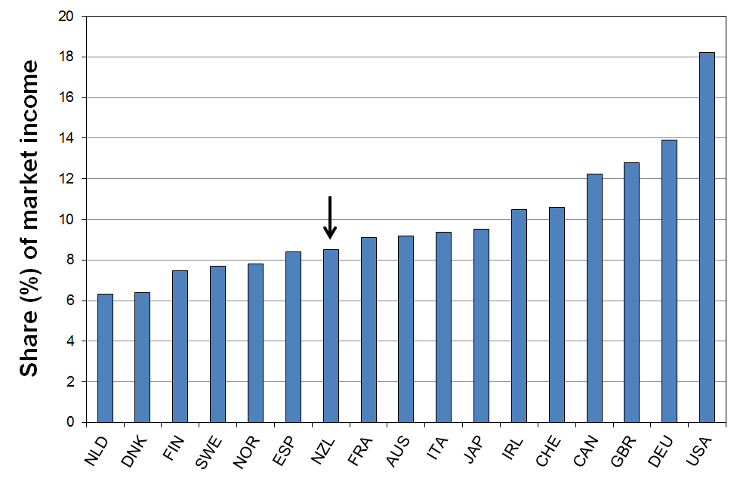

Figures J.9 and J.10 show the trends for the five English-speaking countries shown in Figure J.10 but this time for the top 5% (with the top 1% removed) and the top 10% (with the top 1% removed). The long-run and more recent trends are much flatter for these income groups.

Figure J.9
Very high income: share of income received by the top 5% (less the top 1%), 1920 to 2011
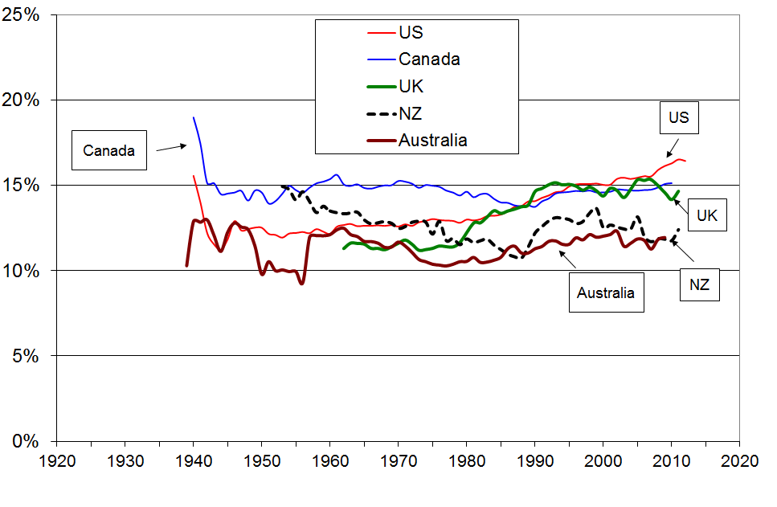

Figure J.10
Very high income: share of income received by the top 10% (less the top 1%), 1920 to 2011
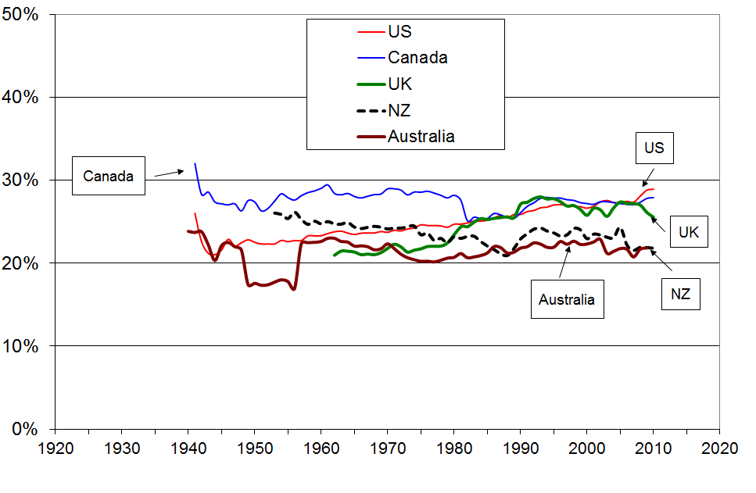

Long-run perspective for the share of income received by the top decile

As noted above, the HES analysis in this report and much of the OECD international comparative analysis are based on sample surveys that begin in the mid 1980s, at the end of the “great compression”. This means that analysis based on these surveys show a generally rising inequality for many countries.

This point is well illustrated in Figure J.11 using the more common “top decile share” measure. The graph shows the rising trend for the HES data from the 1980s, but from the longer perspective from 1955, the income data shows firstly the “great compression” to the 1980s, then a rise to the mid 2000s before falling investment income reduced the share. There is still a broadly U-shaped trend as in Figure J.10 for the top 1% of individuals, albeit the “U” is more flattened as noted in Figure J.13 above.

Figure J.11
Share of income received by top 10%, 1955 to 2013
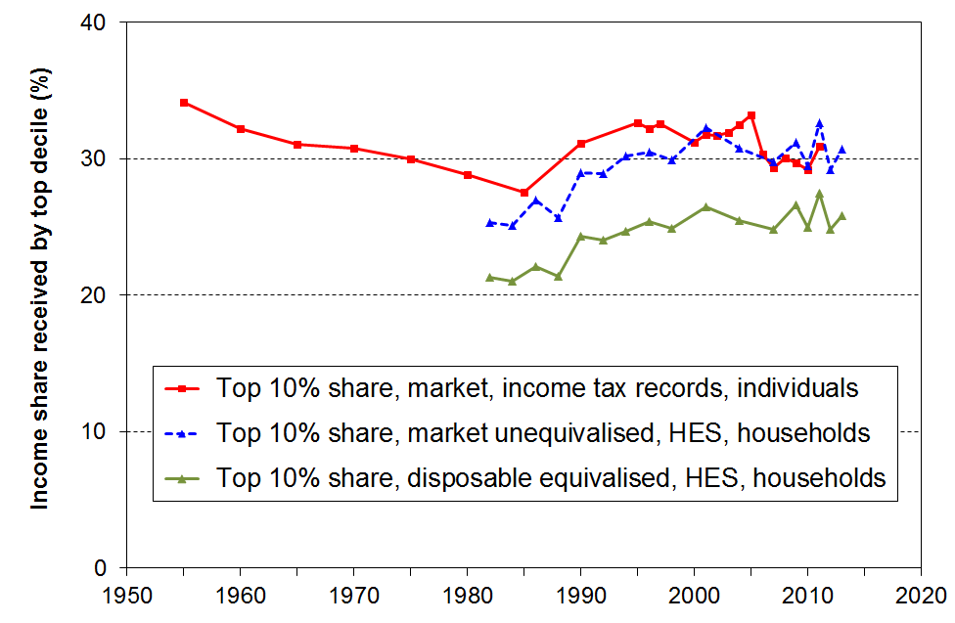

Source: Alvaredo and colleagues (2012), and MSD analysis of HES data.
Note: The data points for 1998 and 1999 for the upper line are omitted to avoid distraction from the main trends – these points were unusually high, reflecting the shifting of income into earlier years ahead of an anticipated tax rise for the top income bracket in 2000.

Correcting the Gini for very high incomes missed in surveys

The Gini inequality figures used by the OECD and others for international comparisons are based on sample surveys. These are known to under-estimate the number of people and households with very high incomes (eg the top 1%). This means that the resulting Gini figures are lower than they would be if the samples were properly representative.

Atkinson (2007) and more lately Alverado (2010) have come up with a formula to correct the sample-based Gini by adding information from the tax records about high individual incomes. If G(sample) is the usual Gini score, then G(corrected) = S + (1-S) * G(sample) where S is the share of total income received by the top 1% or other small group. A key assumption in the derivation of the formula is that the top incomes group is very very small, albeit their income share is non-trivial.

The implication for New Zealand is that any countries with more than 8% share for the top 1% will have a corrected Gini that increases more than New Zealand’s does (see Figure J.8 above). The correction puts New Zealand nearer the OECD median compared with the uncorrected Gini as New Zealand’s top 1% share is relatively low.

Summary

Income inequality in New Zealand, 1984 to 2013 HES
 |  | 1984 | 1994 | 2004 | 2009 | 2012 & 2013 for HES, 2011 & 2012 for tax records
Household disposable income, adjusted for household size … data from sample surveys (HES) | Gini x 100 (trend-line) | 26.6 | 32.5 | 32.9 | 32.9 | 32.9
 | Share ratio, D10 to D1 | 6.1 | 8.2 | 9.1 | 8.6 | 8.3
 | Share ratio, Q5 to Q1 | 4.1 | 5.1 | 5.5 | 5.4 | 5.3
 | Share ratio, D10 to D1-4 (Palma) | 0.92 | 1.21 | 1.31 | 1.29 | 1.27
 | Percentile ratio, P90 to P10 | 3.5 | 4.1 | 4.2 | 4.4 | 4.2
 | Percentile ratio, P80 to P20 | 2.4 | 2.7 | 2.9 | 2.9 | 2.7
Individual market income … data from tax returns – avg of year noted and the one either side | Top 1% share | 5.6 | 8.9 | 9.0 | 7.8 | 8.5
 | Top 10% share | 28 | 33 | 33 | 30 | 31
 | Top 10% - 1% share (ie P90 to P99) | 23 | 24 | 24 | 22 | 22

Income inequality in New Zealand compared with selected other OECD countries, c 2011-2012
(%) | NZ | OECD-34 median | DNK | NOR | FIN | FRA | AUS | CAN | UK | US
Gini x 100 (trend-line) | 32.9 | 30.5 | 25.3 | 25.0 | 26.1 | 30.9 | 32.4 | 31.6 | 34.4 | 38.9
Share ratio, D10 to D1 | 8.2 | 7.6 | 5.3 | 6.1 | 5.5 | 7.4 | 8.5 | 8.5 | 9.6 | 16.5
Share ratio, Q5 to Q1 | 5.2 | 4.8 | 3.6 | 3.7 | 3.7 | 4.7 | 5.4 | 5.2 | 5.6 | 8.2
Share ratio, D10 to D1-4 (Palma) | 1.27 | 1.18 | 0.87 | 0.85 | 0.93 | 1.18 | 1.27 | 1.19 | 1.40 | 1.74
Percentile ratio, P90 to P10 | 4.2 | 3.8 | 2.9 | 2.9 | 3.2 | 3.6 | 4.5 | 4.1 | 4.1 | 6.1
Top 1% share – tax records | 9 | The latest available from 2009 to 2012 | 6 | 8 | 7 | 9 | 9 | 12 | 13 | 18
Top 5% share – tax records | 21 | The latest available from 2009 to 2012 | 17 | 19 | 21 | 22 | 21 | 27 | 28 | 35
Sources: OECD Income Distribution Database, accessed on 25 June 2014 at www.oecd.org/social/income-distribution-database.htm

World Top Incomes database accessed on 7 July 2015

Comparisons between Australia and New Zealand

Table J.10 shows that household income inequality in Australia and New Zealand (c 2011) was similar on six measures.

Table J.10
Income inequality: New Zealand and Australia compared (avg for 2010 and 2011)
 | New Zealand | Australia
Gini (OECD) | 32.4 | 32.7
80:20 percentile ratio | 2.7 | 2.6
90:10 percentile ratio | 4.2 | 4.4
S10:S1 share ratio | 8.2 | 8.7
Q5:Q1 share ratio | 5.2 | 5.4
Palma | 1.27 | 1.27

Source OECD Income Distribution Database, accessed on 20 June 2014 at www.oecd.org/social/income-distribution-database.htm , and Table S.5 in ABS (2013).

Section K
Income mobility and low-income persistence

The income information in the earlier sections of the report is based on data from repeat cross-sectional surveys from the Household Economic Survey (HES) series. For each survey a different sample of households is selected and different individuals are interviewed each time.

For this section, the income information is based on seven waves of longitudinal data from Statistics New Zealand’s Survey of Family, Income and Employment (SoFIE) which began in October 2002. Here the same individuals are followed from one wave of the survey to the next. Longitudinal data give a quite different perspective on trends over time and make possible a richer analysis that can address a new set of questions around income mobility and the persistence of low-income. For example:

- If 20% of New Zealand children are identified as poor in a given year, what proportion of these stay poor over several years or even longer, and for how many is the low income experience ‘just’ a temporary one?

- How much does the household income of individuals change over time? Do most people remain in much the same relative position over 5-10 years, or do most move quite a lot?

- How does income mobility in New Zealand compare with mobility in other countries?

- Higher income inequality is sometimes seen as more tolerable if there is reasonably high income mobility. How much does income mobility reduce single-year income inequality when inequality is measured for incomes averaged over increasing numbers of years?

Source of the SoFIE analysis used in this section

The SoFIE figures used in this section are based in the main on the analysis recently published in Carter and Imlach Gunasekara (2012). [This source document is referred to as UO from here on.] This is the first time that findings of this sort have been available for New Zealand. A few tables and findings in this section are based on unpublished SoFIE analysis kindly provided by the UO authors. The international comparisons and some secondary analysis are from other sources as noted.

This section includes:

- A brief description of the SoFIE data and some of its limitations to be aware of when interpreting the findings.

- An outline of the different ways in which income mobility is conceptualised and measured.

- Findings on income mobility with international comparisons.

- An outline of the different ways in which low-income persistence / poverty dynamics is conceptualised and measured.

- Some findings on low-income persistence and the relationship between cross-sectional (current) poverty rates and poverty rates from a longitudinal perspective.

The SoFIE data

The initial SoFIE sample in wave one (2002-03) comprised around 11,500 households and almost 30,000 respondents (22,000 aged 15+). By wave seven (2008-09), just under 14,000 adults (over 15 years) were left, 66% of those in wave one. The overall attrition rate (63% remaining after seven waves) is comparable to other similar international longitudinal surveys such as Australia’s HILDA (69%) and the UK’s BHPS (67%).

The analyses in UO use a ‘balanced panel’ made up of SoFIE participants who were eligible at wave 1 and who responded in all seven waves, giving a usable sample of just under 19,000.

Three features of the SoFIE data have implications for the interpretation of the findings reported in UO and in this section:
- Unweighted sample numbers are used for all the analysis. The attrition noted above was greater among Maori, those with low income and sole parents. This can lead to attrition bias. To partially address the potential bias issues arising from attrition, longitudinal surveys generally use longitudinal weights to adjust the sample back to the original sample composition. Unfortunately, no suitable longitudinal weights were available for the analysis reported in UO. This means, for example, that median and mean incomes will be over-estimated and the estimated proportion with low incomes will be under-estimated more and more in later waves
- The income measure used is gross equivalised household income – that is, household income from all sources before the deduction of income tax but including all reported transfers and Working for Families tax credits, adjusted for household size and composition. For the analysis of the distribution of income and especially for low-income (poverty) analysis, disposable equivalised household income is the standard income measure used – that is, household income from all sources less income tax, adjusted for household size and composition. Households are ranked a little differently when using gross and disposable incomes as the total household tax deduction depends on the way the household income is distributed across adult household members. Income tax is higher, for example, for a multi-adult single earner household than for a multi-adult multi-earner household with the same gross income. It also means that the usual 50% and 60% of median low-income or poverty thresholds give different proportions as ‘poor’ than when using disposable (after tax) household income. The 50% measure gives a population low-income rate of around 15% on average over the seven waves, and the 60% measure gives an average of 24%, compared with 12% and 18% using disposable household income.
- In common with all income surveys there is measurement error. This is especially the case for the bottom income decile (see Appendix 8 for information on this for the HES).

These features have three main implications for interpreting and using the findings reported in this section:
- The figures here and in the source do not support highly detailed conclusions, for example for population groups or for small changes from wave to wave. The findings reported in this section are kept at a high enough level to ensure that the figures are robust enough to support them.
- It is preferable to look at the poverty persistence findings using the 50% of median figures for gross household income as these are closer to the more usual poverty figures reported than are the ones using the 60% of median gross household income (which in effect look at the lower quartile).
- Transitions from decile one will have more noise associated with them than transitions from other parts of the distribution. This section does not use any of these decile one transitions per se in reaching any conclusions on income mobility or movement out of income poverty. The bottom quintile is the smallest low-income group used for that purpose.
What is meant by income mobility and how is it measured?

The income mobility that is the focus of this section is about the changes in the equivalised (gross) household income of individuals over several years.

In broad terms, these changes can come about through changes in either the level of income of the individual or of some other adult household member, or through changes in the composition of the household itself (eg older children moving out, new children being added, changes in partnering arrangements, and so on). The impacts of the latter changes are captured through the equivalisation of the household incomes. (See Section A for information about equivalisation.)

The number of years (waves) over which changes in income are observed varies from study to study. Intra-generational studies range from shorter-term (say, 2 to 10 years) to longer-term ones which cover a greater part of a person’s life-course (say, 15 to 30 years). Others look at inter-generational changes and associations where the focus is on the relationship between the income of parents and that of their children. The SoFIE study falls into the shorter-term intra-generational group with eight waves from 2002-03 to 2009-10. UO uses data from the first seven waves, 2002-03 to 2008-09.

There are several ways to conceptualise and measure income mobility. The three most straightforward to describe and implement are:
- income mobility as change in relative position
- income mobility as absolute change in income – that is, change in income in real terms
- income mobility as measured by the reduction in income inequality as longer income windows are used.

The two sub-sections that follow focus on the first two approaches, relative positional change and absolute change. Inequality analysis using SoFIE data is underway but has not yet been published. Some international analysis from the UK and Australia is available.

Income mobility as change in relative position

To describe changes in relative position individual survey participants are first ranked by their household income, then they are grouped into quantiles (eg quintiles, deciles or even smaller categories). Transitions between quantiles from one wave to the next or to later waves can then be derived.

When looking at the whole population, not everyone can be upwardly mobile on the relative position definition. In the aggregate, income mobility on this approach is close to a zero-sum analysis: for every person who moves up at least one moves down, and so on. For a population group, however, the analysis is not necessarily zero sum provided the quantiles used are those of the population as a whole, as they are in this section. A further factor to take into account is that the relative sizes of population groups may change over the course of a longitudinal study.

Some of those who are reported as changing quantiles will have moved from just under (over) a quantile boundary to just over (under) it – these are the boundary hoppers. The actual change in income from one wave to the next for these people may be quite small. In fact, some who remain within the quantile will have had a greater change in income than the boundary hoppers, but this larger change is not reflected in the quantile change statistic on the relative position approach.

Within the change-in-relative-position approach, one way to provide estimates of positional (im)mobility, taking into account the boundary hopper possibilities and measurement error, is to report on positional change as transition from, say, a given quintile in one wave to a position in a later wave which is either in the same quintile or in the decile either side, where this is possible. Another way of addressing the issue is to examine changes in real incomes per se rather than positional changes relative to the rest.

Income mobility as change in real income

Change in real income over several waves is a very useful indicator of income mobility, reflecting some aspects of change that the relative approach misses. For example, in contrast to the positional change approach, an increase in income for everyone counts as upward mobility even if all relative positions are unchanged. In the relative approach, this scenario would be reported as zero mobility. It is not a zero sum analysis and it is not susceptible to the boundary hopper issue that can arise in the relative position approach.

Benchmarks for high, medium and low relative mobility?

There is no single statistic that can satisfactorily summarise the degree of relative income mobility nor any simple set of statistics that can cover the range of questions that different users may wish to put to the data.

Nor is there any commonly accepted benchmark of what is ‘high’ mobility and what is ‘low’ mobility.

Countries that have long-running longitudinal studies are able to compare mobility in recent years with mobility a decade or more ago in their own population. New Zealand is not in that position. The best that we can do for New Zealand on this matter is to:
- compare ourselves with other countries, using quintile or decile transitions over time periods of similar length
- compare the relative movement of various sub-populations within New Zealand to identify those more mobile and those less so
- decompose mobility into ‘immobility’, and ‘short-range’ and ‘longer-range’ upward and downward mobility.

Selected findings on income mobility

Wave-on-wave mobility (changes in relative position), with international comparisons

The focus of the analysis in this section is on the changes over the full seven-wave window that the UO SoFIE data covers, with some shorter windows used at times to facilitate international comparisons. These multi-year net changes reflect the cumulative effect of repeated short-run changes from one wave to the next.

Table K.1 shows the average movement from one wave to the next for the six wave pairs w1/w2, w2/w3, and so on.

Individuals are ranked by their household’s income in one wave then grouped into quintiles. For the next wave the same individuals are again ranked and allocated to quintiles according to their household’s new income at that time. For each quintile in the first wave the percentage of individuals ending up in each of the quintiles in the next wave is calculated. For example, two thirds (65%) of those in the lower quintile remain there on average from one wave to the next, 23% move up to the second quintile, and so on. The cells on the diagonal (shaded) show the proportion remaining in the same quintile across the period.

Table K.1
Income quintile transition probabilities (%) for one wave to the next:
averages over all 6 wave pairs, 2002 to 2008, all respondents
 |  | Quintile in wave (i+1)
 |  | 1 | 2 | 3 | 4 | 5
Quintile in wave(i) | 1 | 65 | 23 | 7 | 3 | 2
Quintile in wave(i) | 2 | 20 | 52 | 20 | 5 | 2
Quintile in wave(i) | 3 | 7 | 17 | 50 | 21 | 5
Quintile in wave(i) | 4 | 4 | 6 | 18 | 54 | 19
Quintile in wave(i) | 5 | 3 | 3 | 6 | 17 | 72
Source: Table 4 in UO

On average, 41% of the whole SoFIE sample moved to a new quintile between wave pairs – that is, 59% remained in the same quintile in the next wave.

A comparison is available for selected European countries. Nolan and Erikson (2007) use longitudinal data from the European Community Household Panel (ECHP) for most of the EU-15 countries and report that on average 55% remained in the same quintile from wave 1 to wave 2. At this very high level, at least, New Zealand’s mobility / immobility is similar to that in other more economically developed countries (MEDCs).

This general finding is supported at several places in the rest of this section.

Quintile transitions over the seven SoFIE waves, with international comparisons

The focus now moves to looking in more detail at the changes that occur over multi-wave windows, especially the full seven-wave window that the current release of SoFIE data allows.

Figure K.1 shows that as the income window increases mobility increases (and immobility decreases), as one would expect. By w7, 60% have moved from their original quintile, 40% remain in the same one. The upper quintile has the least mobility with just over half (54%) of those in Q5 in w1 being there again in w7.

Figure K.1
Proportion who move from their original quintile over the seven SoFIE waves:
all in sample
Source: Author’s calculations based on unpublished decile transition tables provided by UO authors.

Figure K.1 makes it look as if there is a very large amount of movement between w1 and w2, much more than for later transitions. The reason for the difference is that whatever wave is taken as w1, the w1 to w2 transition is different from any other transition in that in all the others it is possible to return to the quintile or decile of origin (w1), whereas this is not logically possible for the w1/w2 transition. For a w1/w2 transition, an individual either stays or moves – they cannot ‘return’ to w1.

Table K.2 shows the w1 to w7 transitions by initial location in the income distribution (and repeats some of the information shown in Figure K.1). For example, the first row in Table K.2 shows that 45% of those in the lowest income quintile in w1 were still there in w7, 29% had moved up to the second quintile and so on. The cells on the diagonal (shaded) show the proportion remaining in the same quintile across the period.

Table K.2
Income quintile transition probabilities (%) from w1 to w7, SoFIE:
2002 to 2008, full sample
 |  | Quintile in w7 (2008)
 |  | 1 | 2 | 3 | 4 | 5
Quintile in w1 (2002) | 1 | 45 | 29 | 14 | 9 | 4
Quintile in w1 (2002) | 2 | 25 | 35 | 23 | 12 | 5
Quintile in w1 (2002) | 3 | 13 | 18 | 31 | 26 | 11
Quintile in w1 (2002) | 4 | 9 | 11 | 21 | 34 | 25
Quintile in w1 (2002) | 5 | 7 | 7 | 12 | 20 | 54
Source: Table 5 in UO

Table K.3 shows the same types of transitions for Australia based on their HILDA survey. There are strong similarities between Tables K.2 and K.3. The only difference of note is that New Zealand seems to have more mobility out of the lower quintile than Australia does, 55% compared with 42%. It is not clear on the evidence available whether this difference is ‘real’ or simply a product of different methodologies (eg gross rather than disposable income, and unweighted rather than weighted data). What is clear is the remarkable similarity at all other points.

Table K.3
Income quintile transition probabilities (%) for Australia, using HILDA,
2001 to 2008, whole population
 |  | Quintile in w8 (2008)
 |  | 1 | 2 | 3 | 4 | 5
Quintile in w1 (2001) | 1 | 58 | 23 | 10 | 5 | 4
Quintile in w1 (2001) | 2 | 27 | 33 | 21 | 15 | 6
Quintile in w1 (2001) | 3 | 14 | 21 | 30 | 23 | 13
Quintile in w1 (2001) | 4 | 9 | 12 | 21 | 34 | 24
Quintile in w1 (2001) | 5 | 4 | 8 | 15 | 22 | 51
Source: Table 6.6 in Wilkins et al (2011)

Table K.4 shows that income mobility in New Zealand is similar to that in Canada over a five-wave window, with the same exception as for the comparison with Australia.

Table K.4
Comparison of relative (positional) income mobility in Canada and New Zealand:
transition probabilities (%) to higher and lower quintiles, w1 to w5, full sample
 |  | New Zealand (2002-06) |  | Canada (2005-09)
 |  | to a higher quintile in w5 | to a lower quintile in w5 | to a higher quintile in w5 | to a lower quintile in w5
Quintile in w1 | 1 | 51 | 0 | 43 | 0
Quintile in w1 | 2 | 37 | 24 | 41 | 20
Quintile in w1 | 3 | 35 | 30 | 34 | 29
Quintile in w1 | 4 | 24 | 36 | 24 | 38
Quintile in w1 | 5 | 0 | 40 | 0 | 40
 | Avg | 29 | 26 | 28 | 25
Source: Table A.3 in the UO Appendix, and Table 3 in Statistics Canada (2011).

Table K.5 provides further international comparison (with EU countries this time) showing again that income mobility over 5 waves in New Zealand is very similar to that in other MEDCs.

TableK.5
Income quintile transition probabilities (%) for w1 to w5, EU-15 and New Zealand: whole population
 |  | Most of EU-15 | NZ
Quintile in w1 | 1 | 50 | 49
Quintile in w1 | 2 | ‘generally about one third’ | 39
Quintile in w1 | 3 | ‘generally about one third’ | 36
Quintile in w1 | 4 | ‘generally about one third’ | 40
Quintile in w1 | 5 | 60+ | 61
Quintile in w1 | Avg | 40-45 | 45
Sources: Nolan and Erikson (2007) for EU figures
Author’s calculations based on unpublished decile transition tables provided by UO for the NZ figures
Note: EU-15 are the pre-2004 members of the European Union

Decile transitions over the seven SoFIE waves, with international comparisons

Table K.6 repeats Table K.2, this time using deciles. Table K.6 is more fine-grained and used on its own or together with Table K.2 it can provide a more textured picture of income mobility and immobility. While it is more susceptible to issues arising from regression to the mean and to overstated mobility arising from boundary hoppers, with a little care it is a valuable analytical tool. One of the most notable features of Table K.6 is the very high immobility in decile 10, the highest decile: almost half of those who were there in w1 are there again in w7. This contrasts strongly with the middle deciles which experience much more mobility. Even though the lower three deciles and decile 8 have somewhat less mobility than the middle deciles, they are still relatively mobile compared with those starting in decile 10.

Table K.6
Income decile transition probabilities (%) from w1 to w7:
2002 to 2008, all respondents
 |  | Decile in w7 (2008)
 |  | 1 | 2 | 3 | 4 | 5 | 6 | 7 | 8 | 9 | 10
Decile in w1 (2002) | 1 | 24 | 21 | 14 | 13 | 7 | 6 | 6 | 4 | 3 | 3
Decile in w1 (2002) | 2 | 18 | 27 | 19 | 12 | 9 | 6 | 4 | 3 | 1 | 1
Decile in w1 (2002) | 3 | 10 | 20 | 24 | 15 | 11 | 10 | 5 | 3 | 3 | 1
Decile in w1 (2002) | 4 | 9 | 11 | 14 | 17 | 14 | 12 | 9 | 7 | 5 | 2
Decile in w1 (2002) | 5 | 8 | 6 | 8 | 13 | 19 | 17 | 11 | 10 | 6 | 3
Decile in w1 (2002) | 6 | 7 | 5 | 6 | 9 | 14 | 15 | 18 | 13 | 8 | 6
Decile in w1 (2002) | 7 | 6 | 4 | 6 | 6 | 9 | 15 | 17 | 17 | 13 | 8
Decile in w1 (2002) | 8 | 5 | 4 | 4 | 6 | 9 | 9 | 15 | 19 | 19 | 10
Decile in w1 (2002) | 9 | 5 | 2 | 4 | 5 | 5 | 9 | 10 | 15 | 26 | 20
Decile in w1 (2002) | 10 | 5 | 3 | 2 | 3 | 5 | 4 | 6 | 10 | 17 | 46
Source: Unpublished table provided by UO.

International comparisons are available using decile transitions. They provide further support for the finding that at the population level, the overall degree of income mobility for New Zealand appears to be very similar to that for other MEDCs.

Chen (2009) gives comparisons for Canada, the USA, Germany and Great Britain using two measures based on a five-wave window, one of immobility and one of upward mobility. In Figure K.2 and Figure K.3 these statistics are replicated for New Zealand (albeit on gross rather than disposable income), and on these comparisons New Zealand’s mobility picture is again very similar to these other MEDCs.
Figure K.2 Figure K.3
Immobility: in same decile in w5 as in w1 Upward mobility, at least one decile up, w1 - w5

Source: Figs 2 & 3 in Chen (2009), and Table A.3.

For Great Britain Jenkins (2011, Table 5.1) reports that for 1991-1998 (using BHPS data) 54% remained in the same decile as they started in or were in an immediately adjacent decile. Jenkins refers to this as an ‘immobility index’. The New Zealand figure for seven waves was 53%.
Table K.7 repeats Table K.6, this time limiting the respondents to those aged under 58 years. By removing those who were aged 58+ in wave one, the impact on the reported transitions of those whose incomes drop significantly when they ‘retire’, and of those aged 65+ on relatively fixed incomes, is eliminated. The deciles used in Table K.7 are population deciles, not the deciles for the group aged under 58 years. The main impact of removing those aged 58+ is on deciles 2 and 3 (higher percentage of those under 58 years move out). A slightly higher proportion remain at the top (deciles 9 and 10).

Table K.7
Income decile transition probabilities (%) from w1 to w7:
2002 to 2008, respondents aged 0-57 years in w1
 |  | Decile in w7 (2008)
 |  | 1 | 2 | 3 | 4 | 5 | 6 | 7 | 8 | 9 | 10
Decile in w1 (2002) | 1 | 26 | 18 | 13 | 13 | 7 | 6 | 6 | 4 | 3 | 4
Decile in w1 (2002) | 2 | 22 | 18 | 16 | 14 | 11 | 6 | 6 | 4 | 1 | 1
Decile in w1 (2002) | 3 | 12 | 13 | 16 | 18 | 14 | 13 | 6 | 4 | 4 | 2
Decile in w1 (2002) | 4 | 10 | 9 | 11 | 17 | 15 | 14 | 11 | 7 | 6 | 2
Decile in w1 (2002) | 5 | 9 | 5 | 8 | 12 | 19 | 17 | 11 | 11 | 6 | 3
Decile in w1 (2002) | 6 | 8 | 3 | 6 | 9 | 13 | 14 | 18 | 14 | 9 | 6
Decile in w1 (2002) | 7 | 7 | 3 | 4 | 6 | 9 | 14 | 17 | 18 | 14 | 9
Decile in w1 (2002) | 8 | 6 | 3 | 3 | 6 | 9 | 9 | 15 | 19 | 20 | 11
Decile in w1 (2002) | 9 | 5 | 2 | 3 | 5 | 5 | 8 | 10 | 15 | 27 | 22
Decile in w1 (2002) | 10 | 5 | 2 | 2 | 3 | 4 | 4 | 6 | 10 | 16 | 47
Source: Unpublished table provided by UO.

Based on the decile transition table for those aged 0-57 years in wave one:
- of those starting in deciles 1-3, just over half were still there in wave 7, a quarter had moved up to deciles 4 and 5, and a quarter into the top half (deciles 6-10)
- of those starting in the middle of the income distribution (deciles 4-6), 43% were still there in wave 7, 35% had moved up to deciles 7-10, and 23% had moved down.
- of those starting in the top decile, 63% were still there or were in decile 9 in wave 7.

Income mobility as change in real income (‘absolute’ mobility)

Income mobility can also be looked at in terms of changes in real (CPI-adjusted) income. On this basis it was found that (during a period when cross-sectional incomes were growing on average for all deciles):
- 20% of those starting in the lowest quintile experienced a net decrease in real income over the 7 waves, 30% doubled their income, and the remaining 50% all experienced real increases of substance, albeit less than double
- overall, 38% experienced real declines, and for a third of these the decline was significant (40%+)
- for the middle quintile, two in three (64%) experienced a real increase in income, and the increase for two thirds of these was greater than 20%
- 60% of those in the top quintile (Q5) in w1/w2 and almost half (47%) of those in Q4 experienced real decreases, with most of these experiencing decreases of more than 20%.

What is meant by low-income persistence (poverty persistence) and how is it measured?

In order to capture the different aspects of individuals’ low-income experiences from a longitudinal perspective and to do so in a manageable way, a range of taxonomies and categorisations are used in different studies and reports. In this report three approaches are used:
- number of waves in low income in a given window
- proportion of individuals in low income in w1 who are in low income in subsequent waves
- comparison of average income with the average poverty line over the full 7 waves to produce ‘chronic’ low-income figures.

The first two approaches are self-explanatory and straightforward to understand. One of their limitations however is that they cannot distinguish between those on the one hand who move out of low income and go well above the line and those on the other hand who go from just below the line to just above it and vice versa (the boundary hoppers).

One way to get a better understanding of these movements and to deal with the issue of boundary hoppers is to look at people’s average income over the seven waves and to compare that with the average low income (poverty) line over the seven waves. People whose average income is below the average low income (poverty) line over the seven waves are said to be in chronic low income (poverty).

Figure K.4 uses a stylised approach to illustrate the chronic poverty concept. Both households represented in the diagrams are in (current) poverty for 2 waves out of the 7. Household A in the left-hand graph is in chronic poverty, but household B on the right is not. The window used does not have to be 7 waves. It could for example be 4 waves, and if the survey has a long enough life, a trend in the relationship between current and chronic poverty can be established.

Figure K.4
Stylised diagram showing the value of the chronic low-income concept
for summarising multi-wave poverty
Household A Household B

By examining the relationship between those in chronic poverty and those in current poverty in each wave, a useful set of findings emerges that has value in itself, but which also allows us to look at cross-sectional income poverty findings with longitudinal eyes.

Selected findings on low-income persistence (poverty persistence)

Some of the findings in the income mobility section above are relevant in this one too (for example, the ones under Table K.7 above on the destination after 7 waves of those starting in deciles 1-3).

Number of waves in low income (poverty)

Figure K.5 shows the cumulative number of waves that people were in low income (poverty) over the seven waves, using both the 50% and 60% of gross median thresholds.

Figure K.5
Cumulative number of waves in low income, whole population
Source: Derived from Tables 8 and 9 in UO.

(As discussed above, it is preferable to use the figures generated using the 50% of gross median threshold when looking at income poverty persistence.) Although only a very small proportion were in poverty for all 7 waves (2%), Figure K.5 shows that 40% of the population experienced income poverty at least once in seven the seven waves. This means that more than double the number who are reported as in poverty in any one wave (15%) actually experience poverty at least once in the seven waves.

Findings of this sort are very common across countries like Australia, Canada, the UK, Germany and others in the OECD. It arises from the fact that in any wave, out of those who are identified as poor or in low income there are two groups: those who are more permanently in low income, and those who are only temporarily or sometimes in low income. This latter group becomes quite sizeable over seven waves and produces the finding above. The section below on chronic low income picks up on this theme.

Proportion in low income in w1 who are found in low income in subsequent waves

Table K.8 uses the bottom quintile to define low income, and shows the proportion still in low income in subsequent waves. Just under half (45%) are still in or are back in low income after 7 waves and just over half (55%) have moved up.

Table K.8
Persistence of low income for those in low income in a starting wave:
(low income = in bottom income quintile), all respondents
 |  | In low income in this subsequent wave
 |  | w2 | w3 | w4 | w5 | w6 | w7
In low income in this starting wave | w1 | 62 | 57 | 51 | 49 | 46 | 45
In low income in this starting wave | w2 | - | 65 | - | - | - | -
In low income in this starting wave | w3 | - | - | 66 | - | - | -
In low income in this starting wave | w4 | - | - | - | 66 | - | -
In low income in this starting wave | w5 | - | - | - | - | 66 | -
In low income in this starting wave | w6 | - | - | - | - | - | 66
Source: Author’s calculations based on unpublished tables provided by UO.
Chronic low income

Counting the number of waves for which people are below a given poverty line is a straightforward approach but it clearly has limitations, and can be misleading in the impression it leaves. For example, the fact that so few remain in poverty for all or all but one of the seven waves can point to the conclusion that mobility is sufficient to address most concerns that are raised by cross-sectional low-income issues. As this “chronic poverty” section will show, this is not the case. The main limitation of the number-of-waves approach is that it does not pick up those whose incomes fluctuate from below to just above the line, and vice versa.

One way to address the issue of how best to report on poverty persistence, given that for many households their incomes fluctuate from just above to just below the poverty line and vice versa, is to look at people’s average income over the seven SoFIE waves and to compare that with the average poverty line over the seven waves. People whose average income is below the average poverty line over the seven waves are said to be in chronic poverty.

By examining the relationship between those in chronic poverty and those in current poverty in each wave, a useful set of findings emerges that allows us to look at cross-sectional income poverty findings with longitudinal eyes.

To be in chronic low income, an individual’s average household income over the seven waves must be less than the average low-income rate over that time (see Figure L.4 above). Table K.9 compares the current and chronic poverty rates for the whole population, children and Maori. The chronic poverty rate is typically around 80% of the current poverty rate, a little higher for Maori.

Table K.9
Current and chronic low-income rates
 | current (%) | chronic (%)
50% of gross median
whole population | 15 | 11
children(0-11 yrs in w1) | 19 | 16
60% of gross median
whole population | 26 | 21
children (0-17 yrs in w1) | 29 | 24
Maori | 36 | 32

However, those in chronic poverty do not form a subset of those in current poverty in a given wave. Figure K.6 below summarises the relationship between current and chronic low income. Some who are in current poverty in a particular wave are not in chronic poverty. Similarly, some who are in chronic poverty are not in current poverty each wave.

Figure K.6
Current and chronic poverty:
the chronic oval (on the right) is around 70-80% the size of the current oval (on the left),
but not all in the chronic oval are in the current oval
current and chronic
current only
chronic only

Table K.10 summarises the rate and composition figures for current and chronic poverty. A straightforward way to read the table (for the 50% gross rows) is:
  - for the population as a whole: out of every 100 in current poverty at any time 50 are also in chronic poverty, and in addition another 20 not in current poverty are in chronic poverty
  - for children, out of every 100 in current poverty at any time 60 are also in chronic poverty, and in addition another 20 not in current poverty are in chronic poverty.

Table K.10
Composition for current only, chronic only and both, and rates for current (total) and chronic only
 | composition (% of current) |  |  | rate (as % of group)
 | current only | overlap | chronic only | current (total) | chronic only
Whole population
60% gross | 35 | 65 | +15 | 26 | 4
50% gross | 50 | 50 | +20 | 15 | 4
Children
60% gross (0-17, w1) | 35 | 65 | +18 | 29 | 5
50% gross (0-11, w1) | 40 | 60 | +20 | 18 | 4
Maori
60% gross | 25 | 75 | +16 | 36 | 6

The SoFIE has run its course and New Zealand does not have a longitudinal survey that collects income data that will allow further analysis as above. The SoFIE findings do however allow us to look at and interpret cross-sectional rates with longitudinal eyes:
- in any wave, around half are in both chronic poverty and current poverty, the other half being only in current poverty (ie more temporary or transient poverty)
- the people in this more transient group change a lot over seven waves which is why it turns out that the number in low income at least once in seven waves is around double the number in low income at any one time (see above)
- in addition to those identified as being in current poverty in a wave there is another group who are in chronic poverty but not in current poverty
- chronic poverty rates are around 70% of the cross-sectional rates for the population as a whole and more like 80% for children
- very similar findings have been produced for the UK and Australia.

This picture is in some ways similar to the one we have for the beneficiary population. At any given time, a majority of those on benefit will have been on benefit for many years. A smaller number are new entrants or fairly temporary recipients. Over several years the number who have been on benefit at any time is much greater than the number on benefit at a particular point in time because of the cumulative effect of these temporary recipients.

The number-of-waves-in-poverty approach can easily lead to an overly optimistic view of the ability of income mobility to resolve low-income issues for the bulk of low-income households.

Section L
Wealth

Wealth is a key component of a household’s economic resources as discussed in the Introduction (Section A). For example, households with low incomes but relatively high wealth levels are able to achieve higher actual living standards than low-income households with low wealth levels. In practice, especially for working-age households, income and wealth are reasonably (but far from perfectly) correlated. Most who are counted as income poor also have negligible financial assets and very low net worth.

In OECD countries, the measurement of wealth is not as developed as wage and income measurement. The data issues faced by individual countries are compounded for comparisons between countries because of differences in methods and definitions.

Building on the experience of the Luxembourg Income Study (LIS), a group of researchers and institutions is developing the Luxembourg Wealth Study (LWS), an international project to assemble unit record data on household wealth into a coherent database. The hope is that this will promote a process of reasonable harmonisation of definitions and methodologies across countries, and will facilitate more reliable international comparisons of wealth distribution.

The other source of international comparisons comes from the Credit Suisse project as reported in their Global Wealth Databook (Shorrocks et al, 2014).

The HILDA datasets from Australia also have very useful wealth information (Wilkins, 2014).

Wealth inequality

Wealth is distributed much more unequally than income (especially disposable income after tax and transfers). As shown in Figure L.1, in New Zealand in 2003-2004 the top wealth decile accounted for around 50% of the total wealth, whereas the top income decile accounted for 25% of the total income (see Figure B.4). The Gini for income in 2003-04 was 32, and the wealth Gini was 69. This degree of wealth inequality appears to be not greatly different to what prevails in many other OECD countries (see below for details).

Figure L.1
Wealth and income distribution in New Zealand, 2003-2004: cumulative frequency (%)
Source: Wealth data is from unpublished New Zealand Treasury analysis of wave 2 (2003-2004) of Statistics New Zealand’s Survey of Family, Income and Employment. Income data is from the 2003-2004 HES.
Note: The income sharing unit for the incomes analysis is the household. The distribution is of individuals according to their household’s income For the wealth analysis the sharing unit is the EFU (‘family’). The wealth graph would be slightly differently shaped using the household as the sharing unit, but the finding that wealth inequality is much higher than income inequality is robust.

International comparisons of wealth inequality

Table L.2 shows some of the findings from early research from the LWS project – the share of total wealth held by the top wealth decile for seven OECD countries, and wealth inequality as measured using the Gini coefficient. New Zealand is not a participant in the LWS, but roughly comparable figures are available using the SoFIE dataset as reported in Table L.1.

Wealth inequality in New Zealand appears to be not greatly different to what prevails in many other OECD countries. The Credit Suisse Wealth Report puts New Zealand in the medium wealth inequality category, along with Italy, Australia, Canada, the UK, Finland, and others. Denmark, Norway and Sweden are in their “high” category, which contrasts with the lower-than-average income inequality ranking for these countries. The US and Switzerland are in their “very high” category, and Belgium and Japan in their “low” category. (See Shorrocks et al, 2014.)

Table L.2
Wealth inequality: shares of total wealth held by the top wealth decile (%), and wealth Ginis
 | Italy  2002 | UK  2000 | Finland  1998 | NZ  2003-04 | Canada  1999 | Germany  2002 | Sweden  2002 | USA  2001
Share of wealth held by top decile (%) | 42 | 45 | 45 | 52 | 53 | 55 | 58 | 71
Gini coefficient | 61 | 66 | 68 | 69 | 75 | 80 | 89 | 84
Sources: For New Zealand, the source is Statistics New Zealand (2007), analysis based on the Survey of Family, Income and Employment (2003-04). For the other countries, see OECD (2008), Table 10.3, based on the LWS database. The figures should be taken as indicative only. For more details and an assessment of the reliability of the information from the early LWS research see OECD (2008), Chapter 10. Shorrocks et al (2014) have slightly different figures but the same ranking of countries.

Wealth mobility: changes over several years using HILDA data

Australia’s longitudinal Household, Income and Labour Dynamics in Australia survey (HILDA) can report on changes in the wealth of the household that individuals were in in 2010 compared with their situation in 2002.

Wilkins (2013) reports that:
- 59% of those in the top wealth decile in 2002 were still in the top wealth decile 8 years later, and 77% were still in one of the top two deciles. There is therefore good evidence of wealth persistence, at least over the short term.
- Those who entered the top decile over the eight years before 2010 are slightly more likely to come from lower down the wealth distribution than where those who exit the top decile fall to. For example, 9% in the top decile in 2010 came from deciles 1-5 in 2002, whereas only 5% of those in the top decile in 2002 were in deciles 1-5 in 2010.

References

Alcock, P. (1993), Understanding Poverty, London: Macmillan
Alvaredo, F. (2010). ‘A note on the relationship between top income shares and the Gini coefficient’, Economics Letters, Manuscript Draft.
Alvaredo, F., Atkinson, A., Piketty, T & Saez, E. (2012). ‘The World Top Incomes Database’, http://g-mond.parisschoolofeconomics.eu/topincomes, 12/08/2012
Atkinson, A. (1989), Poverty and Social Security, Hemel Hempstead: Harvester Wheatsheaf.
Atkinson, A. (2007), ‘Measuring Top Incomes: Methodological Issues, in Atkinson and Picketty (2007) Top Incomes over the Twentieth Century, Oxford: Oxford University Press.
Atkinson, A., Piketty, T & Saez, E. (2011). ‘Top incomes in the long run of history’, Journal of Economic Literature, 49(1), 3-71.
Australian Bureau of Statistics (2013a), Household Income and Income Distribution, Canberra: ABS
Australian Bureau of Statistics (2013b), Household Wealth and Wealth Distribution, Canberra: ABS
Aziz, O., Gibbons, M., Ball, C., & Gorman, E. (2012), ‘The effect on household income of government taxation and expenditure in 1988, 1998, 2007 and 2010’, Policy Quarterly, 8(1), 29-38.
Ballantyne, S., Chapple, S., Mare, D., & Timmins, J. (2004), 'Triggering movements into and out of child poverty: a comparative study of New Zealand, Britain and West Germany', Social Policy Journal of New Zealand, (23), 83-96.
Berthoud, R., Blekesaune, M., & Hancock, R. (2006). 'Are 'poor' pensioners 'deprived'?' Research Report # 364, Department for Work and Pensions.
Boarini, R., & Mira d'Ercole, M. (2006). 'Measures of Material Deprivation in OECD Countries.' Social, Employment and Migration Working Paper # 37, OECD, Paris .
Bradbury, B. (2003), 'Child Poverty: a Review.' Report 3/03, Social Policy Research Centre, University of New South Wales.
Bradshaw, J., Middleton, S., Davis, A., Oldfield, N., Smith, N., Cusworth, L.,& Williams, J. (2008), A Minimum Income Standard for Britain: What people think, Joseph Rowntree Foundation, York.
Brewer, M., Goodman, A., Muriel, A., & Sibieta, L. (2007), 'Poverty and Inequality in the UK: 2007.' Institute for Fiscal Studies Briefing Note No. 73, London.
Brewer, M., Goodman, A., Myck, M., Shaw, J., & Shepherd, A. (2004). 'Poverty and Inequality in Britain: 2004.' Commentary 96, Institute for Fiscal Studies, London.
Brewer, M., O’Dea, C., Paull, G. & Sibieta, L. (2009). ‘The Living Standards of Families with Children Reporting Low Incomes’, DWP Research Report no. 577, London: Department for Work and Pensions.
Carter, K. & Imlach Gunasekara, F. (2012). ‘Dynamics of Income and Deprivation in New Zealand, 2002-2009. A descriptive analysis of the Survey of Family, Income and Employment (SoFIE).’ Public Health Monograph Series No. 24. Wellington: Department of Public health, University of Otago, Wellington.
Chen, W. (2009), ‘Cross-national differences in income mobility: evidence from Canada, the United States, Great Britain and Germany’, Review of Income and Wealth 53 (1), 75-100.
Citro, C. F., & Michael, R. T. (eds) (1995). Measuring Poverty: A New Approach. Washington, DC: National Academy Press.
Cobham, A. & Sumner, A. (2013), ‘Is it all about the tails? The Palma measure of inequality.’ Working Paper 343, Center for Global Devlopment.
Crawford, R., & Johnston, G. (2004), 'Household incomes in New Zealand: the impact of the market, taxes and government spending, 1987/88 to 1997/98.' New Zealand Treasury Working Paper, 04/20.
Creedy, J. & Tuckwell, I. (2003), 'Reweighting the New Zealand Household Economic Survey for Tax Microsimulation Modelling.' New Zealand Treasury Working Paper 03 -33.
Creedy, J & Eedrah, J (2014) ‘The role of value judgments in measuring inequality’. New Zealand Treasury Working Paper 14-13.
Department for Work and Pensions (2004), Measuring Child Poverty, DWP.
Department for Work and Pensions (2013), Households Below Average Income 1994/95 - 2011/12 Leeds: Corporate Document Services.
Dixon, S. (1998), 'Growth in the dispersion of earnings: 1984-1997', Labour Market Bulletin, 71-107.
Doyal, L. & Gough, I. (1991), A Theory of Human Need. Basingstoke: Macmillan.
Easton, B. (1995a), 'Poverty in New Zealand, 1981 to 1993', New Zealand Sociology, 10 (2), 182-214.
Easton, B. (1995b), 'Properly assessing income adequacy in New Zealand', New Zealand Economic Papers, 29 (1), 89-102.
Easton, B. (1996), 'Income distribution', in B. Silverstone, A. Bollard, & R. Lattimore (eds), A Study of Economic Reform: The Case of New Zealand. Amsterdam: Elsevier.
Easton, B., & Ballantyne, S. (2002), 'The economic and health status of households.' Wellington School of Medicine.
Eurostat (2005), 'Material Deprivation in the EU.' Statistics in Focus - Population and Social Conditions, 21/2005, Eurostat, Luxembourg.
Eurostat (2008), Living Conditions in Europe. Luxembourg: European Commission.
Eurostat (2009), Key Figures on Europe. Luxembourg: European Commission.
Expert [Canberra] Group on Household Income Statistics (2001). 'Final Report and Recommendations.' Canberra Group, Ottawa.
Fahey, T., Nolan, B., and Maître, B. (2004), Housing, Poverty and Wealth in Ireland. Dublin : Combat Poverty Agency.
Fahey, T. (2007), ‘The case for an EU-wide measure of poverty’, European Sociological Review, 23(1), 35-47
Figari, F. & Paulus, A. (2013), ‘The distributional effects of taxes and transfers under alternative income concepts : the importance of the three ‘I’s’. EUROMOD Working Paper No. EM15/13.
Figari, F., Paulus, A., Sutherland, H., Tsakloglou, P., Verbist, G., Zantomio, F. (2012), ‘Taxing home ownership: Distributional effects of including net imputed rent in taxable income.’ IZA Discussion Paper No. 6493, Bonn.
Figari, F., Iacovou, M., Skew, A., & Sutherland, H. (2010), ‘Approximations to the truth: comparing survey and microsimulation approaches to measuring income for social indicators.’ Institute for Social and Economic Research Working Paper 2010-13.
Förster, M., Llena-Nozal, A., & Nafilyan, V. (2014). 'Trends in top incomes and their taxation in OECD countries', OECD Social, Employment and Migration Working Papers, No 159, OECD, Paris.
Fuchs, V. (1967), ‘Redefining poverty and redistributing income’, The Public Interest (8), 88-95.
Gordon, D. & Townsend, P. (eds) (2000). Breadline Europe. Bristol: Policy Press.
Hills, D et al (2010) An Anatomy of Economic Inequality in the UK.
Hyslop, D., & Maré, D. (2001). 'Understanding changes in the distribution of household incomes in New Zealand between 1983-86 and 1995-98.' New Zealand Treasury Working Paper 01/21.
Hyslop, D., & Yahanpath, S. (2005). 'Income growth and earnings variations in New Zealand, 1998-2004.' New Zealand Treasury Working paper 05/11.
Iceland, J. (2000), 'The family/couple/household unit of measurement in poverty estimation', Journal of Economic and Social Measurement, 26, 1-13.
Iceland, J. & Bauman, J. (2007). ‘Income poverty and material hardship: How strong is the association?, The Journal of Socio-Economics 36 (3): 376-96.
Jantti, M., Sierminska E. and Smeeding T. (2008), “The Joint Distribution of Household Income and Wealth: Evidence from the Luxembourg Wealth Study”, OECD Social, Employment and Migration Working Paper, No. 65, OECD, Paris.
Jenkins, S. (2011). Changing Fortunes: Income Mobility and Poverty Dynamics in Britain. Oxford: Oxford University Press.
Jensen, J., Krishnan, V., Hodgson, R., Sathiyandra, S. G., & Templeton, R. (2006), New Zealand Living Standards 2004, Wellington: Ministry of Social Development.
Jensen, J., Spittal, M., Crichton, S., Sathiyantra, S., & Krishnan, V. (2002), Direct Measurement of Living Standards: the New Zealand ELSI Scale, Wellington: Ministry of Social Development.
Johnson, A. (2015). A Mountain All Can Climb: A State of the Nation Report from the Salvation Army. Auckland: Salvation Army Social Policy and Parliamentary Unit.
Krishnan, V., Jensen, J., & Ballantyne, S. (2002), New Zealand Living Standards 2000, Wellington: Ministry of Social Development.
Lister, R. (2004), Poverty, Cambridge: Polity Press.
Madden, K. (2014), “The heart of poverty: Matching passion with precision for struggling New Zealanders”, Poverty Issues Paper, Maxim Institute, Auckland.
Maestri, V. (2012). ‘Imputed rent and income re-ranking: Evidence from EU-SILC data’. Amsterdam, AIAS, GINI Discussion Paper 29.
Ministry of Social Development (2010), Sole Parenting: An Update on Key Trends and What Helps Reduce Disdavantage, Wellington: Centre for Social Research and Evaluation, MSD
Mowbray, M. (2001), Distributions and Disparity: New Zealand Household Incomes, Wellington: Ministry of Social Policy.
New Zealand Treasury (2010), Distributional Measures in Relation to Tax Changes: Aide-Mémoire for Minister of Finance, Wellington: New Zealand Treasury
Nolan, B., & Whelan, C. T. (1996), Resources, Deprivation and Poverty, Oxford: Clarendon Press.
Nolan, B., & Whelan, C. T. (2007), ‘On the Multidimensionality of Poverty and Social Exclusion’, in Jenkins, S and Micklewright, J. (eds), Inequality and Poverty Re-examined, Oxford: Oxford University Press.
Nolan, B., & Whelan, C. T. (2011), Poverty and Deprivation in Europe, Oxford: Oxford University Press
Nolan, B., W. Salverda, D. Checchi, I. Marx, A. McKnight, I.G. Tóth and H. van de Werfhorst, eds. (2013). Changing Inequalities and Societal Impacts in Rich Countries: Thirty Countries’ Experiences, Oxford: Oxford University Press.
Notten, G. & de Neubourg, C. (2011), ‘Monitoring absolute and relative poverty: “Not enough” is not the same as “much less” ‘, Review of Income and Wealth 57 (2), 247-269.
O'Dea, D. (2000). 'The changes in New Zealand's income distribution.' New Zealand Treasury Working Paper, 00/13.
OECD (2007), OECD Economic Surveys, Paris: OECD.
OECD (2008), Growing Unequal: Income Distribution and Poverty in OECD countries, Paris: OECD
OECD (2009), Pensions at a Glance 2009, Paris: OECD
OECD (2011a), Doing Better for Families, Paris: OECD.
OECD (2011b), Society at a Glance, Paris: OECD.
OECD (2011c), Divided We Stand: Why Inequality Keeps Rising, Paris: OECD.
OECD (2013), OECD Framework for Statistics on the Distribution of Household Income, Consumption and Wealth, Paris: OECD.
Palma, G. (2011), ‘Homogeneous middles vs. heterogeneous tails, and the end of the ‘Inverted-U’: the share of the rich is what it’s all about’, Cambridge Working Papers in Economics 1111, Cambridge, University of Cambridge, Department of Economics.
Perry, B. (2002), 'The mismatch between income measures and direct outcome measures of poverty', Social Policy Journal of New Zealand, (19), 101-127.
Perry, B. (2005), 'The choice of income sharing unit for poverty measurement: household or economic family unit?' Unpublished discussion paper, Ministry of Social Development, Wellington.
Perry, B. (2009), ‘Non-income measures of material wellbeing and hardship: first results from the 2008 New Zealand Living Standards Survey, with international comparisons.’ Working Paper 01/09, Ministry of Social Development, Wellington.
Perry, B. (2015, forthcoming), ‘Non-income measures of material wellbeing and hardship in New Zealand: full findings from the 2008 Living Standards Survey and the Household Economic Survey, 2006-07 to 2012-13.’
Piachaud, D. (1987), ‘Problems in the definition and measurement of poverty’, Journal of Social Policy, 16 (2), 147-164.
Salverda, W., B. Nolan, D. Checchi, I. Marx, A. McKnight, I.G. Tóth and H. van de Werfhorst, eds. (2013). Changing Inequalities in Rich Countries: Analytical and Comparative Perspectives, Oxford: Oxford University Press.
Saunders, P. (1997), 'Living standards, choice and poverty', Australian Journal of Labour Economics, 1(1), 49-70.
Saunders, P. (1999), 'The Perception of Equality.' Social Policy Research Centre Newsletter (75), University of New South Wales .
Sen, A. (1983),’Poor, relatively speaking’, Oxford Economic Papers, 35, 153-169.
Shorrocks, A., Davies, J., & Lluberas, R. (2013), Credit Suisse Global Wealth Databook 2013, Zurich: Credit Suisse Group AG.
Sierminska, E., Brandolini A. & Smeeding T. (2006), “Comparing Wealth Distribution across Rich Countries: First Results from the Luxembourg Wealth Study”, Luxembourg Wealth Study Working Paper No. 1.
Singley, S. & Callister, P. (2003), ‘Work-poor or working poor? A comparative perspective on New Zealand’s rise in household employment inequality’, Social Policy Journal of New Zealand, (20), 134-155
Statistics Canada (2011), Income of Canadians, 2009, Ottawa: Statistics Canada.
Statistics New Zealand (2007), Wealth Disparities in New Zealand, Wellington: Statistics New Zealand.
Stephens, R. J. (1988), 'Issues in the measurement of poverty and standards of living.' Discussion Paper #48, Department of Economics, Victoria University of Wellington .
Stephens, R., Waldegrave, C., & Frater, P. (1995), 'Measuring poverty in New Zealand', Social Policy Journal of New Zealand, (5), 88-112.
Tax Working Group (2010), ‘A Tax System for New Zealand’s Future: Report of the Victoria University of Wellington Tax Working Group’, Victoria University of Wellington, Wellington.
Tomlinson, M. & Walker, R. (2009), ‘Coping with Complexity: Child and Adult Poverty.’ Child Poverty Action Group, London.
Townsend, P. (1979), Poverty in the United Kingdom, Harmondsworth: Penguin Books.
UNECE (2011), The Canberra Group Handbook on Household Income Statistics, Second Edition, ECE/CES/11, United Nations, Geneva.
UNICEF (2000), 'A League Table of Child Poverty in Rich Nations.' Innocenti Report Card No. 1, UNICEF Innocenti Research Centre, Florence.
UNICEF (2007), Child Poverty in Perspective: An Overview of Child Well-being in Rich Countries, Florence: UNICEF Innocenti Research Centre.
Waldegrave, C., Stephens, R., & King, P. (2003), 'Assessing the progress on poverty reduction', Social Policy Journal of New Zealand, (23), 197-222.
Waldegrave, C., Stuart, S., & Stephens, R. (1996), 'Participation in poverty research: drawing on the knowledge of low-income householders to establish an appropriate measure for monitoring social policy impacts', Social Policy Journal of New Zealand, (7), 191-206.
Whelan, C., Nolan, B., & Maître, B. (2014), ‘Multidimensional poverty measurement in Europe: An application of the adjusted headcount approach’, Journal of European Social Policy 24(2), 183-197.
Whiteford, P. (2009), ‘Family Joblessness in Australia’, A paper commissioned by the Social Inclusion Unit, Department of Prime Minister and Cabinet, Canberra.
Whiteford, P. (2014), “Income and wealth inequality: How is Australia faring?” The Conversation, 5 March 2014, http://theconversation.com/income-and-wealth-inequality-how-is-australia-faring-23483
Wilkins, R., Warren, D., Hahn, M., & Houng, B. (2011), ‘Families, Incomes and Jobs, Volume 6: A Statistical Report on Waves 1 to 8 of the HILDA Survey’. Melbourne Institute of Applied Economic and Social Research, Melbourne.
Wilkins, R. (ed). (2013), ‘Families, Incomes and Jobs, Volume 8: A Statistical Report on Waves 1 to 10 of the HILDA Survey’. Melbourne Institute of Applied Economic and Social Research, Melbourne.
Wilkins, R. (ed). (2014), ‘Families, Incomes and Jobs, Volume 9: A Statistical Report on Waves 1 to 11 of the HILDA Survey’. Melbourne Institute of Applied Economic and Social Research, Melbourne.

Appendices

Appendix 1 Key specifications for the incomes analysis in this report

Appendix 2 Choice of income sharing unit

Appendix 3 Equivalence scales: sensitivity of results to choice of scale

Appendix 4 Analysis unit: sensitivity of results to choice of household or individual for calculating medians and reporting poverty rates and inequality

Appendix 5 Incomes before and after deducting housing costs (BHC and AHC)

Appendix 6 Rationale for setting the low-income thresholds or ‘poverty lines’

Appendix 7 Indices used to adjust for inflation

Appendix 8 The bottom income decile: income often not a reliable indicator of economic wellbeing

Appendix 9 Decile and quintile means and shares (BHC)

Appendix 10 Supplementary poverty tables

Appendix 11 Supplementary tables for detailed breakdown for children by household type and so on (Table H.4), using 50% and 60% of median AHC moving line thresholds

Appendix 1

Key specifications for the incomes analysis in this report

Decision point | Option used in this report | Comment
income sharing unit | household (HH) | see Appendix 2
income concept | equivalised disposable HH income (ie after-tax cash income, adjusted for HH size and composition)  - before deducting housing costs (BHC)  - after deducting housing costs (AHC) | see Appendix 5
housing costs | rent, mortgage (principal and interest) and rates on principal residence
equivalence scale | Revised Jensen 1988 | see Appendix 3 for sensitivity analysis using different scales
unit for presentation of results | individual | individuals are grouped by individual characteristics or by those of their HH or family (EFU)
types of low-income thresholds or ‘poverty lines’ | ‘moving line’ thresholds – set relative to the median for the survey year (REL)  ‘fixed line’ thresholds – set in a base year (1998) and kept at a constant value in real terms (CV) | the ‘fixed line’ approach is sometimes referred to in the literature as an ’absolute’ approach
setting of low-income thresholds or ‘poverty lines’ | REL thresholds set at 50% and 60% of the median HH income (BHC)  CV thresholds set at 50% and 60% of the 1998 median HH income (BHC), and adjusted forward and back by the CPI  AHC thresholds are set at 25% less than the corresponding BHC threshold | see Appendix 7 for a discussion of the rationales for the particular thresholds selected
adjusting for inflation | use the average CPI for the survey year | see Appendix 8
method for ranking the population and determining median | rank all individuals on the equivalised income of their respective HHs and identify the middle person (a ‘person-weighted’ approach) | some rank HHs and take the middle HH (a ‘HH weighted ‘ approach) – see Appendix 4
data set adjustments | negative incomes are set to zero  for poverty depth measures, adjustments are made for households with implausibly low incomes | See Appendix 8

Appendix 2

Income Sharing Unit

Estimates of rates of income poverty typically use the income of the household or some version of the (co-resident) family as the indicator of the individual’s resources and economic well-being. This assumes that all members of the income sharing unit (ISU) share equitably in the resources and experience a similar standard of living. Although this assumption clearly does not hold in all cases, it is defensible as an approximation to the complex reality of intra- and inter-ISU patterns of sharing (cf Bradbury, 2003:25). Some grouping of individuals is necessary for determining poverty status, if only because the alternative of using only individual income as an indicator of available resources or economic well-being is clearly highly unsatisfactory. For example, on an individual approach all dependent children would be classed as ‘in poverty’.

This report uses the household as the ISU, in line with international practice.

The reader is referred to the 2007 report for an extended discussion of the implications of the choice of ISU.

Appendix 3

Equivalence scales: sensitivity of results to choice of scale

Equivalisation reflects the two common sense notions that:
- a larger household needs more income than a smaller household for the two households to have similar standards of living (all else being equal)
- there are economies of scale as household size increases.

Most sets of equivalence ratios also assume that children cost less than adults.

Equivalising is a means of standardising household incomes in terms of household size and composition so that the relative material well-being of households of different sizes and compositions can be analysed. The adjustment also makes comparisons over time more realistic because it takes into account the changes over time in the composition and average size of households.

While considerable research has been undertaken to try to estimate appropriate values for equivalence scales, no universally accepted ‘correct’ set of equivalence ratios has emerged, even when household size and composition are the only factors being considered.

Ideally, equivalence scales would also take into account other factors such as the age of children, the costs of being employed, the extra costs of disability, the differing costs faced by people in different geographical locations, the different ratios needed for households of the same type but of different incomes, and so on. Such considerations further complicate an already fraught estimation process and the common practice is to settle for simpler scales as a rough-and-ready but better-than-nothing approximation.

The primary equivalence scale used in the analysis in this paper, the 1988 Revised Jensen Scale (RJS), is (by design) a mid-range scale. In practice it is very close to what has come to be known as ‘the modified OECD scale’ which is now used by EUROSTAT, Australia, the United Kingdom and others. This scale assigns the first adult a value of 1.0, the second and subsequent adults 0.5 and children 0.3. Canada uses a similar equivalence scale for its ‘Low Income Measures’ (LIMs), with second and subsequent adults assigned 0.4 and children 0.3.

For international comparisons the OECD and the Luxembourg Income Study (LIS) use a scale where children and adults are treated as if they costed the same. Economies of scale are taken into account by using an elasticity of 0.5, which implies much higher economies of scale than the RJS. The scale is sometimes known as the ‘square root scale’ as it is calculated by taking the square root of the number of people in the household.

None of the above scales are directly empirically based. For New Zealand, the best available empirically based scale is that developed by Michelini, although even its strongest advocate recognises that ‘there is a strong case for more effort to improve its estimation’ (Easton and Ballantyne, 2002).

These scales are compared in Table 3.1 below for different household types.

Table 3.1
Comparison of five equivalence scales
HH type | RJS 1988 | ‘Modified OECD’ | Michelini | Canada’s LIMs | ‘Square Root’ scale
(1,0) | 0.65 | 0.67 | 0.57 | 0.71 | 0.71
(1,1) | 0.91 | 0.87 | 0.83 | 0.93 | 1.00
(1,2) | 1.14 | 1.07 | 1.06 | 1.14 | 1.23
(2,0) | 1.00 | 1.00 | 1.00 | 1.00 | 1.00
(2,1) | 1.21 | 1.20 | 1.22 | 1.21 | 1.23
(2,2) | 1.41 | 1.40 | 1.45 | 1.43 | 1.42
(2,3) | 1.58 | 1.60 | 1.65 | 1.64 | 1.59
(3,0) | 1.29 | 1.33 | 1.38 | 1.29 | 1.23
Notes: 1 A (2,3) HH has 2 adults and 3 dependent children, and so on.
2 Some of the scales in the table make fine adjustments for the age of the child. This aspect is omitted to keep the comparisons straightforward.
3 The source for the Michelini ratios is Easton and Ballantyne (2002).

The five scales are very similar for their relative assessment of couple, two parent and three adult households. Where the most significant differences occur is in the implied relative costs for single person and single parent households. For example, the Michelini scale implies (relatively) lower costs for these latter households, which means that compared with the results using the Jensen scale the Michelini scale would lead to fewer people below the threshold from sole parent households and single person households, while having similar rates for couples and two parent households. This first principles ’thought experiment’ analysis is confirmed empirically by Easton and Ballantyne (2002) – see Table 3.2 below.

Table 3.2
Comparison of poverty rates by HH type
using the RJS 1988 and Michelini equivalence scales
and the BDL threshold (BHC)
 | RJS 1988 | Michelini
(1,0) | 12 | 7
(1,1) | 34 | 17
(1,2) | 61 | 48
(2,0) | 8 | 8
(2,1) | 16 | 16
(2,2) | 16 | 17
(2,3) | 22 | 25
(3,0) | 8 | 10
Children | 20 | 21
Source: Table 6.6 in Easton and Ballantyne (2002),

For the purposes of reporting on inequality and hardship using household incomes, overall trends are largely unaffected by the choice of equivalence scale from among the five scales above and those similar to them. Reported poverty levels at a point in time and the composition of those identified as poor can be affected by the choice of scale, but the high level findings as to the relative position of various sub-groups are robust to the choice of scale.

Figure 3.1 shows the trend in nominal medians from 1982 to 2004 using the RJS 1988, the modified OECD and the square root scales. The values using the RJS 1988 and the modified OECD scale are so close that the lines are coincident over most of the period. The square root scale gives a higher median in each survey because its assumption of greater economies of scale lead to a lesser change from the unequivalised household income for each household.

Figure 3.1
Sensitivity of medians to choice of equivalence scale (BHC incomes)

Figure 3.2 shows the similarity of the trends for the Gini coefficient using the RJS 1988 and square root scales.

Figure 3.2
Sensitivity of Gini coefficient to choice of equivalence scale (BHC incomes)
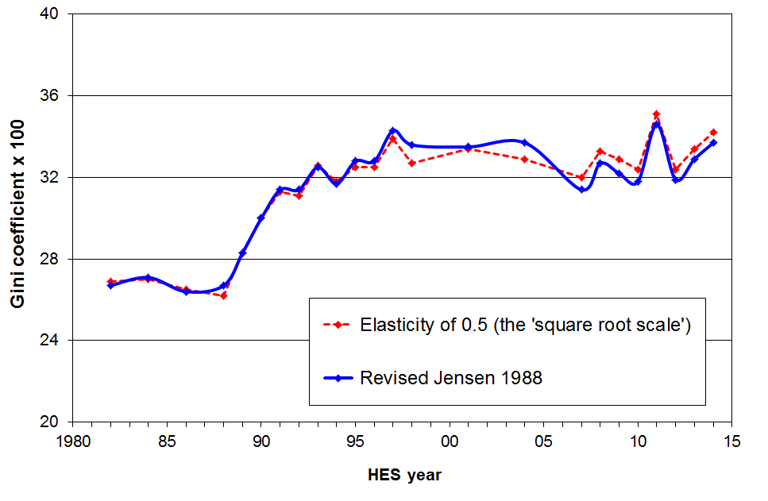

Figures 3.3 and 3.4 show trends in poverty rates for the whole population and for children respectively, using a 60% of contemporary median threshold (REL approach) and three different equivalence scales. Long-run trends are unaffected by the choice of scale, although relative changes between adjacent reporting years do vary a little.

Figure 3.3
Sensitivity of poverty rate to choice of equivalence scale:
whole population, using a threshold of 60% of the contemporary median (BHC)

Figure 3.4
Sensitivity of poverty rate to choice of equivalence scale:
children (0-17), using a threshold of 60% of the contemporary median (BHC)

Figure 3.5 shows trends in poverty rates for children (0-17) using three different scales and the 50% of median REL measure. As expected, the modified OECD and RJS 1988 scales produce very similar results. The big difference in this case is the much higher rates produced by the square root scale in the first half of the 1990s. In relation to households with children the square root scale makes an implicit assessment of higher costs for sole parent families than do the other two. This will generally lead to higher reported child poverty rates using the square root scale, and in particular years, the REL threshold using the square root scale will move enough to just go above a large cluster of families whose sole income source is the Domestic Purposes Benefit together with other government transfers. This can lead to a blip in the relative trends.

Figure 3.5
Sensitivity of poverty rate to choice of equivalence scale:
children (0-17), using a threshold of 50% of the contemporary median (BHC)
Choice of scale for AHC incomes analysis

This report uses the same equivalence ratios for AHC analysis as for BHC analysis. However, because there are greater economies of scale for accommodation than for other expenses, there is a case for using a different set of scales for AHC analysis than for BHC. The AHC scales should reflect the more limited scope for economies of scale when looking only at residual income after housing costs have been deducted (AHC).

The UK’s Households Below Average Income reports now use such a scale for their AHC analysis. Instead of attributing an extra 0.50 for second and subsequent adults as it does for the BHC case (Table 3.1 above, the modified OECD scale), it uses 0.72. This reflects the more limited scope for economies of scale for adults in non-accommodation costs. The child factor increases only slightly from 0.30 to 0.34. For the purposes of comparing scales it is easier to re-base them to a couple HH having a value of 1.00. This makes the first adult 0.58, second and subsequent adults 0.42 and children 0.20.

Table 3.3 below compares the BHC and AHC scales that the UK now uses (DWP, 2007).

Table 3.3
Equivalence scale used in the UK for AHC analysis
compared with the one used for BHC analysis and with the Revised Jensen Scale
HH type | RJS 1988 | ‘Modified OECD’ scale for BHC analysis | ‘Companion’ scale for AHC analysis
(1,0) | 0.65 | 0.67 | 0.58
(1,1) | 0.91 | 0.87 | 0.78
(1,2) | 1.14 | 1.07 | 0.98
(2,0) | 1.00 | 1.00 | 1.00
(2,1) | 1.21 | 1.20 | 1.20
(2,2) | 1.41 | 1.40 | 1.40
(2,3) | 1.58 | 1.60 | 1.60
(3,0) | 1.29 | 1.33 | 1.42

In adopting the ‘companion scale’ for AHC analysis, two sets of relativities are changed compared with staying with ‘modified OECD’ scale for AHC analysis too:
- those between singles and couples – the unequivalised income needed by a single-person HH to reach the same potential living standards as a couple is lower;
- those between sole parent and two parent households - the unequivalised income needed by a sole parent HH to reach the same potential living standards as a two parent HH is lower;

The consequence of this is that poverty rates for single-person households and sole parent households could be expected to reduce somewhat relative to those for couples and two parent households respectively, when using the companion scale. The lower panel in Table 3.4 confirms this. The table also shows that poverty structure remains much the same in that the those sub-groups with higher rates remain relatively high and those with lower rates remain relatively low.

While the theoretical purity of using an alternative scale for AHC analysis is attractive, in practice the difference is not so great as might be expected. This result gives reasonable support for the protocol adopted in this report – the same set of scales is used for BHC and AHC analysis – but points to the need to at least report the sensitivity of findings to the choice of a scale that recognises that on an AHC basis there is much less scope for economies of scale.

Table 3.4
Proportions below a 60% REL threshold, HES 2004:
comparisons using three different equivalence scales (AHC incomes)
 | RJS 1988 | ‘Modified OECD’ | HBAI ‘companion’ scale for AHC analysis
Total population | 20 | 20 | 19
0-17 | 28 | 27 | 26
18-24 | 23 | 23 | 24
25-44 | 19 | 20 | 19
35-64 | 15 | 14 | 14
65+ | 9 | 9 | 7
By household type
Single 65+ | 18 | 19 | 11
Couple 65+ | 5 | 4 | 4
Single < 65 | 30 | 30 | 26
Couple < 65 | 13 | 13 | 13
SP with children | 65 | 57 | 49
2P with children | 19 | 20 | 19
Other family HHs with children | 17 | 19 | 23
Other family HHs, adults only | 12 | 12 | 13
Non-family HHs | 25 | 25 | 26

Note: the AHC threshold is set the 60% of the BHC median, less 25% to allow for average housing costs.

Appendix 4

Analysis unit: sensitivity of results to choice of household or individual for calculating medians and reporting poverty rates and inequality

This report attributes the equivalised household income to each household member as an indicator of each individual’s ‘access to resources’ or material wellbeing. Individuals are then ranked on this income for division into deciles, establishing medians and counting numbers below poverty lines, and so on. This is standard practice internationally.

Before this approach became the standard, some of the literature ranked households rather than individuals. The median income was the middle household’s income and the number in ‘poverty’ were the number of households below a given line.

Figure 4.1 shows that the different ways of ranking make only a very minor difference for medians.

Figure 4.2 shows that there are some noticeable differences for year-on-year comparisons for population poverty rates depending on whether one counts households or individuals, but the overall longer-term trend is not affected by the decision.

Figure 4.1
Median equivalised household incomes ($2014):
comparison using the middle individual and the middle household
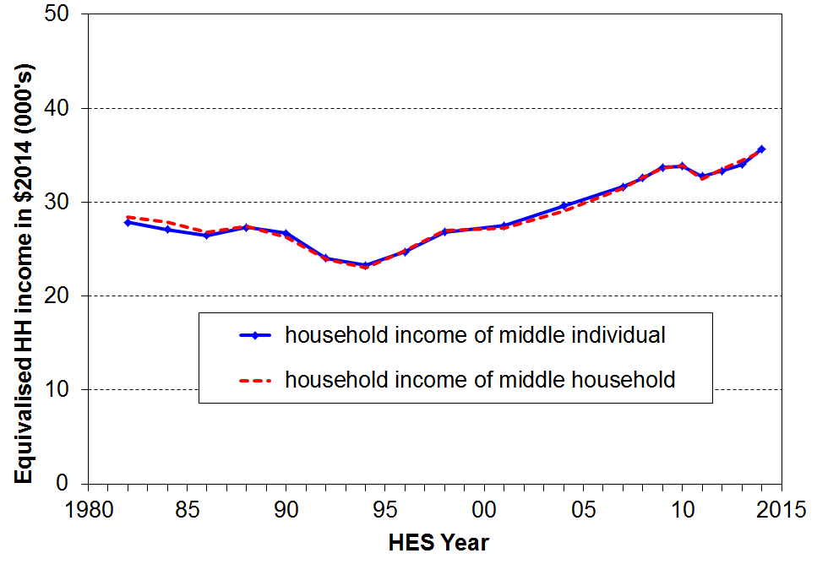

Figure 4.2
Proportions below the 60% REL threshold (BHC):
comparisons using individuals and households

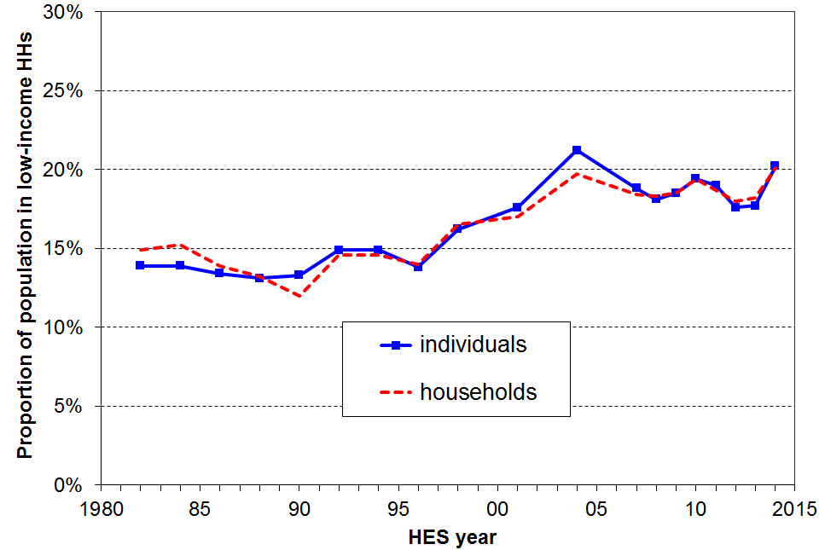

Appendix 5

Incomes before and after deducting housing costs (BHC and AHC)

The report provides information based on household income both before deducting housing costs (BHC) and after deducting housing costs (AHC).

Housing costs include all mortgage outgoings (principal and interest) together with rent and rates for all household members. Repairs and maintenance and dwelling insurance are not included. Any housing-related cash assistance from the state (eg Accommodation Supplement) is included in household income.

For reporting on overall trends in household income and on income inequality, there is value in seeing the similarities and differences between the two measures and in understanding the differing stories they tell.

For reporting on trends in income poverty over time and for comparing hardship across subgroups of the population, the report again reports on both BHC and AHC measures, but recommends the use of AHC measures as the preferred measure.

The use of BHC measures is generally taken as the self-evident starting point. They are important for assessing the adequacy of market and social assistance incomes for delivering a minimum acceptable standard of living. Their use also ensures that the material well-being of those on low incomes who choose to live where accommodation is less expensive (eg some rural areas) or who live in ‘cheap’ sub-standard accommodation is not left overstated (relatively) as the use of an AHC approach on its own can do.

The rationale for the report’s position that AHC analysis should also be reported, and that the AHC approach is preferable for sub-group comparisons in New Zealand is that:
- First, variations in housing costs do not correspond to similar variations in housing quality. Such variations can occur for housing in different regions, but is most significant when comparing the material well-being of age-groups. Many older individuals are in households that have good accommodation and relatively low housing costs (eg those living in mortgage-free homes). Many in an earlier part of the lifecycle have a similar standard of accommodation but relatively high accommodation costs. This variation in costs for the same or similar consumption is higher than for other budget items. This suggests that housing costs should be deducted from income to get a more reliable assessment of relative material well-being across different sub-groups.
- Second, many would argue that the theoretically most acceptable way of dealing with issues around incorporating housing benefits (direct and indirect) and housing costs is to add the imputed value of indirect housing benefits to the income measure and then on the basis of this fuller measure to calculate poverty rates and so on. However, apart from any conceptual or theoretical challenges faced by this approach, there is a practical difficulty in that the value of imputed rent of owner-occupied housing and of government housing subsidies is not often (reliably) available. For the purposes of comparing the economic well-being of different groups using an incomes measure, deducting housing costs from cash income (the AHC approach) can be seen as an approximation to the theoretically more comprehensive approach of estimating and adding imputed rent for homeowners. This rationale is in effect a variant of the first point made above.
- Third, once a household is committed to a particular residence, outgoings on housing costs cannot easily be adjusted or put off in ‘tight times’ as they can for other expenses like entertainment and recreation, and even to some degree for basics like food and clothing. The primary focus of this report is on trends in inequality and hardship and it is important to understand trends in ‘residual income’, taking housing costs as a given fixed cost in effect.
- Fourth, housing costs represent a very significant proportion of the total spending of many low-income households. These housing costs make up on average around a quarter of the budget for working-age low-income households. For many with low incomes, housing costs make up much more than a quarter of the budget. This is the key context for the first three points above.
- Finally, a unique characteristic of the New Zealand BHC income distribution is the very large ‘pensioner spike’ at around the value of New Zealand Superannuation. This occurs close to a 60% of median poverty line (BHC) and can lead to large variations in reported poverty rates for the 65+ group over time, leaving the misleading impression that there are significant changes in material wellbeing occurring for this group. In addition, the same issue can lead to similarly misleading comparisons with the relative wellbeing of other age-groups. An AHC approach avoids these issues and is more suitable as the primary measure (for New Zealand at least). This is further discussed in Section H.

The above arguments are generally seen as sufficient to justify at least the reporting on AHC measures alongside BHC ones. This report goes one step further and recommends the AHC approach for comparing poverty trends over time and especially for examining sub-group relativities, primarily because of the implications of the pensioner spike. Four counter-arguments are sometimes raised when considering the issue.

- First, some would argue that housing costs are like any other cost a household faces. Different households make different choices as to what to prioritise in the budget. It is argued that it is no more justified to deduct housing costs than, say, food costs, which can also vary between households of similar size and composition. One of the challenges to this view is already captured in the third point above – once a household is committed to a particular residence housing costs cannot easily be adjusted or put off in ‘tight times’ as they can for other items.

- Second, it can be argued that an AHC approach understates the relative standard of living of those whose material well-being is higher as a result of paying higher housing costs for better accommodation. The flip-side of this is that a BHC approach overstates the standard of living of those whose housing costs are high relative to the quality of their accommodation.

- Third, when considering changes over time, the AHC approach understates improvements in living standards when higher real housing costs do reflect improving standard of living. The flip-side of this is that a BHC approach may overstate the improvements in living standards when the Accommodation Supplement rises to offset higher rents. BHC income rises, but there is no commensurate rise in living standards.

- Fourth, for international comparisons a BHC approach is needed because that is the metric used internationally. This is true, but the updating over time is usually done on a ‘moving line’ (REL) approach, not on a ‘fixed line’ (CV) approach as this report and the Social Report use as the more fundamental approach.

None of the proposed counter-arguments appear conclusive. In addition, the AHC approach is well supported by the rationale outlined earlier above, and the issue of the ‘pensioner spike’ remains a very awkward one for a BHC analysis of income poverty trends for this age-group and for assessing sub-group relativities.

Appendix 6

Rationale for setting of low-income thresholds or ‘poverty lines’

Different countries and different researchers set low-income thresholds or poverty lines in a number of different ways. The two broad types of approach are to take proportions of the median or mean of the income distribution as the low-income thresholds (a distributional approach) or to use information from outside the distribution based on budget standards, expenditure data, ‘asking the people’, or a mixture of all three.

This report uses a distributional approach, based on 50% and 60% of median household equivalised income, drawing support for the decision from a range of considerations outside the income distribution. For updating thresholds over time, both ‘moving line’ (relative threshold) and ‘fixed line’ (constant-value threshold) approaches are used. The conceptual differences between the two are discussed in Section E.

BHC thresholds

The 60% of median threshold (BHC) has been formally adopted by EU member states as the EU’s primary measure of income poverty. It is also used by the UK as one of its three indicators in its composite official measure of child poverty. The OECD uses the 50% threshold for the bulk of its international comparisons but it also collects and uses analysis based on a 60% threshold.

Despite the reasonable consensus around the use of 50% and 60% thresholds there is an inherent arbitrariness about the choice of any particular percentage of the median. There are however some considerations that provide support for their use, for New Zealand at least.

First, the focus group research with low-income householders carried out by the New Zealand Poverty Measurement Project (NZPMP) found that budgets for minimum adequate income that allows a household to live independently without recourse, for example, to a foodbank, equated to around 60% of the median household income in the early 1990s. The research was not intended to imply that the 60% threshold was fixed for all regions and for all time. Indeed the NZPMP reports indicate that in Auckland for example the budget information suggests a higher threshold of around 66% of the median, with a lower figure for rural areas. More recent focus group work by the PMP team still points to minimum budget requirements on average of around 60% of the median.

Second, the 50% threshold is as low as is reasonable to go on the grounds that anything much under 50% is below social assistance levels which generally lie in the 50% to 65% range. Apart from the self-employed, there should therefore not be great numbers with reported incomes much under the 50% line.

Third, the 50% threshold is as low as is reasonable to go on the grounds that anything less than 50% takes the BHC threshold too far into the bottom decile where income is generally an unreliable indicator of access to resources. Even 50% itself is on the edge in this regard for some purposes. It is possible to devise a defensible rule for deleting or adjusting the most glaring cases for which there is evidence that the reported incomes are unreliable indicators of potential living standards, but this usually requires expenditure information which is not always available in surveys.

Fourth, NZS has ranged from 48% to 67% in the period 1982 to 2010. This suggests some sort of broad consensus that incomes in this ball-park are the minimum acceptable for older New Zealanders.

Fifth, the 1972 Royal Commission on Social Security operationalised the principle of ‘participation and belonging’ by defining a minimum-income level which came to be known as the Benefit Datum Line (BDL) (Easton, 1995a). When the BDL is adjusted by the CPI it is equivalent to 50% of the median for the 2004 HES. Given the general growth in affluence over the three decades following 1972 it would be unlikely that a poverty line lower than the BDL in real terms would command great support.

Sixth, readers are encouraged to look at the low-income thresholds noted in Tables E.3 and E.4 and to make their own call on the reasonableness of these as ‘poverty lines’. It is not likely that many would find them overly generous.

Finally, while the choice of threshold makes a significant difference for reported poverty levels at a given time, the choice very rarely makes a difference to the direction of trends and has very little impact on the identification of those groups most at risk of hardship.

Figure 6.1 shows the proportion of people in low-income (BHC) households for a range of thresholds set relative to the contemporary median (the ‘moving line’ approach). Note that the trend lines move in reasonable synch.

Figure 6.1
Proportion below median-based thresholds (BHC, REL)

AHC thresholds

There are two (related) questions to consider in setting AHC thresholds:
- what concept of housing costs is to be used?
- what rationale is available to guide the setting of AHC thresholds?

Concept of housing costs

This report defines housing costs (HC) fairly narrowly to include mortgage outgoing paid by the household, rent, rates and other payments to local authorities. Repairs and maintenance items are not included. This makes the HC concept different from that used in the HES ‘housing group’ category which includes ‘property maintenance goods’ and ‘property maintenance services’. Dwelling insurance is a possible candidate but are not counted either.

There are good arguments for both wider and narrower conceptualisations of housing costs for the purposes of reporting on hardship and inequality. There is however a very practical matter that directs us to the narrower HC concept: the new ‘incomes only’ HESs for the years in between the three-yearly full HESs (HES 2008 is the first of these) do not have any information on repairs and maintenance costs, as these are derived from the expenditure diary which will not be used for these surveys. If AHC poverty and inequality measures are to be produced each year, then the narrower concept has to be used.

The full Housing Group costs and the HC costs are distributed differently across the income distribution. Housing Group costs are around 24% of total expenditure for each gross income decile. On the other hand, rent, mortgage and rates (the HC concept) are a smaller proportion of outgoings for middle income households than for poorer households. This has implications for the way the AHC thresholds are set.

Rationale for setting AHC thresholds

On the basis of the consensus around the 50% and 60% thresholds for BHC analysis it would seem straightforward to simply use AHC thresholds set at 50% and 60% of the AHC median.

There are two sets of evidence that suggest an alternative approach needs to be considered.

First, AHC medians have been some 18% to 20% lower than BHC medians since 1996. This means that if we used a straight distributional approach to setting the AHC thresholds (eg 50% and 60% of the AHC median), then a given AHC threshold would also be 18% to 20% lower than the corresponding BHC one for the period. The implication of this is that a household with a BHC income just below 60% of the BHC median is declared AHC poor if its housing costs are anything more than 20% of its BHC income.

This (20%) is a very low proportion of income being spent on housing for a low-income household. It is unrealistic and does not square with a range of considerations which point to the use of 25% or 30-33% as reasonable figures. Some of these considerations are that:
- Lower-income working-age households on average spend proportionately more than middle-income households do on housing understood in terms of rent, mortgage and rates (around 25% compared with around 20%, since 1996).
- New Zealand’s income related rents policy uses a 25% setting.
- The entry thresholds for receipt of the Accommodation Supplement (AS) for renters are set at 25% of net household income. (Note that recipients generally pay more than 25% of their household income (including the AS) on housing as the AS does not fully cover the remaining amount).
- There is some rule-of-thumb international consensus that poorer households spending more than 25% to 30% of their BHC income on housing are AHC poor.

The second piece of evidence is that the NZPMP’s focus groups point not only to a BHC threshold of around 60% of the median, but also to a minimum of 25% of the BHC budget being required for housing costs. If the NZPMP research is to guide the choice of 60% for BHC analysis, then in the interests of internal coherence it should also guide for AHC thresholds.

These considerations provide a rationale for setting the AHC threshold equal to the BHC threshold less 25% (at least), rather than simply using a distributional approach based directly on the AHC median, which produces an AHC threshold only 18-20% lower than the corresponding BHC one, depending on the year.

The ‘deduct 25% (or 33%)’ approach also has the advantage of not being influenced by what happens to housing costs for middle-income households, which would be the case if a straight distributional measure were used. If the proportion that middle-income households spend on rent, mortgage and rates rises over time (as it has) then the distributional AHC poverty lines would fall over time and, all else equal, AHC poverty rates would be reported as falling even though nothing was changing for the poor. This is not a desirable property for a poverty measure.

Using 33% rather than 25% as the allowance for housing costs when constructing an AHC poverty line?

As indicated above, 25% is the minimum allowance for housing costs that is reasonable to make for low-income households. There is a case too for using something more like a third (30-33%). The decision depends in the end on a judgement call as to whether an AHC household budget of BHC threshold less 25% or one of BHC threshold less 33% is more congruent with our notion of “minimum acceptable”. Table 6.1 below gives the ‘BHC less 33%’ thresholds. See Table E.3 for ‘BHC less 25%’.

Table 6.1
50% and 60% low-income thresholds for various household types (AHC), ($2014, pw)
(See Table E.3 for BHC less 25%)
AHC = BHC less 33% |  | REL (‘moving’) |  | CV (‘anchored’ /‘fixed’)
Household type | Equiv ratio | 50% of 2014 median | 60% of 2014 median | 60% of 2007 median in $2014
One-person HH | 1.00 | 230 | 275 | 245
SP, 1 child | 1.40 | 320 | 385 | 340
SP, 2 children | 1.75 | 400 | 480 | 430
SP, 3 children | 2.06 | 470 | 570 | 500
Couple only | 1.54 | 350 | 425 | 380
2P, 1 child | 1.86 | 430 | 520 | 455
2P, 2 children | 2.17 | 500 | 600 | 530
2P, 3 children | 2.43 | 560 | 670 | 595
2P, 4 children | 2.69 | 620 | 740 | 660
3 adults | 1.98 | 455 | 545 | 485

Using 33% rather than 25% as the allowance for housing costs lowers the AHC poverty lines in dollar terms. This leads to lower reported AHC poverty rates.

Figure 6.2 shows the difference it makes if the allowance for housing costs were increased to 33% instead of 25%. The reported population poverty rate is lowered as there are fewer low-income households with OTIs >33% than with OTIs > 25%. As is evident from the graphs, the AHC poverty rates are reasonably sensitive to the decision about what % of BHC median income to deduct to construct the AHC thresholds. For example, in HES 2014, the overall population rate using the AHC 60% of median REL (moving line) measure becomes 17% rather than 20% using the 33% and 25% deductions respectively. Trends remain the same whether the 25% or 33% allowance is made.

Figure 6.2
Proportions below the 60% REL threshold (AHC) using 25% and 33%: full population

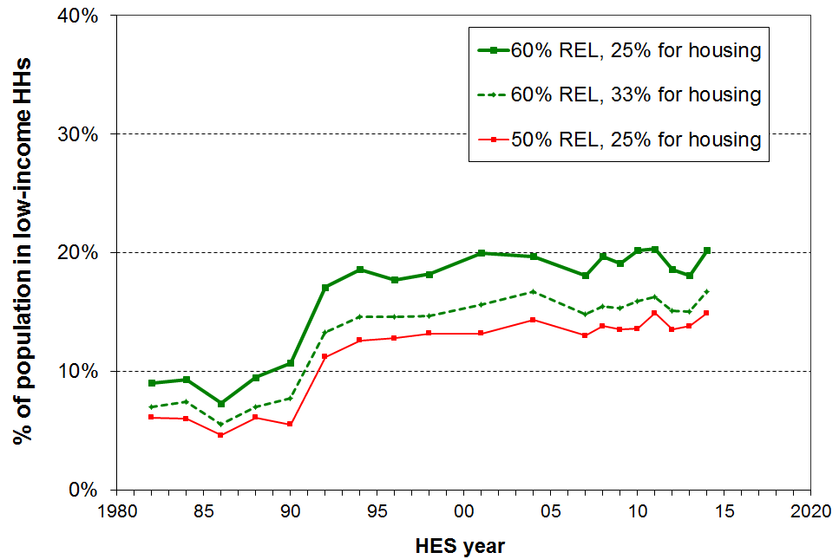

Figure 6.3 repeats Figure 6.2 for children. In HES 2014, the child poverty rate using the 60% of median REL (moving line) measure becomes 23% rather than 29%.

Figure 6.3
Proportions below the 60% REL threshold (AHC) using 25% and 33%: children (0-17 yrs)
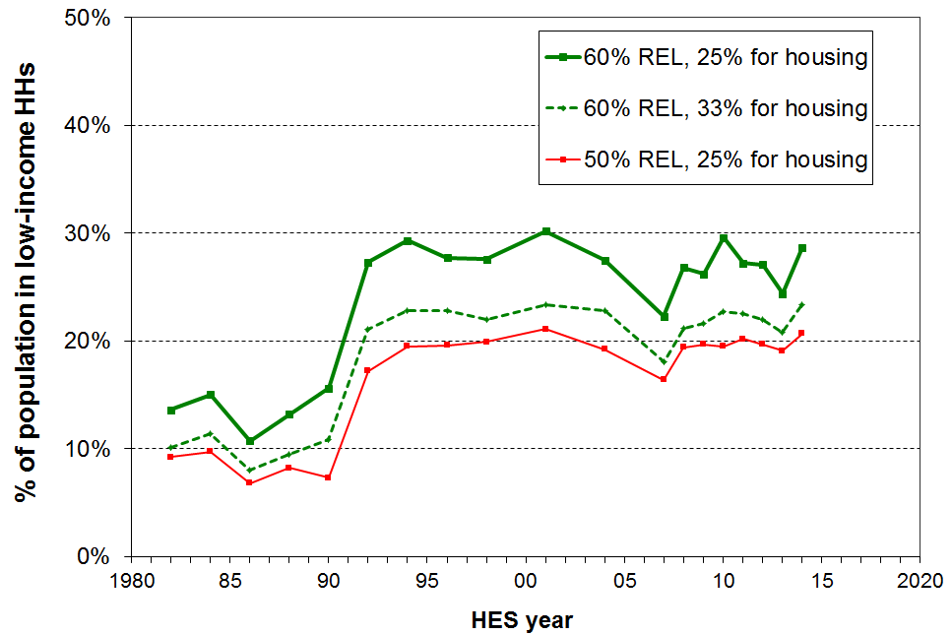

Using non-monetary indicators (NMIs) to illustrate the sorts of restriction on living standards experienced by low-income households

From 2007 the Household Economic Surveys have gathered NMI information from a subset of the items that make up the ELSI scale used in Section L.

The graph and table below use selected NMIs from the HES and from the 2008 Living Standards Survey (LSS) to illustrate some of the restrictions on day-to-day living standards experienced by low-income households. Of particular relevance to the theme of this Appendix (setting poverty thresholds) is the evidence they give for the actual experiences of many in the bottom quintile (AHC incomes). These low-income households:
- have quite significant restrictions on their day-to-day living standards compared with what is the typical experience of most of the rest of the population
- are excluded through lack of financial resources from many aspects of what society more generally would consider to be a minimum acceptable standard of living.
This is the essence of what it means to be in poverty in a more economically developed country, as discussed in Section E.

Figure 6.3, based on NMI data from the 2010 HES, clearly shows the much greater risk of hardship for low-income households than for most of the rest of the population. The 11 items used are all either necessities or ones that are commonplace among the bulk of the population, or both. The graph shows the proportions reporting either an ‘enforced lack’ of an item because of the cost, or the decision to ‘economise a lot’ on the item so as to be able to pay for other basics. The lower two deciles stand out as being quite different in their risk of hardship compared with most of the rest of the population.

Figure 6.3
Proportion reporting not having / economising a lot on 4 or more of 11 basic items, because of cost:
all households, HES 2010

The 11 items used in Figure 6.3 are of two types:
- 7 ‘enforced lacks’ of basics that the respondent ‘wants’ but cannot have or do because of the cost:
- telephone
- good pair of shoes
- heating available in all main rooms
- contents insurance
- give presents to family or friends on special occasions
- have family or friends over for a meal at least once a month
- have a week’s holiday away from home each year
- 4 ‘economising’ items. The survey gives the option of ‘not at all’, ‘a little’ and ‘a lot’ as a response. The graph uses only the more stringent ‘ lot’ response:
- gone without fresh fruit and vegetables to help keep costs down (‘a lot’)
- put off buying new clothes for as long as possible to help keep costs down (‘a lot’)
- postponed or put off visits to the doctor to help keep down costs (‘a lot’)
- did not pick up a prescription to help keep down costs (‘a lot’)
Appendix 7

Indices used to adjust for inflation

Household incomes and low-income thresholds are adjusted for inflation at various places in the report. Incomes are converted to 2010 dollars for reporting on income trends in real terms. For the reporting on trends in income poverty based on a ‘fixed line’ approach, thresholds are based on proportions of the 2007 median and are held constant in real terms over other years.

The adjustments for inflation are carried out using CPI full year averages for a March year up to and including the 1998 survey and a June year from 2001. For BHC incomes Statistics New Zealand’s CPIQ.SE9A series are used – taking the average of the four quarters for the appropriate periods. AHC incomes and thresholds from 1989 are adjusted using the index from the All Groups less Housing series (CPIQ.SE9NS1010) using the same averaging approach as for BHC. For 1982 to 1988 the AHC adjustments are based on the author’s extrapolation of the series. The reported trends in AHC incomes and the size of low-income populations are not sensitive to different assumptions within a plausible range for the index in the estimated years.

Table 7.1 contains the indices used in the report to adjust for inflation.

Table 7.1
Indices used to adjust incomes for inflation
HES year | BHC | AHC
1982 | 375 | 418
1984 | 455 | 503
1986 | 569 | 613
1988 | 740 | 782
1989 | 778 | 823
1990 | 828 | 857
1991 | 873 | 902
1992 | 888 | 918
1993 | 897 | 929
1994 | 910 | 935
1995 | 932 | 947
1996 | 962 | 972
1997 | 983 | 989
1998 | 994 | 993
2001 | 1044 | 1051
2004 | 1113 | 1107
2007 | 1213 | 1186
2008 | 1251 | 1219
2009 | 1292 | 1261
2010 | 1316 | 1283
2011 | 1366 | 1335
2012 | 1396 | 1362
2013 | 1407 | 1366
2014 | 1429 | 1379

Appendix 8

The bottom income decile: income often not a reliable indicator of material wellbeing

While household income is far from perfect as a measure of material wellbeing it is generally a useful enough indicator. There are however some households for whom it would clearly be highly misleading to take their incomes as even a rough and ready indicator of their material living standards. This assessment is based on comparisons with information beyond the incomes reported in the survey:
- some households have implausibly low incomes, well below the minimum social support levels
- some have reported expenditures well above their reported incomes
- some meet both criteria.

Some of these households (whether with implausibly low incomes per se, or with expenditure well above reported income) will be declaring income from self-employment. This can legitimately be much lower than reported expenditure – the declared income may even be negative. Others will have accurately reported their incomes but will have had access to loans, gifts or savings in one form or other which have been used for purchasing goods and services. Others will have intentionally or unintentionally under-reported their incomes.

This Appendix provides an assessment of the significance of the impact of the issue on the key indicators used in the report, and concludes that with the exception of indicators of poverty depth the noise does not unduly compromise the results. To provide both a means of making the assessment and a means of mitigating the impact on poverty depth measures, the Appendix also outlines and applies a noise reducing protocol to modify the dataset.

Most of the unreliability is in the bottom decile

Households with implausibly low incomes are of course found only in the bottom decile (bottom tenth of the income distribution). The reported incomes of many at the bottom are less than the incomes provided by government cash benefits or New Zealand Superannuation. This points to mis-reporting or data entry errors.

Those reporting expenditure much higher than reported income are found in most parts of the income distribution but the bulk of them are found in the bottom decile.
- For example, of all those in households reporting expenditure which is more than three times their income, around 75% to 80% are in the bottom income decile in any survey year.
- In any survey year, around one quarter to one third of those in the bottom decile are in households with this high expenditure-to-income ratio. No other decile is like this in regards to expenditure so greatly exceeding income for so many.
- Average household expenditure for the bottom decile is typically around 2.5 times the average reported income and is more like the reported expenditure of the third and fourth income deciles;
- A sizeable proportion of those in the bottom decile (eg 50% in the 2004 HES) report expenditure higher than the incomes of households at the top of the second income decile.

There is therefore clear evidence that for many of the households in the bottom decile household income is a very unreliable indicator of access to resources and of material wellbeing. In other words, there is considerable ‘noise’ at the bottom end of the distribution. Whatever the explanation is, it would be misleading to assume that the bottom 10% on the income distribution also have the lowest living standards.

Impact of bottom decile noise on key indicators

All of this can have a significant impact on some of the key indicators used in this report. The most significant impact is on measures of poverty depth (see Section E), with a more moderate impact on reported income levels at the top of the bottom decile (P10 incomes). The impact on reported poverty rates at a point in time and on the relative composition of those identified as poor depends on the poverty line used, with the greater impact occurring for lower thresholds.

On the other hand, the noise in the bottom decile does not have a significant impact on the medians as the bulk of households in question remain below the median even if their expenditures were taken as better estimates of their actual income than what was reported as such. There is in general no significant impact on reported trends in inequality and poverty.

Table 8.1 below illustrates the differential impact of the ‘noise’ on various sub-groups and across different thresholds. It shows the proportion of various sub-groups whose household incomes put them below the income threshold in question, but whose expenditure is more than double the selected threshold. Note the large amount of noise when using a 40% threshold, and that even the 50% threshold is marginal on the criterion used.

Table 8.1
Proportions (%) of sub-groups in income poverty whose expenditure is more than double the selected low-income threshold, HES 2004 (BHC)
 | Poverty lines as a % of the 2004 median (BHC)
Sub-group | 40% | 50% | 60% | 70%
Self-employed | 59 | 42 | 30 | 26
0-17 | 29 | 11 | 7 | 4
18-24 | 68 | 55 | 37 | 14
25-40 | 50 | 25 | 17 | 11
41-64 | 50 | 26 | 14 | 9
65+ | 22 | 8 | 6 | 5
Two parent with any dep ch | 24 | 9 | 9 | 6
Sole parent with any dep ch | 51 | 18 | 5 | 2
HHs <65 with 2+ adults, no dep children | 68 | 59 | 38 | 21
Population overall | 46 | 24 | 13 | 8

The self-employed make up only around 5% to 6% of the poor, whichever threshold is used, and their poverty rates are around a quarter to a third less than the rest of the population. The self-employed are not therefore the main source of the noise at the bottom end of the distribution. The main source is working-age households with two or more adults and no dependent children, whatever their income source.

Bottom decile noise is a recognised problem

The unreliability of bottom-decile incomes as an indicator of living standards is not an issue that is unique to New Zealand.

Because of the problems with the bottom decile, the Australian Bureau of Statistics uses deciles 2 and 3 (rather than deciles 1 and 2) as their bottom quintile to encapsulate low-income households (ABS, 2011). This is an extreme approach which makes the production of income poverty figures impossible.

In the United Kingdom, the Department for Work and Pensions warns in its Households Below Average Incomes publications that incomes in the bottom decile cannot be taken as a reliable guide to living standards. They follow through on this in their poverty tables by printing in italics the estimates based on a 50% of median threshold to remind the reader of the greater uncertainties using that threshold compared with using the 60% and 70% thresholds.

One of several pieces of research that supports the UK position is reported in Brewer at al (2009). Figure 8.1 shows that material deprivation increases as expected as household income falls, as expected. However, for households with very low incomes (under around GBP150 per week), material deprivation falls (living standards rise). This is partly explained by the observation that these very low-income households have on average much higher financial assets than the ‘low-income’ counterparts.

Figure 8.1
Some very low-income households with children have good financial assets – these enable these households to avoid the low living standards that their income alone suggests they would experience
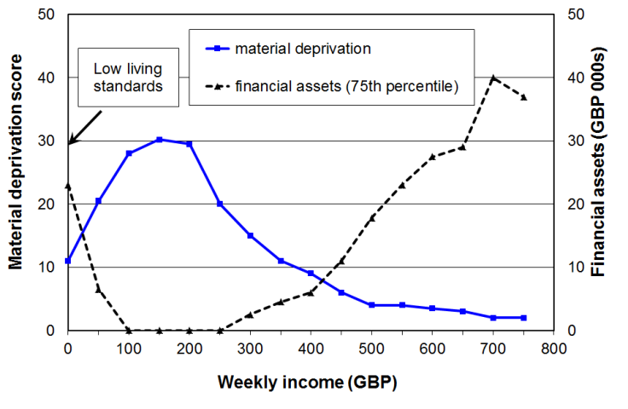
Source: Brewer et al (2009), Tables 5.1 and 5.2

The Luxembourg Incomes Study (LIS) bottom codes to lift all household incomes to at least 1% of the mean equivalised household income.

The New Zealand Poverty Measurement Project (NZPMP) recognised the problem and sought to address it by deleting from the dataset those self-employed who declared losses and those whose expenditure was more than three times their income. The effect of this adjustment to the dataset is to slightly reduce reported poverty rates.

The approach used in this report to reduce the noise in the bottom decile

In selected circumstances this report uses the HES expenditure data to impute a more plausible income to households whose reported incomes are very low compared with their expenditure. All those households with reported expenditures of more than three times reported income are given a notional income equal to the average of their reported income and expenditure.

Figure 8.2 shows that this adjustment significantly reduces the noise at the lower end of the distribution as the imputed incomes more reasonably represent these households’ access to financial resources.

Compared with the option of removing the relevant households from the data set, this approach has the advantage of not impacting on the size and composition of the population and sub-population estimates using the standard Statistics New Zealand weightings.
Figure 8.2
‘Noise’ reduction using the modified dataset:
proportion of the population below selected thresholds and with expenditure > double the selected threshold (HES 2004)
Note: In the modified dataset, all HHs with expenditure more than three times their income are assigned an imputed income equal to the average of their expenditure and income. 75% of these HHs come from the lowest decile and 84% from the lowest two deciles.

Table 8.2 repeats Table 8.1 to show how the imputation approach reduces ‘noise’ as indicated by the proportions of the poor from various subgroups who have expenditure more than double the selected income poverty line. Table 8.1 uses the standard HES dataset. Table 8.2 uses the modified dataset.

Table 8.2
Proportions (%) of sub-groups in income poverty whose expenditure is more than double the selected threshold, HES 2004 (BHC) – modified dataset (see text)

 | Poverty lines as a % of the 2004 median (BHC)
Sub-group | 40% | 50% | 60% | 70%
Self-employed | * | * | 12 | 5
0-17 | 13 | 5 | 3 | 2
18-24 | * | 20 | 12 | 2
26-40 | 23 | 8 | 7 | 2
41-64 | 23 | 6 | 6 | 2
65+ | 0 | 0 | 3 | 2
Two parent with any dep ch | 21 | 5 | 5 | 3
Sole parent with any dep ch | 7 | 6 | 1 | 0
HHs <65 with 2 or more adults, no dep children | 25 | 21 | 13 | 3
Population overall | 18 | 7 | 5 | 2

Notes: An asterisk (*) in a cell indicates that the sample numbers are too small to provide reliable estimates for that cell

What indicators are changed most by reducing the noise at the bottom end?

For reporting on poverty depth the noise at the bottom has a significant impact. This can be seen from the results for the mean poverty depth in Table 8.3 below. The mean poverty depth figures are significantly different (lower) when the modified dataset is used. This is to be expected given that the mean depth is strongly influenced by the proportion of households with very low incomes.

Table 8.3
Comparison of poverty depth (%) using the standard and modified HES 2004 datasets (BHC)
 | Poverty lines as a proportion (%) of the median (BHC)
 | 40% |  | 50% |  | 60%
 | Std | Modified | Std | Modified | Std | Modified
Median poverty depth | 27 | 12 | 20 | 18 | 16 | 12
Mean poverty depth | 43 | 23 | 33 | 23 | 25 | 19

Figure 8.3 shows that estimates of the Total Poverty Gap are also considerably higher when using the standard dataset as so many decile one households having implausibly low low incomes.

Figure 8.3
Total Poverty Gap
(BHC, 60% 1998CV threshold):
estimates compared for standard and modified datasets

Table 8.4 compares the poverty rates for the various subgroups using the standard and modified datasets. Unsurprisingly the poverty rates using the modified dataset are all lower than when using the standard set. Note though that the reported poverty rates for the population as a whole and for sub-groups of special policy interest (children, those in sole-parent households and older New Zealanders) are not greatly changed by using the modified dataset. The largest differences are for those aged 18 to 24 and for working-age households with two or more adults and no dependent children.

Table 8.4
Comparison of poverty rates (%) using the standard and modified HES 2004 datasets (BHC)
 | Poverty lines as a % of the median (BHC)
 | 40% |  | 50% |  | 60%
Sub-group | Std | Modified | Std | Modified | Std | Modified
Self-employed | 4 | 1 | 8 | 5 | 15 | 12
0-17 | 6 | 5 | 15 | 14 | 26 | 26
18-24 | 9 | 4 | 14 | 8 | 18 | 13
26-40 | 5 | 4 | 10 | 8 | 16 | 15
41-64 | 5 | 4 | 9 | 7 | 16 | 15
65+ | 1 | 1 | 3 | 3 | 37 | 38
Two parent with any dep ch | 3 | 3 | 9 | 9 | 16 | 17
Sole parent with any dep ch | 12 | 10 | 34 | 31 | 60 | 59
HHs <65 with ≥ 2adults, no dep children | 6 | 2 | 10 | 4 | 14 | 8
Population overall | 5 | 4 | 10 | 9 | 21 | 20

The differences between the two sets of results would have been larger if an exogenously determined poverty line (eg “$13,000”) had been used and applied to both datasets. As it is, the modified dataset produces a slightly higher median and therefore the poverty thresholds are correspondingly higher (~2%). These higher thresholds (in dollar terms) offset to some degree the poverty-reducing effect of the imputed household incomes being higher than the reported incomes. Nevertheless, this preliminary analysis gives some assurance that the use of the standard dataset does not in the main produce misleading results, for the reporting of poverty rates using 50%, 60% and higher thresholds.

Figure 8.4 shows the difference the modifications make to incomes at the top of the bottom decile (P10). The P10 values over the 1982 to 2004 period are all higher using the modified dataset, as would be expected (around 2-4% higher). The trend is unchanged, except that in the 2004 HES, the noise at the bottom was such that the standard dataset shows a decline in real P10 incomes (‘the poor became poorer’) whereas the modified dataset shows a rise in P10 (‘the poor became less poor’). The difference in 2004 is 8%. In contrast the P20 trends are the same whether the modified or standard datasets are used.

Figure 8.4
Comparison of trends using the original and modified datasets for P10 and P20 incomes

Further work

Further work is planned on the issue of noise at the bottom end of the distribution focussing on the implications for reporting on indicators of hardship and inequality. This will use the more comprehensive information available in the 2014-15 HES. The results from this exercise will be noted in a future update of this report, and adjustments made as and if required.

In the meantime:

(a) the standard unmodified dataset will be used except for estimates of ‘poverty depth’ which use the modified dataset described above.

(b) a special Appendix is provided for better estimates of the means for the bottom decile in the years when expenditure data is available (see Appendix 9).
Appendix 9 [closely linked to Appendix 8]

Decile and quintile means and shares (BHC)

Different parts of the income distribution can show quite different relative movements over time. One way to show the differing changes is to divide the population into ten equal sized groups (deciles) and show the trends in real incomes for the median, the mean or top of each decile.

The main report uses the upper boundaries of deciles one to nine for this purpose. These correspond to the percentiles P10, P20, P30 and so on. Trends for P100 are not given for the top decile as these are simply the highest household income in the surveys. To give an idea of trends for the top decile, some information is given about changes in the top decile median (ie P95).

The upper boundary approach is used in the main report for two reasons:
- it fits well with the use of standard percentile ratios for summarising trends in inequality (eg the 90/10 and 80/20 ratios)
- it avoids the considerable difficulties that arise when decile medians or especially means are used for indicating trends for households reporting very low incomes (ie those in the bottom income decile

Reporting on trends in decile means (or medians) is nevertheless a common practice. This Appendix provides that information in the context of a discussion and a strong health warning regarding the uncritical use of bottom decile means (or medians) to indicate trends in the material wellbeing of low-income households.

In the discussion that follows it is important to remember that this report is not simply about reporting on household incomes per se. Its purpose is to provide information on New Zealanders’ access to economic resources and (potential) living standards as indicated by their household incomes. While household income is far from perfect as a measure of material wellbeing it is generally a useful enough indicator. There are however some households for whom it would be very misleading to take their incomes as even a rough and ready indicator of access to economic resources. This is a particularly acute issue for the bottom income decile as can be illustrated by identifying households with expenditure much greater than their reported income. Those reporting expenditure much higher than reported income are found in most parts of the income distribution but the bulk of them are found in the bottom decile. See Appendix 8 for detail. .

One of the groups of decile one households whose incomes are not even a rough and ready indication of access to economic resources is the group reporting zero or negative income for the year. In the sample for each survey there are typically 20 to 30 households who report zero or negative income out of around 250 households in the bottom decile (before grossing up to population estimates). This is not an insignificant group. Not only are these reported zero or negative incomes completely misleading indicators of access to economic resources (even though they may be quite legitimate and accurate responses to the income questions in the survey) they also lower the mean for the bottom decile, and pull it below the decile median.

The pulling down of the mean can be seen in Figure 9.1. The graph also shows how the difference between mean and median varies from survey to survey. In the 1986 HES and especially in the 1988 HES there were relatively large numbers of households reporting negative incomes – this brought the mean down quite low relative to the median for those years. In the 1990 HES the numbers with reported negative incomes was much smaller which brought the mean closer to the median. This is reflected in the Figure 9.1.

Figure 9.1
Bottom decile means and medians, 1982 to 2007 (2007 dollars)

This difference between median and mean that is observed in the bottom decile does not occur in deciles 2 to 9. In decile 10 the reverse occurs – the mean is higher then the median because of a few very high incomes at the top of the distribution. These things are all illustrated in the HES 2007 analysis shown in Figure 9.2.

Figure 9.2
Decile means and medians: equivalised household incomes, BHC (2007 HES)

To alleviate the bottom decile issues, various approaches have been and are used:
- some use “bottom coding” such as raising all household incomes to at least 1% of the overall mean (eg the Luxembourg Income Study), or re-setting all negatives to zero (as in the data sent to the OECD by statistical agencies, in response to the OECD incomes questionnaire)
- others modify the dataset by deleting various records – examples are:
- deleting records with negative incomes, or incomes less than or equal to zero
- deleting records with high expenditures relative to reported income or with negative self-employment income (the NZPMP uses expenditure of 3x income as an indicator of high expenditure)
- this report modifies the dataset by imputing an income that is an average of reported expenditure and reported income for households with high spending relative to their income (see Appendix 8 for more information on this report’s use of this approach).

Figure 9.3 shows how each of four approaches impacts on the mean for decile 1, relative to the situation of ‘no deletions’ (bottom line in graph below). The NZPMP and the modified dataset approach used in this report have a fairly similar impact.

Figure 9.3
Impact on decile one means of selected dataset modifications $2007)

Figure 9.4 shows how in contrast to what happens for decile 1, each of the four approaches has a very limited impact on the mean for decile 2. The same holds for deciles 3 to 10.

Figure 9.4
Impact on decile two means of selected dataset modifications

One of the main uses for information on decile means is to report on trends in their real values over time. Table 9.1 reports the changes in decile means for selected time periods using the reported income data and the four modifications to the income data used above.

Table 9.1
Percentage change in decile means by different dataset modifications
 | Low | 2 | 3 | 4 | 5 | 6 | 7 | 8 | 9 | High
2004 to 2007
No deletions | 35 | 7 | 15 | 13 | 8 | 4 | 2 | 2 | 5 | 7
Set negatives to zero | 14 | 7 | 15 | 13 | 8 | 4 | 2 | 2 | 5 | 7
Delete LTE zero | 9 | 6 | 15 | 13 | 8 | 3 | 2 | 2 | 5 | 7
NZPMP deletions | 1 | 6 | 14 | 11 | 7 | 2 | 1 | 2 | 5 | 7
Modified dataset (this report) | -1 | 5 | 13 | 11 | 7 | 2 | 1 | 2 | 5 | 7
2001 to 2007
No deletions | 19 | 9 | 19 | 21 | 16 | 11 | 11 | 10 | 10 | 7
Set negatives to zero | 5 | 9 | 19 | 21 | 16 | 11 | 11 | 10 | 10 | 7
Delete LTE zero | 3 | 9 | 19 | 20 | 15 | 11 | 11 | 10 | 10 | 7
NZPMP deletions | 3 | 10 | 19 | 19 | 14 | 11 | 10 | 10 | 10 | 7
Modified dataset (this report) | 0 | 9 | 19 | 19 | 14 | 10 | 10 | 10 | 11 | 9
1998 to 2007
No deletions | 18 | 9 | 21 | 24 | 18 | 16 | 16 | 14 | 16 | 14
Set negatives to zero | 18 | 9 | 21 | 24 | 18 | 16 | 16 | 14 | 16 | 14
Delete LTE zero | 11 | 9 | 21 | 23 | 18 | 16 | 16 | 14 | 16 | 14
NZPMP deletions | 2 | 10 | 20 | 21 | 16 | 15 | 15 | 13 | 16 | 13
Modified dataset (this report) | -1 | 9 | 20 | 21 | 16 | 15 | 14 | 13 | 15 | 13
1982 to 2007
No deletions | 9 | 3 | 10 | 12 | 12 | 12 | 14 | 16 | 22 | 49
Set negatives to zero | 5 | 3 | 10 | 12 | 12 | 12 | 14 | 16 | 22 | 49
Delete LTE zero | 5 | 3 | 10 | 12 | 12 | 12 | 14 | 16 | 22 | 49
NZPMP deletions | 0 | 3 | 10 | 12 | 12 | 12 | 14 | 16 | 23 | 49
Modified dataset (this report) | 0 | 3 | 11 | 13 | 12 | 12 | 14 | 16 | 23 | 47
1988 to 2001
No deletions | 56 | -6 | -7 | -5 | -1 | 3 | 5 | 9 | 15 | 41
Set negatives to zero | 1 | -6 | -7 | -5 | -1 | 3 | 5 | 9 | 15 | 41
Delete LTE zero | -8 | -7 | -7 | -5 | -1 | 2 | 5 | 9 | 15 | 41
NZPMP deletions | -10 | -7 | -7 | -4 | 0 | 3 | 5 | 9 | 15 | 41
Modified dataset (this report) | -6 | -6 | -6 | -4 | 0 | 3 | 6 | 9 | 15 | 39
1988 to 1994
No deletions | 27 | -18 | -18 | -18 | -17 | -14 | -11 | -8 | -4 | 10
Set negatives to zero | -18 | -18 | -18 | -18 | -17 | -14 | -11 | -8 | -4 | 10
Delete LTE zero | -24 | -18 | -18 | -19 | -17 | -14 | -11 | -8 | -4 | 9
NZPMP deletions | -20 | -17 | -19 | -18 | -16 | -13 | -11 | -7 | -3 | 10
Modified dataset (this report) | -18 | -17 | -19 | -18 | -17 | -13 | -11 | -7 | -3 | 8

stable, not sensitive to different modifications to the dataset
very unstable

Note: In 1988 there were more than the usual number of households reporting negative incomes and some reported some quite large negative incomes. This accounts for the incongruous 56% and 27% income growths for the bottom decile shown in the bottom two panels of Table 9.1. See also Fig 9.3.
The upshot of all this is that:
- it is misleading to use bottom decile means based on unadjusted income data as an indication of changes in access to economic resources for this part of the income distribution
- this is one of the reasons behind the use in the main report of the top of decile one as an indicator of trends for those with very low incomes (P10)
- when comparing changes in mean incomes for deciles 2 to 10, the impact of any of the approaches used to alleviate decile one issues is barely noticeable
- changes in means for deciles 2 to 10 and changes at the top of deciles 1 to 9 (main report) show similar patterns
- this report recommends the use of the ‘modified dataset’ approach for tracking changes in the mean for the bottom decile (when the information is being used as an indicator of the access to economic resources for the bottom decile) .

Table 9.2 gives the decile means when negative incomes are re-set to zero (as is the default protocol in the main report), and for the bottom two deciles for the ‘modified dataset’ used in the main report for poverty depth analysis and discussed further in Appendix 8.

Table 9.2
Decile means of equivalised household incomes (BHC), ($2012)
HES year | Modified dataset |  | Negatives set to zero
HES year | 1 | 2 | 1 | 2 | 3 | 4 | 5 | 6 | 7 | 8 | 9 | 10
1982 | 12,100 | 16,800 | 10,300 | 16,600 | 19,300 | 22,300 | 25,600 | 29,300 | 33,300 | 38,400 | 45,000 | 59,700
1986 | 12,500 | 16,300 | 10,300 | 16,000 | 19,000 | 21,400 | 24,300 | 27,200 | 30,600 | 35,100 | 42,100 | 57,700
1988 | 12,800 | 16,900 | 10,300 | 16,500 | 19,200 | 21,900 | 25,000 | 28,600 | 32,600 | 37,200 | 43,400 | 58,800
1990 | 11,600 | 15,100 | 11,800 | 16,100 | 18,500 | 21,100 | 24,300 | 28,100 | 32,100 | 38,000 | 46,200 | 70,800
1992 | 10,600 | 14,500 | 8,300 | 14,100 | 16,000 | 18,500 | 21,900 | 25,400 | 29,700 | 35,000 | 43,000 | 64,200
1994 | 10,500 | 14,000 | 8,400 | 13,600 | 15,700 | 17,800 | 20,800 | 24,800 | 29,000 | 34,400 | 41,800 | 64,500
1996 | 11,100 | 15,100 | 9,000 | 14,700 | 16,700 | 19,000 | 22,200 | 26,200 | 30,300 | 36,400 | 44,300 | 73,000
1998 | 12,200 | 16,000 | 9,600 | 15,600 | 17,600 | 20,300 | 24,200 | 28,200 | 32,900 | 39,100 | 47,400 | 78,100
2001 | 12,100 | 15,900 | 10,400 | 15,600 | 17,900 | 20,800 | 24,700 | 29,400 | 34,400 | 40,500 | 49,800 | 82,900
2004 | 12,200 | 16,400 | 9,500 | 15,900 | 18,500 | 22,200 | 26,400 | 31,600 | 37,300 | 43,600 | 52,200 | 83,100
2007 | 12,100 | 17,400 | 10,800 | 17,000 | 21,300 | 25,100 | 28,600 | 32,700 | 38,100 | 44,500 | 55,000 | 88,900
2009 | - | - | 12,600 | 18,800 | 23,000 | 27,000 | 31,100 | 35,600 | 41,000 | 47,700 | 58,700 | 102,500
2010 | 13,800 | 19,400 | 11,700 | 18,300 | 22,700 | 27,100 | 31,000 | 35,500 | 40,900 | 47,400 | 57,500 | 96,700
2011 | - | - | 11,200 | 17,800 | 21,500 | 25,700 | 29,800 | 34,500 | 40,600 | 48,000 | 58,200 | 106,200
2012 | - | - | 12,300 | 18,800 | 22,800 | 27,300 | 30,800 | 35,200 | 41,400 | 49,200 | 60,100 | 97,200
2013 | 14,000 | 19,100 | 13,000 | 18,900 | 23,000 | 27,200 | 31,200 | 36,600 | 43,700 | 50,900 | 61,100 | 105,100
2014 | - | - | - | 19,000 | 23,200 | 27,700 | 32,400 | 38,400 | 44,500 | 52,800 | 64,400 | 108,400

this report advises against the use of this column for reporting on trends for low-income HHs
Notes: (1) The decile one means calculated with negatives set to zero (shaded column) are very unreliable indicators of the access to economic resources for the bottom decile – those from the ‘modified dataset’ (LH column) are better indicators.
(2) In the ‘modified dataset’ households with reported expenditure of more than three times their reported income are assigned an imputed income equal to the average of their reported income and expenditure (see Appendix 8 for more detail).
(3) The full ‘modified dataset’ approach is not able to be implemented for the HES (Income) years as these surveys do not collect full expenditure information.
(4) For deciles 2 to 10, similar trends and figures for a given year are produced by each approach.
Income shares

Table 9.3 reports decile shares for 1982 to 2014. The same issues apply to decile one shares as they do to decile one means. In particular they impact on the D10 to D1 share ratio, a ratio used by the OECD and Eurostat and others as an inequality indicator (sometimes referred to as the “S90:S10” share ratio). The Revised Jensen scale (1988) is used.

Table 9.4 gives quintile shares recalculated from the dataset rather than from simply adding the decile shares, to avoid the rounding errors that can occur with the latter.

Table 9.3
Decile shares (%) of equivalised household incomes (BHC)
 | Modified dataset |  | Negatives set to zero
 | 1 | 2 | 1 | 2 | 3 | 4 | 5 | 6 | 7 | 8 | 9 | 10
1982 | 4.0 | 5.5 | 3.4 | 5.5 | 6.4 | 7.4 | 8.5 | 9.8 | 11.1 | 12.8 | 15.0 | 19.9
1984 | 4.0 | 5.5 | 3.5 | 5.5 | 6.4 | 7.4 | 8.4 | 9.6 | 11.0 | 12.8 | 15.0 | 20.2
1986 | 4.3 | 5.7 | 3.6 | 5.6 | 6.7 | 7.5 | 8.6 | 9.6 | 10.8 | 12.4 | 14.9 | 20.3
1988 | 4.3 | 5.6 | 3.5 | 5.6 | 6.6 | 7.5 | 8.5 | 9.8 | 11.1 | 12.7 | 14.8 | 20.1
1990 | 4.3 | 5.2 | 3.8 | 5.2 | 6.0 | 6.9 | 7.9 | 9.2 | 10.4 | 12.4 | 15.0 | 23.1
1992 | 3.7 | 5.1 | 3.0 | 5.1 | 5.8 | 6.7 | 7.9 | 9.2 | 10.8 | 12.7 | 15.6 | 23.3
1994 | 3.8 | 5.1 | 3.1 | 5.0 | 5.8 | 6.6 | 7.7 | 9.1 | 10.7 | 12.7 | 15.5 | 23.8
1996 | 3.7 | 5.1 | 3.1 | 5.0 | 5.7 | 6.5 | 7.6 | 9.0 | 10.4 | 12.5 | 15.2 | 25.0
1998 | 3.8 | 4.9 | 3.1 | 5.0 | 5.6 | 6.5 | 7.7 | 9.0 | 10.5 | 12.5 | 15.1 | 25.0
2001 | 3.6 | 4.8 | 3.2 | 4.8 | 5.5 | 6.4 | 7.6 | 9.0 | 10.5 | 12.4 | 15.3 | 25.4
2004 | 3.5 | 4.7 | 2.8 | 4.7 | 5.4 | 6.5 | 7.7 | 9.3 | 10.9 | 12.8 | 15.4 | 24.5
2007 | 3.3 | 4.7 | 3.0 | 4.7 | 5.9 | 6.9 | 7.9 | 9.0 | 10.5 | 12.3 | 15.2 | 24.6
2009 | - | - | 3.2 | 4.7 | 5.8 | 6.8 | 7.8 | 8.9 | 10.2 | 12.2 | 14.9 | 25.9
2010 | 3.4 | 4.7 | 3.0 | 4.7 | 5.8 | 7.0 | 8.0 | 9.1 | 10.5 | 12.1 | 14.7 | 24.6
2011 | - | - | 2.9 | 4.5 | 5.5 | 6.5 | 7.6 | 8.8 | 10.3 | 12.2 | 14.8 | 27.0
2012 | - | - | 3.1 | 4.7 | 5.8 | 6.9 | 7.8 | 8.9 | 10.5 | 12.5 | 15.2 | 24.6
2013 | 3.4 | 4.6 | 3.2 | 4.6 | 5.6 | 6.6 | 7.6 | 8.9 | 10.7 | 12.4 | 14.9 | 25.6
2014 | - | - | - | 4.5 | 5.5 | 6.5 | 7.7 | 9.0 | 10.5 | 12.5 | 15.2 | 25.7

Table 9.4
Quintile shares (%) of equivalised household incomes (BHC)
 | Modified dataset | Negatives set to zero
 | Q1 | Q1 | Q2 | Q3 | Q4 | Q5
1982 | 9.4 | 9.0 | 13.9 | 18.3 | 23.9 | 34.9
1986 | 10.0 | 9.3 | 14.2 | 18.2 | 23.2 | 35.2
1988 | 9.9 | 9.1 | 14.0 | 18.3 | 23.8 | 34.8
1990 | 9.5 | 9.1 | 12.9 | 17.1 | 22.8 | 38.1
1992 | 8.9 | 8.1 | 12.5 | 17.1 | 23.4 | 38.9
1994 | 8.9 | 8.1 | 12.4 | 16.8 | 23.4 | 39.3
1996 | 8.8 | 8.1 | 12.2 | 16.6 | 22.9 | 40.2
1998 | 8.7 | 8.0 | 12.1 | 16.7 | 23.0 | 40.1
2001 | 8.4 | 7.9 | 11.8 | 16.6 | 22.9 | 40.7
2004 | 8.2 | 7.5 | 11.9 | 17.0 | 23.7 | 39.8
2007 | 8.0 | 7.7 | 12.8 | 16.9 | 22.8 | 39.7
2009 | - | 7.9 | 12.6 | 16.7 | 22.3 | 40.5
2010 | 8.2 | 7.7 | 12.8 | 17.1 | 22.7 | 39.7
2011 | - | 7.4 | 12.0 | 16.3 | 22.5 | 41.8
2012 | - | 7.9 | 12.7 | 16.7 | 22.9 | 39.8
2013 | 8.0 | 7.8 | 12.2 | 16.5 | 23.0 | 40.5
2014 | - | (7.4) | 12.0 | 16.7 | 23.0 | 40.9

Appendix 10

Supplementary poverty tables

In the main text the figures are rounded to the nearest whole number to avoid unwarranted impressions of precision. They are usually given here to one decimal place to assist with charts or rankings. The Jensen and modified OECD equivalence scales generally give similar figures (see also Table 3.1 in Appendix 3).

Table 10.1
Income poverty rates using three relative thresholds (% of median) and three equivalence scales,
by age groups, BHC
 |  | 50% |  |  | 60% |  |  | 70%
Age gp | Year | sq rt | Jensen | m OECD | sq rt | Jensen | m OECD | sq rt | Jensen | m OECD
0-17 | 1995 | 10.8 | 9.4 | 9.4 | 22.1 | 19.5 | 19.4 | 36.3 | 32.9 | 34.0
 | 1998 | 11.3 | 9.4 | 9.7 | 22.9 | 20.4 | 18.9 | 37.9 | 36.5 | 36.5
 | 2001 | 14.6 | 11.8 | 11.2 | 27.1 | 24.3 | 22.7 | 38.7 | 35.6 | 36.2
 | 2004 | 15.1 | 14.4 | 13.8 | 27.5 | 25.6 | 24.6 | 37.6 | 36.6 | 35.8
 | 2007 | 14.6 | 13.1 | 12.6 | 21.4 | 19.6 | 18.8 | 29.1 | 27.6 | 27.9
 | 2010 | 13.5 | 12.6 | 11.7 | 21.0 | 20.2 | 19.4 | 29.6 | 29.9 | 28.2
 | 2013
18-64 | 1995 | 6.7 | 6.6 | 6.7 | 11.8 | 10.9 | 11.1 | 19.9 | 18.8 | 19.2
 | 1998 | 7.4 | 6.6 | 6.8 | 13.3 | 12.7 | 11.8 | 20.9 | 21.1 | 21.4
 | 2001 | 9.1 | 7.8 | 8.0 | 15.9 | 14.3 | 14.4 | 22.9 | 21.9 | 21.9
 | 2004 | 10.6 | 10.0 | 9.7 | 17.2 | 16.3 | 16.3 | 23.3 | 23.2 | 23.1
 | 2007 | 9.8 | 9.3 | 9.1 | 14.3 | 13.9 | 14.1 | 19.4 | 18.6 | 18.8
 | 2010 | 8.9 | 8.5 | 8.6 | 13.5 | 13.4 | 13.0 | 18.1 | 18.3 | 18.0
 | 2013
65+ | 1995 | 0.4 | 0.3 | 0.4 | 2.6 | 1.8 | 1.8 | 36.0 | 33.3 | 29.7
 | 1998 | 2.8 | 2.4 | 1.7 | 29.2 | 24.8 | 14.5 | 48.1 | 45.9 | 45.4
 | 2001 | 1.6 | 1.6 | 1.6 | 29.5 | 20.1 | 17.8 | 51.6 | 47.7 | 47.1
 | 2004 | 8.8 | 2.8 | 2.7 | 43.9 | 37.1 | 34.0 | 58.3 | 56.2 | 54.7
 | 2007 | 18.0 | 7.9 | 7.6 | 41.7 | 38.4 | 38.7 | 57.0 | 54.7 | 53.1
 | 2010 | 12.7 | 4.9 | 5.4 | 36.6 | 35.9 | 34.8 | 49.1 | 48.0 | 46.9
 | 2013
ALL | 1995 | 7.2 | 6.7 | 6.7 | 13.7 | 12.3 | 12.4 | 26.2 | 24.3 | 24.5
 | 1998 | 8.0 | 6.9 | 7.1 | 17.7 | 16.2 | 14.1 | 28.6 | 28.1 | 28.2
 | 2001 | 9.8 | 8.2 | 8.1 | 20.5 | 17.6 | 17.1 | 30.5 | 28.6 | 28.7
 | 2004 | 11.6 | 10.4 | 10.0 | 22.9 | 21.2 | 20.5 | 31.1 | 30.5 | 30.1
 | 2007 | 12.1 | 10.1 | 9.9 | 19.4 | 18.3 | 18.2 | 26.4 | 25.2 | 25.3
 | 2010 | 10.6 | 9.1 | 9.0 | 18.3 | 17.9 | 17.4 | 24.9 | 24.9 | 24.2
 | 2013
sq rt Square root scale (elasticity of 0.5), used by OECD
Jensen Revised Jensen Scale (1998), used in New Zealand
m OECD Modified OECD scale, used in EU and many countries (but not usually in OECD analysis)

Table 10.5
Poverty depth for households with children (0-17 yrs):
gap between the poverty line and the median income of those in poor households with children (%),
using two relative thresholds (% of median) and two equivalence scales, BHC
 | 50% |  | 60%
Year | Jensen | mod OECD | Jensen | mod OECD
2004 | 17 | 18 | 18 | 18
2007 | 14 | 16 | 22 | 24
2010 | 16 | 18 | 21 | 19
2013 | 13 | 10 | 17 | 19
Jensen Revised Jensen Scale (1998), used in New Zealand
mod OECD Modified OECD scale, used in EU and many countries (but not usually in OECD analysis)
Notes for Table 5:
(1) This table was prepared for UNICEF to use in its Report Card #10 in 2012 (Figure 7). The corrected figure for 2010 (18%) puts New Zealand more in the middle of the table with Netherlands and the UK (the figure was 16% using the earlier incorrect income data)..
(2) Poverty depth figures tend to move around from survey to survey, reflecting the changes from survey to survey in the number of households (with children) with unusually low incomes. Differences should be treated with caution until it is clear that a new pattern is established, averaging over two or three surveys. For example, there is no policy shift or other obvious reason as to why most measures show a fall from 2010 to 2013. It illustrates the data issues involved in trying to measure poverty depth, especially for a population sub-group.
(2) The figures in Table 10.5 are for households with children rather than for children per se – the impact on the figures using this slightly different conceptualisation is likely to be very small in itself, and is certainly negligible compared with the uncertainties arising from the data issues noted above.
Appendix 11

Table 11.1 Children in low-income households by household and family type:
50% AHC REL
A. Proportions of children below the threshold, by household and family type
 | 84 | 86 |  | 88 |  | 90 |  | 92 |  | 94 |  | 96 |  | 98 |  | 01 |  | 04 |  | 07 |  | 09 | 10 |  | 11 |  | 12 |  | 13 |  | 14
By household type
Children in SP HHs | - | - |  | - |  | - |  | - |  | - |  | - |  | - |  | - |  | - |  | - |  | 49 | 55 |  | 56 |  | 56 |  | 56 |  | 58
Children in 2P HHs | - | - |  | - |  | - |  | - |  | - |  | - |  | - |  | - |  | - |  | - |  | 13 | 12 |  | 11 |  | 12 |  | 12 |  | 13
Children in other fam HHs | - | - |  | - |  | - |  | - |  | - |  | - |  | - |  | - |  | - |  | - |  | 13 | 14 |  | 15 |  | 12 |  | 12 |  | 17
By family type (n1)
Children in SP families | - | - |  | - |  | - |  | - |  | - |  | - |  | - |  | - |  | - |  | - |  | 41 | 46 |  | 47 |  | 46 |  | 47 |  | 52
- in SP families on own | - | - |  | - |  | - |  | - |  | - |  | - |  | - |  | - |  | - |  | - |  | 52 | 59 |  | 63 |  | 61 |  | 61 |  | 62
- within wider HHs | - | - |  | - |  | - |  | - |  | - |  | - |  | - |  | - |  | - |  | - |  | 19 | 21 |  | 20 |  | 18 |  | 14 |  | 30
Children in 2P families | - | - |  | - |  | - |  | - |  | - |  | - |  | - |  | - |  | - |  | - |  | 12 | 12 |  | 11 |  | 12 |  | 12 |  | 12
By # of children in HH
1 or 2 children | - | - |  | - |  | - |  | - |  | - |  | - |  | - |  | - |  | - |  | - |  | 16 | 17 |  | 17 |  | 17 |  | 18 |  | 18
3 or more children | - | - |  | - |  | - |  | - |  | - |  | - |  | - |  | - |  | - |  | - |  | 26 | 23 |  | 26 |  | 24 |  | 21 |  | 25
By main source of household income in the 12 months prior to interview
Market | - |  | - |  | - |  | - |  | - |  | - |  | - |  | - |  | - |  | - |  | - | 10 |  | 8 |  | 7 |  | 9 |  | 10 | -
Income-tested benefit | - |  | - |  | - |  | - |  | - |  | - |  | - |  | - |  | - |  | - |  | - | 80 |  | 73 |  | 73 |  | 75 |  | 73 | -
By work status of adults at time of interview (all HHs with children)
- Self-employed | - | - |  | - |  | - |  | - |  | - |  | - |  | - |  | - |  | - |  | - |  | 13 | 10 |  | 12 |  | 16 |  | 13 |  | 13
- One or more FT | - | - |  | - |  | - |  | - |  | - |  | - |  | - |  | - |  | - |  | - |  | 18 | 8 |  | 6 |  | 7 |  | 9 |  | 8
- None FT | - | - |  | - |  | - |  | - |  | - |  | - |  | - |  | - |  | - |  | - |  | 60 | 54 |  | 63 |  | 62 |  | 59 |  | -
- Workless | - | - |  | - |  | - |  | - |  | - |  | - |  | - |  | - |  | - |  | - |  | 60 | 59 |  | 67 |  | 73 |  | 68 |  | -
By work status of adults at time of interview (two parent HHs)
- Both full-time | - | - |  | - |  | - |  | - |  | - |  | - |  | - |  | - |  | - |  | - |  | 5 | 4 |  | 6 |  | 6 |  | 2 |  | 2
- One FT, one PT | - | - |  | - |  | - |  | - |  | - |  | - |  | - |  | - |  | - |  | - |  | 4 | 13 |  | 3 |  | 6 |  | 5 |  | 10
- One FT, one workless | - | - |  | - |  | - |  | - |  | - |  | - |  | - |  | - |  | - |  | - |  | 15 | 11 |  | 7 |  | 9 |  | 17 |  | 12
All children, all HHs | - | - |  | - |  | - |  | - |  | - |  | - |  | - |  | - |  | - |  | - |  | 20 | 20 |  | 20 |  | 20 |  | 19 |  | 21

B. Composition of children below the threshold, by household and family type
 | 84 | 86 |  | 88 | 90 | 92 | 94 | 96 | 98 | 01 | 04 | 07 | 09 | 10 | 11 | 12 | 13 | 14
Children by household type
Children in SP HHs | - | - |  | - | - | - | - | - | - | - | - | - | 48 | 48 | 53 | 49 | 49 | 47
Children in 2P HHs | - | - |  | - | - | - | - | - | - | - | - | - | 43 | 44 | 39 | 42 | 42 | 44
Children in other fam HHs | - | - |  | - | - | - | - | - | - | - | - | - | 8 | 8 | 8 | 8 | 8 | 8
Children by family type (n1)
Children in SP families | - | - |  | - | - | - | - | - | - | - | - | - | 52 | 53 | 60 | 55 | 53 | 54
- in SP families on own | - | - |  | - | - | - | - | - | - | - | - | - | 45 | 45 | 51 | 48 | 48 | 44
- within wider HHs | - | - |  | - | - | - | - | - | - | - | - | - | 8 | 8 | 9 | 7 | 5 | 10
Children in 2P families | - | - |  | - | - | - | - | - | - | - | - | - | 48 | 47 | 40 | 45 | 47 | 46
By main source of household income in the 12 months prior to interview
Market | - |  | - | - | - | - | - | - | - | - | - | - | 43 | 34 | 28 | 39 | 45 | -
Income-tested benefit | - |  | - | - | - | - | - | - | - | - | - | - | 57 | 66 | 72 | 61 | 55 | -
By work status of adults (all HHs with children)
Self-employed | - | - |  | - | - | - | - | - | - | - | - | - | 8 | 6 | 7 | 7 | 7 | -
One or more FT | - | - |  | - | - | - | - | - | - | - | - | - | 29 | 27 | 20 | 24 | 32 | -
None FT | - | - |  | - | - | - | - | - | - | - | - | - | 64 | 68 | 73 | 69 | 61 | -
- PT only | - | - |  | - | - | - | - | - | - | - | - | - | 16 | 16 | 14 | 14 | 10 | -
- Workless | - | - |  | - | - | - | - | - | - | - | - | - | 48 | 52 | 59 | 55 | 51 | -
All children | 100 | 100 |  | 100 | 100 | 100 | 100 | 100 | 100 | 100 | 100 | 100 | 100 | 100 | 100 | 100 | 100 | 100
Notes: 1 Family here is ‘economic family unit’ (see Section A for definition).

Table 11.2 Children in low-income households by household and family type:
60% AHC REL
A. Proportions of children below the threshold, by household and family type
 | 84 | 86 |  | 88 |  | 90 |  | 92 |  | 94 |  | 96 |  | 98 |  | 01 |  | 04 |  | 07 |  | 09 | 10 |  | 11 |  | 12 |  | 13 |  | 14
By household type
Children in SP HHs | - | - |  | - |  | - |  | - |  | - |  | - |  | - |  | - |  | - |  | - |  | 59 | 65 |  | 70 |  | 67 |  | 65 |  | 73
Children in 2P HHs | - | - |  | - |  | - |  | - |  | - |  | - |  | - |  | - |  | - |  | - |  | 18 | 22 |  | 17 |  | 18 |  | 16 |  | 20
Children in other fam HHs | - | - |  | - |  | - |  | - |  | - |  | - |  | - |  | - |  | - |  | - |  | 19 | 27 |  | 17 |  | 24 |  | 9 |  | 19
By family type (n1)
Children in SP families | - | - |  | - |  | - |  | - |  | - |  | - |  | - |  | - |  | - |  | - |  | 49 | 59 |  | 59 |  | 59 |  | 55 |  | 64
- in SP families on own | - | - |  | - |  | - |  | - |  | - |  | - |  | - |  | - |  | - |  | - |  | 61 | 71 |  | 74 |  | 72 |  | 70 |  | 76
- within wider HHs | - | - |  | - |  | - |  | - |  | - |  | - |  | - |  | - |  | - |  | - |  | 24 | 35 |  | 32 |  | 35 |  | 21 |  | 88
Children in 2P families | - | - |  | - |  | - |  | - |  | - |  | - |  | - |  | - |  | - |  | - |  | 19 | 21 |  | 16 |  | 17 |  | 16 |  | 19
By # of children in HH
1 or 2 children | - | - |  | - |  | - |  | - |  | - |  | - |  | - |  | - |  | - |  | - |  | 21 | 26 |  | 22 |  | 25 |  | 26 |  | 26
3 or more children | - | - |  | - |  | - |  | - |  | - |  | - |  | - |  | - |  | - |  | - |  | 34 | 34 |  | 37 |  | 34 |  | 28 |  | 37
By main source of household income in the 12 months prior to interview
Market | - |  | - |  | - |  | - |  | - |  | - |  | - |  | - |  | - |  | - |  | - | 16 |  | 17 |  | 13 |  | 16 |  | 15 | -
Income-tested benefit | - |  | - |  | - |  | - |  | - |  | - |  | - |  | - |  | - |  | - |  | - | 86 |  | 88 |  | 84 |  | 88 |  | 83 | -
By work status of adults at time of interview (all HHs with children)
- Self-employed | - | - |  | - |  | - |  | - |  | - |  | - |  | - |  | - |  | - |  | - |  | 18 | 23 |  | 23 |  | 22 |  | 15 |  | 21
- One or more FT | - | - |  | - |  | - |  | - |  | - |  | - |  | - |  | - |  | - |  | - |  | 14 | 16 |  | 11 |  | 12 |  | 13 |  | 15
- None FT | - | - |  | - |  | - |  | - |  | - |  | - |  | - |  | - |  | - |  | - |  | 70 | 69 |  | 75 |  | 78 |  | 70 |  | -
- Workless | - | - |  | - |  | - |  | - |  | - |  | - |  | - |  | - |  | - |  | - |  | 75 | 73 |  | 80 |  | 84 |  | 78 |  | -
By work status of adults at time of interview (two parent HHs)
- Both full-time | - | - |  | - |  | - |  | - |  | - |  | - |  | - |  | - |  | - |  | - |  | 10 | 8 |  | 9 |  | 8 |  | 3 |  | 4
- One FT, one PT | - | - |  | - |  | - |  | - |  | - |  | - |  | - |  | - |  | - |  | - |  | 6 | 17 |  | 6 |  | 10 |  | 11 |  | 14
- One FT, one workless | - | - |  | - |  | - |  | - |  | - |  | - |  | - |  | - |  | - |  | - |  | 22 | 27 |  | 14 |  | 17 |  | 28 |  | 28
All children, all HHs | - | - |  | - |  | - |  | - |  | - |  | - |  | - |  | - |  | - |  | - |  | 26 | 30 |  | 27 |  | 27 |  | 24 |  | 29

B. Composition of children below the threshold, by household and family type
 | 84 | 86 |  | 88 | 90 | 92 | 94 | 96 | 98 | 01 | 04 | 07 | 09 | 10 | 11 | 12 | 13 | 14
Children by household type
Children in SP HHs | - | - |  | - | - | - | - | - | - | - | - | - | 44 | 37 | 50 | 43 | 45 | 43
Children in 2P HHs | - | - |  | - | - | - | - | - | - | - | - | - | 46 | 53 | 43 | 45 | 46 | 50
Children in other fam HHs | - | - |  | - | - | - | - | - | - | - | - | - | 10 | 10 | 7 | 11 | 9 | 6
Children by family type (n1)
Children in SP families | - | - |  | - | - | - | - | - | - | - | - | - | 47 | 44 | 56 | 51 | 49 | 48
- in SP families on own | - | - |  | - | - | - | - | - | - | - | - | - | 40 | 35 | 45 | 41 | 43 | 39
- within wider HHs | - | - |  | - | - | - | - | - | - | - | - | - | 8 | 9 | 11 | 10 | 6 | 9
Children in 2P families | - | - |  | - | - | - | - | - | - | - | - | - | 53 | 56 | 44 | 49 | 51 | 52
By main source of household income in the 12 months prior to interview
Market | - |  | - | - | - | - | - | - | - | - | - | - | 54 | 48 | 38 | 48 | 49 | -
Income-tested benefit | - |  | - | - | - | - | - | - | - | - | - | - | 46 | 52 | 62 | 52 | 51 | -
By work status of adults (all HHs with children)
Self-employed | - | - |  | - | - | - | - | - | - | - | - | - | 8 | 9 | 9 | 7 | 7 | -
One or more FT | - | - |  | - | - | - | - | - | - | - | - | - | 36 | 33 | 26 | 30 | 36 | -
None FT | - | - |  | - | - | - | - | - | - | - | - | - | 56 | 58 | 65 | 63 | 57 | -
- PT only | - | - |  | - | - | - | - | - | - | - | - | - | 15 | 16 | 13 | 17 | 11 | -
- Workless | - | - |  | - | - | - | - | - | - | - | - | - | 41 | 42 | 52 | 46 | 46 | -
All children | 100 | 100 |  | 100 | 100 | 100 | 100 | 100 | 100 | 100 | 100 | 100 | 100 | 100 | 100 | 100 | 100
Notes: 1 Family here is ‘economic family unit’ (see Section A for definition).
Table 11.3
Individuals in low-income households by age band, household and family type
50% AHC CV (2007 reference year)
(see Tables G.2 and G.8 for the 60% AHC CV equivalent)
Proportions below the threshold
 | 84 | 86 | 88 |  | 90 |  | 92 |  | 94 | 96 | 98 |  | 01 |  | 04 |  | 07 |  | 09 |  | 10 |  | 11 |  | 12 |  | 13 |  | 14
By age-group
0-17 | 14 | 10 | 12 |  | 15 |  | 32 |  | 34 | 31 | 27 |  | 27 |  | 23 |  | 16 |  | 18 |  | 17 |  | 19 |  | 19 |  | 17 |  | 17
18-24 | 5 | 5 | 6 |  | 8 |  | 16 |  | 20 | 18 | 16 |  | 21 |  | 21 |  | 18 |  | 12 |  | 14 |  | 21 |  | 16 |  | 14 |  | 19
25-44 | 10 | 8 | 10 |  | 11 |  | 22 |  | 22 | 21 | 18 |  | 17 |  | 17 |  | 12 |  | 12 |  | 12 |  | 14 |  | 12 |  | 13 |  | 11
45-64 | 5 | 5 | 6 |  | 6 |  | 11 |  | 15 | 13 | 12 |  | 14 |  | 13 |  | 12 |  | 10 |  | 11 |  | 12 |  | 9 |  | 11 |  | 11
65+ | 2 | 4 | 5 |  | 6 |  | 6 |  | 7 | 7 | 8 |  | 7 |  | 6 |  | 7 |  | 5 |  | 5 |  | 5 |  | 5 |  | 3 |  | 4
Total population | 9 | 8 | 9 |  | 10 |  | 20 |  | 22 | 20 | 18 |  | 18 |  | 17 |  | 13 |  | 12 |  | 12 |  | 14 |  | 12 |  | 12 |  | 13
In all households
Single 65+ | 3 | 9 | 12 |  | 13 |  | 10 |  | 13 | 11 | 14 |  | 9 |  | 14 |  | 10 |  | 9 |  | 10 |  | 8 |  | 8 |  | 5 |  | 4
Couple 65+ | 1 | 2 | 2 |  | 3 |  | 4 |  | 5 | 6 | 5 |  | 8 |  | 3 |  | 6 |  | 3 |  | 2 |  | 4 |  | 4 |  | 3 |  | 4
Single under 65 | 10 | 10 | 12 |  | 15 |  | 30 |  | 30 | 29 | 22 |  | 28 |  | 27 |  | 29 |  | 26 |  | 26 |  | 30 |  | 23 |  | 24 |  | 22
Couple under 65 | 5 | 4 | 6 |  | 7 |  | 11 |  | 12 | 11 | 10 |  | 9 |  | 12 |  | 11 |  | 7 |  | 7 |  | 12 |  | 7 |  | 10 |  | 7
Sole parent with children | 27 | 22 | 15 |  | 25 |  | 69 |  | 72 | 74 | 62 |  | 70 |  | 55 |  | 46 |  | 43 |  | 43 |  | 50 |  | 52 |  | 48 |  | 51
Two parent with children | 12 | 9 | 12 |  | 12 |  | 25 |  | 26 | 21 | 19 |  | 19 |  | 16 |  | 10 |  | 10 |  | 10 |  | 11 |  | 10 |  | 10 |  | 10
Other family HHs with children | 10 | 7 | 3 |  | 12 |  | 14 |  | 16 | 21 | 16 |  | 13 |  | 16 |  | 14 |  | 10 |  | 14 |  | 13 |  | 10 |  | 10 |  | 10
Other family HHs, adults only <65 | 2 | 2 | 2 |  | 4 |  | 5 |  | 6 | 5 | 6 |  | 6 |  | 12 |  | 7 |  | 8 |  | 10 |  | 8 |  | 5 |  | 11 |  | 8
Non-family HHs | 3 | 2 | 7 |  | 4 |  | 14 |  | 22 | 15 | 20 |  | 24 |  | 24 |  | 13 |  | 10 |  | 8 |  | 14 |  | 15 |  | 7 |  | 14
In households with dependent children
Total | 13 | 10 | 11 |  | 14 |  | 29 |  | 31 | 29 | 24 |  | 25 |  | 20 |  | 15 |  | 15 |  | 15 |  | 17 |  | 16 |  | 15 |  | 15
- with 1 child | 7 | 7 | 8 |  | 8 |  | 26 |  | 25 | 25 | 19 |  | 18 |  | 16 |  | 15 |  | 10 |  | 16 |  | 19 |  | 13 |  | 17 |  | 16
- with 2 children | 12 | 9 | 9 |  | 13 |  | 25 |  | 28 | 29 | 27 |  | 26 |  | 16 |  | 12 |  | 15 |  | 13 |  | 12 |  | 14 |  | 12 |  | 12
- with 3 or more children | 17 | 13 | 15 |  | 21 |  | 36 |  | 39 | 32 | 27 |  | 30 |  | 28 |  | 19 |  | 22 |  | 17 |  | 22 |  | 21 |  | 16 |  | 19
In families (EFUs) with dependent children
SP families overall | - | - | 13 |  | 22 |  | 57 |  | 62 | 63 | 52 |  | 61 |  | 42 |  | 38 |  | 37 |  | 37 |  | 43 |  | 43 |  | 41 |  | 45
- living on their own | - | - | 17 |  | 29 |  | 79 |  | 76 | 77 | 68 |  | 76 |  | 56 |  | 47 |  | 48 |  | 47 |  | 58 |  | 59 |  | 54 |  | 58
- within wider HHs | - | - | 4 |  | 9 |  | 18 |  | 24 | 31 | 22 |  | 23 |  | 20 |  | 25 |  | 17 |  | 19 |  | 18 |  | 16 |  | 13 |  | 20
2P families | - | - | 11 |  | 13 |  | 24 |  | 26 | 22 | 19 |  | 19 |  | 16 |  | 10 |  | 10 |  | 10 |  | 11 |  | 10 |  | 10 |  | 9
Under 65, by main source of household income in the 12 months prior to interview
Market | 7 | 6 | 7 |  | 9 |  | 12 |  | 14 | 14 | 12 |  | 13 |  | 12 |  | 8 |  | 8 |  | 6 |  | 7 |  | 7 |  | 8 |  | 8
Income-tested benefit | 33 | 28 | 26 |  | 24 |  | 64 |  | 66 | 65 | 61 |  | 62 |  | 56 |  | 59 |  | 63 |  | 60 |  | 68 |  | 65 |  | 60 |  | -
All in households under 65 | 10 | 8 | 9 |  | 12 |  | 23 |  | 25 | 23 | 19 |  | 20 |  | 18 |  | 13 |  | 13 |  | 13 |  | 16 |  | 13 |  | 14 |  | 14
Under 65, by work status of adults in household at time of interview
Self-employed | - | - | - |  | - |  | - |  | - | - | - |  | - |  | - |  | 7 |  | 9 |  | 12 |  | 12 |  | 11 |  | 11 |  | 9
One or more FT | - | - | - |  | - |  | - |  | - | - | - |  | - |  | - |  | 7 |  | 6 |  | 5 |  | 6 |  | 5 |  | 7 |  | 5
None FT | - | - | - |  | - |  | - |  | - | - | - |  | - |  | - |  | 48 |  | 46 |  | 43 |  | 56 |  | 53 |  | 48 |  | -
Workless | - | - | - |  | - |  | - |  | - | - | - |  | - |  | - |  | 53 |  | 52 |  | 47 |  | 59 |  | 60 |  | 56 |  | -

Notes: 1 ‘01’ means the 2000-01 HES year, and so on.
2 In 2007, the 60% of median anchored or “CV” threshold (ref yr = 1998) was numerically almost the same as the 50% of median threshold for 2007. This is an historical fluke. What it means though is that the low-income figures for the 60% AHC CV 1998 measure are almost identical to those using the 50% AHC CV 2007 measure.
3 See notes under Table G.8 for further information

The full HES is run each three years (2003-04, 2006-07, 2009-10, and so on). Starting with 2007-08, a shortened version of the full HES is run in the two intervening years to collect data on incomes, housing cost expenditure and living standards indicators. It is referred to as the HES (Income). For more detail on the HES in general, and especially on the 2013-14 HES, see www.stats.govt.nz/hes
The report shares many of the assumptions used by the New Zealand Poverty Measurement Project (Stephens et al, 1995; Waldegrave et al, 1996), Mowbray (2001) and Easton (1995a, 1995b, 1996) in their reporting on poverty trends in New Zealand.
In general, income is regarded as all receipts which are received regularly or are of a recurring nature. The sources are wages and salaries, self-employed income (defined as the before-tax profit/loss of the business), social welfare benefits (including Family Support and its tax credit successors, and the Accommodation Supplement and its pre-cursors), New Zealand Superannuation and war pensions, income from investment, and other regular income (such as maintenance and directors’ fees). For a business which recorded a loss in its latest balance sheet or profit and loss account, the respondent concerned is allocated a negative amount for self-employment income, the amount being the full loss or, in the case of a partnership, the respondent's share of the loss.
For 1982 to 2004, the incomes data is calculated using Taxmod, the predecessor of Taxwell.
UNECE (2011).
See Section E for a more detailed stylised diagram and further discussion.
Australia currently has better developed surveys and datasets on wealth than New Zealand does and the analysis that follows draws on both the Survey of Income and Housing (SIH) run by the Australian Bureau of Statistics (ABS), and the Household, Income and Labour Dynamics in Australia (HILDA) Survey run by the Melbourne Institute and funded by the Australian Department of Social Services. For New Zealand comparisons, unpublished New Zealand Treasury analysis of the wealth and income information from the 2003-04 wave of Statistics New Zealand’s Survey of Family, Income and Employment (SoFIE) is used. In Section L (on wealth), HILDA data is used to briefly report on wealth mobility.
See Whiteford (2014) for further commentary on the joint distribution.
The OECD recently published a report on a “Framework for Statistics on the Distribution of Household Income, Consumption and Wealth” (OECD, 2013). It was one of the products of a 2011-12 work programme of an OECD expert group, chaired by Bob McCall from the Australian Bureau of Statistics, whose task was to improve existing metrics for measuring people’s economic well-being at the micro level, i.e. at the level of individuals and households.
See Jensen et al (2002), Krishnan et al (2002), Jensen et al (2006), and Perry (2009) available at: http://www.msd.govt.nz/work-areas/social-research/living-standards/index.html
Ideally, equivalence scales would also take into account other factors such as the age of children, the costs of being employed, the extra costs of disability, the differing costs faced by people in different geographical locations, the different ratios needed for households of the same type but of different incomes, and so on. Such considerations further complicate an already fraught estimation process and the common practice is to settle for simpler scales as a rough-and-ready but better-than-nothing approximation. It is important to keep in mind that equivalisation is not intended (or able) to ‘fix’ the fundamental limitations of using current household income as an indicator of available resources, in particular that it does not take into account wealth, or “other factors” as noted in Figure A.1.
‘Canberra Group Handbook’, (UNECE, 2011).
This is sometimes referred to as a person-weighted approach, in contrast to a household-weighted approach. The latter reports the proportion of households below various thresholds, income inequality across households, and so on. The person-weighted approach is the international standard for the sort of analysis reported in this paper. See Appendix 4 for a comparison of poverty rates using the two approaches.
See Appendix 2 in Perry (2005) for an extended discussion on the choice of income sharing unit.
BHC income is the same as disposable or after-tax cash income. AHC income is sometimes referred to as ‘income adjusted for housing costs’, ‘disposable income net-of-housing-costs’ or ‘residual income’.
There is an argument for excluding repayment of mortgage principal from housing costs on the grounds that it is simply a form of near-compulsory saving. This report includes repayment of principal in housing costs on the grounds that for most mortgages there is little scope for adjusting principal repayments to help cope with ‘tight times’. It is in effect income not available to households in the short to medium term for other uses.
See the Statistics New Zealand website for general information about the HES, and for Statistics New Zealand’s first release reports. The Hot Off the Press release from November 2014 has analysis and general information on the 2014 HES. See www.stats.govt.nz/browse_for_stats/people_and_communities/Households/household-economic-survey-info-releases.aspx
For more detail on the imputation process and the impact on achieved response rates, see the Technical Appendix to the 2013-14 HES Hot Off the Press release (see link noted in the previous footnote).
An Appendix is being developed to report sensitivity testing on the use of Taxwell and Statistics New Zealand weights for the HES. This new Appendix is expected to be ready for next year’s report.
In reports prior to the 2010 report, the reference or base year for the fixed line poverty measures was 1998. The shift to 2007 has had an impact on the poverty levels for a given point in time, but no significant impact on the trends, nor on subgroup relativities. See pp 85ff for further discussion on the choice of base or reference year for the fixed line approach to poverty measurement.
Starting with the 2007 HES, the ‘Other’ ethnicity category includes those who identified themselves as ‘New Zealanders’. Prior to this, the proportion reporting in this way was smaller, and they were included with the European/Pakeha category.
For poverty analysis, the denominator has large enough numbers, but the numerator has too few sample numbers to sustain the analysis for the Pacific group. On the other hand, poverty trends are given for people in one person 65+ households, even though this group and those in Pacific households make up about the same proportion of the population (4% to 6%). Poverty trend analysis for the former is unlikely to show the volatility that the latter can show as the 65+ group are much more homogeneous than the Pacific group who come from a wide range of household types, have a wide range of ages and incomes.
See Creedy and Tuckwell (2003) for an account of a HES re-weighting exercise carried out by the New Zealand Treasury for tax-benefit microsimulation modelling purposes using TAXMOD.
Some of the tables and charts are not updated to 2014, especially where there is no noticeable change or where the charts and tables are not often used. These will be updated for the next edition in 2016.
In addition to the age qualification, there are also residency requirements.
There is often a bunching in the income distributions in other countries but they tend not to have the spike that New Zealand does because of the different retirement income regimes. For example, see Figure 3.3 in Brewer et al (2004) for the UK.
This is for family or household income adjusted for family size and composition (equivalised family income). Using unadjusted family income makes little difference to this finding.
For example, a survey conducted in 1999 by the Social Policy Research Centre (University of New South Wales, Sydney) showed that the vast majority of Australians thought that their household incomes placed them in the middle of the distribution. Around half thought they were in either the 4th or 5th deciles and virtually none thought they were in the top quintile (Saunders, 1999). A similar perception is likely to hold in New Zealand too.
The calculations in the table assume that any children are aged around 8 to 10 years, but the figures are close enough if the children are younger or older.
See Appendices 8 and 9 for a detailed discussion of the limitations of the income data in decile 1 in relation to its use as an indicator of (potential) living standards.
In Figures B.5 and B.6 the deciles are deciles of individuals ranked according to the equivalised disposable income of their respective households. The difference for each decile between total income tax paid and government cash transfers received is calculated (in ordinary dollars) for the households to which the individuals belong.
OECD Income Distribution Database, accessed on 24 June 2014 at: www.oecd.org/social/income-distribution-database.htm
Note that Figures B.5 and B.7 are both simply cross-sectional snapshots of income re-distribution across the deciles and do not show how incomes of individuals or households change over time. At one point in time a household may be a net ‘receiver’ and at another time, a net ‘payer’.
For example, see ABS (2013), Appendix 4 for Australia.
See Chapter 9 in OECD (2008).
See Section D for more on the Gini and other measures of inequality.
For more detailed analysis and explanation see, for example, Easton (1996), Dixon (1998), O’Dea (2000), Hyslop and Maré (2001), Singley and Callister (2003), Hyslop and Yahanpath (2005), OECD (2011c), Nolan et al (eds) (2013), Salverda et al (eds) (2013).
Changes in tax credits or other forms of state cash assistance for families with children (such as the Working for Families package introduced over the 2004 to 2007 period) can also have significant impacts on the incomes of two-parent families, but generally do not have a great impact on the median itself as they are usually targeted at families below or well below the median.
OECD (2011), Figure 1.10, p38.
Note that if the household incomes derived from social assistance were equivalised, there would be much less of a difference in income between the different household and benefit types used in the graphs.
The ratio used is that of gross (unequivalised) housing costs to (unequivalised) household disposable income, in much the same way that home-loan lenders do for assessing risk. The impact of size and composition of different households is brought in through looking at the lower quintiles of equivalised household income.
When the income distribution is divided into 100 equal groups each group is called a percentile (P). The top of the first decile is labelled P10 as it is also the top of the 10th percentile.
When using equivalised household income, virtually all the new money for WFF went to households at or below the median. When using unequivalised income, some of the WFF transfers go to higher-income families who have more dependent children.
When the income distribution is divided into 100 equal groups each group is called a percentile (P). The top of the first decile is labelled P10 as it is also the top of the 10th percentile.
See Section I for details of the NZS ‘floor’.
Using a “total counts” ethnicity approach makes no significant difference to the findings in this report (see Section G).
See the discussion in Section A on the issue of sampling error and the care needed in interpreting estimates for small subgroups like Pacific (6%) or slightly larger subgroups like Other (13%) that are very diverse groups. The issue is addressed in part here by using a rolling two survey average from HES 2008 on for these groups and Maori.
Inequalities within households (intra-household inequality) are also important dimensions of inequality. They are outside the scope of the Incomes Report.
In practice, it would be very difficult to have a zero measured income poverty rate for a country. This is so, even if a government set out to ensure that all household incomes were topped up to be at least, say, 50% of median household income and this was the single official poverty measure. People change households over the data collection period and therefore change the size and composition of households and therefore the equivalised disposable income of their households. It is also difficult to envisage a policy and associated agency apparatus that could ensure the sort of household income top-up required. There is always measurement error too.
Note also the volatility in quintile share ratios Figure D.12.
See Palma (2011).
Cobham and Sumner (2014)
See Creedy and Edrah (2014) for a recent New Zealand analysis and discussion.
In April 2011, following the government-commissioned Independent Review on Poverty and Life Chances by Frank Field, the coalition proposed an expanded set of child poverty and life chance indicators. These included the measures prescribed in the Child Poverty Act but included many more. The response was generally positive although some were concerned that it meant that there was a heightened risk that the core measures would be downplayed. More recently (November 2012), the UK government proposed a new single measure of child poverty which incorporated a wide range of dimensions into the one measure. The proposal met with widespread and stringent criticism for its naivety and intellectual incoherence, not least because of the muddling together in the one measure of causes and consequences as well as the core concepts of poverty and hardship.
New Zealand Herald 13 April 1996.
For one of the earliest examples, see New Zealand Herald 12 April 1996 Section 1(5).
Townsend’s conceptualisation of poverty is illustrated in the following: “Individuals, families and groups in the population can be said to be in poverty when they lack the resources to obtain the type of diet, participate in the activities and have the living conditions and amenities which are customary, or at least widely encouraged, or approved, in the societies to which they belong. Their resources are so seriously below those commanded by the average individual or family that they are, in effect, excluded from ordinary living patterns, customs and activities.” (Townsend 1979:31)
For useful summaries of the transition from relative and absolute as alternatives to the new synthesis, see chapter one in Lister (2004), and chapter 4 in Gordon and Townsend (eds) (2000).
See the separate NIMs report for more on the use of non-income measures using data from the HES and MSD’s Living Standards Surveys.
Another version of this misunderstanding is the claim that when low-income households have more income transferred to them in an attempt to reduce income poverty, the process is at least partially self-defeating, as this action raises the mean and therefore also raises a poverty line set as a % of the mean (unless there’s a perfectly matching income reduction for those above the mean). The misunderstanding here is that poverty lines are only very rarely set as a % of the mean these days: the median is used as the reference for the middle and raising the incomes of low-income households has no impact on the median.
See also Notten and de Neubourg (2011).
See Table I.2.
Middle-income households spend around 25% of their income on the full Housing Group expenditure category.
Carter and Imlach Gunasekara (2012)
See Section K for selected findings based on non-income measures using data from the HES (2007 to 2011), and the Ministry’s Living Standards Surveys (2000, 2004 and 2008).
Reports of WFF financial support going to above average and even to high-income households with children are normally based on incomes not adjusted for household size and composition.
See Section C in the companion NIMs report.
It is not clear why there was such a drop in mean income for low-income households in the 1990 HES compared with all other years.
Estimates of poverty rates by ethnicity are too volatile to provide reliable information on survey by survey trends. See the discussions in Section A (Introduction) and Section B. Trends in median household incomes by ethnicity are given in Section D, and indicative relativities between ethnic groups are given in this Section, and in Section H for children.
See p128 for definition of risk ratio.
See p128 for definition of risk ratio.
Some of the embedded SP EFUs are in the HH grouping ‘sole-parent HHs with (any) dependent children’ (along with adult children), and some are in the grouping ‘Other family HHs with children’. Note that individuals retain the equivalised income of their household of origin for this analysis on the grounds that those in the wider households share to a reasonable degree in the benefits of the wider households and the economies of scale.
Preliminary analysis using non-income measures from the 2008 Living Standards Survey indicates that the hardship rates for sole parent families in households on their own are very close to those for sole parent families living with others in a wider household. This is a quite different finding from the income-based one in this report . Further investigation is being undertaken to better understand the difference.
The income poverty relativities between children from the Maori and European/Pakeha ethnic groups are generally relatively stable from survey to survey and are similar to those reported from the 2008 Living Standards Survey (hardship rates of 32% and 14% respectively). Rates for Pacific children are more volatile as the Pacific population is around half that for Maori and the sample numbers are smaller too.
See p128 for definition of risk ratio.
In HES 2013 there were only 50 HNZC households in the sample, compared with 80 to 100 in each of 2010, 2011 and 2012. The 2010 to 2012 average is more robust than the 2013 figure for HNZC tenure.
Preliminary analysis using non-income measures from the 2008 Living Standards Survey indicates that the hardship rates for sole parent families in households on their own are very close to those for sole parent families living with others in a wider household. This is a quite different finding from the income-based one in this report . Further investigation is being undertaken to better understand the difference.
In 2014, 38% of children were in households with 3 or more children, 39% with 2 or more and 23% in one child households.
There is some repetition here from earlier in this Section. Information from this Incomes Report and from elsewhere is brought together in one place for the reader’s convenience.
The proportion of children in beneficiary families is unlikely to ever match either of the other two lines for several reasons: (a) a beneficiary family may live in a household where an adult is in FT work (eg a sole parent family living with the mother’s parents or other relatives), (b) some beneficiary families receive income from PT employment, and (c) the beneficiary information is a snapshot at 30 June whereas the HES based figures are an average over the full year.
The material wellbeing of older New Zealanders is determined by more than just their incomes. Physical and financial assets are important too, as are special demands on the budget such as high health-related or debt-servicing costs. These issues are discussed in the Introduction. See especially Figure A.1 and the reference there to MSD’s research using non-income measures of wellbeing. Nevertheless, income does matter, and in line with the focus of this Incomes report, this section reports only on incomes of older New Zealanders. The international section (Section J) has further relevant material.
For older New Zealanders living alone, NZS is paid at 65% of the married couple rate. The equivalence ratio for a one-person household relative to a couple household is 0.65 (for the equivalences usually used in this report). This means that equivalised household income is the same for older (65+) one person and couple households where there is little or no other income over and above NZS.
The net weekly rates of NZS/VP must by law be adjusted on 1 April each year, in line with any annual percentage increase in the Consumers Price Index (CPI) for the year ending the previous 31 December. After this adjustment, the after-tax weekly amount of NZS/VP payable to a married couple (where both qualify) must be at least 65 per cent of the average wage after tax (NAOTWE), but cannot be greater than 72.5 per cent of the average wage after tax. It is current Government policy to ensure that the after-tax married couple rate is maintained at a minimum of 66 per cent of the average wage after tax. If the after-tax married couple rate after the CPI adjustment is less than 66 per cent of the average wage after tax, a further adjustment is made to bring the rate up to this level. Following the price and wage adjustment, the single sharing and living alone rates are set at: • a lower rate of 60 per cent of the married couple rate for single people sharing accommodation • a higher rate of 65 per cent of the married couple rate for single people who are living alone.
The HES gathers information on those in private residences. This means that older New Zealanders in residential care are not included in the survey findings.
In all other places this report uses the household as the income sharing unit, as the focus is usually on (household) income as an indicator of material wellbeing. This subsection has a different focus – the sources of income for older New Zealanders – and it uses the EFU as the income sharing unit rather than the household, as the EFU is better suited for the task. Some older New Zealanders live in wider households and share in and/or contribute to the overall standard of living of the household, sometimes having their living standards raised by the participation and sometimes having them lowered (eg where the rest of the household contributes little other income). Using the EFU enables the analysis to look just at the 66+ units to report their income sources, distinct from the incomes of the rest of the household.
That is, $100 nominal in 2007 to 2012.
See Appendix 3 for comparisons of trends using different equivalence scales.
The OECD and Eurostat data used in this section is accessible on their websites.
See, for example, Fahey (2007), chapter 1 in Ward and colleagues (2009), and chapter 4 in Nolan and Whelan (2011).
See Boarini and Mira d’Ercole (2006), and OECD (2008).
See also Perry (2009), Section D, pp29ff.
Because international league tables almost always use ‘moving line’ (REL) thresholds, the income poverty rate for a country whose median income is falling in real terms can show a decrease in poverty, whereas a country whose median incomes are rising through strong economic growth can show a rise in poverty, even if in both cases the incomes of those with low incomes remain much the same in real terms.
But see the Introduction to this section on the misleading nature of this finding for the Czech Republic.
The rate for Ireland also changed by a large amount, although in their case the rate fell from 2004 (31%) to 2009 (13%). Figures for Australia rose from 27% to 39%. Changes for almost all other OECD countries were in the zero to three percentage point range.
OECD (2007:11).
The Gini score used here is 33, the trend-line figure shown in Figure J.5 below and elsewhere.
See Palma (2011). My thanks to Brian Easton for drawing the Palma to my attention.
Cobham and Sumner (2014)
See Förster and colleagues (2014: 30) for an application of the correction to trends in the US.
See UO Table A:1 for detail.
See Jenkins (2011) for a recent and comprehensive discussion of these and other approaches using British data (BHPS).
See, for example, Table 4.4 in Wilkins (2014) for analysis based on HILDA data.
It is rare that the number of rises is exactly the same as the number of falls. Consider for example the situation where a person moves from decile one in wave one to decile ten some waves later. If that person were the only one with a change in income, then one goes up and nine go down in relative position. With a large sample and the usual employment, wage and demographic changes that occur over several years, the movements are such that the number of rises is usually fairly close to the number of falls.
Table L.1 shows the average for the six two-wave pairs. The proportions are in fact very similar for each of the two-wave pairs.
The EU-15 countries are those who were EU members prior to the enlargement in 2004. Nolan and Erickson (2007) report on 12.
A household’s wealth or ‘net worth’ is its total assets (financial and non-financial) less its total liabilities (mortgage and other home-secured debt, vehicle loans, credit card and instalment debt, educational loans, loans from financial institutions, informal debt, and so on).
The ISU is sometimes referred to as the unit of income aggregation.
The scale is called the ‘modified’ OECD scale because there was an earlier scale which assigned 0.7 to each additional adult and 0.5 to each child which in 1982 the OECD suggested for possible use in countries which did not have their own equivalence scale. This came to be known as the ‘(old) OECD scale’ even though the OECD rarely used it. For its incomes analysis, the OECD uses neither the ‘old’ nor the ‘modified’ OECD scales, choosing instead the ‘square root scale’ noted above.
Throughout the rest of the report the one person HH is used as the reference for equivalising. This is done in part to have a reasonably sensible unit of ‘dollars per equivalent adult’. In Tables 3.1 and 3.2 the couple household is used as the reference to make the comparison of different scales over different HH types easier to grasp in these tables. The reference HH used makes no difference to any analysis.
The Michelini scale implies very limited economies of scale in going from a single person to a two person HH.
BHC income is the same as disposable or after-tax cash income. AHC income is sometimes referred to as income adjusted for housing costs, disposable income net-of-housing-costs, or ‘residual income’.
There is an argument for excluding repayment of mortgage principal from housing costs on the grounds that it is simply a form of near-compulsory saving. This report includes repayment of principal in housing costs on the grounds that for most mortgages there is little scope for adjusting principal repayments to help cope with ‘tight times’ and that it is in effect income not available to households in the short to medium term for other uses.
See Ritakallio (2003) , Fahey, Nolan and Mâitre (2004), and Figari and colleagues (2012).
For many years 50% of the mean was commonly used as a poverty line or low-income threshold. 60% of the median is usually close to 50% of the mean.
Stephens et al (1995); Waldegrave et al (1996); Waldegrave et al (2003).
Personal communication with the NZPMP team (23 November 2006).
See Whiteford (2009: 49) for a similar observation regarding Australian income figures and some related discussion.
See Appendices 8 and 9 for further discussion of the matter of noise in the lowest decile.
If the BDL were updated by wage inflation it would be equivalent to a level much higher than 50% of the 2008 median.
See Bradshaw et al (2008) for a recent UK perspective based on ‘asking the people’.
The exception is older New Zealanders. Because a substantial proportion of those aged 65+ are in households receiving just NZS or NZS plus only a little more, the choice of BHC threshold relative to NZS makes a very large difference to reported poverty rates for this group. This is discussed in Section I.
For example, Australia’s Affordable Housing National Research Consortium sets a benchmark for ‘housing stress’ for the lower 40% of the household income distribution at 30%, and Canada’s Mortgage and Housing Corporation uses 30% in its ‘affordability’ measure. Auckland’s Regional Affordable Housing Strategy focuses on households with incomes in the bottom four deciles and uses a 30% rule. It notes that this definition is consistent with those used by a number of other countries. See CHRANZ (2004), ‘Housing Costs and Affordability in New Zealand’.
“Comparisons of household income and expenditure suggest that those households reporting the lowest incomes may not have the lowest living standards. The bottom 10 per cent of the income distribution should not, therefore, be interpreted as having the bottom 10 per cent of living standards.” (DWP, 2013:21).
See Stephens, Waldegrave and Frater (1995: 99) and Stephens and Waldegrave (2001: 81). Note that the removal of the identified records raises the median and therefore the threshold. This has an upward impact on the number below the threshold. The deletion of records naturally has a downward impact. The net reduction occurs because the latter factor is the stronger.
This imputation method may not capture all those whose incomes do not give a reasonable indication of material wellbeing. One such group is those who under-report both income and expenditure.
This adjustment is not possible in the new incomes-only HES (starting with HES 2008) as no expenditure diary is kept.
Poverty depth and the Total Poverty Gap are defined and discussed at the end of Section E.
The boundary analysis is sometimes described as ‘the upper boundaries of deciles one to nine’ and sometimes as ‘the lower boundaries of deciles two to ten’. These are the same thing.
See Table B.4 (p28) for an indication of incomes for different household types in decile one.
For 2001, 2004 and 2007, the mean incomes of those with reported negative or zero incomes were -$40,600, -$22,600 and -$5,800, while their reported spending was $39,700, $37,800 and $29,500.

